

WEB-BASED INTERFACE DESIGN
(CSF 3133)

LAB REPORT 4

NAME : LIM CHIA YING
MATRIC : S75063
DATE : 12 NOVEMBER 2025
GROUP : K4
PROGRAMME : COMPUTER SCIENCE (SOFTWARE ENGINEERING)

4.2 Page Structure Elements

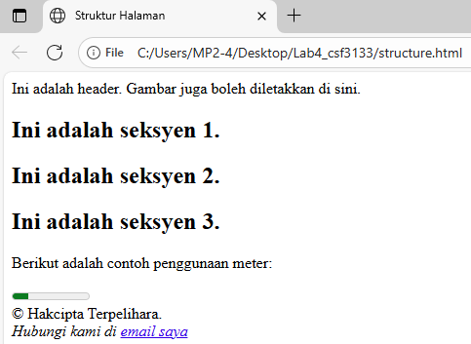
4.3 Insert Video into HTML5 Document

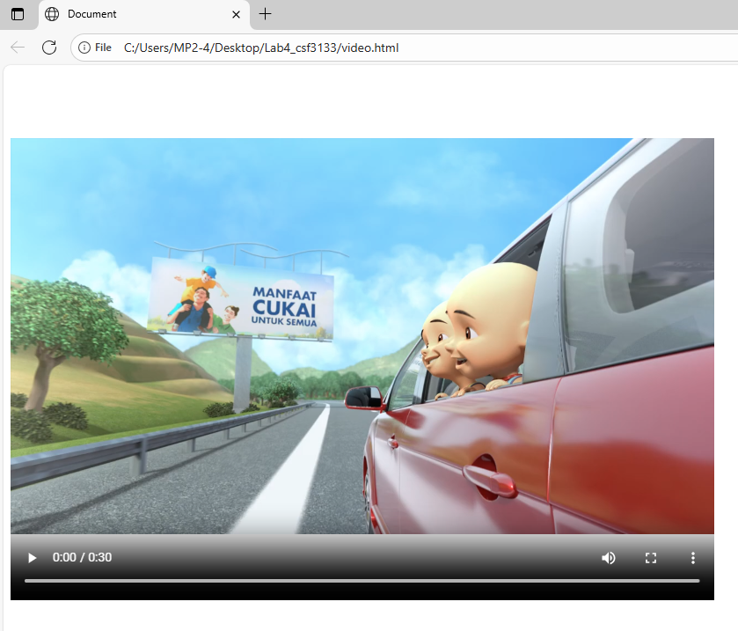
Change the width to 800 and height to 600
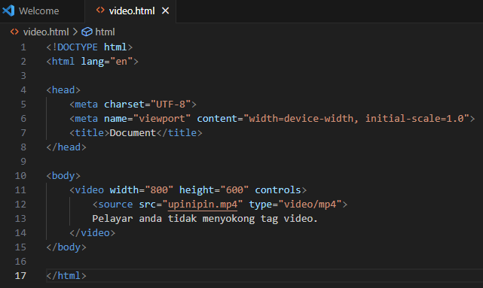
4.4 Cascading Style Sheets

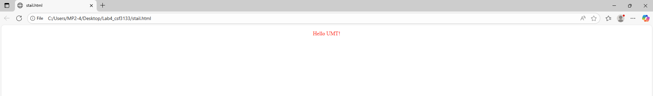
4.5 Recognize ID and Selector Class

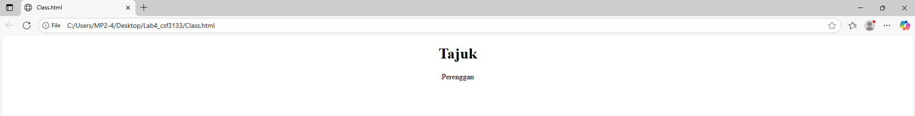
4.6 Navigation Bar Using CSS

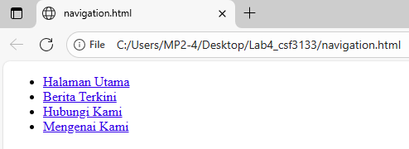
4.7 Recognizing Text Decoration

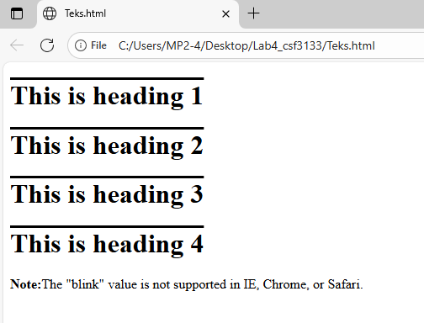
4.8 Recognizing Styling Links

Unvisited link
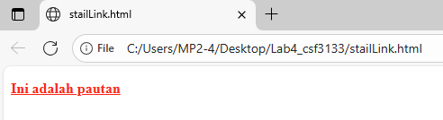

Mouse over link
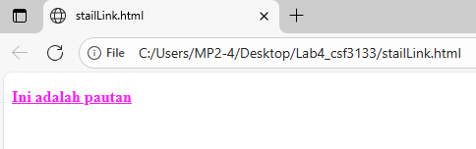

Selected link
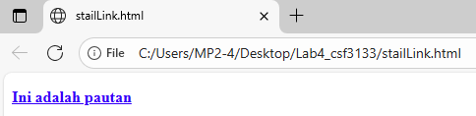

Visited link
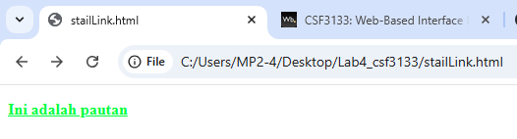
4.9 Lab Exercise 4

Source Code
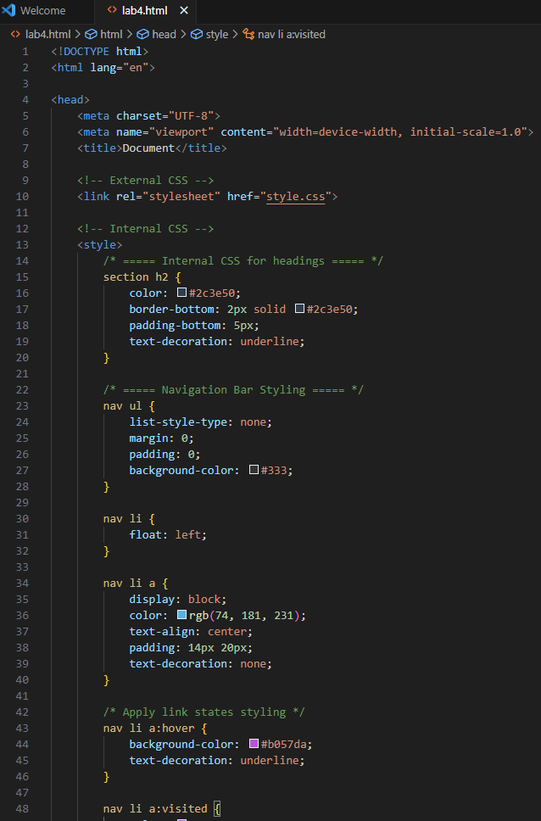
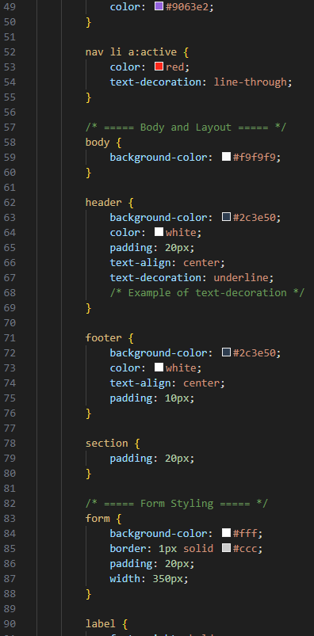
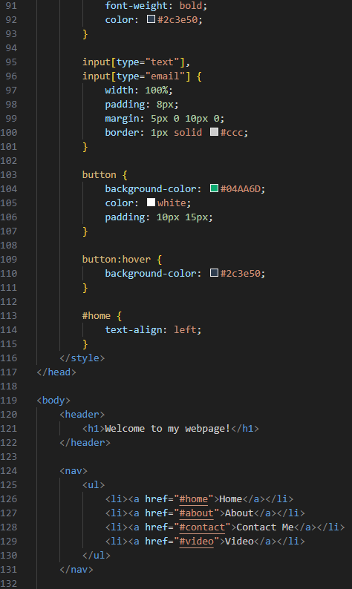
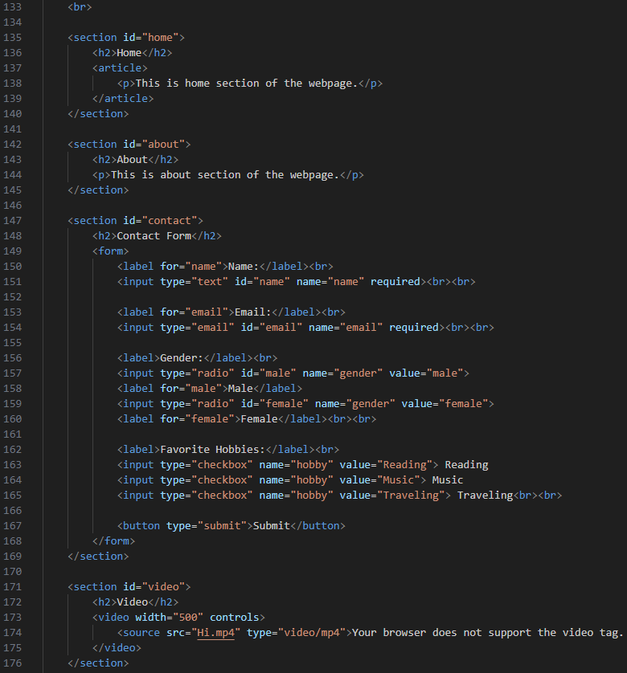
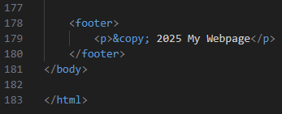

Output

