

WEB-BASED INTERFACE DESIGN
(CSF 3133)

LAB REPORT 8

NAME : LIM CHIA YING
MATRIC : S75063
DATE : 14 DECEMBER 2025
GROUP : K4
PROGRAMME : COMPUTER SCIENCE (SOFTWARE ENGINEERING)

8.3 Create First Web Page with Bootstrap
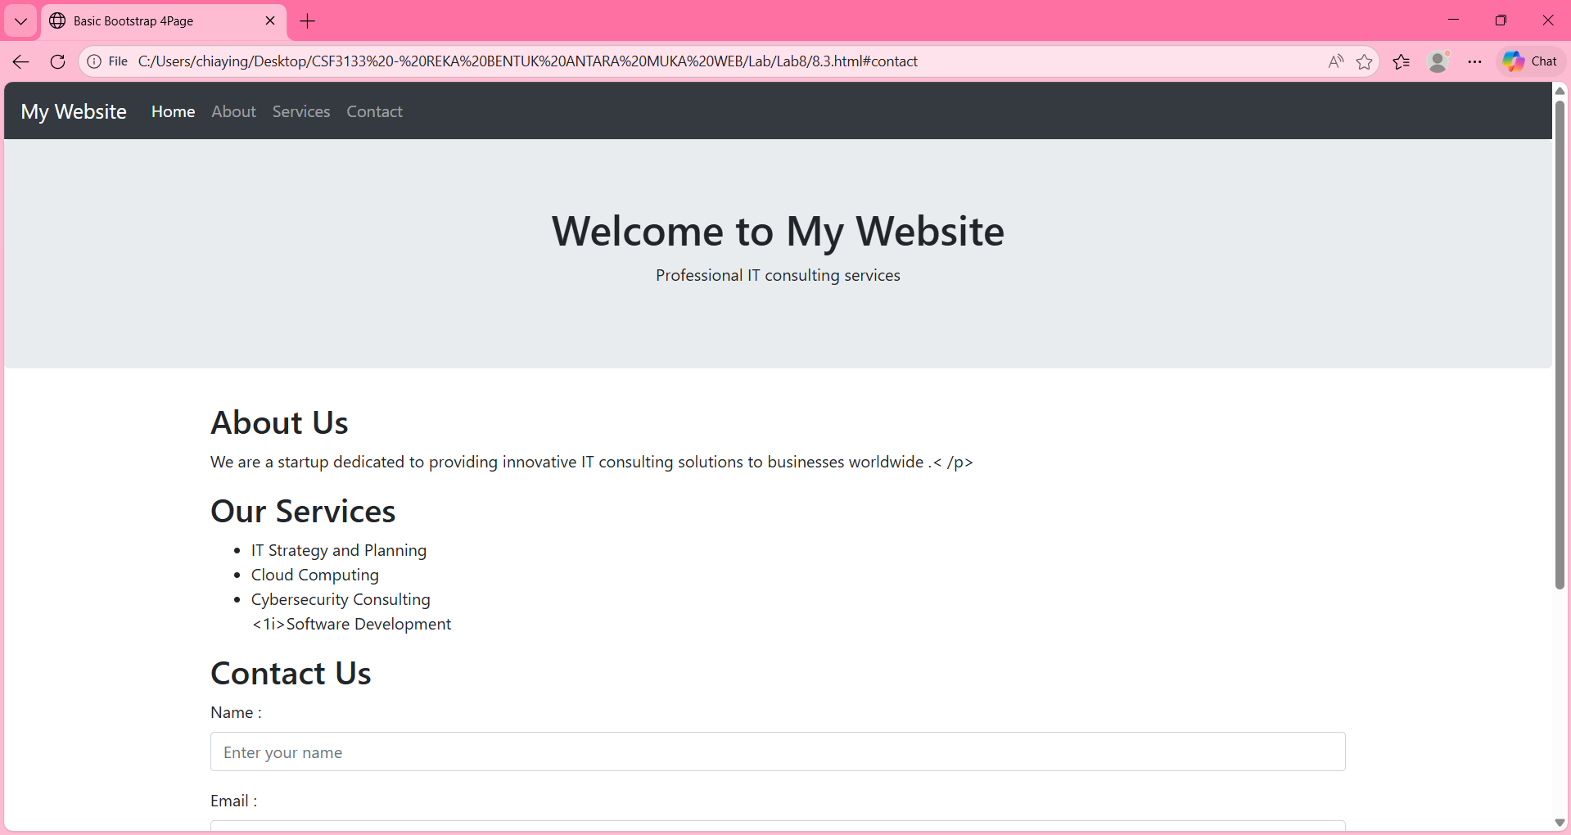
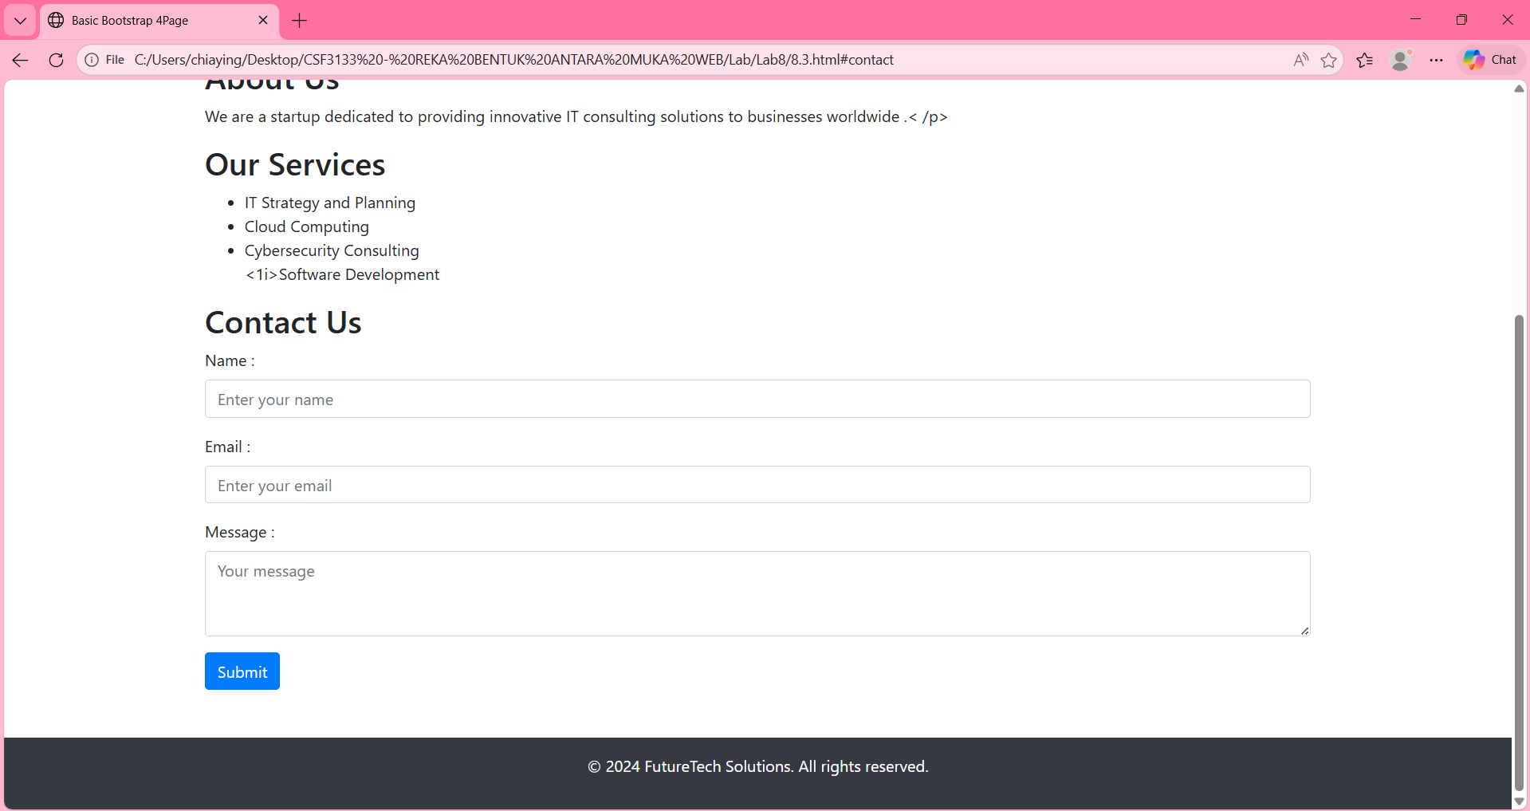
8.4 Responsive Image
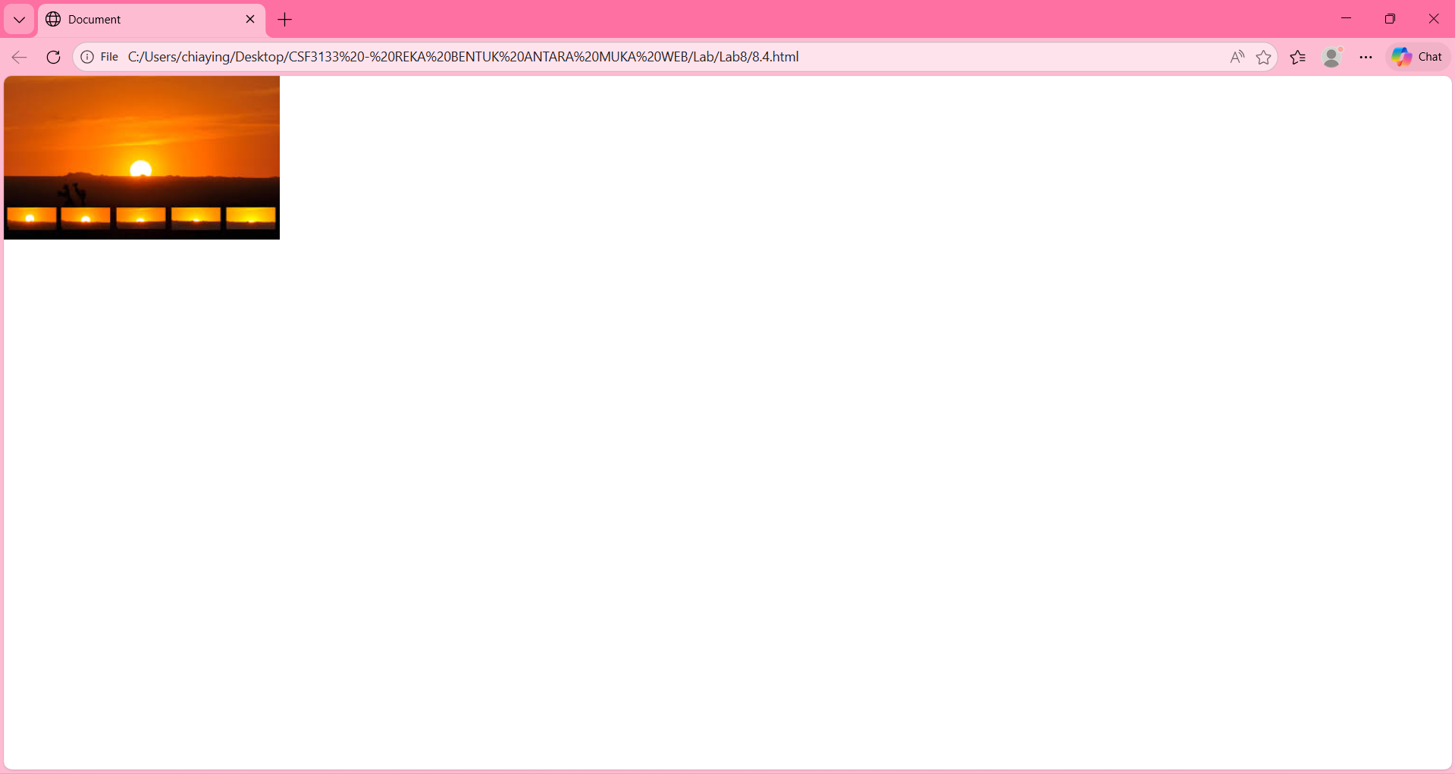
8.5 Bootstrap Text/Typography
8.5.1 Headings
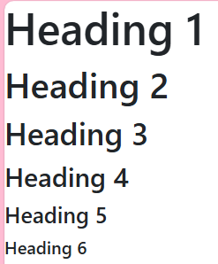

8.5.2 Display Headings
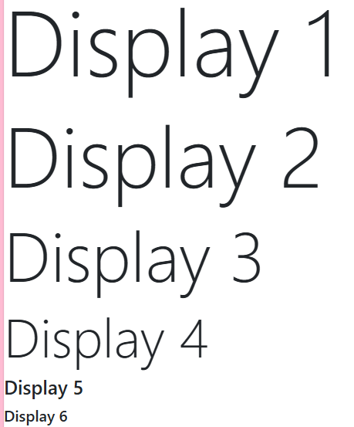

8.5.3Inline Text Elements
8.5.4 Text Color and Background

8.5.5 Text Wrapping and Overflow
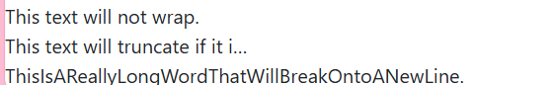

8.5.6 Font Size
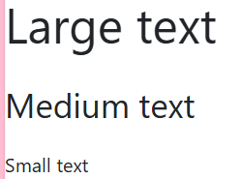

8.5.7 Font Weight and Style
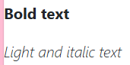

8.5.8 Line Height


8.5.9 Lists
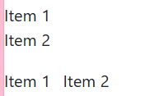
8.6 Bootstrap CSS Forms
8.6.1 Basic Form Structure
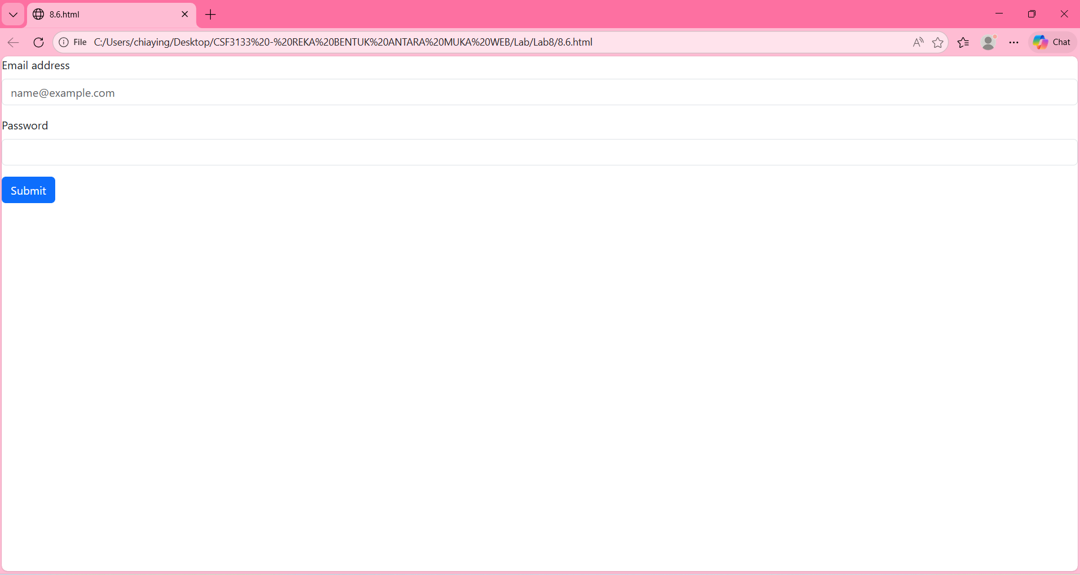

8.6.2 Form Layouts
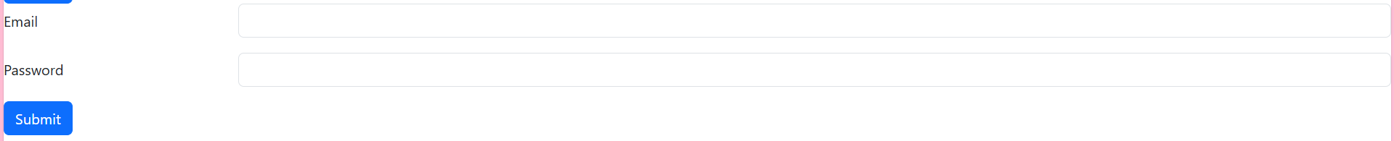

8.6.3 Inline Forms

8.6.4 Form Controls

8.6.5 Select Menus
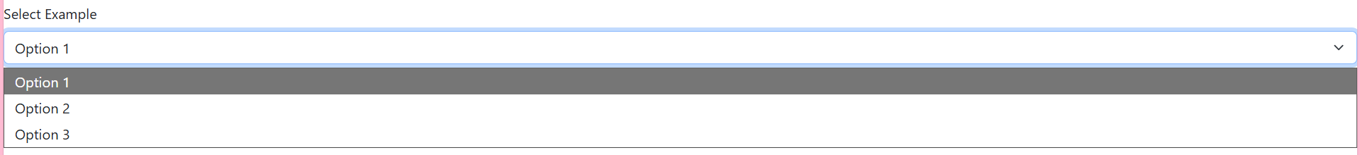
8.6.6 Form Validation
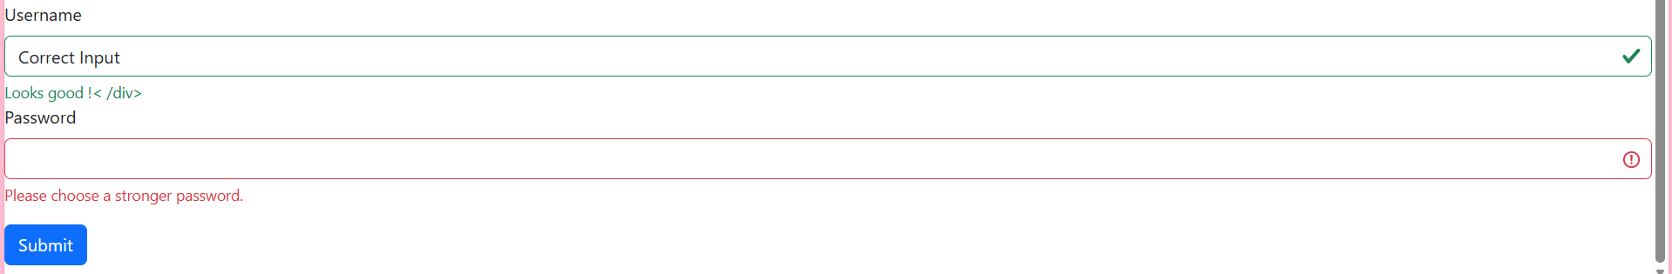

8.6.7 Checkboxes and Radios
Checkboxes

Radio Buttons
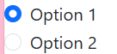

8.6.8 Input Groups

8.6.9 Floating Labels

8.6.10 Disabled and Readonly Inputs

8.6.11 Example Forms
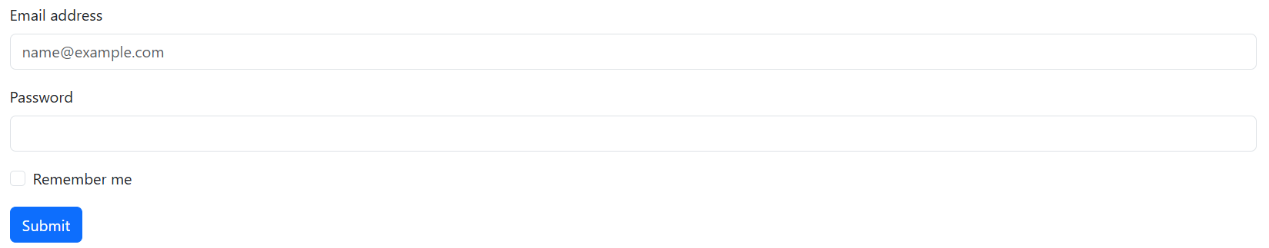
8.7 Using Bootstrap Theme
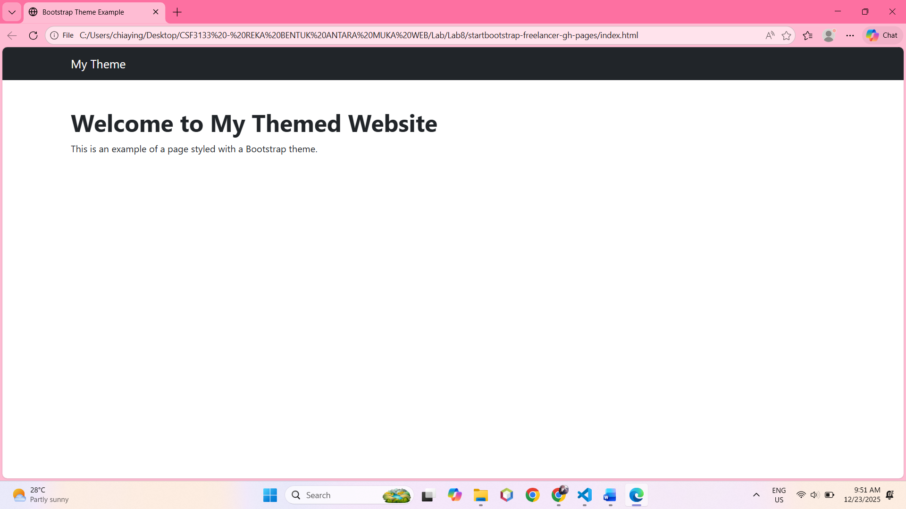
8.8 Lab Exercise 8

