

WEB-BASED INTERFACE DESIGN
(CSF 3133)

LAB REPORT 3

NAME : LIM CHIA YING
MATRIC : S75063
DATE : 5 NOVEMBER 2025
GROUP : K4
PROGRAMME : COMPUTER SCIENCE (SOFTWARE ENGINEERING)

3.2 Block and Inline Elements
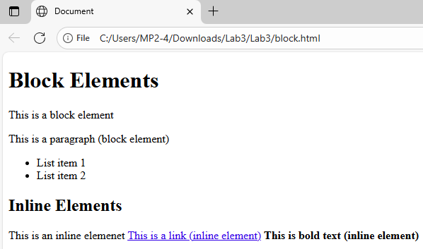

3.3 Using <div> to Organize Content
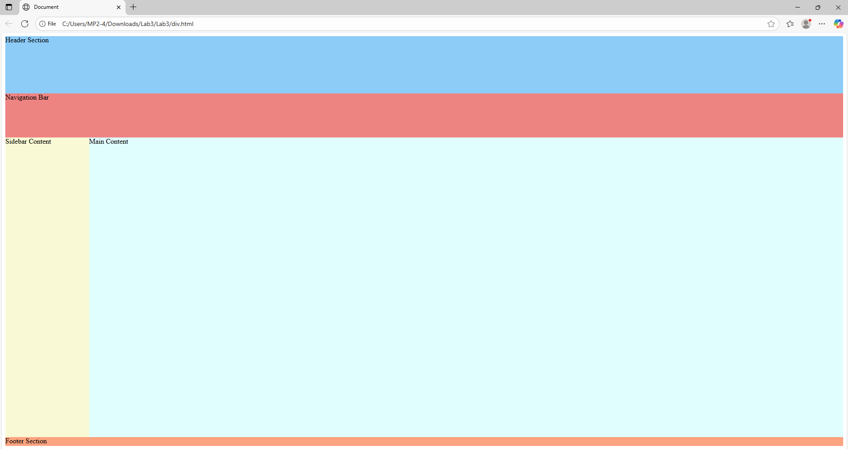

3.4 Understanding HTML Entities
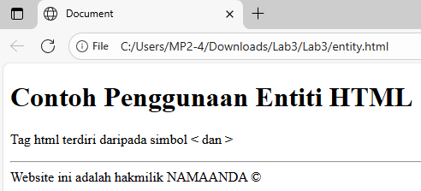
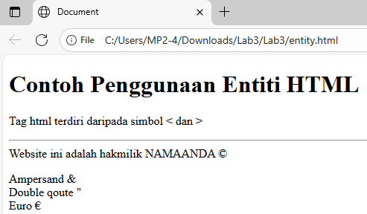

3.5 Hypertext Mark Up Language 5 (HTML5)
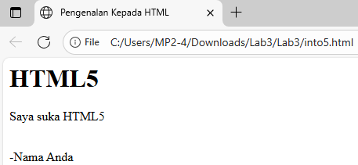
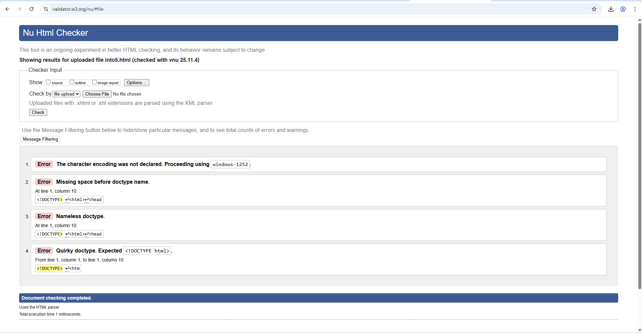
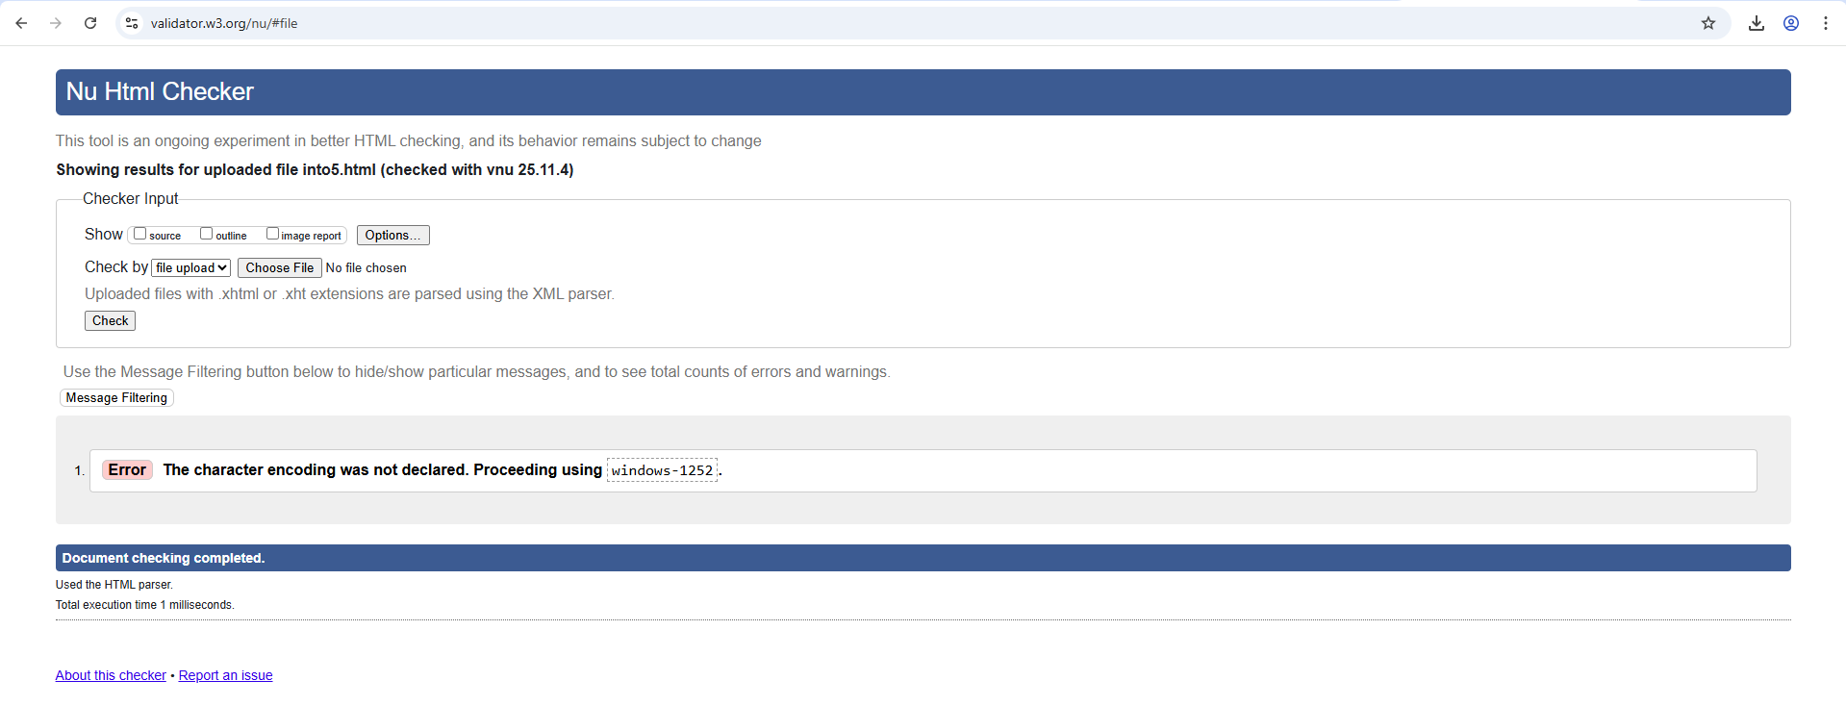

3.6.1 Input Elements in HTML5
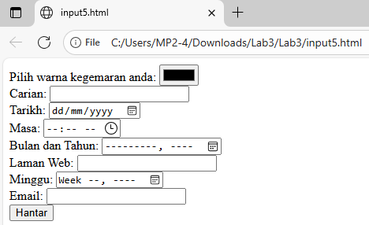
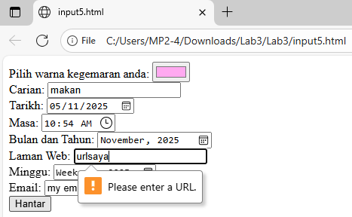
3.6.2 Attributes for Input HTML5
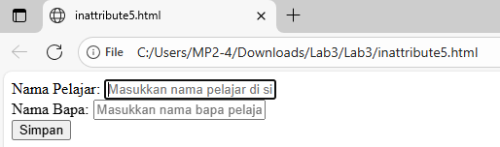
“Nama Pelajar” text box has flashing cursor
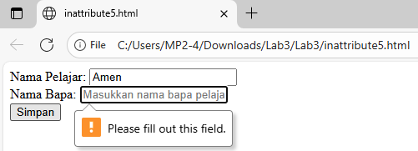
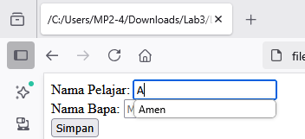

3.6.3 HTML5 <output> element
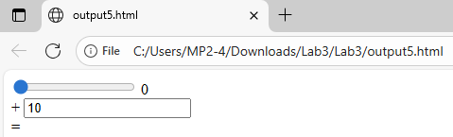

Lab Exercise

Source Code:
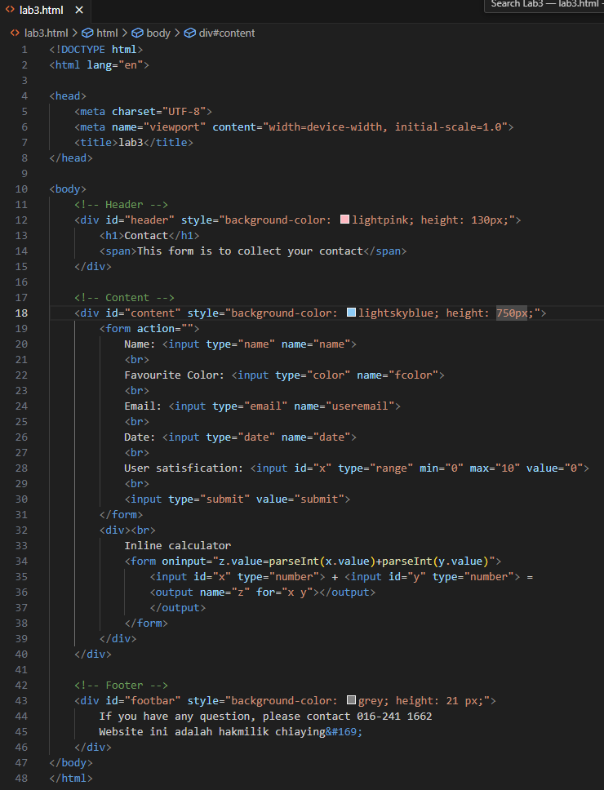

Output:
