Stat 107: Quantitative Methods for Economics Take Home Exam

Xiner Zhou

10/20/2016

Note: My answer to Question 21is 0, my version doesn’t allow to choose the right answer, I’ve sent email to Prof. Parzen to confirm this issue.

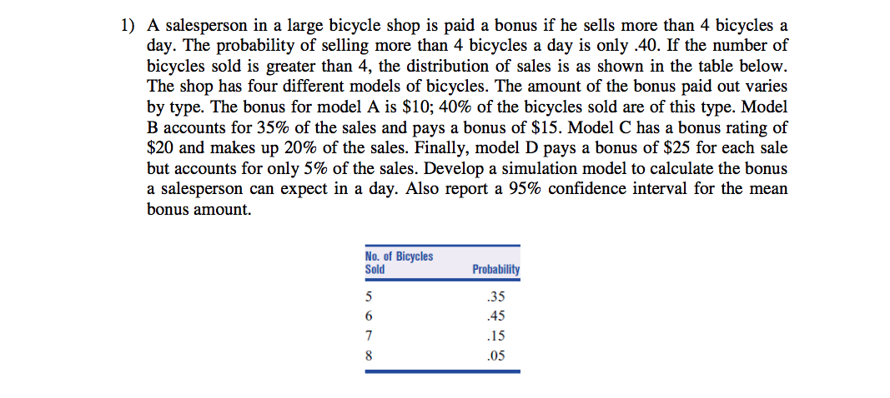.

set.seed(02138)  
# set the number of simulation  
n.sim<-1000000  
# initialize place-holder for simulated bonus  
bonus<-rep(0,n.sim)  
  
for(i in 1:n.sim){  
 # step 1: sell more than 4 bicycles ?   
 sell.more.4<-rbinom(n=1,size=1,prob = 0.4)  
   
 if(sell.more.4==1){  
 # step 2: if sell more than 4, decide how many sold  
 n.sell<-sample(x=c(5,6,7,8), size=1, replace = FALSE, prob =c(0.35,0.45,0.15,0.05))  
   
 # step 3: for each sold bicycle, decide which model it is and its associated bonus  
 bonus.each<-sample(x=c(10,15,20,25), size=n.sell, replace = TRUE, prob = c(0.4,0.35,0.2,0.05))  
   
 # step 4: add up bonus  
 bonus[i]<-sum(bonus.each)  
 }  
}  
  
cat("The expected bonus in a day is", mean(bonus), '\n')

## The expected bonus in a day is 34.17213

cat("95% confident interval for the mean bonus is", "(", quantile(bonus, probs = c(0.025)),",",quantile(bonus, probs = c(0.975)),")", '\n')

## 95% confident interval for the mean bonus is ( 0 , 110 )

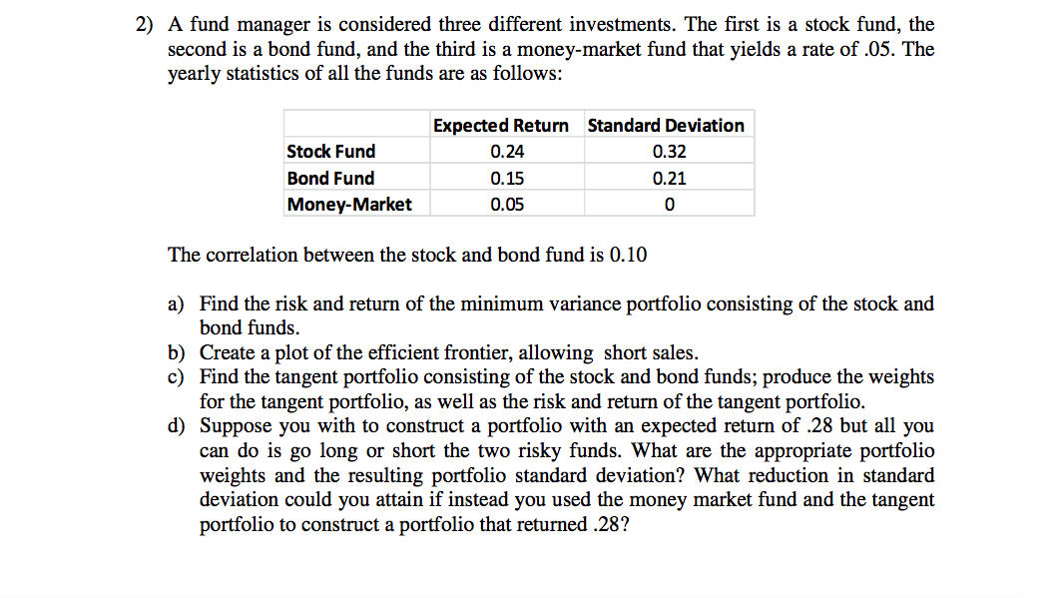.

##### (a)

# Loading required libraries  
library(quantmod)  
  
# include source code  
source("/Volumes/NO NAME/Course Work at Harvard/Introduction to Financial Statisitcs/Eric Zivot.R")  
  
# expected return vector  
er<-c(0.24,0.15)  
  
# covariance matrix  
cov.mat<-matrix(c(0.32^2, 0.1*0.32*0.21,   
 0.1*0.32*0.21, 0.21^2),nrow=2,ncol=2,byrow = T)  
names(er)<-c("Stock Fund","Bond Fund")  
colnames(cov.mat)<-c("Stock Fund","Bond Fund")  
rownames(cov.mat)<-c("Stock Fund","Bond Fund")  
  
############################################  
## Global Minimum Variance Portfolio  
###########################################  
gmin.port<-globalMin.portfolio(er,cov.mat)  
print(gmin.port)

## Call:  
## globalMin.portfolio(er = er, cov.mat = cov.mat)  
##   
## Portfolio expected return: 0.1752833   
## Portfolio standard deviation: 0.1833003   
## Portfolio weights:  
## Stock Fund Bond Fund   
## 0.2809 0.7191

plot(gmin.port)

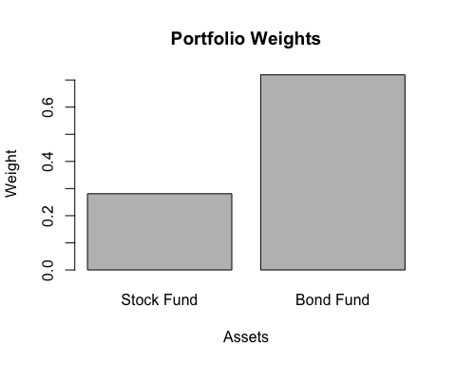

**The Global Minimum Variance porfolio puts 28.09% wealth in Stock Fund and 71.91% in Bond Fund, and it has expected return of 17.53% and risk(standard deviation) of 18.33%.**

##### (b)

###########################################  
## Efficient Frontier Curve  
###########################################  
ef<-efficient.frontier(er, cov.mat, nport=100, alpha.min=-5, alpha.max=5)  
plot(ef, plot.assets=T)  
   
# More interestingly, add a point for the Global Minimum Variance Portfolio  
points(gmin.port$sd, gmin.port$er, col="blue", pch=21, bg="blue")  
text(gmin.port$sd+0.01, gmin.port$er, "Minimum Variance", col="blue")

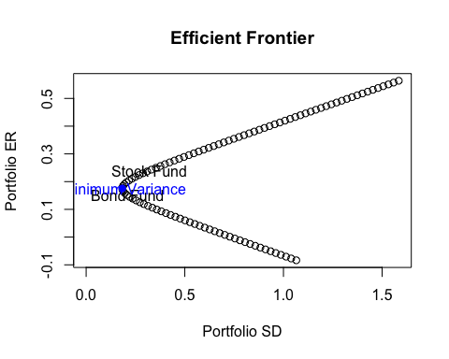

##### (c)

###########################################  
## Tangency Portfolio and Capital Market Line  
###########################################  
  
# Compute tangency portfolio  
rk.free<-0.05 # Money Market  
tan.port<-tangency.portfolio(er, cov.mat, rk.free)  
print(tan.port)

## Call:  
## tangency.portfolio(er = er, cov.mat = cov.mat, risk.free = rk.free)  
##   
## Portfolio expected return: 0.191609   
## Portfolio standard deviation: 0.1948776   
## Portfolio weights:  
## Stock Fund Bond Fund   
## 0.4623 0.5377

plot(tan.port)

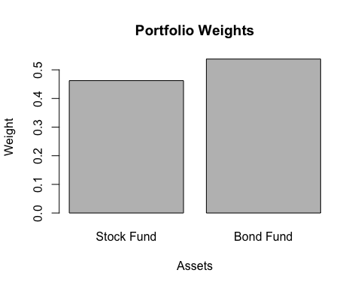

**The tangent portfolio puts 46.23% wealth in Stock Fund and 53.77% in Bond Fund, and it has an expected return of 19.16% and risk(standard deviation) of 19.49%.**

Let's visualize the Efficient Frontier with GMV and Tangent Portfolio.

# compute slope of tangent line (aka capital market line)  
sr.tan<-(tan.port$er-rk.free)/tan.port$sd  
  
plot(ef, plot.assets=T)  
  
# Adds points to the plot representing GMV and tangent portfolios  
points(gmin.port$sd, gmin.port$er, col="blue", pch=21, bg="blue")  
points(tan.port$sd, tan.port$er, col="red", pch=21, bg="red")  
  
# Adds a line to the plot representing the CML  
abline(a=0.05, b=sr.tan,col="red")

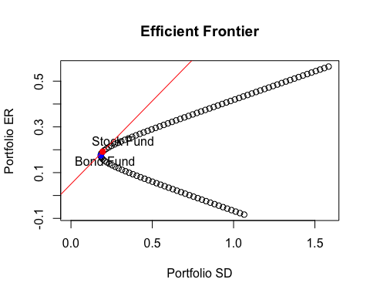

##### (d)

eff.port<-efficient.portfolio(er, cov.mat, target.return = 0.28)  
print(eff.port)

## Call:  
## efficient.portfolio(er = er, cov.mat = cov.mat, target.return = 0.28)  
##   
## Portfolio expected return: 0.28   
## Portfolio standard deviation: 0.462312   
## Portfolio weights:  
## Stock Fund Bond Fund   
## 1.4444 -0.4444

plot(eff.port)

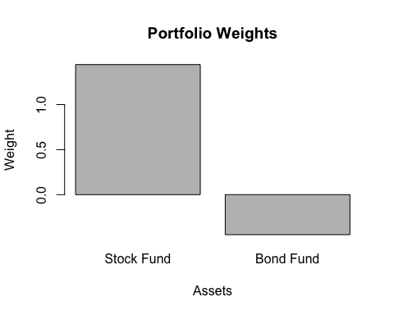

**The weight for Stock Fund is 144.44% and weight for Bond Fund is -44.44%, it means you would long Stock Fund and short Bond fund to ahieve the expected return of 28%, the risk(standard deviation) is 46.23%.**

**If instead you used the money market fund and the tangent portfolio to construct a portfolio that returns 28%:**

# weight for tangent portfolio  
w.tangent<-(28-5)/(19.16-5)  
cat("The weight for tangent portflio is", round(w.tangent,2), "%\n")

## The weight for tangent portflio is 1.62 %

cat("The weight for money market is", round(1-w.tangent,2), "%\n")

## The weight for money market is -0.62 %

# risk/standard deviation  
cat("The resulting portfolio standard deviation is", round(w.tangent*19.49,2), "%\n")

## The resulting portfolio standard deviation is 31.66 %

cat("The reduction in standard devation you could attain is", round(46.23-w.tangent*19.49,2), "%\n")

## The reduction in standard devation you could attain is 14.57 %

**The portfolio with an expected return of 28% based on two risky assets has standard deviation 46.23%, the associated weights for Stock Fund and Bond Fund is 144.44% and -44.44%, respectively, if willing to go long and short. However, this risk can be reduced to 31.66%, almost reduced one third (1/3) of risk, if instead you used the money market fund and the tangent portfolio to construct a portfoio that has the same expected return.**

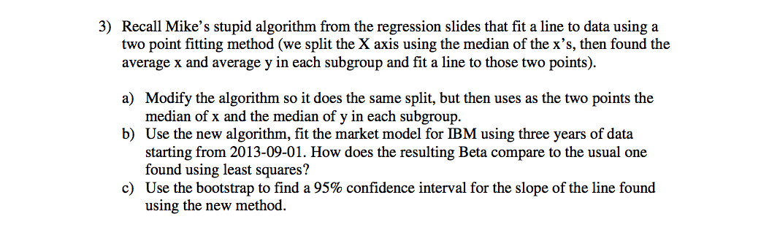.

##### (a)

# Mike's moidified algorithm  
mikeline<-function(x,y){  
 xmed<-median(x)  
 xbar1<-median(x[x<=xmed])  
 ybar1<-median(y[x<=xmed])  
 xbar2<-median(x[x>xmed])  
 ybar2<-median(y[x>xmed])  
   
 slope<-(ybar2-ybar1)/(xbar2-xbar1)  
 inter<-ybar1-slope*xbar1  
 cat("Intercept = ",inter, " Slope = ", slope, "\n")  
 #return(slope)  
}

##### (b)

# get IBM monthly adjusted return  
getSymbols("IBM",from="2013-09-01")

## [1] "IBM"

ibm.ret<-monthlyReturn(Ad(IBM))  
  
# get S&P 500 index monthly adjusted return  
getSymbols("SPY", from="2013-09-01")

## [1] "SPY"

spy.ret<-monthlyReturn(Ad(SPY))  
  
# Use Mike's algorithm, fit the Market Model  
mikeline(spy.ret, ibm.ret)

## Intercept = -0.005915919 Slope = 0.5156135

# Use Least Square Regression, fit the Market Model  
lm.fit<-lm(ibm.ret~spy.ret)  
coef(lm.fit)

## (Intercept) spy.ret   
## -0.008683103 0.800288160

**Mike's modified model produces a smaller Beta than the usual least square regression produces, 0.5156 versus 0.8, therefore implies less volatility or systematic risk in comparison to the market as a whole.**

##### (c)

# confident interval via Bootstrap   
library(boot)  
  
mikeline<-function(x,y){  
 xmed<-median(x)  
 xbar1<-median(x[x<=xmed])  
 ybar1<-median(y[x<=xmed])  
 xbar2<-median(x[x>xmed])  
 ybar2<-median(y[x>xmed])  
   
 slope<-(ybar2-ybar1)/(xbar2-xbar1)  
 inter<-ybar1-slope*xbar1  
 #cat("Intercept = ",inter, " Slope = ", slope, "\n")  
 return(slope)  
}  
  
myfunc<-function(data,i){  
 x<-data[i,1]  
 y<-data[i,2]  
 fit<-mikeline(x, y)  
 return(fit)  
}  
mydata<-cbind(as.numeric(spy.ret),as.numeric(ibm.ret))  
boots.fit<-boot(mydata,myfunc,R=100000)  
boot.ci(boots.fit)

## BOOTSTRAP CONFIDENCE INTERVAL CALCULATIONS  
## Based on 100000 bootstrap replicates  
##   
## CALL :   
## boot.ci(boot.out = boots.fit)  
##   
## Intervals :   
## Level Normal Basic   
## 95% (-0.6016, 1.3868 ) (-0.8569, 1.1806 )   
##   
## Level Percentile BCa   
## 95% (-0.1493, 1.8881 ) (-0.1650, 1.8552 )   
## Calculations and Intervals on Original Scale

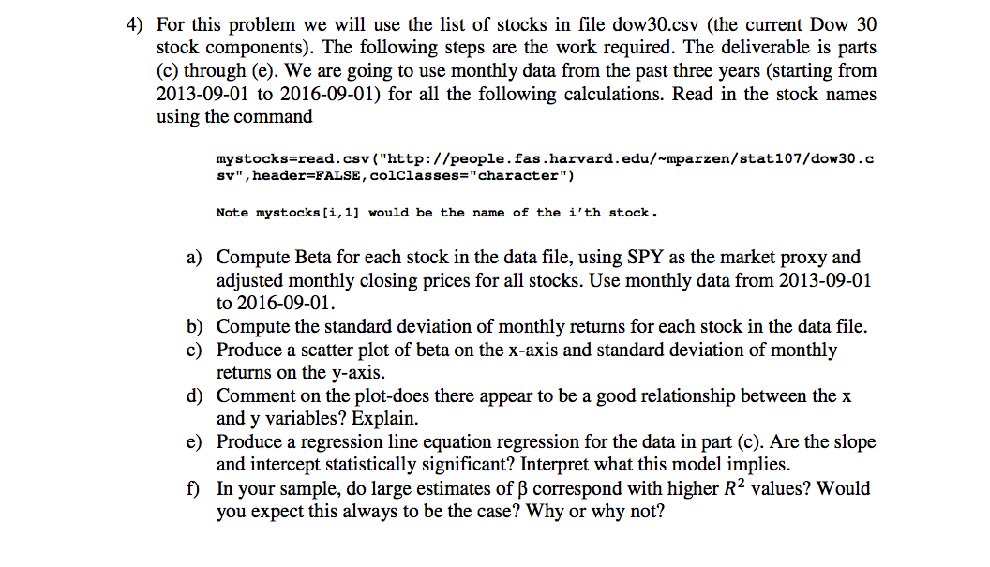.

##### (a)

# Download stock names  
mystocks<-read.csv("http://people.fas.harvard.edu/~mparzen/stat107/dow30.csv",header = FALSE, colClasses = "character")  
  
# how many stocks  
n.stock<-nrow(mystocks)  
   
# get SPY as market proxy   
getSymbols("SPY",from="2013-09-01",to="2016-09-01")

## [1] "SPY"

spy.ret<-monthlyReturn(Ad(SPY))  
  
# Initialize a placeholder for Beta's  
beta<-rep(NA,n.stock)  
names(beta)<-mystocks[,1]  
# Initialize a placeholder for R-squared  
R2<-rep(NA,n.stock)  
names(R2)<-mystocks[,1]  
  
# Compute Beta and R-squared for each stock  
for(i in 1:n.stock){  
 ticker<-mystocks[i,1]  
 stockdata<-getSymbols(ticker,from="2013-09-01",to="2016-09-01",auto.assign = FALSE)  
 y.ret<-monthlyReturn(Ad(stockdata))  
 beta[i]<-coef(lm(y.ret~spy.ret))[2]  
 R2[i]<-summary(lm(y.ret~spy.ret))$r.squared  
}  
beta

## AXP AAPL BA CAT CSCO CVX   
## 1.28780006 1.52005585 1.31298263 1.35482519 1.14499834 1.21474883   
## DD XOM GE GS HD IBM   
## 1.85453944 0.80797719 1.23246595 1.23868401 1.01629234 0.78188226   
## INTC JNJ KO JPM MCD MMM   
## 1.15387437 0.70391472 0.81062976 1.08763873 0.64278186 1.00592520   
## MRK MSFT NKE PFE PG TRV   
## 0.73581486 1.37373461 0.53965005 0.96611797 0.60482902 1.17625507   
## UNH UTX VZ V WMT DIS   
## 0.54828803 0.94344919 0.53294059 1.16055308 0.09761214 1.44669225

##### (b)

# Compute the standard deviation of monthly returns for each stock in the data file  
# Initialize a placeholder for sd  
sd.vec<-rep(NA,n.stock)  
names(sd.vec)<-mystocks[,1]  
# Compute sd for each stock  
for(i in 1:n.stock){  
 ticker<-mystocks[i,1]  
 stockdata<-getSymbols(ticker,from="2013-09-01",to="2016-09-01",auto.assign = FALSE)  
 y.ret<-monthlyReturn(Ad(stockdata))  
 sd.vec[i]<-sd(y.ret)  
}  
  
sd.vec

## AXP AAPL BA CAT CSCO CVX   
## 0.06178961 0.06819514 0.06300284 0.06817515 0.05779864 0.05890890   
## DD XOM GE GS HD IBM   
## 0.08474073 0.04413338 0.05160430 0.05390488 0.04726693 0.05333572   
## INTC JNJ KO JPM MCD MMM   
## 0.06163815 0.03495707 0.04085390 0.05332388 0.03843067 0.04071944   
## MRK MSFT NKE PFE PG TRV   
## 0.04698572 0.06868396 0.05115607 0.04629331 0.03806209 0.04979770   
## UNH UTX VZ V WMT DIS   
## 0.04689247 0.04865234 0.04562569 0.05158382 0.04814606 0.05635154

##### (c)

# Produce a scatter plot of beta on the x-axis and standard deviation of monthly returns on the y-axis  
plot(beta, sd.vec,  
 type="p",  
 col="brown",  
 ylab="Risk/Standard Deviation",  
 xlab="Beta")

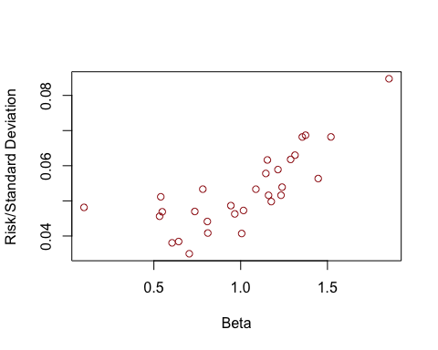

##### (d)

**The plot-Beta versus standard deviation-appear to suggest that there is a positive linear relationship between Beta and risk (as measured by standard deviation). It is reasonable, because individual stock's standard deviation can be decomposed into two components under the Single Index Model -- systematic risk in proportional (Beta) to market risk (same for every stock), and non-systematic/residual risk independent of the market and all other stocks. Therefore, if we regress or plot individual stock's risk on beta, we would expect to observe they fit a line with a positive slope close to the market risk, and the noise represents firm/stock-specific risk independent of the market as a whole.**

##### (e)

fit<-lm(sd.vec~beta)  
summary(fit)

##   
## Call:  
## lm(formula = sd.vec ~ beta)  
##   
## Residuals:  
## Min 1Q Median 3Q Max   
## -0.0118894 -0.0055356 -0.0003023 0.0045135 0.0162856   
##   
## Coefficients:  
## Estimate Std. Error t value Pr(>|t|)   
## (Intercept) 0.029631 0.003815 7.766 1.85e-08 ***  
## beta 0.022843 0.003557 6.423 5.91e-07 ***  
## ---  
## Signif. codes: 0 '***' 0.001 '**' 0.01 '*' 0.05 '.' 0.1 ' ' 1  
##   
## Residual standard error: 0.007046 on 28 degrees of freedom  
## Multiple R-squared: 0.5957, Adjusted R-squared: 0.5812   
## F-statistic: 41.25 on 1 and 28 DF, p-value: 5.913e-07

**The intercept = 0.029631 and the slope = 0.022843 are both statistically significant.The model implies that, when individual stock's beta =0, that is, it doesn't move with the market, it still has a standard deviation of 2.96%, this can be viewed as average firm-specific or unsystematic risk that is independent of the overall market; and as the stock responds more sensitively to the market, with each 1-unit increase in beta, the standard deviation increases 2.28%, due to response to market swing, the 2.28% can be viewed as the market risk/standard deviation.**

##### (f)

# plot R-squared vs Beta  
plot(beta, R2,  
 type="p",  
 col="brown",  
 ylab="R-Squared",  
 xlab="Beta")

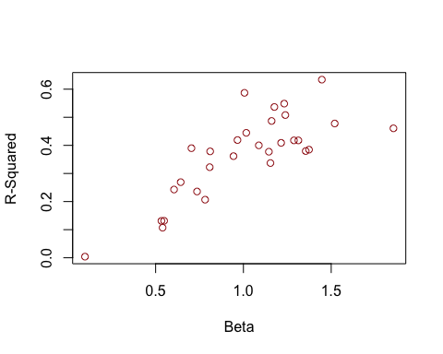

**In my sample, large estimate of beta correspond with higher R-squared values, this agrees with my expectation. R-squared measures the percentage of a stock's historical price movements that could be explained by movements in a benchmark index. A larger estimate of beta indicates higher sensitivity of a stock's respond to swings in the market as whole, it's equivalent to say that, more variation in individual stock's movement can be explained by the market, therefore, has higher R-squared. So I expect Beta and R-squared should have a significant positive relationship.**

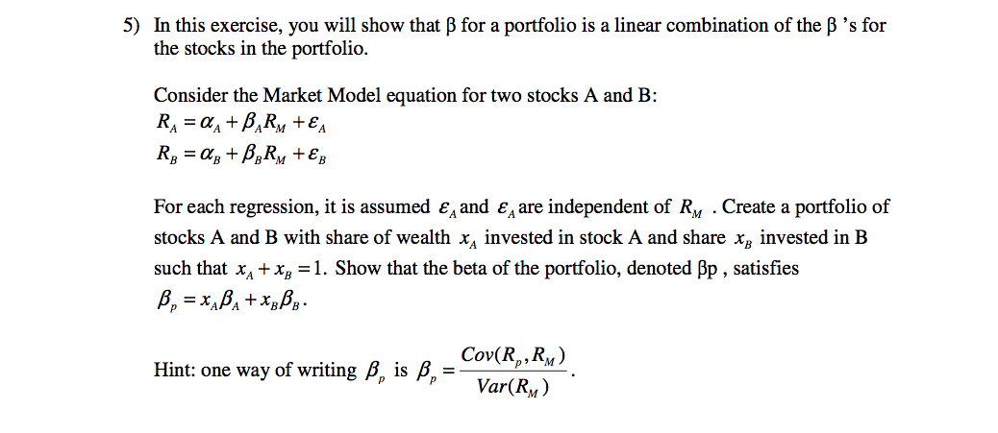.

.

$$β_{p}=\frac{Cov(R_{p},R_{M})}{Var(R_{M})}$$

$$=\frac{Cov(x_{A}R_{A}+x_{B}R_{B},R_{M})}{Var(R_{M})}$$

$$=\frac{x_{A}Cov(R_{A},R_{M})+x_{B}Cov(R_{B},R_{M})}{Var(R_{M})}$$

$$=\frac{x_{A}Cov(α_{A}+β_{A}R_{A}+ϵ_{A},R_{M})+x_{B}Cov(α_{B}+β_{B}R_{B}+ϵ_{B},R_{M})}{Var(R_{M})}$$

Since $α_{A}$ and $α_{B}$ are constant, and $ϵ_{A}$ and $ϵ_{B}$ are independent of $R_{M}$, therefore:

$$=\frac{x_{A}Cov(β_{A}R_{M},R_{M})+x_{B}Cov(β_{B}R_{M},R_{M})}{Var(R_{M})}$$

$$=\frac{x_{A}β_{A}Cov(R_{M},R_{M})+x_{B}β_{B}Cov(R_{M},R_{M})}{Var(R_{M})}$$

$$=\frac{x_{A}β_{A}Var(R_{M})+x_{B}β_{B}Var(R_{M})}{Var(R_{M})}$$

$$=x_{A}β_{A}+x_{B}β_{B}$$