## Prototype UI

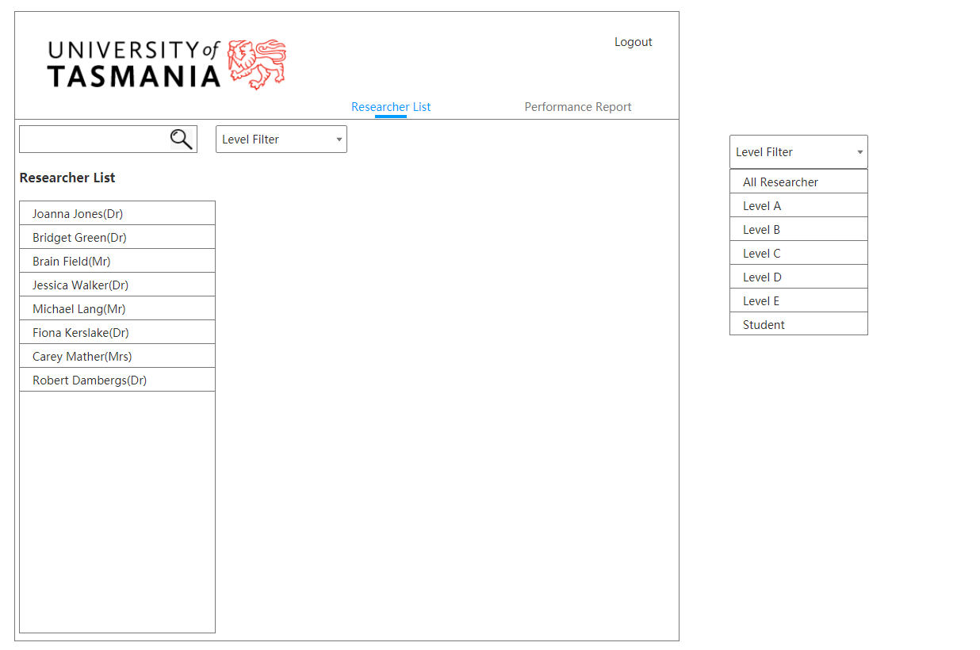

*Figure 1. Researcherlist View*

This is the home page of the application, shows the researcher list.

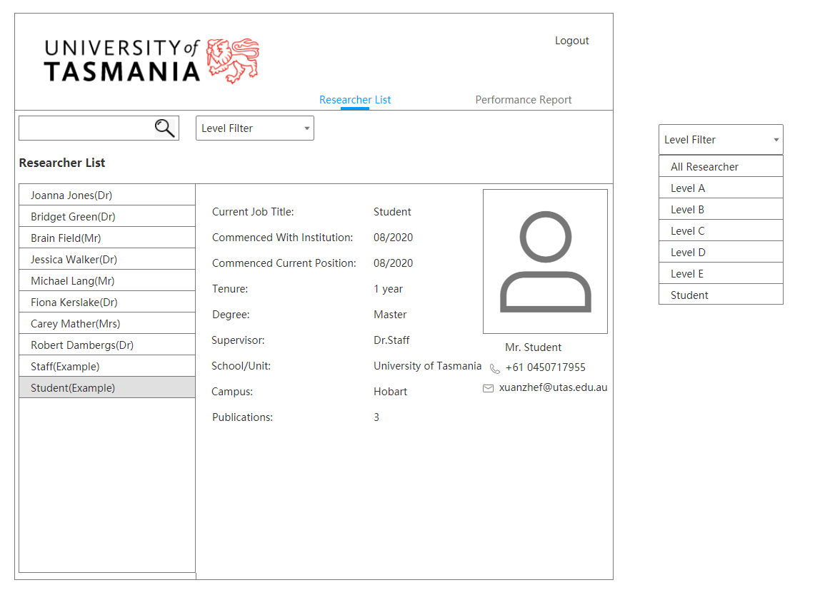

*Figure 2.1. Researcher Student View*

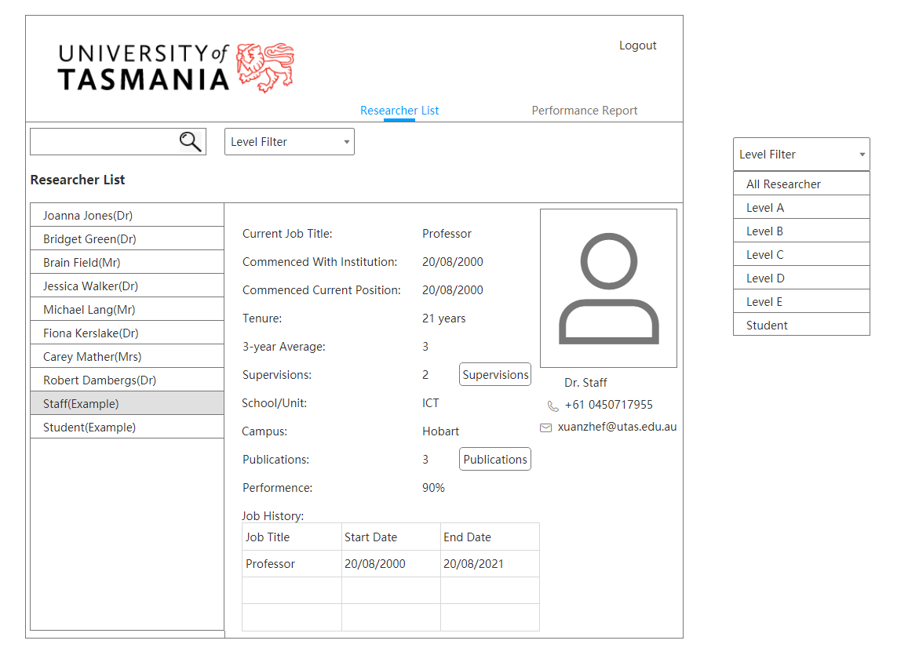

*Figure 2.2. Researcher Staff View*

After select one researcher in the list, the application will display the details of him/her depends on his/her role.

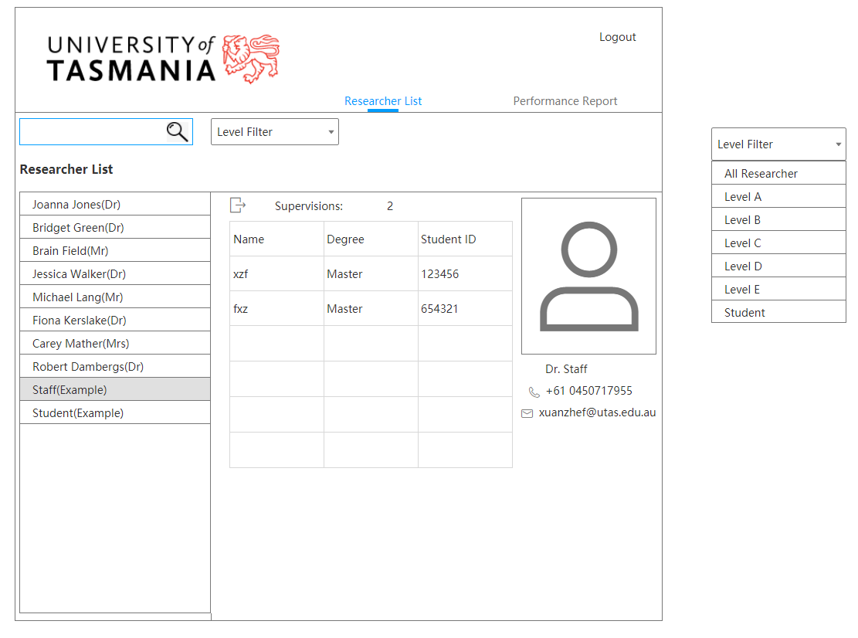

*Figure 3. Supervisions View*

This figure will display after clicking the ‘Supervision’ button, it will contains selected staff’s supervisions.

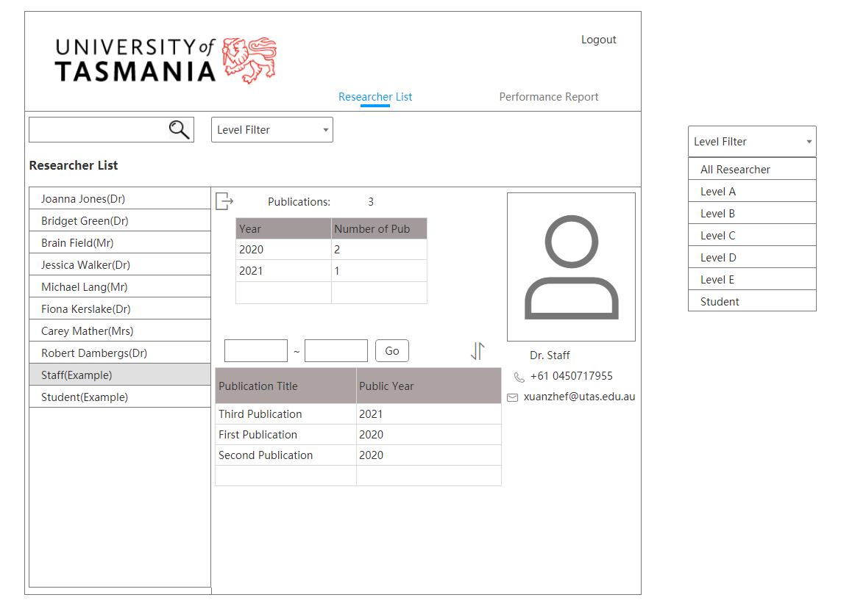

*Figure 4. Publications View*

After clicking the ‘Publications’ button in both staff’s and student’s detail page, the new window will show the cumulative number of publications by year in the upper table. For the lower table, it will show the details of publications.

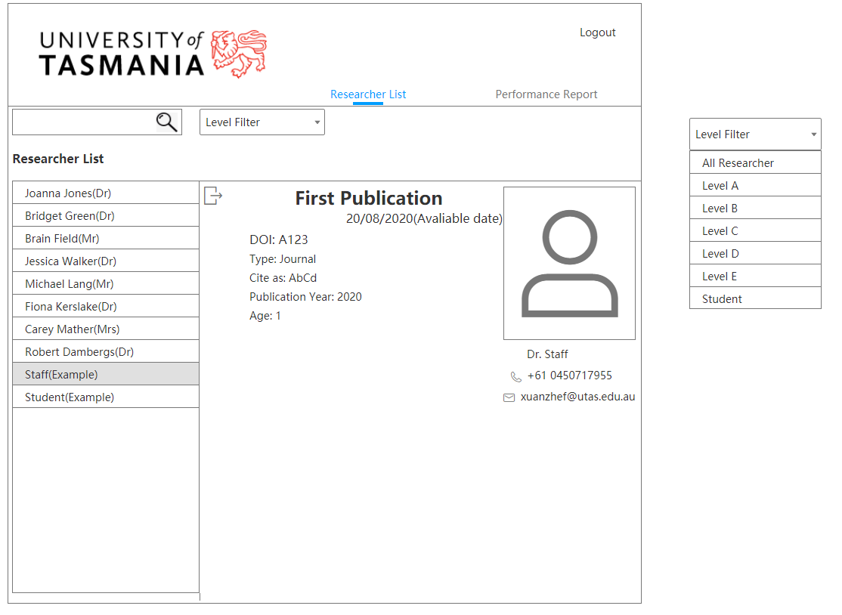

*Figure 5. Publication detail View*

After selecting one publication in the last page lower table, it will jump to the publication detail page, contains necessary details about the selected publication.

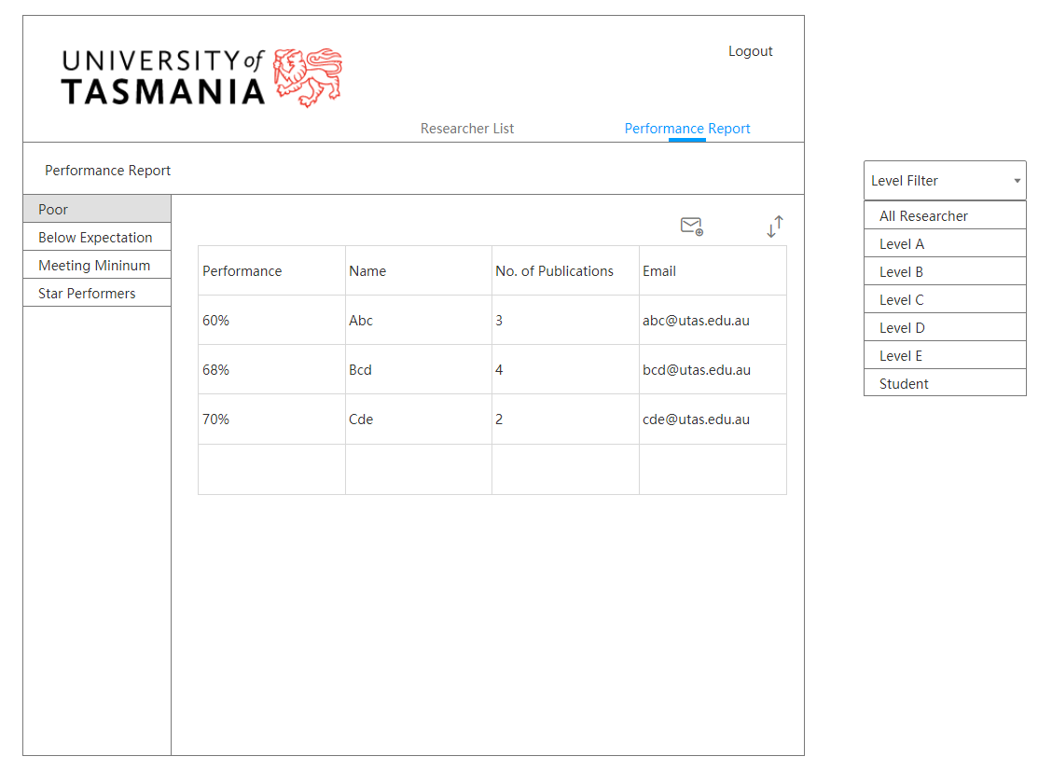

*Figure 6.1. Poor Report View*

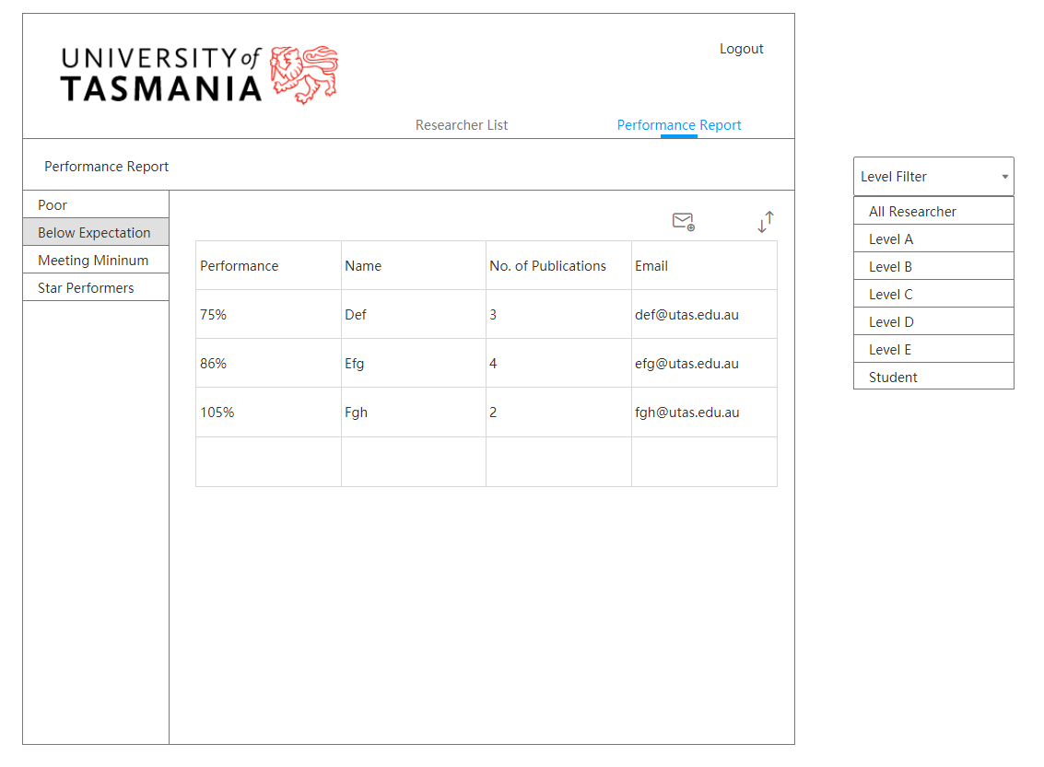

*Figure 6.2. Below Expectation Report View*

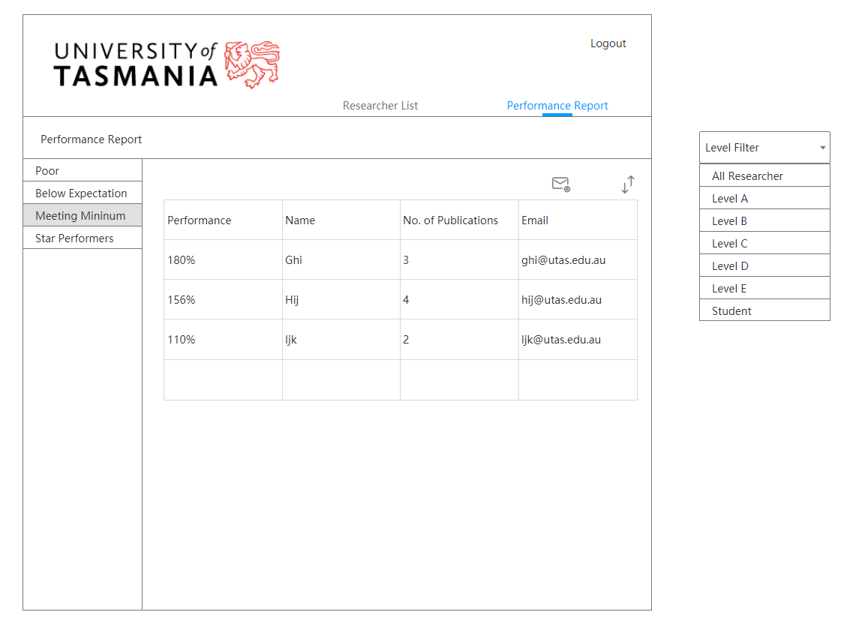

*Figure 6.3. Meeting Minimum Report View*

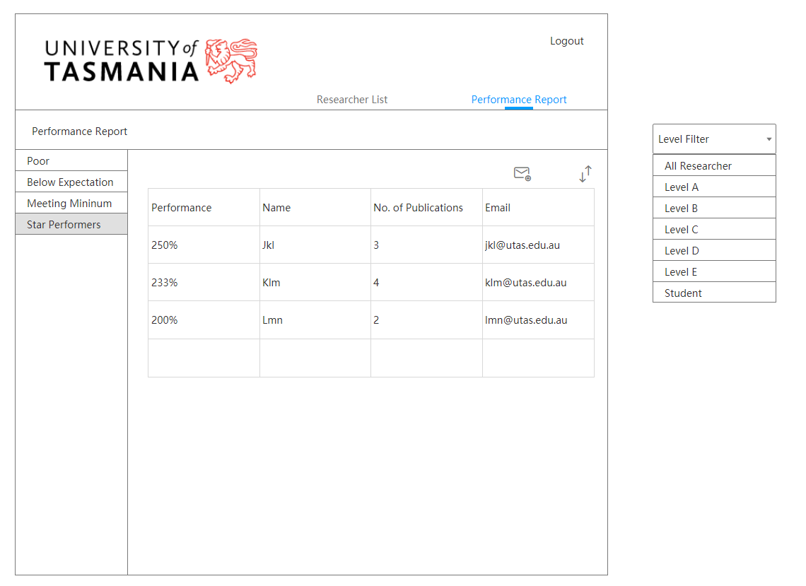

*Figure 6.4. Star Performers View*

The four figures above show the performance report feature in the application, contain different performance report. And the email button above the table allow the user to copy the email address of those listed in a report to the clipboard.