进度条
MaterialLoadingProgressBar

见目录E:\Android\0711笔记\常用项目\加载中的View\MaterialLoadingProgressBar

带进度功能的按钮
https://github.com/dmytrodanylyk/android-process-button


https://github.com/lzyzsd/CircleProgress
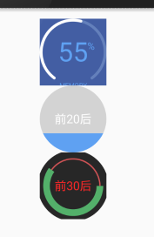

https://github.com/jakob-grabner/Circle-Progress-View

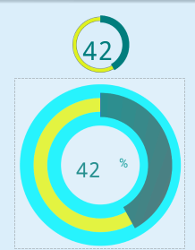

https://github.com/pnikosis/materialish-progress


https://github.com/fenjuly/SpinnerLoader/
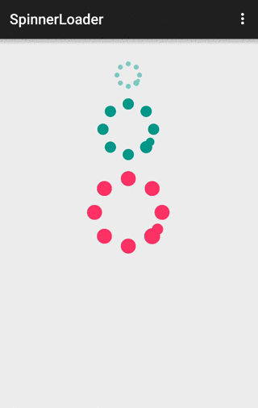

简单的进度条
https://github.com/akexorcist/Android-RoundCornerProgressBar
这个好像有点问题

