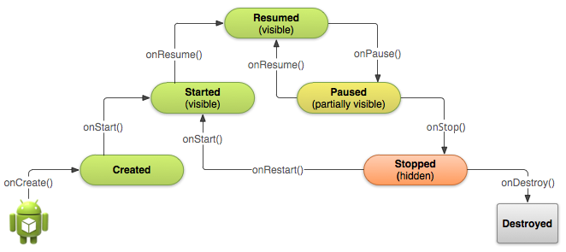
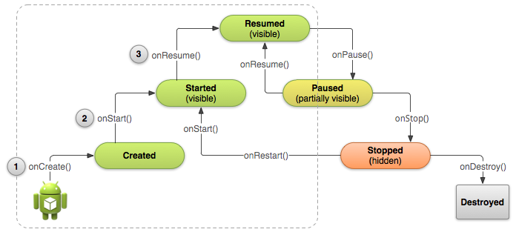

主应用
<activity android:name=".MainActivity" android:label="@string/app_name">
<intent-filter>
<action android:name="android.intent.action.MAIN" />
<category android:name="android.intent.category.LAUNCHER" />
</intent-filter>
</activity>
除非你在onCreate里调用finish 否则 肯定是 onPause onStop onDestroy 方式结束你的activity
onResume onPause 这两个频率比较高
应该避免在他们里面做耗时的操作
这些操作可以考虑在onStart onStop里做

如果一个activity是由操作系统杀掉的 那么它会保存一个Bundle里面存了状态 下次你可以恢复
Your activity will be destroyed and recreated each time the user rotates the screen. When the screen changes orientation, the system destroys and recreates the foreground activity because the screen configuration has changed and your activity might need to load alternative resources (such as the layout).
In order for the Android system to restore the state of the views in your activity, each view must have a unique ID, supplied by the android:id attribute.
想要在Bundle保存额外的数据就去实现onSaveInstanceState当用户离开的时候(好像是在onPause之后就会调用它,我测试了一下是在onPause和onStop之间)就会调用这个函数并且在程序被操作系统杀死后,需要恢复时,这个bundle会被传给onCreate和onRestoreInstanceState()
As your activity begins to stop, the system calls onsave…
onRestoreInstanceState()会在在onStart之后调用 并且肯定保证 Bundle!=null

