部署及技术要点 2017年12月27日

# 图层数据

图层数据在data.gdb中。

shennongjia_polygon – 神农架边界面图层

short_road – 道路图层

shennongjia_view_point – 神农架风景点图层

shennongjia_station_point – 神农架站点图层

# 发布ArcGIS Server 服务

* 涉及的mxd：map.mxd （可能需要自己调整设置数据源），发布为地图服务（Map Server）
* 发布完的地图服务地址为

<https://gis.xzdbd.com/arcgis/rest/services/dev/shennongjia/MapServer>

# 程序代码

* Web框架是Go语言写的Beego框架。其本身即可作为web server，当然也可以与其他web server 配置部署。

<https://beego.me/>

* 使用ArcGIS API for JavaScript 4.x版本

<https://developers.arcgis.com/javascript/>

* 代码结构

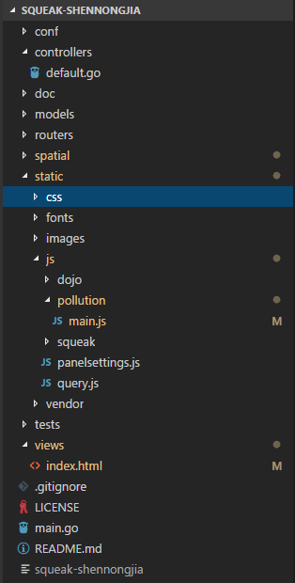

如需修改，主要涉及的内容:

* static/js/pollution/main.js 主要的js文件，用来完成arcgis js api相关的功能
* views/index.html 主页面

# 代码中涉及的技术点

* ArcGIS Online底图

<http://www.arcgisonline.cn/>

* 显示地块GraphicsLayer

<https://developers.arcgis.com/javascript/latest/api-reference/esri-layers-GraphicsLayer.html>

* 图层查询QueryTask

<https://developers.arcgis.com/javascript/latest/api-reference/esri-tasks-QueryTask.html>

* 地图显示MapView

<https://developers.arcgis.com/javascript/latest/api-reference/esri-views-MapView.html>

* GP服务

<https://developers.arcgis.com/javascript/latest/api-reference/esri-tasks-Geoprocessor.html>

* 路径规划 network analysis

<http://desktop.arcgis.com/zh-cn/arcmap/10.3/tools/network-analyst-toolbox/an-overview-of-the-network-analyst-toolbox.htm>

* 代码中核心的查询图层实现(参考注释)

//----------------------------------

// Views GraphicsLayer

//----------------------------------

function initializeViewsLayer() {

var graphicsLayer = new GraphicsLayer();

var layer = "https://gis.xzdbd.com/arcgis/rest/services/dev/shennongjia/MapServer/1";

var viewsSymbol = new PictureMarkerSymbol({

url: location.pathname.replace(/\/[^/]+$/, "") + "/static/images/view.png",

width: "48px",

height: "48px",

});

var template = {

title: "<font color='#008000'>保护区：{name}",

content: [{

type: "fields",

fieldInfos: [{

fieldName: "id",

visible: true,

label: "编号",

format: {

places: 0,

digitSeparator: true

},

}, {

fieldName: "name",

visible: true,

label: "名称",

}, {

fieldName: "category",

visible: true,

label: "类别",

},

]

},],

actions: [{

title: "详情",

id: "detail",

className: "esri-icon-dashboard",

}]

};

var queryTask = new QueryTask({

url: layer

});

var query = new Query();

query.returnGeometry = true;

query.outFields = ["*"];

query.where = "1=1";

queryTask.execute(query, { cacheBust: false }).then(function (result) {

if (result.features.length > 0) {

result.features.forEach(function (graphic) {

graphic.symbol = viewsSymbol;

graphic.popupTemplate = template;

graphicsLayer.add(graphic);

});

app.mapView.map.layers.add(graphicsLayer);

// remove loading

app.loading.endLoading();

}

});

}