作业题:
2.1(a,c,d), 2.8(a,c,d), 2.12,
3.3, 3.4,
4.8, 4.12
5.8(a,b,c), 5.12,
6.7, 6.8, 6.13
7.4, 7.15

第二章作业：
  - (a) a | a[a-z]*a
- [1-9][0-9]*
- [0-9]*[02468]

2.8（a）

Start

a

a

[b-z]

a

[b-z]

正则表达式中丢了单独a的情况的比较多，另外有些同学在有NFA到DFA的转化过程中，不能够正确的确定最终的状态，造成有两个终结状态的情况。
（c）

Start

[1-9]
[0-9]

（d）
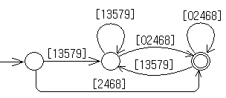
问题比较多，建议同学画出DFA图生成的全部过程。

2.12
a
a
b
a
a
b
b
b

a
a
a
b
b
b

3．4
（c）.rewrite this grammar to establish the correct precedences for the operator.
rexp -> rexp “|” rexp1 | rexp1
rexp1 -> rexp1 rexp2 | rexp2
rexp2 -> rexp3 * | rexp3
rexp3 -> (rexp) | letter
左结合

4．8
- 消除左递归
lexp -> atom | list
atom -> number | identifier
list -> (lexp-seq)
lexp-seq -> lexp lexp-seq’
lexp-seq’ -> lexp lexp-seq’ | ε

first (lexp)= { number ,identifier,( }
first (atom)= { number, identifier }
first (list) = { ( }
first (lexp-seq)= { number ,identifier,( }
first (lexp-seq’)= { number ,identifier,( , ε}

follow(lexp)= { $,),number,identifier,(}
follow (atom)= { $,), number,identifier,( }
follow (list) = {$,), number,identifier,(}
follow (lexp-seq)= { )}
follow (lexp-seq’)= { )}

M[N,T] | number | identifier | ( | ) | $
lexp | lexp->atom | lexp->atom | lexp->list
atom | atom->number | atom->identifier
list |  |  | list -> (lexp-seq)
lexp-seq | lexp-seq -> lexp lexp-seq’ | lexp-seq -> lexp lexp-seq’ | lexp-seq -> lexp lexp-seq’
lexp-seq’ | lexp-seq’ -> lexp lexp-seq’ | lexp-seq’ -> lexp lexp-seq’ | lexp-seq’ -> lexp lexp-seq’ | lexp-seq’ -> ε

4.12
- LL（1）文法不会是二义的，因为它的分析表的每个入口是唯一的。就不会是二义文法了。
- 二义文法也不可能是LL（1）的，否则在LL（1）的parsing table 中会产生各种冲突。
非二义的文法不一定是LL（1）的，因为二义文法是非LL（1）文法的一个因素，但不是唯一的因素。如一些带有左递归的文法也不是LL（1）文法。

第五章作业
5．12
s’ →s
s→a A d | b B d | a B e | b A e
A→c
s’ →·s,$
s→·a A d,$
s →·b B d ,$
s→· a B e,$
s→ ·b A e,$
a
b

s→a·A d,$
s→a·B e,$
A→·c, d
B→·c, e
s →b·B d ,$
s→ b·A e,$
A→·c, e
B→·c, d

s’ →s·,$
s→aA·d,$
A
s→aAd·,$
s→aB·e,$
B
s→aBe·,$
A
s→ bA·e,$
s→bAe·,$
B
s→bB·d,$
s→bBd·,$
A→c·, e
B→c·, d
A→c·, d
B→c·, e
c
c
B→c

5.8 Consider the following grammar
declaration -> type var-list
type -> int | float
var-list -> identifier, var-list | identifier

(a) declaration -> type var-list
type -> int | float
var-list -> var-list, identifier | identifier
(b) decl -> type vlist
type -> int
type ->float 7
,
Decl-> . type vlist
type->.int
type ->.float
type
decl -> type. vlist
vlist -> . vlist , id
vlist -> .id
vlist
decl -> type vlist.
vlist -> vlist. , id
vlist -> vlist, .id
vlist -> vlist, id.
vlist -> id.
id
type->int.
type -> float.
id
vlist -> vlist, id
vlist -> id

0
6

1 2

4
3

5
follow(decl)= { $ }, follow(type)= { id }
follow(vlist)= { $, , }
(c ) construct the SLR(1) parsing table for the rewritten grammar

state | input |  |  |  |  | goto
 | int | float | id | , | $ | type | Decl | vlist
0 | 6 | 7 |  |  |  | 1
1 |  |  | 3 |  |  |  |  | 2
2 |  |  |  | 4 | r1
3 |  |  |  | r5 | r5
4 |  |  | 5
5 |  |  |  | r4 | r4
6 |  |  | r2
7 |  |  | r3

6.7
decl → var-list: type var-list.dtype = type.dtype
vsr-list11 → var-list2, id var-list2.dtype = var-list1.dtype
id.dtype = var-list1.dtype
type → integer type.dtype = int
type → real type.dtype = float

6.8
decl → id var-list id.dtype = var-list.dtype
var-list1 → , id var-list2 var-list1.dtype = var-list2.dtype
id.dtype = var-list2.dtype
var-list → : type var-list.dtype = type.dtype
type →integer type.dtype = int
type → real type.dtype = float

6.13 Solution:
a.
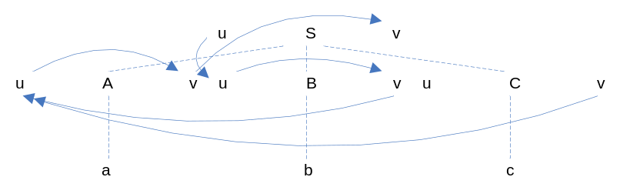
One correct order can be:
C.v = 1
B.u = S.u
B.v = B.u
A.u = B.v + C.v
A.v = 2 * A.u
S.v = A.v

b.
8.

c.
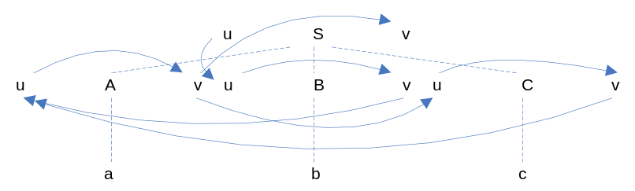
The value is not calculable due to the circularity of the dependency graph. The value of C.u depends on that of A.v, which in turn depends on that of A.u, which in its own turn depends on C.v, which finally depends on that of C.u, which is to be decided by the calculation.

  - s.v = -2, 存在环，不是一个拓扑排序。

7．4 main procedure
< no access link >
control link
return address
x:
access link
control link
return address
access link
control link
return address
access link
control link
return address
access link
control link
return address
fp
sp

a procedure

b procedure

c procedure

b procedure

c procedure

7．15

A、1，1
B、3，1
C、2，1
D、2，2

