测试结果

大家把跑过的测试结果都写到这个文档里，写明测试的配置

1. 配置：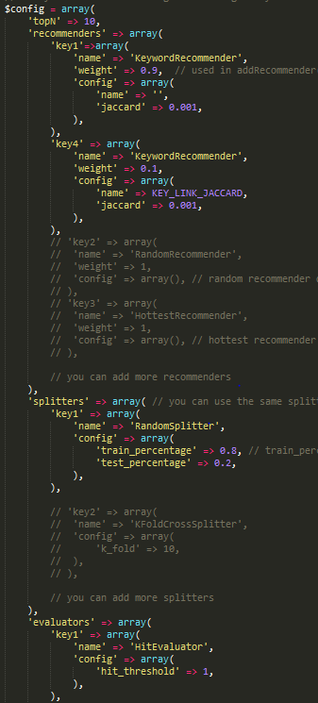

结果：test_count is 512, hit_count is 184, hit percentage is 0.359375

|  |  |  |  |  |  |  |
| --- | --- | --- | --- | --- | --- | --- |
| Test case | Original Keyword weight : Keyword link weight | Jaccard threshold | Train: Test | Hit_threshold | Hit/test count | percentage |
| 1 | 0.8:0.2 | 0.2 | 9:1 | 1 | 78/256 | 0.3046875 |
| 2 | 0.9:0.1 | 0.1 | 9:1 | 1 | 93/256 | 0.36328125 |
| 3 | 0.9:0.1 | 0.1 | 9:1 | 1 | 82/256 | 0.3203125 |
| 4 | 0.85:0.15 | 0.1 | 9:1 | 1 | 96/256 | 0.375 |