Tourism
日本国家旅游协会（JNTO）
2025/11/18
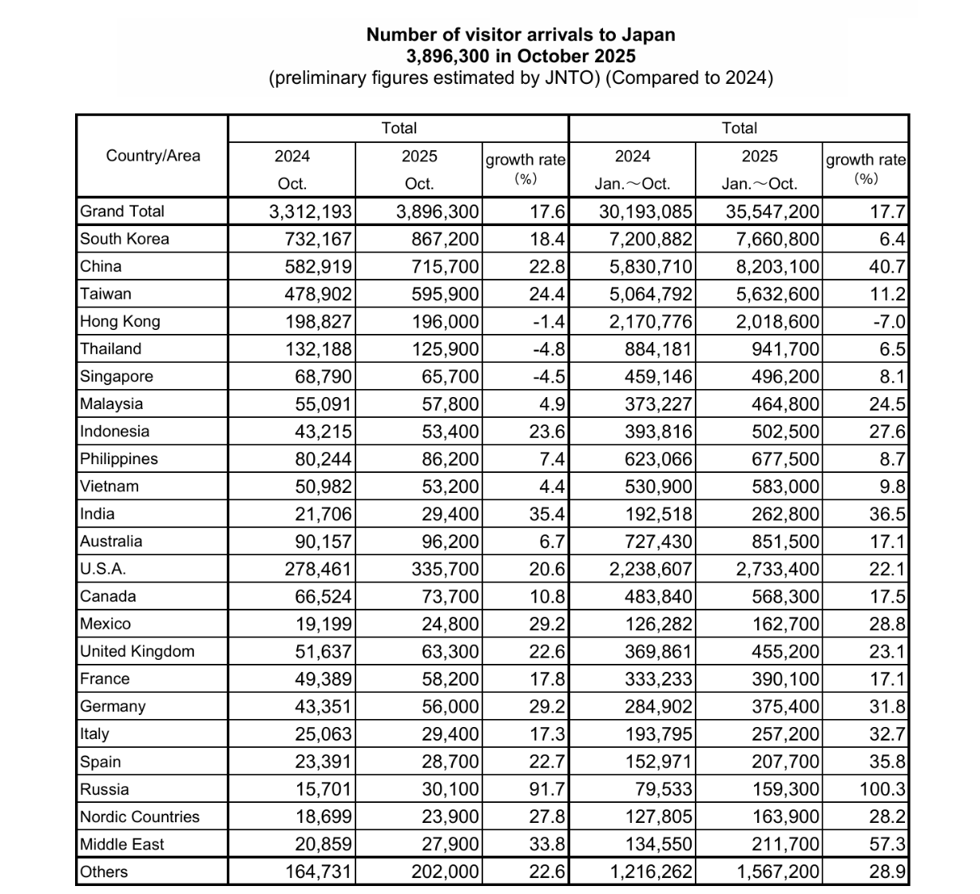

2026/04/15
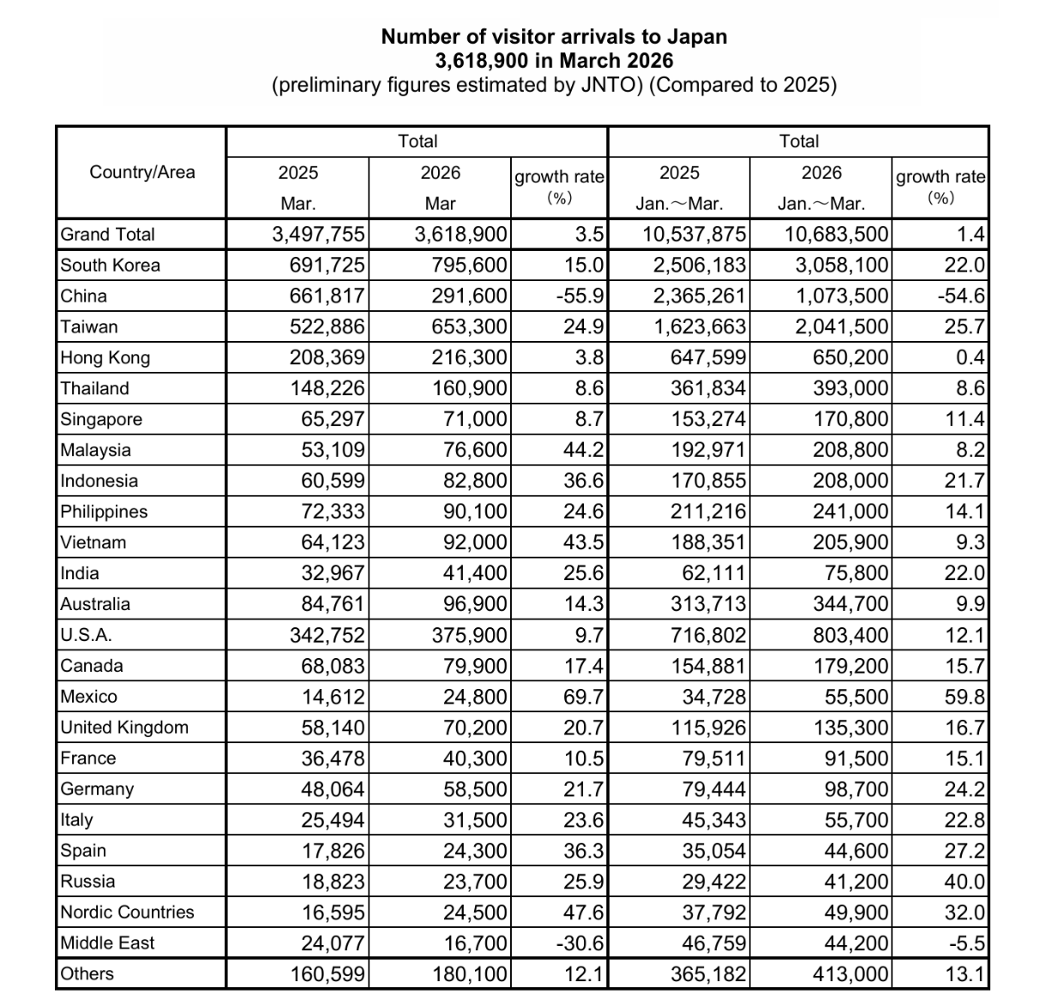

搜索结果 | 日本旅游厅
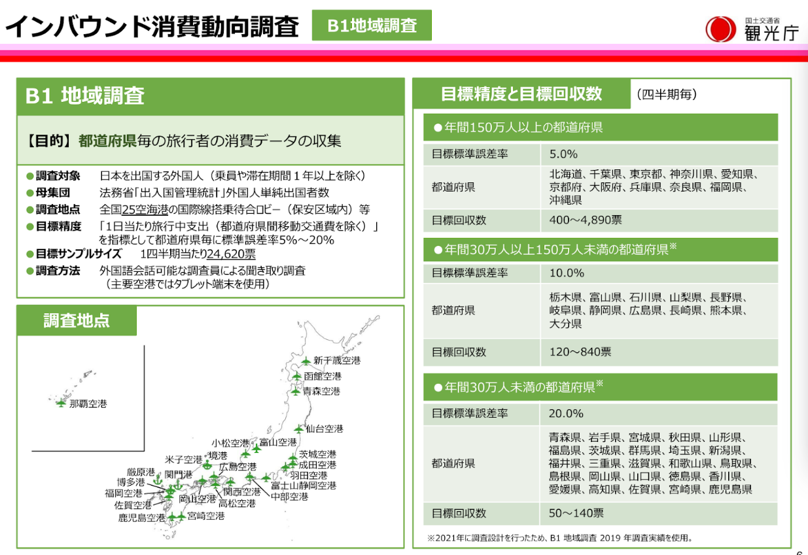
Fukui Prefecture is classified in the category of "annual visitors to Japan between 300,000 and less than 1.5 million", corresponding to:
Target standard error rate: 10.0%
Target number of responses: within the range of 120–840 votes (the specific figure will be adjusted based on the actual number of visitors; Fukui's visitor volume falls in the mid-to-lower level within this category, so the sample size will also correspond to the lower-middle part of the range)

搜索结果 | 日本旅游厅
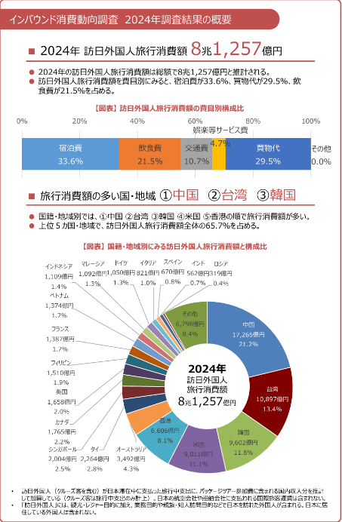

1.English is absolutely mainstream, covering tourists from most markets in Europe, America, Southeast Asia, and the Middle East. 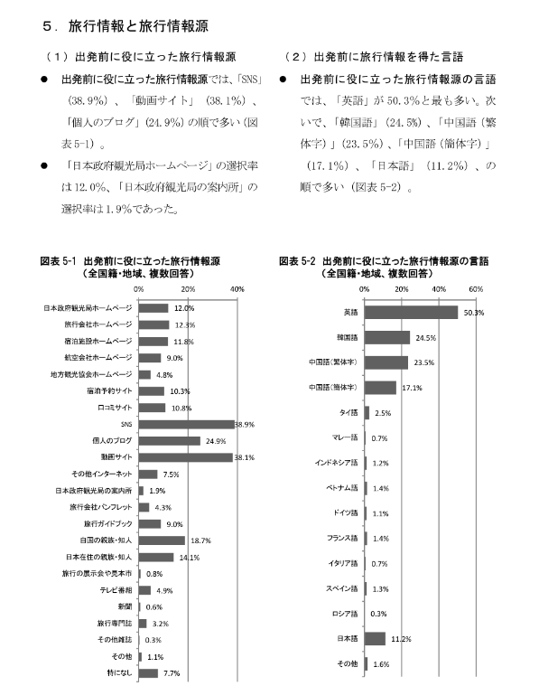
2.Chinese (both Traditional and Simplified) and Korean are the core languages for the Asian market, together accounting for over 40%, indicating that multilingual information services targeting Chinese and Korean tourists are crucial.
3.Japanese information has very low appeal to foreign tourists and is almost not a mainstream planning channel.

1.Channel strategy: Rather than investing in the official website / offline service points, it is better to focus on SNS (Xiaohongshu / Instagram) and video platforms (Douyin / YouTube), using user-generated content to promote Fukui.
2.Language strategy: For Mainland Chinese tourists, Simplified Chinese guides / videos are key; for Hong Kong and Taiwan tourists, supplementing with Traditional Chinese content can significantly improve information reach.
3.Content direction: Tourists rely on third-party user sharing, so encouraging Chinese tourists visiting Fukui to post authentic experience notes / videos is more persuasive than official publicity.
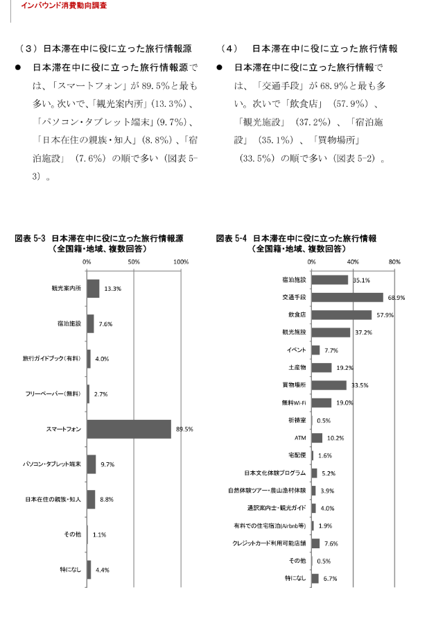
Tourists rely on their phones almost all the time, so Fukui's tourism information must be mobile-friendly, for example:
- Optimize the official attraction websites and guide pages for mobile devices
- Provide offline maps and multilingual transportation guides
- Use platforms like Xiaohongshu / Douyin to publish short, mobile-friendly guides and video
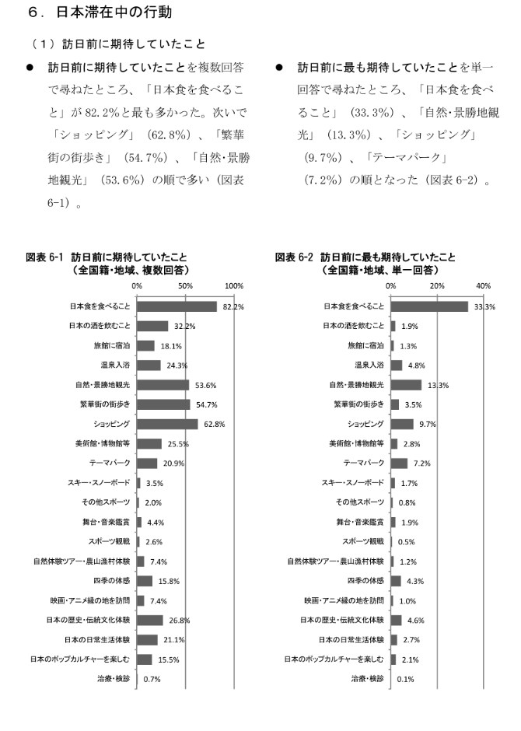
Tourists' expectations are three-dimensional and balanced. Cuisine (82.2%) is overwhelmingly the top priority, but shopping (62.8%) and support for natural scenery / city strolling are also above 50%. This indicates that Japan, as a tourist destination, successfully satisfies tourists' taste buds, shopping desires, and cultural aesthetics at the same time.
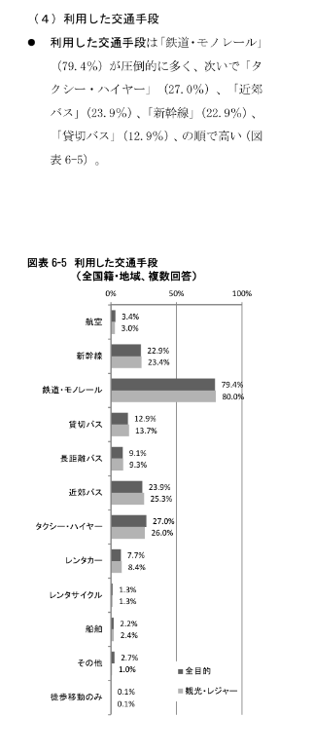
The main mode of transportation for visitors to Japan is rail / Shinkansen

hk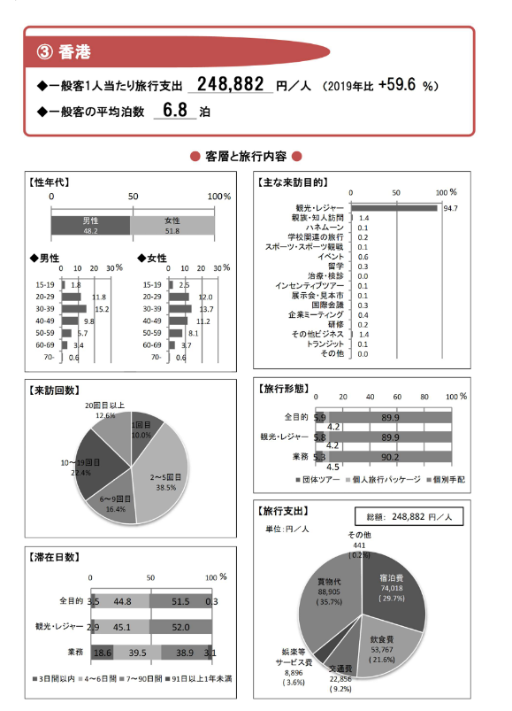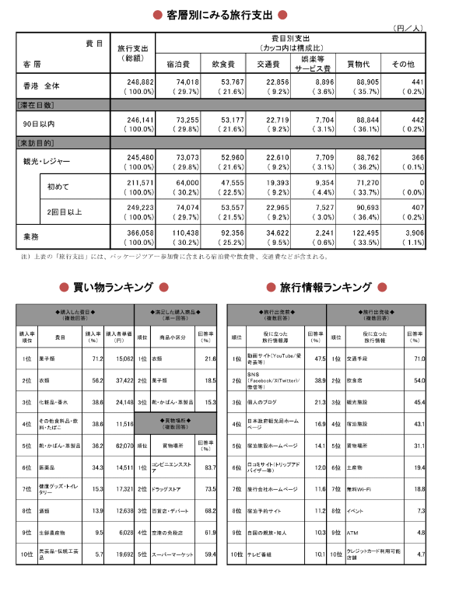

China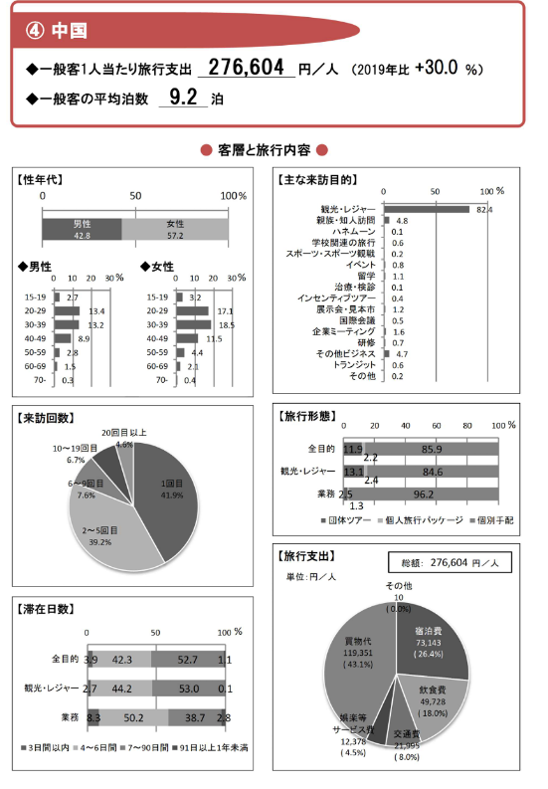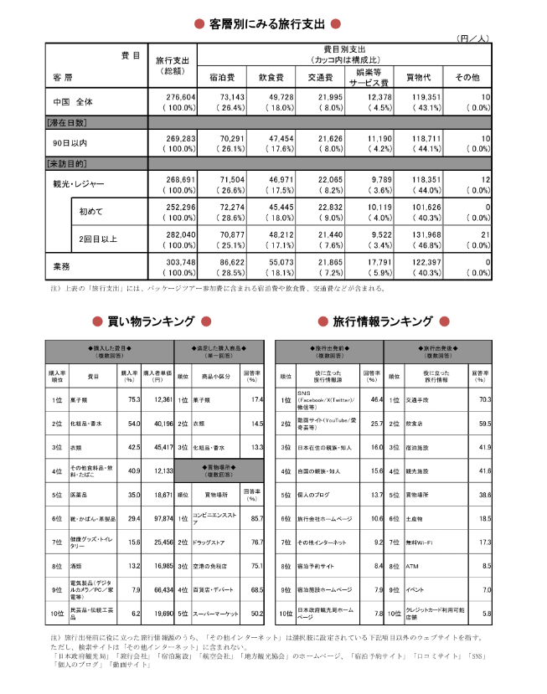

石川统计指数土地 石川县统计信息门户网站
2026福井市観光ガイド：観光・グルメ・ホテル・アクセス・口コミ| Trip Mome

https://www.xiaohongshu.com/search_result?keyword=%25E7%25A6%258F%25E4%25BA%2595&source=web_explore_feed
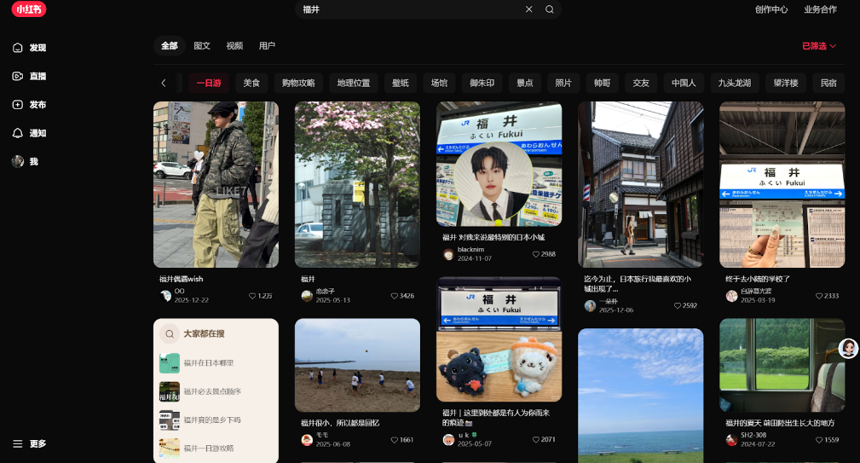
1.Why are young tourists rushing to Fukui now?
— The 'Idol Hometown' 'Fan Economy'
From the titles and content of the posts in the pictures, it’s clear that NCT’s Maeda Riku is currently Fukui’s hottest 'traffic code':
Many posts mention his hometown, the same check-in spots, merchandise, and there are even guides specifically summarizing 'nctwish Fukui merchandise and similar items.'
Titles like 'Come see Fukui’s sea recommended by Riku' and 'Fukui in summer, the place where Maeda Riku was born and raised' directly indicate that many fans are visiting just to check in at their idol’s hometown.
This 'idol effect' brings not only one-time check-ins but also extremely strong secondary spreading power: fans take similar photos, write guides, post notes, turning Fukui’s niche attractions, train stations, and beaches into 'fan pilgrimage sites,' influencing more passersby to become interested.
2.Fukui's 'off-the-beaten-path' nature is its biggest advantage.
Compared to popular destinations like Tokyo, Kyoto, and Osaka, where crowds are overwhelming, Fukui's 'rural feel' has become a favorite among young travelers. The phrase that frequently appears in travel notes, 'Fukui is small, so everything feels like memories,' reflects this atmosphere: few people, quiet, clean scenery, and the possibility to take photos with a strong sense of ambiance without struggling through crowded spots.

It hasn't been overly commercialized; many beaches, forests, and temples still maintain an original Japanese tranquility, making it ideal for young people who enjoy a sense of 'healing' and 'off-the-beaten-path' experiences, especially those tired of crowded popular places.

This can also be seen in search queries: people often ask 'Where is Fukui in Japan?' and 'Is Fukui really rural?' indicating that its recognition is still low and it is in a period of 'undiscovered potential.'

94 【本以为京都已
经很美~直到我来到了福井🇯🇵 - Q桑 | 小红书 - 你的生活兴趣社区】 😆 p9SVImWG3q5UEXX 😆 https://www.xiaohongshu.com/discovery/item/68c93569000000001203d614?source=webshare&xhsshare=pc_web&xsec_token=ABLPGKOzuzj6CuxNZfutJ_JQFDWchPuPzHt2Br_WJ8ivU=&xsec_source=pc_share