A Bibliometric Review of Artificial Intelligence-Assisted Diagnosis: Research Landscape, Thematic Evolution, and Future Directions

Ziyi Xu, Yu Tang, Rongxin Li, Xin Ling, Xiaoming Chen

Abstract
Artificial intelligence (AI) has been increasingly integrated into diagnostic medicine, yet the intellectual structure and evolutionary trajectory of AI-assisted diagnosis research remain to be systematically mapped. This bibliometric review analyzes the development trends, collaboration networks, research hotspots, thematic evolution, and knowledge base of AI-assisted diagnosis from 2015 to 2026. A total of 3,504 publications were retrieved from the Web of Science Core Collection (2015–2026). VOSviewer 1.6.20 was used to conduct co-authorship analysis, keyword co-occurrence analysis (both cluster view and temporal overlay view), and document co-citation analysis following established bibliometric protocols. Annual publication output grew from 59 in 2017 to a peak of 700 in 2025. Three major research clusters were identified: technology and methods (red), imaging and disease analysis (blue/green), and clinical application (yellow). Temporal evolution reveals a three-stage progression from method-driven research (2021) to application explosion (2022) to clinical translation (2023). Core research teams have formed, though cross-institutional collaboration remains limited. The intellectual base comprises U-Net, ResNet, and domain surveys/clinical milestones. AI-assisted diagnosis is transitioning from algorithm development to clinical translation. Future research should prioritize prospective validation, multi-center collaboration, explainable AI, and biomarker-driven outcome prediction.
Keywords: artificial intelligence; computer-aided diagnosis; deep learning; bibliometrics; VOSviewer

1. Introduction
The rapid advancement of artificial intelligence (AI) is reshaping healthcare delivery and clinical decision-making. Among various AI applications, AI-assisted diagnosis has emerged as a particularly promising field, with deep learning algorithms demonstrating performance comparable to human experts in tasks ranging from radiological image interpretation to pathological diagnosis.
Traditional narrative reviews have made significant contributions to summarizing technical advances in specific diseases or imaging modalities. However, as the volume of published research expands exponentially, traditional approaches struggle to systematically capture the intellectual structure and evolutionary dynamics of rapidly growing interdisciplinary fields ^{[1]}. Researchers cannot realistically read every publication that may be relevant to their inquiry.
Bibliometric analysis offers a powerful solution to this challenge. Bibliometrics refers to a set of techniques that highlight patterns in the literature based on bibliographic data, providing objective means for describing and classifying existing scientific production ^{[2]}. By applying quantitative methods to large-scale publication data, bibliometrics enables researchers to identify core research themes, track paradigm shifts, visualize collaboration networks, and uncover the intellectual roots of a field ^{[3]}. Unlike narrative reviews, bibliometric approaches are data-driven, reproducible, and capable of handling thousands of publications simultaneously.
Despite the growing number of primary studies in AI-assisted diagnosis, a comprehensive bibliometric review that systematically maps the field's evolution, knowledge structure, and research frontiers remains absent. To address this gap, this study poses the following research questions (RQs):
· RQ1: What is the publication trend and development trajectory of AI-assisted diagnosis research from 2015 to 2026?
· RQ2: What is the collaboration pattern among core authors and research teams in this field?
· RQ3: What are the major research hotspots, and how have they evolved over time?
· RQ4: What constitutes the intellectual base of the AI-assisted diagnosis field?

2. Data and Methods
2.1 Data Source and Search Strategy
Data were retrieved from the Web of Science (WoS) Core Collection, one of the most authoritative databases for bibliometric analysis ^{[4]}. The search was conducted on June 1, 2026. The search query was constructed as:
TS = ("artificial intelligence" OR "machine learning" OR "deep learning" OR "neural network" OR "radiomics" OR "AI-assisted diagnosis") AND TS = ("clinical diagnosis" OR "medical diagnosis" OR "computer-aided diagnosis" OR "diagnostic imaging" OR "disease detection") AND PY=2015-2026 AND (DT=Article OR DT=Review) AND SU=(Medicine OR Radiology OR Pathology OR Oncology OR "General & Internal Medicine")
The search was restricted to publications from 2015 to 2026, including only Articles and Reviews.

2.2 Screening and Data Cleaning
Following established protocols for bibliometric analysis in biomedicine ^{[5]}, a systematic screening process was applied. A total of 3,771 raw records were initially retrieved. After duplicate removal (n=5), eligibility screening excluding records without keywords (n=255), without authors (n=1), or without citation information (n=6), a final sample of 3,504 valid publications was retained for analysis.

2.3 Analytical Tools and Parameters
VOSviewer 1.6.20 ^{[6]} was used for author co-authorship analysis, keyword co-occurrence analysis, and document co-citation analysis. Parameter settings: clustering resolution = 1.0 ^{[8]}. The threshold for author co-authorship analysis was set to a minimum of 6 publications per author. The threshold for keyword co-occurrence analysis was set to a minimum of 30 occurrences. The threshold for document co-citation analysis was set to a minimum of 40 citations per document.

2.4 Analytical Techniques
Three complementary bibliometric techniques were applied. Co-authorship analysis was used to identify collaboration patterns among core researchers and research teams. Keyword co-occurrence analysis was used to identify major research hotspots and their thematic structure. Document co-citation analysis was used to map the intellectual base of the field, identifying foundational publications and knowledge clusters ^{[2,4]}.

3. Bibliometric Results
3.1 Development Trends (RQ1)
Figure 1 presents the annual publication trend of AI-assisted diagnosis research from 2015 to 2026.
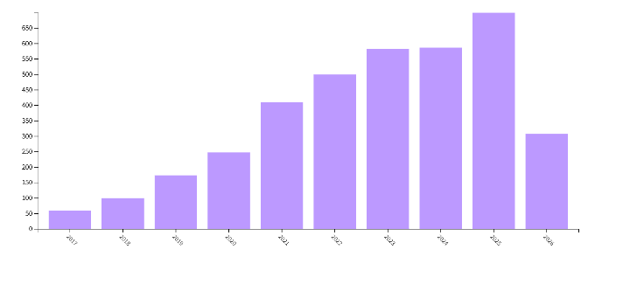
Figure 1. Annual publication output in AI-assisted diagnosis research (2015–2026)
Note: Data were retrieved from the Web of Science Core Collection. The decline in 2026 is attributable to incomplete database indexing at the time of retrieval (June 1, 2026).
The analysis reveals sustained growth over the study period. Annual publication output grew from 59 in 2017 to a peak of 700 in 2025, representing a nearly 12-fold increase over nine years.
The development trajectory can be divided into two phases. Phase 1: Initial Growth Period (2017–2020). Annual publications increased from 59 to 247, with an average annual growth rate of approximately 60%. This phase was driven by the introduction and adoption of foundational deep learning architectures, particularly U-Net ^{[7]} for biomedical image segmentation and ResNet ^{[8]} for image classification. Phase 2: Rapid Expansion Period (2021–2025). Annual publications increased from 409 to a peak of 700, with an average annual growth rate of approximately 14%. While the growth rate moderated compared to Phase 1, the absolute increase was substantially larger. This phase coincided with the translation of AI technologies from research laboratories into clinical departments, including radiology, pathology, and oncology.
The decline shown for 2026 reflects incomplete database indexing at the time of data retrieval rather than an actual reduction in research activity.

3.2 Collaboration Patterns (RQ2)
Figure 2 displays the author co-authorship network generated by VOSviewer.
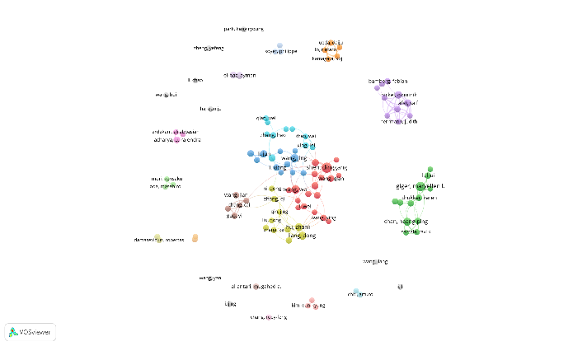
Figure 2. Author co-authorship network in AI-assisted diagnosis research
Note: Nodes represent authors, with node size proportional to publication volume. Colors indicate co-authorship clusters. Edge thickness represents collaboration strength. Generated using VOSviewer 1.6.20 with a threshold of ≥6 publications per author ^{[6]}.
The co-authorship network reveals three key features. First, core research teams have formed, with multiple densely connected clusters representing stable, productive research groups at the intersection of computer vision and medical imaging. Second, team-internal collaboration dominates; within each cluster, nodes are densely connected, while inter-cluster connections remain relatively sparse, suggesting that cross-institutional collaboration is an area for potential growth. Third, high-impact authors are concentrated at disciplinary intersections, bridging methodological innovation and clinical problem-solving.

3.3 Research Hotspots and Thematic Evolution (RQ3)
3.3.1 Thematic Structure (Cluster View)
Figure 3 presents the keyword co-occurrence network (cluster view) generated by VOSviewer.
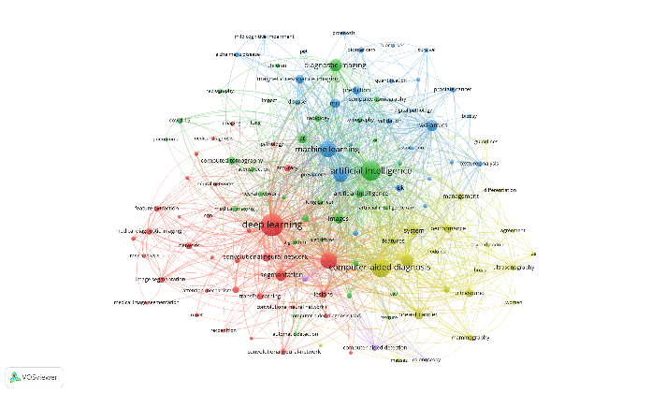
Figure 3. Keyword co-occurrence network (cluster view) for AI-assisted diagnosis research
Note: Data were retrieved from the Web of Science Core Collection (2015–2026). Analysis unit is author keywords. Generated using VOSviewer 1.6.20 with a minimum of 30 occurrences and clustering resolution = 1.0 ^{[6]}. Node size represents keyword frequency. Colors represent thematic clusters automatically identified by VOSviewer.
Three major thematic clusters are identified.
The technology and methods cluster (red) centers on deep learning, convolutional neural network, U-net, transfer learning, image segmentation, and feature extraction. Deep learning is the largest node with the densest connections in the entire network, confirming its role as the technical foundation of the field.
The imaging and disease analysis cluster (blue and green) comprises machine learning, diagnostic imaging, MRI, CT, radiomics, prognosis, and biomarkers. This cluster serves as a bridge connecting technical methods and clinical practice. The presence of prognosis and biomarkers indicates that the field has expanded beyond image segmentation and disease classification toward outcome prediction.
The clinical application cluster (yellow) is anchored by computer-aided diagnosis and includes breast cancer, ultrasound, mammography, and thyroid nodule. This cluster represents the most direct clinical value of the field, with breast diseases and thyroid nodules as the most active application scenarios.

3.3.2 Temporal Evolution (Overlay View)
Figure 4 presents the keyword co-occurrence temporal overlay network generated by VOSviewer.
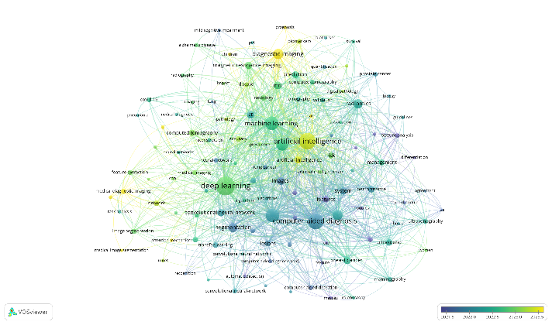
Figure 4. Keyword co-occurrence network (temporal overlay view) for AI-assisted diagnosis research
Note: Colors represent a temporal gradient from blue (earlier, around 2021) to green (mid, around 2022) to yellow (later, around 2023), indicating the average year of appearance for each keyword ^{[6]}.
The temporal evolution reveals a clear three-stage progression. Stage 1 (around 2021, blue nodes) includes segmentation, convolutional neural network, U-net, and lesions, focusing on image segmentation and foundational model optimization. Stage 2 (around 2022, green nodes) includes deep learning, machine learning, CT, MRI, and COVID-19, marking an explosion of technical applications with multi-modal imaging and pandemic-related research. Stage 3 (around 2023, yellow nodes) includes artificial intelligence, prognosis, biomarkers, and survival, indicating a shift toward clinical translation and outcome prediction.

3.3.3 Summary of Thematic Evolution
Several key observations emerge. First, the field has evolved from a method-driven phase to a clinical-value-driven phase. Second, multi-modal imaging research persists across all time periods as a consistently active direction. Third, the conceptual iteration from deep learning (peak in 2022) to artificial intelligence (rising in 2023) suggests the field is moving from narrow technical discussions toward broader AI frameworks. The strong coupling between deep learning and computer-aided diagnosis confirms that deep learning-driven computer-aided diagnosis constitutes the core research paradigm.

3.4 Intellectual Base and Core Literature (RQ4)
Figure 5 presents the document co-citation network generated by VOSviewer.
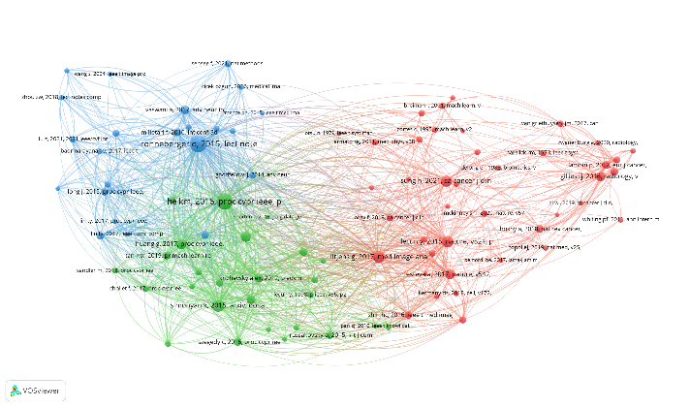
Figure 5. Document co-citation network in AI-assisted diagnosis research
Note: Nodes represent cited references. Node size represents citation frequency. Colors represent co-citation clusters. Generated using VOSviewer 1.6.20 with a threshold of ≥40 citations per document ^{[6]}.
The co-citation network identifies three major intellectual clusters. Cluster A (Biomedical Image Segmentation Foundation) is anchored by Ronneberger's U-Net ^{[7]}. Cluster B (Deep Representation Learning Foundation) is anchored by He's ResNet ^{[8]}, the most central document in the network. Cluster C (Domain Surveys and Clinical Milestones) is anchored by Litjens' deep learning survey ^{[9]} and Esteva's skin cancer classification study ^{[10]}.

Table 1 summarizes the most influential documents in the field.
First Author | Year | Source | Core Contribution | Citations | Total Link Strength
Ronneberger O | 2015 | LNCS | U-Net for biomedical segmentation | 466 | 1,927
He KM | 2016 | CVPR | ResNet residual learning | 445 | 2,077
Simonyan K | 2015 | arXiv | VGG deep convolutional networks | 236 | 1,202
LeCun Y | 2015 | Nature | Deep learning perspective | 220 | 892
Litjens G | 2017 | Med Image Anal | Deep learning in medical image analysis | 220 | 1,058
Sung H | 2021 | CA Cancer J Clin | Global cancer statistics | 199 | 530
Huang G | 2017 | CVPR | DenseNet | 171 | 1038
Selvaraju RR | 2020 | IJCV | Grad-CAM explainability | 169 | 633
Esteva A | 2017 | Nature | Skin cancer classification | 153 | 586
Gillies RJ | 2016 | Radiology | Radiomics | 153 | 496
Table 1. Highly cited representative publications in AI-assisted diagnosis research
The intellectual base of AI-assisted diagnosis comprises three pillars: (1) segmentation architectures (U-Net), (2) deep representation learning (ResNet), and (3) domain surveys and clinical validations (Litjens, Esteva). The dense connectivity among these clusters indicates an integrated, mutually reinforcing knowledge system ^{[2,3]}.

4. Discussion
4.1 Summary of Principal Findings
This bibliometric review provides a systematic mapping of the AI-assisted diagnosis research landscape based on 3,504 publications from 2015 to 2026.
First (RQ1), the field has experienced sustained growth, transitioning from a method-driven phase (2017–2020, ~60% annual growth) to an application-driven rapid expansion phase (2021–2025, ~14% annual growth), with a peak of 700 publications in 2025. This nearly 12-fold increase demonstrates that AI-assisted diagnosis has become a major research field.
Second (RQ2), while core research teams have formed with strong internal cohesion, cross-team collaboration remains limited—a pattern characteristic of scientific fields in mid-stage development ^{[3]}.
Third (RQ3), the field has evolved through three thematic layers (technology/methods, imaging/analysis, clinical application) with a clear temporal progression from method-driven (2021) to application explosion (2022) to clinical translation (2023). However, keyword co-occurrence reflects literature-level attention, not clinical-level validation.
Fourth (RQ4), the intellectual base rests on three pillars: segmentation architectures (U-Net), representation learning (ResNet), and domain surveys/clinical milestones (Litjens, Esteva), with ResNet showing the highest total link strength (2,077).

4.2 Research Gaps and Future Directions
Five research gaps emerge from this mapping.
First, prospective clinical validation. The vast majority of included studies are retrospective, using archived datasets. Future research should prioritize prospective, multi-center trials assessing not only diagnostic accuracy but also clinical impact.
Second, explainability and trust. While deep learning models achieve high accuracy, their "black box" nature remains a barrier to clinical adoption. Research on explainable AI and interpretable models should be prioritized.
Third, generalizability and bias. Most studies are single-center and use institution-specific datasets. The generalizability of AI models across different patient populations, imaging equipment, and clinical settings remains underexplored.
Fourth, human-AI collaboration. Rather than asking "AI versus human," future research should investigate optimal models of human-AI interaction and conditions under which AI assistance improves diagnostic performance.
Fifth, biomarker-driven outcome prediction. While prognosis and biomarkers show growing attention, this direction remains underdeveloped compared to disease detection research.

4.3 Limitations
Several limitations should be acknowledged. First, this review relied exclusively on the Web of Science Core Collection, potentially omitting relevant publications in other databases such as Scopus or PubMed ^{[2,4]}. Second, citation counts reflect academic attention but not direct measures of clinical utility or technical quality. Third, the decline in 2026 publications is an artifact of database indexing delays at the time of data retrieval (June 1, 2026). Fourth, co-citation relationships require time to accumulate, potentially underrepresenting very recent influential papers. Fifth, keyword co-occurrence analysis assumes that author-selected keywords accurately represent article content, which may not always hold. Sixth, 255 records (6.8% of raw data) were excluded due to missing keywords, which may introduce selection bias.

4.4 Practical Implications
For early-career researchers, the co-citation network (Figure 5) and Table 1 provide a curated reading list of foundational works. The keyword clusters (Figure 3) and temporal overlay (Figure 4) can help identify established research fronts versus emerging directions.
For research groups and funders, the collaboration network (Figure 2) identifies both established centers of excellence and potential collaboration opportunities. Funding mechanisms that explicitly encourage multi-center, cross-team collaboration could help address the observed collaboration gap.
For clinicians and policymakers, the thematic evolution toward clinical translation signals that AI-assisted diagnosis is moving closer to clinical readiness. However, the gap between research attention and clinical implementation remains substantial. Regulatory frameworks and clinical workflow integration studies are urgently needed.

5. Conclusion
This bibliometric review systematically mapped the landscape of AI-assisted diagnosis research from 2015 to 2026 based on 3,504 publications. The main conclusions are as follows:
- Development trajectory. The field has experienced sustained growth from 59 publications in 2017 to a peak of 700 in 2025, transitioning from a method-driven phase (2017–2020) to an application-driven rapid expansion phase (2021–2025).
- Collaboration structure. Core research teams have formed with strong internal cohesion, but cross-institutional collaboration remains limited, presenting opportunities for enhanced knowledge flow.
- Thematic composition and evolution. Three major clusters were identified: technology and methods (red), imaging and disease analysis (blue/green), and clinical application (yellow). Temporal evolution shows a clear progression from method-driven research (2021) to application explosion (2022) to clinical translation (2023).
- Intellectual base. The knowledge foundation comprises three pillars: U-Net, ResNet, and domain surveys/clinical milestones (Litjens, Esteva), constituting an integrated, mutually reinforcing knowledge system.
Future research should prioritize prospective clinical validation, multi-center collaboration, explainable AI, systematic assessment of algorithmic bias, and biomarker-driven outcome prediction. As the field continues to mature, the ultimate measure of success will not be accuracy on retrospective datasets but tangible improvement in patient outcomes and clinical workflows.

References
[1] C. Chen, “Science mapping: A systematic review of the literature,” Journal of Data and Information Science, vol. 2, no. 2, pp. 1–40, 2017.
[2] N. J. Van Eck and L. Waltman, “Software survey: VOSviewer, a computer program for bibliometric mapping,” Scientometrics, vol. 84, no. 2, pp. 523–538, 2010.
[3] N. J. Van Eck and L. Waltman, “Visualizing bibliometric networks,” in Measuring Scholarly Impact: Methods and Practice, Y. Ding, R. Rousseau, and D. Wolfram, Eds. Springer, 2014, pp. 285–320.
[4] U. A. Bukar, M. S. Sayeed, S. F. A. Razak, et al., “A method for analyzing text using VOSviewer,” MethodsX, vol. 11, p. 102339, 2023.
[5] “Protocol for conducting bibliometric analysis in biomedicine and related research using VOSviewer software,” STAR Protocols, vol. 5, no. 3, p. 103269, 2024.
[6] I. Zupic and T. Cater, “Bibliometric methods in management and organization,” Organizational Research Methods, vol. 18, no. 3, pp. 429–472, 2015.
[7] O. Ronneberger, P. Fischer, and T. Brox, “U-Net: Convolutional networks for biomedical image segmentation,” in Medical Image Computing and Computer-Assisted Intervention – MICCAI 2015, LNCS, vol. 9351, Springer, 2015, pp. 234–241.
[8] K. He, X. Zhang, S. Ren, and J. Sun, “Deep residual learning for image recognition,” in Proceedings of the IEEE Conference on Computer Vision and Pattern Recognition (CVPR), IEEE, 2016, pp. 770–778.
[9] G. Litjens, T. Kooi, B. E. Bejnordi, et al., “A survey on deep learning in medical image analysis,” Medical Image Analysis, vol. 42, pp. 60–88, 2017.
[10] A. Esteva, B. Kuprel, R. A. Novoa, et al., “Dermatologist-level classification of skin cancer with deep neural networks,” Nature, vol. 542, no. 7639, pp. 115–118, 2017.
[11] K. Simonyan and A. Zisserman, “Very deep convolutional networks for large-scale image recognition,” arXiv, arXiv:1409.1556, 2015.

[12] Y. LeCun, Y. Bengio, and G. Hinton, “Deep learning,” Nature, vol. 521, no. 7553, pp. 436–444, 2015.
[13] H. Sung, J. Ferlay, R. L. Siegel, et al., “Global cancer statistics 2020: GLOBOCAN estimates of incidence and mortality worldwide for 36 cancers in 185 countries,” CA: A Cancer Journal for Clinicians, vol. 71, no. 3, pp. 209–249, 2021.
[14] G. Huang, Z. Liu, L. Van Der Maaten, and K. Q. Weinberger, “Densely connected convolutional networks,” in Proceedings of the IEEE Conference on Computer Vision and Pattern Recognition (CVPR), IEEE, 2017, pp. 2261–2269.
[15] R. R. Selvaraju, M. Cogswell, A. Das, et al., “Grad-CAM: Visual explanations from deep networks via gradient-based localization,” International Journal of Computer Vision, vol. 128, no. 2, pp. 336–359, 2020.
[16] R. J. Gillies, P. E. Kinahan, and H. Hricak, “Radiomics: Images are more than pictures, they are data,” Radiology, vol. 278, no. 2, pp. 563–577, 2016.
Declaration of AI Use
This manuscript was prepared with AI assistance for language polishing, reference formatting, and preliminary literature organization following the BIBGT method's guidance on iterative literature review development ^{[6]}. All analytical decisions, interpretations, and conclusions were made by the human authors.

Data Availability Statement
All data, search queries, screening records, analysis parameters, and figure files are available at the accompanying GitHub repository, structured following established protocols for reproducible bibliometric analysis.

