Green Backgroundmarks new options, white background ist options that are already in flask manager

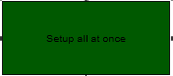

As there are options to setup each slot individually this ist he old style of setup that sets up all flasks oft hat category at once.

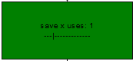

Save x uses instead of x flask charges, so that all flasks independant of their max charges and charges per use can be handeled. Slider sets the number.

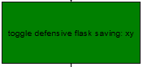

This hotkey toggles the saving of flasks on or off, so that the player can save up flask charges for boss fights and use all charges while fighting the boss.

Another solution would be to detect whether or not a player is in fight with a boss and having an option to override flask saving in that case.

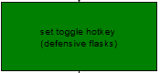

Sets the hotkey for toggling.

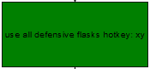

Hotkey to manually use all defensive flasks, for example to prevent oneshots on heavy hitting boss abilities.

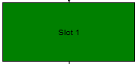

Same options as in setup all at once, this time for a specific slot though, this should take priority over the setup all at once setting, so those could be setup as a baseline and then be tweaked in the single slot menue.

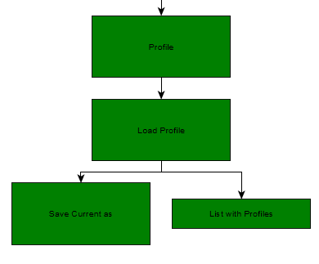

Options to save settings per character or to have some generic setups for different playstyles

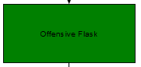

Offensive Flasks are similar to defensive flasks regarding new options, the hotkey for use all and toggle should be able tob e the same as on defensive flasks, so that the player is able to use the toggle and use all mechanic for both groups if desired.

On skill use should include the possibility to set rmb as a key without clunkyy workaround.

I hope you like my Idea, let me know what you think about it.