CS611

Legends: Monsters and Heroes

Renxuan Cao

renx@bu.edu

U39593434

---------------------------------------------------------------------------

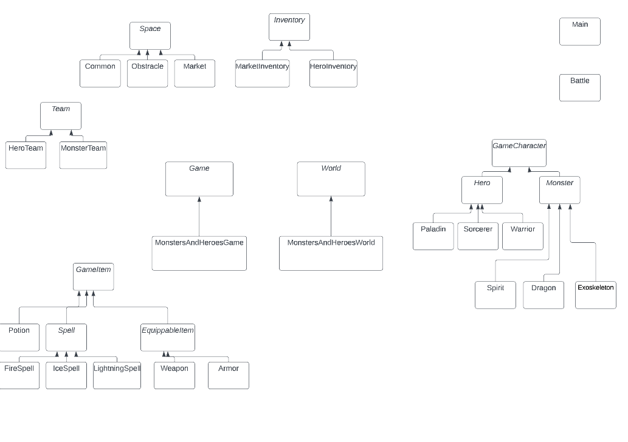UML diagram

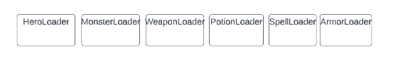

Description of classes:

There are generally 4 kinds of classes in my project:

1. Logic

Where the main process or game logic are implemented

Including: Main, Battle, MonstersAndHeroesGame, MonstersAndHerosWorld

2. Abstract

I used these classes to make my design more structural and extendable.

With this design, other types of games, different types of grids of the World, or other kinds of Monsters and Heroes can be easily added into this project in future.

Including: Game, World, GameCharacter, GameItem, EquippableItem, Hero, Monster, Team, Inventory, Space, Spell

3. Concrete

Some of these classes are concrete classes that are mainly used to store data; There are also classes that can handle parts of the game logic and perform actions/functions which are within one’s scope of responsibility

Including: Weapon, Armor, Potion, FireSpell, IceSpell, LightningSpell; HeroInventory, MarketInventory, HeroTeam, MonsterTeam; Common, Obstacle, Market; Paladin, Warrior, Sorcerer, Dragon, Exoskeleton, Spirit

4. Utilities

These are utility classes for reading data from config files

Including: WeaponLoader, ArmorLoader, PotionLoader, SpellLoader, HeroLoader, MonsterLoader

Changes made to the data files: no change was made

Instructions for running the program:

1. Unzip the files

2. Update the file path to ‘/src’ in Main(line3):

static String SRC_FILEPATH =

3. compile and run Main

javac -d bin ./*.java

java -cp bin Main

Bonus:

1.Some statistics about the hero team is tracked, i.e. how many monsters were defeated

2.Colorful prompt messages using ANSI

Input/output example

