Problem Chosen  C | 2022  MCM/ICM  Summary Sheet | Team Control Number  25125
Balancing Risk, Balancing Reward: Adaptive Strategies for Gold and Bitcoin Trading
Summary
In stock market trading, it is important to find a way to maximize the profit. Now we get daily price on gold and Bitcoin as it is shown in the following figures:
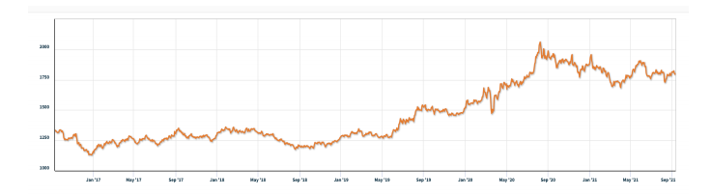
Figure 1 Gold daily prices, U.S. dollars per troy ounce. Source: London Bullion Market Association, 9/11/2021
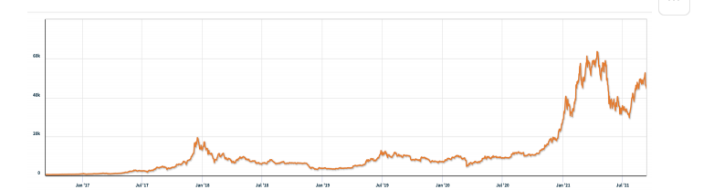
Figure 2 Bitcoin daily prices, U.S. dollars per bitcoin. Source: NASDAQ, 9/11/2021

How should a trader determine what he/she can buy each day only basing on the past stream of daily prices starting with $1000?
For this problem, we develop a model based on machine learning to help the trader. We use time series prediction to train and test data sets above, then the Random Forest Regression is used to find the optimization solution. Finally we test the sensitivity of the strategy to transaction costs, it will show how transaction costs affect the strategy and results. We use the five-year trading period to fit the transaction, assuming αgold=1% and αbitcoin=2%, then we get the final asset that is 6807.671 dollar.

Keywords: Random forest regression; Genetic Algorithm; investment strategy

Contents
1 Introduction 3
1.1 Problem Background 3
1.2 Restatement of the Problem 4
1.3 Our Work 5
2 Assumptions and Justifications 5
3 Notations 5
4 Problem 1 5
4.1 The Establishment of Model 1 5
4.2 The Solution of Model 1 7
5 Problem 2 9
5.1 Random Forest Regression Algorithm 9
5.1.1 Expressions 9
5.1.2 Advantage Analysis 10
5.2 Genetic Algorithm 10
5.2.1 Expressions 10
5.2.2 Advantage Analysis 11
5.2.3 Overall Synergistic Advantage 12
6 Problem 3 (sensitivity analysis) 13
6.1.1 Mathematical Framework 13
6.1.2 Implementation methodology 14
6.1.3 Sensitivity Analysis Method 14
6.1.4 Expected Results and Comparison 14
7 Model Evaluation and Further Discussion 15
7.1 Strengths 15
7.2 Weaknesses 15
7.3 Further Discussion 15
8 Conclusion 15
References 16
Appendices 16

Introduction

Problem Background
Bitcoin is an online virtual currency that can be used to cash out. Compared with fiat currencies, Bitcoin does not have a fixed issuer, but is generated by the calculation of network nodes, anyone may participate in the creation of Bitcoin, and can be circulated all over the world, can be bought and sold on any computer connected to the Internet, no matter where they are, anyone can mine, buy, sell, or use bitcoin, and the transaction record is open and transparent. The total number of bitcoins is limited to 21 million 4 years ago^{[1]}.
While the gold, as a tangible asset, has been highly valued for thousands of years.

Figure 3 Bitcoin and gold

One of the most important differences between Bitcoin and gold is the different volatility of these two assets.
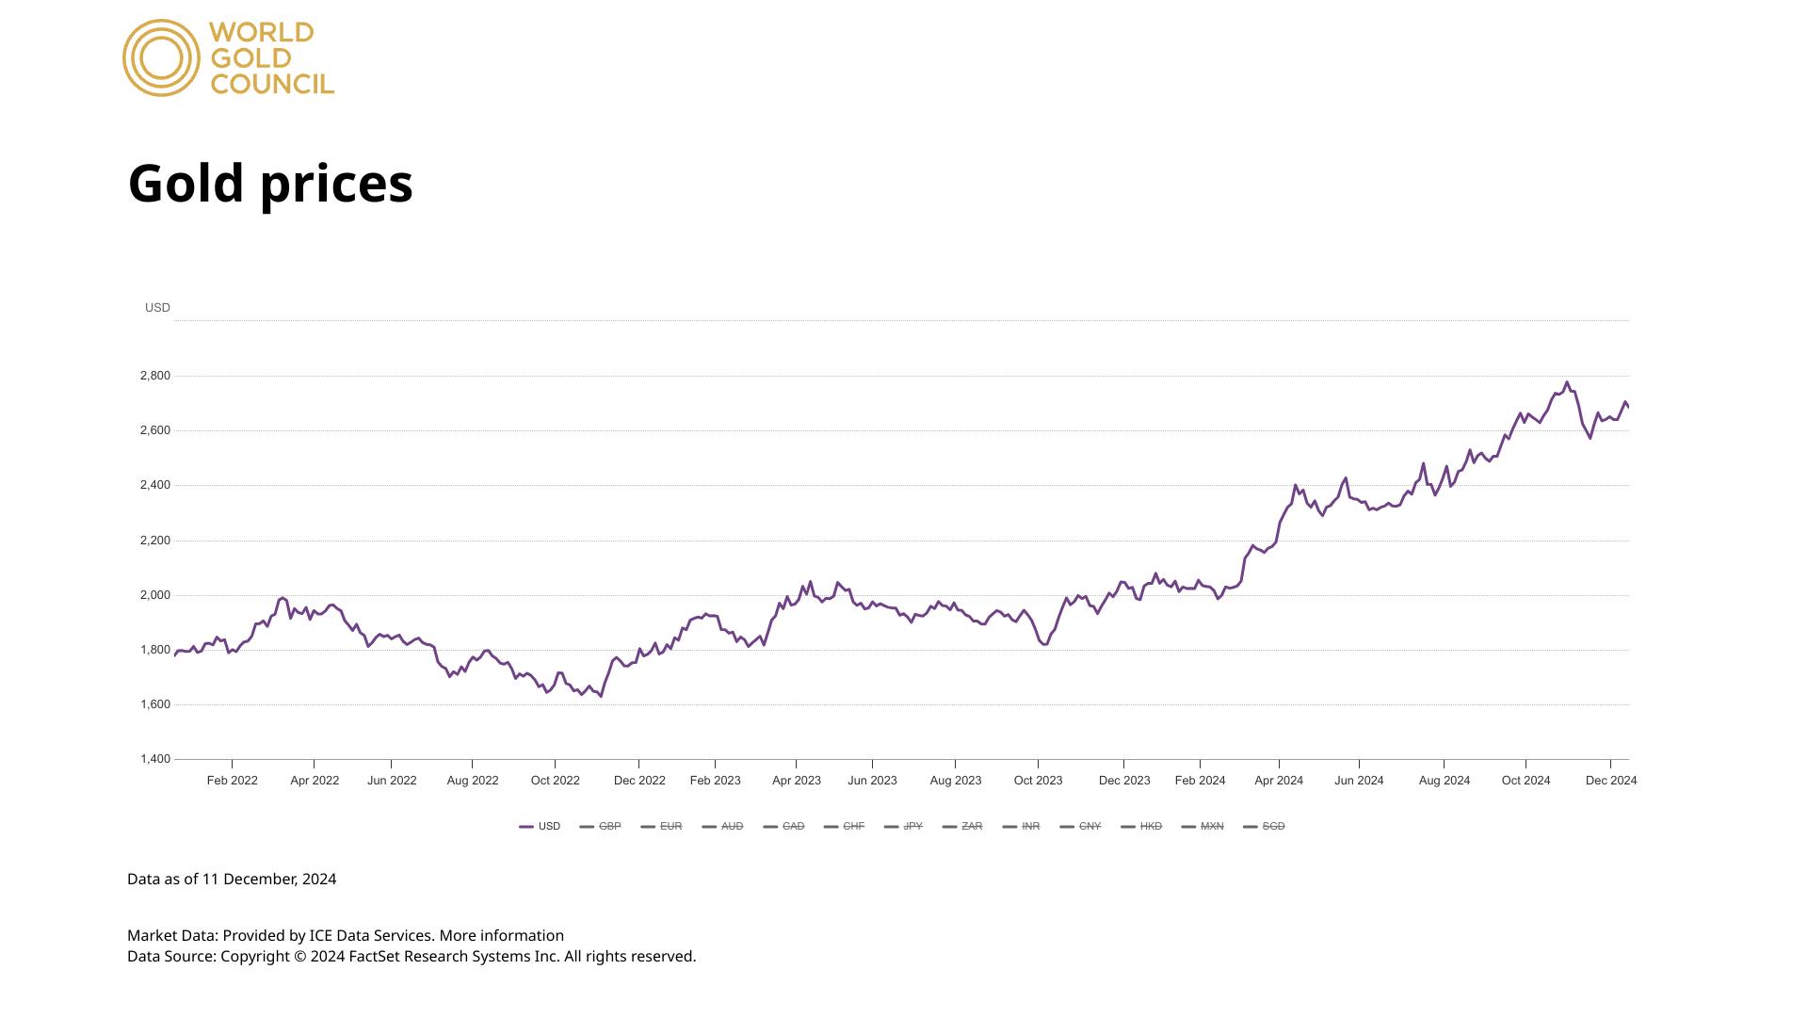
The prices in the gold market are mainly influenced by the amount of mining and the relationship between supply and demand. The global annual mining volume is approximately 3,500 tons, and the demand in the gold market has been around 2,500 tons per year in the past three years. Both figures are relatively stable, making gold a relatively safe investment asset. As shown in the figure, it presents the trend of gold prices in the past three years (Data Source: Gold Spot Prices & Market History | World Gold Council). It can be seen that the price of gold has been growing steadily. In recent years, due to global financial events such as the Russia-Ukraine conflict and the COVID-19 pandemic, the price of gold has witnessed certain fluctuations. During the impact of the COVID-19 pandemic in 2020, the world gold price rose by 25.07% ^{[2]}. After each extreme event occurs, the price of gold will experience an upward trend for a long period of time. Compared with Bitcoin, gold remains the top choice for traders considering risk reduction.
Figure 4 Gold prices in nearly 3 years. Source: WORLD GOLD COUNCIL
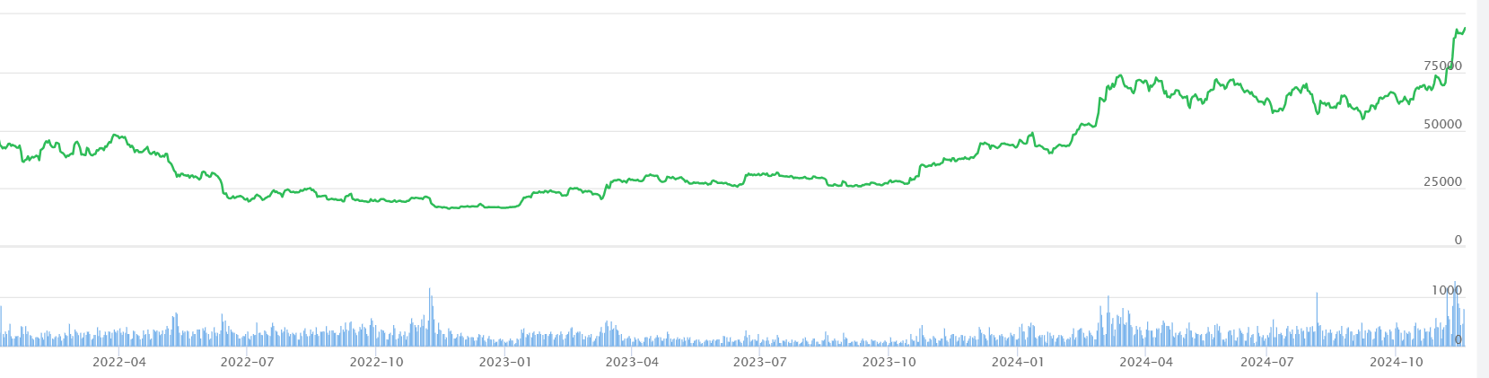
For Bitcoin, the uncertainties in the global economy and the changes in monetary policies are the main factors influencing its price increase. In the past four years, the global quantity of Bitcoin has been limited to 21 million. The price fluctuations of Bitcoin are much larger than those of gold. As shown in the figure, it presents the price trend of Bitcoin in the past three years.
Figure 5 Gold prices in nearly 3 years. Source: BTC123.FANS
As of November 28, the price of Bitcoin has remained at a high level of around $95,000, and its total global market value is approximately $2 trillion, making it the eighth-largest asset in terms of global market value. However, in January of this year, the price of Bitcoin once dropped below $40,000 per coin^{[3]}. In less than a year, its price has more than doubled.
An appropriate trading strategy is potential for a trader. We must make it high-profited and low-risked. Trading strategies not only have a direct impact on traders' assets but also exert a significant influence on the stock market - such as the fund diversion effect and the emotional conduction effect. Meanwhile, the fluctuations of gold in the stock market will also affect the ecology of the entire industrial chain. Therefore, it is very important to establish reasonable mathematical models for generating correct investment decisions.

Restatement of the Problem
Considering the background information and restricted conditions identified in the problem statement, we need to solve the following problems:
- Problem 1
Develop a model that can make a correct strategy of investment while forecasting the price of Bitcoin and gold in the next day. The relative factors including the holding amount of the day, the expected increase of the day and the assets of the day. We only use the given data from Gold daily prices, U.S. dollars per troy ounce. Source: London Bullion Market Association, 9/11/2021 and Bitcoin daily prices, U.S. dollars per bitcoin. Source: NASDAQ, 9/11/2021.
- Problem 2
Prove that our decision-making model is the optimal one from the perspectives of investment risks and so on.
- Problem 3
Test the sensitivity of this model to demonstrate that the model has strong stability and can be applicable to various application scenarios of investment and trading.

Our Work
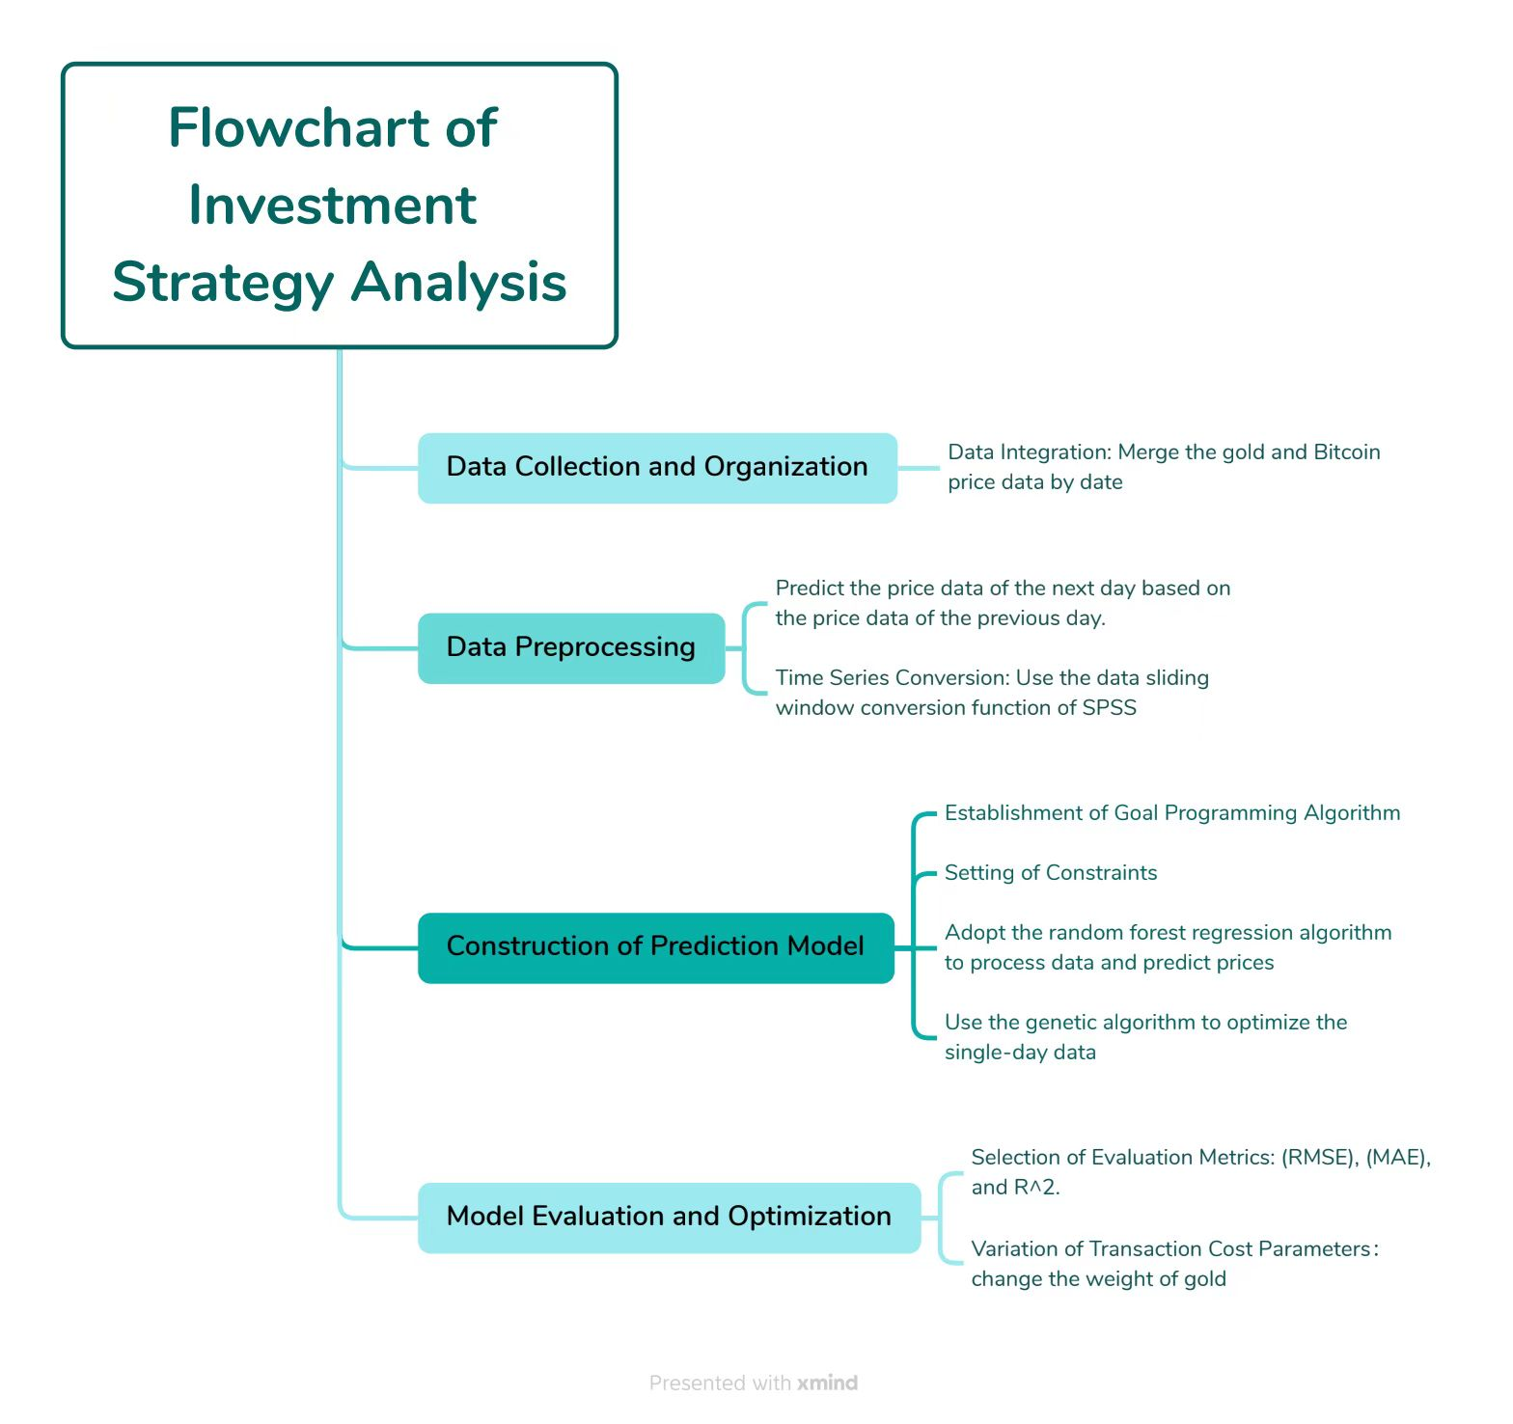
Figure 6 Flowchart of our work

Assumptions and Justifications
i．Assume that there are no major sudden influencing factors in five years.
ii．The trend of prices is predictable and periodic.
iii．Assume that there is no limit on the number of transactions.

Notations
The key mathematical notations used in this paper are listed in Table 1.

Symbol | Definitions
z_{1i} | the quantity of gold in i_{th} day
z_{2i} | the number of Bitcoin in i_{th} day
m₁ | Gold price of the day
m₂ | Bitcoin price of the day
n₁ | Gold price of the next day
n₂ | Bitcoin price of the next day
x_{1i} | number of gold transactions in i_{th} day
x_{2i} | number of Bitcoin transactions in i_{th} day
Table 1: Notations used in this paper

Problem 1

The Establishment of Model 1
For Problem 1, we firstly merged the given data and converted the time series data into regression data through the data sliding window conversion function of SPSS, which facilitated the subsequent price prediction. For price prediction, we adopted a step size of one - that is, we predicted the price data of the next day based on the price data of the previous day. Meanwhile, we found that the opening hours of gold and Bitcoin are different: Bitcoin opens every day and can be traded every day, while gold will be closed on specific dates, meaning that trading is not allowed. Therefore, we trained the data of the two separately and obtained the fitting result with R =0.994, which shows the good fitting result.
Then we established a simple goal programming algorithm and used the genetic algorithm to conduct optimization on a single day to find the weights of gold and Bitcoin when the daily Y value is maximized. After cycling for five years, the final asset of $6,807.671 can be calculated. The work is simply showed on the following figure:
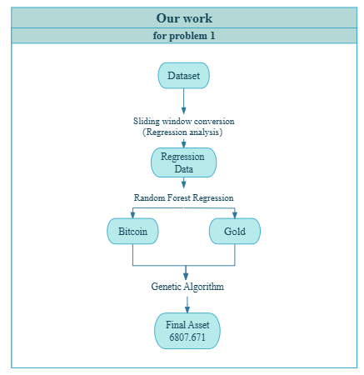
Figure 7 Our work for Problrm 1

We define the rate of return (ω) as:

$$ω_{Gold}=\left(\frac{n_{1i}}{m_{1i}}-1\right)×100\%$$ | ()
$$ω_{Bitcoin}=\left(\frac{n_{2i}}{m_{2i}}-1\right)×100\%$$ | ()
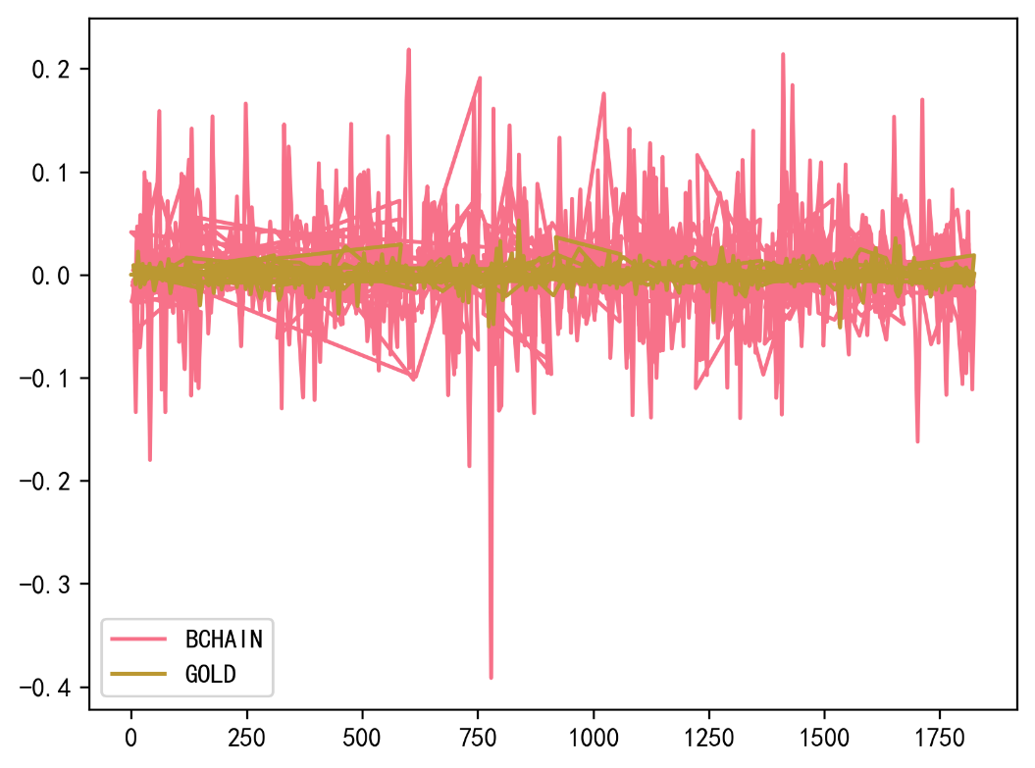
Figure 8 ω of Bitcoin and Gold

Define the objective function of Y within time t:

$$Y={(ω}_{Gold}{+1)(z}_{1}+x_{1})+(ω_{Bitcoin}+1)({(z}_{2}+x_{2})$$ | ()

We formulate the constraints as:
i.$\left\{\begin{aligned}-z_{1}-z_{2}<x_{1}+x_{2} \\ x_{1}+x_{2}<z_{1}+z_{2} \\ -z_{1}<x_{1}<z_{1} \\ -z_{2}<x_{2}<z_{2}\end{aligned}\right.$
Which indicates that the number of gold and Bitcoin transactions on the day shall not exceed the total holdings and their respective holdings.
ii.$\left\{\begin{aligned}ω_{Gold}≥0.01 \\ ω_{Bitcoin}≥0.02\end{aligned}\right.$
Which indicates that transactions will be conducted only when the amount is higher than taxes and fees.

The Solution of Model 1

Our code framework is shown in the following figure.

Figure 9 Code Framwork
The final asset of $6,807.671 can be calculated.
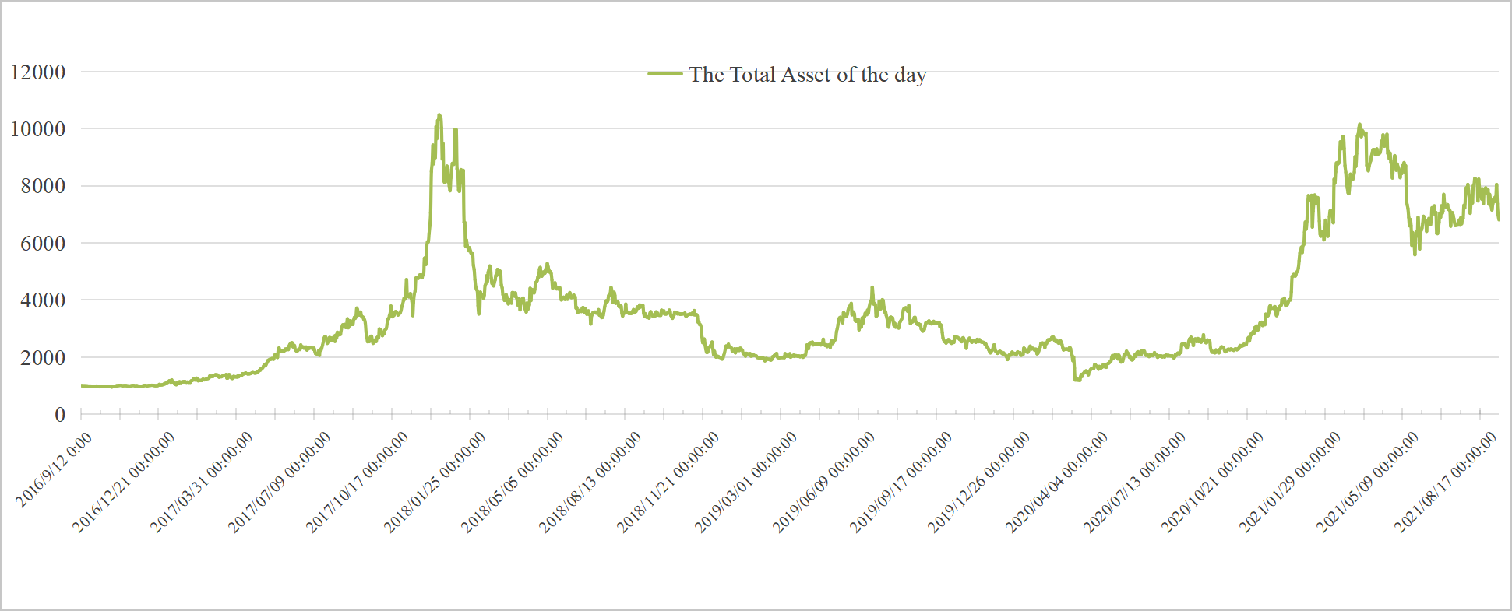
Figure 10 The total assets of the day

Problem 2

Random Forest Regression Algorithm

Expressions
The random forest algorithm has many advantages in data processing and price prediction. It can handle complex nonlinear relationships, has strong robustness, and also has the advantages of ensemble learning. The following figure indicates the basic logic of random forest regression.
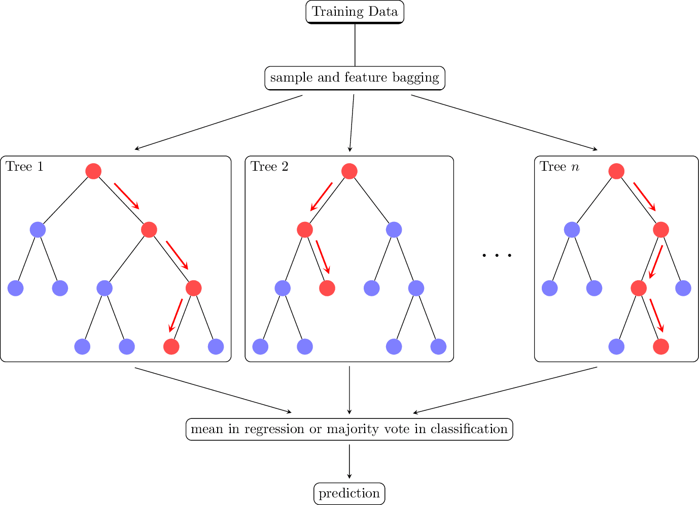
Figure 11 the basic logic of random forest regression

Advantage Analysis
i.Handling Complex Nonlinear Relationships
The price data of Bitcoin and gold in the financial market has high complexity and nonlinear characteristics. The random forest regression algorithm can effectively capture these complex nonlinear relationships, which makes it very suitable for modeling financial time series data. Compared with traditional linear models, it can better fit the actual price fluctuation situation, thus significantly improving the accuracy of price prediction. Accurate price prediction provides a reliable basis for formulating trading strategies and helps investors make wiser trading decisions.
ii.Strong Robustness
In actual financial data, outliers and noise inevitably exist. The random forest regression algorithm is insensitive to these outliers and noise. Even if there is a certain error or interference in the data, it can still maintain good prediction performance. This characteristic ensures the stability of trading decisions and reduces the risk of wrong decisions caused by abnormal data. In the volatile financial market, this robustness is particularly important and can help investors stay calm and make reasonable investment decisions in a complex market environment.
3. Advantages of Ensemble Learning
The random forest regression algorithm performs ensemble learning by constructing multiple decision trees. In the decision-making process, it comprehensively considers multiple features and decision paths, which effectively reduces the bias and variance of a single model. By integrating the prediction results of multiple decision trees, the generalization ability of the model is significantly improved, making the prediction results more robust and reliable. Whether in different market conditions or facing different data distributions, the random forest regression model can provide relatively stable and accurate price predictions, providing strong support for the long-term effectiveness of trading strategies.

Genetic Algorithm

Expressions
Two functions, `model_1_ga` and `model_2_ga`, are defined to adapt to different trading scenarios. In the design of the fitness function, the performance of the strategy is measured based on the change in the value of the investment portfolio, fully considering factors such as transaction costs (2% for Bitcoin and 1% for gold) and price fluctuations. At the same time, a series of constraint conditions are set, such as the upper and lower limits of trading volume and the price fluctuation range. These constraint conditions ensure the rationality and feasibility of the generated trading strategies in actual trading and avoid unrealistic trading behaviors, such as overtrading or trading beyond the asset holding capacity.
The figure shows how our algorithm works.
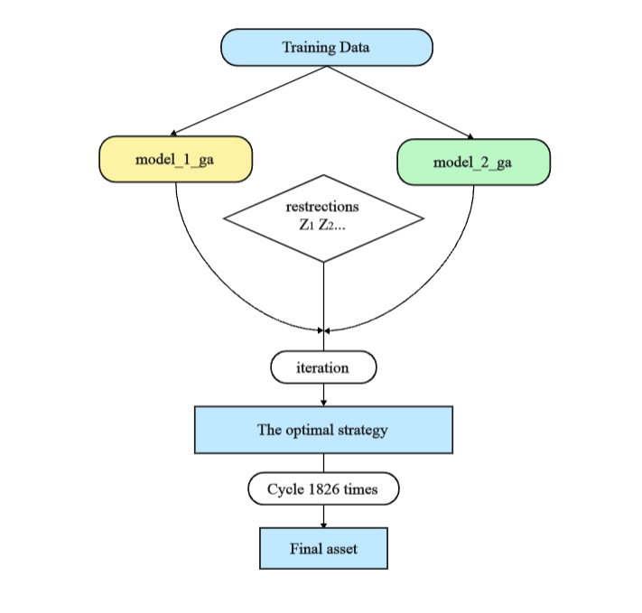
Figure 12 the basic logic of genetic algorithm

Advantage Analysis
The genetic algorithm has multiple initial solutions and can conduct extensive searches in the solution space. Due to its inherent parallelism, it has many advantages. The following is a detailed introduction to the advantages of this algorithm:
i.Global Search Ability
The genetic algorithm starts from multiple initial solutions and conducts extensive searches in the solution space. Through operations such as selection, crossover, and mutation, it can cross local optimal solutions and is more likely to find the global optimal or near-optimal trading strategy. In the complex multi-peak trading strategy space, this global search ability is particularly prominent. For example, when there are various price trends and trading opportunities in the market, the genetic algorithm can comprehensively explore various possible strategy combinations and avoid falling into the trap of local optimality, thus providing investors with more potential trading strategies.
ii.Parallelism and Adaptability
The genetic algorithm has inherent parallelism. It can evaluate multiple individuals (trading strategies) simultaneously, which greatly accelerates the search process and improves the efficiency of the algorithm. At the same time, the algorithm can automatically adjust the search direction according to the fitness function, enabling it to quickly adapt to market changes and different trading scenarios. When market conditions change, such as sudden events leading to large price fluctuations, the genetic algorithm can optimize the trading strategy in real time and adjust the asset allocation in a timely manner to cope with market uncertainty and ensure the stability and profitability of the investment portfolio.
iii.Handling Complex Constraint Conditions
In actual trading, there are various complex constraint conditions, such as asset holding limits and transaction cost constraints. The genetic algorithm can flexibly handle these constraint conditions and search for the optimal trading strategy under the premise of meeting the actual trading rules and restrictions. This ensures that the generated trading strategies are not only optimal in theory but also feasible and effective in actual operation, highly consistent with the real market trading environment, and avoid the problem of strategy failure caused by ignoring constraint conditions.

Overall Synergistic Advantage
In the entire prediction and investment strategy algorithm, there are also relatively strong advantages in synergy. The following is a detailed analysis:
The random forest regression algorithm provides accurate price predictions, providing key information for the genetic algorithm to make decisions. The genetic algorithm, based on these prediction results, optimizes the trading strategy to maximize the value of the investment portfolio. The combination of the two realizes data-driven trading decisions, making the formulation of trading strategies more scientific and reasonable. This data-driven approach reduces subjective judgment and blindness, improves the accuracy and reliability of trading decisions, and enables investors to better cope with market changes.
In the trading process, multiple factors such as price fluctuations and transaction costs are comprehensively considered. Through reasonable asset allocation and trading strategy adjustment, risks are effectively controlled while maximizing investment returns. For example, according to price trends and risk assessments, the holding ratios of gold and Bitcoin are determined to avoid over-concentration of investment in a single asset. The price prediction of the random forest regression helps evaluate risks, and the genetic algorithm optimizes asset allocation to balance risks and returns, enabling the investment portfolio to maintain relatively stable performance under different market conditions.
For the random forest regression model, its performance can be accurately evaluated through evaluation metrics such as MSE, RMSE, MAE, and R2 to understand the accuracy and reliability of the model prediction. The genetic algorithm evaluates the pros and cons of trading strategies through the fitness function. These evaluation methods facilitate in-depth analysis of the effects of the model and strategy and provide a clear direction and basis for further optimization and improvement. Through continuous evaluation and improvement, the effectiveness of the trading strategy can be continuously enhanced to better adapt to market changes and create greater value for investors.
According to the final calculation data, it can be known that using our strategy for investment, the odds are very low. In terms of days, in five years, there are only 79 days when the investment strategy will have a certain degree of loss, and the odds are as low as 4.3%. In terms of amount, in five years, there is only 1 day when the loss exceeds 5%, only 14 days when the loss exceeds 3%, and only 34 days when the loss exceeds 1%, and the probabilities are all less than 1%. Compared with our returns, the risk of loss is small. For Bitcoin, which is a trading object whose specific price cannot be accurately predicted and is extremely unstable, the smaller the loss, the smaller the risk, and it will be more stable in an unstable trading environment.

Problem 3 (sensitivity analysis)

Mathematical Framework
Transaction costs directly reduce the potential profits from frequent trades and can also discourage beneficial trades that become unprofitable after accounting for commissions. By performing a sensitivity analysis—varying transaction cost parameters and observing the final wealth—we can quantify how these costs affect the strategy’s performance. As transaction costs increase, we typically see lower final wealth and potentially fewer executed trades, illustrating the model’s sensitivity to cost parameters.
Suppose at each trading day $t$, the strategy decides the trading vector $Δ=\left(Δ_{G},Δ_{B}\right)$, where $Δ_{G}$is the net change in gold holdings (in troy ounces) and $ΔB$ is the net change in bitcoin holdings.
i.Let $m_{1}^{t}$ and $m_{2}^{t}$ be the gold and bitcoin prices at day $t$.
ii.Let $α_{\text{gold}}$and$α_{\text{bitcoin}}$ be the transaction cost percentages for gold and bitcoin, respectively. These costs apply both to purchases and sales.

When we execute a trade $Δ_{G}$ in gold, if $Δ_{G}$> 0 (buying), the cost in USD is

$${\text{Cost}}_{\text{gold,buy}}=\left(m_{1}^{t}Δ_{G}\right)\left(1+α_{\text{gold}}\right)$$ | ()

If $Δ_{G}$< 0 (selling), the proceeds are reduced by the transaction cost:

$${\text{Revenue}}_{\text{gold,sell}}=\left|m_{1}^{t}Δ_{G}\right|\left(1-α_{\text{gold}}\right)$$ | ()

Similarly for Bitcoin:
$${\text{Cost}}_{\text{bitcoin,buy}}=\left(m_{2}^{t}Δ_{B}\right)\left(1+α_{\text{bitcoin}}\right)$$ | ()

$${\text{Revenue}}_{\text{bitcoin,sell}}=\left|m_{2}^{t}Δ_{B}\right|\left(1-α_{\text{bitcoin}}\right)$$ | ()

The final wealth $W\left(α_{\text{gold}},α_{\text{bitcoin}}\right)$ after the full trading horizon (5 years in this example) is a function of the transaction cost parameters. To perform sensitivity analysis, we treat $α_{\text{gold}}$
and $α_{\text{bitcoin}}$ as variables and measure changes in final wealth:
$$\frac{∂W}{∂α_{\text{gold}}}\text{ and }\frac{∂W}{∂α_{\text{bitcoin}}}.$$
While an analytic derivation may be complicated, we can numerically approximate these sensitivities by running the simulation multiple times at different cost levels.

Implementation methodology
By varying the parameters characterizing $α_{\text{gold}}$ and $α_{\text{bitcoin}}$ in the algorithms mentioned earlier, we can examine the overall robustness of the developed model with different combinations of commissions.

Sensitivity Analysis Method
Parametric Sweep:
i.Choose a range of values for $α_{\text{gold}}$, for example from 1% to 2%, and for $α_{\text{bitcoin}}$,for example from 1% to 2%.
ii.For each pair ($α_{\text{gold}}$,$α_{\text{bitcoin}}$), run the entire simulation from 09/11/2016 to 09/10/2021 with the same trading strategy logic.
iii.Store the final wealth $W\left(α_{\text{gold}},α_{\text{bitcoin}}\right).$

Expected Results and Comparison
i.Higher transaction costs reduce the frequency and/or volume of profitable trades because many marginal trades (those barely profitable at low costs) become unprofitable.
ii.The final wealth tends to decrease as $α_{\text{gold}}$​ and $α_{\text{bitcoin}}$ increase. The relationship may be approximately linear for small changes or could become nonlinear if the strategy drastically shifts behavior to avoid transaction costs.
iii.A well-designed strategy might become more passive when transaction costs are high, resulting in fewer trades and lower realized gains but potentially less transaction cost expenditure.
After collecting these results, we are capable of comparing different commission portfolios on five-year total assets under the same initial asset division.
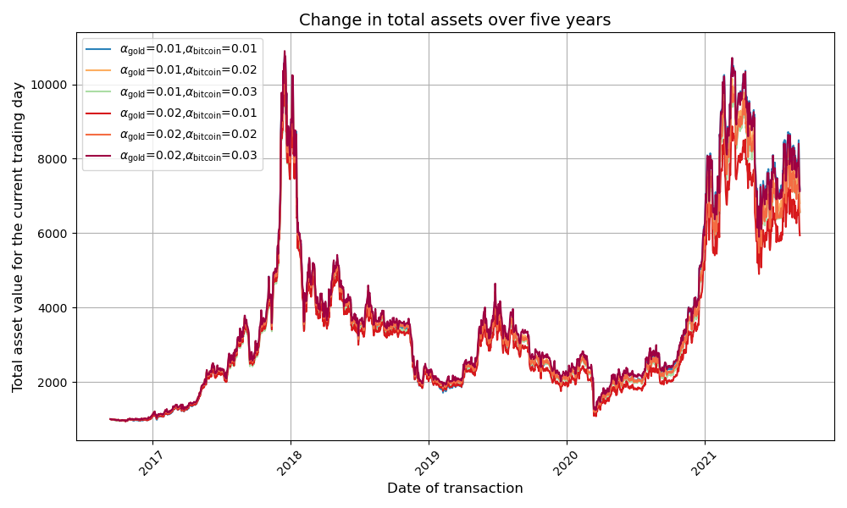
Figure 13 different commission portfolios on five-year total assets under the same initial asset division
From the images we can see that the curves of total assets overlap very well for different combinations of commissions

Model Evaluation and Further Discussion

Strengths
i. Since we iterate every day for five years in the model, it makes the changes in the money visible, ensures the viability and effectiveness of the trading strategy, and makes the trading results easy to analyze.
ii. Predictions of the next day's data based on all bitcoin and gold market data up to that day through Random Forests are a good fit to the true situation.
iii. The genetic algorithm we use can handle large-scale search spaces, has global search capability, can avoid falling into local optimums, is adaptive, can handle dynamically changing problems, does not rely on the gradient information of the problem, and is suitable for complex optimization problems

Weaknesses
Our model does not perform as well in more robust trading patterns as it does in more aggressive trading patterns.

Further Discussion
7.3.1 Model Improvements
i.Enhancing Robustness in Trading Patterns:
The model currently performs better in aggressive trading patterns, which might lead to higher risks in volatile markets. To improve robustness, a more conservative strategy can be implemented by introducing thresholds for trades. For instance:
Adding a volatility filter: Only trade when the expected return exceeds a certain threshold relative to market volatility (e.g., Sharpe Ratio or Conditional Value-at-Risk).
Adjusting the genetic algorithm's constraints to prioritize stability over aggressive gains, such as incorporating stricter transaction cost penalties or minimum holding periods.
ii.Improved Price Prediction Models:
While Random Forests are a good choice for time-series predictions, incorporating other advanced methods, such as Long Short-Term Memory (LSTM) networks or Transformer-based models, could further improve the accuracy of predictions, especially in capturing long-term dependencies in price data.
Combining ensemble models, such as stacking or blending Random Forests with gradient boosting algorithms like XGBoost or LightGBM, could provide more reliable predictions.
7.3.2 Model Extensions
Multi-Asset Portfolio Optimization:
Extend the model to optimize a multi-asset portfolio, including stocks, commodities, bonds, and cryptocurrencies. This would make the model more applicable to real-world investment strategies.

Conclusion
This paper presents a robust and adaptive trading strategy leveraging machine learning techniques, specifically Random Forest Regression, and optimization through Genetic Algorithms (GA). Our strategy demonstrates significant improvements in decision-making for trading Bitcoin and gold over a five-year period.
The core strengths of our approach lie in its adaptability and accuracy. The Random Forest Regression model ensures reliable price predictions for both assets, while the Genetic Algorithm efficiently optimizes daily trading decisions, balancing transaction costs and potential profits. This synergy between prediction and optimization provides a solid framework for maximizing returns in volatile markets.
The sensitivity analysis highlights the model's resilience to varying transaction costs, showcasing its practical applicability in real-world scenarios. Despite some limitations, such as suboptimal performance under conservative trading patterns, our methodology provides a strong foundation for developing advanced trading models.
Future Directions: To enhance robustness and applicability, future work can integrate advanced predictive models, such as LSTMs or Transformer-based architectures, and expand the strategy to multi-asset portfolios. Additionally, incorporating dynamic risk management mechanisms could further align the model with real-world trading environments.
This study illustrates the potential of combining machine learning with optimization techniques to address complex financial problems, offering a promising direction for future research in algorithmic trading.

References
[1] Financial literacy--- Bitcoin's "past and present" - preventing illegal fundraising. Gaocheng District Government.2018-11-14
[2] Li Jiangping and Wang Zhenying: The Logical Chain Behind Gold Price Fluctuations - HSBC Financial Research Institute of Peking University. Seen on December 13, 2024..
[3] "Bitcoin price goes up with high risk". Seen on December 13, 2024.

Appendices
Appendix 1
Introduce: Two Genetic Algorithms for gold open and closed markets
def model_1_ga(z1, z2, m1, m2, n1, n2):
"""
The model_1_ga function is optimized using GA to maximize future asset values (gold and bitcoin scaling)
z1, z2: current gold and bitcoin asset values of holdings
m1, m2: current gold and bitcoin prices (real)
n1, n2: Predicted gold and bitcoin prices for the next period
"""
demo_func = lambda x: -((n1 / m1) * (z1 + x[0]) + (n2 / m2) * (z2 + x[1]))
'''
Daily return = (next day's gold price/today's gold price) (previous day's gold holdings + current day's gold trades) + (next day's bitcoin price/today's bitcoin price) (previous day's bitcoin holdings + current day's bitcoin trades)
'''
# Nonlinear constraints
constraint_ueq = [
lambda x: x[0] + x[1] - (z1 + z2), # Binding 1: the number of gold and bitcoin transactions on the day must not exceed the total holdings
lambda x: (-z1 - z2) - (x[0] + x[1]), # Bound 2: the number of gold and bitcoin transactions on the day must not exceed the previous day's respective holdings
lambda x: 0.01*x[0] - ((n1 / m1) - 1), # Binding 3: gold profit is higher than the fee before trading
lambda x: 0.02*x[1] - ((n2 / m2) - 1), # Binding 4: Bitcoin is only traded if the profit is higher than the fee
]
ga = GA(func=demo_func, n_dim=2, size_pop=100, max_iter=500, prob_mut=0.001,
lb=[-z1, -z2], ub=[z1, z2], precision=[1e-7, 1e-7], constraint_ueq=constraint_ueq)
'''
func <- the objective function of the genetic algorithm optimization, i.e. daily returns
n_dim <- 2 Dimension of the decision variables (number of independent variables of the optimization problem)
x[0] Gold adjustment
x[1] Bitcoin adjustment
size_pop <- 100 size of the population, number of candidate solutions included in each generation of the genetic algorithm
max_iter <- 500 maximum number of iterations, the maximum number of generations allowed by the genetic algorithm before it stops
prob_mut <- 0.001 probability of gene mutation, lower helps stabilize the optimization process
lb <- [-z1,-z2] lower bounds for the decision variables, -z1 and -z2 means that the minimum value of gold and bitcoin adjustments must not exceed the negative value of their current assets, i.e., they must not be adjusted by more than the sum of their asset holdings
ub <- [z1, z2] Meaning: The upper bounds of the decision variables z1 and z2 denote the maximum values of the adjusted amount of gold and bitcoin, i.e., the adjusted amount of assets cannot exceed the sum of their current holdings.
precision <- [1e-7, 1e-7] The precision of the decision variable (the accuracy of the solution) corresponds to the smallest unit of change of the two decision variables (Gold and Bitcoin Adjustment). 1e-7 means that the smallest adjustment value allowed is 0.0000001.
constraint_ueq <- constraint_ueq: nonlinear inequality constraints
'''
ga.register(operator_name='selection', operator=selection.selection_roulette_2) # Register the selection operator. selection.selection_roulette_2: use the “roulette selection” algorithm for individual selection
ga.register(operator_name='ranking', operator=ranking.ranking) # Register ranking operator. ranking.ranking: rank populations by fitness, assign selection probabilities.
ga.register(operator_name='crossover', operator=crossover.crossover_2point_bit) # Register the crossover operator. crossover.crossover_2point_bit: uses the “two-point crossover” method to recombine the genes of two individuals.
ga.register(operator_name='mutation', operator=mutation.mutation) # Register the mutation operator. mutation.mutation:Use the default mutation method.
best_x, func = ga.run() # best_x, func <- ga.run()
return -func[0], best_x[0], best_x[1]
def model_2_ga(z1, z2, m2, n2):
'''
The model_2_ga function is a model optimized for bitcoin only when gold data is missing
'''
demo_func = lambda x: -(z1 + (n2 / m2) * (z2 + x[0]))
'''
Daily return = previous day's gold holdings + (next day's bitcoin price/today's bitcoin price) * (previous day's bitcoin holdings + current day's bitcoin transactions)
'''
constraint_ueq = [
lambda x: x[0] - z2, # constraint 1: the number of bitcoin transactions on that day must not exceed the total bitcoin holdings
lambda x: - z2 - x[0], # constraint 2: the number of bitcoin transactions on that day must not exceed the previous day's holdings
lambda x: 0.02*x[0] - ((n2 / m2) - 1) # constraint 3: Bitcoin is only traded if the profit is higher than the fee
]
ga = GA(func=demo_func, n_dim=1, size_pop=100, max_iter=500, prob_mut=0.001,
lb=[-z2], ub=[z2], precision=[1e-7], constraint_ueq=constraint_ueq)
'''
func <- the objective function of the genetic algorithm optimization, i.e., daily returns
n_dim <- 1 Dimension of the decision variable (number of independent variables of the optimization problem)
x[0] the amount of bitcoin adjustment
size_pop <- 100 size of the population, number of candidate solutions included in each generation of the genetic algorithm
max_iter <- 500 maximum number of iterations, the maximum number of generations allowed by the genetic algorithm before it stops
prob_mut <- 0.001 probability of gene mutation, lower helps stabilize the optimization process
lb <- [-z2] lower bound for the decision variable, -z2 means that the minimum value of and bitcoin adjustments cannot exceed the negative value of their current assets, i.e., they cannot allow the asset adjustments to exceed the sum of the asset holdings
ub <- [z2] Meaning: The upper bound of the decision variable, z2, represents the maximum value of the bitcoin adjustment, i.e., the adjusted amount of assets must not exceed the sum of their current holdings.
precision <- [1e-7] The precision of the decision variable (the accuracy of the solution) corresponds to the smallest unit of change of the decision variable (Bitcoin Adjustment). 1e-7 means that the smallest adjustment allowed is 0.0000001
constraint_ueq <- constraint_ueq: nonlinear inequality constraints
'''
ga.register(operator_name='selection', operator=selection.selection_roulette_2)# Register the selection operator. selection.selection_roulette_2: use the “roulette selection” algorithm for individual selection
ga.register(operator_name='ranking', operator=ranking.ranking) # Register ranking operator. ranking.ranking: rank populations by fitness, assign selection probabilities.
ga.register(operator_name='crossover', operator=crossover.crossover_2point_bit) # Register the crossover operator. crossover.crossover_2point_bit: uses the “two-point crossover” method to recombine the genes of two individuals.
ga.register(operator_name='mutation', operator=mutation.mutation)# Register the mutation operator. mutation.mutation:Use the default mutation method.

best_x, func = ga.run()
return -func[0], best_x[0]

Appendix 2
Introduce: Transactions that change the initial asset allocation and iterate for five years
outer_total = len(range(1, 1001, 20)) # 50times
# Initialize the outer loop counter
outer_idx = 1
x = []
y = []
for initial_gold_holdings in range(1, 1001, 20):
print(f'Outer loop {outer_idx}/{outer_total}: initial_z1 = {initial_gold_holdings}')
x.append(initial_gold_holdings)

# Initialize the holdings
z1 = initial_gold_holdings
z2 = 1000 - z1

alldata_inner = []
final_ojb = None # Used to record the ojb value for the last day of each iteration

# Iterate over all trading days

for i in range(1, df___.shape[0]):: # for all trading days
df___.shape[0]: try.
if i == df___.shape[0] - 1: # Exit if there are no predicted gold and bitcoin prices on the second day.
break
# m1 real today's gold price
m1 = df___['real gold price'].iloc[i]
# m2 real today's bitcoin price
m2 = df___['real bitcoin price'].iloc[i]
# n1 Predicted gold price for tomorrow
n1 = df___['predicted gold price'].iloc[i]
# n2 Predicted tomorrow's bitcoin price
n2 = df___['predicted bitcoin price'].iloc[i]
# N1 Real tomorrow's gold price
N1 = df___['real gold price'].iloc[i + 1]
# N2 The real tomorrow's bitcoin price
N2 = df___['real bitcoin price'].iloc[i + 1] # Fix spelling error

if (np.isnan(m1) == True) or (np.isnan(n1) == True): # Execute genetic algorithm for gold closure if current gold price is null or day 2 is null
final_ojb, x_bit = model_2_ga(z1, z2, m2, n2)
z2 = N2 / m2 * (z2 + x_bit)
alldata_inner.append([
df___['Date'].iloc[i], m1, m2, n1, n2, N1, N2.
z1, z2, np.nan, x_bit, final_ojb
])

else: # i.e. gold data is not missing
final_ojb, x_hj, x_bit = model_1_ga(
z1, z2, m1, m2, n1, n2
)
if (np.isnan(N1) == True) or (np.isnan(N2) == True).
pass
else: z1 = N1 / m1
z1 = N1 / m1 * (z1 + x_hj)
z2 = N2 / m2 * (z2 + x_bit)

alldata_inner.append([df___['Date'].iloc[i], m1, m2, n1, n2, N1, N2, z1, z2, x_hj, x_bit, final_ojb]))
if z1 == 0 or np.isnan(z1) == True.
z1 = 0.0001
print(f' Outer {outer_idx}/{outer_total} - Inner {i + 1}/{df___.shape[0]}') # progress
except.
print(df___['Date'].iloc[i])
break
# After cycling through all the days at a given weight, add the final ojb value to y for subsequent plotting
if final_ojb is not None.
print(final_ojb) # double insurance
y.append(final_ojb)
else.
# if final_ojb is not None: print(final_ojb) # double insurance: y.append(final_ojb) else.
y.append(np.nan)
outer_idx += 1
# At the end of the outer loop, export alldata_inner
alldata_inner_df = pd.DataFrame(alldata_inner, columns=columns1) # columns1 need to be defined in advance
alldata_inner_df.to_excel(f'five-year investment summary table_z1_{initial_gold_holdings}.xlsx', in-dex=False)

