1.Mathematical Framework
Transaction costs directly reduce the potential profits from frequent trades and can also discourage beneficial trades that become unprofitable after accounting for commissions. By performing a sensitivity analysis—varying transaction cost parameters and observing the final wealth—we can quantify how these costs affect the strategy’s performance. As transaction costs increase, we typically see lower final wealth and potentially fewer executed trades, illustrating the model’s sensitivity to cost parameters.
Suppose at each trading day $t$, the strategy decides the trading vector $Δ=\left(Δ_{G},Δ_{B}\right)$, where $Δ_{G}$is the net change in gold holdings (in troy ounces) and $ΔB$ is the net change in bitcoin holdings.
- Let $m_{1}^{t}$ and $m_{2}^{t}$ be the gold and bitcoin prices at day $t$.
- Let $α_{\text{gold}}$and$α_{\text{bitcoin}}$ be the transaction cost percentages for gold and bitcoin, respectively. These costs apply both to purchases and sales.

When we execute a trade $Δ_{G}$ in gold, if $Δ_{G}$> 0 (buying), the cost in USD is
$${\text{Cost}}_{\text{gold,buy}}=\left(m_{1}^{t}Δ_{G}\right)\left(1+α_{\text{gold}}\right)$$
If $Δ_{G}$< 0 (selling), the proceeds are reduced by the transaction cost:
$${\text{Revenue}}_{\text{gold,sell}}=\left|m_{1}^{t}Δ_{G}\right|\left(1-α_{\text{gold}}\right)$$
Similarly for Bitcoin:
$${\text{Cost}}_{\text{bitcoin,buy}}=\left(m_{2}^{t}Δ_{B}\right)\left(1+α_{\text{bitcoin}}\right)$$
$${\text{Revenue}}_{\text{bitcoin,sell}}=\left|m_{2}^{t}Δ_{B}\right|\left(1-α_{\text{bitcoin}}\right)$$
The final wealth $W\left(α_{\text{gold}},α_{\text{bitcoin}}\right)$ after the full trading horizon (5 years in this example) is a function of the transaction cost parameters. To perform sensitivity analysis, we treat $α_{\text{gold}}$
and $α_{\text{bitcoin}}$ as variables and measure changes in final wealth:
$$\frac{∂W}{∂α_{\text{gold}}}\text{ and }\frac{∂W}{∂α_{\text{bitcoin}}}.$$
While an analytic derivation may be complicated, we can numerically approximate these sensitivities by running the simulation multiple times at different cost levels.
2.Implementation methodology
By varying the parameters characterizing $α_{\text{gold}}$ and $α_{\text{bitcoin}}$ in the algorithms mentioned earlier, we can examine the overall robustness of the developed model with different combinations of commissions.
3.Sensitivity Analysis Method
Parametric Sweep:
(a)Choose a range of values for $α_{\text{gold}}$, for example from 1% to 2%, and for $α_{\text{bitcoin}}$,for example from 1% to 2%.
(b)For each pair ($α_{\text{gold}}$,$α_{\text{bitcoin}}$), run the entire simulation from 09/11/2016 to 09/10/2021 with the same trading strategy logic.
(c)Store the final wealth $W\left(α_{\text{gold}},α_{\text{bitcoin}}\right).$
4.Expected Results:
(a)Higher transaction costs reduce the frequency and/or volume of profitable trades because many marginal trades (those barely profitable at low costs) become unprofitable.
(b)The final wealth tends to decrease as $α_{\text{gold}}$​ and $α_{\text{bitcoin}}$ increase. The relationship may be approximately linear for small changes or could become nonlinear if the strategy drastically shifts behavior to avoid transaction costs.
(c)A well-designed strategy might become more passive when transaction costs are high, resulting in fewer trades and lower realized gains but potentially less transaction cost expenditure.
5.Comparisoon
After collecting these results, we are capable of comparing different commission portfolios on five-year total assets under the same initial asset division.
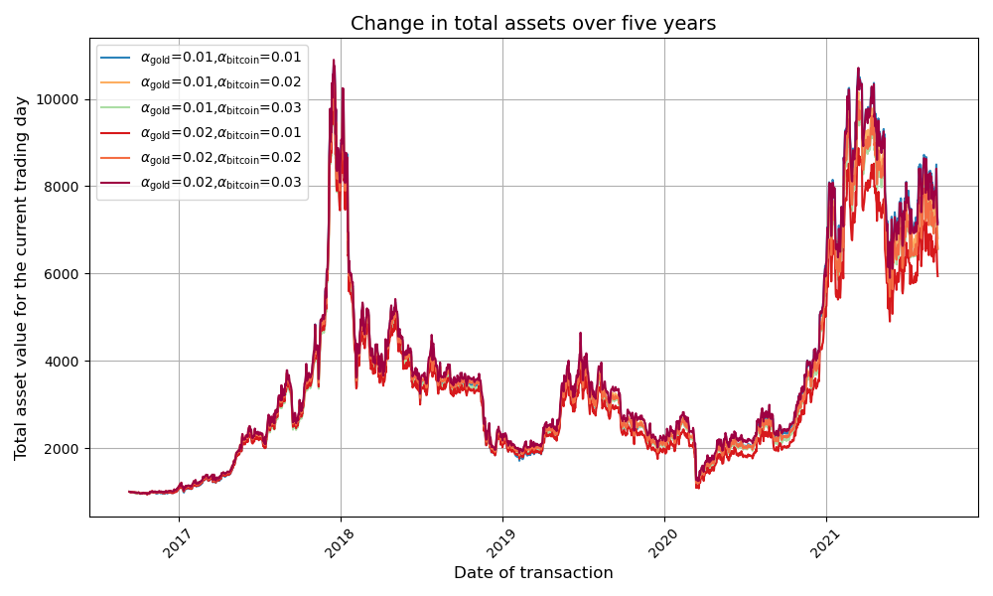
From the images we can see that the curves of total assets overlap very well for different combinations of commissions

