**1)- Software Installation File**

Language : JDK 1.5, Net beans 6.9

Database : My Sql 5.0

Operating System : Any Operating System.

**JDK 1.5**

**We install this software by simple instruction follow.**

Sun is planning to release a major revision of the Java programming language in summer 2004. This release is code named "Tiger," but it will receive the official designation of JDK 1.5.

This version of the Java language will incorporate Java Specification Requests 14 and 175 (JSR-14, JSR-175). It will also have major enhancements for runtime performance, scalability, manageability, and monitoring.

In this article, we'll discuss several of the new language features of JDK 1.5, including:

Generics—Provides compile-time type safety for collections and eliminates the need for casting every time you get an object out of Collections.

Enhanced For loop—Eliminates error-proneness of iterators.

Autoboxing/unboxing—Eliminates need of manual conversion between primitive types (such as double) and wrapper types (such as Double).

Typesafe enums—Provides all benefits of the Typesafe enum pattern.

Static import—Eliminates the need for using class names prior to using the static member variables of other classes. This will make the code a bit neater.

Metadata—Allows programmers to avoid writing boiler plate code and gives the opportunity for declarative programming.

Let's discuss each feature in detail and take a look at some examples.

Generics

Generics is one of the coolest features of JDK 1.5. By introducing generics, we will have compile-time type safety and possibly fewer ClassCastExceptions during run time. In JDK 1.5, you can declare the type of objects one collection will accept/return. In JDK 1.4, creating a List of employee names requires a collection object like the following statement:

List listOfEmployeeName = new ArrayList();

In JDK 1.5, you would use this statement:

List<String> listOfEmployeeName = new ArrayList<String>();

The cool part is that if you try to insert something that's not a string, you will find out at compile time and then you can fix the problem. Without generics, you discover such a bug when your customer calls and tells you that the program you shipped crashed with a ClassCastException.

The other cool thing is that you don't have to cast when you get an element out of the collection. So instead of this type of statement:

String employeeName = ((String) listOfEmployee.get(i));

It's simply:

String employeeName = listOfEmployee.get(i);

Casting objects without knowing the type of object is not good, and more importantly, it can fail at run time. Suppose the user accidentally passes in a collection that contains string buffers rather than strings. In Listing A, the client is required to pass in a collection of strings that the compiler can't enforce.Listing B shows how the same method looks with generics.

Now it's clear from the method signature that the input collection must contain only strings. If the client tries to pass in a collection of string buffers, the program won't compile. And notice that the method doesn't contain any casts. It's one line shorter and, once you get used to reading generics, it's clearer too.

**Net beans 6.9**

When ever we start to install this software we start with next after that we click on customize button and select apache server.And after that click on simple next next button .And last click on finished button.

Jump to: navigation, search

NetBeans IDE NetBeans.svg

NetBeansIDE.png

NetBeans IDE 6.9 in Microsoft Windows 7.

Developer(s) Oracle Corporation

Stable release 7.3 / February 21, 2013

NetBeans is an integrated development environment (IDE) for developing primarily with Java, but also with other languages, in particular PHP, C/C++, and HTML5. It is also an application platform framework for Java desktop applications and others.

The NetBeans IDE is written in Java and can run on Windows, OS X, Linux, Solaris and other platforms supporting a compatible JVM.

The NetBeans Platform allows applications to be developed from a set of modular software components called modules. Applications based on the NetBeans Platform (including the NetBeans IDE itself) can be extended by third party developers.

NetBeans IDE 6.0 introduced support for developing IDE modules and rich client applications based on the NetBeans platform, a Java Swing GUI builder (formerly known as "Project Matisse"), improved CVS support, WebLogic 9 and JBoss 4 support, and many editor enhancements. NetBeans 6 is available in official repositories of major Linux distributions.

NetBeans IDE 6.5, released in November 2008, extended the existing Java EE features (including Java Persistence support, EJB 3 and JAX-WS). Additionally, the NetBeans Enterprise Pack supports development of Java EE 5 enterprise applications, including SOA visual design tools, XML schema tools, web services orchestration (for BPEL), and UML modeling. The NetBeans IDE Bundle for C/C++ supports C/C++ and FORTRAN development.

NetBeans IDE 6.8 is the first IDE to provide complete support of Java EE 6 and the GlassFish Enterprise Server v3. Developers hosting their open-source projects on kenai.com additionally benefit from instant messaging and issue tracking integration and navigation right in the IDE, support for web application development with PHP 5.3 and the Symfony framework, and improved code completion, layouting, hints and navigation in JavaFX projects.

NetBeans IDE 6.9, released in June 2010, added support for OSGi, Spring Framework 3.0, Java EE dependency injection (JSR-299), Zend Framework for PHP, and easier code navigation (such as "Is Overridden/Implemented" annotations), formatting, hints, and refactoring across several languages.

NetBeans IDE 7.0 was released in April 2011. On August 1, 2011, the NetBeans Team released NetBeans IDE 7.0.1, which has full support for the official release of the Java SE 7 platform.

**My Sql 5.0**

**We install mysql server for database connectivity.We install it simple next next option .In the end of installation we need to input password and username .**

**Password :root**

**Username:root**

MySQL 5.0 features. This manual describes features that are not included in every edition of MySQL 5.0 and such features may not be included in the edition of MySQL 5.0 licensed to you. If you have any questions about the features included in your edition of MySQL 5.0, refer to your MySQL 5.0 license agreement or contact your Oracle representative.

2.Project installation file

We open netbeans id .We go to file menu and click open file

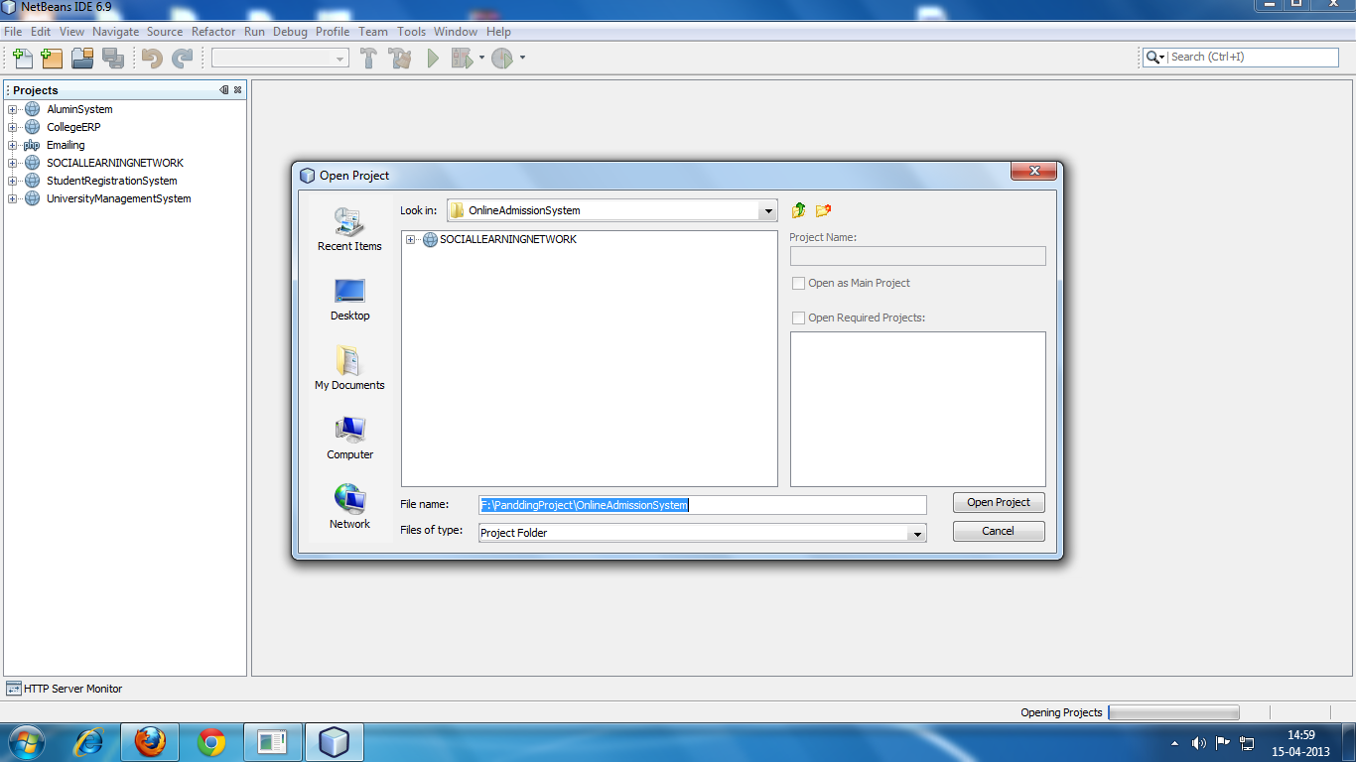

And Select project from our system drive .And Finally click on run button.

**3)- Software environment setting file**

For this we do right click on project and click on properties.

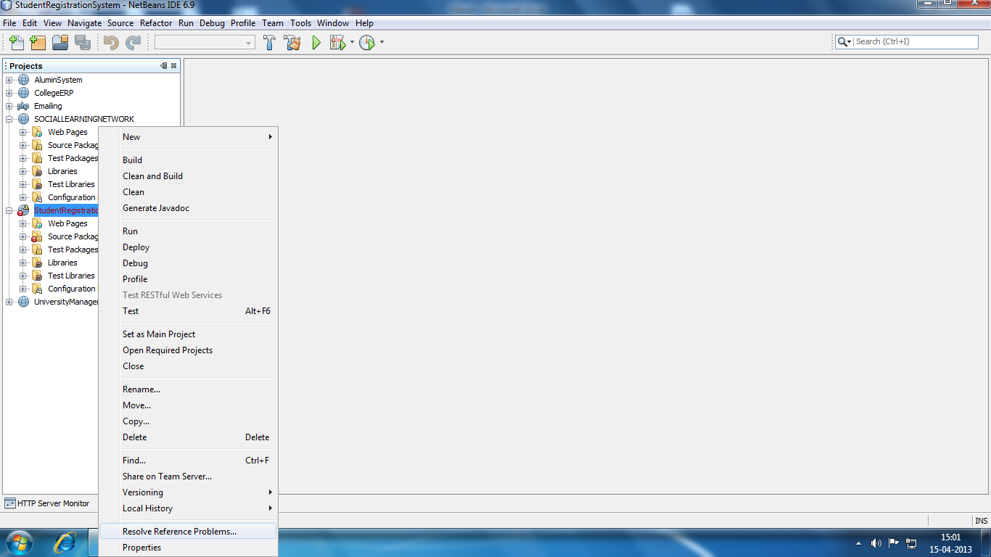

And go to libraries and add jar file from out project.

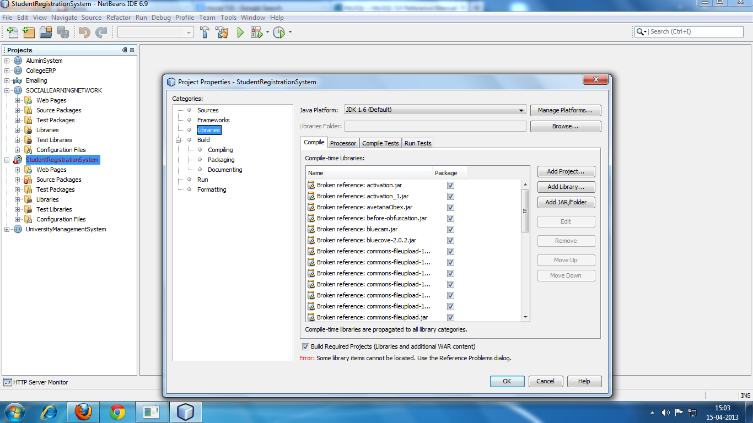-

**4)- Project help file**

In project help file we show how to project run and which type of data we have to enter in our application. To run our application first of all open netbeans id .After that go to file menu and select open file after that select our project and run it.

Database is automatically connected to our project. Our application ask password and id .in that position enter password –admin

Id –admin

After that we access our application.

**5)- Project operating File**

**Apache Tomcat**

**Apache Tomcat** (or simply **Tomcat**, formerly also *Jakarta Tomcat*) is an [open source](http://en.wikipedia.org/wiki/Open_source) [web server](http://en.wikipedia.org/wiki/Web_server) and [servlet](http://en.wikipedia.org/wiki/Java_Servlet) [container](http://en.wikipedia.org/wiki/Web_container) developed by the [Apache Software Foundation](http://en.wikipedia.org/wiki/Apache_Software_Foundation) (ASF). Tomcat implements the [Java Servlet](http://en.wikipedia.org/wiki/Java_Servlet) and the [JavaServer Pages](http://en.wikipedia.org/wiki/JavaServer_Pages) (JSP) specifications from [Sun Microsystems](http://en.wikipedia.org/wiki/Sun_Microsystems), and provides a "pure [Java](http://en.wikipedia.org/wiki/Java_%28programming_language%29)" [HTTP](http://en.wikipedia.org/wiki/Hypertext_Transfer_Protocol) [web server](http://en.wikipedia.org/wiki/Web_server) environment for [Java](http://en.wikipedia.org/wiki/Java_%28programming_language%29) code to run.

Apache Tomcat includes tools for configuration and management, but can also be configured by editing [XML](http://en.wikipedia.org/wiki/XML) configuration

|  |  |
| --- | --- |
| Installing Apache Tomcat Server  Installing Apache Tomcat Server | http://www.eclipse.org/webtools/images/wtplogosmall.jpg |

|  |  |
| --- | --- |
|  | **By Kathy Chan**  April 29, 2005 |
|  |  |
|  | In this tutorial, you will install an Apache Tomcat server using the Server Installed Runtimes preference page. |
|  |  |
| **Installing server runtime** | |
|  |  |
|  | 1. If you do not have Apache Tomcat on your machine, you will first need to download and unzip [Apache Tomcat](http://jakarta.apache.org/tomcat/) (this scenario was written using Apache Tomcat version 5.0.28, but other versions can be substituted). 2. Start the Eclipse WTP workbench. 3. Open **Window -> Preferences -> Server -> Installed Runtimes** to create a Tomcat installed runtime. 4. Click on **Add...** to open the **New Server Runtime** dialog, then select your runtime under **Apache** (Apache Tomcat v5.0 in this example):   http://www.eclipse.org/webtools/jst/components/ws/M4/tutorials/resources/InstallTomcat1.JPG   1. Click **Next** , and fill in your **Tomcat installation directory** :   http://www.eclipse.org/webtools/jst/components/ws/M4/tutorials/resources/InstallTomcat2.JPG   1. Ensure the selected **JRE** |

**8)- Reference File**

1.JAVA-2 Complete-Reference

Author : Patric Norton & Herberlt Schild

Publisher : Tata McGraw Hill

2.System Analysis & Designing

Author : James A. senn

Publisher : Tata McGraw Hill

3.Software Engineering Concepts

Author : Fairley

Publisher : Tata McGraw Hill Publication,3rd

Edition.

4.Software Engineering Principles

Author : Pressman

5.Java Server Pages

Author : James Good Will

Publisher : Techmedia