PROGRESS
REPORT
ON
PROJECT

EMAIL MANAGEMENT

SUBMITTED TO:- SUBMITTED BY:-
MR. DILBAG BALESH&HARBIR
(LECT IN CSE) YADAV
CSE 8TH SEM
206/08 & 211/08

PROGRESS REPORT

WEEKS:-

Date: 4 MARCH 2012 – 11 MARCH 2012

- Coding of changing the theme.

Date: 11MARCH 2012 – 18 MARCH 2012

- Coding of sent page.
- Confirmation, if the mail is sent or not .

THEME

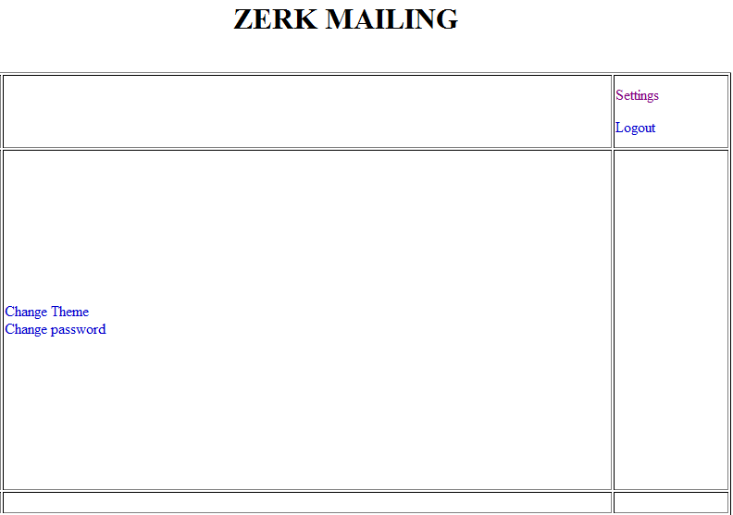

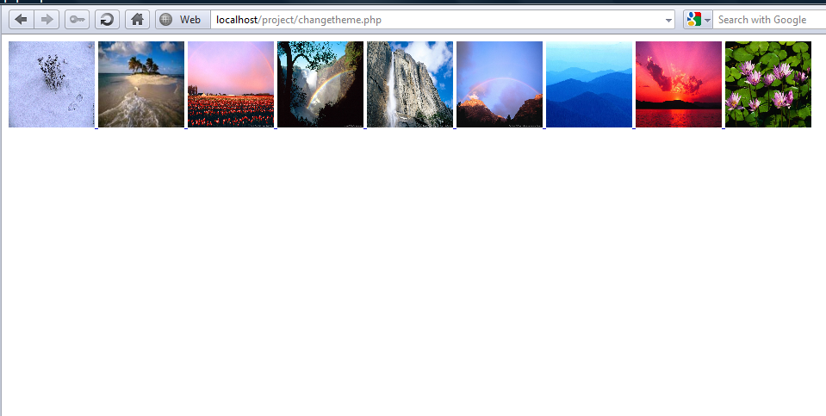

<?php
$od=opendir("image");
while($file=readdir($od))
{
if($file !="." && $file !="..")
{
echo "<a href='useraccount.php?img=$file'> <img src='image/$file' height='100' width='100'> </a>";
}
}
?>

SENT

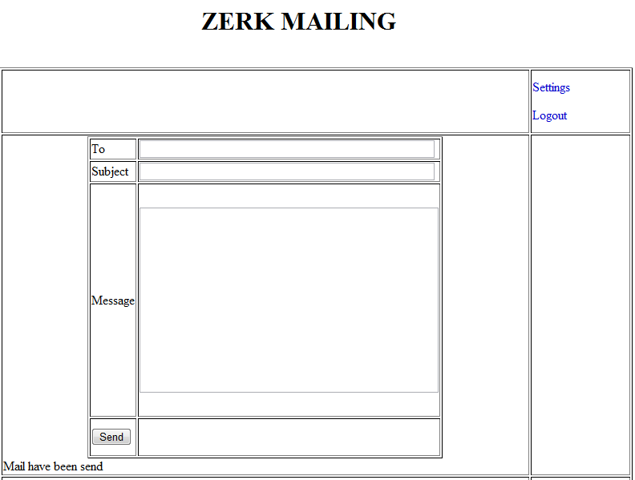

<?php
if(!$mail=Sent())
{
echo _YOUR_EMAIL_WAS_NOT_SENT . "<br>" . $mail->ErrorInfo;
include('newmessage.php');
}
else
{
echo _YOUR_EMAIL_WAS_SENT_SUCCESSFULLY . "<br><br>";
$header = $mail->CreateHeader();
$body = $mail->CreateBody();
//this CreateHeader & CreateBody are phpMailer functions

include('mailconnect.php');
imap_append($stream,"{name_OF_MY_MAILSERVER.net}INBOX.Sent", "$header\r\n" . "$body\r\n");//
imap_close($stream);

include('inbox.php');
}
?>

