

rr

PROJECT REPORT

ON

DOEACC SOCIETY
Electronics Niketan 6,cc,0,complex
New delhi 11003(india)

A

SUBMITTED BY: - POOJA

ENROLL NO-675793

DICS
16,Vaishali Enclave,Pitampura
Delhi-110088

Ë Acknowledgement Ë

At the outset, I am offering gratitude to my guide, who gave me great insight into what had to be done, and for their encouragement, without which it couldn’t have been possible to complete this project.
I am indicated to my friends for help me to prepare this project and for several useful suggestions.
I would also like to thank to every one of the organization who helped me in preparing this project and who guided me and gave me many useful suggestions by time to time in resolving difficulties.

I hope that my efforts on the project will fully satisfy experts who will examine this project. And I pray god to give me success and brilliance in the field of computer. It’s my first opportunity by DOEACC-A, So very thankful to give me first golden occasion in my life. And I will be eager to work on various projects in the future.
Thanks to all.

NAME POOJA
COURSE BCA
Enrolment No – 675793

Ë Certification Ë

It Certified that this project report Employee Management System is the bonafide work by Pooja who carried out the project work under my supervision, towards partial fulfillment of the requirements of the Degree of Bachelor of Engineering in Computer Science & Engineering from DICS ,pitampura-88(New Delhi)

XXXX XXXX
Sign. Of Supervisor Culture Manager-
Name-
Name- Seal Of Insitute-
Designation-
Insitute-
Ë Declaration 

I POOJA hereby declare that the work presented in the project report titled “Online Smart Banking” submitted to the DOEACC A Level for the partial fulfillment of the requirement for the award of Degree of “Bachelor of Engineering in Computer Sc. & Engg.” is our authentic record of work carried out during the final semester, at Dronacharya College Of Engineering, Gurgaon (Haryana) under the supervision of Ms. Pooja Kamra, Lecturer, Deptt. Of Computer Sc. & Engg., Dronacharya College Of Engineering, Gurgaon (Haryana)
The matter embodied in this project report has not been submitted elsewhere by anybody for the award of any degree or diploma.

POOJA
(675793)

CONTENTS

CHAPTER:1 Introduction
CHAPTER:2 Objectives
CHAPTER:3 Tools/Environment Used
CHAPTER:4 Analysis Document
CHAPTER:5 SRS
- E-R diagrams
- Data flow diagrams
- Data dictionary
CHAPTER:6 Program code
CHAPTER:7 Testing
CHAPTER:8 Input and Output Screens
CHAPTER:9 Implementation of Security for the Software developed
CHAPTER:10 Limitations of the Project
CHAPTER:11 Future Application of the Project
CHAPTER:13 Bibliography

INTRODUCTION

Employee Management System is the software aimed at providing a wide range of access to the administrator in managing and monitoring the requirment registered by the Admin regarding the problems they face in accessing the connections extended by the Employee Management System.

The administrator can even maintain the record of the Employee in the organization in allocating the unique id. This intranet-based application provides the Employee of the system a centralized view of the things maintained in the software depending on the privileges assigned by the administrator accordingly.

In this, there are admin are there to solve problems which have posted by the users. Administrator has to assign the new task which Employee has to do . Whenever Employee login then his login details is accessed by admin every time.Now if Employee have any problem then he can chat with admin to solve the problem.His salary is calculated automatically according to the attendance.

It has the following objectives:
• Enhancement:
The main objective of Employee Management System is to enhance and upgrade the existing system by increasing its efficiency and effectiveness. The software improves the working methods by replacing the existing manual system with the computer-based system.

• Automation:
The Employee Management System automates each and every activity of the manual system and increases its throughput. Thus the response time of the system is very less and it works very fast.
• Accuracy:
The Employee Management System provides the uses a quick response with very accurate information regarding the users etc. Any details or system in an accurate manner, as and when required.
• User-Friendly:
The software Employee Management System has a very user-friendly interface. Thus the users will feel very easy to work on it. The software provides accuracy along with a pleasant interface.Make the present manual system more interactive, speedy and user friendly.
• Availability:
The transaction reports of the system can be retried as and when required. Thus, there is no delay in the availability of any information, whatever needed, can be captured very quickly and easily.
• Maintance Cost:
Reduce the cost of maintenance.
Objective & Scope of the project
The aim of this project i.e. Employee Management System is all about Employee Management System from anywhere, anytime. The extra feature involved is our chat facility which increase the throughput of the application.Employee can view their task which is assign by the admin. And his attendance is accessed by admin every moment. our application is that it is secured in a way that only registered employee can enter this application which have valid password and id.

Main Objectives are :-
- The Employee Management System is meant to keep the security of the admin and between the Employee.
- A Employee can easily put feedback to admin and can chat every moment with admin .
- A user can view his salary slip which is automatically generated according to attendance..
- The main concern of this project is to improve the efficiency and effectiveness of the whole system.

BRIEF ANALYSIS: After strategizing, I gathered specific information, analyzed the specific requirements of the Employee Management System and then produce a set of clear cut functional requirements that the system must address. This stage focuses largely on filling in the details for the system element. Information gathered are analyzed and systematically dealt in detail by using DFD.

Other Objectives
- User friendly interface.
- A central database holds the key to system.
- All forms are html templates driven
- Integration among all functional areas.
- The availability of the information is easy.
- Routine tasks are easily performed.
- It automates the redundant tasks.
- It will save time and money.
- In summary we can say that main objective of the project is to make the work easy and smooth.
- It will provide the better customer service and enhance the profit of the organization.

CHAPTER-3
Tools/Environment Used

Tools / Platform, Hardware and Software Requirement specifications

HARDWARE SPECIFICATION

VIRTUAL MEMEORY
PROCESSOR : 32 BIT, Pentium – IV

RAM : 1 GB
HARD DISK : 40 GB
MONITOR : SVGA Monitor (800 * 600RESOLUTIONS)
CLOCK SPEED : 266 MHz

SOFTWARE SPECIFICATION

OPERATING SYSTEM : Windows 2000/XP.
FRONT END : Java
BACK END : My Sql

CHAPTER-4
Analysis Document

SYSTEM ANALYSIS
PRELIMINARY INVESTIGATION
Things are expected to get even more critical since the company’s growing numbers of clients and related requirements have been projected to demand a massive number of employees in the coming future from the past and the today’s date. Such events and projections have forced a strong need for modification in the current way of handling activities. it is better to implement the latest of it rather than to go through the pain of updating the system over and over again. Also the solution would be developed by in-house developers. Their time have to be managed with their other client dependent schedules.
FEASIBILITY STUDY
Depending on the results of the initial investigation, the survey is expanded to a more detailed feasibility study. Feasibility study is a test of system proposal according to its workability, impact on the organization, ability to meet user needs, and effective use of resources. The objective of the feasibility study is not to solve the problem but to acquire a sense of its scope . During the study, the problem definition is crystallized and aspects of the problem to be included in the system are determined.

Consequently, costs and benefits are described with greater accuracy at this stage. It consists of the following:

Statement of the problem: A carefully worded statement of the problem that led to analysis.

TECHNICAL FEASIBILITY
This involves financial considerations to accommodate technical enhancements. If the budget is a serious constraint, then the project is judged not feasible.

ECONOMICAL FEASIBILITY
With the help of banking application it will lead to decrease in cost of opening and maintaining offices which will be more than the cost of developing and maintaining the Application.

OPERATIONAL FEASIBILITY
This Application is very easy to operate as it is made user friendly. Main consideration is user’s easy access to all the functionality of the Application.

IDENTIFICATION OF NEED
To identify the need for software we use the Principles of Requirement Engineering. Requirement engineering provides the appropriate mechanism for understanding what the customer wants, analyzing need, assessing feasibility, negotiating a reasonable solution, specifying the solution unambiguously, validating the specification and managing the requirement as they are transformed into an operational system. The requirement engineering process can be described in five distinct steps: -
- Requirement elicitation.
- Requirement analysis & negotiation.
- Requirement specification.
- System Modeling.
- Requirement validation.
- Requirement Management.
In other words we can say that requirement analysis is a software task that bridges the gap between system level requirement engineering and software design. Requirement analysis allows the software engineering to refine the software allocation and build models of the data, functional and behavioral domains that will be treated by software. Requirement analysis provides the software designer with a representation of information, function and behavior that can be translated into data, architectural, interface and component level design; finally the requirement specification provides the developer and the customer with the means to assess quality once software is built.
The most commonly used requirement elicitation technique is to conduct a meeting or interview. The first meeting between a software engineer and customer can be likened to the awkwardness of a first date between to adolescents. Neither person knows what to say or ask, Both are worried that what they do say will be misinterpreted, both are thinking about where it might lead (Both likely have radically different expectation here) Both want to get the think over with, but at the same time, both want it to be a success.
Here according to this principle the analyst starts by asking context-free-questions. That is a set of question that will lead to a basic understanding of the problem, the people who want a solution, the nature of solution that is desired, and the effectiveness of the first encounter itself. The first set of Context-free question focuses on the customer, the overall goals, and the benefits. For example, the analyst might ask: -
- Who is behind the request for this work?
- Who will use the solution?
- What will be economic benefit of a successful solution?
- Is there another source for the Solution that you need?
The next set of the questions enables the software engineer to gain a better Understanding of the problem and the customer to voice his or her perceptions about a solution: -
- How would you characterize “good” output that would be generated by a successful solution?
- What problem(s) will this solution address?
- Can you show me (or describe) the environment in which the solution will be used?
- Will special performance issues or constraints affect the way of the solution is approached?
- Are you the right person to answer these questions? Are your answers? Official”?
- Are my questions relevant to the problem that you have?
- Am I asking too many questions?
- Can anyone else provide additional information?
- Should I be asking you anything else?
According to the above concepts I went to the various IT companies and met its staffs, management, and some persons related with the organizational work, which advised me related with my project.

Preliminary Investigation
The first step in the system development life cycle is the preliminary investigation to determine the feasibility of the System. The purpose of the preliminary investigation is to evaluate project requests. It is neither a design study nor does it includes the collection of details top describe the business system in all respect. Rather, it is collecting of information that helps committee members to evaluate the merits of the project request and make an informed judgment about the feasibility of the proposed project.
Here for the “Employee Management System”, I have worked on the preliminary investigation that accomplished the following objectives:
- Clarify and understand the project request.
- Determine the size of the project.
- Assess costs and benefits of alternative approaches.
- Determine the technical and operational feasibility of alternative approaches.
Report the findings to management with recommendation outlining the acceptances or rejection of the proposal.
Considering above criteria I also keep in mind that the requirements are clearly understandable when the clarification of project request is enquired. The data of the IT Companies which are collected by me during preliminary investigation, are: -

- Reviewing organization Documents
- Onsite observation and
- Conducting interviews.

Feasibility Study
Not everything imaginable is feasible, not even in software, evanescent as it may appear to outsiders. Feasibility is the determination of whether or not a project is worth doing. On the contrary, software feasibility has seven solid dimensions as below: -
- Technical feasibility.
- Operational feasibility.
- Economic feasibility.
The process followed in making this determination is called a feasibility study. This type of study determines when a project can or should be taken. Once it has been determined that the project is feasible, and then analyst can go ahead and prepare the project specification, which finalizes project requirements. Generally, feasibility studies are undertaken within tight time constraints and normally culminate in a written and oral feasibility report. The contents and recommendation of such a study will be used as a sound basis for deciding whether to proceed, postpone or cancel the project. Thus, since the feasibility study may lead to the commitment of large resources, it becomes necessary that it should be conducted competently and that no fundamental errors of judgment are made.
In other words we can say that a feasibility study is conducted to select the best system that meets performance requirement. This contains and identification description, an evaluation of candidate system and the selection of best system for the job. The system required a statement of constraints; the identification of specific system objective and a description of outputs define performance.
a) Technical Feasibility
Technical feasibility is concerned with specifying equipment and software that will successfully satisfy the user requirements. My project is fit in technical feasibility because it requires neither too much heavy configuration system for its run nor in its development.
b) Economical Feasibility
Economic analysis is the most frequently used technique for evaluation of the effectiveness of a proposed system. More commonly known as Cost/Benefit analysis, the procedure is to determine the benefits and saving that are expected from a proposed system and compare them with costs. If benefits outweigh costs, a decision is taken to design and implement the system. Other weight costs, a decision is taken to design and implement the system. Otherwise, further justification or alternative in the proposed system will have to be made if is to have a chance of being approved. This is an on going effort that improves in accuracy at each phase of the system life cycle.
c) Operational Feasibility
My project is also fit in Operational Feasibility Study. As I have explained before this about Technical Feasibility and Economical Feasibility, this Software is very easy and user-friendly.
I have used a very easy menu system and also used some control buttons in the easy way by which one can choose the options on his desire. Though this is fully protected with the security by word (Password and user name),If both are matched only then one can get access of this software. Various Reports, Forms and Queries can be generated on the fingertips for the user. In nutshell we can say that it has following operational features:
- It is User-Friendly.
- It is having less paperwork.
- Efficient tractability.
- Query can be generated.
Project Planning
The planning, design, and installation of a system termed a project and is directed by a project leader who uses the available resources to produce a new or better system for the organisations.
Thus, project planning for any company has the following four main steps:
1. Organising the resources available for the project.
2. Scheduling the events of the project.
3. Evaluating the progress.
4. Establishing standards for the project.
An effective manager is essential for successful project planning. The techniques of project planning are not a substitute for good management, but merely a tool to be used by managers to achieve better results. Only effective management can complete the project on time, within budget, and with satisfactory results.

Project Scheduling
In project management, a schedule consists of a list of a project's terminal elements with intended start and finish dates. Terminal elements are the lowest element in a schedule, which is not further subdivided. Those items are often estimated in terms of resource requirements, budget and duration, linked by dependencies and scheduled.
The charting techniques are the scheduling tools of the project planner. Even the simplest project should be charted so that progress can be measured. The Gantt chart is effective in simple projects, especially when the interrelationships among events are not too complex. Complicated scheduling usually requires a PERT chart.
A schedule must be flexible because unexpected events may occur that may affect the schedule of development of the system. Seldom do systems projects meet the original schedule at each milestone. This does not imply that schedules are made to be broken, but a schedule cannot be so rigid that when the unexpected occurs, subsequent events cannot be rescheduled.
A schedule has two primary functions, it is both a plan and a device for measuring progress. The key steps in a schedule are called milestones, or checkpoints. As the project progresses, the date on which each milestone is completed is compared with the date for which it was projected. In any project, frequent progress reviews take place in which the status of events is reported and evaluated. When a project is behind schedule, corrective steps must be taken. Establishing milestones is meaningless unless the project manager can enforce adherence to schedule. Enforcement is a normal managerial duty. If a project leader cannot enforce a schedule, someone else should be leading the project. The following are variety of options that are open to the project leader:
• Increase the budget.
• Increase manpower in the form of overtime or additional people.
• Add equipment.
• Change priorities.
• Replace the individual responsible.

GANTT CHART OF THE ACTIVITY
A Gantt chart is a type of bar chart, developed by Henry Gantt, that illustrates a project schedule. Gantt charts illustrate the start and finish dates of the terminal elements and summary elements of a project. Terminal elements and summary elements comprise the work breakdown structure of the project. Some Gantt charts also show the dependency (i.e., precedence network) relationships between activities.

Gantt charts are useful tools for planning and scheduling projects.
- Gantt charts allow you to assess how long a project should take.
- Gantt charts lay out the order in which tasks need to be carried out.
- Gantt charts help manage the dependencies between tasks.
- Gantt charts determine the resources needed.
- Gantt charts are useful tools when a project is under way.
- Gantt charts monitor progress. You can immediately see what should have been achieved at a point in time.
- Gantt charts allow you to see how remedial action may bring the project back on course.

TASKS | Apr 1’st &2’nd  Week | Apr3’rd & 4’th  Week | May 1’st  & 2’nd  Week | Jun 3’rd-July 1’st  Week | July 2’nd &  Augt 3’rd  Week | Aug 4’rd & Sept 1’st  Week | Sept 1’st  & Sept 3’rd  Week | Sept  3’rd & 4’th  Week | Sept  4’th  Week
Problem  Analysis | Day  1-12  12 Days
Analysis of  Existing  Systems  like the proposed on |  | Day  13-22  10 Days
Selection & Learning the S/W  To be used |  |  | Days  23-32  10 Days
Understanding  Database |  |  |  | Days  33-47  15 Days
Coding |  |  |  |  | Days 48-62  15 days
Page Designing |  |  |  |  |  | Days  63-72  10 days
Testing |  |  |  |  |  |  | Days  73-82  10 Days
Evaluation |  |  |  |  |  |  |  | Days-83-92  10 Days
Implemetation |  |  |  |  |  |  |  |  | Days  93-98  6 Days

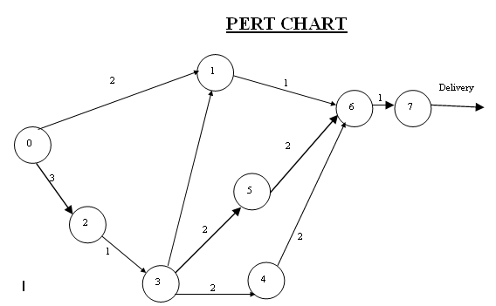
The list of tasks and events is networked in PERT chart in above figure. The arrow length is not significant, but the sequence and interconnections must give a true picture of the precedence of activities to be completed. The numbers on the activity lines are the time (in week) required between events.
Duration (in weeks) 2 + 3 + 1 + 2 + 2+ 2 + 2 + 1+1 = 16 weeks
The critical path is the longest path through the network. No. task on the critical path can be held up without delaying the start of the next tasks and, ultimately, the completion of the project. So the critical path determines the project completion date.

SOFTWARE REQUIREMENTS SPECIFICATION
SRS is software requirement specification it contains the s/w requirement details like what is front-end technology, backend technology, os and hardware architecture of the project.
SRS stands for Software Requirement Specification. It establishes the basis for agreement between customers and contractors or suppliers on what the software product is expected to do, as well as what it is not expected to do.
Some of the features of SRS are –
• It sets permits a rigorous assessment of requirements before design can begin.
• It sets the basis for software design, test, deployment, training etc. It also sets pre-requisite for a good design though it is not enough.
• It sets basis for software enhancement and maintenance.
• It sets Basis for Project plans like Scheduling and Estimation.
Thus, SRS should be consistent, correct, unambiguous & complete, document. The developer of the system can prepare SRS after detailed communication with the customer. An SRS clearly defines the following:
• External Interfaces of the system: They identify the information which is to flow ‘from and to’ to the system.
• Functional and non-functional requirements of the system. They stand for the finding of run time requirements.
• Design constraints:
The SRS outline is :
1. Introduction
1.1 Purpose
1.2 Scope
1.3 Definitions, acronyms, and abbreviations
1.4 References
1.5 Overview
2. Overall description
2.1 Product perspective
2.2 Product functions
2.3 User characteristics
2.4 Constraints
2.5 Assumptions and dependencies
3. Specific requirements
3.1 External Interfaces
3.2 Functional requirements
3.3 Performance requirements
3.4 Logical Database requirements
3.5 Design Constraints
3.6 Software system attributes
3.7 Organising the specific requirements
3.8 Additional Comments
4. Supporting information
2.1 Table of contents and index
2.2 Appendixes
The requirements gathering process is intensified and focused specifically on software. To understand the nature of the program(s) to be built, the software engineer (“analyst”) must understand the information domain for the software, as well as required function, behavior, performance, and interface. Requirements for both the system and the software are documented and reviewed with the customer.
DESIGN
Software design is actually a multi step process that focuses on four distinct attributes of a program data structure, software architecture, interface representations, and procedural (algorithmic) detail. The design process translates requirements into a representation of the software that can be accessed for quality before coding begins. Like requirements, the design is documented and becomes part of the software configuration.
Code Generation: -
The design must be translated into a machine-readable form. The code generation step performs this task. If design is performed in a detailed manner, code generation can be accomplished mechanistically.
Testing: -
Once code has been generated, program testing begins. The testing process focuses on the logical internals of the software, ensuring that all statements have been tested and on the functional externals, that is, conducting tests to uncover errors and ensure that defined input will product actual results that agree with required results.
Waterfall Model
It is the simplest, oldest and most widely used process model. In this model, each phase of the life cycle is completed before the start of a new phase. It is actually the first engineering approach of software development.
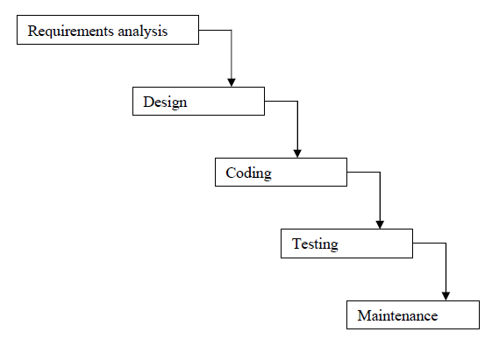
The waterfall model provides a systematic and sequential approach to software development and is better than the build and fix approach. But, in this model, complete requirements should be available at the time of commencement of the project, but in actual practice, the requirements keep on originating during different phases. The water fall model can accommodate the new requirements only in maintenance phase. Moreover, it does not incorporate any kind of risk assessment. In waterfall model, a working model of software is not available. Thus, there is no methods to judge the problems of software in between different phases.
A slight modification of the waterfall model is a model with feedback. Once software is developed and is operational, then the feedback to various phases may be given.

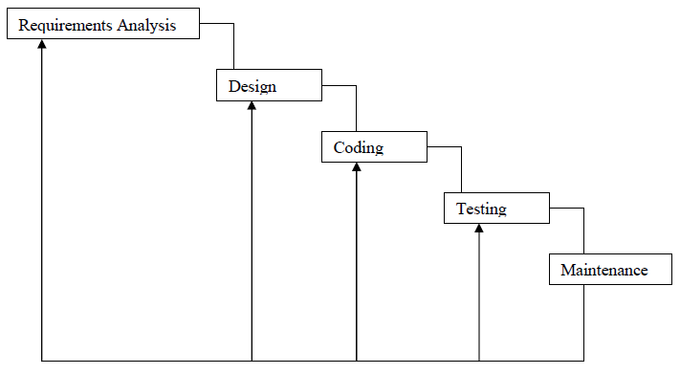

SOFTWARE ENGINEERING PARADIGM
Linear Sequential Model has been used in carrying out this project work. The Linear Sequential Model is the oldest and the most widely used paradigm for Software Engineering. Linear Sequential Model is called sometimes the Classic Life Cycle or the Waterfall Model.
The Linear Sequential Model suggests a systematic, Sequential approach to software development that begins at the system level and progresses through Analysis, Design, Coding, Testing and Support.
Linear Sequential Model contains the following activities:
System / Information Engineering and Modelling: -
Because software is always part of a larger system (or business), work begins by establishing requirements for all system elements and then allocating some subset of these requirements to software. This system view is essential when software must interact with other elements such as hardware, people and database. System engineering and analysis encompass requirements gathering at the system level with a small amount of top-level design and analysis. Information engineering encompasses requirements gathering at the strategic business level and at the business area level.
In this project, very first I get to know how the processing is done in the social network system. When I had accepted this project the purpose is to develop software that should assists to generate the report. The software will serve them as an automated system in performing all the operation of the Employee Management System.
Before starting this project or system there are some information’s needed, they are:
- First one is that understand about the working mechanism of The social site.
- Find out that which type of functionality should be adopted by the proposed project.
- Which type hardware and software platform will be most suitable for the proposed project?
As the proposal system was being maintained onto the form of paper based, literature relating to this system was available in the forms of various reports. Various documents were available to collect data about the shortcoming of the existing system. The system provides information that how the work is being done and how data are maintained which are useful for the user, what changes need to be made.
- Requirement specification
Problem clarifications in this case are much more difficult. In either case, before any further steps can be taken, the project requests must be clearly states.
This phase (initial study) involves estimating whether or not a development project is worthwhile. Problems with the current automated or manual system are identified, as well as the benefits and costs of an alternative system. If the benefits seem to outright the costs (especially when compared with competing projects), a green signal may be given to continue the project, and detailed plans and schedules are drafted for making the system a reality.
The proposed solution to the user’s problem may involve something between dramatic change (completely new system) and slight change to the present system. If the present system is manual and a computer system is proposed, the development project will probably be very large.

Project Modules

Module 1: Registration Module
In this module new Employee can submit his personal details regarding the user’s email id, password, contact no, date of birth etc.

Module 2: Login Module
In this module, Member enters a password and the software checks its validity. If the password is valid then he is allowed to enter, otherwise “Invalid User/Password” message is displayed. Different data access rights are assigned to different users. A new member can also be registered in this module.
Module 3: Registration Module
In this module admin can add new Employee details with his personal details regarding the user’s email id, password, contact no, date of birth etc. He can update and delete it also.
Module 4: Employees details Module
In this module admin can view employee details with his full discription.
Module 5: Leaves Type Module
In this module admin can view employee leaves type and response it. 6 Payroll calculation
Module 6: Payroll calculation Module
In this module admin can calculate payroll of employee according to his attandance .
Module 7: Add Task Module
In this module admin can assign task to employee so that he can do the work.

Module 8: Change Password Module
In this module, user can change password. But user has to login to first of all login into their account.

Module 9: Online Chat Module
In this module, user can chat with admin in every moment so that he can resolve his query .

Module 10: View Attandance
In this module, admin can view attendance of employee and then after he can make the salary

DATA FLOW DIAGRAM

The Data flow diagram can be explained as the separate levels indicating the individual complexity in the each level of the system and gives a detailed explanation in the further levels that are following them.
LEVEL 0
Initially in the first level of the Data flow the level 0 explains the basic outline of the system. The end-user sends the packets to the system to determine the source and destination address. The diagram marked as the 0 represents the complete Packet watching system which simply represents the basic operation that is being performed by it in the initial level.
LEVEL 1
The level 1 of the Data flow diagram given explains in detail about the Packet watching system which was marked as 0 in the previous level. In this level the end-user who passes the request for the system enters into the first process, the capturing process and then to the processing module. After processing the packets it was send for storing.
LEVEL 2
The level 2 provides the clear explanation about the whole system. In this level first we have to select the packet and perform test over that selected packets. Then identify the end address of the packet and send that packet for processing. After processing the packet it was send to the identity content. Then send the processed packet for storing and display the source and destination addresses.

Data Flow Diagram (Context level)

Context Level DFD

Employee

Employee Management System
REPORT
Administrator
Enters or update users data
Administrate the entire process
Generates the entire processes reports
Data Flow Diagram (Level-1)
1.0
Admin Module
2.0
Employee Module
3.0
Reports Module
Administrator
Info about Admin

Generate reports

Admin login
Employee Profile

Give permission

Employee details
Salary List
Chat System
Attandance Details
Second level DFD

2nd Level DFD for Admin Module
1.0
Admin Module
Admin login
Administrator

1.1
Data Entry of Employee

Employee

1.2
Update Employee

1.3
Salary

1.4
Attandance Details

Attandance

ER- Diagram

date
Address
Name
Total
id
NAME
Days
Message
ID
Net Total
id
Name

Employee Details

Salary

Online chat

Has
Join
create
message
Mess_id

send
message
Admin
ID

Login
Date
Status
EMP_login

Search

site
Attandance

login
Search Report
admin

CHEPTER-5

CODING

Code

/*
* To change this template, choose Tools | Templates
* and open the template in the editor.
*/

package connection;
import java.sql.ResultSet;
import java.sql.Connection;
import java.sql.PreparedStatement;
import java.sql.DriverManager;

/**
*
* @author Administrator
*/
public class Connect {
static Connection con = null;
PreparedStatement ps = null;
ResultSet rs = null;

public static Connection makeCon() {
try {
Class.forName("com.mysql.jdbc.Driver").newInstance();
con = DriverManager.getConnection("jdbc:mysql://localhost:3306/employeemanagementsystem", "root", "root");

} catch (Exception e) {
e.printStackTrace();
}
return con;
}

public static void CloseConnection() throws Exception {

if (con != null) {
con.close();
}

}

}

New Registration
<!DOCTYPE HTML>
<html>

<head>
<title>Employee Management System</title>
<meta name="description" content="website description" />
<meta name="keywords" content="website keywords, website keywords" />
<meta http-equiv="content-type" content="text/html; charset=windows-1252" />
<link rel="stylesheet" type="text/css" href="style/style.css" title="style" />
</head>
<script type="text/javascript">
function validatePassword(){
if(document.getElementById("pwd").value!=document.getElementById("cpwd")){
alert("Please enter correct confirm password !");
return false;
}
}
</script>
<script type="text/javascript">
function contact(i)
{
if(i.value.length>0)
{
i.value = i.value.replace(/[^\d]+/g, '');

}
}
function CheckForAlphabets(elem)
{
var alphaExp = /^[a-z A-Z]+$/;
if(elem.value.match(alphaExp)){
return true;
}else{
alert("give alphabatic name ");
return false;
}
}
function mob()
{
var rl=document.getElementById("number").value;
if(rl.toString().length<10)
{
alert("Contact No. should be of ten digits");
return false;
}

}
</script>
<script type="text/javascript">
function valid() {
//alert('calling');
var reg = /^([A-Za-z0-9_\-\.])+\@([A-Za-z0-9_\-\.])+\.([A-Za-z]{2,4})$/;
// var address = document.forms[form_id].elements[txtemail_id].value;
var address = document.getElementById('txtemail').value;
if(reg.test(address) == false) {
alert('Invalid Email Address');
return false;
}
}
</script>
<script type="text/javascript">

function pin()
{
var rl=document.getElementById("txtpwd").value;
if(rl.toString().length<6)
{
alert("Pin Number should be of Six digits");
return false;
}

}

</script>
<script type="text/javascript">
function validate12(){
if(document.getElementById('uname').value == "")
{
alert('Student Name Field Cannot be Blank Left !!');
return false;
}
if(document.getElementById('pwd').value == "")
{
alert('Password Field Name Field Cannot be Blank Left !!');
return false;
}
if(document.getElementById('txtImage').value == "")
{
alert('Image Field Name Field Cannot be Blank Left !!');
return false;
}
if(document.getElementById('txtname').value == "")
{
alert('First Name Field Cannot be Blank Left !!');
return false;
}
if(document.getElementById('txtlname').value == "")
{
alert('Student Last Name Field Cannot be Blank Left !!');
return false;
}
if(document.getElementById('cmbgender').value == "")
{
alert('Select Gender... !!');
return false;
}
if(document.getElementById('txtdb').value == "")
{
alert('Select Date of Birth.... !!');
return false;
}
if(document.getElementById('number').value == "")
{
alert('Contact Number Field Cannot be Blank Left !!');
return false;
}
if(document.getElementById('txtemail').value == "")
{
alert('Email Field Name Field Cannot be Blank Left !!');
return false;
}
if(document.getElementById('txtaddress').value == "")
{
alert('Address Name Field Cannot be Blank Left !!');
return false;
}
if(document.getElementById('cmbcity').value == "")
{
alert('City Name Field Cannot be Blank Left !!');
return false;
}
if(document.getElementById('txtpin').value == "")
{
alert('Pin Field Name Field Cannot be Blank Left !!');
return false;
}
if(document.getElementById('txtstate').value == "")
{
alert('State Name Field Cannot be Blank Left !!');
return false;
} if(document.getElementById('cmbcountry').value == "")
{
alert('Country Name Field Cannot be Blank Left !!');
return false;
}

}
</script>
<script type="text/javascript">

function validate1(){
if(document.getElementById("uname").value==""){
alert("Please enter passport No. name !");
return false;
}

if(document.getElementById("pwd").value==""){
alert("Please enter Date of Issue No. name !");
return false;
}

if(document.getElementById("cpwd").value==""){
alert("Please enter Place Of Issue !");
return false;
}

if(document.getElementById("txtname").value==""){
alert("Please enter Name!");
return false;
}
if(document.getElementById("txtid").value==""){
alert("Please select valid up to !");
return false;
}

}

</script>
<%

String userid = connection.Auto_Gen_ID.globalGenId("Citizen-", "citizen");
%>
<body>
<script src="scw.js" type="text/javascript"></script>
<div id="main">
<div id="header">
<div id="logo">
<div id="logo_text">
<!-- class="logo_colour", allows you to change the colour of the text -->
<h1><a href="index.html">Employee<span class="logo_colour">Management System</span></a></h1>
<h2>Employee Management System</h2>
</div>
</div>
<div id="menubar">
<%@include file="agent.html" %>
</div>
</div>
<div id="site_content">
<div class="sidebar">
<!-- insert your sidebar items here -->

</div>
<div id="content">
<!-- insert the page content here -->
<h1>Welcome to the New Employee Page </h1>
&nbsp;&nbsp;&nbsp;&nbsp;&nbsp;&nbsp;
<form action="citizen" method="post" enctype="multipart/form-data">
<table border="0" cellspacing="10" cellpadding="8" align="center">
<% String msg = (String) session.getAttribute("MSG");
if (msg != null) {
%>
<tr>
<td style="font-family: verdana;color: red;font-size: 10px" align="center" colspan="2"><%=msg%></td>
</tr>
<%
session.removeAttribute("Mess");
} else {
session.setAttribute("Mess", "");
}
%>
<tr>
<td>
<fieldset>
<legend class="tabHeading">Login Information</legend>
<table cellpadding="5" cellspacing="5">
<tr>
<td class="text"><span style="color: red;"></span>&nbsp;Employee&nbsp;Id:</td>
<td> <input type= "text" size="25" id="txthidden" name="txthidden" value="<%=userid%>"></td>
<td class="text"><span style="color: gray;">*</span> Employee&nbsp;Name:</td>
<td class="text-1"><input type="text" size="25" id="uname" name="uname"></td>

</tr>
<tr>
<td class="text"><span style="color: red;">*</span>Password&nbsp;:</td>
<td> <input type= "password" size="25" id="pwd" name="pwd"></td>
<td class="text"><span style="color: red;">*</span>Confirm&nbsp;Password&nbsp;:</td>
<td> <input type= "password" size="25" id="cpwd" name="cpwd"></td>

</tr>
<tr>
<td class="text"><span style="color: red;">*</span>Department&nbsp;:</td>
<td> <input type= "text" size="25" id="pwd1" name="pwd1"></td>
<td class="text"><span style="color: red;">*</span>&nbsp;Date&nbsp;Of&nbsp;Joining:</td>
<td> <input type= "text" size="25" id="cpwd1" name="cpwd1"></td>

</tr>
</table>
</fieldset>
</td>
</tr>
<tr>
<td>
<fieldset>
<legend class="tabHeading">Personal Information</legend>
<table cellpadding="5" cellspacing="5">

<tr>
<td class="text">
Add&nbsp;Profile&nbsp;Image
</td>
<td>
<input type="file" name="txtImage" id="txtImage"/>
</td>
</tr>
<tr>
<td class="text"><span style="color: red;">*</span>First&nbsp;Name:</td>
<td><input type="text" size="25" id="txtname" name="txtname" onblur=" CheckForAlphabets(this)" ></td>
<td class="text"><span style="color: red;">*</span>Last&nbsp;Name&nbsp;:</td>
<td> <input type= text size="25" id="txtlname" name="txtlname" onblur=" CheckForAlphabets(this)" ></td>
</tr>
<tr>
<td class="text"><span style="color: red;">*</span>
Gender
</td>
<td class="text">
<select id="cmbgender"name="cmbgender" style="width: 180px">
<option value="Select"> - - - - - - - - - Select- - - - - - - - - </option>
<option value="Male">Male</option>
<option value="Female">Female</option>
</select>
</td>
<td class="text"><span style="color: red;">*</span>Date&nbsp;of&nbsp;Birth</td>
<td> <input type= text size="25" name="txtdb" id="txtdb" readonly onclick="scwShow(this,event)" ></td>
</tr>
<tr>
<td class="text"><span style="color: red;">*</span>Contact&nbsp;Number:</td>
<td> <input type= text size="25" id="number" name="number" onkeyup="contact(this)" onblur="mob()"></td>
<td class="text"><span style="color: red;">*</span>Email&nbsp;Id:</td>
<td><input type="text" size="25" id="txtemail" name="txtemail" onblur="valid()"></td>
</tr>
<tr>
<td class="text">Address:</td>
<td><input type= text size="25" id="txtaddress" name="txtaddress"></td>

<td class="text">City:</td>
<td>
<select id="cmbcity" name="cmbcity" style="width: 180px;">
<option value="Select"> Select </option>
<option value="Delhi"> Delhi </option>
<option value="Gurgoan"> Gurgoan </option>
<option value="Noida"> Noida </option>
</select>
</td>
</tr>
<tr>
<td class="text">Pin&nbsp;Code:</td>
<td> <input type= text size="25" id="txtpin" name="txtpin" onkeyup="contact(this)" onblur="pin()"></td>
<td class="text">State:</td>
<td><input type= text size="25" id="txtstate" name="txtstate"></td>
</tr>
<tr>
<td class="text">Country:</td>
<td>
<select id="cmbcountry"name="cmbcountry" style="width:180px">
<option value="Select">- - - - Select - - - - </option>
<option value="America">America</option>
<option value="Australia">Australia</option>
<option value="Africa">Africa</option>
<option value="Bangalore">Bangalore</option>
<option value="Bangkok">Bangkok</option>
<option value="India">India</option>
</select>
</td>
</tr>
</table>
</fieldset>
</td>
</tr>

<tr>
<td align="center" colspan="2" >
<input type="submit" value="Submit" onclick="return validate12();"/>
<input type= "reset" value="Reset">
</td>
</tr>
</table>
</form>
</div>
</div>
<div id="content_footer"></div>
<div id="footer">
Copyright &copy;Employee Management System
</div>
</div>

</body>
</html>

Reservation.java
/*
* To change this template, choose Tools | Templates
* and open the template in the editor.
*/
package connection;

import java.io.IOException;
import java.io.PrintWriter;
import javax.servlet.ServletException;
import javax.servlet.http.HttpServlet;
import javax.servlet.http.HttpServletRequest;
import javax.servlet.http.HttpServletResponse;
import java.sql.Connection;
import java.sql.ResultSet;
import java.sql.PreparedStatement;
import javax.servlet.http.HttpSession;

/**
*
* @author Surendra
*/
public class Reservation extends HttpServlet {

Connection con = null;
ResultSet rs = null;
PreparedStatement ps = null;
Connection con1 = null;
ResultSet rst1 = null;
PreparedStatement pst1 = null;

@Override
protected void doPost(HttpServletRequest request, HttpServletResponse response)
throws ServletException, IOException {

response.setContentType("text/html;charset=UTF-8");
HttpSession session = request.getSession(true);
PrintWriter out = response.getWriter();

String id = request.getParameter("txtid");
String name = request.getParameter("txtname");
String source = request.getParameter("cmbs");
String dis = request.getParameter("cmbd");
String fair = request.getParameter("txttotal");
String doj = request.getParameter("txtdb");
String ticket = request.getParameter("txttic");
String total = request.getParameter("txtfare");
String user = request.getParameter("txtuser");
String age = request.getParameter("txtage");
String gender = request.getParameter("cmbgender");
String mob = request.getParameter("txtmob");
String address = request.getParameter("address");

if (id != null) {

try {

con = connection.Connect.makeCon();

String SqlQuery = "insert into reservation(id,name,source,distination,fair,doj,ticket,total,user,age,gender,mob,address) values(?,?,?,?,?,?,?,?,?,?,?,?,?)";
ps = con.prepareStatement(SqlQuery);
ps.setString(1, id);
ps.setString(2, name);
ps.setString(3, source);
ps.setString(4, dis);
ps.setString(5, fair);
ps.setString(6, doj);
ps.setString(7, ticket);
ps.setString(8, total);
ps.setString(9, user);
ps.setString(10, age);
ps.setString(11, gender);
ps.setString(12, mob);
ps.setString(13, address);
int i = ps.executeUpdate();
if (i > 0) {
connection.Auto_Gen_ID.updateAutoID("tic", id);

response.sendRedirect("Reservation.jsp");
} else {

response.sendRedirect("Reservation.jsp");
}

} catch (Exception e) {
e.printStackTrace();
}
}
}
}

EMPLOYEE.JAVA
/*
* To change this template, choose Tools | Templates
* and open the template in the editor.
*/
package connection;

import java.io.IOException;
import java.io.PrintWriter;
import javax.servlet.ServletException;
import javax.servlet.http.HttpServlet;
import javax.servlet.http.HttpServletRequest;
import javax.servlet.http.HttpServletResponse;
import javax.servlet.http.HttpSession;
import java.util.*;
import java.io.*;
import org.apache.commons.fileupload.*;
import org.apache.commons.fileupload.servlet.*;
import org.apache.commons.fileupload.disk.DiskFileItemFactory;
import java.sql.Connection;
import java.sql.PreparedStatement;
import java.sql.ResultSet;
import javax.servlet.ServletConfig;

/**
*
* @author softavate
*/
public class SignUp extends HttpServlet {

Connection con = null;
PreparedStatement ps = null;
ResultSet rs = null;
String pname = null;
String pname1 = null;
String userid = null;
String uname = null;
String password = null;
String fname = null;
String lname = null;
String gender = null;
String dob = null;
String contactNo = null;
String emailid = null;
String address = null;
String city = null;
String pincode = null;
String state = null;
String country = null;
String fullImagepath = null;
HttpSession session = null;

@Override
protected void doPost(HttpServletRequest request, HttpServletResponse response)
throws ServletException, IOException {
//String size1 = request.getParameter("txtsiz");

PrintWriter out = response.getWriter();
int i = 0;
response.setContentType("text/html");
ServletConfig config = getServletConfig();
String context = config.getServletContext().getRealPath("/");
String imagePath = context + "UploadedImage";
boolean status = false;
String fullfilename = null;
java.util.Date d = new java.util.Date();
long timestamp = d.getTime();
try {
File projectDir = new File("imagePath");
if (!projectDir.exists()) {
projectDir.mkdirs();

}
} catch (Exception e) {
e.printStackTrace();
}
boolean isMultipart = ServletFileUpload.isMultipartContent(new ServletRequestContext(request));
if (isMultipart) {
FileItemFactory factory = new DiskFileItemFactory();
ServletFileUpload upload = new ServletFileUpload(factory);
try {
List/*FileItem*/ items = upload.parseRequest(request);
Iterator iter = items.iterator();
while (iter.hasNext()) {
FileItem item = (FileItem) iter.next();
if (item.isFormField()) {
if (item.getFieldName().equalsIgnoreCase("txthidden")) {
userid = item.getString();
//System.out.println("user name : " + uname);
}
if (item.getFieldName().equalsIgnoreCase("uname")) {
uname = item.getString();
//System.out.println("user name : " + uname);
}
if (item.getFieldName().equalsIgnoreCase("pwd")) {
password = item.getString();
//System.out.println("user name : " + uname);
}
if (item.getFieldName().equalsIgnoreCase("txtname")) {
fname = item.getString();
//System.out.println("user name : " + uname);
}
if (item.getFieldName().equalsIgnoreCase("txtlname")) {
lname = item.getString();
//System.out.println("user name : " + uname);
}
if (item.getFieldName().equalsIgnoreCase("cmbgender")) {
gender = item.getString();
//System.out.println("user name : " + uname);
}
if (item.getFieldName().equalsIgnoreCase("txtdb")) {
dob = item.getString();
//System.out.println("user name : " + uname);
}
if (item.getFieldName().equalsIgnoreCase("number")) {
contactNo = item.getString();
//System.out.println("user name : " + uname);
}
if (item.getFieldName().equalsIgnoreCase("txtemail")) {
emailid = item.getString();
//System.out.println("user name : " + uname);
}
if (item.getFieldName().equalsIgnoreCase("txtaddress")) {
address = item.getString();
//System.out.println("user name : " + uname);
}
if (item.getFieldName().equalsIgnoreCase("cmbcity")) {
city = item.getString();
//System.out.println("user name : " + uname);
}
if (item.getFieldName().equalsIgnoreCase("txtpin")) {
pincode = item.getString();
//System.out.println("user name : " + uname);
}
if (item.getFieldName().equalsIgnoreCase("txtstate")) {
state = item.getString();
//System.out.println("user name : " + uname);
}
if (item.getFieldName().equalsIgnoreCase("cmbcountry")) {
country = item.getString();
//System.out.println("user name : " + uname);
}
} else {
fullfilename = "UserImage" + "_" + timestamp;
System.out.println("fullfilename : " + fullfilename);
if (item.getFieldName().equalsIgnoreCase("txtImage")) {
String filename = item.getName();
if (!filename.equalsIgnoreCase("")) {
pname = filename.substring(filename.lastIndexOf("."), filename.length());
pname1 = imagePath + File.separator + fullfilename + pname;
fullImagepath = fullfilename + pname;
File file3 = new File(pname1);
try {
item.write(file3);
status = true;
} catch (Exception e1) {
e1.printStackTrace();
status = false;
}
}
}
}
}
} catch (Exception e) {
e.printStackTrace();
status = false;
}
}
String msg = null;
if (status == true) {
try {
Connection con2 = connection.Connect.makeCon();
PreparedStatement pst = null;
String sqlquery = "insert into signup(UserID,Image,uname,pass,FirstName,LastName,Gender,DOB,ContactNo,EmailID,Address,City,PinCode,State,Country)values(?,?,?,?,?,?,?,?,?,?,?,?,?,?,?)";
System.out.println(" sql query : " + sqlquery);
pst = con2.prepareStatement(sqlquery);
pst.setString(1, userid);
pst.setString(2, fullImagepath);
pst.setString(3, uname);
pst.setString(4, password);
pst.setString(5, fname);
pst.setString(6, lname);
pst.setString(7, gender);
pst.setString(8, dob);
pst.setString(9, contactNo);
pst.setString(10, emailid);
pst.setString(11, address);
pst.setString(12, city);
pst.setString(13, pincode);
pst.setString(14, state);
pst.setString(15, country);
i = pst.executeUpdate();
} catch (Exception e) {
e.printStackTrace();
}
if (i > 0) {
connection.Auto_Gen_ID.updateAutoID("stu", userid);
msg = "Successfully Registered";
session = request.getSession(true);
session.setAttribute("MSG", msg);
response.sendRedirect("SignUp.jsp");
} else {
msg = "Not Registered";
session = request.getSession(true);
session.setAttribute("MSG", msg);
response.sendRedirect("SignUp.JSP");
}
}
if (status == false) {
msg = "Not Registered";
session = request.getSession(true);
session.setAttribute("MSG", msg);
response.sendRedirect("SignUp.jsp");
}
}
}

CHEPTER-7

TESTING

TESTING
The testing of software means measuring or accessing the software to determine the quality. Testing is a measuring instrument for software quality with the unit of measurement being the number of defects found during testing.
Testing activities also help to achieve software quality. Testing is essential in the development of any system software. Testing is essential in the development of any software system. Testing is in order to access what the system actually does and how well expected to spend approximately40% of development cost and time in testing in order to achieve reasonable quality levels.

Levels of Testing
- Unit Testing
- Component Integration Testing
- System Testing
- Acceptance Testing
Unit Testing
Unit testing comprises the set of tests performed usually by the programmers prior to the integration of the unit in to a large Program. This is the lowest level of testing and is done by the programmer (Who develops it) who can test it in great detail. The function is done in isolation. This is where the most detailed investigation of internal working of the individual unit is carried out.

Component Integration Testing

When two or more tested components are combined into a larger structure, the testing process should look for errors in two ways:-
- In the interface between the components
- The functions, which can be performed by the new group
System Testing
After in integration testing is completed, the entire system is tested as whole. The functional specifications or requirements specification are used to derive the test case. At this level the system testing looks for errors in the end-to-end functional quality. Attributes such as performance, reliability,
Volume, stress tolerance, usability, maintainability, security etc. Independent testers can carry out this testing.
Acceptance Testing
After system testing was complete, the system was handed over to the training section. Acceptance testing mark the transaction from ownership by the develop to ownership by the users. The acceptance test is different in nature to the development testing in three ways.
Firstly, it is a responsibility of the accepting section rather than development department (computer Centre).
Secondly, the purpose of the acceptance testing was to find out whether the software is working rather than trying to find errors.
Thirdly, it also includes the testing of user’s department’s working practices to ensure that the computer software will fit into clerical & administrative procedures of the concerned section well.
Acceptance testing gave confidence to the user that the system is ready for operational use.

Security concern of computer where software is to be installed:
- Use of name-brand hardware with extensive fault-tolerance. Fault-tolerance features can keep the computer from going down even if a single piece of hardware inside of it fails.
- Hardware and software maintenance.
- Facility security, network security, and firewall services.
- Guaranteed service level agreement. Remember to insist on the highest level of service available – 99% availability might seem great, but it means that our computer might be down for than three days a year.
- Battery and generator power.
- Backup devices like tap drive/zip drive or cd writer should install. User should keep backup of database every day so that it could save data during crisis time
Protecting the database
To secure the database, the following steps are taken:-
- The server logged off and physically locked up when it has not use.
- The database must be not shared on network. If it is shared then change the properties.
- The database on oracle provides fine-grained permission mechanism that allows protecting particular database tables and columns. The table and column must be the restricted to administrator of database so that it is not update by the any one.
- Using NTFS (NT file system) security to further access to the database, it is used by using ntfs permission dialog to further protect sensitive information.

Testing objectives
- No bugs blocks the execution of tasks
- System states are visible
- All factors affecting the output are visible
- Functional simplicity
- Distinct output is generated for each input

Debugging
Debugging occurs as a consequence of successful testing. Debugging refers to the process of identifying the cause for defective behavior of a system and addressive that problem. In less complex terms- fixing a bug. When a test case uncovers an
Error, debugging is the process that results in the removal of the error. The debugging process begins with the execution of a test case. The debugging process attempts to match symptoms with cause, thereby leading to error correction. The following are two alternative outcomes of the debugging:
- the cause will be found and necessary action such as correction or removal will be taken.
- The cause will not be found.
Characteristics of bugs
- The symptoms ant the cause may be geographically remote. That is, the symptoms may appear in one part of a program. While the cause may actually be located at a site that is far removed. Highly coupled program structures exacerbate this situation.
- The symptoms may disappear (temporarly) when another error is connected.
- the Symptom may actually be caused by non error(e.g, round-Off inaccuracies).
- The symptoms may be caused by human error that is not easily traced.
- The symptom may be a result of timing problems, rather than processing problems.
- It may be difficult to accurately reproduce input conditions(e.g, a real-time application in which input ordering is indeterminate).
- The symptom may be intermittent. This is particularly common in embedded systems that couple hardware and software inextricably.
- The symptoms may be due to causes that are distributed across a number of tasks running on different processors.

Validation Checks
There are six types of validations:
- Intrinsic control: In this control text Box, label, drop down list are use for simple input and output.
- Rich control: Rich control have a two control `Add Repeater` and ‘Calendar Control’.
- Transfer Control: This control used to redirect pages to next page like, Buttton, Hyperlink, linkButtons.
- Validation control: There are six control:-
  - Required Filled Validator:- this control are using for check the requirement is fulfill or not.
  - Compare Validator:- This control are used for comparing two values with help of controlToValidate and CompareToValidate.
The Type are taken in compare Validator are following:-
- String
- Integer
- Double
- Date
- Currency
Operator is used to specify a type are following:-
- Equal
- No Equal
- Greater Than
- Greater than equal
- Less than
- Less than equal
- RangeValidator:- the range validator is used to check if the value of control lies within a range. The Range can be specified with the help of two control
- Min
- Max
- RegularExpressionValidator:- a pre specified format can excepted only if they form a part of a particular pattern, this usually occurs in Phone no., credit card number or E-mail
Address from user. The phone no. should be numeric. This is made possible by regular Expression Validator Control. The pattern to which the value must specified in validationExpression property. The value can be checked agains mini Pattern or expressions by separating each expressions with a pipe Sign and enclosed expression in round bracket.

- CustomValidator:- custom validator control can be used to provide validator in case all validator control are not enough to validate the input.
- Validation Summary:- validation error message on the Web page can be display in two way. The errors can either be displayed as when the user line the control or summary of error can be display together. This control can be use to produce such as summery. The error can be view in the form of list bullet by setting display made.
CODE EFFICIENCY
MEASURES OF CODE EFFICIENCY
The code is designed with the following characteristics in mind.
- Uniqueness: The code structure must ensure that only one value of the code with a single meaning is correctly applied to a give entity or attribute.
- Expandability: The code structure are designed for in a way that it must allow for growth of it’s set of entities or attributes, thus providing sufficient space for the entry of new items with in each classification.
- Conciseness: The code requires the fewest possible number of positions to include and define each item.
- Uniform size and format: Uniform size and format is highly desirable in mechanized data processing system. The addition of prefixes and suffixes to the root code should not be allowed especially as it is incompatible with the uniqueness requirement.
- Simplicity: The codes are designed in a simple manner to understand and simple to apply.
- Versatility: The code allows modifying easily to reflect necessary changes in conditions, characteristics and relationship of the encoded entities. Such changes must result in a corresponding change in the code or coding structure.
- Sortability: Reports are most valuable for user efficiency when sorted and presented in a predetermined format or order. Although data must be sorted and collaged, the representative code for the date does not need to be in a sortable form if it can be correlated with another code that is sortable.
- Stability: Codes that do not require to be frequently updated also promote use efficiency. Individual code assignments for a given entity should be made with a minimal likelihood of change either in the specific code or in the entire coding structure.
- Meaningfulness: Code is meaningful. Code value should reflect the characteristics of the coded entities, such as mnemonic features unless such a procedures results in inconsistency and inflexibility.

OPTIMIZATION OF CODE
A good program is not the one that solves the intended problem alone but the one that does it efficiently. An ideal compiler should produce target code that is as good as can be written by hand crafted meticulously to run on the target machine in the most efficient manner both in terms of time of execution and memory requirements. The reality however is that this goal is achieved only in limited, cases and that too with difficulty. Nonetheless, the code produced by straight forward compiling algorithms can often be made more space and time efficient. This is accomplished by applying transformations on the produced code. These transformations aiming at optimization of compiled code are known as code optimization and compilers that apply code improving transformations are called optimizing compilers.
The optimization may be machine dependent or machine independent. A machine independent optimization is a set of program transformations that improve the target code without taking into consideration any properties of the target machine. Machine dependent optimizations, such as register allocation and utilization of special machine instruction sequences, on the other hand, depend on the target machine.
The overall performance of a program can be effectively improved if we can identify the frequently executed parts of a program and then make these parts as efficient as much as possible. According to Pareto principle, most programs spend ninety per cent of their execution time in ten percent of the code. While the actual percentages may vary, it is often the case that a small fraction of a program accounts for most of the running time. Profiling the run-time execution of a program on representative input data accurately identifies the heavily traveled regions of a program. Unfortunately, a compiler does not have the benefit of sample input data, so it must make best guess as to where the program hot spots are.
In practice, the program's inner loops are good candidates for improvement. In a language that emphasizes control constructs like while and for statements, the loops may be evident from the syntax of the program; in general, a process called contra/flow analysis identifies loops in the flow graph of a program.
The best technique for deciding what transformations are worthwhile to put into a compiler is to collect statistics about the source programs and evaluate the benefit of a given set of optimizations on a representative sample of real source programs

CHEPTER-8
Input and Output Screens
Home Page

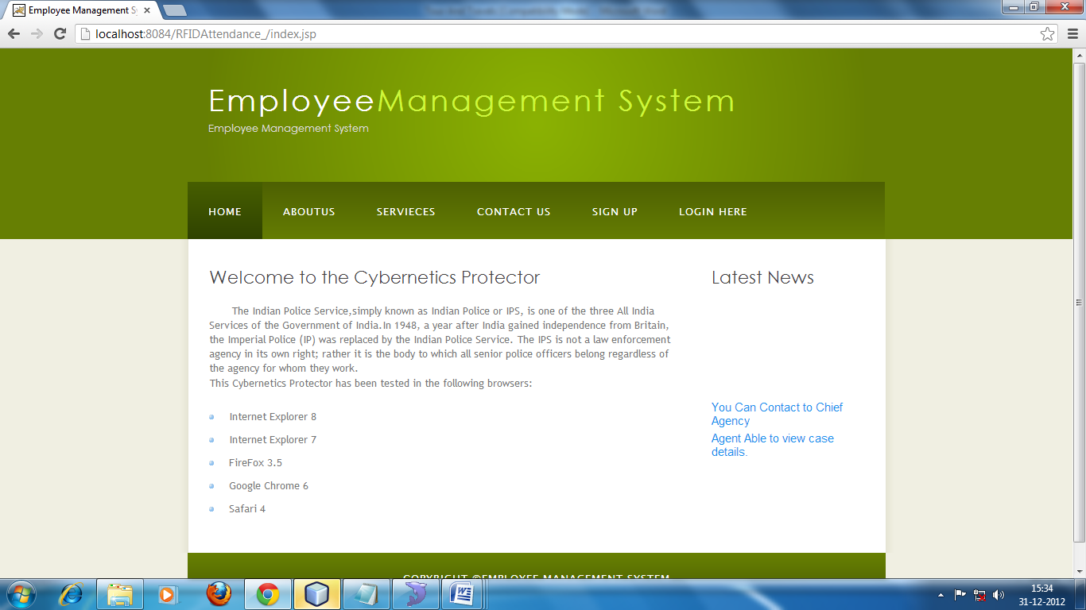

About us
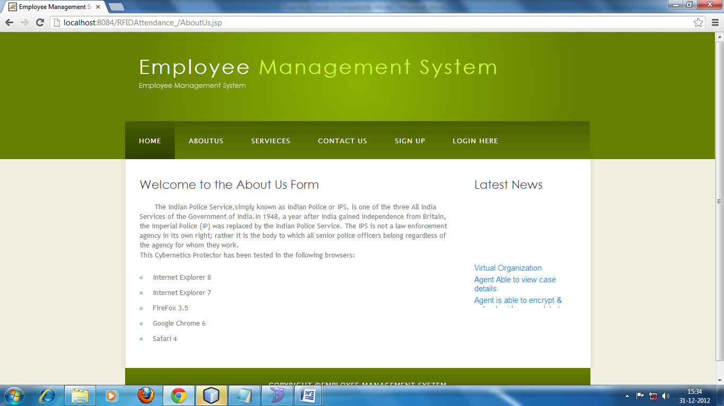

Login
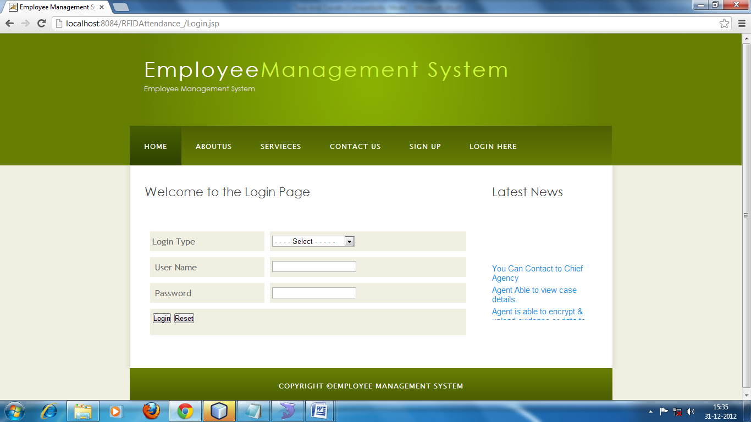

Employee Registration
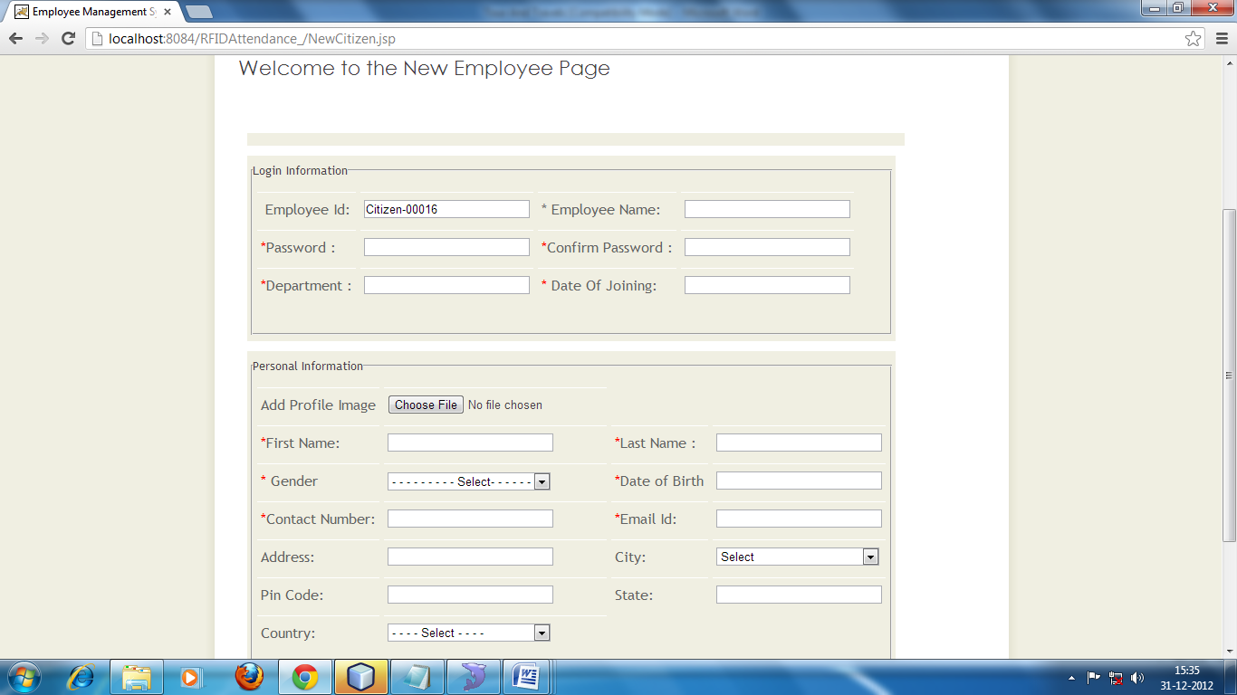

Admin home page
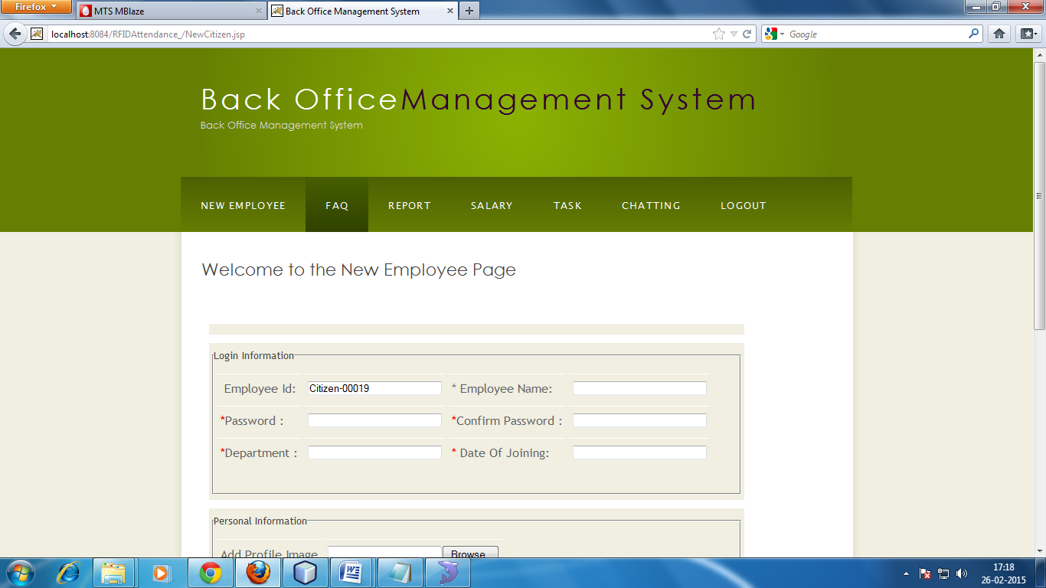

Faq
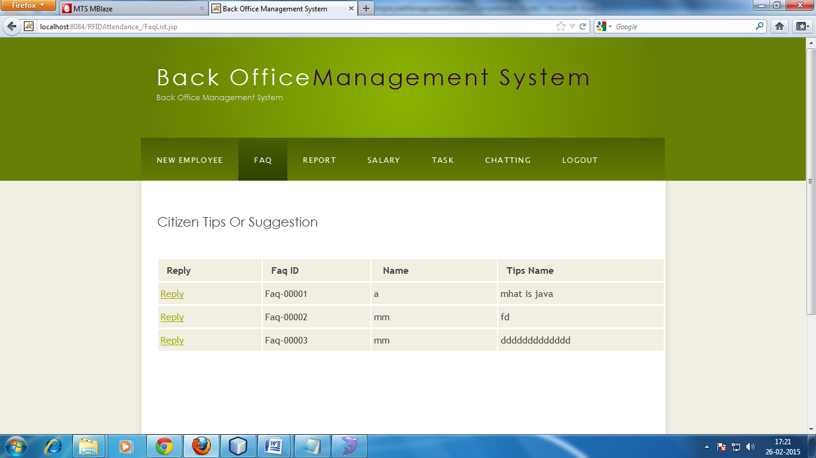

Salary
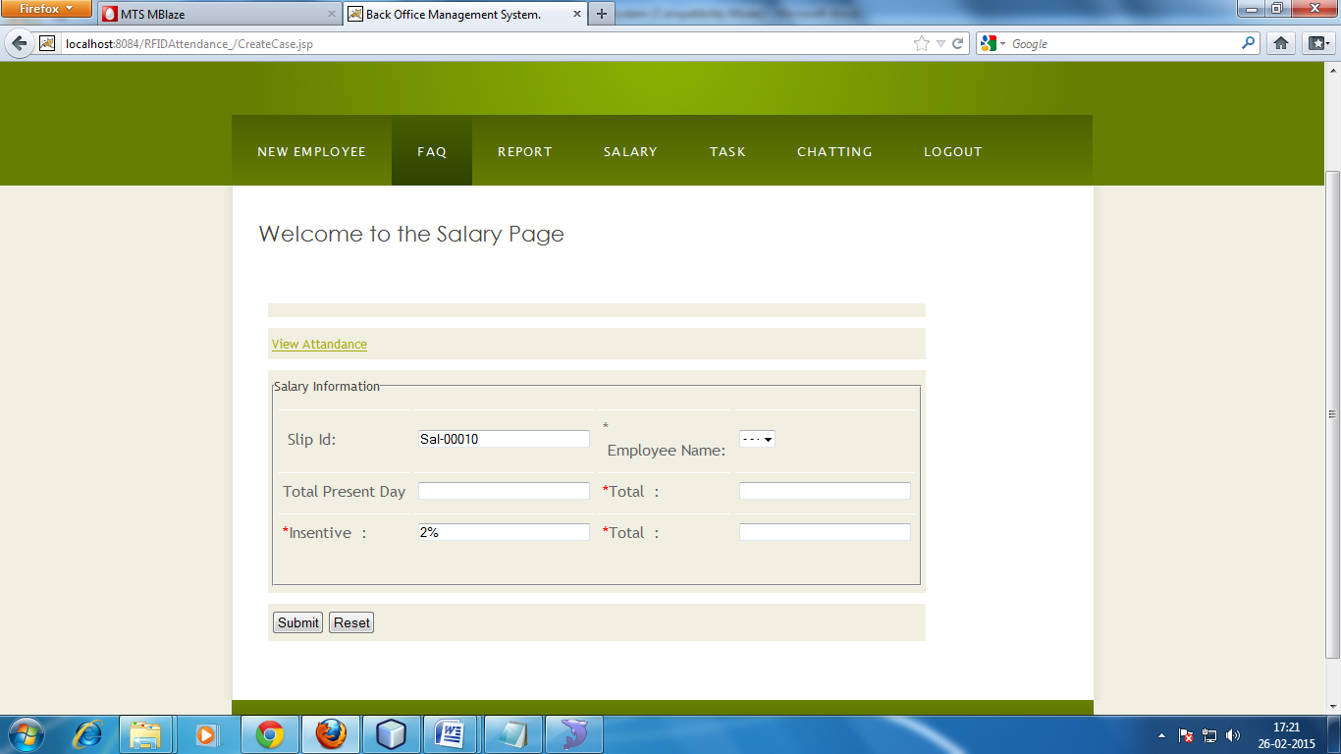

Task
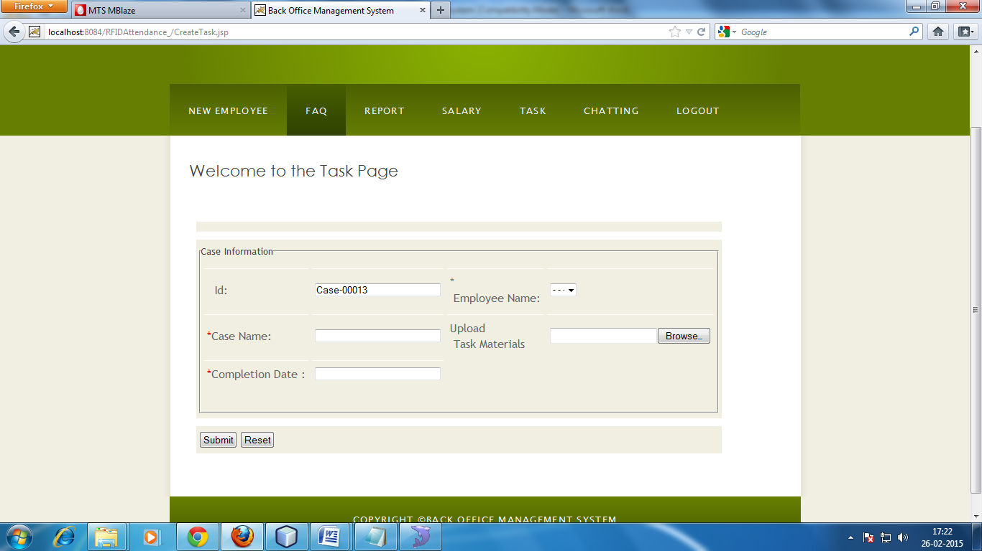

Chat system
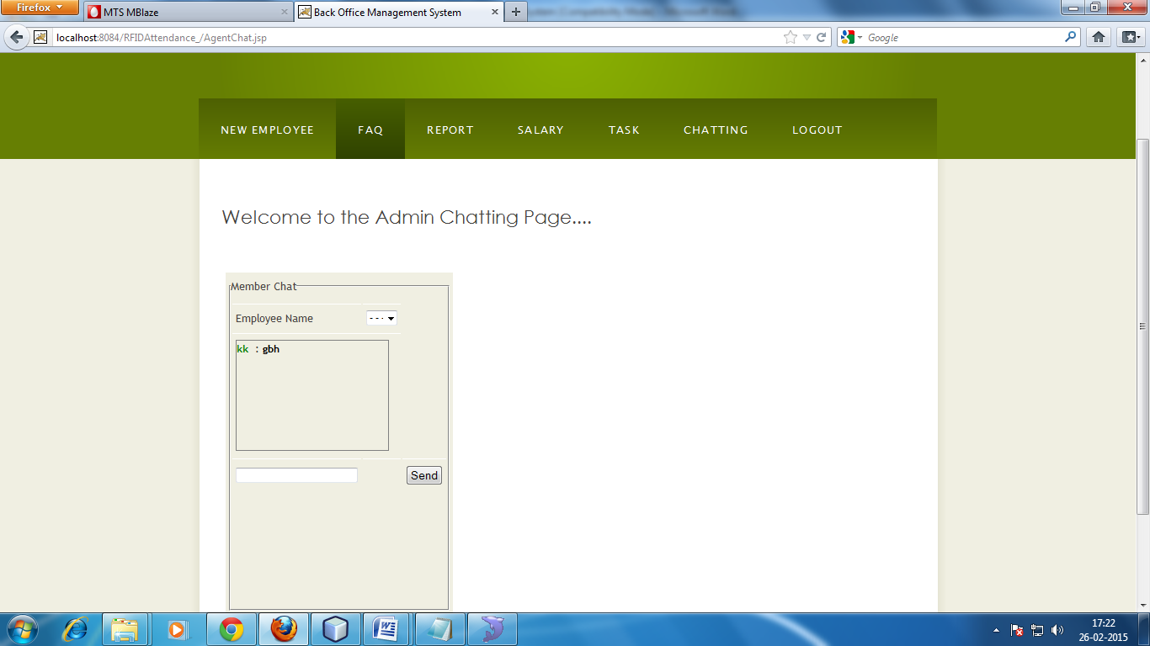

View attandance
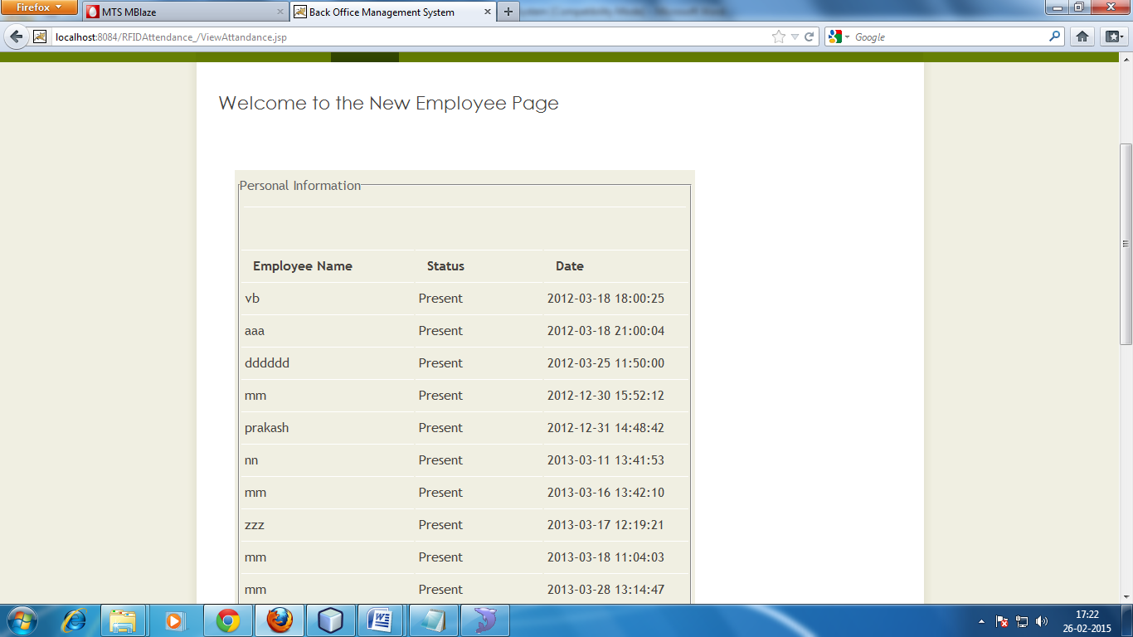

View task
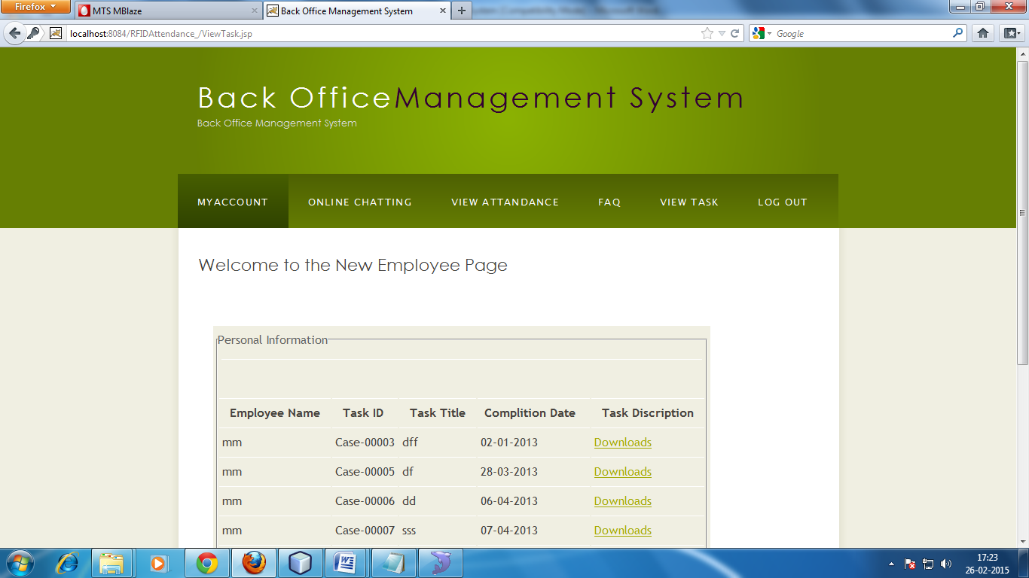

CHEPTER-9
Implementation of Security
for the Software developed

SYSTEM SECURITY MEASURES
To do an adequate job on security, a systems analyst must analyze the risk, exposure, and costs and specify measures such as passwords and encryption to provide protection. The backup copies of software and recovery restart procedures must be available when needed.

SECURITY AGAINST UNAUTHORIZED ACCESS:

(1) Use of administrator passwords: The password provides security to the administrator of Associates user so that unauthorized user can not access the facility of Associates User.
(2) User related checks and validations: For this
software, The developer uses user related checks and
validations from the user.

(3) User authorization keys: Password checking for logging

of Users.

SECURITY AGAINST DATA LOSS:
- Provision of efficient data backup system : In this software an efficient system is used for adequate backup facility .

- Offline data storage : this system is capable for offline data Storage.

- Multiple database backup : the efficient system is use for this Software to give multiple data backup.

User Level:
User are does not change Health, Transport Information. Its only View Information and it’s allowed after fill own profile and then insert username and password. User is sending Matrimonial information view any other user by allow administrator.

Administrator Level:
Administrator is able to change Health, Transport Information. Administrator is allowing matrimonial information any Change. And also allow user view bride picture and groom picture information.

CHAPTER-9
Future Application of the Project

FUTURE SCOPE OF THE APPLICATION
The Employee Management System is for the manage process can be further developed into a separate, automated system with the following enhancements:
- Help file can be included. The system, as of now, does not support any help facility for the users of the system. A help menu can be provided with a special function key and help command in the main page itself. Help can be either introduced as a separate window, a reference to a printed manual or as one or two line suggestion produced in a fixed screen location.
- The system can use typed commands, as they were once the most common mode of communication with the system. The typed command can be provided through control sequence or function keys or typed word.
- A training module can be included in the system. This module can be used to train the users of the system about the systems usage.

CONCLUSION

There was a lot of fun in making this project. This project was very useful to us as it provided us the inside view of the planning and implementation of the data base. In this project we had to think about the various options which we can provide to user. The implementation was not easy as we had to look into the minute details in order to achieve my goals. We have tried to make this project user friendly and also interactive by providing many features.
We are satisfied by achieving the goals for which we had planned. A lot of experimental work can be done with this project. Looking forward for any advice which can help us to improve the project.

The result of the EMPLOYEE MANAGEMENT SYSTEM is that it supports many type of different-different tour and the individual Employee with unique interface, through which the employee management problems are solved within given time and it shows efficiency in the internal messaging system and results in accurate task scheduling system and this can be run with the minimal administration.

In future, we can have the SMS facility for the employees and employee search engine that can provide the result on the basis of different criteria to search. We can also have one more module of implementing this project on web.

CHAPTER-11
Bibliography

- Software Engineering, A Practitioner’s Approach, Pressman McGraw Hill.
- An Introduction To Database Systems by Bipin C Desai
- Object-Oriented Modelling and Design by James Rambagh
- Microsoft SQL Server by NIIT
- Java Complete Reference by Patrick Naughton, Herbert Schildt
- Jdbc Database Access With Java By Graham Amelton

