**Docker**

# Deploying a containerized

## Warp speed run-though

Application=> docker package => registry => run it as a container

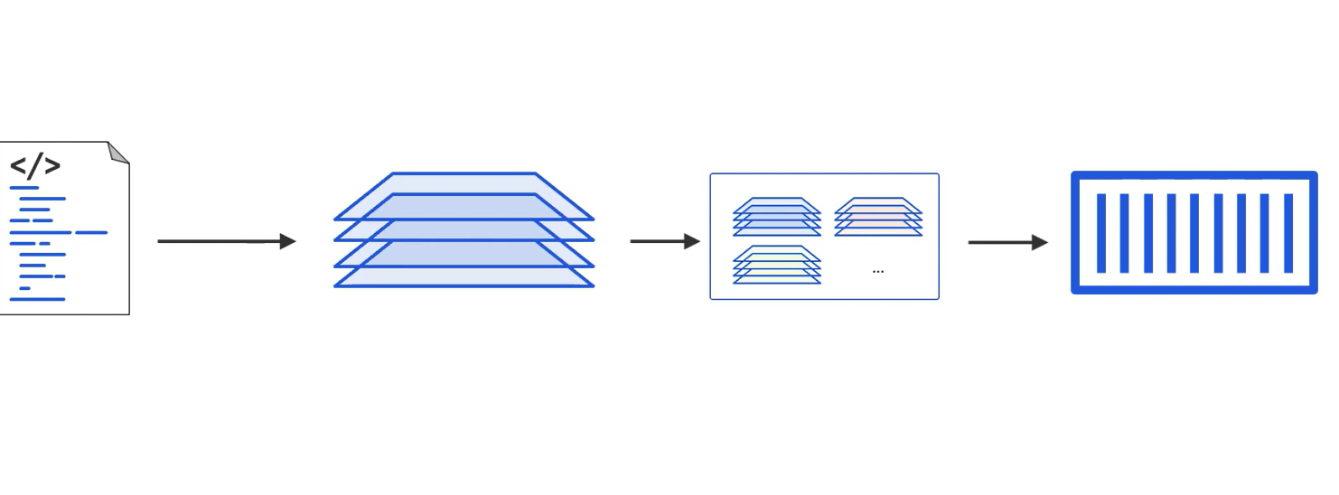

Docker image build => build and download dependencises

Docker image ls => to list all the image

Docker image push yald/gsd:ctr => registry to docker hub

Docker container run -d –name web -p 8080:8080 yald/gsd:ctr

Docker container ls => container

## Containerinzing and App

Dockerfile :

* FROM: node:current-alpine ( node image on docker)
* Label
* RUN mkdir -p /usr/src/app create directory in container image for app code
* COPY . /usr/src/app copy app code to /usr/src/app
* WORKDIR

## Hosting on a registry

## Running a containerized App

Docker image rm yald/gsd:first-ctr

## docker run -d -p 8000:8080 --name web yald/gsd:first-ctr

## Managing a Containerized App

Docker container stop web

Docker container start web

Docker container rm

Docker container run -it –name test alpine sh

# MicroSercice and the Real World

# Cloud nadive microservices

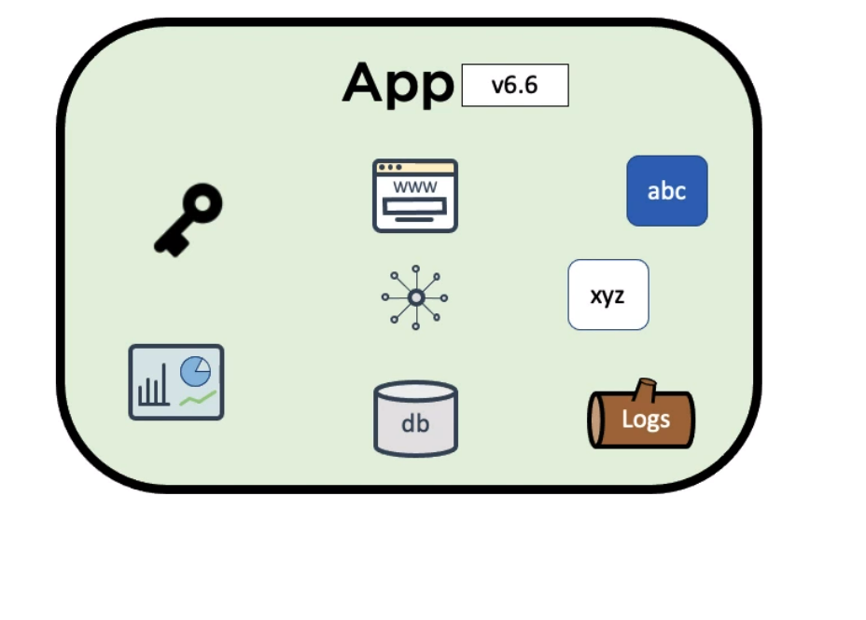 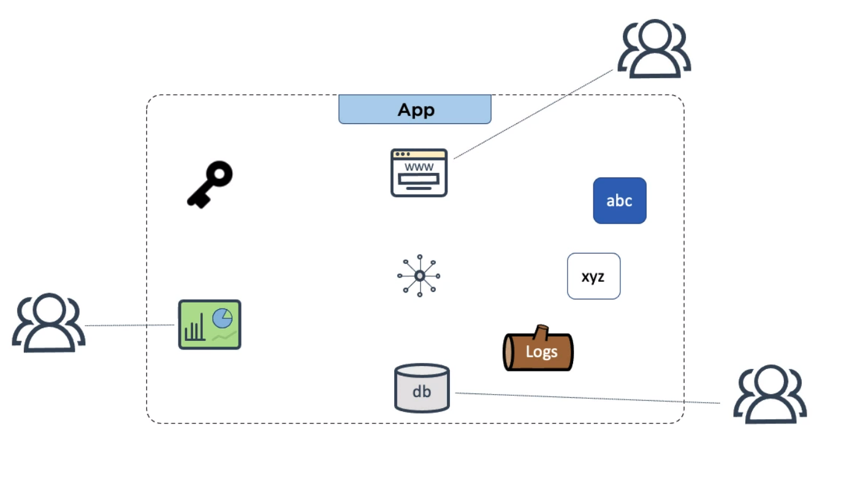

## Multi container apps with docker compose

## Docker swarm

Run multiservice in a secure environment   
Swarm is cluster of manger node and woker nodes

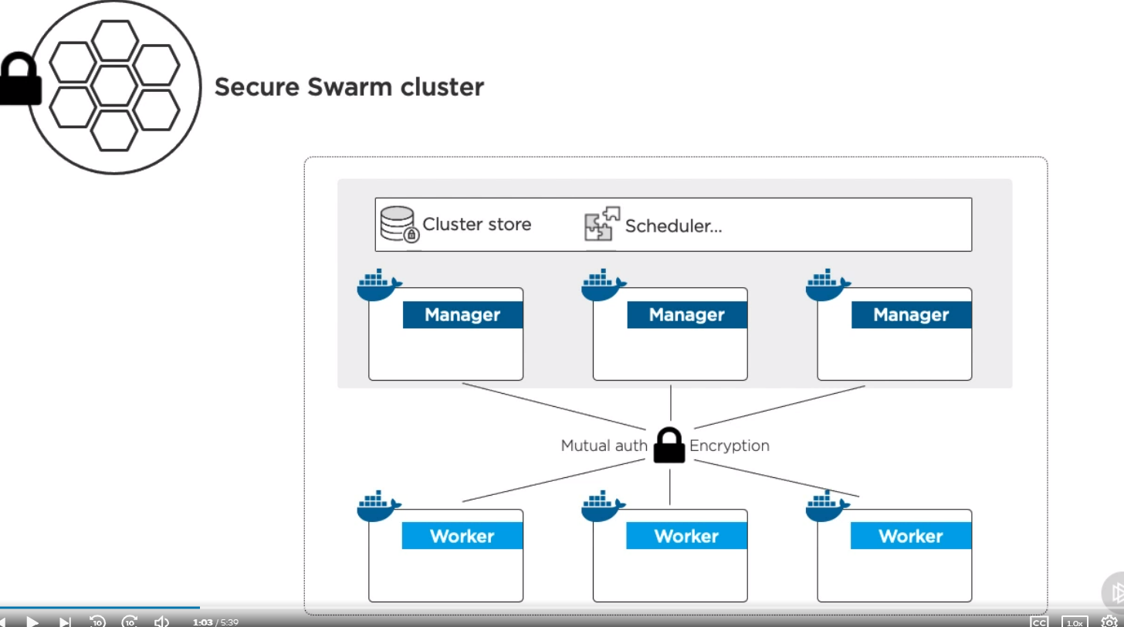

## Docker services

## Multi container App with Docker stacks