**Prometheus :**

Monitoring to tracks metrics and take action before thing go really bad

Fonctrion :

Fecthing metrics from differents device (every minute)

Put metrics in the database (add timestamp when feetchinh metric)

API, for the ui, run query

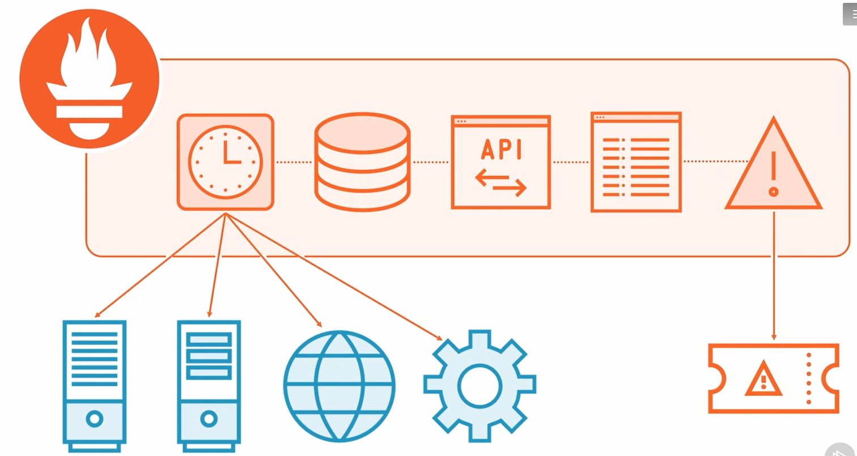

**What makes prometheurs so awesome :**

Provide metrics on https end point , Prometheus fetch data from that end point, so the process of collecting is the same for all of them   
Have:

* Client librairies to fetch data
* Exporter

Running and Configure Prometheus

Configure through YAML file

