Data Validation Report
Enterprise Human Capital Management Data Platform (EHCMDP)
Database: EHCMDP_PostgreSQL | Validation layer: Staging and Warehouse

1. Purpose and Scope
This report records the data-quality and referential-integrity checks confirmed during development of the EHCMDP PostgreSQL warehouse and Power BI star schema. It uses the latest validation results available from the project work. It is not a live database-generated report; rerun the supplied SQL validation script to refresh results before final submission.

2. Validation Output – PostgreSQL
Staging Row Count Report
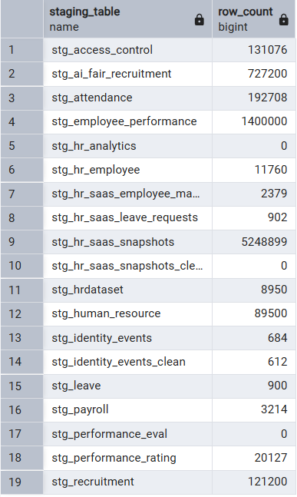

Warehouse row-count Report
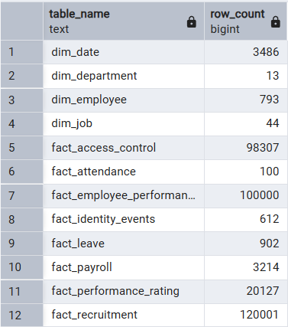
Warehouse validation summary
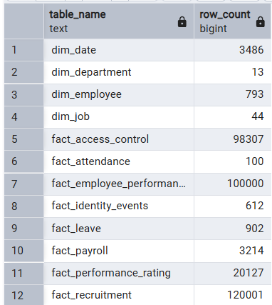
Key Validation Results
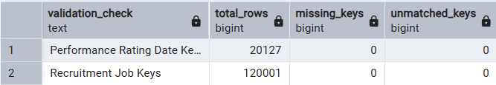

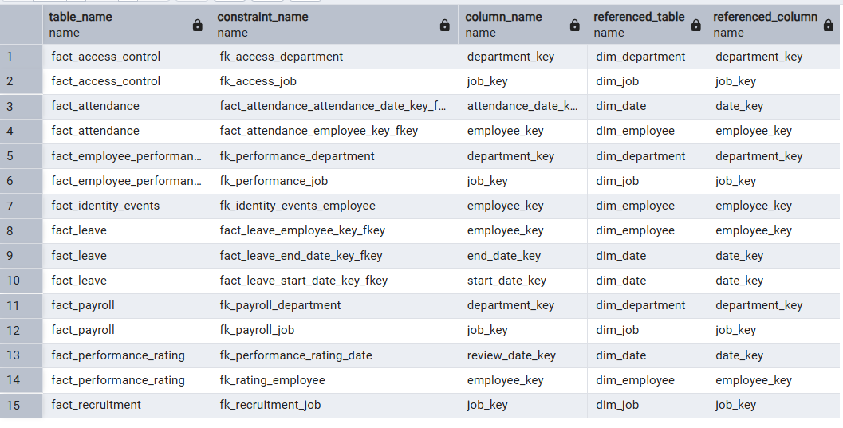
Foreign-key Relationships

Foreign Key Orphan Check
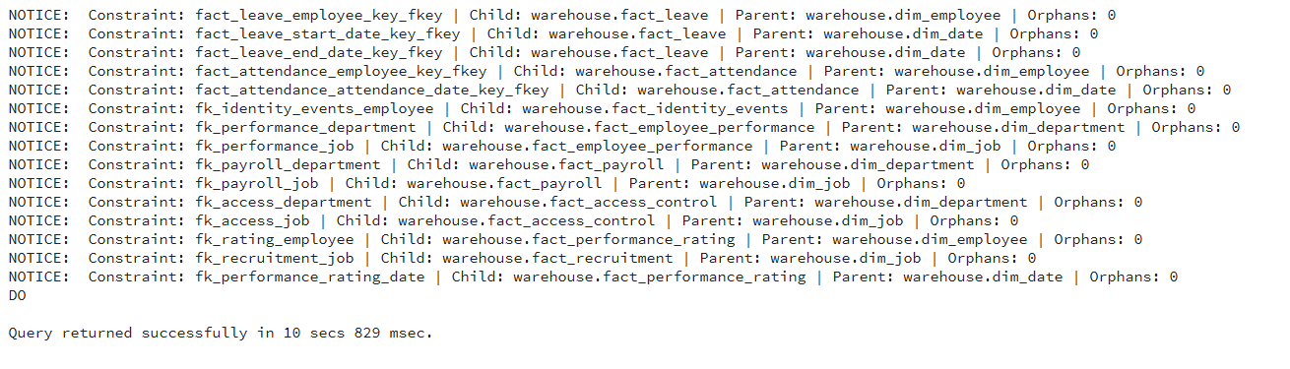
Performance rating date-key validation

3. Star Schema Validation – Power BI
The data warehouse schema was reviewed to verify the relationships between fact tables and shared dimension tables. The star schema organizes HR data to support consistent analysis across employee performance, attendance, payroll, recruitment, leave, access control, and identity events. The relationships were examined to identify disconnected tables and potential ambiguity in filter paths. The validated model provides a structured foundation for Power BI reporting.

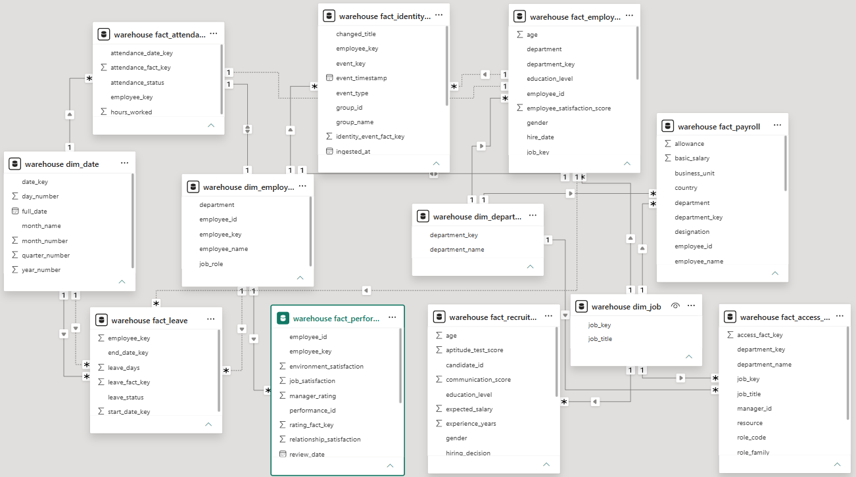

4. Conclusion and Inference
The EHCMDP project successfully integrates multiple HR datasets into a centralized data warehouse using Pentaho ETL workflows and PostgreSQL. Data validation checks were performed on warehouse table counts, key mappings, duplicate dimension keys, and foreign-key relationships to assess data quality and referential integrity. The star schema organizes data into fact and dimension tables, enabling effective analysis and Power BI reporting. The identification of staging tables with zero records also highlights areas requiring further investigation. Overall, the platform establishes a foundation for HR analytics, employee performance monitoring, recruitment analysis, and data-driven decision-making.

