Business Requirements Document (BRD)
UC17: Enterprise Human Capital Management Data Platform (EHCMDP): Building a Unified Workforce & HR Analytics Platform

Project Charter
Charter Item | Details
Project | Enterprise Customer Relationship Management Data Platform (EHCMDP)
Project Title | Building a Unified Workforce & HR Analytics Platform
Organization in Case Study | ABC Global Enterprises Ltd.
Methodology | Agile Scrum
Team Members | Ankita Yeleswarapu, Madhumitha Maheswaran, Likisha Ulhas Kharche
Sprint Coverage | Sprint 0, Sprint 1, Sprint 2 and Sprint 3
Project Sponsor/ Faculty Instructor | Dr. Renuka Devi
Start Date | 07.08.2026

Project: EHCMDP; Building a Unified Workforce & HR Analytics Platform
Organization: ABC Global Enterprises Ltd.
Sprint 0 Project Initiation & Architecture

1. Introduction
ABC Global Enterprises Ltd. is a multinational organization with over 75,000 employees operating across multiple countries and business units. The Human Resources department manages workforce operations through an Enterprise Human Capital Management (HCM) platform that integrates Recruitment, Employee Onboarding, Payroll, Attendance, Leave Management, Performance Management, Learning & Development, Employee Self-Service, and Workforce Planning.
The Enterprise Human Capital Management Data Platform (EHCMDP) will provide a unified data engineering platform for collecting, cleaning, transforming, storing, governing, and analyzing workforce and HR data generated across these independent systems.

2. Business Problem
HRMS, Payroll Systems, Attendance Devices, Recruitment Portals, Learning Management Systems, Performance Management Systems, Employee Portals, and Identity Management Systems each operate independently. Because of this, the organization faces challenges in:
- Maintaining a unified, single view of every employee
- Monitoring workforce productivity across business units
- Tracking recruitment pipelines and hiring trends
- Managing payroll accuracy and compliance
- Improving employee retention
- Generating consistent, enterprise-wide HR insights and reports

A centralized data platform is required to provide reliable and consistent workforce information for analytics and decision-making.

3. Business Objectives
The EHCMDP is intended to:
- Collect workforce and HR data from multiple enterprise systems.
- Clean, validate, and standardize employee and HR records.
- Store curated datasets in an enterprise PostgreSQL data warehouse.
- Maintain metadata, audit logs, and end-to-end data lineage.
- Support workforce analytics, payroll reporting, recruitment insights, and executive dashboards.
- Use Git and GitHub for collaborative version control.
- Produce enterprise-standard technical documentation and sprint deliverables.

4. Project Scope
The project will cover the following, in line with the business objectives:
- HR and workforce data source identification across the enterprise (Sprint 0)
- Data ingestion from CSV, Excel, JSON, XML, and SQL sources using Pentaho (Sprint 1)
- Data cleaning, validation, and standardization (Sprint 2)
- Data profiling using Python/Pandas (Sprint 2)
- PostgreSQL staging and data warehouse development (Sprint 2)
- ETL orchestration, logging, and exception handling using Pentaho (Sprint 2)
- Power BI dashboard development for executive and HR reporting (Sprint 3)
- Metadata, audit logging, and end-to-end data lineage documentation (Sprint 3)
- Git/GitHub-based version control and collaboration to be carried out throughout all sprints
5. Stakeholders
Stakeholder | Responsibility
HR Operations Team | Manage employee onboarding, records, attendance, and leave
Payroll Team | Manage payroll processing, disbursement, and compliance
Recruitment Team | Manage the hiring pipeline and candidate data
Learning & Development Team | Manage training programs and LMS data
Performance Management Team | Manage appraisal cycles and performance data
IT / Identity Management Team | Manage system access and identity data
Data Engineering Team | Develop and maintain the HCM data platform
Executive Management | Use workforce and HR reports for decision-making

6. Data Sources
The platform will integrate the following open-source HR datasets, all with a frequency of one-time batch ingestion. All sources land in PostgreSQL Staging first, each into its own staging table; cleaning, profiling, and warehouse loading follow in Sprint 2.
Dataset Name | Format | Description | Target
Employee Performance and Productivity Dataset | CSV | Employee-level performance and productivity metrics for HR and workforce analysis. | stg_employee_performance
Human Resources Dataset | CSV | Employee demographic, hiring, termination, and performance records (HRDataset_v14). | stg_employee_master
AI Fairness in Recruitment Dataset | JSON | Simulated applicant records used to evaluate bias and fairness in AI-driven recruitment. | stg_recruitment
Employee Payroll Dataset | Excel | Employee pay data including salary, designation, and compensation details. | stg_payroll
Employee Attendance Ratings Dataset | XML | Employee attendance and time-tracking records. | stg_attendance
Employee Leave Tracking Dataset | CSV | Employee leave requests, types, and balances over time. | stg_leave
HR Analytics – Employee Dataset | CSV | Employee attributes (department, satisfaction, tenure, income) used to analyze attrition patterns. | stg_hr_analytics
HR Analytics – PerformanceRating Dataset | CSV | Performance rating attributes for tracking employee evaluations. | stg_hr_performance_rating
Amazon Employee Access Dataset | JSON | Historical employee resource-access requests and approval/denial outcomes. | stg_access_control
SaaS Employee Master Dataset | Excel | Core employee master attributes modeled on a high-growth SaaS workforce. | stg_saas_employee_master
SaaS Employee Leave Requests Dataset | JSON | Leave request logs and metrics from SaaS enterprise operations. | stg_saas_leave_requests
SaaS Employee Snapshot Dataset | XML | Periodic point-in-time snapshots of SaaS workforce status and metrics. | stg_saas_snapshot
Employee Performance Evaluation – Structured Data Dataset | XML | Quantitative metrics and structured numerical indicators for performance ratings. | stg_eval_structured
Employee Performance Evaluation – Behavior Logs Dataset | JSON | Qualitative and behavioral interaction logs used for performance evaluations. | stg_eval_behavior_logs
Employee Performance Evaluation – Audio Features Dataset | Excel | Audio features and derived vocal metrics utilized in multi-modal performance evaluations. | stg_eval_audio_features

7. Functional Requirements
ID | Requirement
FR-01 | The system shall identify and document all HR data sources used by the project, including source name, type, format, description, relevant fields, and expected data volume.
FR-02 | The system shall ingest workforce and HR data from heterogeneous sources, including CSV, Excel, JSON, XML, and SQL, using Pentaho Data Integration.
FR-03 | The system shall identify and handle common data-quality issues, including missing values, duplicate employee records, invalid values, incorrect data types, and inconsistent formats.
FR-04 | The system shall validate incoming records before loading them into curated PostgreSQL tables, including required-field, data-type, range, duplicate, and date validation.
FR-05 | The system shall standardize employee and HR data, including employee names, department and designation codes, dates, and categorical values, to ensure consistency across datasets.
FR-06 | The system shall load raw and processed HR datasets into PostgreSQL, including staging tables, dimension and fact tables, curated datasets, and supporting metadata.
FR-07 | The system shall use Python/Pandas to profile workforce datasets, identifying record and column counts, missing values, duplicates, data types, and outliers.
FR-08 | The system shall document the movement of data from source to target (Source → Transformation → Target), covering the flow from HR source systems through Pentaho processing to PostgreSQL staging and the warehouse.
FR-09 | The ETL pipelines shall maintain logging information on successful records, failed records, transformation errors, validation failures, and processing status.
FR-10 | Power BI shall be used to build dashboards from curated PostgreSQL data to support workforce, payroll, recruitment, and executive analytics.

8. Proposed ETL Workflow
The high-level workflow for the platform is:
- HR & Workforce Data Sources
- Data Ingestion (Pentaho)
- Raw / Staging Zone (PostgreSQL)
- Data Profiling (Python/Pandas)
- Data Validation and Cleaning
- Data Transformation and Standardization
- PostgreSQL Dimensional Data Warehouse (Star Schema)
- Power BI
- Workforce & Executive Analytics

9. Business Analytics Enablement
The curated datasets should enable analytics teams to:
- Analyze workforce demographics and organizational structure.
- Monitor recruitment pipeline and hiring trends.
- Evaluate payroll and attendance patterns.
- Analyze employee performance and training effectiveness.
- Support employee retention and workforce planning.
- Generate executive HR dashboards.

10. High-Level Architecture

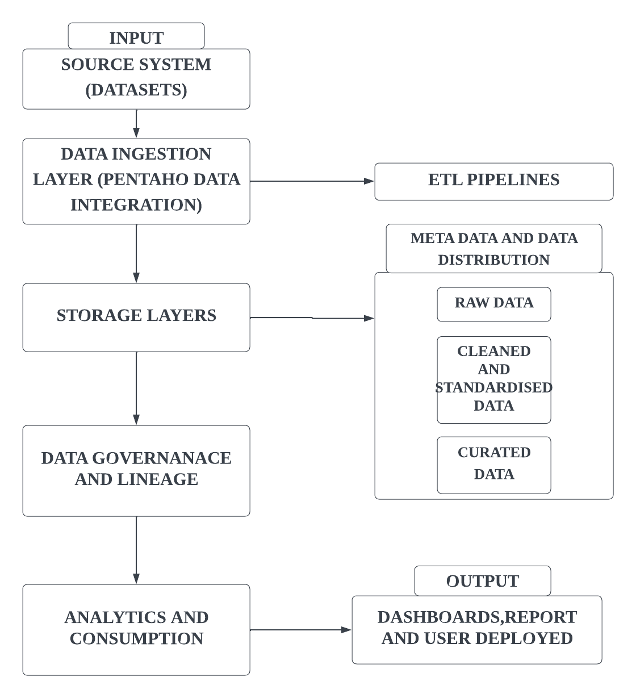

11. Non-Functional Requirements
- Data Quality: Data should be accurate, complete, consistent, and validated.
- Auditability: Data processing activities should be traceable.
- Scalability: The platform should support large volumes of workforce data across 75,000+ employees.
- Reliability: Data processing should be consistent and dependable.
- Maintainability: ETL processes and database structures should be easy to maintain.
- Traceability: Data should be traceable from source systems to final curated datasets.
The project specifically requires metadata, audit logs, and end-to-end data lineage.

12. Assumptions
- Required workforce and HR data will be available for the project team.
- Sample/representative datasets may be used during development when real enterprise data is unavailable.
- PostgreSQL will be used as the target data warehouse.
- Pentaho will be used for ETL.
- Python/Pandas will be used for data profiling and processing.
- Git/GitHub will be used for version control.
- Power BI will be used for reporting.

13. Constraints
- Source datasets may contain missing or inconsistent values.
- Different HR systems may use different formats and naming conventions.
- Data transformation rules may vary between source systems.
- The project is implemented as an academic enterprise data-engineering project rather than a production HCM platform.
- The quality of analytics depends on the quality and completeness of the available source datasets.

14. Success Criteria as defined
The project will be considered successful when:
- Data from the identified HR sources can be integrated.
- Employee and HR data is cleaned and standardized.
- Curated data is successfully stored in PostgreSQL.
- Data quality issues can be identified and managed.
- Data processing can be traced through audit and lineage information.
- The resulting data supports workforce, payroll, recruitment, and performance analysis.
- The platform provides a reliable foundation for executive HR reporting.

15. Technology Stack
Component | Technology
ETL | Pentaho Data Integration (Spoon)
Database | PostgreSQL
Data Processing | Python, Pandas
Version Control | Git, GitHub
Reporting | Power BI
Documentation | Markdown / MS Word
Methodology | Agile Scrum

16. Project Backlog
Task | Backlog Item | Description | Sprint | Expected Deliverable
T-01 | Understand HR Business Processes | Review the HCM ecosystem and understand the major HR processes and their role in workforce management and analytics. | Sprint 0 | HR Process Understanding
T-02 | Identify Business Stakeholders | Identify the key business and technical stakeholders involved in HR operations, requirements, analytics, and platform development. | Sprint 0 | Stakeholder Register
T-03 | Develop Business Requirements | Document the business problem, objectives, scope, stakeholders, source systems, requirements, expected outcomes, solution approach, assumptions, and constraints. | Sprint 0 | Business Requirement Document (BRD)
T-04 | Identify HR Data Sources | Identify the enterprise HR systems and relevant source datasets that will provide workforce and HR information to the platform. | Sprint 0 | HR Source System List
T-05 | Establish Project Scope | Define the boundaries of the project and align the planned work with the DA-1 objectives and overall sprint roadmap. | Sprint 0 | Project Scope
T-06 | Design High-Level Architecture | Define the high-level flow from HR source systems through Pentaho ingestion and the Bronze/Staging layer, considering the later platform flow. | Sprint 0 | Solution Architecture
T-07 | Establish Git Repository | Create the GitHub repository to support collaborative development, version control, and management of project artifacts. | Sprint 0 | GitHub Repository
T-08 | Establish Enterprise Repository Structure | Create the standardized project directory structure for documentation, datasets, ingestion, staging, transformations, SQL, metadata, lineage, dashboards, deployment, and testing. | Sprint 0 | Enterprise Repository Structure
T-09 | Develop Product Backlog | Organize the planned project activities into a structured backlog covering the required Sprint 0 and Sprint 1 work. | Sprint 0 | Product Backlog
T-10 | Analyze HR Source Systems | Examine each available HR source to identify its data content, format, intended use, and appropriate landing/staging target before ingestion. | Sprint 1 | Source System Analysis
T-11 | Develop Data Dictionary | Document the fields of the datasets selected for ingestion, including data type, description, nullability, source, and relevant notes. | Sprint 1 | Data Dictionary
T-12 | Develop Pentaho Ingestion Pipelines | Build Pentaho Data Integration transformations to ingest the identified HR datasets into the landing/staging environment. | Sprint 1 | Pentaho ETL Transformations
T-13 | Configure PostgreSQL Staging | Create the PostgreSQL staging database/schema and tables required to receive raw HR data while preserving source traceability. | Sprint 1 | Staging Database
T-14 | Implement Logging and Exception Handling | Capture transformation/job status, relevant errors, execution information, and supported failed-record or failed-step details. | Sprint 1 | Logging and Error Handling
T-15 | Validate and Commit Ingestion Work | Validate source-to-target ingestion, check mappings and staging results, and commit completed artifacts to Git with meaningful commit messages. | Sprint 1 | Validated Ingestion and Git History

17. Conclusion
The Enterprise Human Capital Management Data Platform will provide a unified data foundation for managing workforce and HR information. By integrating heterogeneous HR data sources, improving data quality, and storing curated information in PostgreSQL, the platform will support workforce analytics, payroll reporting, recruitment insight, performance and retention analysis, and executive-level HR reporting. This BRD establishes the foundation for the subsequent sprints covering data ingestion, profiling, warehouse development, governance, lineage, and analytics.

