1. Create a list of student names and print the second and last student.

Code:

n=['Yash','Anash','Daksh','Ved']

print('Second Name:',n[1])

print('Last Name:',n[-1])

Output:

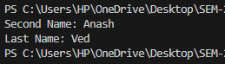

2. Create a list of 5 fruits and print all using a loop.

Code:

n=['mango','banana','apple','orange','grape']

i=0

while(i<len(n)):

    print(n[i])

    i+=1

Output:

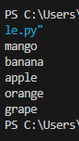

3. Create a list of numbers and print only even-indexed elements.

Code:

n=[1,2,3,4,5,6,7,8,9,10]

i=0

print('Numbers in even index:')

while(i<len(n)):

    if n[i]%2==0:

        print(n[i])

    i+=1

Output:

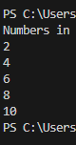

4. Access and print a slice of a list using range (slicing).

Code:

n=[1,2,3,4,5,6,7,8,9,10]

print('Range of numbers from 1 to 5:')

print(n[1:6])

Output:

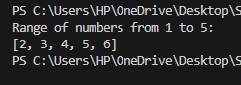

5. Create a list with mixed data types and access each type.

Code:

n=[1,'Yash',2.5,True]

print('List:')

i=0

while(i<len(n)):

    print(n[i])

    i+=1

Output:

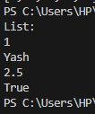

6. Append elements to a list dynamically using user input.

Code:

n = []

num = int(input("Enter Number of element you want to add in list :"))

i = 0

while (i < num):

    myList = input("Enter your element :")

    n.append(myList)

    i += 1

print(n)

Output:

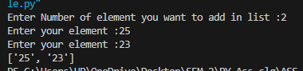

7. Copy a list and show the difference between original and copied list.

Code:

n = ["apple","cherry","banana","watermelon","pappaya","mango"]

print("Original List: ",n)

myList = n.copy()

print("Copied List: ",n)

Output:

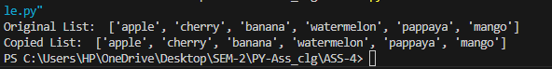

8. Count how many times a number appears in a list.

Code:

n = [1,2,2,6,2,3]

count = n.count(2)

print(count)

Output:

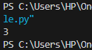

9. Use insert() to add a value at a specific index.

Code:

n = ["apple","cherry","banana","watermelon","pappaya","mango"]

n.insert(3,"dragon fruit")

print(n)

Output:



10. Use pop() to remove and display the last item.

Code:

n = ["apple","cherry","banana","watermelon","pappaya","mango"]

n.pop(-1)

print(n)

Output:



11. Use remove() to delete a specific item by value.

Code:

n = ["apple","cherry","banana","watermelon","pappaya","mango"]

print("Original List: ",n)

n.remove("apple")

print("Removed Item List: ",n)

Output:



12. Use clear() to empty the entire list and print it.

Code:

n = ["apple","cherry","banana","watermelon","pappaya","mango"]

print("Original List: ",n)

n.clear()

print("Cleared List: ",n)

Output:



13. Create a list of numbers and sort them in ascending and descending order.

Code:

n = [1,3,2,4,5,6]

n.sort()

print("Ascending Order:  ",n)

n.sort(reverse = True)

print("Descending Order: ",n)

Output:



14. Reverse a list using reverse() method and print both original and reversed list.

Code:

n = ["apple","cherry","banana","watermelon","pappaya","mango"]

print("Original List: " ,n)

n.reverse()

print("Reversed List: ",n)

Output:



15. Find the index of a given element using index() and print it.

Code:

n = ["apple","cherry","banana","watermelon","pappaya","mango"]

print(n)

print(n.index("watermelon"))

Output:

