

SQL Developer Access Advisor

Oracle Homework Rapport

Made by: Dada Yacine G2

Introduction

This document provides a comprehensive guide on how to perform a SQL Access Advisor analysis using Oracle SQL Developer. The SQL Access Advisor is a powerful tool that helps optimize database performance by analyzing SQL workloads and recommending improvements. The steps outlined in this guide cover everything from granting necessary privileges to executing the advisor task and viewing the recommendations.

Objective

The objective of this guide is to streamline the process of SQL optimization for database administrators. By following the steps provided, users will be able to:

* Grant the required roles and privileges to the user.
* Import data and execute necessary scripts.
* Create and manage SQL Tuning Sets.
* Capture SQL statements from the Automatic Workload Repository (AWR).
* Create and configure a SQL Access Advisor task.
* View and interpret the results and recommendations provided by the SQL Access Advisor.

Steps to Perform SQL Access Advisor Analysis

**1. Grant Required Roles and Privileges**

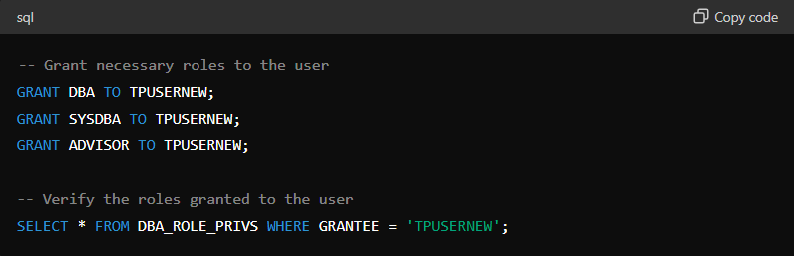First, ensure that the user TPUSERNEW has the necessary roles and privileges to perform SQL Access Advisor tasks.

**2. Import Data and Execute Script**

Import your data tables into the database and execute the script containing the 113 queries.

**3. Create a SQL Tuning Set for SQL Access Advisor**

Grant the required privileges to TPUSERNEW to create and manage SQL Tuning Sets.

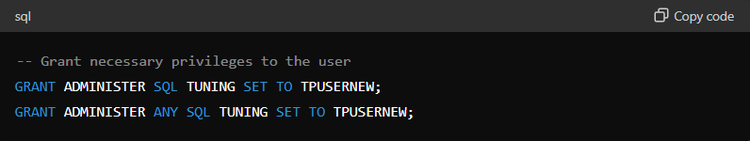

**4. Capture SQL Statements from the Automatic Workload Repository**

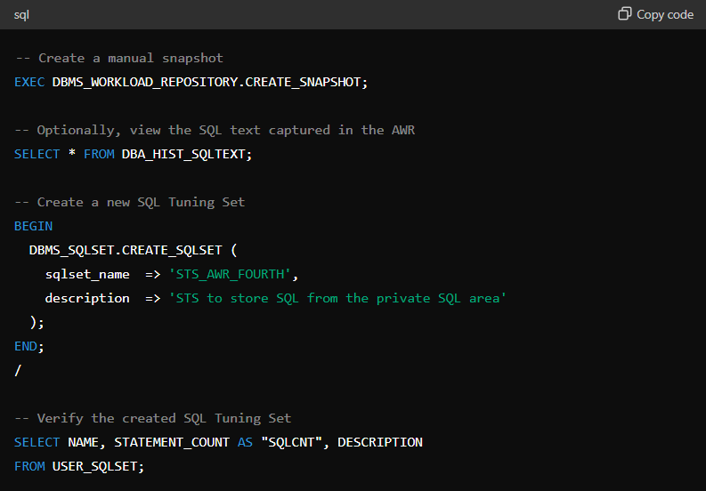Create a manual snapshot of the database performance data in the AWR and create a new SQL Tuning Set (STS).

**5. Populate SQL Tuning Set with AWR Data**

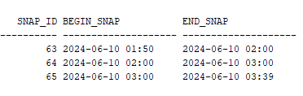Retrieve the snapshot IDs, populate the SQL Tuning Set with SQL statements from the AWR snapshots, and verify the SQL statements.

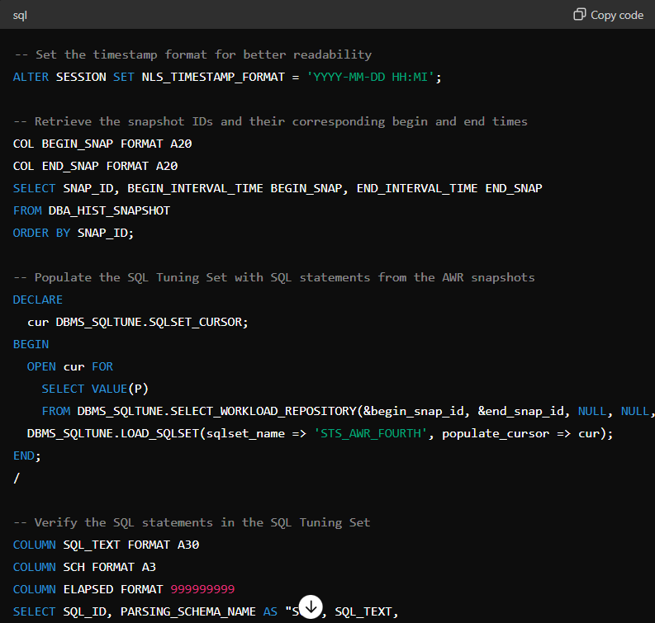

**6. Create and Configure the SQL Access Advisor Task**

Create a new SQL Access Advisor task, set its parameters, and add the SQL Tuning Set as a reference for the task.

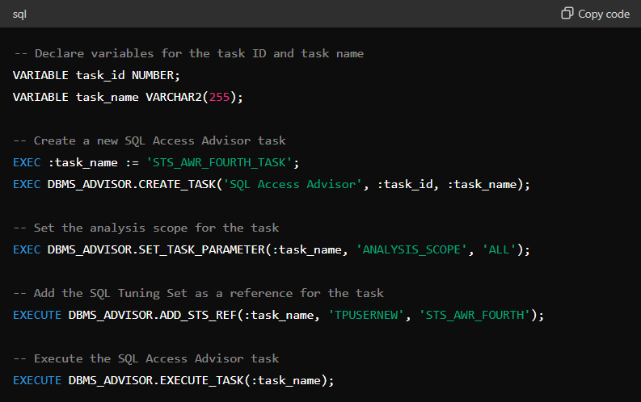

**7. View SQL Access Advisor Task Results**

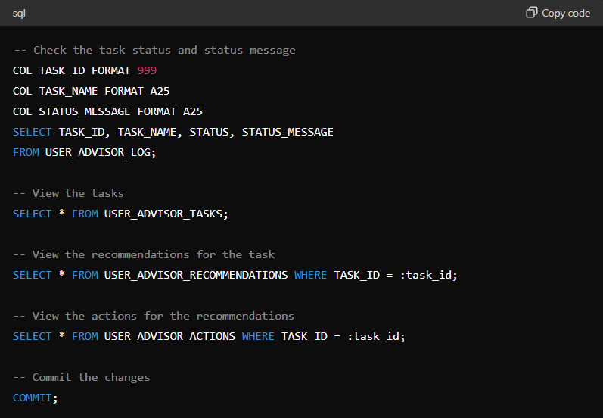Check the task status, view the tasks, recommendations, and actions, and commit the changes.

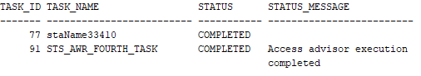

**8. Display Recommendations**

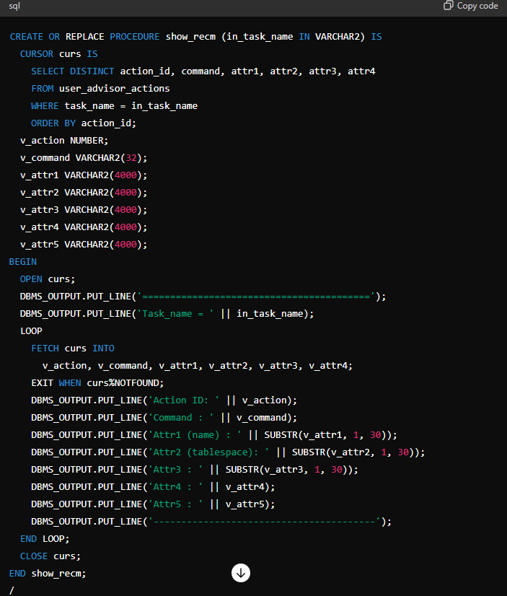Execute the provided show_recm procedure to display the recommendations and their attributes.

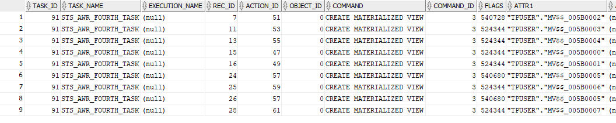

Conclusion

By following this comprehensive guide, you can effectively utilize the SQL Access Advisor to analyze and optimize SQL workloads in your Oracle database.The steps ensure that the necessary privileges are granted, data is correctly imported and managed, SQL Tuning Sets are created and populated, and the SQL Access Advisor task is configured and executed.

The recommendations provided by the SQL Access Advisor will help in enhancing database performance, ensuring efficient and effective database operations.