
Personal Information
Name: Yang Yuanchao
Birth: 1989.01.03
Education: Master
School: University of Electronic Science and technology
Email: 395976266@qq.com
Cellphone: 13668214304
Research Area: Web Application, Web Game
Education
2007 – 2011 Chengdu Institute of Technology
Electronic Information Engineering Monitor
2011 – Now University of Electronic Science and Technology
Software Engineering
English Level
CET-6 Score: 509
Working Experience
2011.09 - Now Signal Processing Laboratory of UESTC Member
2013.06 - 2013.09 Tencent(Chengdu) Cloud BG Intership
Web Front-End Develop
Project Experience: Clog data statistics, Cloud Object Service Optimization
Skills
My Web Games:
- Snake (mobile barriers）
- LianLianKan（OO, can fight against AI, prop, custom map, save and load game）
- Bomber（OO, TDD）
Database:
- Know Transaction, Concurrency
- Know SQLServer, Mysql, Oracle, Database Design
- Familiar with SQL, Procedure, Trigger
- Master ADO.Net 2.0, LinqToSQL, JDBC
Web Front-End:
- Know Canvas Of Html5
- Familiar With Html, Css, Ajax
- Good At Javascript
- Master jQury
- Optimization Experience
Web Background:
- Know PHP
- Familiar With JSP + Servlet + Javabean + JDBC
- Familiar With Asp.net
- Master Asp.net Mvc
Test:
- Familiar With TDD
- Master Test Tool Of Vs2010, Nunit, Jasmine, Moq, JUnit, DBunit, EasyMock
Tools:
- Know PhotoShop, MyEclipse, Sublime Text2, WebStorm, Project, Svn
- Know Phantomjs, dynaTrace Ajax, Page Speed, Freemarker,
SecureCRT
- Familiar With VS2012, Mono, PowerDesigner, Visio, Word, PPT
Language:
- Know Java, PHP
- Know TypeScript
- Familiar With C#
- Good At Javascript
Others:
- Know Design Pattern, Agile Development, OOD, OOP, DDD,
Project Manager, Basic Operation Of Linux
- Familiar With MVC, UML, Refactor
Part Project Demo
- Snake Game
http://yang222.s2.jutuo.net/Snake
- LianLianKan Game
http://yang222.s2.jutuo.net/LianLianKan
- Bomber Game
http://yang222.s2.jutuo.net/Bomber
- High and low voltage assembly logistics management information platform
http://xingkeda.xicp.net:8089/
- Sichuan Boda company website
http://www.bdjd.org/
Blog
http://www.cnblogs.com/chaogex/
Project Experience
- High and low voltage assembly logistics management information platform
Date: 2011.09 – 2012.08
The number of members: 2
Major technique:
Asp.net Mvc 2, SQLServer2005, LinqToSQL
Content：
It takes me eight months to build the platform of website.
In the website, members could publish their own information, manage own shop, send and receive mails, enter user center and so on. Administrators can enter website background to manage the member and their information and shops.
I do all the work except developing the main page. My task involves requirement analysis, designing, realization, testing and writing the document.
- Information reporting system for disabled children in Shanghai Health Bureau
Date: 2012.04
The number of members: 6
Major technique:
JSP, Oracle10.0, JDBC, Procedure, Trigger
Content：
I’m responsible for the development and testing of seven modules including History_BornAge module, History _BornDefectRate module, Search_History_BornAge module and so on.
- Mobile phone synchronization server management system
Date: 2012.08 – 2012.09
The number of members: 1
Major technique:
Mono, VCard, Asp.net Mvc2, Mysql, ADO.Net 2.0, Procedure, Trigger
Content：
My key work:
- Build the Mono environment and use Jexus server In Ubuntu
- Analysis and assemble VCard
- System development
- Advanced research of software management system
Date: 2012.11
The number of members: 1
Content：
To investigate OAuth2.0 and open platform such as Open Platform Renren, Open Platform Happy Network, Open Platform 360.
My achievement is the 67 page report.
- Snake Game
Date: 2012.10
The number of members: 1
Major technique:
Javascript
Feature：
- Mobile barriers
- Prop
- 5 levels.
- LianLianKan Game
Date: 2012.10-2013.01
The number of members: 1
Major technique:
OO , Javascript
Feature：
- OOD, OOP
- Develop the Object Oriented framework named YOOP for Javascript
- Summarize the document
- Sichuan Boda company website
Date: 2013.01-2013.02
The number of members: 1
Major technique:
TDD, Asp.net mvc2
Content：
It’s my first time to use TDD.
- Bomber Game
Date: 2013.04-2013.05
The number of members: 2
Major technique:
OO, TDD , Canvas Of Html5, Javascript
Feature：
- OOD, OOP, TDD
- I’m responsible for all the work except the development of the path finding algorithm(A*)
- Summarize the document and the blog post
- Clog data statistics
Date: 2013.06-2013.07
The number of members: 1
Major technique:
TDD, JSP, Servlet, JDBC, Mysql, SQL, Procedure, JUnit, DBunit, Phantomjs
Content：
This is my first project during the intership in Tencent.
The main work is to reade data from mysql and create html page and Highcharts pictures.
Key point:
- Data layer operation optimization under the condition of big data
There are millons data in mysql table which I operate with.So I need to optimize the data layer operation.
At first, I use cursor and temp table in procedure to operate the data. But the performance is poor that it takes me over 40 seconds to get the data from the database. So I change to use only one SQL (using group by and sub query) to get the data and it only takes me about 7 seconds.
- Create static html page
I find the Freemarker and use it in the web background to create the static html page.
- Get the Highcharts pictures and page in client
I use the Phantomjs by command line to execute javascript to create Highcharts pictures and I download the page from server to client.
- Cloud Object Service Optimization
Date: 2013.08-2013.09
The number of members: 2
Major technique:
TDD, Javascript, Web Optimization
Content：
This is my second project during the intership in Tencent.
My main work is to optimize and add fectures.
I’m responsible for the work of Web Front-End.
Key point:
- Optimize Highcharts source code
The memo.html page should show four statistical charts which are generated by Highcharts. It’s too slow when the data increase. So I find the performance bottleneck in Highcharts souce code by using dynaTrace Ajax and then improve the performance. .
Part Project Screenshot
- High and low voltage assembly logistics management information platform
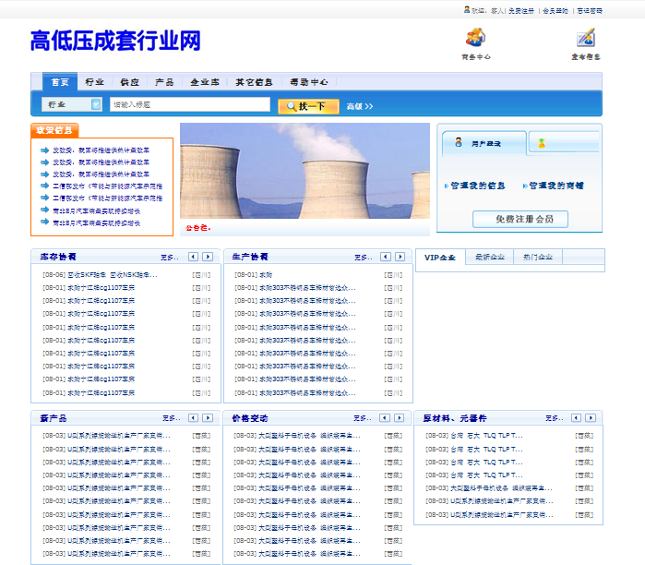
Picture 1 home page
- Snake Game
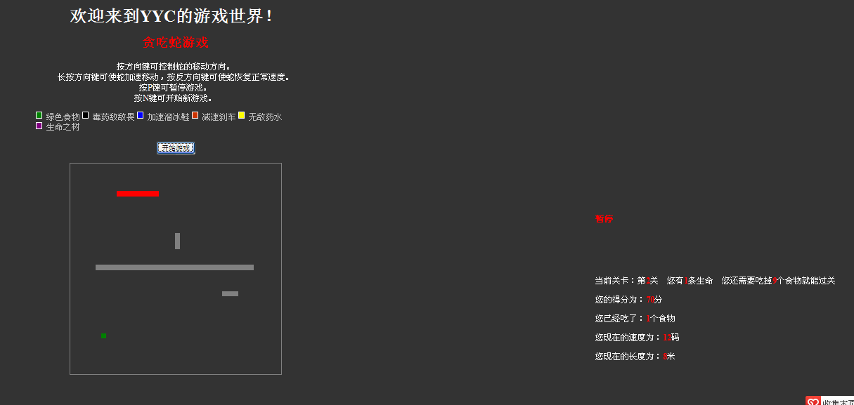
Picture 2 snake
- LianLianKan Game
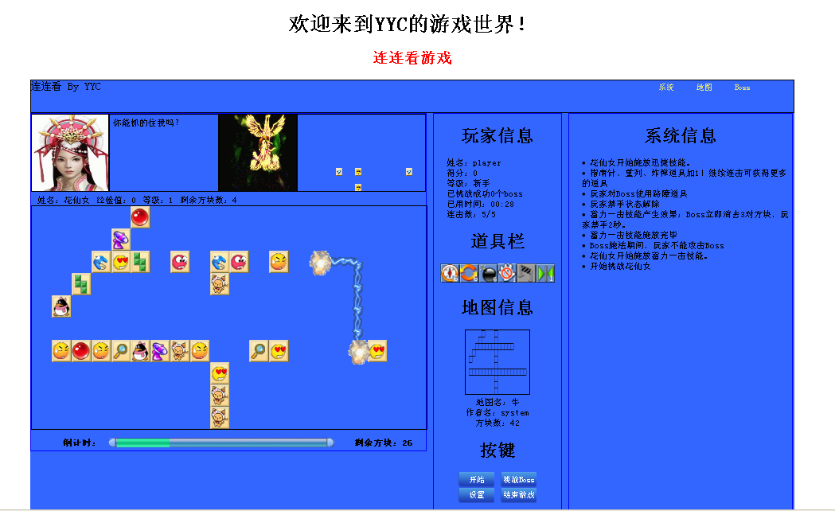
Picture 3 fight against AI
- Bomber Game
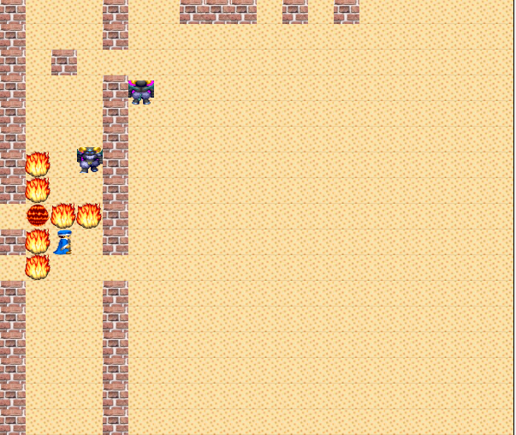
Picture 4 bomber

