SIL765
Assignment 1
Yash Gupta (2013CS10302), Ujjwal Sinha (2012CH70185)

Project 1: Implementation of DES

Problem statement:

You are required to develop a program to encrypt (and similarly decrypt) a 64-bit plaintext using DES.
Instead of using an available library, I insist that you program any/every element of each of the 16 rounds of DES (and that means F-box, 32-bit exchanges, generation of sub-key required in each round).
Having done that, with one or more 64-bit plaintext(s), verify that indeed the output of the J^{th} encryption round is identical to the output of the (16-J)^{th} decryption round.

DES is a block cipher, meaning that it operates on plaintext blocks of a given size (64-bits) and returns ciphertext blocks of the same size. Our version of DES uses a 56-bit private key (with additional 8 bits used to store parity of 7-bit blocks at 8th, 16th, … , 64th bits).
We use C++ to implement and validate DES for this project.

ENCRYPTION

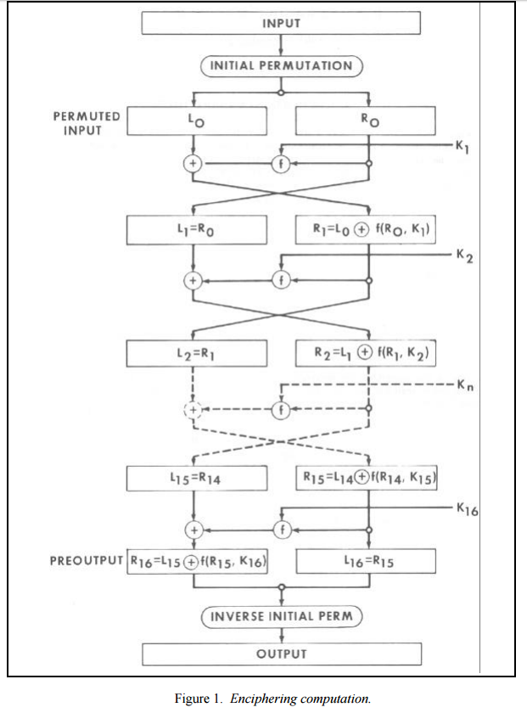
- We have implemented a function encrypt(plain, key) which returns the cipher text using DES.
- Here we take plain-text to be FEED1337BEAD8787 and key to be 0E329232EA6D0D73 in hexadecimal format.
- plain: FEED1337BEAD8787
key: 0E329232EA6D0D73
- Both plain text and the key is converted in binary format and we get a 64 bit block of plain text and key. Out of 64 bits of key, 8 bits of key are redundant parity bits.
- Encrypt() proceeds in the following manner:
  - Calculate initial permutation of plaintext and split into L and R.
  - Perform 16 rounds based on fiestel cipher, with the specified DES f-box and key schedule.
  - Swap L and R, and join them.
  - Apply inverse of the initial permutation to obtain cipher text.

Step 1:
Function initial_permutation_box(in) permutes the input 64 bits using the permutation table defined in the DES specification:
40,8,48,16,56,24,64,32,
39,7,47,15,55,23,63,31,
38,6,46,14,54,22,62,30,
37,5,45,13,53,21,61,29,
36,4,44,12,52,20,60,28,
35,3,43,11,51,19,59,27,
34,2,42,10,50,18,58,26,
33,1,41,09,49,17,57,25

From the above table, we get the new arrangement of the bits from their initial order as such the 40th bit of the plain text will become the first bit of result and similarly, 8th bit of the plaintext becomes the second bit of the result.

Step 2:
After initial permutation, we divide initial permuted block into halves each of 32 bit.

Round 0 - L: 031DFBEE R: F33B33DD

Step 3:
Next we iterate through the 16 rounds, in each generating the round key using function “key_round(i, CD)” which expects two arguments (round number and internal key schedule state) and it generates the 48-bit round key “K”, while updating the key schedule state (CD). Initially CD is equal to “key”.
Using the right 32-bit block “R” and round key “K” we execute the function “fiestel_box(R, K)” which calculates the f box as defined in DES specs to produce a 32 bit output block (H). This 32-bit output is XOR’d with “L”.

Y = L XOR fiestel_box(R, K)

After this, we do a swap between Y and R for the next step. R (F33B33DD) will become the left sub half (L) after the first round and Y will become the right sub half (R). This will continue for 16 rounds.

Output for each round:

00 - L: 031DFBEE R: F33B33DD
01 - L: F33B33DD R: 51D8987D K: 36146478E1E1 CD: 0029617503EC2E3D
02 - L: 51D8987D R: A9C71419 K: 40BD1176E8FD CD: 0052C2EA07D85C7A
03 - L: A9C71419 R: 38255661 K: 45A473239DDB CD: 004B0BA81F6171E9
04 - L: 38255661 R: F7F0DE37 K: E7C4828FB533 CD: 002C2EA05D85C7A7
05 - L: F7F0DE37 R: EC67ABB5 K: 7A83826F4F64 CD: 00B0BA8146171E9F
06 - L: EC67ABB5 R: EA49F160 K: 38901B58C9DE CD: 00C2EA05285C7A7D
07 - L: EA49F160 R: D46E0D99 K: 25005EC5D49D CD: 000BA814B171E9F6

08 - L: D46E0D99 R: 8FFCB3E7 K: 264894CB36E9 CD: 002EA052C5C7A7D8
09 - L: 8FFCB3E7 R: 72EBB23C K: 54554179F633 CD: 005D40A58B8F4FB0
10 - L: 72EBB23C R: C0AF3554 K: 43C9453F4C2E CD: 007502961E3D3EC2
11 - L: C0AF3554 R: E849DBA6 K: 09E1878C79D6 CD: 00D40A5858F4FB0B
12 - L: E849DBA6 R: 3C314F65 K: 3105ABA5E2F5 CD: 0050296173D3EC2E
13 - L: 3C314F65 R: 85577A6D K: F100A1F38EC3 CD: 0040A585DF4FB0B8
14 - L: 85577A6D R: 5465A8F8 K: 918A949E871F CD: 000296175D3EC2E3
15 - L: 5465A8F8 R: EC0C0B33 K: 1432961F77C4 CD: 000A585D44FB0B8F
16 - L: EC0C0B33 R: 2EE990D4 K: 606F044C3AE7 CD: 0014B0BA89F6171E

L: Left Sub Half, R: Right Sub Half, K: Round Key, CD: key schedule state

Step 4:
In the final step, we swap the left sub half(L) and right sub half(R) of round 16
(LR: 2EE990D4EC0C0B33) and then performed an inverse permutation of LR using “inv_initial_permutation_box(in)” to get the cipher text as 1A4AE1F807D29195.

DECRYPTION

Here we take cipher-text to be 1A4AE1F807D29195 and key to be 0E329232EA6D0D73 in hexadecimal format, and decrypt it using “decrypt(ciphertext, key)”, which results in 64-bit plaintext output.

cipher-text: 1A4AE1F807D29195
key: 0E329232EA6D0D73

Both Cipher text and the key is converted in binary format and we get a 64 bit block of Cipher text and key. The cipher text is same as output of encrypt() and key is identical to the one used for encryption.

Step 1:
Initial permutation is computed using “initial_permutation_box(in)”, as in “encrypt()”.

Step 2:
Next, we divide initial permuted block into halves each of 32 bit and swap the left sub half (32 bits of the cipher-text) and the right sub half (next 32 bits of cipher-text).

Step 3:
Our next step is to go through 16 iterations of decryption using “inv_key_round()” for the decryption key schedule. It expects two arguments (round number and internal key_schedule state) and it generates the key “K” for that round.

For i^{th} round of decryption, we use the same key which was used in i^{th} round of encryption.

Using the round key “K” we perform the inverse of the operation performed while encryption, which operates updates “L” and “R” using “K”.
Y = R XOR fiestel_box(L,K)
After this step, we do a swap between Y and R for the next step. L (EC0C0B33) becomes the right sub block “R” after the first round and Y becomes the left sub-block “L” for the next round.
This continues for 16 rounds.

Output for each round:

00 - L: EC0C0B33 R: 2EE990D4
01 - L: 5465A8F8 R: EC0C0B33 K: 606F044C3AE7 CD: 000A585D44FB0B8F
02 - L: 85577A6D R: 5465A8F8 K: 1432961F77C4 CD: 000296175D3EC2E3
03 - L: 3C314F65 R: 85577A6D K: 918A949E871F CD: 0040A585DF4FB0B8
04 - L: E849DBA6 R: 3C314F65 K: F100A1F38EC3 CD: 0050296173D3EC2E
05 - L: C0AF3554 R: E849DBA6 K: 3105ABA5E2F5 CD: 00D40A5858F4FB0B
06 - L: 72EBB23C R: C0AF3554 K: 09E1878C79D6 CD: 007502961E3D3EC2
07 - L: 8FFCB3E7 R: 72EBB23C K: 43C9453F4C2E CD: 005D40A58B8F4FB0
08 - L: D46E0D99 R: 8FFCB3E7 K: 54554179F633 CD: 002EA052C5C7A7D8
09 - L: EA49F160 R: D46E0D99 K: 264894CB36E9 CD: 000BA814B171E9F6
10 - L: EC67ABB5 R: EA49F160 K: 25005EC5D49D CD: 00C2EA05285C7A7D
11 - L: F7F0DE37 R: EC67ABB5 K: 38901B58C9DE CD: 00B0BA8146171E9F
12 - L: 38255661 R: F7F0DE37 K: 7A83826F4F64 CD: 002C2EA05D85C7A7
13 - L: A9C71419 R: 38255661 K: E7C4828FB533 CD: 004B0BA81F6171E9
14 - L: 51D8987D R: A9C71419 K: 45A473239DDB CD: 0052C2EA07D85C7A
15 - L: F33B33DD R: 51D8987D K: 40BD1176E8FD CD: 0029617503EC2E3D
16 - L: 031DFBEE R: F33B33DD K: 36146478E1E1 CD: 0014B0BA89F6171E
LR: 031DFBEEF33B33DD
plain: FEED1337BEAD8787

L: Left sub-block, R: Right sub-block, K: round key, CD: Internal key_schedule state

Step 4:
In the final step, we combine L and R into LR (031DFBEEF33B33DD) and then perform the inverse initial permutation on it to get the plain text as FEED1337BEAD8787.
FIESTEL BOX

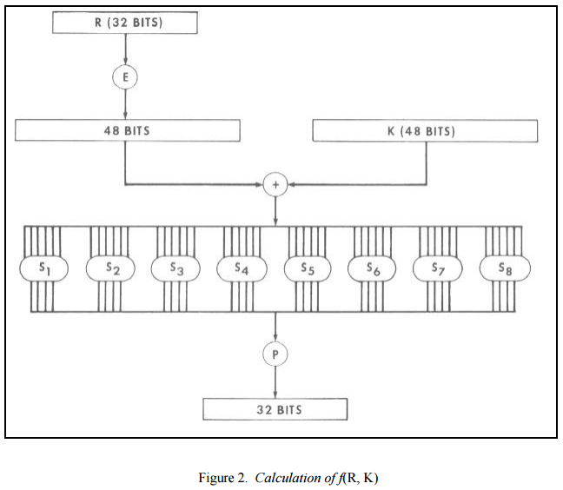

- Fiestel box is implemented by the function “fiestel_box(R,K)” which returns 32-bit output block from 32 bit input right sub-block “R” and 48 bit round key “K”.
- We first expand R to 48-bits using “expansion_box(in)” and obtain E.
- Then the expanded block “E” and round key “K”are XOR’d
- Then each 6-bit sub-block of the result is passed through a S_{i}-box with i = 1…8
- S_{i} box is implemented by the function “selection_box(i, in)”.
- Finally the function “permutation_box(in)” calculates the final 32-bit output of fiestel_box().
KEY SCHEDULE
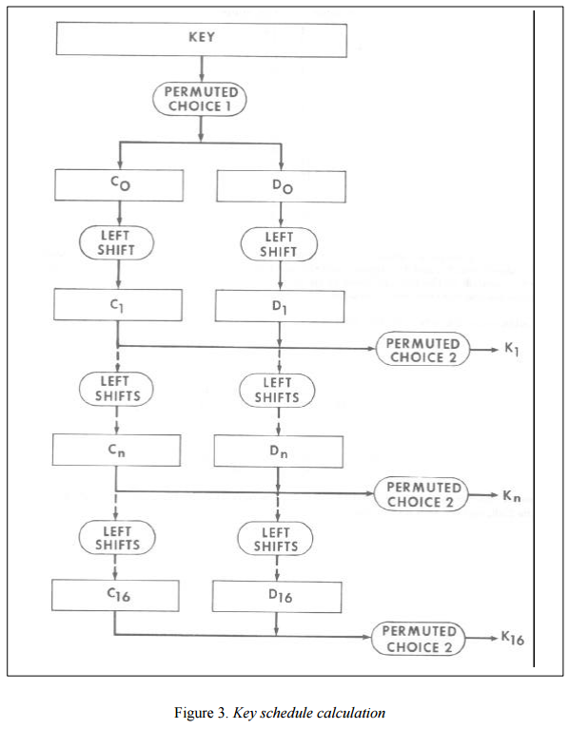

- Key schedule is generated by functions “key_round(i, CD)” and “inv_key_round(i,CD)” for encryption and decryption respectively. Here I is the round number and CD is the internal state.
- Initially, CD is equal to the input key.
- In the first round, “permutation_choice1_box(in)” generates the actual CD as per specs.
- For each round, K is generated using “permutation_choice2_box(in)” and internal state CD is updated by left-circular shifts following a shifting schedule as defined in the specs.
- Functions “shift_boxes(count, CD)” and “inv_shift_boxes(count, CD)” perform this action during encryption and decryption respectively.

VALIDATION

To validate the DES implementation, output of the J^{th} encryption round should be identical to the output of the (16-J)^{th} decryption round.

In function “main()”, we verify this by storing intermediate outputs from encryption and decryption and asserting encrypt_outputs[i] == decypt_outputs[16-i], for each i.

For instance, let J = 15: It means output of 15th encryption round should be identical to the output of the 1st round of decryption.

Output of 15th encryption round:
15 - L: 5465A8F8 R: EC0C0B33

Output of 1st decryption round:
01 - L: 5465A8F8 R: EC0C0B33

RESULTS

All assertions in the program are passed and thus the implementation of DES is validated.

