ShopEZ - API Output Screenshots
E-Commerce Backend REST API | ASP.NET Core

— Authentication —

1. Admin Registration
POST /api/auth/register-admin
Registers a new admin user. Returns a JWT token, role "Admin", email, and success message.
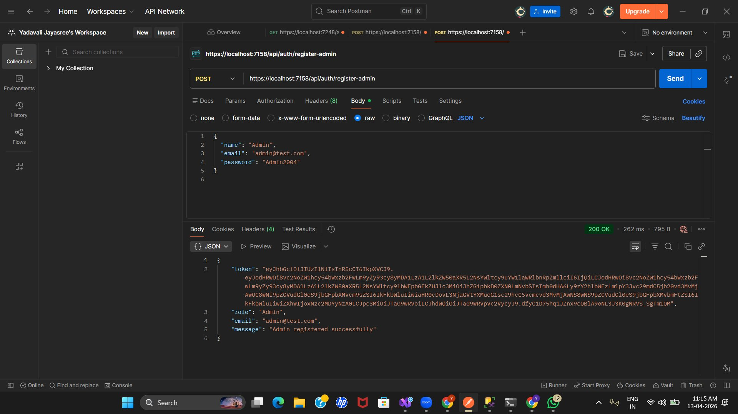

2. Admin Login
POST /api/auth/login
Admin login with email and password. Returns JWT token with role "Admin" and success message.
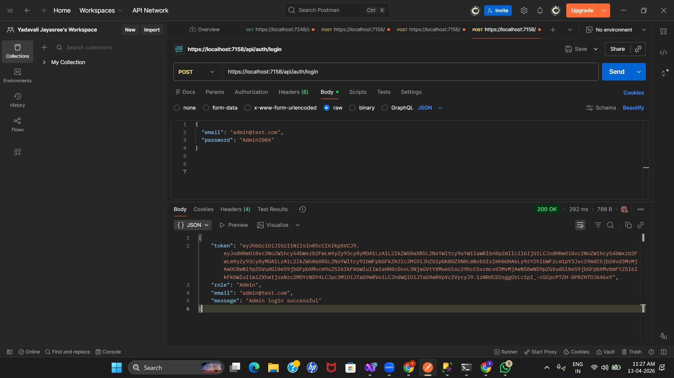
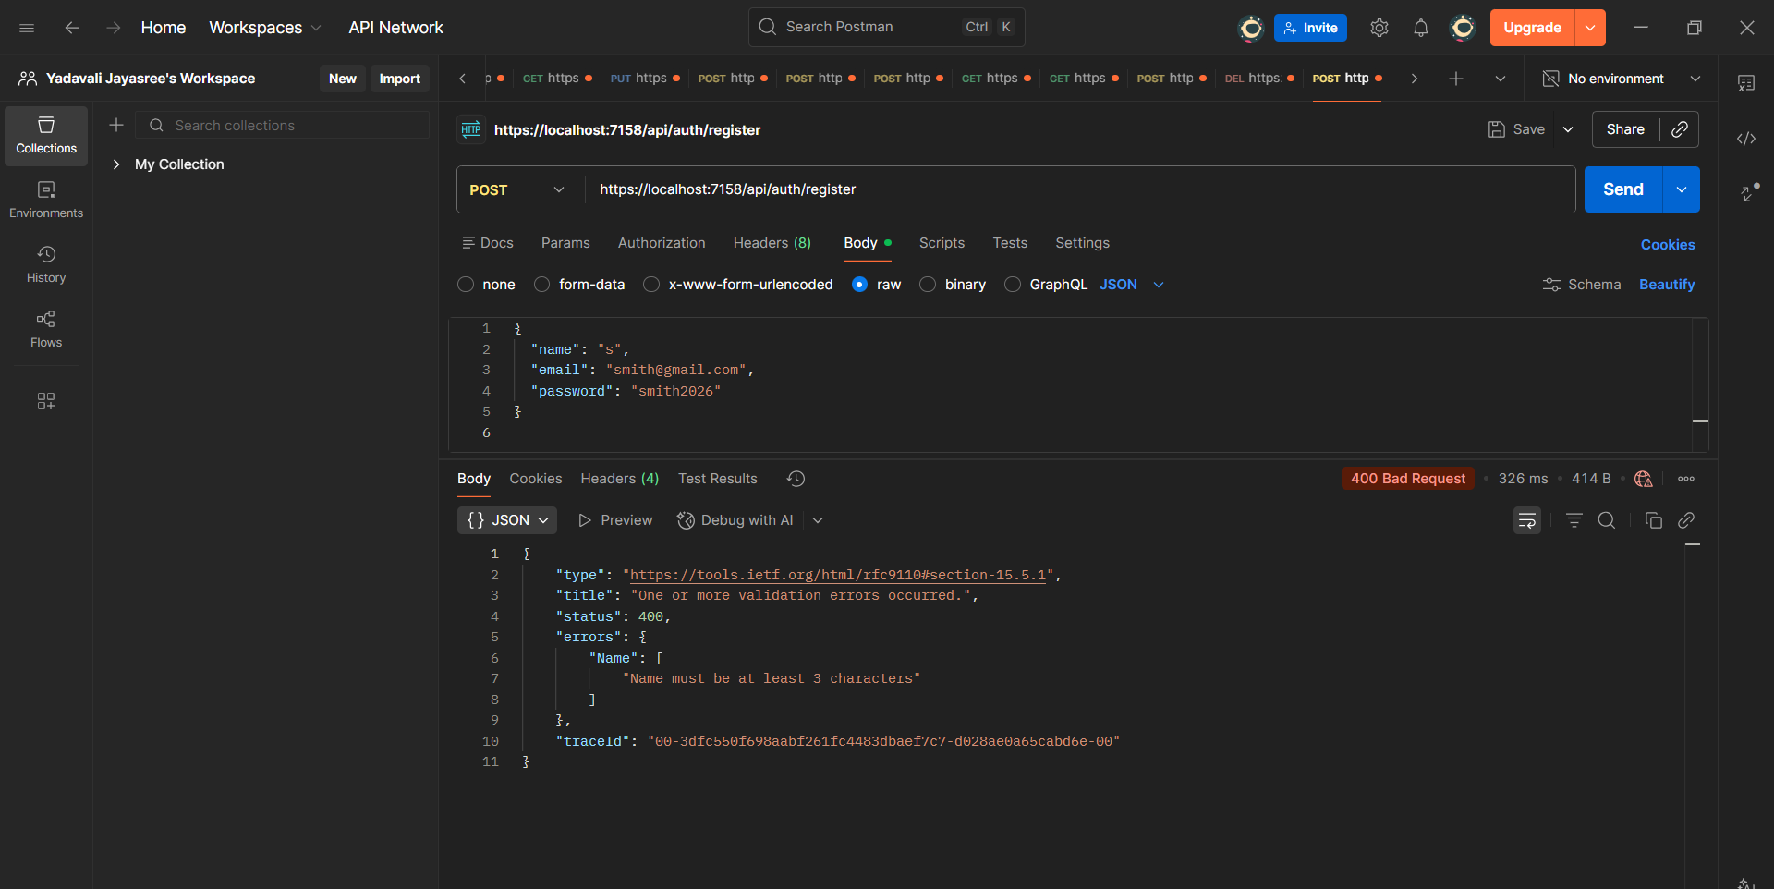
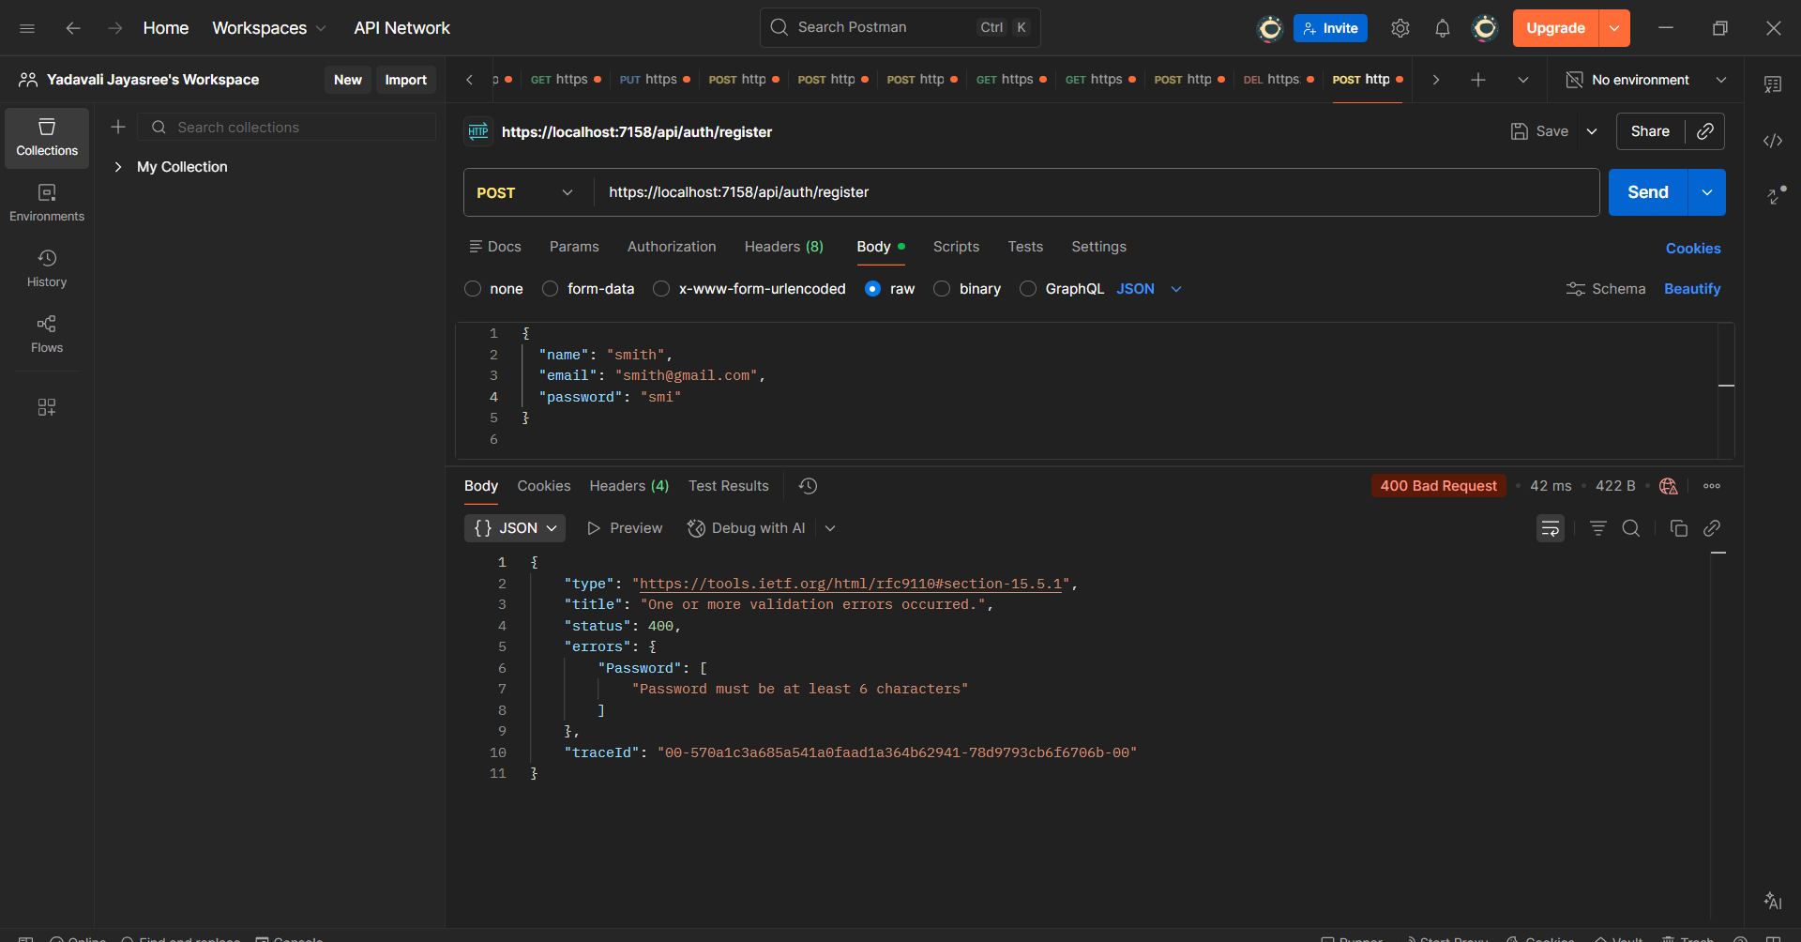

— Products —

3. Create Product (Admin Only)
POST /api/products
Admin adds a new product (iPhone 15). Returns productId, name, description, price, imageUrl, and stock.
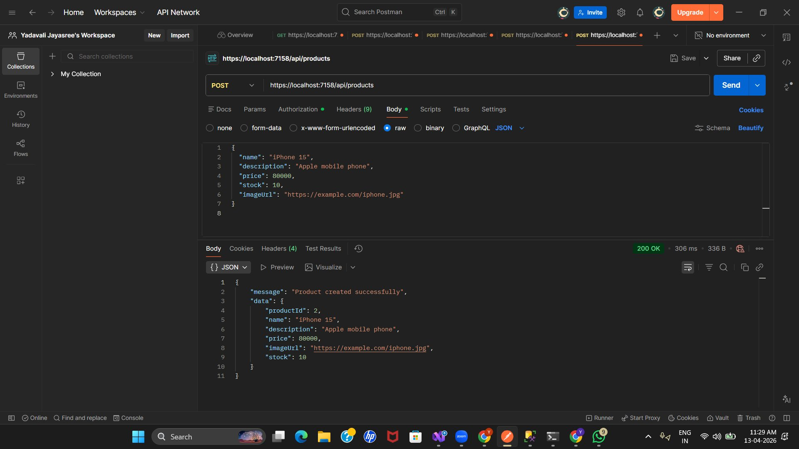

4. Get All Products
GET /api/products
Retrieves all products from the catalog. Returns a list of 10 products with count and details.
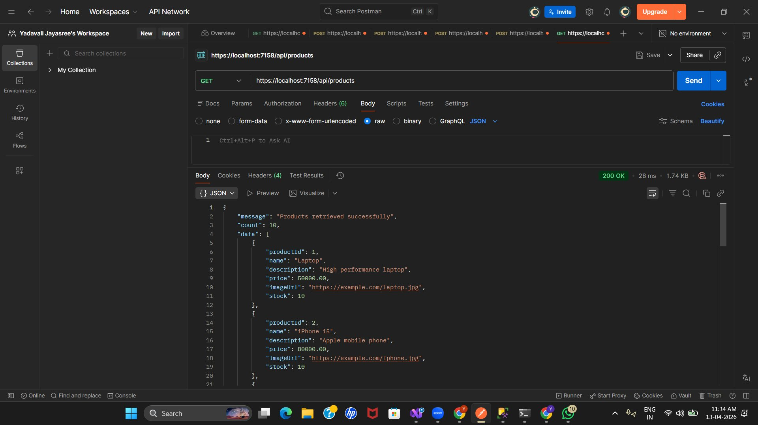

5. Get Product by ID
GET /api/products/{id}
Fetches a single product by ID (e.g., product ID 5 - Apple AirPods Pro).
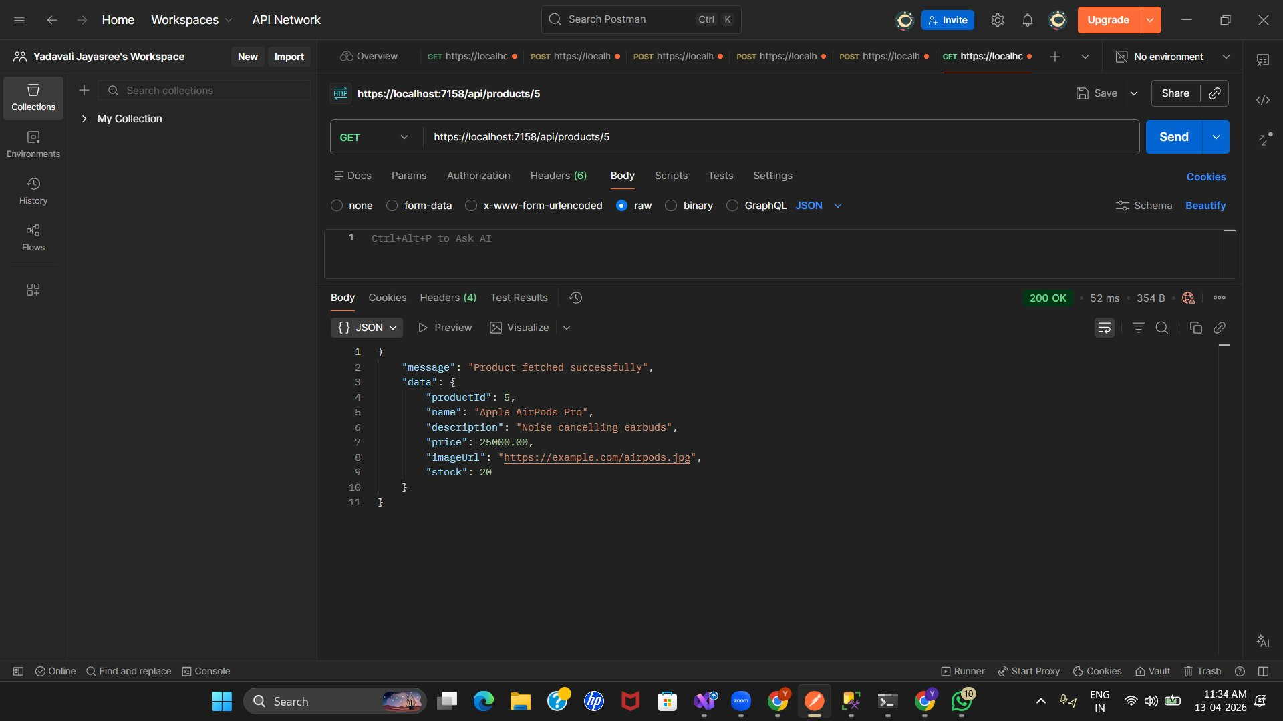

6. Update Product (Admin Only)
PUT /api/products/{id}
Updates product details (AirPods Pro price changed to 35000). Returns updated product data.
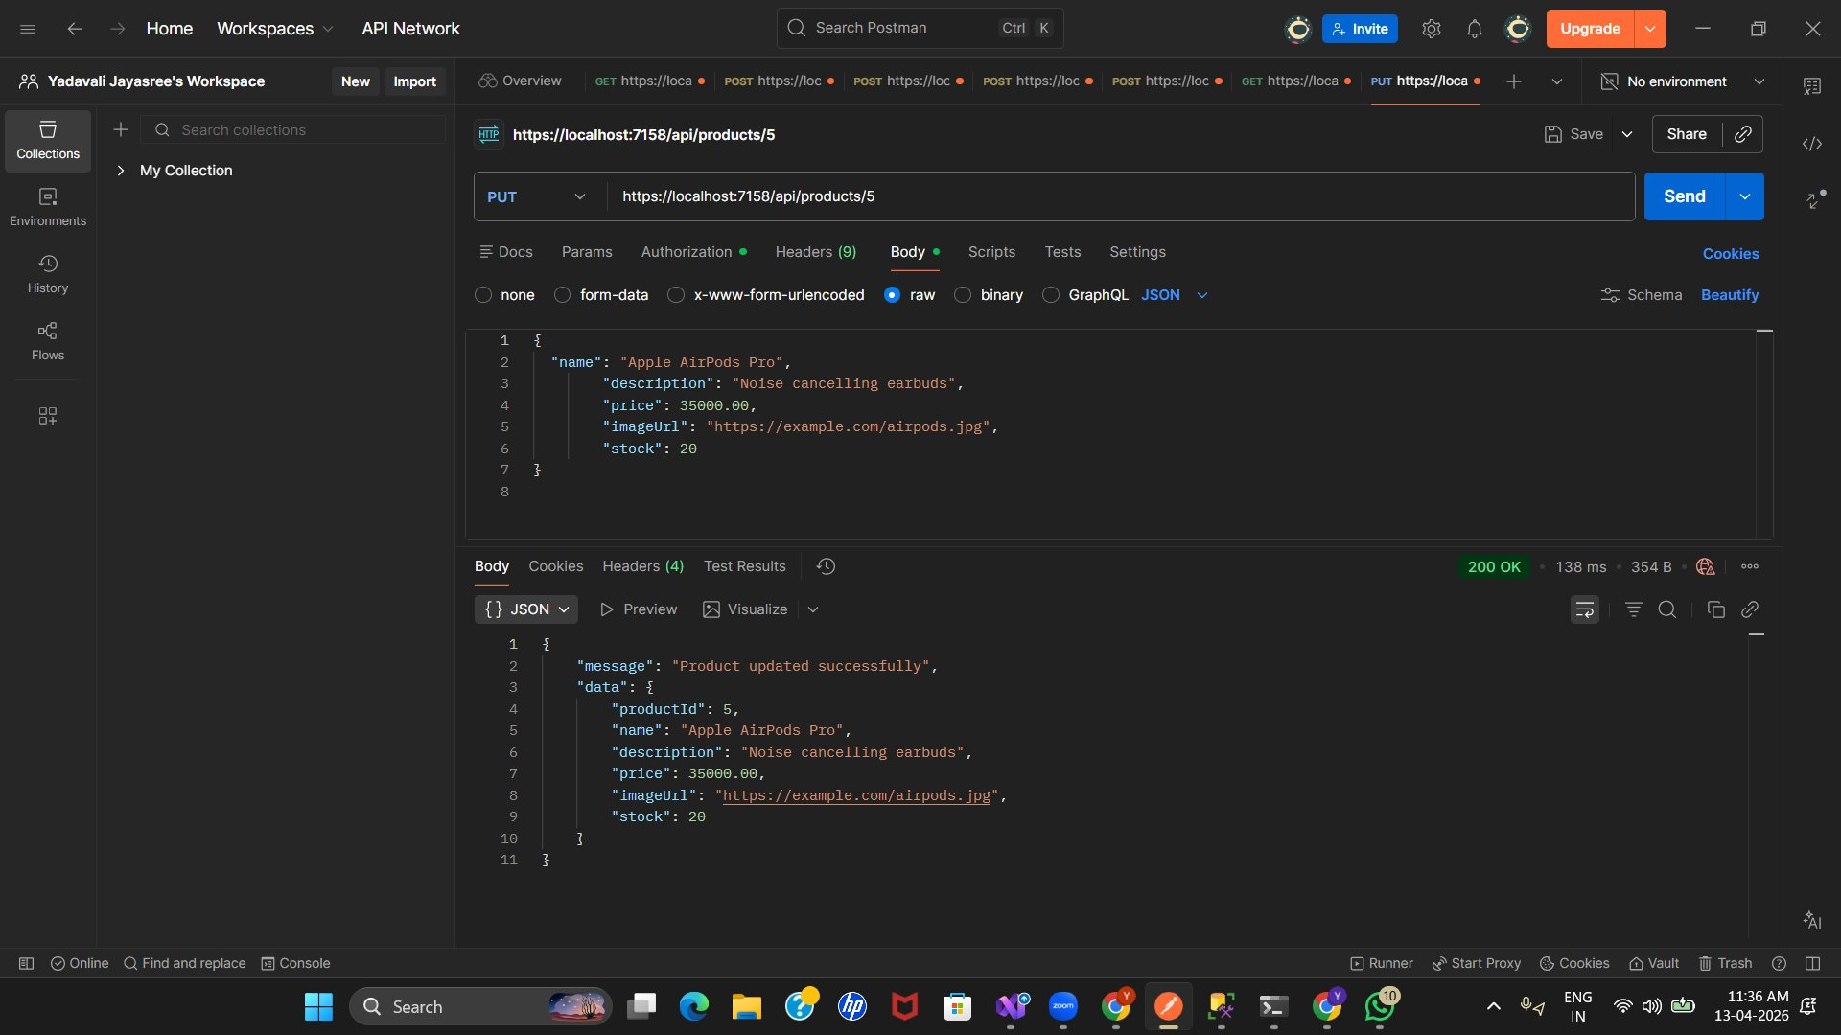

— Authentication —

7. Customer Registration
POST /api/auth/register
Registers a new customer (John). Returns JWT token, role "Customer", email, and success message.
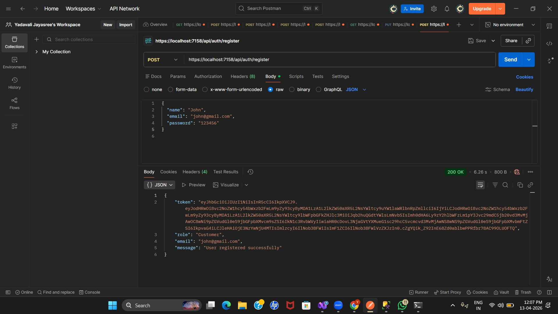

8. Customer Login
POST /api/auth/login
Customer login with email/password. Returns JWT token with role "Customer" and success message.
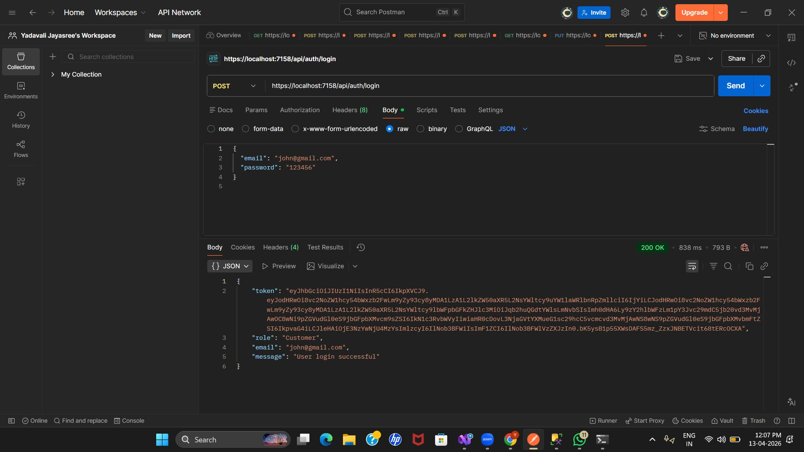

— Orders —

9. Place Order (Customer)
POST /api/orders
Customer places an order with cart items. Returns orderId, userId, orderDate, totalAmount, and item breakdown.
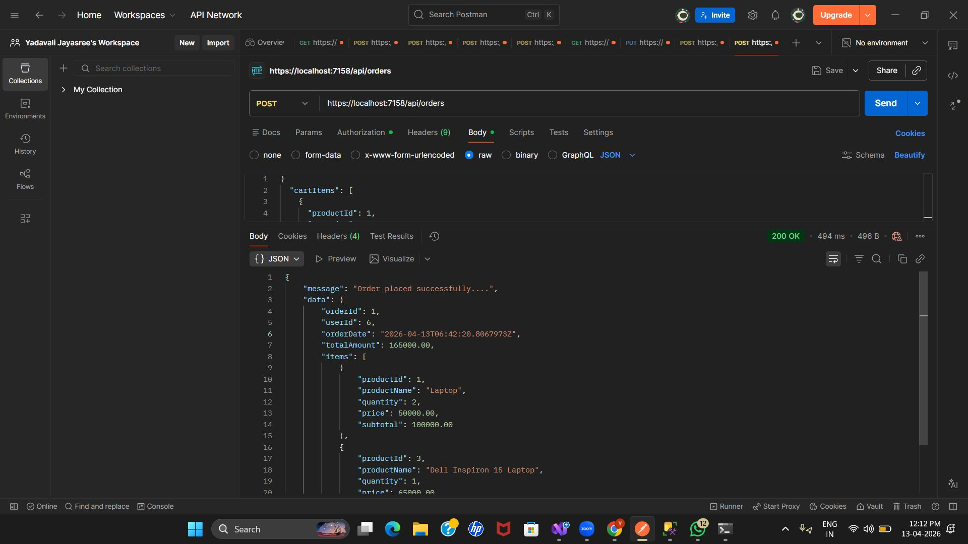

— Orders - Validation —

10. Place Order - Empty Cart Validation
POST /api/orders
Validation error when cart is empty. Returns 400 Bad Request with error "Cart cannot be empty".
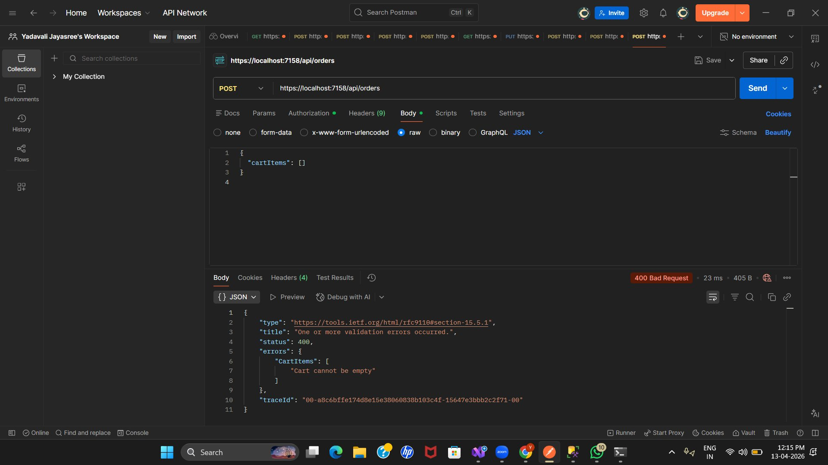

11. Place Order - Invalid Product ID (404)
POST /api/orders
Returns 404 Not Found when order contains a product ID (9999) that does not exist.
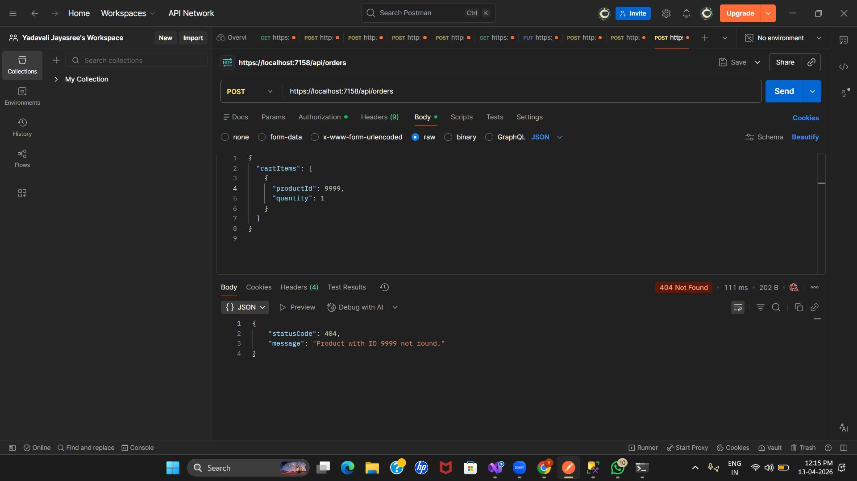

12. Place Order - Zero Quantity Validation
POST /api/orders
Returns 400 Bad Request when quantity is 0. Error: "Quantity must be at least 1".
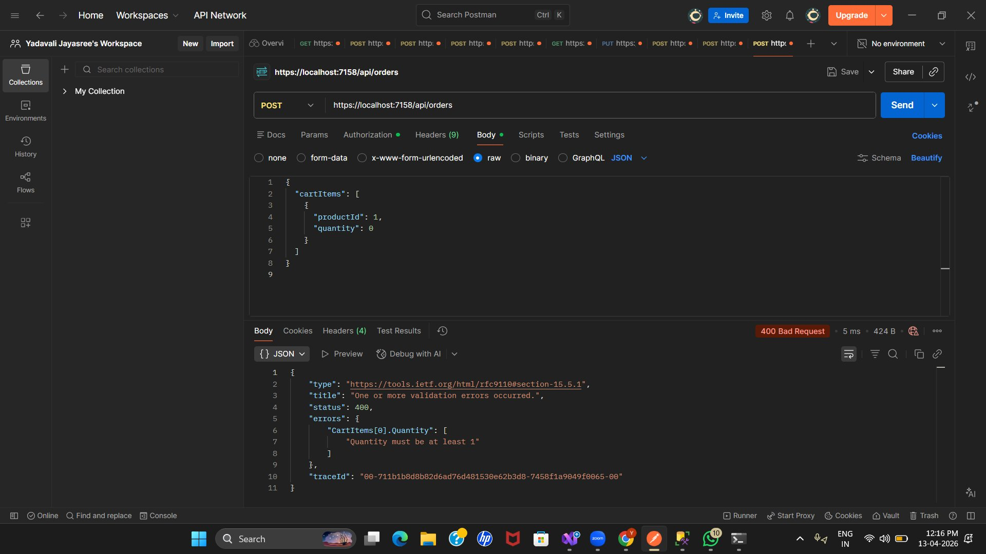

13. Place Order - Insufficient Stock (409)
POST /api/orders
Returns 409 Conflict when requested quantity exceeds available stock (e.g., only 3 items available for Laptop).
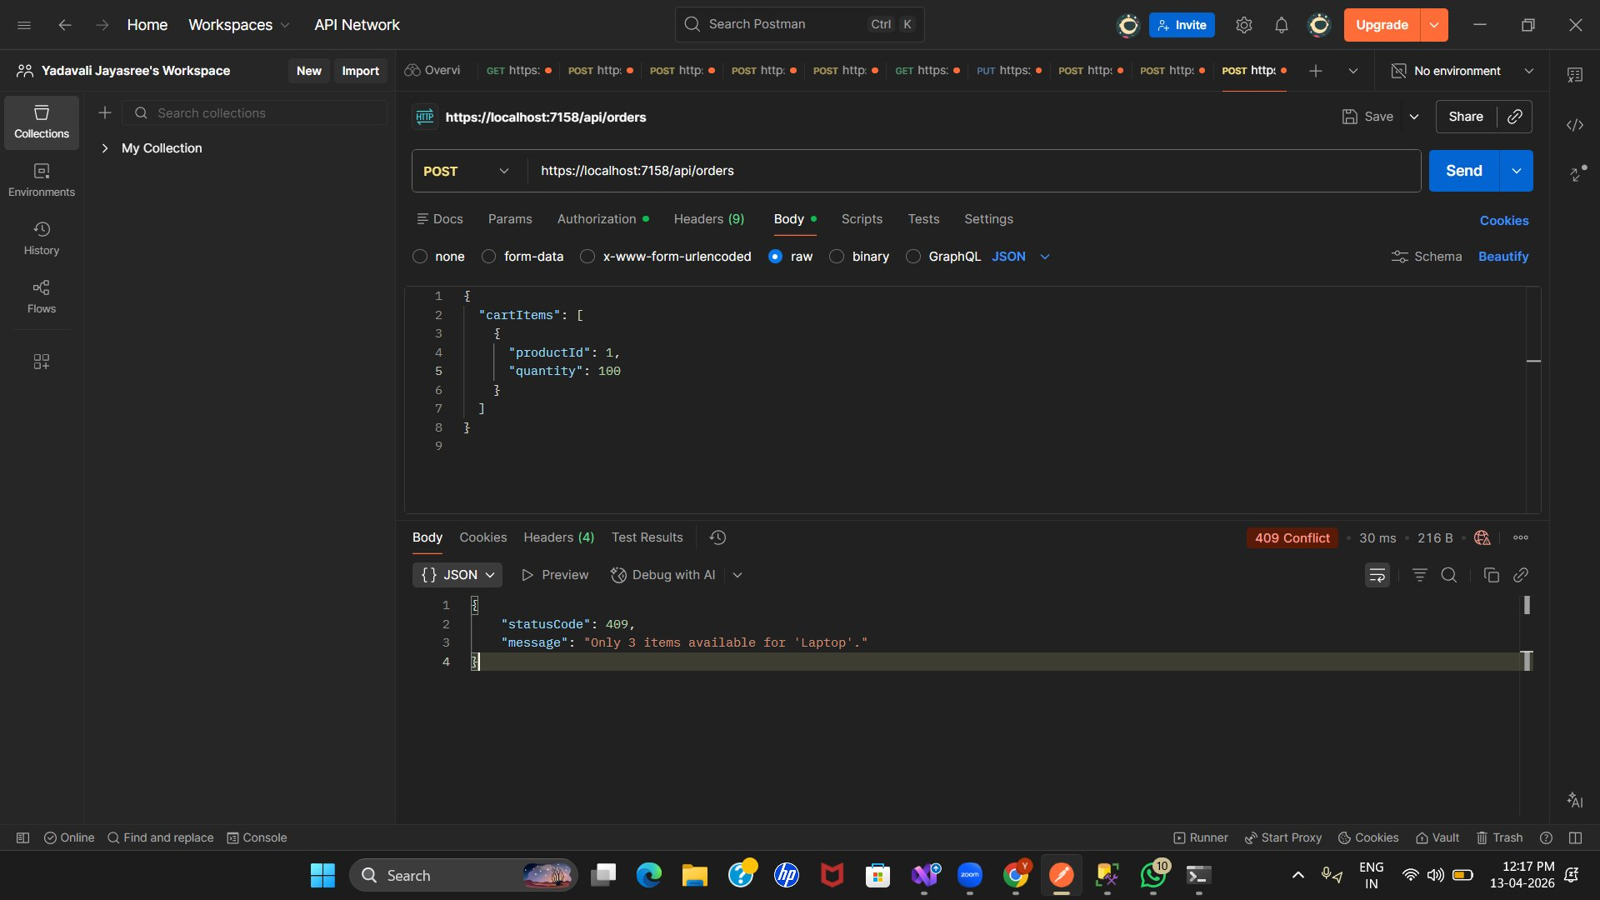

— Orders —

14. Get My Orders (Customer)
GET /api/orders/my-orders
Customer retrieves their own orders. Returns count and full order details with items and subtotals.
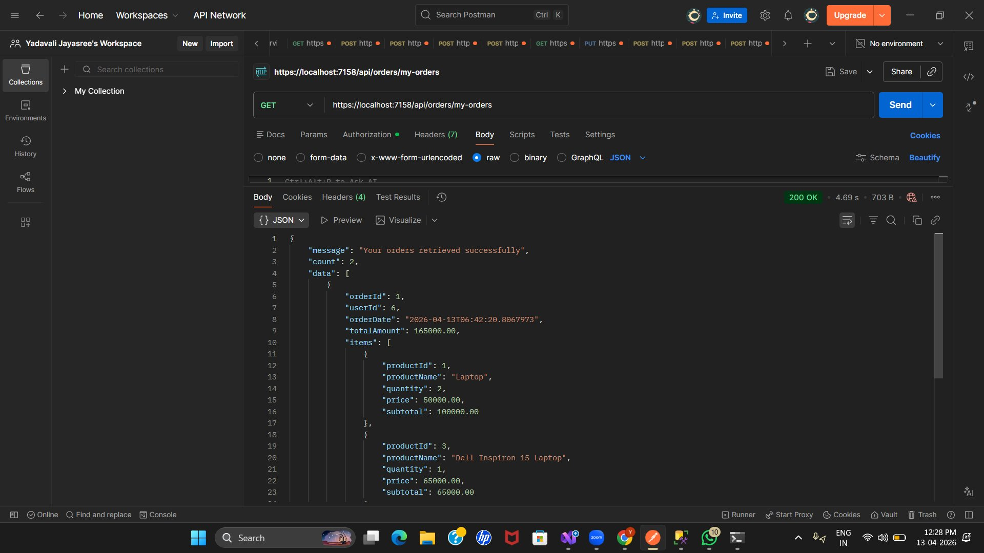

15. Get All Orders (Admin)
GET /api/orders/all-orders
Admin retrieves all orders in the system. Returns count and full details for all user orders.
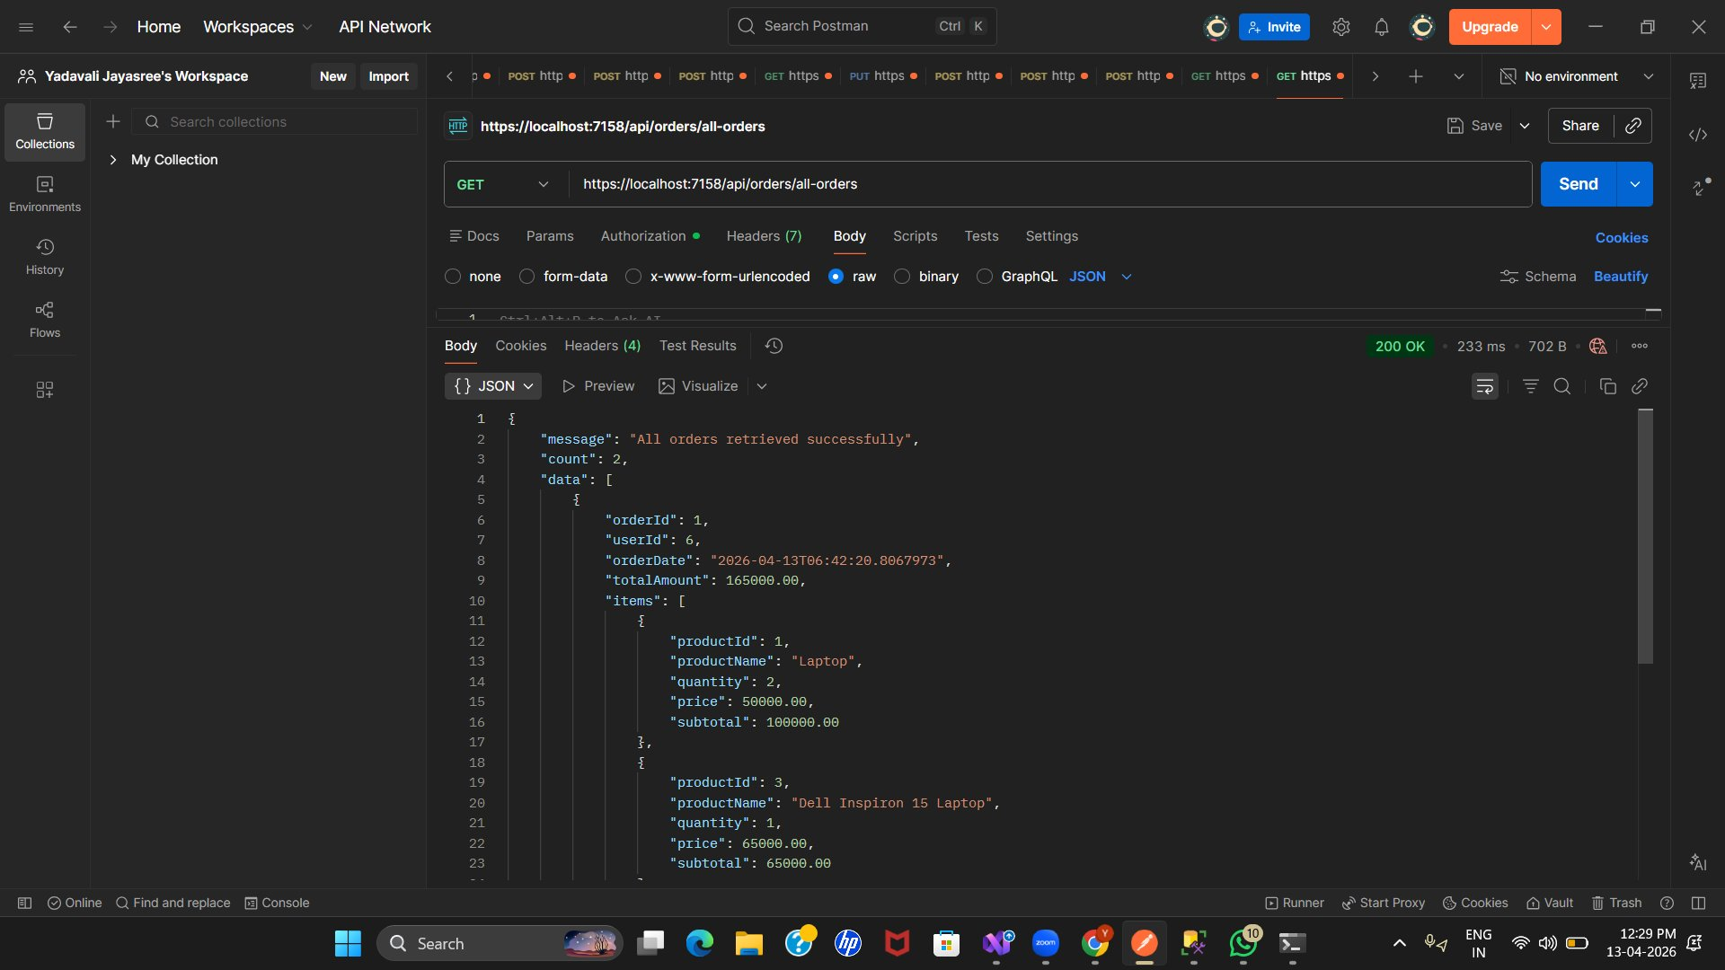

16. Get Order by ID
GET /api/orders/{id}
Fetches a specific order by ID (Order ID 1). Returns order details, items, prices, and subtotals.
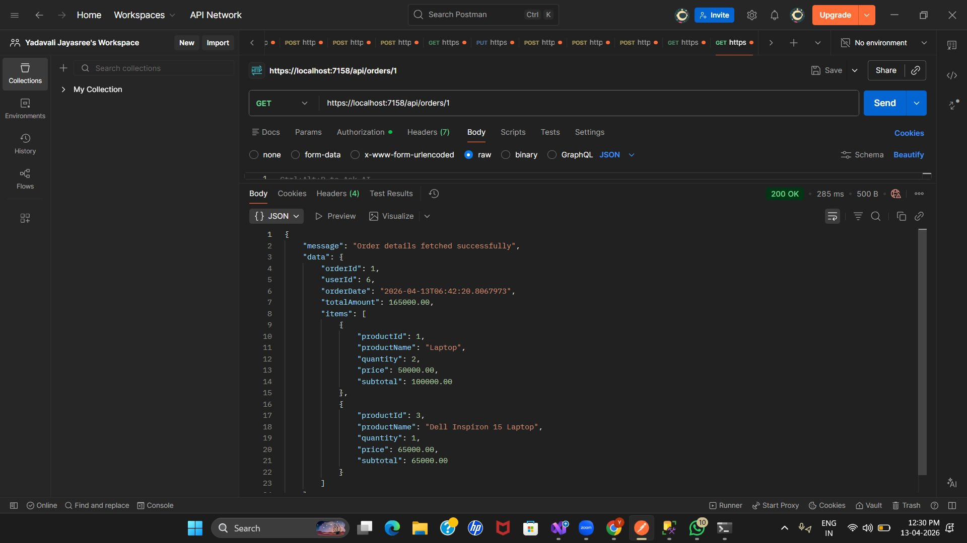

— Products —

17. Delete Product - Success (Admin Only)
DELETE /api/products/{id}
Admin successfully deletes product ID 4 from the catalog. Returns 200 OK with success message.
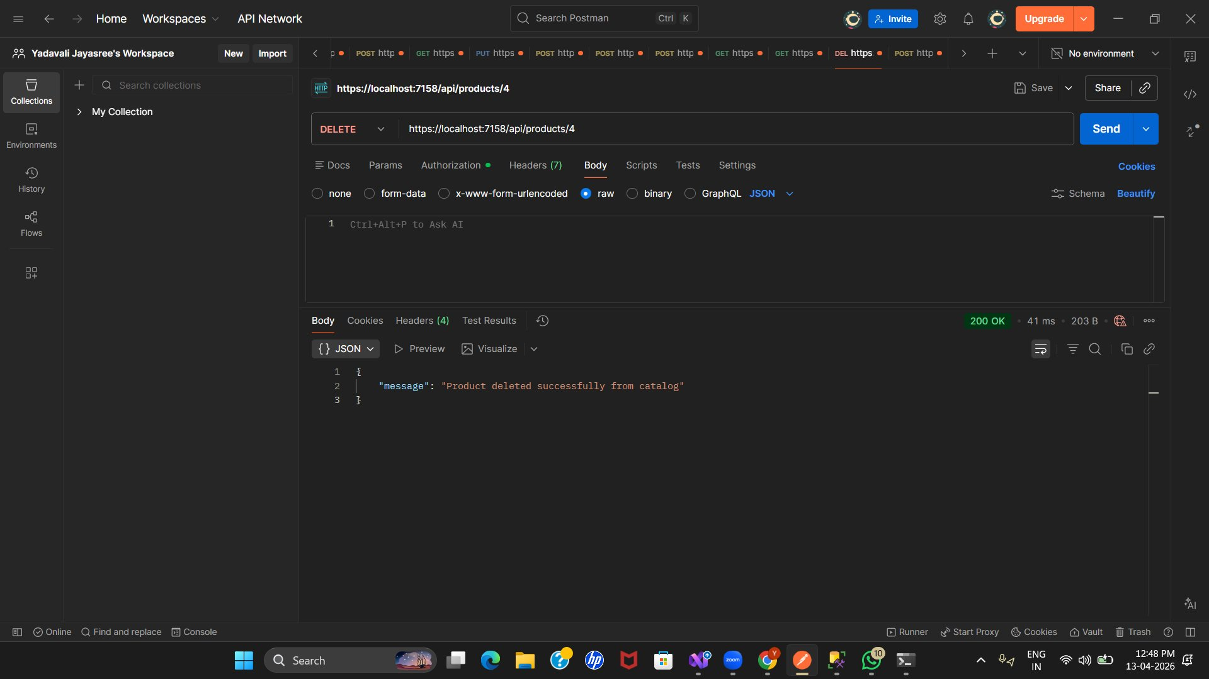

— Products - Validation —

18. Delete Product - Conflict (Product in Orders)
DELETE /api/products/{id}
Returns 409 Conflict when trying to delete product ID 3 that is already used in existing orders.
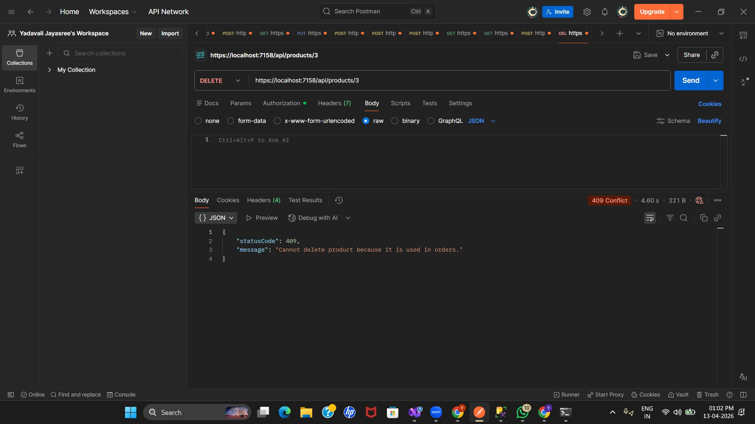

19. Delete Product - Conflict (Product in Orders)
DELETE /api/products/{id}
Returns 409 Conflict when trying to delete product ID 1 (Laptop) that is referenced in orders.
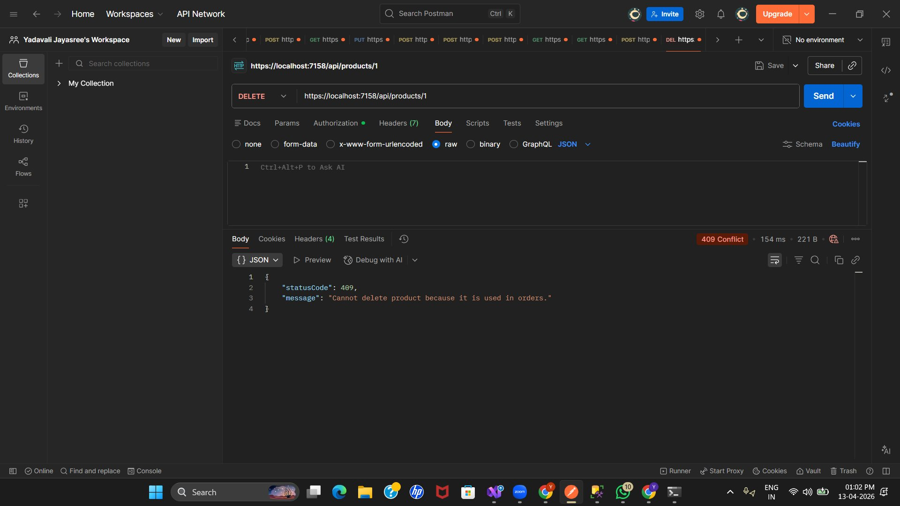

— Orders —

20. Get My Orders - Final State
GET /api/orders/my-orders
Customer retrieves their orders after all operations. Shows 2 orders with complete item details and totals.
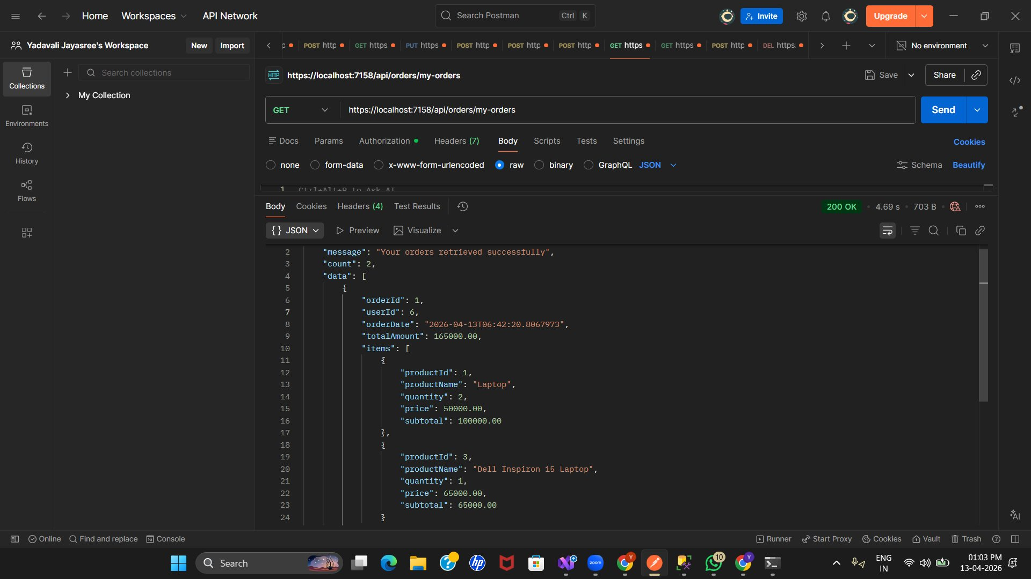

DataBase - Tables

