Bald Carrot in Dark KMU

Team Bald Carrot

5585955 최시은

5470573 김윤기

5470772 정호섭

INDEX

**1.High Concept** **3**

-High Concept 3

**2.Game Mechanism** **4**

-object collision 4

- Bullet catching system 4

-Mapping 4

-Bullets 4

**3.How to play** **5**

-Control 5

- Cheat key 5

-Goal 5

**4.Design** **6**

-environment 6

-map 6

-Item 7

-Character 8

-player 8

- Boss 8

**5.Physics** **9**

-Raycasting 9

-Movement 9

# 

# 1.High Concept

## -High Concept

Our game concept is Escape and attack game. In the midnight, bald carrot opened his eyes, he was in a dark KMU. He has to find the route using flashlight and firework items to escape the mage. When bald carrot arrives exit, he moves to boss room. In the boss room, the boss shoots the bullets to player with several attack patterns. Player catches bullets from the boss (The maximum is three) , attacks the boss using parrying system. When the boss dies, the game will end.

# 2.Game Mechanism

## -object collision

In our game, we have two collision system. One is AABB collision by assuming object shape is rectangle. It has minimum means left side - down position and maximum means right side-up position. By comparing two objects minimum and maximum position can know that two objects are colliding.

Second, there are circle collision. Circle collision is simple, if have two object’s position and radius can know that two circles are colliding.

I used circle collision only at player and bullet collision, and all the other collision system is using AABB collision

## - Bullet catching system

Bullet catching system is the main system of our game.

Player can only shoot bullet what player have caught. Player can only hold 0~3 bullets at one time. When available to catching a bullet, player circle and mouse cursor lights up.

## -Mapping

Mapping is based on tile base. We use 2D Vector (Array), I assign the case each array place. In each case, 0 case make nothing and 1 case make walls. When the 1 case save on the vector each tile position’s value and tile’s width,height. Based on this Vector Drawing rectangles on the screen and using in 2D Raycasting.

## -Bullets

Excepting player’s bullets, all the bullets are managed at one class, when the boss or something want to add bullets and shoot, just simply add bullet and it’s own vector and time when it will be shot is enough. Because our game has many bullets, to organize bullet system was important

# 3.How to play

## -Control

‘space’ key - Mainmenu - > stage 1

‘w’key - go forward

‘s’key - go back

‘a’key - go left

‘d’key - go right

‘f’ key - use firework items

mouse direction - flashlight direction

Left mouse - attack the boss

Right mouse - catch the bullet (parrying system)

## - Cheat key

‘9’ - reveal a map

‘esc’ - skip the stage

## -Goal

Player finds route to escape using flashlight and firework items. And In the boss room, Player avoid the boss’s attacking and catches the bullets from the boss. Player shoots the bullets to the boss. When the boss dies, game will end.

# 4.Design

## -environment

### -map

mage

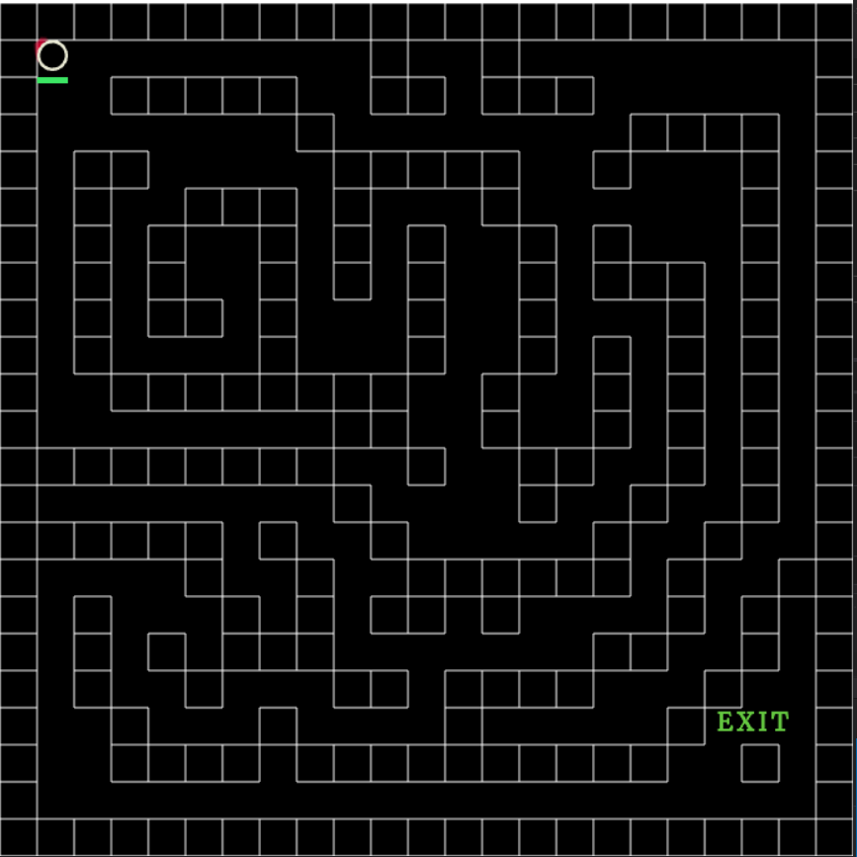

boss map

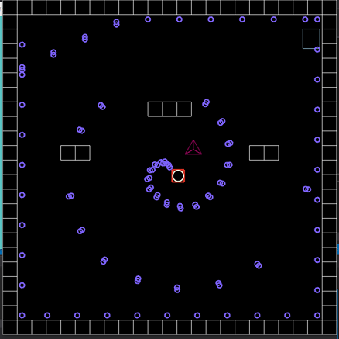

### -Item

Flashlight(The flashlight will hold for 10 seconds and blink for 1 second.)

* Player can find the escape route to use flashlight.



Firework(player can use 2 times.)

* Player can watch the mage.



* The red blocks show numbers of firework items.

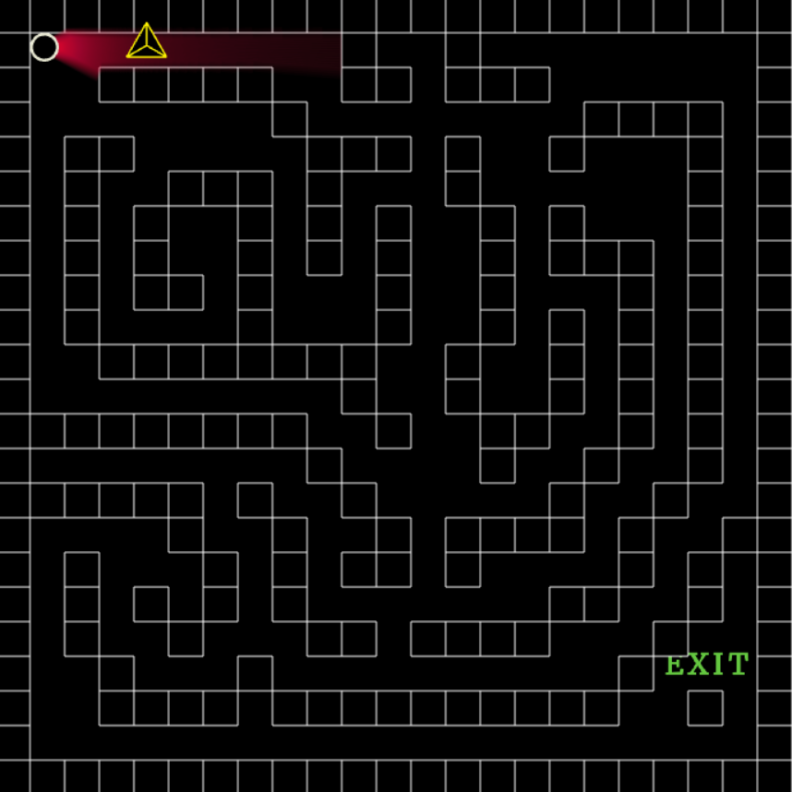

## -Character

### -player

- Player can move left,right,forward,and back.



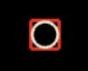

* Boss can’t attack the player this state (invincibility).



* In this state,Player can catch the bullets from the boss.
* The Green bar shows player’s life.

### - Boss



* Boss moves left and right.
* Boss has 6 attacking patterns.



* When the player attacks the boss, boss is filled with color.

# 5.Physics

## -Raycasting

Shoot a lot of line that seems like lights.

To shoot the lights, it need to math vectors class because ray casting algorithm works based on line-line intersection. so made math vector class. In vector class, function get-intersect-limit that gets the x,y values of point.

If line and wall are intersect. draw the line from light start point to intersect point.

shoot the line vector to every 0.5 degrees round the starting point.

It was a little hard to reduce the resource.

## -Movement

All the moving objects has its own vector, so just modify that vector is enough to make movement.