Slimy Doodly

Dislocation

***Team Dislocation*  
이하늘(5585895) - Producer**

**김윤기(5470573) - Technical Designer**

**박유진(5585787) - Lead Designer**

Table of Contents

**High Concept** **2**

**Summary** **2**

**Story** **2**

**Game Flow** **3**

**Game Mechanics** **3**

Wave Gun Mechanics

Player Jump Mechanics

Slime Size Change Mechanics

Puzzle Mechanics

**Game Characters** **5**

**Game Resources** **7**

Player Resources

Wave Gun Resources

**Game Environment** **7**

**Visual Design** **9**

Overall

Camera move

Perspective

**Audio Design** **10**

BGM

SFX

**Behavior Design** **10**

Slime

**Physics Design** **11**

Follow the Gravity’s Law

Follow the Law of Action, Reaction

Collision Check

# High Concept

* ‘Slimy Doodly’ is 2D side-view puzzle platformer game which player use his wave gun to push slime or to activate slime’s ability. Slimy Doodly is a game where the player solves puzzles and escapes using wave guns and slime. The hint for each puzzle is just to remember and use the characteristics of the given elements, so the player's judgment and memory is required a little bit.

# Summary

* Did you ever fall asleep while graffiti in a boring class as a child? We'll be one of the main characters of graffiti once, and once on an adventure. This game is what made our experience into a game. If you play the game thinking about the dream of the time when you went on an adventure as the main character of a graffiti character, it will be more fun, and you will be able to recall your memories by saying, “I have had these things in my dreams.”

# Story

* The player dreamed of falling asleep while drawing a doodly during a boring class, and he became the main character of the doodly. The player was trying to go somewhere on a boat and was caught in an uninhabited island by a big wave. The island's where player has arrived was Slime Island. The player thought he was going to die here and started to find a way to survive. Then he found a suspicious gun and holding it in his hand. At that moment, the slime that was hiding to attack the player, and the player was embarrassed and pointed the gun at the slime and triggered it. Soon the player saw an amazing sight of slime got pushed back and turning into a block. He thought that he can escape with this slime block, so he goes on a slime hunt ...

# Game Flow

# Game Mechanics

## Wave Gun Mechanics

In our game, player’s gun does not shoot the bullet. Instead of that, It shoot the wave. You can simply Imagine Overwatch’s Lúcio’s RightMousePress behavior. Wave can push Enemy slime.

Gun has its limits to shoot, it is automatically charged when the times passed by, or can restore it by get item about it.

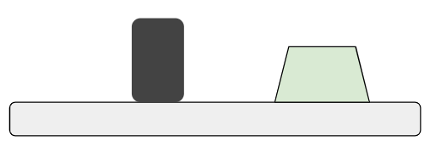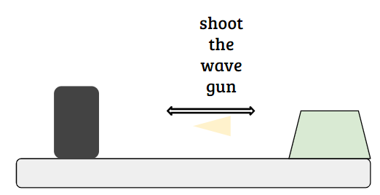

## Player Jump Mechanics

* Player can only jump once only he is on ground, but by using gun’s wave player is pushed back forward, by using it. Player can do Mega Jump while shoot Wave Gun while he is on jumping.

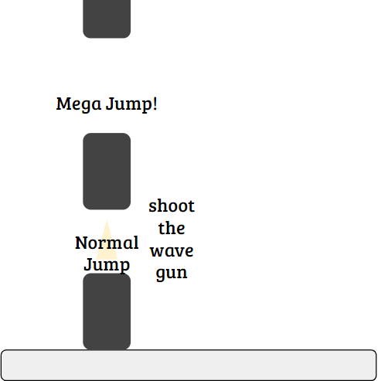

## Slime Size Change Mechanics

* There will be some kind of box makes slime bigger if it pass through, bigger slime means it can make a bigger effect in a process how to interactive with environments (etc: bigger Lava slime can make bigger block when it fall into water) player have to use this mechanic to solve problem

## Puzzle Mechanics

* Slimes are have different characteristics, You have to push this slimes to solve the puzzle.
* Some triggers only work at slimes on, player have to move slime to go forward or go to next stage.
* Examples / Trigger to make bridge or to open the door, push Lava slime into the water to make block.

# Game Characters

|  |  |
| --- | --- |
| **Player** | |
|  | Can use the wave gun to interact with slimes to escape from the map. |
| **Monster** | |
|  | ***Basic Slime***  It is a common slime, and has no characteristics. You can only make it with blocks. |
|  | ***Lava Slime***  It makes rock block when it fall into the water or can make bigger fire when it collide with fire. |
|  | ***Blue Slime***  It makes rock block when it fall into the lava or can turn off the light of the fire when it collide with fire. |
|  | ***Rainbow Slime***  It makes rainbow bridge when it get shot by Player. |
|  | **Micic Slime**  it looks similar to player, it mimics player’s behavior, if player moves, it moves same direction, if player jumps, it jumps |

# 

# Game Resources

## Player Resources

* Pollution gauge - Simply it is just the health gauge, Instead of using health, We define hit by slime makes player polluted by Ink - It will appear with not using UI, player can simply notice by just see the playable character.

## Wave Gun Resources

* Ammo - Full capacity is 3, It is automatically recharged 1 ammo per every five seconds.

# Game Environment

|  |  |
| --- | --- |
|  | **Slime Character Block**  Match the characteristics of each slime. |
|  | **Inked Block**  It can damage to player when you on that block |
|  | **Water**  Player Instantly died, To lava slime it changes slime to block. So, player have to make slime to block to go over it. |
|  | **Lava**  If blue slime gets into this lava, it becomes the Obsidian Block. If a player falls into this place, he dies. |
|  | **Grass Block**  It makes everything's move slower when it is on (it’s friction is more higher than others). |
|  | **Mic / Speaker**  Some maps have one pair of this, When player shoot the wave gun to mic block, it came out to speaker, it behavior looks like ‘Portal’(Valve)’s portal behavior. player can move speaker. |
|  | **Triggers**  All kind of triggers works when some objects on it, some trigger construct bridge, somes opens the door. you have to strategically use it to go to next stage. |

# 

# Visual Design

## Overall

* Our game is 2D platformer game, so the game played on 2D side view perspective.
* There will be a camera, because our game is also side scrolling game, it will follow playable character.
* There will be some special effects when slime get into other objects like block

All the arts are looks like poor - hand drawn by following game’s concept.

## 

## Camera move

Camera always follow the player

## 

## Perspective

2D side scrolling view

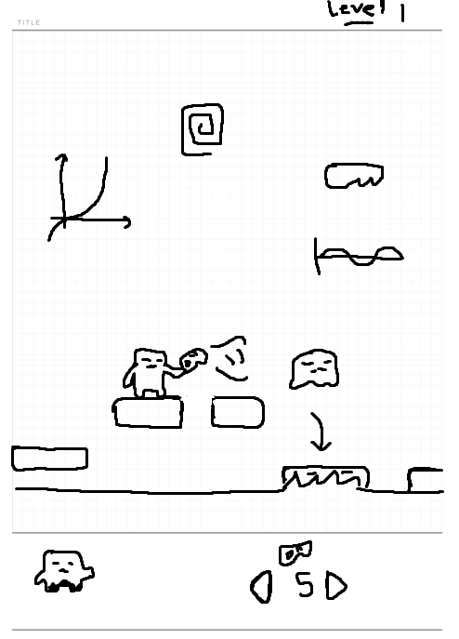

**<Design concept arts>**

# Audio Design

Video design looks like cartoon, so I try to make our BGM and SFX like cartoon. I try to make simple and not overwhelmed but good enough sound.

## BGM

### Main menu theme(Loop)

### Main game theme(Loop)

## SFX

### Player

* Move sound
* Jump sound
* Wave gun sound
* Interact with other object sound

### Slime

* Jump sound
* Turn into block sound
* Interact with other object sound

# 

# Behavior Design

## Slime

* If their move interrupted by player, they try to follow player to dealt damage.
* Slime move try not to fall into, player have to shoot then to make them fall.
* They jump once every few seconds

# Physics Design

## Follow the Gravity’s Law

* In our game, physics is quite important thing. it will be applied to our wavegun system and gameplay over all.

## Follow the Law of Action, Reaction

* It is also needed for wave gun menacincs to push other objects like slime, and also it can push player behind where gun shooted we have to add it too.

## Collision Check

* To make player keep on floor, and to check enemy hit by wave, or to give damage to player when collide with enemy object we have simple collision check