**Исследуем данные ETL**

SELECT * FROM customers;

SELECT * FROM restaurants;

SELECT * FROM orders;

SELECT * FROM riders;

SELECT * FROM deliveries;

SELECT COUNT(*) FROM customers

WHERE

customer_name IS NULL

OR

reg_date IS NULL

SELECT COUNT(*) FROM restaurants

WHERE

restaurant_name IS NULL

OR

city IS NULL

OR

opening_hours IS NULL

SELECT * FROM orders

WHERE

order_item IS NULL

OR

order_date IS NULL

OR

order_time IS NULL

OR

order_status IS NULL

OR

total_amount IS NULL

--Проверили на наличие null,не обнаружено, а так бы удалили нижеследующим кодом

--DELETE FROM orders

--WHERE

--order_item IS NULL

**Отвечаем на вопросы**

--1 Напишите запрос, чтобы найти топ-5 наиболее часто заказываемых клиентом Арджун Мехта блюд за последний 1 год.

--нужен join customers orders

--фильтры-за последний год и Арджун Мехта

SELECT c.customer_name, o.order_item as dish, count(*) as total_orders

FROM orders as o

join customers as c

ON c.customer_id=o.customer_id

where (o.order_date>= current_date-interval '1 Year') and c.customer_name='Arjun Mehta'

group by c.customer_name, o.order_item

order by total_orders desc

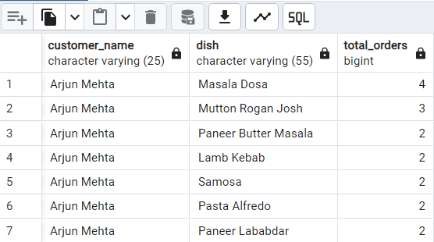

--2.Определите временные интервалы, в течение которых размещается наибольшее количество заказов. Исходя из 2-часовых интервалов.

SELECT (CASE

WHEN EXTRACT(HOUR FROM order_time) BETWEEN 0 AND 1 THEN '00:00 - 02:00'

WHEN EXTRACT(HOUR FROM order_time) BETWEEN 2 AND 3 THEN '02:00 - 04:00'

WHEN EXTRACT(HOUR FROM order_time) BETWEEN 4 AND 5 THEN '04:00 - 06:00'

WHEN EXTRACT(HOUR FROM order_time) BETWEEN 6 AND 7 THEN '06:00 - 08:00'

WHEN EXTRACT(HOUR FROM order_time) BETWEEN 8 AND 9 THEN '08:00 - 10:00'

WHEN EXTRACT(HOUR FROM order_time) BETWEEN 10 AND 11 THEN '10:00 - 12:00'

WHEN EXTRACT(HOUR FROM order_time) BETWEEN 12 AND 13 THEN '12:00 - 14:00'

WHEN EXTRACT(HOUR FROM order_time) BETWEEN 14 AND 15 THEN '14:00 - 16:00'

WHEN EXTRACT(HOUR FROM order_time) BETWEEN 16 AND 17 THEN '16:00 - 18:00'

WHEN EXTRACT(HOUR FROM order_time) BETWEEN 18 AND 19 THEN '18:00 - 20:00'

WHEN EXTRACT(HOUR FROM order_time) BETWEEN 20 AND 21 THEN '20:00 - 22:00'

WHEN EXTRACT(HOUR FROM order_time) BETWEEN 22 AND 23 THEN '22:00 - 00:00'

END) AS time_slot , COUNT(order_id) as order_count

FROM Orders

GROUP BY time_slot

ORDER BY order_count DESC;

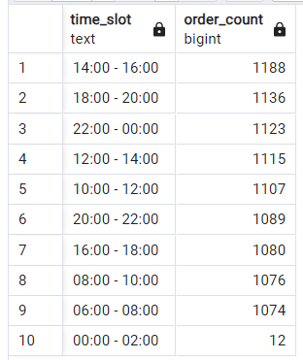

--3. Найдите среднюю стоимость заказа для каждого клиента, который разместил более 750 заказов.

SELECT c.customer_name, COUNT(o.order_id) as total_orders, AVG(o.total_amount) as avg_money

FROM orders o

JOIN customers c

ON c.customer_id = o.customer_id

GROUP BY c.customer_name

HAVING COUNT(order_id) > 750

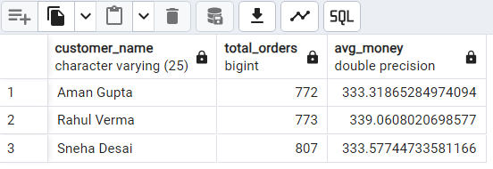

--4.Перечислите клиентов, которые потратили в общей сложности более 100 тысяч долларов на заказы еды.

SELECT c.customer_name, SUM(o.total_amount) as total_money

FROM orders o

JOIN customers c

ON c.customer_id = o.customer_id

GROUP BY c.customer_name

HAVING SUM(o.total_amount) > 100000

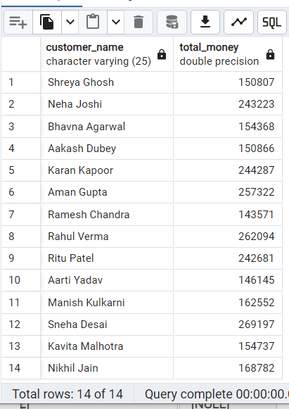

--5.Напишите запрос, чтобы найти заказы, которые были размещены, но не доставлены. Укажите название каждого ресторана, город и количество не доставленных заказов

SELECT r.restaurant_name, r.city, COUNT(o.order_id) as cnt_not_delivered_orders

FROM orders as o

LEFT JOIN

restaurants r

ON r.restaurant_id = o.restaurant_id

LEFT JOIN

deliveries d

ON d.order_id = o.order_id

WHERE d.delivery_id IS NULL

GROUP BY r.restaurant_name,r.city

ORDER BY cnt_not_delivered_orders DESC

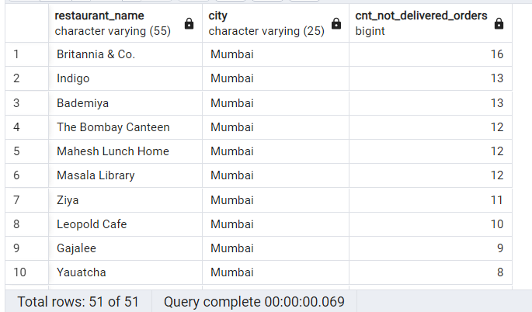

--6.Проранжируйте рестораны по их общему доходу с клиентов за последний год для каждого города, выведите топовые рестораны для каждого города

WITH tab AS (SELECT r.city, r.restaurant_name, SUM (o.total_amount) as revenue,

DENSE_RANK() OVER(PARTITION BY r.city ORDER BY SUM(o.total_amount) DESC) as rank1

FROM orders o

JOIN

restaurants r

ON r.restaurant_id = o.restaurant_id

WHERE o.order_date >= CURRENT_DATE - INTERVAL '1 year'

GROUP BY r.city, r.restaurant_name )

SELECT *

FROM tab

WHERE rank1 = 1

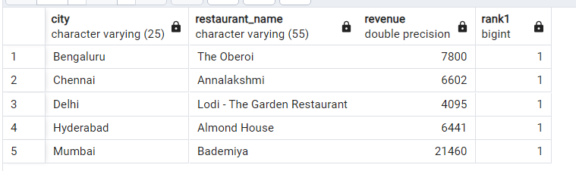

--7. Определите самое популярное блюдо в каждом городе, основываясь на количестве заказов.

WITH cte as (SELECT r.city, o.order_item as dish, COUNT(order_id) as total_orders, RANK() OVER(PARTITION BY r.city ORDER BY COUNT(order_id) DESC) as rank1

FROM orders o

JOIN restaurants r

ON r.restaurant_id = o.restaurant_id

GROUP BY r.city, o.order_item )

SELECT*

from cte

WHERE rank1 = 1

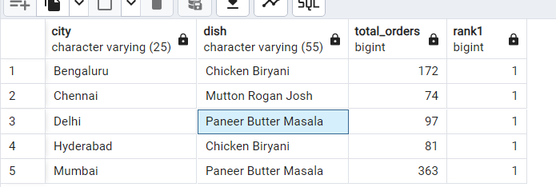

-- 8.Найдите клиентов, которые не размещали заказы в 2024 году, но сделали это в 2023 году.

SELECT DISTINCT customer_id FROM orders

WHERE EXTRACT(YEAR FROM order_date) = 2023

AND customer_id NOT IN (SELECT DISTINCT customer_id FROM orders WHERE EXTRACT(YEAR FROM order_date) = 2024)

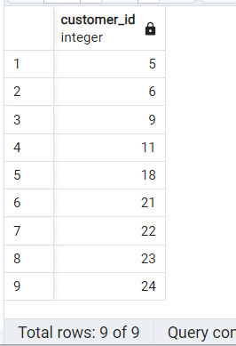

-- 9.Рассчитайте и сравните частоту отмены заказов в каждом ресторане за текущий и предыдущий годы.

WITH cte_2023 AS (

SELECT o.restaurant_id,

COUNT(o.order_id) AS total_orders,

COUNT(CASE WHEN d.delivery_id IS NULL THEN 1 END) AS count_not_delivered2023

FROM orders o

LEFT JOIN deliveries d ON o.order_id = d.order_id

WHERE EXTRACT(YEAR FROM order_date) = 2023

GROUP BY o.restaurant_id

),

cte_2024 AS (

SELECT o.restaurant_id,

COUNT(o.order_id) AS total_orders,

COUNT(CASE WHEN d.delivery_id IS NULL THEN 1 END) AS count_not_delivered2024

FROM orders o

LEFT JOIN deliveries d ON o.order_id = d.order_id

WHERE EXTRACT(YEAR FROM order_date) = 2024

GROUP BY o.restaurant_id

),

Rat_2024 AS (

SELECT restaurant_id,

total_orders,

count_not_delivered2024,

ROUND((count_not_delivered2024::numeric / total_orders::numeric) * 100, 2) AS cancel_rat24

FROM cte_2024

),

Rat_2023 AS (

SELECT restaurant_id,

total_orders,

count_not_delivered2023,

ROUND((count_not_delivered2023::numeric / total_orders::numeric) * 100, 2) AS cancel_rat23

FROM cte_2023

)

SELECT Rat_2024.restaurant_id,

Rat_2023.cancel_rat23,

Rat_2024.cancel_rat24

FROM Rat_2023

JOIN Rat_2024 ON Rat_2023.restaurant_id = Rat_2024.restaurant_id;

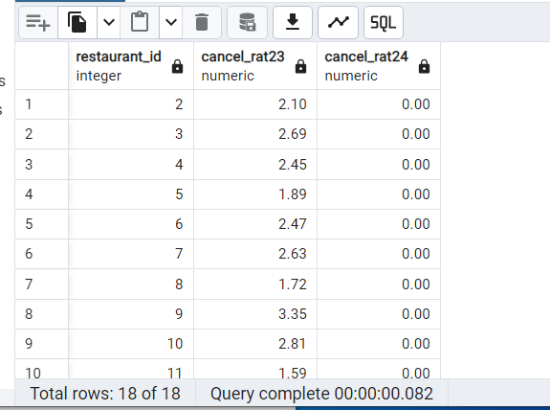

--10.Определите время доставки каждого доставщика.

SELECT d.rider_id, o.order_id,o.order_time,d.delivery_time,

d.delivery_time - o.order_time AS time_difference,

ROUND(EXTRACT(EPOCH FROM (d.delivery_time - o.order_time +

CASE WHEN d.delivery_time < o.order_time THEN INTERVAL '1 day' ELSE

INTERVAL '0 day' END))/60,2) as time_difference_minutes

FROM orders o

JOIN deliveries d

ON o.order_id = d.order_id

WHERE d.delivery_status = 'Delivered'

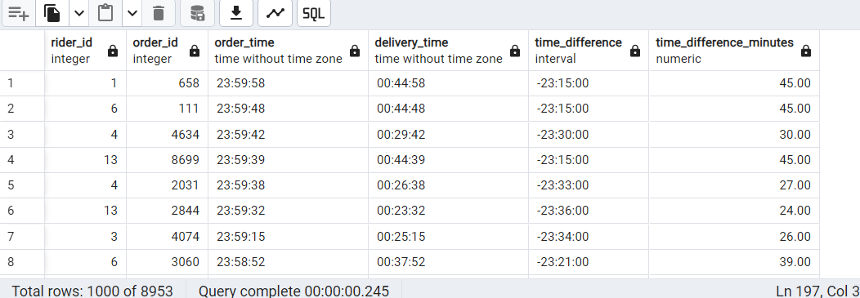

--11. Рассчитайте рост заказов в процентах от предыдущего месяца для каждого ресторана на основе количества доставленных заказов.

WITH tab AS

(SELECT o.restaurant_id,

EXTRACT(YEAR FROM o.order_date) as year1,

EXTRACT(MONTH FROM o.order_date) as month1,

COUNT(o.order_id) as month_orders,

LAG(COUNT(o.order_id), 1) OVER(PARTITION BY o.restaurant_id ORDER BY EXTRACT(YEAR FROM o.order_date), EXTRACT(MONTH FROM o.order_date)) as prev_month_orders

FROM orders o

JOIN deliveries d

ON o.order_id = d.order_id

WHERE d.delivery_status = 'Delivered'

GROUP BY o.restaurant_id, EXTRACT(YEAR FROM o.order_date), EXTRACT(MONTH FROM o.order_date)

ORDER BY o.restaurant_id, year1, month1

)

SELECT restaurant_id, year1, month1, month_orders, prev_month_orders,

ROUND((month_orders::numeric -prev_month_orders::numeric)/prev_month_orders::numeric * 100,2) as growth_rat

FROM tab;

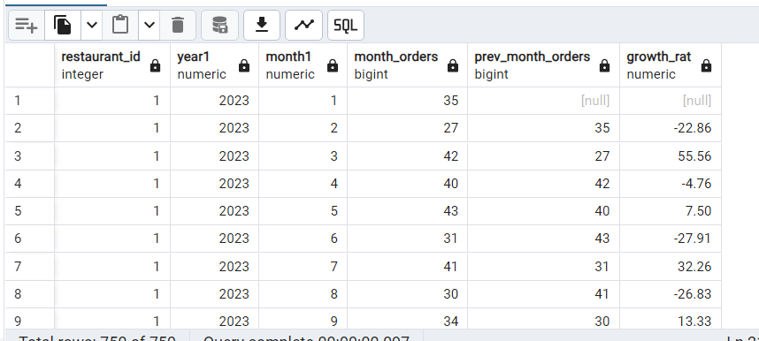

--12.Сегментация клиентов: Разделите клиентов на "Золотые" или "Серебряные" группы на основе их общих расходов.

-- в сравнении со средней стоимостью заказа (AOV). Если общие расходы клиента превышают AOV,

-- обозначьте их как "Золотые", в противном случае - как "Серебряные". Напишите SQL-запрос, чтобы определить

-- общее количество заказов в каждом сегменте и общий доход.

WITH tab AS

(SELECT customer_id,

SUM(total_amount) as total_spent,

COUNT(order_id) as total_orders,

CASE WHEN SUM(total_amount) > (SELECT AVG(total_amount) FROM orders) THEN 'Gold' ELSE 'silver' END as category

FROM orders

GROUP BY customer_id

)

SELECT category, SUM(total_orders), SUM (total_spent)

FROM tab

GROUP BY category

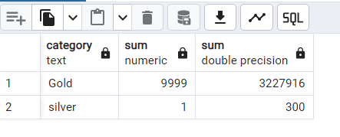

--13. Рассчитайте общий ежемесячный заработок каждого доставщика, предполагая, что он зарабатывает 8% от суммы заказа.

SELECT

d.rider_id,

TO_CHAR(o.order_date, 'mm-yy') as month1,

SUM(total_amount) as revenue,

SUM(total_amount)* 0.08 as riders_earning

FROM orders as o

JOIN deliveries as d

ON o.order_id = d.order_id

GROUP BY d.rider_id,TO_CHAR(o.order_date, 'mm-yy')

ORDER BY d.rider_id,month1

