Week 1

- Create database
mysql> create database college;
Query OK, 1 row affected (0.09 sec)

mysql> use college
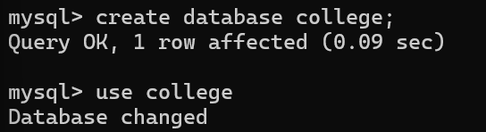
Database changed

- Create tables
Student Table :
create table Student(VTU_No varchar(15) primary key,Name varchar(150),Email varchar(100),Phone varchar(15),Department varchar(50));

Course Table:
create table Course(C_Code varchar(15) primary key,C_name varchar(150),Faculty_ID int,Student_ID varchar(15),F_Email varchar(100));

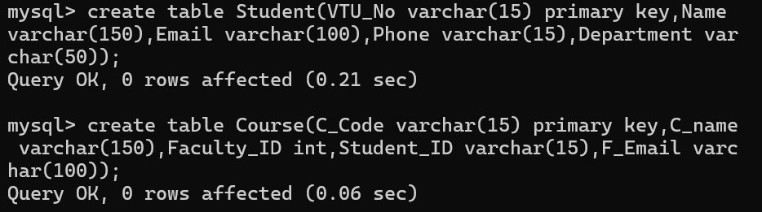

- Insert values
insert into Student
(VTU_No,Name,Email,Phone,Department)
values
('VTU2134','Aditya','adity@gmail.com','9090876540','CSE'),
('VTU2135','Rishi','rishi@gmail.com','7063932945','CSE'),
('VTU2136','Shreya','shreya@gmail.com','9531552990','BioTech'),
('VTU2137','Sneha','sneha@gmail.com','9933255889','ECE');

insert into Course values
('CS201','DBMS','101','VTU2134','david@vtu.edu'),
('CS202','Operating System','102','VTU2135','uma@vtu.edu'),
('BT202','Chemical Engineering','103','VTU2136','prof_shetty@vtu.edu'),
('EC201','Digital Electronics','104','VTU2137','prof_reema@vtu.edu');

- Select, Aggregate Functions

- select* from Student;

- select* from Course;

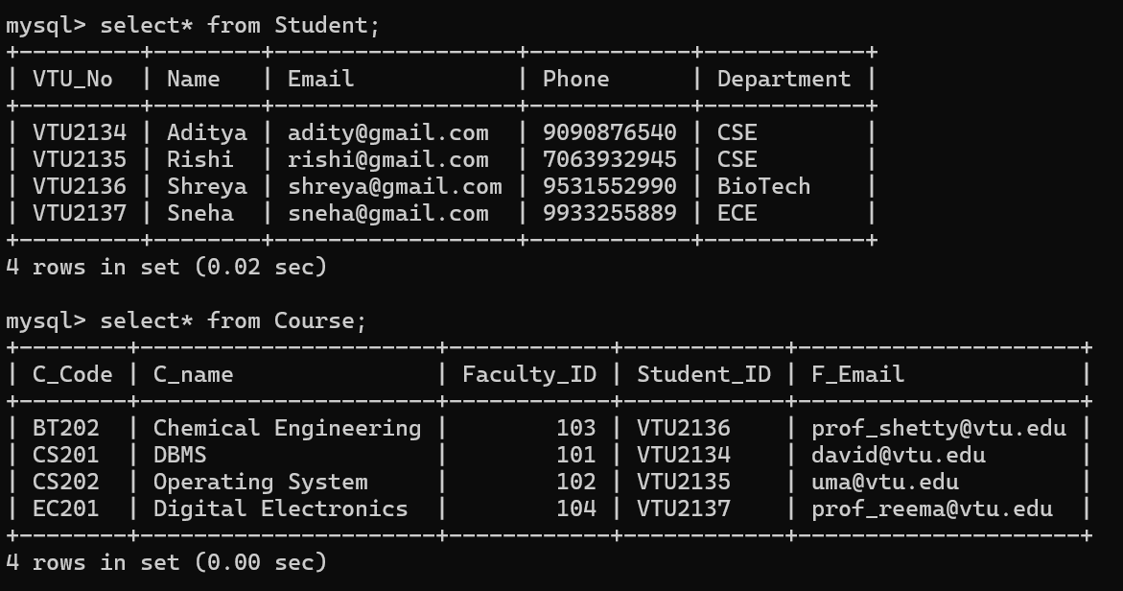

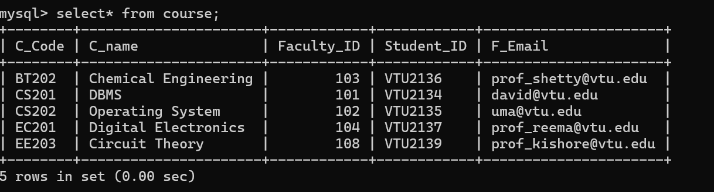

- select* from Student where Department='CSE';
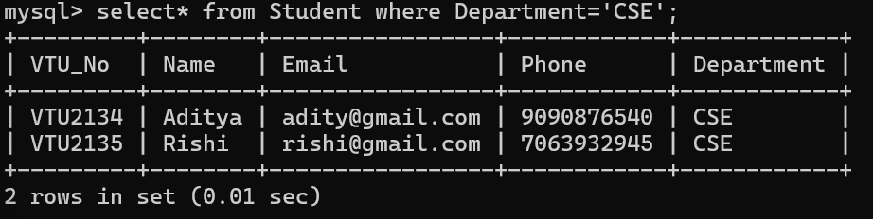

- select* from Student order by VTU_No asc;
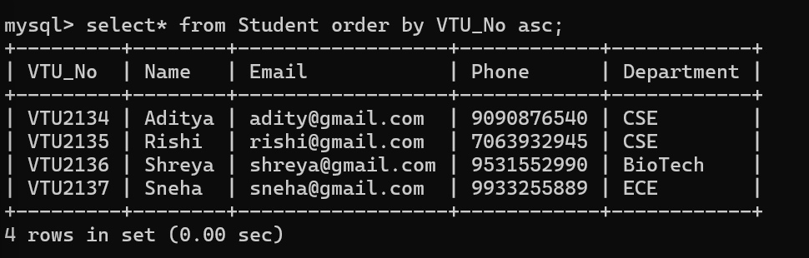

- select count(*) from Course;

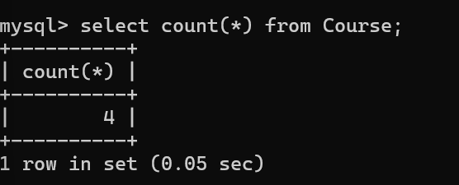

- select max(Faculty_ID) from Course;

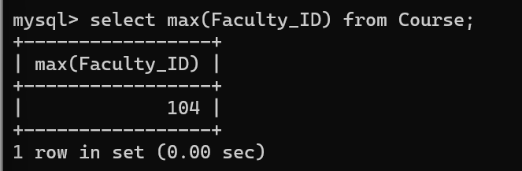

- select sum(Faculty_ID) from course;

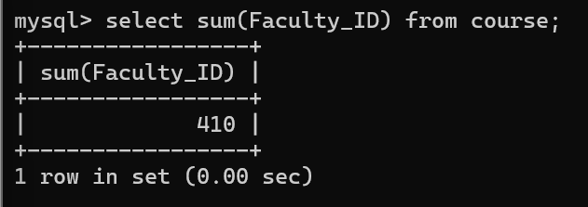

- Joins
- Inner Join

Select
Student.Name, Student.VTU_No,
Course.C_name,Course.Faculty_ID
from Student Inner Join Course on Student.VTU_No=Course.Student_ID;
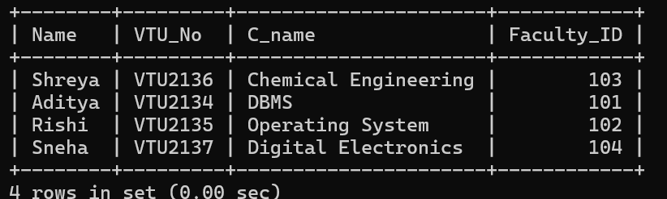

- Left Join
select Student.Name,Student.VTU_No,
Course.C_name,Course.Faculty_ID
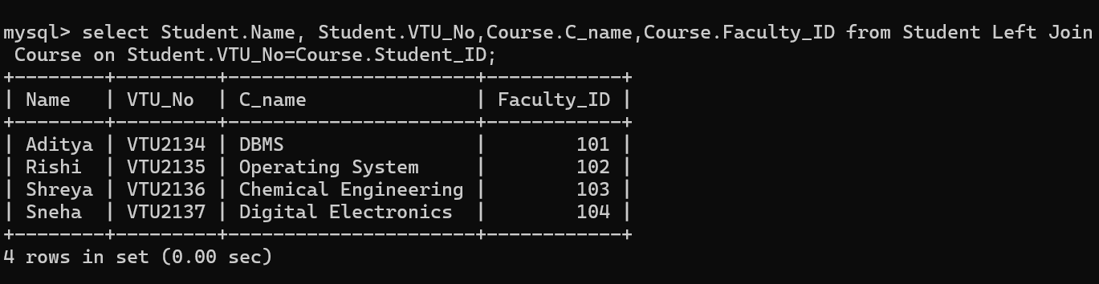
from Student Left Join Course on Student.VTU_No=Course.Student_ID;

- Right Join
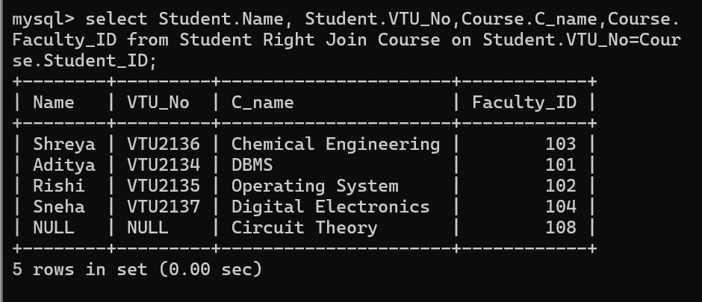
select Student.Name, Student.VTU_No,Course.C_name,Course.Faculty_ID from Student Right Join Course on Student.VTU_No=Course.Student_ID;

- Full Join
select Student.Name,Course.C_name from Student Left Join Course on Student.VTU_No=Course.Student_ID
Union
select Student.Name,Course.C_name from Student Right Join Course on Student.VTU_No=Course.Student_ID;
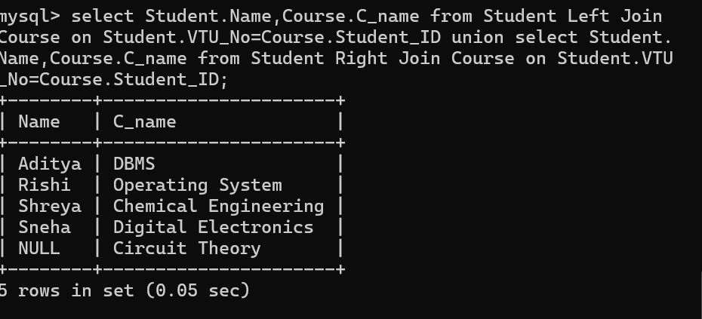

- TCL – commit,rollback,savepoint, transaction

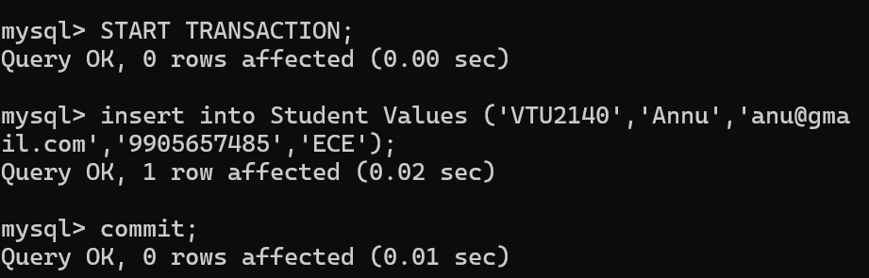

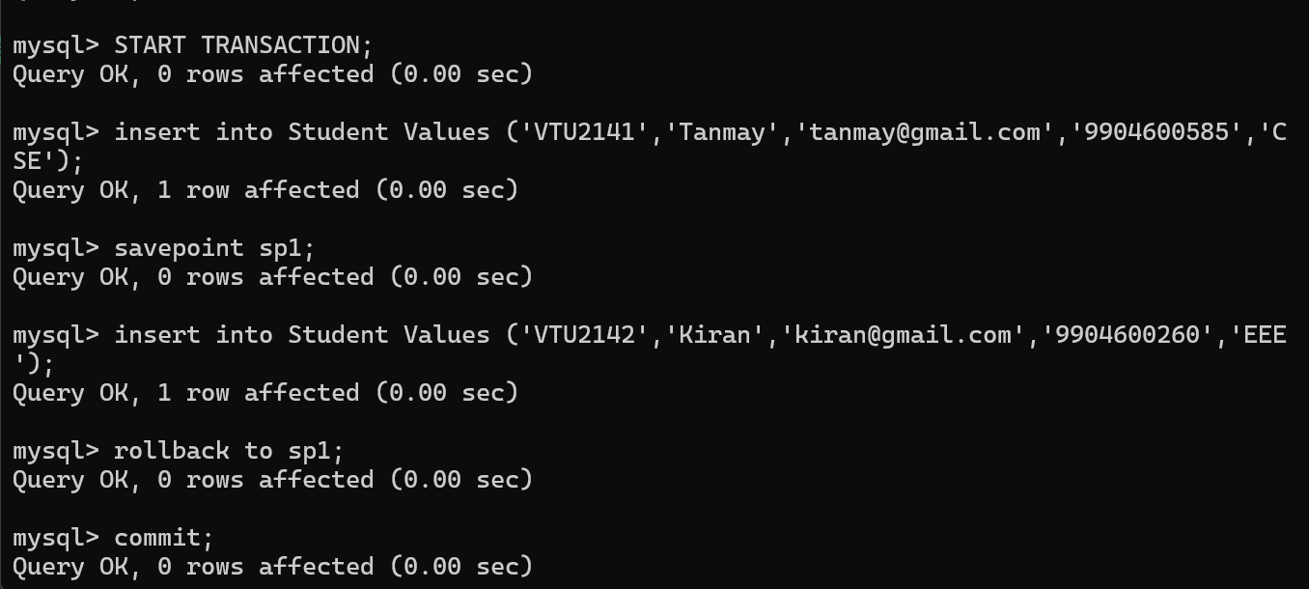
- Inbuilt functions
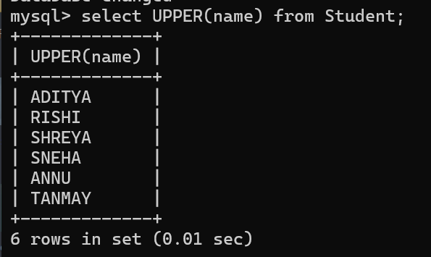

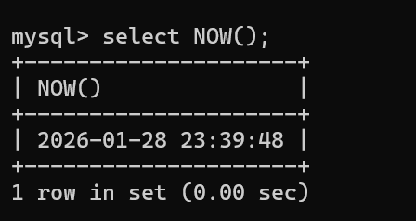

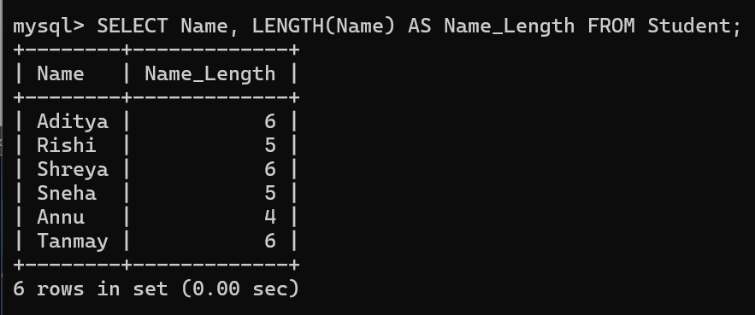

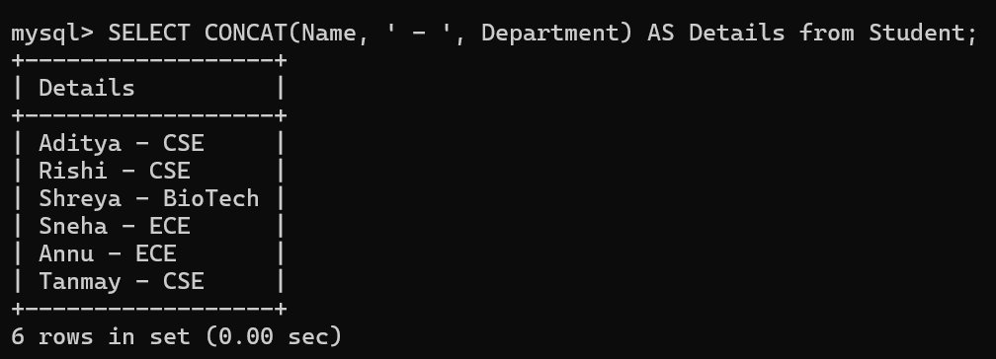

- View

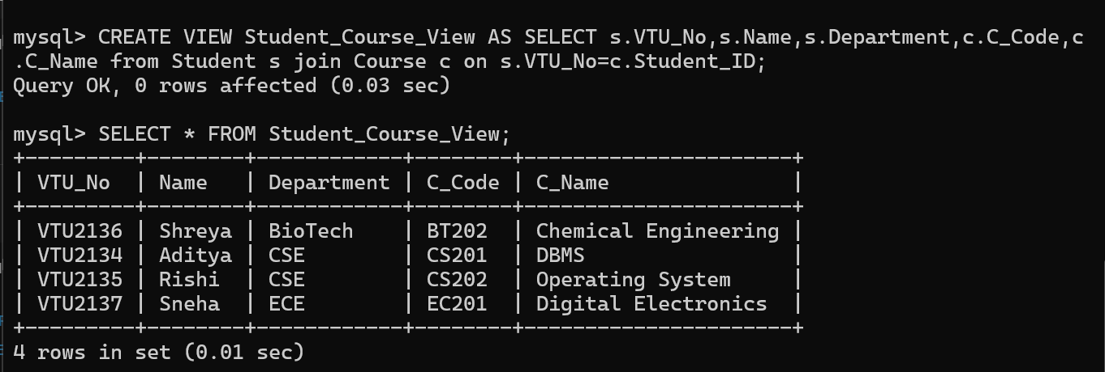

- Exception Handling

