Week 2:
Triggers

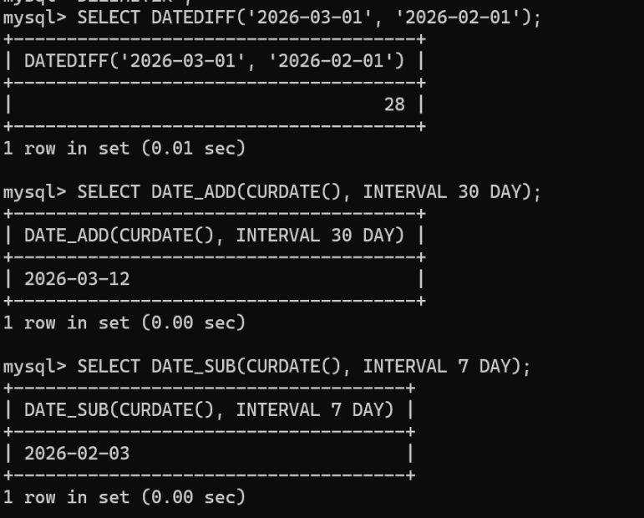
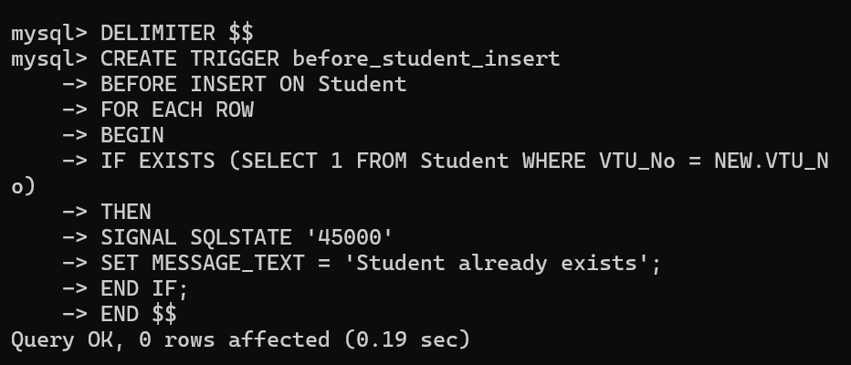
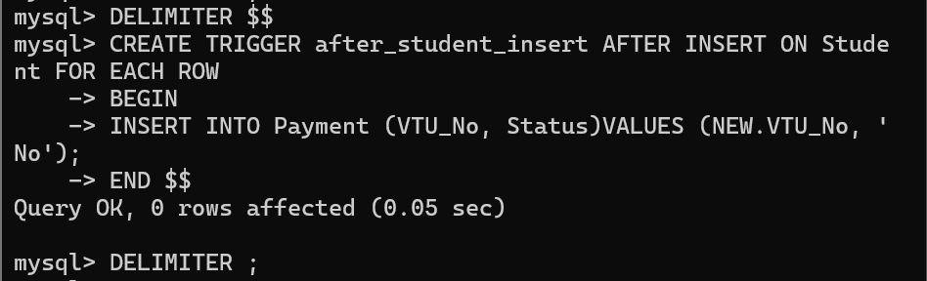

2. Date function :

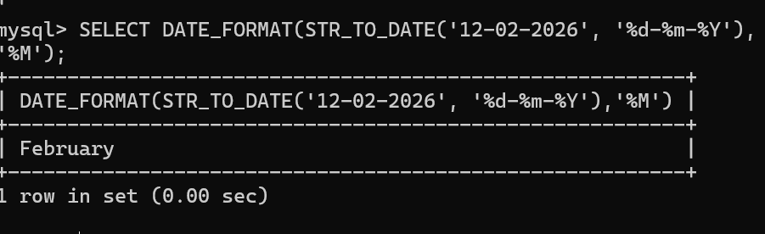
3. Indexes
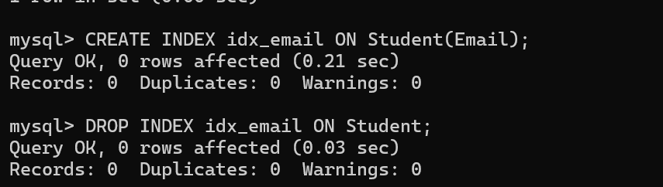

Task : user defined functions
Function: Net Salary after 10% tax
DELIMITER $$
CREATE FUNCTION net_salary(salary DOUBLE)
RETURNS DOUBLE
DETERMINISTIC
BEGIN
RETURN salary - (salary * 0.10);
END $$
DELIMITER ;
Function: User Activity Check
DELIMITER $$
CREATE FUNCTION user_status(last_login DATE)
RETURNS VARCHAR(20)
DETERMINISTIC
BEGIN
IF DATEDIFF(CURDATE(), last_login) <= 30 THEN
RETURN 'Active';
ELSE
RETURN 'Inactive';
END IF;
END $$
DELIMITER ;
Dynamic Tax Slab Function
DELIMITER $$
CREATE FUNCTION tax_amount(salary DOUBLE)
RETURNS DOUBLE
DETERMINISTIC
BEGIN
DECLARE tax DOUBLE;
IF salary <= 300000 THEN
SET tax = 0;
ELSEIF salary <= 600000 THEN
SET tax = salary * 0.10;
ELSEIF salary <= 1000000 THEN
SET tax = salary * 0.20;
ELSE
SET tax = salary * 0.30;
END IF;
RETURN tax;
END $$
DELIMITER ;
Late Fee Calculator
DELIMITER $$
CREATE FUNCTION late_fee(days_late INT)
RETURNS INT
DETERMINISTIC
BEGIN
DECLARE fee INT;
SET fee = days_late * 50;
IF fee > 1000 THEN
SET fee = 1000;
END IF;
RETURN fee;
END $$
DELIMITER ;

