Practice SQL Questions (Books Database)
Contents
Overview 1
Database Diagram (i.e. an Entity Relationship Diagram) 1
Descriptions of each table 1
The data 2
Questions and Answers 4
Single Table queries 4
Single table queries with aggregate functions but no “group by” (i.e. these will return EXACTLY one row for each query). 4
Single table queries with calculated values 5
Single table queries with “group by”. These can use aggregate functions but will return at most one row in the output for each “group” of rows as defined in the “group by” 5
Multiple table queries with group by 6
Multiple table queries 6
Subqueries, outer joins, unions and other stuff … 9

Overview
This file contains a description of a relational (i.e. SQL) database and numerous SQL questions and answers.

Database Diagram (i.e. an Entity Relationship Diagram)
Below is the Entity Relationship Diagram and a short description of the tables in the books.mdb database.
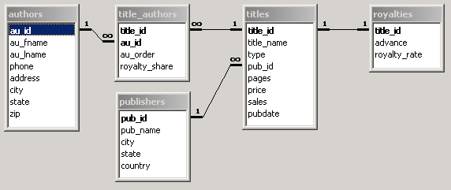

Descriptions of each table
authors table: This table stores one row for each author.
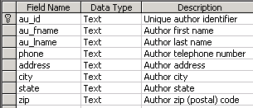

publishers table: This table stores one row for each publisher.
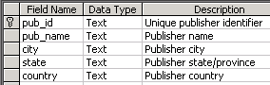

titles table: This table stores one row for each book (AKA title).
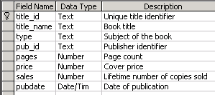
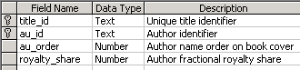
title_authors table: Each row in this table represents a relationship between an author and a book that (s)he wrote. If a book has 3 authors, there will be 3 rows in this table for that book. This table has a composite primary key (title_id, au_id). The "royalty_share" field represents the percent of the royalties that this author receives. If there is only one author for a book then this will be 1. If there are two authors for the book, the "royalty_share" could be the same for both or it could be different (e.g. 0.6 and 0.4).

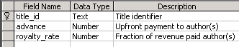royalties table: This table the information about royalties that the publisher will pay to the author(s) of a book. "advance" is the fixed amount that the publisher pays the author when (s)he starts to write the book. "royalty_rate" is a decimal value that contains the percent of each book's sale price that is paid to the author(s). If there is more than one author then the royalties and advaces are split between them

The data
Publishers:
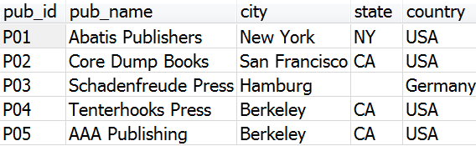
Titles:
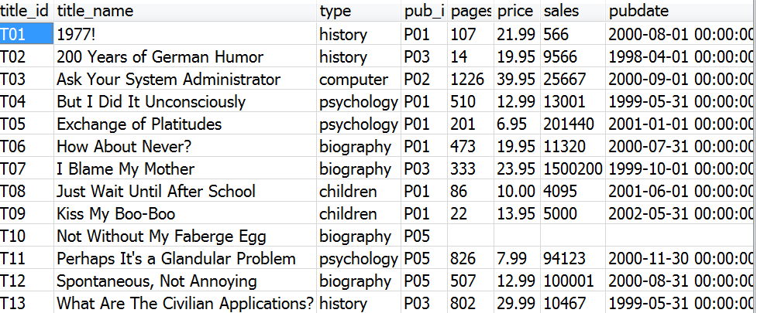
Authors:
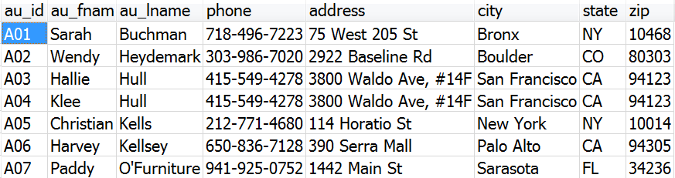

Title_Authors:
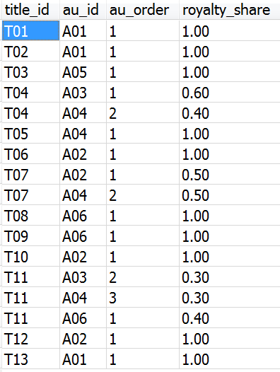
Royalties:
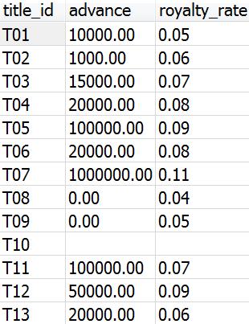

Questions and Answers
Create the following queries for the “books” database. For each query make sure to only include those tables that are necessary to answer the question. NOTE: the answers shown below are just some possible answers. For some questions there may be more than one possible answer.

Single Table queries

- List all books (title and number sold) that sold more than 1000 copies. List the books with the most sales at the top.
ANSWER:
select title_name, sales
from titles
where sales > 1000
order by sales desc;
- List all authors who are live either in NY or CA and whose last name begins with a "K".
ANSWER:
select au_fname, au_lname
from authors
where (state = 'NY' or state='CA') and substr(au_lname,1,1) = 'K'; -- (parentheses are required
-- since AND is done before OR by default)
- List the first and last names of all authors whose last name starts with a letter from A through J (HINT: specify the author's name twice but only show one of them. In the criteria for one of them list >="A" and in the criteria for the other list <"K")
ANSWER:
select au_fname, au_lname
from authors
where substr(au_lname,1,1) >= 'A' and substr(au_lname,1,1) < 'K';
- For each author, show their first initial, followed by a period and a space, followed by their last name. In the 2nd column show the author's state. Show the column heading for the first column as 'AuthorName'. Order the results in alphabetical order based on the full name of the person.
ANSWER:
select substr(au_fname,1,1) || '. ' || au_lname as 'AuthorName', state
from authors
order by au_lname, au_fname;
- Show the titles of all books. Also show the length of the title, i.e. how many characters, including spaces and punctuation. Display the 2nd column with the name 'TitleLength'. Sort the output so that the shortest titles are listed first. If two titles are the same length then sort those titles alphabetically.
ANSWER
select title_name, length(title_name) as 'TitleLength'
from titles
order by length(title_name), title_name;

Single table queries with aggregate functions but no “group by” (i.e. these will return EXACTLY one row for each query).
- List the average price of all books.
ANSWER:
select avg(price)
from titles;

- List the average price of history books.
ANSWER:
select avg(price)
from titles
where type = 'history';
- List the number of pages in the longest and shortest books (don't list the actual title of the book).
ANSWER:
select min(pages) , max(pages) from titles;

Single table queries with calculated values

- List the title_name and total revenue for each book. (Revenue for a book is the number sold times the price of the book.)
ANSWER:
select title_name, sales * price as 'Total Revenue'
from titles;
- List title of each book and the sale price for the book where the sale price is 10% off of the original price.
ANSWER:
select title_name, price * 0.90 as 'Sale Price'
from titles;

Single table queries with “group by”. These can use aggregate functions but will return at most one row in the output for each “group” of rows as defined in the “group by”
- For each "type" of book (e.g. biography, children, etc) list the number of pages in the shortest book of that type and the number of pages in the longest book of that type. Sort the results alphabetically by the type of book.
ANSWER:
select type, min(pages) AS 'Length of Shortest' , max(pages) as 'Length of Longest'
from titles
group by type
order by type;

- List the types of books (e.g. history, biography, etc) and the average price of those books for which the average price of books in that category is at least $12.00.
ANSWER:
select type, avg(price)
from titles
group by type
having avg(price) >= 12;
- List the types of books (e.g. history, biography, etc) and the average price of those books for which the average price of books in that category is at least $12.00.
ANSWER:
select type, avg(price)
from titles
group by type
having avg(price) >= 12;
- For each type of book (e.g. biography, children, etc), show the number of those books that are 450 pages or longer. The column heading should be '# of long books'. If there are no titles of a particular type that are so long, then don't show that type at all.
ANSWER
select type, count(*) as '# of long books'
from titles
where pages >= 450
group by type;
- Modify the answer to the previous question so that only those types for which there are at least 2 long books are displayed.
ANSWER - NOTE: the only change to the above answer is the addition of the HAVING clause at the end.
select type, count(*) as '# of long books'
from titles
where pages >= 450
group by type
having count(*) >= 2; -- this is the only change.

Multiple table queries with group by

- For each publisher, list the name of the publisher and total number of pages that the publisher has published in all their books (ie. add up all the pages in all books for each publisher). Show the publishers who have published the most pages at the top of the result list.
ANSWER
select pub_name, sum(pages)
from publishers join titles on publishers.pub_id = titles.pub_id
group by pub_name
order by sum(pages) desc;
- Modify the previous query so that only publishers who have published at least 1250 pages will show up.
ANSWER
select … -- same as previous question
from … -- same as previous question
group … -- same as previous question
having sum(pages) >= 1250 -- THIS LINE IS THE ONLY CHANGE
order … -- same as previous question
- List each publisher's name and the numbers of pages in their longest and shortest books. Sort the results by the publisher's name.
ANSWER:
select pub_name, min(pages) AS 'Length of Shortest' , max(pages) as 'Length of Longest'
from titles join publishers on titles.pub_id = publishers.pub_id
group by pub_name
order by pub_name;

Multiple table queries
- List the authors first and last names, the author's state, the title name, the publisher name and the publishers state for all books.
ANSWER:
select au_fname, au_lname, authors.state, title_name, pub_name, publishers.state
from authors join title_authors on authors.au_id = title_authors.au_id
join titles on title_authors.title_id = titles.title_id
join publishers on publishers.pub_id = titles.pub_id;
- List the title, number of pages, authors first and last names and author's state for all books that are longer than 150 pages and whose author lives in NY or CA.
ANSWER:
select title_name, pages, au_fname, au_lname, authors.state
from authors join title_authors on authors.au_id = title_authors.au_id
join titles on title_authors.title_id = titles.title_id
where pages > 150 and (state = 'NY' or state = 'CA') ; -- (parentheses ARE necessary since by default AND is done before OR)
- List the authors first and last names, the author's state, the title name, the publisher name and the publishers state only for those books where the author and publisher are from the same state. (HINT: specify authors.state [note: there is a period between author and state] in the criteria for the publisher's state).
ANSWER:
select au_fname, au_lname, authors.state, title_name, pub_name, publishers.state
from authors join title_authors on authors.au_id = title_authors.au_id
join titles on title_authors.title_id = titles.title_id
join publishers on publishers.pub_id = titles.pub_id
where authors.state = publishers.state;
- List the title and authors of all books published by "Abatis Publishers" sort the results in alphabetical order by title and then by the au_order column. Do NOT show that au_order column in the output.
ANSWER:
select au_fname, au_lname, title_name, pub_name
from authors join title_authors on authors.au_id = title_authors.au_id
join titles on title_authors.title_id = titles.title_id
join publishers on publishers.pub_id = titles.pub_id
where pub_name = 'Abatis Publishers'
order by title_name, au_order;
- List the publisher name, author name, and title name for all books that have at least 100 pages and that sold at least 200 copies. Sort the results in alphabetical order first by publisher and then by author.
ANSWER:
select pub_name, au_fname, au_lname, title_name
from authors join title_authors on authors.au_id = title_authors.au_id
join titles on title_authors.title_id = titles.title_id
join publishers on publishers.pub_id = titles.pub_id
where pages >= 100 and sales >= 200
order by pub_name, au_lname, au_fname;
- List authors first and last names and the titles they wrote for publishers whose name (ie. the publisher's name) begins with "A", "B" or "C"
ANSWER:
select au_fname, au_lname, title_name, pub_name
from authors join title_authors on authors.au_id = title_authors.au_id
join titles on title_authors.title_id = titles.title_id
join publishers on publishers.pub_id = titles.pub_id
where substr(pub_name, 1,1) IN ('A','B','C');
ANOTHER ANSWER: Same as above but use the following WHERE clause instead:
select … # same as above
from …. # same as above
where pub_name like 'A%' or pub_name like 'B%' or pub_name like 'C%';
- List the publisher name, author's name and phone number for all authors that have written books for the publisher's whose name begins with a letter from A through J. (HINT: specify the publisher's name twice but only show one of them. In the criteria for one of them list >="A" and in the criteria for the other list <"K").
ANSWER:
select pub_name, au_fname, au_lname, phone
from authors join title_authors on authors.au_id = title_authors.au_id
join titles on title_authors.title_id = titles.title_id
join publishers on publishers.pub_id = titles.pub_id
where substr(pub_name,1,1) >= 'A' and substr(pub_name,1,1) < 'K';

- List the titles of all books and the number of authors for the book (NOT the actual author names). Sort the results so that the books with the most authors appear on top. All books that have the same number of authors should be listed in alphabetical order.
ANSWER:
select title_name, count(*) as 'Number of Authors'
from authors join title_authors on authors.au_id = title_authors.au_id
join titles on title_authors.title_id = titles.title_id
group by titles.title_id, title_name
order by count(*) desc, title_name;
- List the titles of all books that have 2 or more authors and that are longer than 50 pages.
ANSWER:
select title_name, count(*) as 'Number of Authors'
from authors join title_authors on authors.au_id = title_authors.au_id
join titles on title_authors.title_id = titles.title_id
where pages >= 50
group by titles.title_id, title_name
having count(*) >= 2
order by count(*) desc, title_name;

- List all publishers and the number of books that the publisher has published (not the actual titles, just the number of books). Sort the list so that the publisher with the most books appears on top.
ANSWER:
select pub_name, count(*) as '# of Books'
from titles join publishers on publishers.pub_id = titles.pub_id
group by publishers.pub_id, pub_name
order by count(*) desc;

- List the publisher name and total revenue for each for each publisher. (Total revenue for a publisher is the total revenue for all books published by that publisher. Revenue for a book is the number sold times the price of the book.)
ANSWER:
select pub_name, sum(sales * price) as 'Total Revenue'
from titles join publishers on publishers.pub_id = titles.pub_id
group by publishers.pub_id, pub_name ;
- Modify the previous query to only list those publishers who have at least ten thousand dollars in total revenue.
ANSWER:
select pub_name, sum(sales * price) as 'Total Revenue'
from titles join publishers on publishers.pub_id = titles.pub_id
group by publishers.pub_id, pub_name ;
having sum(sales * price) >= 10000;
- List the title and author of each book. For each author for a particular book, list the amount of the "advance" that (s)he got for that book.
ANSWER:
select title_name, au_fname, au_lname, advance
from authors join title_authors on authors.au_id = title_authors.au_id
join titles on title_authors.title_id = titles.title_id
join royalties on royalties.title_id = titles.title_id;
- List the title and author of each book. For each author for a particular book, list the total amount in royalties that (s)he got for that book.
Hint: the royalty dollars for a particular book is the "price" times the "sales" times the "royalty_rate" times the "royalty_share". Sort the results so that the authors who made the most royalty dollars are listed at the top. (NOTE: make sure to read the database description at the top of this document to understand the fields ROYALTIES.ROYALTY_RATE and the field TITLE_AUTHORS.ROYALTY_SHARE).
ANSWER:
select title_name, au_fname, au_lname, royalty_share * royalty_rate * sales * price as 'Total Royalties for Author'
from authors join title_authors on authors.au_id = title_authors.au_id
join titles on title_authors.title_id = titles.title_id
join royalties on royalties.title_id = titles.title_id;

- List the name of each author and the total amount of royalty dollars that they received for all of their books (name this column “RoyaltyDollars”). Hint: the royalty dollars for a particular book is the "price" times the "sales" times the "royalty_rate" times the "royalty_share". Sort the results so that the authors who made the most royalty dollars are listed at the top.
ANSWER:
select au_fname, au_lname, sum(royalty_share * royalty_rate * sales * price) as 'Total Royalties for Author'
from authors join title_authors on authors.au_id = title_authors.au_id
join titles on title_authors.title_id = titles.title_id
join royalties on royalties.title_id = titles.title_id
group by authors.au_id, au_fname, au_lname
order by sum(royalty_share * royalty_rate * sales * price) desc;

- Modify the query from the previous question so that the list only includes authors who made more than $50,000.00 in royalties.
ANSWER:
select au_fname, au_lname, sum(royalty_share * royalty_rate * sales * price) as 'Total Royalties for Author'
from authors join title_authors on authors.au_id = title_authors.au_id
join titles on title_authors.title_id = titles.title_id
join royalties on royalties.title_id = titles.title_id
group by authors.au_id, au_fname, au_lname
having sum(royalty_share * royalty_rate * sales * price) > 50000
order by sum(royalty_share * royalty_rate * sales * price) desc;

Subqueries, outer joins, unions and other stuff …
- Show the title names and number of pages for those books that are longer than (ie. more pages) the average length of all books.
ANSWER:
select title_name , pages
from titles
where pages >= (select avg(pages) from titles);
- Show the publisher's name and number of authors who have written books for that publisher:
ANSWER:
select pub_name, count(DISTINCT authors.au_id) as '# of authors'
from authors join title_authors on authors.au_id = title_authors.au_id
join titles on title_authors.title_id = titles.title_id
join publishers on publishers.pub_id = titles.pub_id
group by pub_id, pub_name;
- Show the pub_name and the number of titles published by that publisher. Only include publishers for whom at least 5 authors have worked.
ANSWER:
select pub_name, count(*) as 'Number of Titles'
from publishers as pub1 join titles on pub1.pub_id = titles.pub_id
group by pub1.pub_id, pub_name
having 5 <= ( select count(DISTINCT authors.au_id)
from authors join title_authors on authors.au_id = title_authors.au_id
join titles on title_authors.title_id = titles.title_id
join publishers as pub2 on pub2.pub_id = titles.pub_id
where pub2.pub_id = pub1.pub_id ) ;
- Show the names of publishers who did not publish any books (I guess they are just getting started ☺ )
ANSWER – with a subquery
select pub_name
from publishers as pub1
where not exists
( select *
from publishers as pub2 join titles on pub2.pub_id = titles.pub_id
where pub2.pub_id = pub1.pub_id );
ANSWER – with a left join
select pub_name from publishes left join titles on publishers.pub_id = titles.pub_id
where title_id is NULL;

- List the name of each publisher and the total number of books that each publisher has published. Sort the results so that the publishers who published the most books appear at the top. If two or more publishers published the same number of books then they should be listed in alphabetical order.

  - The answer should only include publisher who have published some books.
ANSWER:
select pub_name, count(*)
from titles join publishers on publishers.pub_id = titles.pub_id
group by pub_name
order by count(*) desc, pub_name;
  - This time make sure to also include publishers who have published zero books
ANSWER:
select pub_name, count(titles.title_id)
from publishers left join titles on publishers.pub_id = titles.pub_id
group by pub_name
order by count(*) desc, pub_name;
ANSWER – with a UNION – however the previous answer is shorter and more to the point
select pub_name , 0 as NumTitles
from publishes left join titles on publishers.pub_id = titles.pub_id
where title_id is NULL
UNION
select pub_name, count(*) as NumTitles
from titles join publishers on publishers.pub_id = titles.pub_id
group by pub_name;

