Assignment: Relational Database Tables and their Relationships
Contents
Questions about a particular entity relationship diagram 1
Longer form questions - Directions 2
Longer form questions - Questions (and answers) 3

Questions about a particular entity relationship diagram
Answer the questions below by referring to the following ERD:
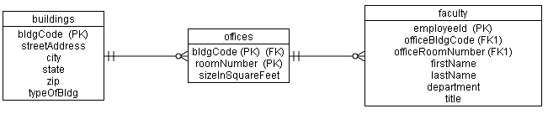
Answer the questions by referring to the ERD above. Make sure to JUSTIFY YOUR ANSWER by identifying the parts of the diagram that your answer is based on.
- Does every faculty member get an office or is it possible for a faculty member to NOT have an office? Can a faculty member have MORE than one office?
ANSWER: Every faculty member has at least one office. This is indicated by the "1" for the minimum cardinality symbol on the right side of the offices table. Also every faculty member has no more than one office. This is indicated by the "1" for the maximum cardinality symbol on the right side of the offices table. In other words, every faculty member has EXACTLY ONE office.
- Is every office guaranteed to be occupied by a faculty member?
ANSWER: No. This is indicated by the "zero" for the minimum cardinality symbol to the left of the faculty table.
- Is it possible that some offices are shared by more than one faculty member or does every faculty member get their own private office?
ANSWER: Some offices may be shared by more than one faculty member. This is indicated by the "crows foot" that is used for the maximum cardinality symbol on the left hand side of the faculty table.
- Does every building contain at least one office?
ANSWER: No. Some buildings may contain no offices (e.g. a dormitory). This is indicated by the minimum cardinality symbol of "0" on the left hand side of the offices table.

Longer form questions - Directions
For each of the following :
  - Draw the Entity Relationship Diagram (ERD) for the tables that are used to represent this relationship. Note that some relationships may need more than two tables. For each table, make sure to indicate ...
    - ... which columns would be part of the primary key and
    - ... which columns would be part of a foreign key
    - ... some additional columns that would be useful

  - Explain your reasoning for the maximum cardinalities. Also state if the relationship is one-to-many, many-to-many or one-to-one.
  - Explain your reasoning for the minimum cardinalities.
  - Explain any interesting fields in your tables. Explain your choice for any non-obvious primary key or foreign key fields.
  - It is possible that based on different "business rules" the minimum cardinalities would be different? Explore any different possibilities for the minimum cardinalities based on your understanding of how such a relationship might work.

Longer form questions - Questions (and answers)
- A new car dealership in the United Sates needs to keep track of
  - the cars that they have for sale and that were sold
  - information about the customers who bought cars
How is the "cars" table is related to the "customers" table?
ANSWER:
- The following ERD describes the relationship and is explained more fully below.
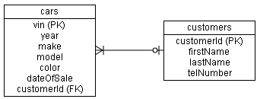
- Maximum Cardinalities (i.e. the "outer" symbols on the line - i.e. the symbols closest to the boxes):
A single customer can theoretically purchase many cars (represented by the "crows foot" next to the cars table)
A single car can only be purchased by one customer. (represented by the "one" next to the customers table)
Therefore the relationship is one to many (i.e. one customer to many cars).
- Minimum Cardinalities (i.e. the "inner" symbols on the line):
A single car might be never be purchased by any customers (represented by the zero next to the customers table)
By definition, a customer at the minimum must buy at least one car (represented by the "one" next to the cars table)
- The ERD above uses the car's vehicle identification number, or "vin", i.e. a unique number imprinted on every car in the USA, as the primary key value.
The dateOfSale for a car would initially be NULL. It would be filled in with the current date when a sale happens.
The customerId in the cars table is a foreign key that relates a particular car to the customer that purchased that car.
The customerId in a row of the cars table for a car that was never purchased would be NULL.
- Note that a car dealership may desire to maintain information about potential customers in the database too. In that case, it WOULD be possible to have a row in the "customers" table not be related to any rows in the cars table. This changes that side min cardinality from one to zero. The ERD for that approach would yield the following ERD. (The only change is that the one on the line changes to a zero).
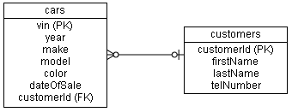

- How would the design of the previous model change if we were building the database for a used car dealership instead of a new car dealership?
ANSWER:
Differences between new car dealerships and used car dealerships (as pertains to the database)
In the previous question, note that a specific new car can only be sold by a new car dealership once (keep reading) ... Note that this assumes that the new car dealership will not sell trade ins to general public, but rather sell them in bulk to a wholesaler. (We will not address at this time where information about the wholesaler is stored in the database). Note that in reality some new car dealers do sell trade-ins to the general public, in which case the answer from the previous question, would look more like the answer for used car dealers explained below.
A used car dealership, might theoretically sell a car more than once. For example, the dealership might sell a car, then reacquire the car from the original customer (as a "trade in") and then sell the car again to another customer. This leads to the following ...
  - The following ERD assumes that by definition a customer must purchase at least one car for that customer to appear in database:
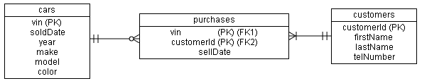
  - Maximum Cardinalities
A single used car can be sold to more than one customer (ie. to different customers at different times).
A single customer can buy more than one used car.
Therefore the relationship is many to many.
  - Minimum Cardinalities
It is possible that a specific used car might never be sold to any customers.
By definition, a customer at the minimum must buy at least one car. This is what is shown in the diagram below.
  - Since we have a many-many relationship we must use three tables.
    - The customer table appears as it did above.
    - The cars table is mostly the same as above. We will move the customerId which indicates which customer purchased the car to the "middle table" which we will name "purchases" (see below). In addition, since a single car can be sold multiple times, it doesn't make sense to have the sellDate in the cars table. Rather we will also move the sellDate information into the "middle table".
    - The "middle table", we will name "purchases". This records information about which customer purchased which car and when the purchase was made. This table has a composite primary key made up of the car's VIN number and the customer's ID number. There will be one row in this table for each time that a car is sold.
In addition the vin number ALSO acts as a foreign key to the cars table and the customerId acts as a separate foreign key to the customer's table.
  - As in the previous question, if we would want to allow the database to store information about potential customers who might have never bought any cars we would change the diagram above in the following way. We would change the "one" that appears on the right hand side of the "purchases" table to a zero (as shown below).
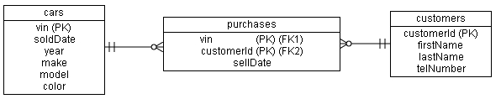
- A supermarket needs to keep track of
  - The products on the shelf in a supermarket
  - Each purchase (where a single purchase includes potentially several products bought at once)
  - Information about customers who have a "loyalty card" with the supermarket and which purchases they made
Describe how the "products" are related to "purchases" and how purchases are related to customers that are participating the store's loyalty card program.
ANSWER: (note, the letters a,b,c, etc do not directly relate to the a,b,c, etc in the instructions. This answer includes several tables and different relationships so I was a little liberal with how I numbered the items in the answer.)
- The following ERD will be explained below.
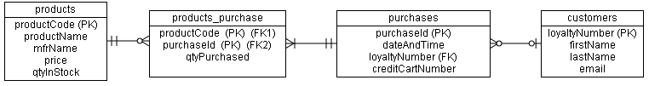
- This question is slightly different from the previous question about car dealerships. With regard to cars we wish track the sale of specific cars. With regard to products in a supermarket, we track the sale of different types of products. However, each physical individual product, e.g. a particular box of cereal, is not tracked, just the number of boxes of cereal that are sold would be tracked.
Also, for many customers, the supermarket does not have information about them. However some customers may have signed up for a "loyalty card program" in which case, the supermarket may know information about the customer making the purchase if the customer provides their loyalty card number when making a purchase.
- How are products related to purchases?
Maximum Cardinalities:
A single type of product can be included in many different purchases (i.e. the "crows foot" on the left of products_purchase)
A single purchase may include many types of products (i.e. the "crows foot" on the right of the products_purchase table)
Therefore this relationship is many-many and will require three tables to represent it in the database.
The three tables are products, purchases and the "middle table", products_purchase.
A row that appears in the products_purchase table represents a particular product that was included in a particular purchase.
Note that the two "ones" near the products table indicate that a particular row in the products_purchase table must
relate to EXACTLY ONE row in the products table.
Similarly, the two "ones" to the left of the purchases table indicate that a particular row in the products_purchase table must relate to EXACTLY ONE row in the purchases table.
Minimum Cardinalities:
A single type of product might never be purchased (ie. the "zero" on the left of the products_purchase table)
By definition, at the minimum a purchase must include at least one type of product (ie. the "one" to the right of the
products_purchase table)
- The products table contains a qtyInStock field which can be used to track how many of a particular product, the store has in stock. Every time a purchase is scanned by the cashier, the program in the point-of-sale software will decrease the qtyInStock by one.
The purchases table contains a single row for each time a cutomer makes a purchase. The purchase can consist of several items.
The products_purchase table contains one row for each type of item that was included in a single purchase. The qtyPurchased field in this table records the quantity for the type of item that was purchased. For example, if a purchase included two boxes of Honey Nut Cheerios and one quart of milk, then there would be two rows in the products_purchase table for this purchase. The row for the Honey Nut Cheerios would record the number 2 for the qtyPurchased field and the row for the quart of milk would record the number 1 in the qtyPurchased field.
- How are purchases related to customers?
Maximum Cardinalities:
A single purchase is related to at most one customer
A single customer may have made many purchases.
Therefore this relationship is one-to-many (i.e. one customer to many purchases).
Minimum Cardinalities:
A single purchase might not be related to any loyalty-card-customers
A customer who signed up for the loyalty card program might never have made any purchases (this is shown in the ERD above).
However note that if the business is such that customers can only sign up for a loyalty card when they make their first
purchase then a single loyalty-card-customer would have to be related to at least one purchase. If so, then the zero minimum
cardinality number that is near the customers table would instead be changed to a one.

- A hotel needs to keep track of
  - The names and other information about visitors to the hotel
  - the information about the rooms in the hotel
Describe how the "rooms" table is related to the "visitors" table.

Answer:
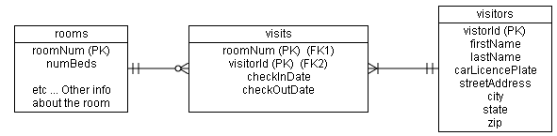
Max cardinalities:
One room can be rented by many different visitors (i.e. at different times)
A visitor can rent out many different rooms (at the same time ie. parents and kids in different rooms, or at different times)
Therefore this is a many-many relationship and will require 3 tables
Min cardinalities:
It may be unlikely, but theoretically, a room might never be rented by any visitors
A visitor by definition has rented at least one room.

- The website for a university has information about
  - buildings owned by the university
  - offices for faculty and where those offices are located
Describe how the "buildings" table is related to the "offices" table.
Answer: The following is one possible answer - see the description below for considerations that went into this answer.
Max Cardinalities:
A single building may have many offices
A single office is in at most one building (i.e. exactly one building)
Therefore this is a one to many relationship (i.e. one building to many offices)
Min Cardinalities
A single building may contain zero offices (e.g. a dormitory).
A single office is in at least one building (i.e. exactly one building)

Other considerations
The relationship between the offices table and the faculty table is affected by the following considerations. Different answers to these questions would lead to different versions of the diagram.
- Can a faculty member have more than one office?
For example if a faculty member teaches on different campuses then perhaps they might have an office on each campus.
The diagram above assumes that a faculty member only has at most one office.
- Do all faculty members have an office or is it possible for a faculty member to NOT have any office (not even a shared office)? For example, an adjunct faculty member who comes in once a week to teach one class might not have an office. Alternatively, it's possible that even such faculty members are assigned a shared office with other such faculty members.
The diagram above assumes that all faculty members are assigned exactly one office.
- Can an office be shared by more than one faculty member or is each office assigned to a single indivisual?
The diagram above assumes that some offices might be shared by different faculty members.

Note that the offices table has a composite primary key that is made up of the bldgCode and the roomNumber within the building.
Also note that because the offices table has a composite primary key, the faculty table contains a single composite foreign key (that is comprised of the officeBldgCode and the officeRoomNumber)

- The website for a real estate firm has information about
  - different neighborhoods and
  - information about different properties that are up for sale.
Design the tables for a database that represents this information.

- A catering company keeps information in a database about
  - parties that it is catering
  - the waiters that are work each party
  - venues for the parties
Design the tables for a database that represents this information.

- Major League Baseball keeps a database that records information about
  - baseball games, including the score, the date, etc
  - the home team and away team that were playing in those games, including the city, the name of the team, the manager of the team, etc
Design the tables for a database that represents this information.

