Other websites for studying: sqlitetutorial.net w3schools.com/sql

As I mentioned in class during the semester, I refer you to the following websites for more info about SQL. Both do a decent job of covering the topics we covered. Both have an interactive component to allow you to work with the examples in a browser. Keep reading this document to see the list of topics that we covered from these websites.

* <https://www.sqlitetutorial.net/>
* <https://www.w3schools.com/sql/>

## WEBSITE: <https://www.sqlitetutorial.net/>

The specific topics on this website are listed below in the next section of this document. Note that this website contains an interactive component. For example the following is an example from the page <https://www.sqlitetutorial.net/sqlite-select/>

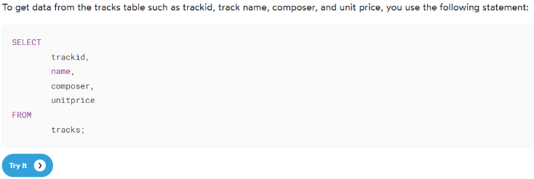

If you click on the “Try It” button you will be taken to the following page that shows the results of the query. If you change the code and click on the “Execute” button, you will see the new results.

## String Functions – see the page - <https://www.sqlitetutorial.net/sqlite-string-functions/>

We covered the “string functions” that are described on this page:   
Click each link on the page for more info about that function.

|  |  |
| --- | --- |
| [SUBSTR](https://www.sqlitetutorial.net/sqlite-functions/sqlite-substr/) | Extract and return a substring with a predefined length starting at a specified position in a source string |
| [LENGTH](https://www.sqlitetutorial.net/sqlite-functions/sqlite-length/) | Return the number of characters in a string or the number of bytes in a BLOB. |
| [UPPER](https://www.sqlitetutorial.net/sqlite-functions/sqlite-upper/) | Return a copy of a string with all of the characters converted to uppercase. |
| [LOWER](https://www.sqlitetutorial.net/sqlite-functions/sqlite-lower/) | Return a copy of a string with all the characters converted to lowercase. |
| [Concatenation Operator](https://www.sqlitetutorial.net/sqlite-string-functions/sqlite-concat/) || | Concatenate multiple strings into a single string. |

## Everything else – see the page - <https://www.sqlitetutorial.net/>

The following menu of topics runs down the right side of the page. We covered the following topics:

GETTING STARTED

* [SQLite Sample Database](https://www.sqlitetutorial.net/sqlite-sample-database/)

SQLITE TUTORIAL

* [SQLite Select](https://www.sqlitetutorial.net/sqlite-select/)
* [SQLite Order By](https://www.sqlitetutorial.net/sqlite-order-by/)
* [SQLite Select Distinct](https://www.sqlitetutorial.net/sqlite-distinct/)
* [SQLite Where](https://www.sqlitetutorial.net/sqlite-where/)
* [SQLite AND Operator](https://www.sqlitetutorial.net/sqlite-and-operator/)
* [SQLite OR Operator](https://www.sqlitetutorial.net/sqlite-or-operator/)
* [SQLite Limit](https://www.sqlitetutorial.net/sqlite-limit/)
* [SQLite BETWEEN](https://www.sqlitetutorial.net/sqlite-between/)
* [SQLite IN](https://www.sqlitetutorial.net/sqlite-in/)
* [SQLite Like](https://www.sqlitetutorial.net/sqlite-like/)
* [SQLite IS NULL](https://www.sqlitetutorial.net/sqlite-is-null/)
* [SQLite Join](https://www.sqlitetutorial.net/sqlite-join/)
* [SQLite Inner Join](https://www.sqlitetutorial.net/sqlite-inner-join/)
* [SQLite Group By](https://www.sqlitetutorial.net/sqlite-group-by/)
* [SQLite Having](https://www.sqlitetutorial.net/sqlite-having/)
* [SQLite Union](https://www.sqlitetutorial.net/sqlite-union/)
* [SQLite Insert](https://www.sqlitetutorial.net/sqlite-insert/)

SQLITE FUNCTIONS   
(NOTE: these are “aggregate functions” – the “string functions” mentioned at the top of this file are “non-aggregate functions”)

* [SQLite AVG](https://www.sqlitetutorial.net/sqlite-avg/)
* [SQLite COUNT](https://www.sqlitetutorial.net/sqlite-count-function/)
* [SQLite MAX](https://www.sqlitetutorial.net/sqlite-max/)
* [SQLite MIN](https://www.sqlitetutorial.net/sqlite-min/)
* [SQLite SUM](https://www.sqlitetutorial.net/sqlite-sum/)

## WEBSITE: <https://www.w3schools.com/sql/>

This website contains numerous examples such as the following:

Clicking on the “Try it Yourself” button takes you to a webpage where you run the code. button to run your new version of the code and see the results.

## TOPICS from <https://www.w3schools.com/sql/>

There is a menu that goes down the left side of this page. We covered the following topics from this menu:

* SQL Select
* SQL Select Distinct
* SQL Where
* SQL Order By
* SQL And
* SQL Or
* SQL Not
* SQL Null Values
* SQL Select Top (note - we did the LIMIT version of this command, not the TOP version - this webpage covers both versions. Some database SQL software uses "TOP", other SQL software uses "LIMIT")
* SQL Aggregate Functions
* SQL Min and Max
* SQL Count
* SQL Sum
* SQL Avg
* SQL Like
* SQL Wildcards (NOTE: we only covered the % and _ wildcards)
* SQL In
* SQL Between
* SQL Aliases
* SQL Joins
* SQL Inner Join
* SQL Group By
* SQL Having
* SQL Exists
* SQL Comments
* SQL Create Table (NOTE: we only covered the first version on this page – You should know what the statement does. I won’t ask you to write a CREATE TABLE statement by yourself but you should be able to read one).