SUMMARY EXCEL FUNCTION LIST (you refer to this sheet as you work on the questions)

Numeric Functions
AVERAGE(number1,[number2],…)
SUM(number1,[number2],…)

Counting Functions
COUNT(value1,[value2],…)
COUNTA(value1,[value2],…)
... also see COUNTIF and COUNTIFS in the "...IF/...IFS" functions section below

max, min, large, small functions
MAX(number1,[number2],…)
MIN(number1,[number2],…)
LARGE(array,k)
SMALL(array,k)

Logical Functions
IF(logical_test,[value_if_true],[value_if_false])
IFS(logical_test1 , value_if_true1 , … )
AND(logical1,[logical2],…)
OR(logical1,[logical2],…)
IFERROR(value,value_if_error)

"IS" Functions
ISBLANK(value)
ISERROR(value) ... also se IFERROR in the Logical Functions section
ISEVEN(number)
ISODD(number)

"...IF/...IFS" functions
SUMIF(range,criteria,[sum_range])
SUMIFS(sum_range,criteria_range1,criteria1,…)
AVERAGEIF(range,criteria,[average_range])
AVERAGEIFS(average_range,criteria_range1,criteria1,…)
COUNTIF(range,criteria)
COUNTIFS(criteria_range1,criteria1,…)

Date and Time Functions
TODAY()
DATE(year, month, day)
MONTH(serial_number)
YEAR(serial_number)
WEEKDAY(serial_number)
EDATE(start_date, months)
TEXT(value, format_text)

Lookup Functions
VLOOKUP(lookup_value,table_array,col_index_num,FALSE)

Textual Functions
CONCATENATE(text1,[text2],…)
LEN(text)
LEFT(text,[num_chars])
RIGHT(text,[num_chars])
MID(text,start_num,num_chars)
FIND(find_text, within_text, [start_num])

Random Numbers functions
RAND( )
RANDBETWEEN(bottom, top)

Part I – Answer these questions WITHOUT using Excel or a computer. Write all your answers neatly. Show all work for partial credit.

Given this data what is the outcome of the formulas below?

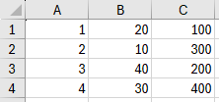
- =3+IF(SUM(AVERAGE(B1:B2),A4)<20,IF(A4>100,300,5),IF(A1>5,100,200))*3
- =AND(B1>1,OR(B2>1000,B3>1000))

The following questions apply to any spreadsheet:

- Suppose cell E7 contains the following formula: =F9+$F9+F$9+$F$9
If you copy that formula to cell G8, what will be the formula in cell G8?

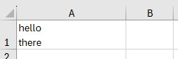
- How can you type an “ENTER” into a cell so that the data in the cell appears on two lines (such as in this example)

*** YOU MAY TEAR OUT THIS PAPER – use this for PART II – see below for the questions to PART II. ***

Part II – The following spreadsheet contains data about the inventory kept by a department store. Each row contains the data for a different product. Each product has a color, a manufacturer (mfr), etc. Columns C through L contain data. Each row contains the data for a different product. Each product has a color, a manufacturer (mfr), etc. Other columns should be filled in with formulas as described in the questions below e.g. column B is for question 1 (q1), column M is for question 3, etc. (For question 2 there are already results shown in the picture below – for more info see the instructions below for q2). For each question make sure you design your formula so that it can be written once in the cell with a BOX around it and dragged down so that all cells in the column have the correct version of the formula.
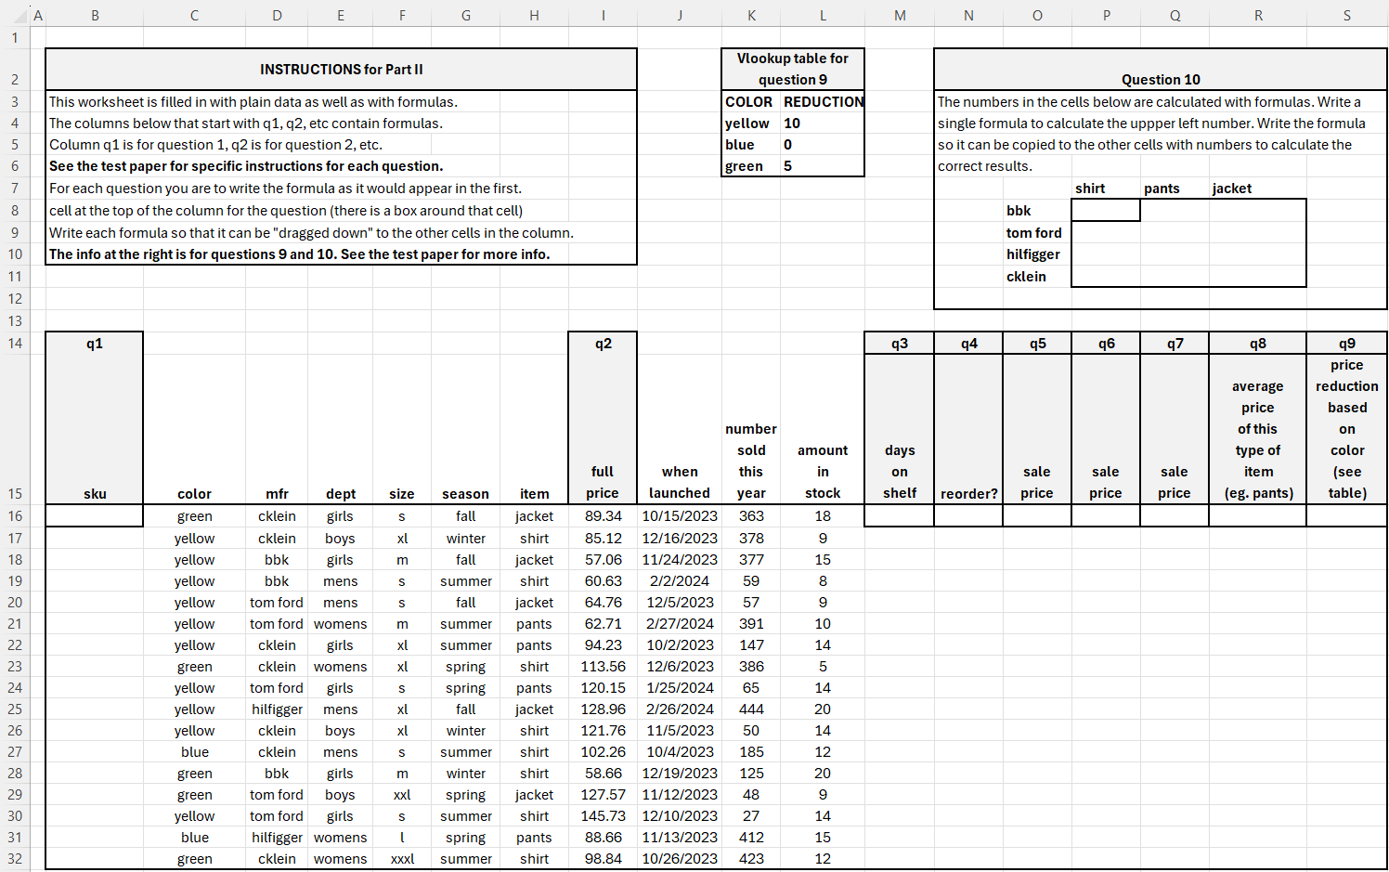
The following shows the same spreadsheet after the formulas for all questions have been filled in correctly:
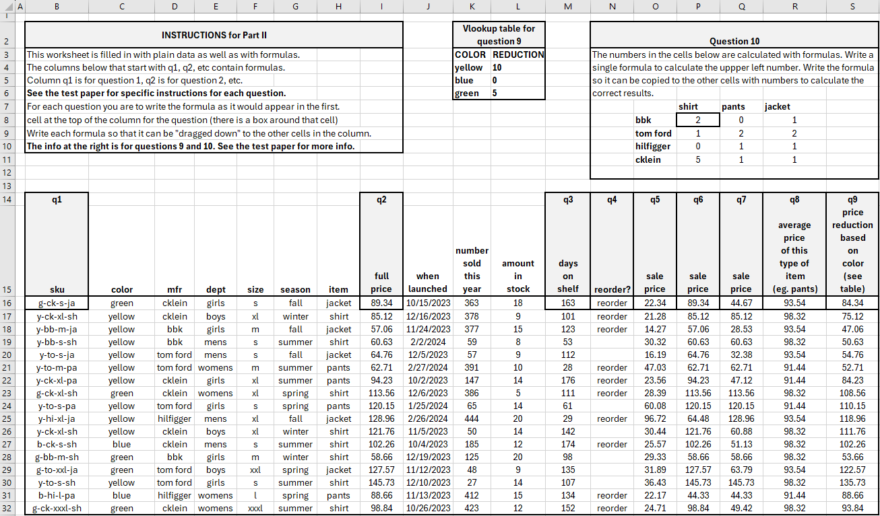

Refer to the pictures of the spreadsheet above.
Follow the instructions below to answer each question.
For each question, write the formula as it would appear in the first cell at the top of the column for the question (there is a box around that cell). Write each formula so that it can be "dragged down" to the other cells in the column.

- Write a formula to generate the “sku”. It is made up of the following info. Each piece of info is separated from the others with a dash.
* first letter of the color
* a dash (i.e. - )
* first 2 letters of the mfr
* a dash (i.e. - )
* the size (including all the letters)
* a dash (i.e. - )
* first 2 letters of the item
- Answer all parts shown below:
  - Write a formula that generates a random price between 50.00 and 199.99, similar to the prices shown in the picture for question 2. (NOTE – write this in the first cell in the column for “q2”. However, keep in mind that if you drag it down the numbers in your spreadsheet will be different than the picture above. Therefore, for this question do NOT drag it down.)
  - How can you force Excel to generate new numbers for this cell?
  - How can you “lock in” the numbers that are generated?
- Number of “days on shelf” - calculate how many days it has been since the date in the “when launched” column until now.
- Write a formula to show the word “reorder" if the “amount in stock” is less than 10% of the “number sold this year”. Otherwise the cell should show a blank.
- Calculate a sale price based on the following:
75% off the full price if the item has been on the shelf for more than 100 days,
50% off if item has been on shelf more than 50 days,
25% off if item has been on the shelf more than 25 days.
Otherwise full price.
- Calculate a sale price based on the following:
50% off “Hilfigger” mens and womens (not boys and girls) items. Full price for everything else.
- Calculate a sale price based on the following:
50% off all items that have been “on the shelf” more than average.
- Write a formula to calculate the average price of the type of items that appear on a particular row. E.g. the first row contains a jacket so on the first row the formula should show the avg price of jackets. The 2nd row has a shirt so when you drag the formula to the 2nd row, it should show the avg price of shirts.
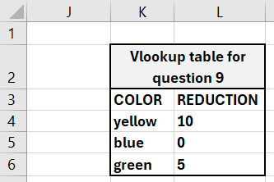
- The store decided to take a little off the price of products whose colors are unpopular. The following VLOOKUP table is from at the top of the worksheet. It shows the price REDUCTION for different colors. Write a formula using VLOOKUP to show the new prices based on the price reduction for different colors listed in the VLOOKUP table.
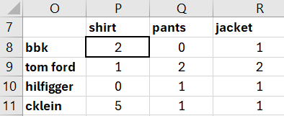
- The following chart is copied from the top of the worksheet. The cells with numbers contain formulas. The chart shows how many of each type of product the store carries per manufacturer. E.g cell P8 shows there are 2 rows with bbk shirts, cell Q8 shows there are 0 of rows with bbk pants, cell P9 shows there is 1 row with tom ford shirts, etc.
Write a formula for cell P8 that calculates the number of rows with bbk shirts. Write the formula so that when the formula is copied to the other cells in range P8:R11, the correct numbers are calculated.

