Google OAuth

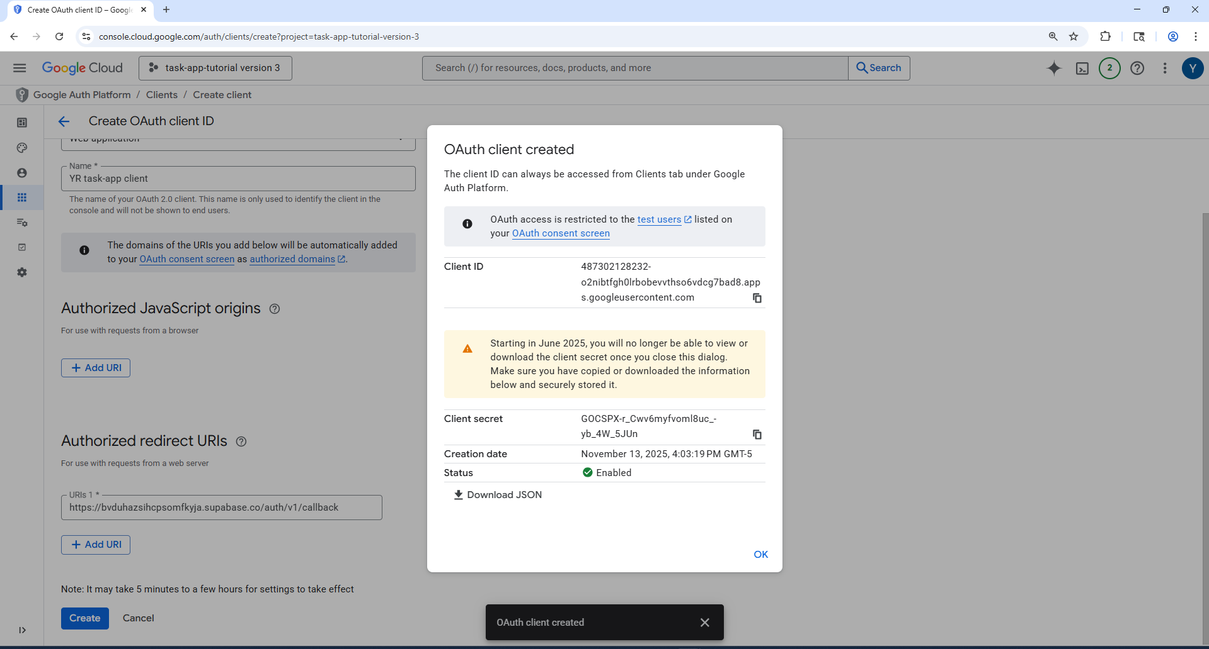

Stripe
Publishable Key:
ID: mk_1SVeKNDGgALqQyZnwhnDskBx
Token: pk_test_51SVeKMDGgALqQyZnaGZ7UemIokoibfilKOHYjgKCmIPUTu82I9diGLn5e9ppuBFpbEbEQSxd0myOAhZKyKPrdqXB00n2TGgwaC

Secret Key:
ID: mk_1SVeKrDGgALqQyZnr48nqMqG
Token: sk_test_51SVeKMDGgALqQyZnNHEHzxCMJXcI8DtFkyvAO8q8S9vTP9PEbUSkY5o8or79twGb2efDtYMbZTCfGQYjKOzLK46V00Q4Wm1Nev
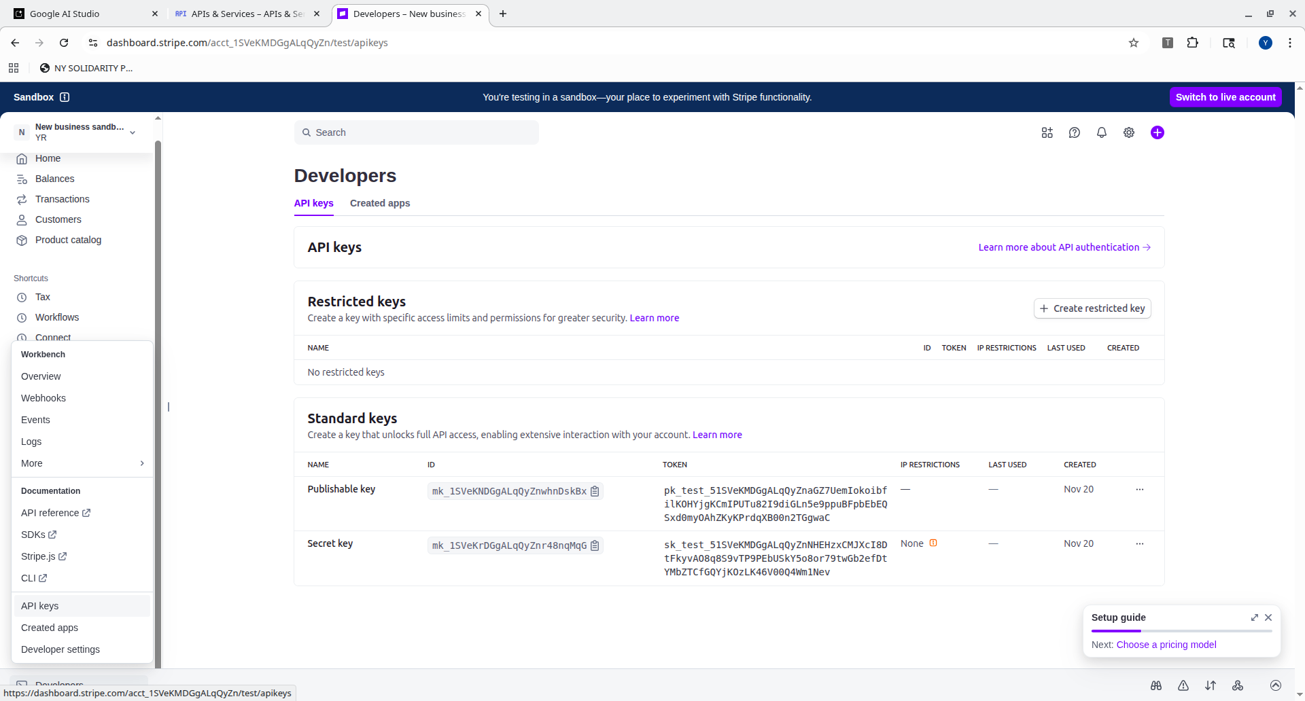
Price: Pro Plan
Product ID: prod_TSZgHEWfaDySWa
Price_id: price_1SVeXODGgALqQyZnqkrxA2Lg

