The following topics are on the final exam:
- Excel - While the focus of the questions will be on material covered after the midterm, you must sill know the material from before the midterm. The material covered after the midterm can be found in the files posted on Canvas on days 15,16,17,18
- SQL and relational databases
See below for details.

EXCEL
Excel Study materials:
- All material on https://yrosenthal.com/excel/
- Files from class – posted on Canvas on days 15,16,17,18.
Note that most of the material is included in the one file “day17-afterClass.xlsx”.
Review and understand all of the formulas in this file. You can view the formulas using the “Show Formulas” button on the “Formulas” tab.
- Sorting data - https://www.youtube.com/watch?v=Bm_uWOUiUFI
- Excel tables – see this video: https://www.youtube.com/watch?v=yLWJFjRk9zM
- Pivot tables - See the video and sample excel file posted in the day18 folder on canvas to review pivot tables.
- Microsoft Documentation for functions we learned, for example
  - Xlookup - https://support.microsoft.com/en-us/office/xlookup-function-b7fd680e-6d10-43e6-84f9-88eae8bf5929
  - Vlookup - https://support.microsoft.com/en-us/office/vlookup-function-0bbc8083-26fe-4963-8ab8-93a18ad188a1
  - Sort - https://support.microsoft.com/en-us/office/sort-function-22f63bd0-ccc8-492f-953d-c20e8e44b86c
  - Unique - https://support.microsoft.com/en-us/office/unique-function-c5ab87fd-30a3-4ce9-9d1a-40204fb85e1e
  - Index - https://exceljet.net/functions/index-function
  - Match - https://exceljet.net/functions/match-function
  - Formulatext - https://support.microsoft.com/en-us/office/formulatext-function-0a786771-54fd-4ae2-96ee-09cda35439c8#:~:text=The%20FORMULATEXT%20function%20returns%20what,%23N%2FA%20error%20value
  - In general, for other functions Google for “Microsoft Excel documentation for FUNCTION_NAME”
Excel topics covered after the midterm:
- Dynamic Array functions – i.e. Excel functions that “spill”
The results of these functions get placed into multiple cells.
Formula will have a #spill error if there is anything already in the cells in which the results would be placed.
You cannot delete part of the results of a dynamic array function.
Example Dynamic array functions
  - Sort
  - Unique
  - Filter
  - Xlookup
    - know all of the arguments to xlookup and what they do
    - use xlookup to get data from a grid (similar to match and index – see below)
- vlookup and vlookup tables with range_lookup=TRUE and range_lookup=FALSE
- match and index functions for looking up data where the lookup table can't be used with vlookup
  - Know how each function works on its own
  - Know how to combine the functions to retrieve a single cell from a range of cells
- Sort rows of data with Data>Sort button. Know how to apply multiple levels of sorting.
- Use the format painter button to copy the exact formatting from one cell to other cells.
- Excel tables
  - Convert a range to a table with “Insert tab > Insert Table” or hotkey ctrl-t
  - Sort rows in a table with buttons at the top of the table
  - Sort rows in a table based on more than one column (apply the sort to the columns in the reverse order)
  - Filter rows of the table using the controls at the top of each column of the table.
Remove filters from a table
- Convert a table back to a range with "Table Design > Convert to Range"
Warning the colorization of the table doesn't automatically go away. You can either convert the format before you convert the table to a range or – you can copy the format of another cell with the “format painter” button after you’ve converted the table to a range.
- how excel stores dates and times – dates are stored as the number of days since Jan 1, 1900. Times are store as the percentage of the day that has elapsed by that time, e.g. 12am is 0 6am is 0.25 11:59pm is 0.999999999
- pivot tables

SQL and RELATIONAL DATABASE
SQL Study materials:
- The following sections of: https://yrosenthal.com/datamgmt/
  - 14 "databases" and "database management systems"
(Only the first part about “Relational Databases”
  - 15 Relational Databases and SQL (using R)
  - 16 The "books database"
  - 17 Inner Joins.
  - 18 aggregate functions, group by, having
- See files posted on Canvas days 19-27
- Sqlitetutorial.net - see below for specifics
- W3schools.com/sql - see below for specifics

Websites for SQL - sqlitetutorial.net and w3schools.com/sql

As I mentioned in class during the semester, I refer you to the following websites for more info about SQL. Both do a decent job of covering the topics we covered. Both have an interactive component to allow you to work with the examples in a browser. Keep reading this document to see the list of topics that we covered from these websites.

- https://www.sqlitetutorial.net/
- https://www.w3schools.com/sql/

WEBSITE: https://www.sqlitetutorial.net/
The specific topics on this website are listed below in the next section of this document. Note that this website contains an interactive component. For example the following is an example from the page https://www.sqlitetutorial.net/sqlite-select/
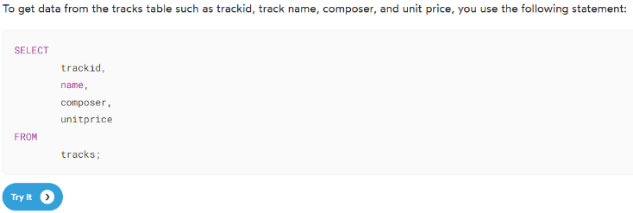
If you click on the “Try It” button you will be taken to the following page that shows the results of the query. If you change the code and click on the “Execute” button, you will see the new results.
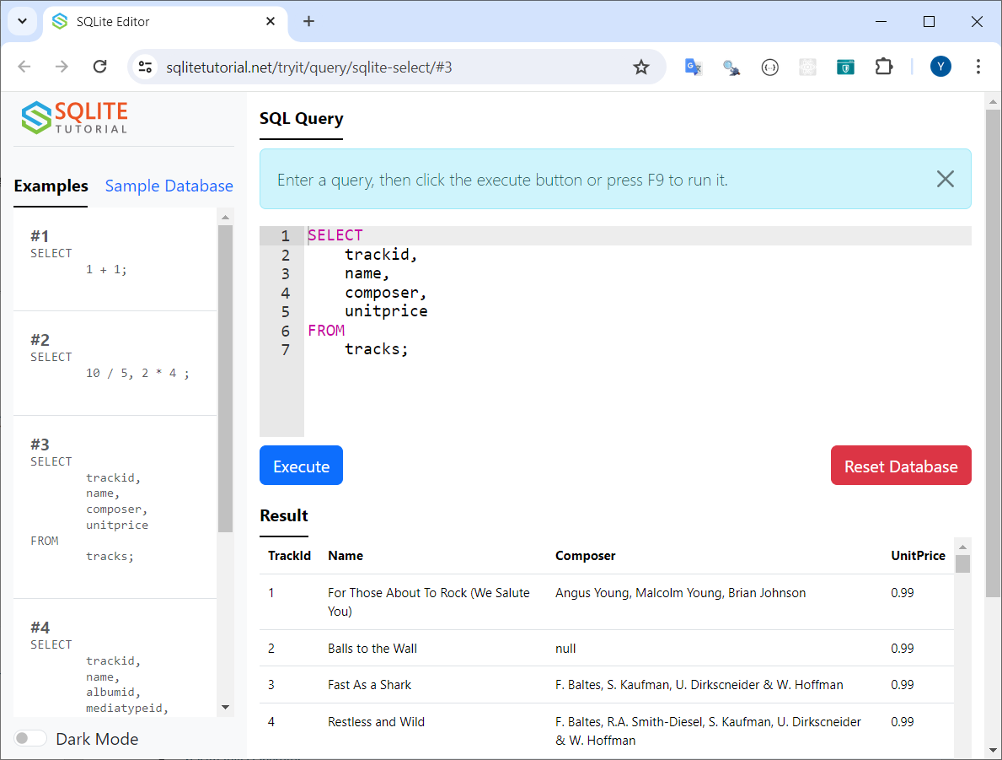

String Functions – see the page - https://www.sqlitetutorial.net/sqlite-string-functions/
We covered the “string functions” that are described on this page:
Click each link on the page for more info about that function.

SUBSTR | Extract and return a substring with a predefined length starting at a specified position in a source string
LENGTH | Return the number of characters in a string or the number of bytes in a BLOB.
UPPER | Return a copy of a string with all of the characters converted to uppercase.
LOWER | Return a copy of a string with all the characters converted to lowercase.
Concatenation Operator || | Concatenate multiple strings into a single string.

Everything else – see the page - https://www.sqlitetutorial.net/
The following menu of topics runs down the right side of the page. We covered the following topics:
GETTING STARTED
- SQLite Sample Database

SQLITE TUTORIAL

- SQLite Select
- SQLite Order By
- SQLite Select Distinct
- SQLite Where
- SQLite AND Operator
- SQLite OR Operator
- SQLite Limit
- SQLite BETWEEN
- SQLite IN
- SQLite Like
- SQLite IS NULL
- SQLite Join
- SQLite Inner Join
- SQLite Group By
- SQLite Having
- SQLite Insert

SQLITE FUNCTIONS
(NOTE: these are “aggregate functions” – the “string functions” mentioned at the top of this file are “non-aggregate functions”)

- SQLite AVG
- SQLite COUNT
- SQLite MAX
- SQLite MIN
- SQLite SUM

WEBSITE: https://www.w3schools.com/sql/
This website contains numerous examples such as the following:
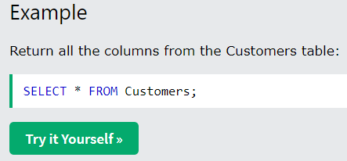
Clicking on the “Try it Yourself” button takes you to a webpage where you run the code. You can also modify the code then click the 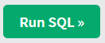 button to run your new version of the code and see the results.

TOPICS from https://www.w3schools.com/sql/
There is a menu that goes down the left side of this page. We covered the following topics from this menu:
- SQL Select
- SQL Select Distinct
- SQL Where
- SQL Order By
- SQL And
- SQL Or
- SQL Not
- SQL Null Values
- SQL Select Top (note - we did the LIMIT version of this command, not the TOP version - this webpage covers both versions. Some database SQL software uses "TOP", other SQL software uses "LIMIT")
- SQL Aggregate Functions
- SQL Min and Max
- SQL Count
- SQL Sum
- SQL Avg
- SQL Like
- SQL Wildcards (NOTE: we only covered the % and _ wildcards)
- SQL In
- SQL Between
- SQL Aliases
- SQL Joins
- SQL Inner Join
- SQL Group By
- SQL Having
- SQL Exists
- SQL Comments
- SQL Create Table (NOTE: we only covered the first version on this page – You should know what the statement does. I won’t ask you to write a CREATE TABLE statement by yourself but you should be able to read one).

