INKLUMARKET: AN AI-ENABLED E-COMMERCE SMART APPLICATION
FOR PROMOTING PRODUCTS OF PERSONS WITH DISABILITIES (PWDs)
IN AVRC REGION IX
A Capstone Project

Presented to

The Faculty of the College of Information and Computing Science
Zamboanga Peninsula Polytechnic State University

In Partial Fulfillment of the Requirements
For the Degree of Bachelor of Science in Information Technology

By

Basco, John Michael B.
Jalem, Christian Mathew B.
Macas, Eric T.
Salvador, John Paul T.

Aldeliene K. Tulawie, MEngg. Ed
Adviser

May 2026

CHAPTER 1
INTRODUCTION

1.1 BACKGROUND OF THE PROBLEM
The rapid advancement of information and communication technology has fundamentally transformed various sectors of society, including commerce, education, and social services. Among these, the e-commerce industry has experienced exponential growth due to the widespread adoption of digital platforms and the integration of artificial intelligence (AI) technologies that enhance user experience, automate business processes, and expand market reach globally. AI-driven systems such as recommendation engines, conversational chatbots, and personalized search functionalities have significantly improved customer engagement and operational efficiency in online marketplaces (Abdullah, 2025; Saxena, 2025). Furthermore, digital platforms have been widely recognized as powerful instruments in promoting inclusive economic participation, particularly for marginalized sectors, by providing alternative means of income generation and access to broader consumer markets (Dakung et al., 2025; Gutterman, 2025).
Despite these technological advancements, existing e-commerce platforms are predominantly designed for general users and frequently fail to accommodate the specific needs of vulnerable groups, particularly persons with disabilities (PWDs). Although research affirms that AI can substantially improve accessibility through features such as adaptive interfaces, voice-assisted navigation, and intelligent support systems (Sundaramoorthy et al., 2024), the majority of commercial platforms still demand a high level of digital literacy, technical proficiency, and marketing capability to enable effective participation in online selling. Studies further indicate that PWDs encounter persistent barriers in entrepreneurship, including limited access to business information, inadequate technological support, and the absence of structured market platforms tailored to their unique circumstances (Mendoza, 2023; Malhotra et al., 2025).
In the Philippine context, these challenges are especially pronounced among PWDs enrolled in livelihood training programs at institutions such as the Area Vocational Rehabilitation Center (AVRC) Region IX, located in Zamboanga City. AVRC provides skills development in domains such as handicrafts, food processing, and small-scale entrepreneurship; however, no centralized digital platform currently exists that consistently facilitates the promotion and commercial sale of products created during these training sessions. Consequently, PWD trainees are compelled to rely on limited physical selling opportunities, informal social media posts, or occasional local exhibitions, all of which significantly constrain their market reach and income sustainability. This reflects a critical gap between skills development and actual economic participation, wherein training outputs are not effectively connected to real-world market opportunities (Hughes, 2025; Akanfe et al., 2025).
Given these conditions, a technology-driven solution is necessary to bridge the gap between livelihood training and product commercialization for PWDs. The integration of AI within an accessible e-commerce platform offers a promising approach to address these challenges by simplifying product listing, enhancing product visibility through recommendation systems, and providing a user-friendly interface tailored to the needs of PWD entrepreneurs. Therefore, this study proposes the development of InkluMarket, an AI-enabled smart e-commerce application designed to serve as a centralized platform for displaying, promoting, and selling products made by PWDs under AVRC Region IX. This system aims to empower PWDs by improving their access to digital markets, enhancing their entrepreneurial capabilities, and supporting their journey toward economic independence and social inclusion.
1.2 PROJECT CONTEXT
InkluMarket is conceptualized within the context of AVRC Region IX's operational environment and the broader landscape of disability-inclusive economic development in the Philippines. AVRC Region IX is a government-operated vocational rehabilitation center mandated to provide training, livelihood support, and social integration services to individuals with physical, sensory, and other forms of disability. Despite the center's active training programs, there is a notable absence of a structured digital channel through which products produced by trainees can be systematically promoted and sold to a wider consumer base.
The project situates itself at the intersection of three key domains: inclusive technology, digital entrepreneurship, and AI-driven commerce. Within this context, InkluMarket is envisioned as a mobile-based smart application that harnesses the power of AI to level the playing field for PWD entrepreneurs. The platform will integrate product listing, smart search, AI-based product recommendations, and an administrative dashboard into a cohesive and accessible digital marketplace.
The project is aligned with national policies such as the Magna Carta for Disabled Persons (Republic Act No. 7277) and the United Nations Sustainable Development Goal 10 (Reduced Inequalities), which collectively emphasize the rights of PWDs to full economic participation and access to technology. By providing a digital infrastructure for product commercialization, InkluMarket operationalizes these policy mandates at the community level, offering a practical and replicable model for inclusive digital trade.
  - PURPOSE AND DESCRIPTION
The primary purpose of InkluMarket is to develop a functional, accessible, and AI-enabled mobile e-commerce application that bridges the gap between PWD livelihood training at AVRC Region IX and actual product commercialization in the digital marketplace. The system is designed to empower PWD trainees as active digital entrepreneurs by providing them with user-friendly tools to list, promote, and sell their products online, while also enabling AVRC staff to manage platform operations efficiently.
InkluMarket is described as a smart application because it integrates artificial intelligence at its core through features such as an AI-based product recommendation engine and smart search functionality. These features enhance product discoverability and user engagement, ensuring that PWD-made products receive greater visibility among potential buyers. The system also incorporates accessibility principles such as simplified navigation, high-contrast visual design, and clear instructional cues to accommodate users with varying levels of digital literacy and physical ability.
The application will serve three primary user groups: (1) PWD trainees who will act as sellers and product creators, (2) AVRC administrators who will manage platform operations, product listings, and user accounts, and (3) general consumers who will browse, search, and purchase products from the marketplace. The system will be built using modern mobile development frameworks and will leverage open-source AI tools to ensure sustainability and scalability within the academic and institutional context.
1.4 OBJECTIVES
1.4.1 GENERAL OBJECTIVES
The primary objective of this study is to design and develop “INKLUMARKET: An AI-Enabled E-Commerce Smart Application for Promoting Products of Persons with Disabilities (PWDs) in AVRC Region IX” that will serve as a centralized digital marketplace for showcasing, promoting, and selling products made by Persons with Disabilities under the Department of Social Welfare and Development Region IX. Specifically, the system aims to enhance product visibility, improve customer accessibility, simplify online transactions, and integrate Artificial Intelligence (AI) features such as smart product recommendations and automated product management to support inclusive entrepreneurship and sustainable livelihood opportunities for PWD communities.
1.4.2 SPECIFIC OBJECTIVES

No. | Objective | Specific | Measurable | Achievable | Relevant | Time-bound
1 | Design the system architecture. | Create a detailed framework of the INKLUMARKET application including user interface, database structure, AI integration, and e-commerce functionalities | Completion of the system architecture and design documents approved by the project advisers and stakeholders. | The design phase will involve collaboration with developers, stakeholders, and IT experts. | A well-designed architecture is essential for developing an efficient and reliable e-commerce platform. | August 2026
2 | Develop the AI-enabled e-commerce platform. | Build an online marketplace that allows PWDs to upload, manage, and promote their products digitally. | Successful implementation of product listing, ordering, and account management features with at least 95% functional accuracy. | The development team has the necessary programming skills, tools, and resources to complete the platform. | The platform addresses the need for accessible and inclusive online selling opportunities for PWDs. | October 2026
3 | Integrate AI-powered product recommendation features. | Develop AI functionalities that recommend products based on customer preferences and browsing behavior. | Measure recommendation accuracy and customer engagement through testing and user feedback. | AI integration can be achieved using existing technologies and development frameworks | Smart recommendations improve customer experience and increase product visibility and sales opportunities. | November 2026
4 | Implement online transaction and order management features. | Create functionalities for product ordering, order tracking, inventory management, and customer notifications. | Monitor successful transaction processing and inventory updates with real-time reporting features. | The system functionalities can be implemented within the project timeline using available resources. | Efficient transaction management ensures smooth and reliable e-commerce operations. | December 2026
5 | Evaluate the usability and performance of the system. | Conduct system testing and gather feedback from administrators, PWD sellers, and customers. | Collect evaluation results through surveys, usability testing, and system performance metrics. | User testing will involve selected participants familiar with online shopping platforms. | Evaluation ensures that the system effectively meets the needs of users and stakeholders. | January 2027

1.5 SCOPE AND LIMITATIONS
1.5.1 Scope
- The study focuses on the design and development of “INKLUMARKET: An AI-Enabled E-Commerce Smart Application for Promoting Products of Persons with Disabilities (PWDs) in AVRC Region IX.”
- The system will be developed primarily for the Department of Social Welfare and Development Region IX and AVRC Region IX to support the promotion and selling of products made by PWDs.
- The application will function as an online marketplace similar to e-commerce platforms where users can browse, search, and purchase products online.
- The system will accommodate products such as bags, wallets, bracelets, necklaces, accessories, and other handcrafted products made by PWDs.
- The application will include user account management for administrators, sellers, and customers.
- The system will feature AI-enabled functionalities such as smart product recommendations and automated product categorization.
- The study will include product management features such as adding, updating, and deleting product information.
- The system will provide order management and transaction monitoring functionalities for both sellers and administrators.
- The study will evaluate the system’s usability, functionality, and performance through user testing and surveys.
- The project will utilize web-based and mobile-responsive technologies for accessibility and convenience.

1.5.2 Limitations
- The study is limited only to PWD products under AVRC Region IX and will not include products from other organizations or regions.
- The system will require internet connectivity to access the online marketplace and its features.
- The AI functionalities will only focus on product recommendations and basic automated categorization.
- The study will not include advanced AI technologies such as predictive analytics, voice assistants, or facial recognition.
- The system will not directly handle external logistics and shipping services beyond order tracking features.
- Online payment integration may be limited to selected payment methods available during system development.
- The application will not include international shipping and global marketplace functionalities.
- The study will only evaluate the system within the specified testing period and selected respondents.
- The security features of the system will be limited to standard authentication and data protection methods implemented during development.
- The project is intended solely for academic and institutional purposes and may require further enhancement for large-scale commercial deployment.

1.6 SIGNIFICANCE OF THE STUDY
This study is significant as it develops an AI-enabled e-commerce platform, “INKLUMARKET,” which aims to promote and enhance the marketing and sales of products made by Persons with Disabilities (PWDs) in AVRC Region IX under the Department of Social Welfare and Development Region IX. The system provides a centralized and accessible digital marketplace that supports inclusivity, livelihood development, and technological innovation.
- Students/End-Users- The students and end-users, particularly PWD entrepreneurs and customers, will benefit from the system through easier access to a digital marketplace where products can be conveniently displayed, searched, and purchased. PWD sellers will gain increased visibility for their products such as bags, wallets, bracelets, necklaces, and other handicrafts, leading to improved sales opportunities and income generation. Customers, on the other hand, will benefit from a user-friendly platform that allows them to discover and support PWD-made products more efficiently.
- Faculty/Administrators- Faculty members and administrators, especially those involved in AVRC Region IX, will benefit from the system as it provides a more organized and efficient way of monitoring PWD livelihood products and activities. The platform will help streamline product listing, transaction tracking, and reporting processes, reducing reliance on manual documentation. It also supports decision-making by providing accessible data and system-generated reports related to product performance and sales.
- Future Researchers- Future researchers will benefit from this study as it serves as a reference for developing AI-enabled e-commerce systems, especially those focused on inclusive digital marketplaces. The findings, system design, and methodologies used in this study can be used as a basis for further improvements, enhancements, or related research studies in e-commerce, artificial intelligence applications, and social innovation technologies.
- Institution (ZPPSU/CICS)- The institution, particularly Zamboanga Peninsula Polytechnic State University (ZPPSU) College of Information and Computing Sciences (CICS), will benefit from this study as it showcases a practical application of information technology in addressing real-world social and economic issues. The project strengthens the institution’s research output, promotes innovation in system development, and enhances its contribution to community development and inclusive technology solutions.
1.7 DEFINITION OF TERMS
- Artificial Intelligence (AI)- In this study, AI refers to the application of machine learning algorithms and intelligent computational techniques embedded within InkluMarket to enable smart product search, recommendation generation, and adaptive system behavior tailored to user interactions.
- Area Vocational Rehabilitation Center (AVRC) Region IX- A government-operated institution in Zamboanga City, Philippines, that provides vocational skills training, livelihood programs, and rehabilitation services to persons with disabilities. In this study, AVRC Region IX serves as the primary institutional partner and deployment context.
- E-commerce Application- A digital platform that facilitates the online promotion, listing, and selling of products and services. In this study, InkluMarket functions as a mobile-based e-commerce application specifically designed for PWD-produced goods.
- InkluMarket- The proposed AI-enabled smart e-commerce mobile application developed in this study. The name combines 'Inklu' (derived from 'inclusive') and 'Market' to reflect its mission of creating an inclusive digital marketplace for persons with disabilities in AVRC Region IX.
- Person with Disability (PWD).- As defined by the Magna Carta for Disabled Persons (RA 7277), a PWD is any individual whose ability to participate in activities is restricted or limited due to a physical, mental, or sensory impairment. In this study, PWDs specifically refer to trainees at AVRC Region IX who are the primary users and beneficiaries of the InkluMarket system.
- Product Recommendation Engine.- An AI-driven component within InkluMarket that analyzes user behavior and product attributes to suggest relevant products to buyers, thereby enhancing product discoverability and increasing the potential for sales of PWD-made goods.
- Smart Search- A search functionality enhanced by AI and natural language processing techniques that allows users to find products using keywords, categories, or descriptive phrases, returning contextually relevant results even with partial or imprecise queries.
- Usability- The degree to which a system can be used by specified users to achieve specified goals with effectiveness, efficiency, and satisfaction in a specified context of use (ISO 9241-11). In this study, usability is evaluated through user testing conducted with PWD trainees and AVRC staff.

CHAPTER 2
REVIEW OF RELATED LITERATURE AND SYSTEMS
  - TECHNICAL BACKGROUND
The development of InkluMarket draws upon a broad technical foundation encompassing artificial intelligence, mobile application development, e-commerce systems architecture, and inclusive design principles. Understanding these technical underpinnings is essential to appreciating the novelty and practical value of the proposed system.
Artificial intelligence has become a cornerstone of modern e-commerce systems. At its most practical level, AI in marketplace applications manifests through recommendation engines, intelligent search, and personalization algorithms. Collaborative filtering and content-based filtering are among the most widely validated techniques for product recommendation, allowing systems to predict user preferences based on behavioral patterns and item attributes (Saxena, 2025). For the InkluMarket context, these techniques are particularly valuable because PWD-produced products may lack the commercial visibility of mainstream goods, and AI-driven promotion can compensate for this market disadvantage.
Natural language processing (NLP) forms another critical pillar of the InkluMarket technical stack. Smart search powered by NLP allows users to query products using everyday language, reducing the technical barrier for PWD users and buyers who may not be familiar with formal category taxonomies. TensorFlow, a widely adopted open-source machine learning framework maintained by Google, provides a robust and validated foundation for implementing these AI features within resource-constrained development environments (TensorFlow, n.d.).
From an e-commerce systems architecture perspective, InkluMarket adopts a modular design pattern comprising a client layer (mobile application), an application programming layer (backend API), a data management layer (relational database), and an AI services layer. This architecture ensures scalability, maintainability, and the clear separation of concerns required for an academically rigorous system prototype. MedusaJS is considered as the backend commerce framework, offering open-source, headless e-commerce capabilities including product management, order processing, and user authentication (MedusaJS, n.d.).
Inclusive design principles further inform the technical development of InkluMarket. The Web Content Accessibility Guidelines (WCAG) and universal design frameworks advocate for systems that are perceivable, operable, understandable, and robust across diverse user abilities (W3C, 2018). Practically, this translates to high-contrast interface elements, enlarged touch targets, simplified navigation hierarchies, and clear instructional text — all of which are prioritized in the InkluMarket UI/UX design.
  - RELATED STUDIES
    - FOREIGN
Sundaramoorthy, Raleigh, and Owolabi (2024) investigated AI-driven accessible e-commerce platforms for people with visual, hearing, and mobility impairments. The objective was to examine how artificial intelligence improves accessibility and user experience in digital commerce environments. The study employed a review-based and system-level analysis of AI tools including voice-assisted navigation, adaptive user interfaces, conversational chatbots, sign language integration, and intelligent product recommendations. Findings demonstrated that AI promotes digital inclusion and enables users with disabilities to interact more effectively with e-commerce platforms. This study is highly relevant to InkluMarket because the proposed project also aims to create an inclusive digital marketplace for PWDs. However, the study's primary limitation lies in its focus on PWDs as platform customers rather than as product creators and sellers, a gap directly addressed by InkluMarket's seller-centric design.
Gutterman (2025) analyzed market opportunities within the disability community, examining how businesses can engage PWDs as consumers, suppliers, business partners, and entrepreneurs. Through market and policy analysis encompassing DisabilityTech and inclusive business strategies, the study found that the disability community represents a significant but underserved market segment. This is relevant to InkluMarket because it reinforces the economic potential of PWDs as active market participants beyond welfare beneficiary status. The study's limitation is its broad, conceptual framing without providing a deployable e-commerce solution, which InkluMarket addresses through a localized and practical application.
Adewusi, Adekunle, Mustapha, and Uzoka (2023) examined advances in AI-augmented user experience design for personalized public and enterprise digital services. Through conceptual and technical analysis of AI-enhanced UX systems, the study found that AI personalization, chatbot-based assistance, and adaptive interfaces improve responsiveness and accessibility for diverse user groups. This is relevant to InkluMarket as it supports the integration of AI-augmented design features for PWD entrepreneurs, AVRC administrators, and buyers. The limitation is its broad applicability to enterprise services, whereas InkluMarket applies these principles specifically to a PWD livelihood marketplace.
Dakung et al. (2025) explored the role of technology in entrepreneurship education for persons with disabilities, finding through a global best-practices review that digital platforms and assistive technologies reduce barriers and support inclusive entrepreneurial ecosystems. This supports InkluMarket's premise that technology must be integrated into PWD entrepreneurship support programs. The study's limitation is its focus on education and training rather than actual product commercialization, which InkluMarket extends into a functional marketplace.
Mishrif and AlQamshoui (2026) identified entrepreneurial knowledge and skill gaps among disabled students through focus group discussions and surveys, finding that disabled individuals possess entrepreneurial aspirations but lack sufficient business knowledge and technical skills. This is relevant because PWD trainees in AVRC may face similar barriers in digital selling and transaction management. InkluMarket's simplified product listing and AI-assisted promotion directly respond to these gaps. The study's limitation is its educational setting focus rather than actual livelihood product commercialization.
Csillag, Svastics, Gyori, and Hidegh (2026) examined lived experiences of Hungarian entrepreneurs with disabilities through qualitative research, finding that entrepreneurship provides economic inclusion and social participation for PWDs when supported by accessible systems and inclusive policies. This supports InkluMarket's conceptual framing of digital entrepreneurship as a pathway for PWD independence. The limitation is the Hungarian context and absence of a digital platform solution, addressed by InkluMarket's Philippines-based, AVRC-centered design.
Akanfe, Bhatt, and Lawong (2025) conducted a scoping review of 95 information systems studies on AI and financial inclusion, finding that AI can address low digital literacy, personalization gaps, and unequal access for underserved communities. This supports InkluMarket's use of AI to simplify interactions and improve product visibility for PWD sellers. The study's limitation is its financial inclusion focus rather than e-commerce product selling, which InkluMarket directly targets.
Fontana and Mitra (2023) developed an analytical framework for disability-inclusive trade through policy and project analysis, finding that inclusive trade requires improved ICT infrastructure access, employment integration, and market participation channels for PWDs. This is relevant as InkluMarket operationalizes inclusive trade principles at the community level. The limitation is the policy-level framing without a deployable system, addressed by InkluMarket's concrete e-commerce application.
Saxena (2025) analyzed strategic applications of AI-powered recommendation systems across industries through technical and comparative analysis, finding that these systems improve product discovery, personalization, and marketplace performance. This directly supports InkluMarket's AI recommendation feature for promoting PWD-made products. The limitation is the focus on large industries rather than small community-based sellers, which InkluMarket addresses through localized application of recommendation technology.
Abdullah (2025) conducted a systematic review and meta-analysis of 52 peer-reviewed articles on AI-powered personalization in e-commerce, finding significant improvements in customer loyalty, satisfaction, trust, and engagement. This supports InkluMarket's use of personalization to increase repeat visits and purchases of PWD-made products. The limitation is the commercial e-commerce orientation rather than social-impact platforms, which InkluMarket bridges by applying personalization for inclusive economic empowerment.
    - LOCAL
Mendoza (2023) investigated entrepreneurial capability and engagement of PWDs in the Philippines through descriptive and correlational research involving respondents from General Trias and Rosario registered under local PWD Affairs Offices. Findings revealed that PWDs were only 'somehow capable' and 'somehow engaged' in entrepreneurship, with major challenges including lack of financial capacity, limited business information access, weak business skills, and insufficient support systems. This study provides critical Philippine-based empirical evidence of the barriers that InkluMarket aims to address. The limitation is its framework proposal without an operational AI-enabled marketplace, directly addressed by InkluMarket's functional system development.
Malhotra et al. (2025) explored the inclusive entrepreneurship ecosystem for PWDs in relation to the Sustainable Development Goals through qualitative semi-structured interviews, finding that PWD entrepreneurs require accessible infrastructure, financial access, tailored support, and coordinated institutional assistance. This supports AVRC's role as an institutional support system within InkluMarket's operational model. The limitation is the ecosystem analysis focus without a specific technological platform, filled by InkluMarket's concrete e-commerce tool.
Hughes (2025) examined education technology and digital upskilling in emerging economies, finding through market analysis that digital tools improve skills development and entrepreneurship but face barriers including affordability and digital inequality. This is relevant as AVRC trainees require digital skills exposure to promote and sell products online. InkluMarket serves as both a selling platform and a digital entrepreneurship learning tool. The limitation is the broad emerging-economy scope without PWD-specific application, addressed by InkluMarket's targeted system design.
Lee et al. (2025) analyzed workforce development in the AI era through policy analysis, finding that localized support systems and training are necessary for workers to benefit from AI-driven labor changes. This supports InkluMarket's approach of providing AI-assisted selling tools to help PWDs access the digital economy. The limitation is the general workforce policy focus without PWD-centered e-commerce intervention, which InkluMarket specifically provides.
Volkova et al. (2021) assessed digital economy and e-commerce development trends through secondary data analysis and statistical methods, finding that digital platforms facilitate economic participation and market integration for producers at all scales. This supports InkluMarket's premise that even small PWD producers can benefit from digital market access. The limitation is the macroeconomic focus without addressing localized inclusive platforms, which InkluMarket specifically introduces.
  - RELATED SYSTEMS
    - FOREIGN
AI-Enabled Price Negotiation Chatbot (Ghildiyal et al., 2025). This system automates price negotiation in online retail platforms using NLP, sentiment analysis, and ensemble machine learning classifiers for real-time buyer-seller negotiation. While demonstrating advanced AI interaction capabilities, it lacks accessibility considerations and does not support marginalized sellers such as PWDs, gaps directly addressed by InkluMarket's inclusive, user-friendly interface and PWD-dedicated platform.
Amazon AI E-commerce System (Paul, 2023). This system optimizes large-scale retail through recommendation engines, predictive analytics, automated logistics, and customer behavior tracking. While demonstrating high scalability, it lacks targeted support for small-scale PWD entrepreneurs. InkluMarket addresses this by providing a simplified, localized platform tailored for AVRC trainees.
AI Customer Service in E-commerce (Gupta et al., 2024). This system enhances customer interaction using chatbots, virtual assistants, and NLP. While improving responsiveness, it lacks focus on empowering product creators, particularly PWD entrepreneurs. InkluMarket integrates both selling and promotion functionalities for PWD-produced goods.
AI E-tailing Platforms (Ranjit et al., 2024). This system improves e-commerce operations in platforms like Amazon and Flipkart through personalized search and automated issue detection. While demonstrating strong AI integration, it lacks inclusive design for users with disabilities, addressed by InkluMarket's accessibility-focused development.
AI Integrated E-commerce Platform (Jakkula, 2023). This system enhances online shopping through AI analytics and predictive modeling. While improving user experience, it lacks focus on small-scale livelihood-based sellers such as PWD trainees. InkluMarket supports training-based product commercialization.
Tech-Powered Marketplace and Learning Hub (Krithika et al., 2026). This system supports women artisans through AI-based product recommendations, e-learning modules, chatbot assistance, and secure transactions. While closely related to the proposed system, it lacks focus on PWDs and the AVRC training-to-market pipeline that InkluMarket specifically targets.
Intelligent Agriculture Marketplace (Gadhve et al., 2025). This system connects farmers and buyers through AI analytics, IoT integration, and direct marketplace transactions. While demonstrating improved market access for producers, it is domain-specific to agriculture and not designed for PWD users. InkluMarket focuses on inclusive livelihood products from AVRC trainees.
AI Product Description Generator (Bansal et al., 2024). This system automates product listing content using computer vision and NLP. While improving product visibility, it lacks full marketplace integration and user accessibility considerations. InkluMarket combines product generation support with a complete selling platform.
    - LOCAL
E-commerce Learning Platform (Dinamika & Siregar, 2022). This system integrates e-commerce into educational settings through product listing, transaction simulation, and student-based selling activities. While effective for skill development, it lacks real-world deployment for sustained income generation. InkluMarket provides a fully operational marketplace for AVRC trainees.
SME E-commerce Platform (Costa & Rodrigues, 2024). This system supports small and medium enterprises through user-friendly interfaces and transaction systems. While effective for SMEs, it lacks accessibility features and targeted support for PWD entrepreneurs. InkluMarket incorporates inclusive design and dedicated user support.
BenguetFresh System (Palileng, 2024). This Philippine-developed system improves agricultural monitoring in Benguet through IoT-based monitoring and data analytics. While demonstrating effective use of technology for livelihood support, it lacks an e-commerce component for product selling. InkluMarket addresses this by integrating AI with a marketplace for PWD-generated products.
AgriFresh AI System (Barayuga et al., 2025). This Philippine-based system improves agricultural productivity through IoT sensors, AI-based prediction models, and cloud-based monitoring. While demonstrating innovation in smart agriculture, it does not provide a marketplace for product selling. InkluMarket fills this gap with an AI-enabled e-commerce platform for PWD-generated products.
Consumer AI Readiness Study (Rodrigo et al., 2024). This study evaluated user adoption of AI in online shopping among Shopee and Lazada consumers in the Philippines using quantitative PLS-SEM analysis. While providing insights into user readiness, it does not offer an actual selling platform. InkluMarket advances these findings by implementing a full system development for a PWD-inclusive marketplace.
AI Job Matching Platform (Suhas et al., 2024). This system connects job seekers and providers through AI-based matching algorithms and chatbot assistance. While supporting livelihood opportunities, it focuses on employment rather than product-based entrepreneurship. InkluMarket enables PWDs to sell products instead of seeking jobs, representing a complementary but distinct approach.

    - SYNTHESIS OF THE STUDY
The reviewed literature and systems consistently underscore the transformative potential of artificial intelligence and digital platforms in enhancing e-commerce functionality, user experience, and economic participation. Recurring themes across international and local literature include AI personalization (Saxena, 2025; Abdullah, 2025), accessibility improvements (Sundaramoorthy et al., 2024), and technology-driven support for entrepreneurship among marginalized groups (Dakung et al., 2025; Mendoza, 2023). Related systems such as Amazon's AI commerce platform, intelligent agricultural marketplaces, and artisan-focused learning hubs demonstrate strong capabilities in automation, recommendation systems, and scalable digital commerce (Paul, 2023; Krithika et al., 2026).
A critical and consistent gap identified across both literature and systems is the absence of platforms that directly support PWDs as active economic producers rather than passive users or beneficiaries. While policy-oriented studies such as Gutterman (2025) and Fontana and Mitra (2023) emphasize inclusion and market participation, they remain conceptual without providing concrete technological implementations. Similarly, domain-specific systems such as Gadhve et al. (2025) and Kumar et al. (2023) demonstrate e-commerce with livelihood support but are limited to agriculture and do not address the unique needs of PWDs. In the Philippine context, Mendoza (2023) reveals that PWDs face persistent barriers including lack of market platforms and digital skills, while local systems like BenguetFresh and AgriFresh showcase technological innovation without e-commerce or inclusive design for PWD entrepreneurs. Crucially, no existing study or system establishes a direct linkage between vocational training programs and a functional AI-enabled marketplace for product commercialization.
In response to these gaps, InkluMarket introduces a novel approach by integrating artificial intelligence, inclusive design, and a centralized e-commerce platform specifically tailored for PWDs under AVRC Region IX. Unlike existing systems, it bridges the critical transition from skills training to actual income generation. Its key differentiation lies in combining accessibility features, AI-driven product recommendation and smart search, and administrative support from AVRC into a single, locally contextualized platform. This approach addresses the technological and market access limitations identified in prior studies while aligning with Philippine policy mandates for PWD empowerment and SDG commitments for reduced inequalities.
Table 2. Synthesis of Related Literature and Research Gaps
No. | Author/Year | Objective | Methodology | Key Findings | Relevance | Research Gap
1 | Sundaramoorthy et al., 2024 | Examine AI accessibility in e-commerce for PWD users | Review of AI tools & user-centered design | AI tools improve usability for PWDs | Supports accessibility features in InkluMarket | Focuses on PWDs as customers, not sellers
2 | Gutterman, 2025 | Analyze business opportunities in disability community | Market & policy analysis | PWDs can be consumers, suppliers, entrepreneurs | Supports PWDs as economic participants | No deployable e-commerce platform
3 | Adewusi et al., 2023 | Explore AI-augmented UX for digital services | Conceptual & technical analysis | AI improves personalization & accessibility | Supports smart search & UI design | Broad services focus, not PWD marketplace
4 | Dakung et al., 2025 | Examine technology in disability entrepreneurship education | Literature review | Digital platforms support inclusive entrepreneurship | Supports tech integration in AVRC programs | Training focus, not product commercialization
5 | Mishrif & AlQamshoui, 2026 | Identify skill gaps among disabled students | FGD & survey | Disabled students want to be entrepreneurs but lack skills | Supports simplified platform design | Student setting, not PWD livelihood products
6 | Csillag et al., 2026 | Examine PWD entrepreneurs' lived experiences | Qualitative research | Entrepreneurship supports inclusion of PWDs | Supports entrepreneurship as independence pathway | Hungarian context, no digital marketplace
7 | Akanfe et al., 2025 | Study AI & financial inclusion | Scoping review (95 studies) | AI improves access for underserved groups | Supports AI for inclusive access | Financial inclusion, not e-commerce selling
8 | Fontana & Mitra, 2023 | Framework for disability-inclusive trade | Policy & project analysis | PWDs need ICT access & inclusive trade support | Supports InkluMarket as local inclusive trade | Policy-focused, no digital commerce system
9 | Mendoza, 2023 | Assess PWD entrepreneurship in Philippines | Descriptive-correlational | PWDs face limited business skills & support | Philippine evidence of PWD barriers | Framework proposal, no AI-enabled platform
10 | Malhotra et al., 2025 | Examine PWD entrepreneurship ecosystem | Qualitative interviews | PWDs need accessible infrastructure & support | Supports AVRC institutional support role | Ecosystem analysis, no technology platform
11 | Hughes, 2025 | Examine digital upskilling in emerging economies | Market & development analysis | Digital tools improve entrepreneurship readiness | Supports digital skills for AVRC trainees | Broad focus, not PWD e-commerce selling
12 | Lee et al., 2025 | Study workforce development in AI era | Policy analysis | Localized support needed for AI-driven economy | Supports AI-assisted livelihood tools | Workforce policy, not PWD e-commerce
13 | Saxena, 2025 | Analyze AI recommendation systems across industries | Technical & comparative analysis | Recommendation systems improve product discovery | Supports InkluMarket recommendation feature | Large industries, not small PWD sellers
14 | Abdullah, 2025 | Analyze AI personalization in e-commerce | Systematic review & meta-analysis | AI personalization improves loyalty & satisfaction | Supports personalized promotion for PWD products | Commercial focus, not social-impact marketplace
15 | Volkova et al., 2021 | Assess digital economy & e-commerce trends | Secondary data & statistical analysis | Digital platforms support economic participation | Supports e-commerce for PWD producers | Macro-level, not localized AI marketplace

Table 3. Synthesis of Related Systems and Research Gaps

No. | System | Author/Year | Objective | Key Features | Relevance | Research Gap
1 | AI Price Negotiation Chatbot | Ghildiyal et al., 2025 | Automate price negotiation in e-commerce | NLP, ML, sentiment analysis | AI automation in selling processes | No PWD support or accessibility
2 | Amazon AI E-commerce | Paul, 2023 | Optimize large-scale retail | Recommendation engine, analytics | Advanced AI marketplace features | Not for small/marginalized sellers
3 | AI Customer Service | Gupta et al., 2024 | Improve customer interaction | Chatbots, virtual assistants, NLP | Chatbot integration reference | Focuses on buyers, not PWD sellers
4 | AI E-tailing Platforms | Ranjit et al., 2024 | Enhance e-commerce operations | Personalized search, AI integration | Real-world AI e-commerce adoption | Lacks accessibility & inclusive design
5 | AI Integrated E-commerce | Jakkula, 2023 | Improve online shopping experience | AI analytics, predictive modeling | AI-based marketplace features | Not focused on livelihood sellers
6 | Tech Marketplace & Learning Hub | Krithika et al., 2026 | Support women artisans via AI | Recommendations, chatbot, e-learning | Closely related system model | Women artisans, not PWDs or AVRC
7 | Intelligent Agriculture Marketplace | Gadhve et al., 2025 | Connect farmers and buyers | AI, IoT, product listing | Marketplace model for producers | Domain-specific to agriculture
8 | AI Product Description Generator | Bansal et al., 2024 | Automate product descriptions | Computer vision, NLP | Product listing automation reference | Not a complete marketplace
9 | E-commerce Learning Platform | Dinamika & Siregar, 2022 | Integrate e-commerce in education | Product listing, transaction simulation | AVRC training alignment | Not a real marketplace for selling
10 | SME E-commerce Platform | Costa & Rodrigues, 2024 | Support SMEs in digital selling | User-friendly interface, transaction system | Usability design reference | No PWD accessibility focus
11 | BenguetFresh System | Palileng, 2024 | Agricultural monitoring in Philippines | IoT monitoring, data analytics | Local PH system development model | No e-commerce or product selling
12 | AgriFresh AI System | Barayuga et al., 2025 | Improve farming via AI & IoT | IoT sensors, AI prediction, cloud | PH-based AI system reference | No marketplace for selling products
13 | Consumer AI Readiness Study | Rodrigo et al., 2024 | Analyze AI adoption in e-commerce | Quantitative PLS-SEM | User readiness & acceptance insights | No actual platform developed
14 | AI Job Matching Platform | Suhas et al., 2024 | Connect job seekers & providers | AI matching, chatbot, NLP | AI for livelihood support reference | Employment-focused, not product selling

CHAPTER 3
DESIGN AND METHODOLOGY
This chapter presents the design methodology, requirements analysis, system design, and architectural specifications of InkluMarket. The development of the system follows the Agile Software Development Life Cycle (SDLC), which facilitates iterative development, continuous stakeholder feedback, and adaptability to evolving requirements. This methodology is particularly appropriate for InkluMarket given the need for regular engagement with PWD trainees and AVRC staff throughout the development process.
  - REQUIREMENTS ANALYSIS
The requirements analysis phase involved a thorough examination of the needs of all stakeholder groups, namely PWD trainees (sellers), AVRC administrators, and general buyers (consumers). Data for requirements elicitation was gathered through direct observation of AVRC operations, review of existing literature and related systems, and informal consultations with AVRC personnel. The analysis produced a comprehensive set of functional and non-functional requirements that guide the system's design and development.
Stakeholder Identification.
- PWD Trainees / Sellers: Individuals enrolled in AVRC Region IX livelihood training programs who will use InkluMarket to list, promote, and manage their products. These users require simplified, accessible interfaces with clear navigation and minimal technical complexity.
- AVRC Administrators / Staff: Personnel responsible for overseeing platform operations, approving product listings, managing user accounts, and monitoring transactions. These users require a comprehensive administrative dashboard with data visualization and management tools.
- General Buyers / Consumers: Members of the public who will browse, search, and purchase PWD-made products through InkluMarket. These users require an intuitive shopping experience with effective product discovery tools.

Problem Identification.
- Absence of a centralized digital platform for PWD product promotion and selling;
- Limited market reach due to reliance on physical selling channels and informal social media;
- Low product visibility due to lack of AI-assisted promotion and recommendation tools;
- Digital literacy barriers preventing effective use of mainstream e-commerce platforms;
- Absence of administrative tools for AVRC staff to manage and monitor PWD selling activities.

  - REQUIREMENTS DOCUMENTATION
Based on the requirements analysis, the following functional and non-functional requirements were documented for the InkluMarket system
Functional Requirements.
Table 4. Functional Requirements of InkluMarket
Req. ID | Module | Description | Priority
FR-01 | User Authentication | The system shall allow users to register accounts with role-based access (Seller/Admin/Buyer) using email or social login. | High
FR-02 | User Authentication | The system shall authenticate users through secure login with email and password. | High
FR-03 | Product Management | The system shall allow PWD sellers to create, edit, and delete product listings with images, descriptions, categories, and pricing. | High
FR-04 | Product Management | The system shall allow AVRC admins to approve or reject product listings before they appear in the marketplace. | High
FR-05 | AI Recommendation | The system shall generate personalized product recommendations for buyers based on browsing history and item attributes. | High
FR-06 | Smart Search | The system shall provide AI-enhanced search functionality returning relevant results from partial or descriptive queries. | High
FR-07 | Shopping Cart | The system shall allow buyers to add products to a cart and manage cart contents before checkout. | High
FR-08 | Order Management | The system shall process buyer orders and generate order confirmations for both buyers and sellers. | High
FR-09 | Admin Dashboard | The system shall provide AVRC admins with a dashboard displaying user statistics, product listings, and transaction summaries. | High
FR-10 | Notifications | The system shall send in-app notifications to users for order updates, product approval status, and system alerts. | Medium
FR-11 | User Profile | The system shall allow users to view and edit their profile information, including contact details and profile picture. | Medium
FR-12 | Category Management | The system shall allow admins to create and manage product categories for organized browsing. | Medium
FR-13 | Sales Reports | The system shall generate basic sales and transaction reports accessible to AVRC administrators. | Medium
FR-14 | Product Rating | The system shall allow buyers to submit product ratings and reviews after purchase. | Low
FR-15 | Seller Analytics | The system shall provide sellers with basic analytics including product views, inquiry counts, and order history. | Low

Non-Functional Requirements.
Table 5. Non-Functional Requirements of InkluMarket
Req. ID | Category | Description | Metric
NFR-01 | Usability | The system shall provide a user interface that is navigable by users with varying levels of digital literacy within 10 minutes of first use. | SUS Score ≥ 70
NFR-02 | Accessibility | The system shall adhere to WCAG 2.1 Level AA accessibility standards including high-contrast elements and enlarged touch targets. | WCAG 2.1 AA compliance
NFR-03 | Performance | The system shall load product listings within 3 seconds under normal network conditions (3G/LTE). | Response time ≤ 3s
NFR-04 | Security | The system shall encrypt user data and passwords using industry-standard hashing algorithms (bcrypt/SHA-256). | Zero unencrypted credentials
NFR-05 | Reliability | The system shall maintain 99% uptime during evaluation and testing phases. | Uptime ≥ 99%
NFR-06 | Scalability | The system architecture shall support expansion to additional AVRC branches without fundamental redesign. | Modular architecture
NFR-07 | Maintainability | The system shall be developed with well-documented code and modular components to facilitate future maintenance. | Code documentation coverage
NFR-08 | Compatibility | The system shall be compatible with Android 9.0 and above, and iOS 13.0 and above. | Cross-platform compatibility
NFR-09 | Accuracy | The AI recommendation engine shall achieve a minimum precision of 70% in relevant product suggestions during user testing. | Precision ≥ 70%
NFR-10 | Data Privacy | The system shall comply with the Philippine Data Privacy Act (RA 10173) in the collection, storage, and processing of user data. | RA 10173 compliance
  - DESIGN OF SOFTWARE SYSTEM PRODUCTS AND PROCESS
3.3.1 System Architecture
InkluMarket follows a three-tier client-server architecture consisting of the Presentation Layer (mobile frontend), the Application Logic Layer (backend API server), and the Data Layer (relational database and AI services). This layered architecture promotes separation of concerns, maintainability, and scalability.
- Presentation Layer: A cross-platform mobile application developed using React Native (or Flutter), providing the user interface for all three user roles. The frontend communicates with the backend via RESTful API calls.
- Application Logic Layer: A Node.js/Express backend server handling business logic, user authentication (JWT-based), product management, order processing, and AI service integration. MedusaJS is considered as the headless commerce framework to accelerate development of core e-commerce functionalities.
- Data Layer: A PostgreSQL relational database storing user profiles, product data, order records, and transaction history. The AI services layer integrates TensorFlow.js or Python-based ML models for the recommendation engine and NLP-powered search.

3.3.2 Use Case Diagrams
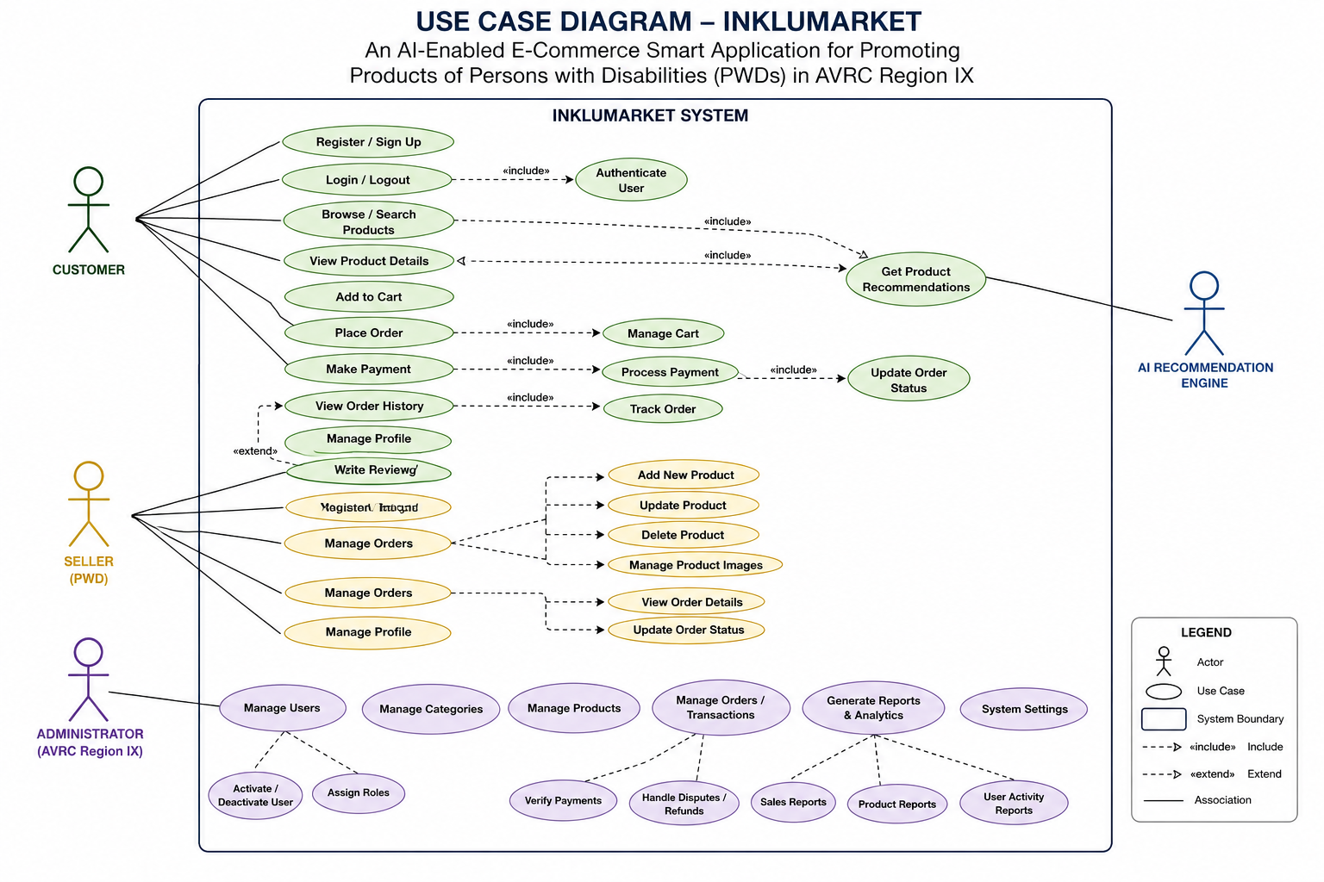
Figure 2 Use Case Diagram of PWD Seller/Admin - AVRC Staff - Buyer / Customer
Figure 2 shows the Use Case Diagram of the proposed system entitled “InkluMarket: An AI-Enabled E-Commerce Smart Application for Promoting Products of Persons with Disabilities (PWDs) in AVRC Region IX.” The diagram illustrates the interactions between the different actors and the system’s functional processes. It presents the major activities performed by customers, sellers, administrators, and the AI recommendation engine within the InkluMarket platform. The use case diagram serves as a visual representation of the system’s functionalities and user interactions.
The primary actors identified in the diagram are the Customer, Seller (PWD), Administrator (AVRC Region IX), and the AI Recommendation Engine. Each actor interacts with the system according to their specific roles and responsibilities.
The Customer actor is responsible for activities related to purchasing products and interacting with the e-commerce platform. Customers can register or sign up for an account, log in or log out of the system, browse and search products, and view detailed product information. Additionally, customers can add products to their shopping cart, place orders, make payments, and view their order history. The customer is also capable of managing personal profile information and writing product reviews after completing purchases. The system further enhances the customer experience by providing personalized product recommendations through the AI Recommendation Engine.
The Seller (PWD) actor represents Persons with Disabilities who use the platform to market and sell their products. Sellers can register and log into the system to manage their accounts and business operations. The seller is responsible for adding new products, updating product information, deleting products, and managing product images. Moreover, sellers can manage customer orders, view order details, update order statuses, and monitor sales activities. These functionalities allow sellers to effectively operate their online stores within the InkluMarket platform.
The Administrator (AVRC Region IX) actor supervises and manages the overall operations of the system. Administrative responsibilities include managing users, categories, products, orders, and transactions. The administrator also verifies payments, handles disputes and refunds, and oversees system settings. Furthermore, the administrator generates reports and analytics such as sales reports, product reports, and user activity reports. These functions ensure proper system monitoring, maintenance, and decision-making support for the organization.
An important component of the proposed system is the AI Recommendation Engine. This module is responsible for generating intelligent productrecommendations based on customer preferences, browsing history, product interactions, and transaction records. The recommendation engine improves user engagement and product visibility, particularly benefiting PWD sellers by increasing the exposure of their products to potential customers.
The use case diagram also demonstrates the relationships among different processes through the use of include and extend associations. The include relationships indicate mandatory sub-processes such as user authentication, cart management, payment processing, and order tracking, which are necessary for completing major transactions. Meanwhile, the extend relationships represent optional or conditional functionalities, such as writing reviews after successful purchases.
3.3.3 Data Flow Diagrams (DFD).

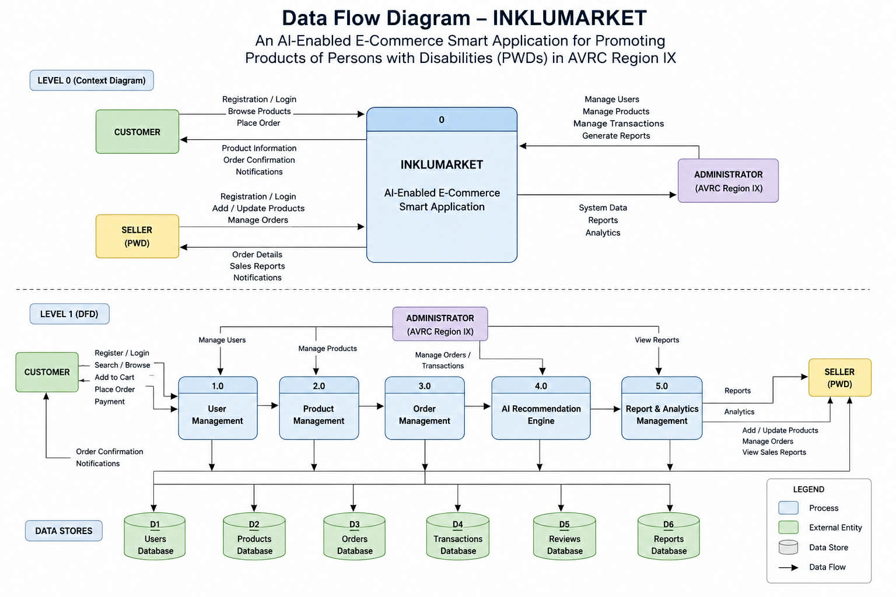
Figure 3 DFD of InkluMarket
Figure 3 shows the Data Flow Diagram (DFD) of the proposed system entitled “InkluMarket: An AI-Enabled E-Commerce Smart Application for Promoting Products of Persons with Disabilities (PWDs) in AVRC Region IX.” The diagram illustrates the flow of data within the system, including the interaction between external entities, system processes, and data stores. It provides a comprehensive representation of how information is processed, stored, and transmitted throughout the application.
The Level 0 or Context Diagram presents the overall interaction between the system and its major external entities, namely the Customer, Seller (PWD), and Administrator (AVRC Region IX). The customer interacts with the system by performing activities such as registration, login, browsing products, and placing orders. In return, the system provides product information, order confirmations, and notifications. On the other hand, sellers utilize the platform to register, log in, add or update products, and manage customer orders. The system then supplies order details, sales reports, and notifications to support seller operations.
The administrator serves as the supervisory entity responsible for managing users, products, and transactions, as well as generating reports and analytics. Through these functions, the administrator ensures the effective monitoring and maintenance of the platform. The system, in turn, provides system-generated data, reports, and analytical information to assist decision-making and operational evaluation.
The Level 1 Data Flow Diagram further decomposes the system into five major processes, namely User Management (1.0), Product Management (2.0), Order Management (3.0), AI Recommendation Engine (4.0), and Report and Analytics Management (5.0). These processes collectively support the primary functionalities of the proposed application.
The User Management process handles user-related activities such as registration, login authentication, and account management. This process interacts with the Users Database (D1), where user credentials and profile information are securely stored. Customers and administrators both interact with this module to ensure proper access control and account maintenance.
The Product Management process is responsible for handling product-related operations, including adding, updating, searching, and browsing products. Sellers can manage their product listings through this process, while customers can search and browse available products within the platform. All product-related information is stored in the Products Database (D2).
The Order Management process manages customer purchases, order placement, payment processing, and transaction monitoring. Customers can add products to their cart, place orders, and complete payments through this module. The process stores order details in the Orders Database (D3) and transaction information in the Transactions Database (D4). This ensures proper tracking and management of customer purchases and payment records.
One of the significant features of the proposed system is the AI Recommendation Engine. This process utilizes available user interactions, transaction history, and product information to generate intelligent product recommendations for customers. By analyzing purchasing behavior and preferences, the recommendation engine enhances user experience and supports product visibility for sellers, particularly Persons with Disabilities (PWDs). The process also interacts with the Reviews Database (D5) to improve recommendation accuracy based on customer feedback and ratings.
The Report and Analytics Management process is designed to generate reports, sales summaries, and analytical data for administrators and sellers. This module provides insights regarding product performance, customer transactions, and system activities. The generated information is stored in the Reports Database (D6) and serves as a decision-support mechanism for monitoring business performance and platform effectiveness.

3.3.4 Entity-Relationship Diagram (ERD).
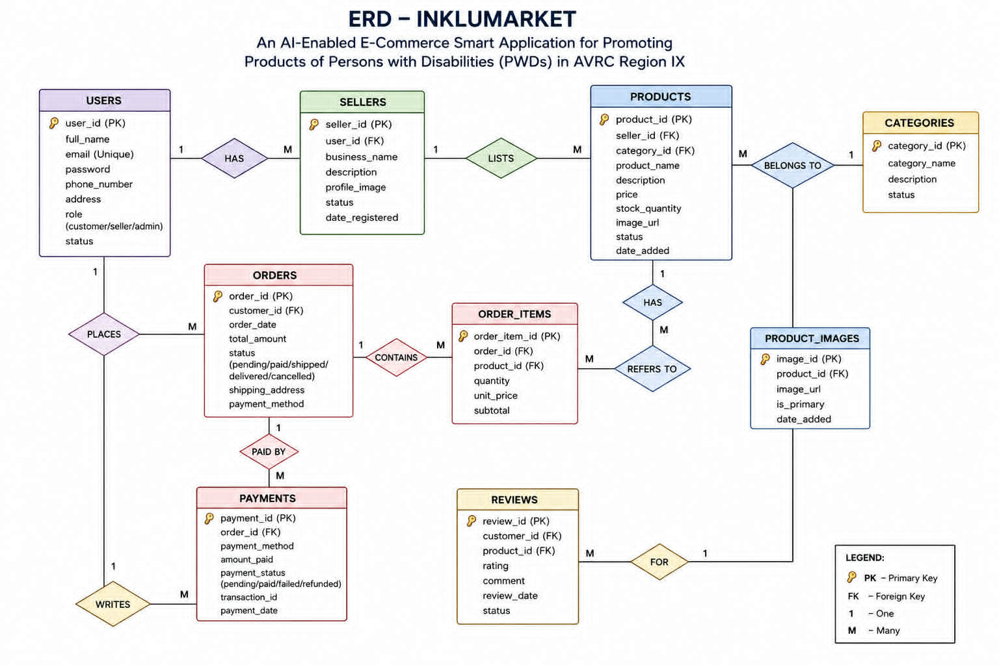
Figure 4 Entity Relationship Diagram (ERD)
Figure 4 shows the Entity Relationship Diagram (ERD) of the proposed system entitled “InkluMarket: An AI-Enabled E-Commerce Smart Application for Promoting Products of Persons with Disabilities (PWDs) in AVRC Region IX.” The diagram illustrates the logical structure of the database, including the entities, attributes, primary keys, foreign keys, and the relationships among the different components of the system. The ERD serves as the foundation for organizing and managing data efficiently within the application.
The Users entity functions as the central table of the system. It contains important user information such as user_id, full_name, email, password, phone_number, address, role, and status. The role attribute identifies whether the user acts as a customer, seller, or administrator. A one-to-many relationship exists between Users and Sellers, indicating that one user may register as a seller within the platform. The Sellers entity stores seller-specific information including business_name, description, profile_image, status, and date_registered.
The Products entity represents the items being sold in the application. It includes details such as product_name, description, price, stock_quantity, image_url, status, and date_added. Each product is associated with a specific seller through the seller_id foreign key, establishing a one-to-many relationship where one seller can list multiple products. Furthermore, each product belongs to one category through the category_id foreign key. This relationship is represented by the Categories entity, which contains category-related information such as category_name, description, and status. The categorization feature improves product organization and enhances user navigation within the platform.
To support multiple product images, the system includes the Product_Images entity. This table stores image-related information such as image_url, is_primary, and date_added. The relationship between Products and Product_Images is one-to-many, meaning a single product may contain several images for better visual presentation and marketing purposes.
The purchasing process is managed through the Orders and Order_Items entities. The Orders table records transaction details including order_date, total_amount, status, shipping_address, and payment_method. A one-to-many relationship exists between Users and Orders, signifying that one customer can place multiple orders. Meanwhile, the Order_Items entity acts as a junction table that connects orders and products. It contains attributes such as quantity, unit_price, and subtotal, enabling the system to manage multiple products within a single order transaction efficiently.
The payment functionality of the system is represented by the Payments entity. This table stores information related to financial transactions, including payment_method, amount_paid, payment_status, transaction_id, and payment_date. The relationship between Orders and Payments indicates that each order may have one or more associated payment records, ensuring proper tracking and validation of transactions within the platform.
Additionally, the system incorporates a Reviews entity to support customer feedback and product evaluation. This table contains attributes such as rating, comment, review_date, and status. Each review is linked to both the customer and the product through foreign keys, allowing customers to provide ratings and comments regarding purchased items. This feature contributes to transparency, trustworthiness, and product quality assessment within the e-commerce platform.

1.3.5. USER INTERFACE (Mock-Ups)
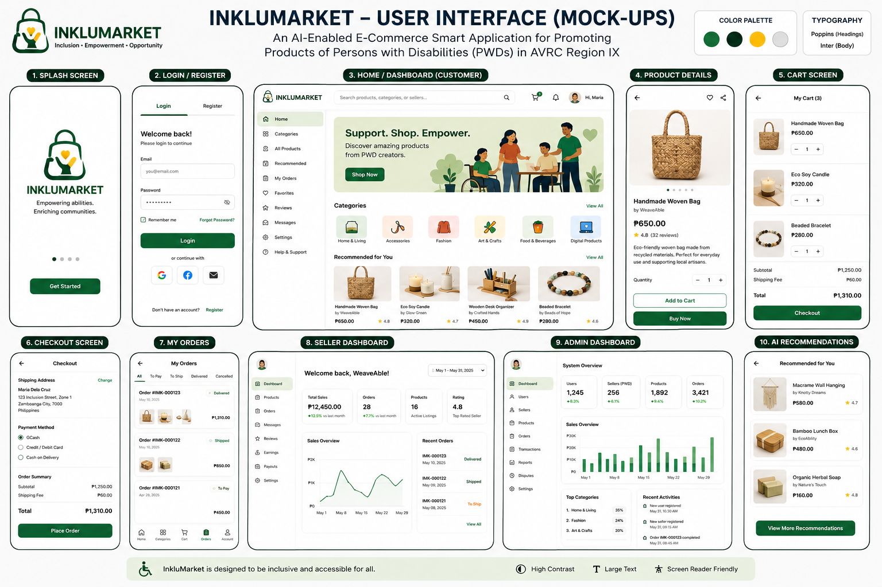










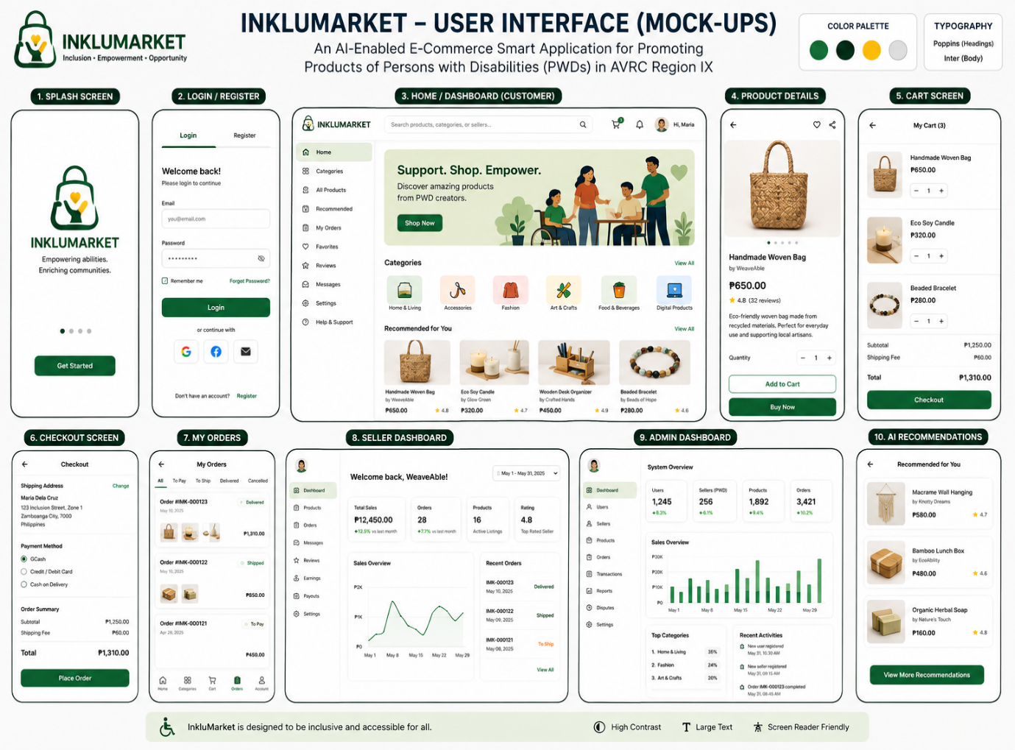
3.3.8 Development Methodology.
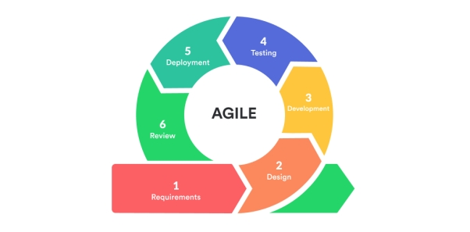
- Sprint 1 (Weeks 1-2): Requirements finalization, environment setup, database schema design, and UI wireframe development;
- Sprint 2 (Weeks 3-4): Backend API development — user authentication, product management, and database integration;
- Sprint 3 (Weeks 5-6): Frontend mobile application development — user interface implementation for all three user roles;
- Sprint 4 (Weeks 7-8): AI module integration — recommendation engine and smart search implementation;
- Sprint 5 (Weeks 9-10): Administrative dashboard development and notification system implementation;
- Sprint 6 (Weeks 11-12): System integration testing, UAT with AVRC stakeholders, and prototype refinement;
- Sprint 7 (Week 13): Final deployment preparation, documentation, and evaluation.

REFERENCES
Abdullah, M. S. (2025). Examining the effect of AI-powered personalization on customer loyalty: A meta-analysis of e-commerce studies. Review of Applied Science and Technology, 4(2), 309–338. https://doi.org/10.63125/780spe97
Adewusi, B. A., Adekunle, B. I., Mustapha, S. D., & Uzoka, A. C. (2023). Advances in AI-augmented user experience design for personalized public and enterprise digital services. International Journal of Information Systems.
Akanfe, O., Bhatt, P., & Lawong, D. A. (2025). Technology advancements shaping the financial inclusion landscape: Present interventions, emergence of artificial intelligence and future directions. Information Systems Frontiers, 27, 2189–2212. https://doi.org/10.1007/s10796-025-10597-z
Barayuga, V. J. D., Gacula, A. Q., Batin, R. T., & Valdez, G. V. (2025). AgriFresh: Design and implementation of an IoT and AI-integrated ecosystem for sustainable agriculture in Ilocos Sur. In Proceedings of the IEEE International Conference on Agrosystem Engineering, Technology & Applications (pp. 51–56).
Bansal, R., Jain, K., Tyagi, T., & Bansal, R. (2024). Leveraging AI and computer vision for generating precise e-commerce product descriptions. IOSR Journal of Computer Engineering, 26(6), 15–24. https://www.iosrjournals.org
Costa, P., & Rodrigues, H. (2024). The ever-changing business of e-commerce: Net benefits while designing a new platform for small companies. Review of Managerial Science, 18, 2507–2545. https://doi.org/10.1007/s11846-023-00681-6
Csillag, S., Svastics, C., Gyori, Z., & Hidegh, A. L. (2026). Half-open doors? Disability and inclusion: The lived experience of entrepreneurs with disabilities. In Palgrave Studies in Equity, Diversity, Inclusion, and Indigenization in Business. https://doi.org/10.1007/978-3-032-12722-8_13
Dakung, R. J., Nuhu, L. Y., Mshelmbula, J. P., et al. (2025). Rethinking disability entrepreneurship: The role of technology in entrepreneurship education for persons living with disabilities. Entrepreneurship Education. https://doi.org/10.1007/s41959-025-00160-x
Dinamika, S. G., & Siregar, E. B. A. (2022). Actualizing the business English course by using an e-commerce platform. Journal of English Language Teaching and Linguistics, 7(3), 497–512.
Fontana, M., & Mitra, S. (2023). Inclusive trade and persons with disabilities. Sustainable Trade Report.
Ghildiyal, S., Rai, A., Tiwari, D. P., Chopra, M., Joshi, A., & Farooq, O. (2025). AI-enabled price negotiation chatbot using ensemble classifier for e-commerce platform. International Journal of Advances in Signal and Image Sciences, 248–270.
Gutterman, A. S. (2025). Market opportunities in the disability community. SSRN Electronic Journal. https://doi.org/10.2139/ssrn.5100409
Gupta, C. P., Ravi Kumar, V. V., & Khurana, A. (2024). Artificial intelligence application in e-commerce: Transforming customer service, personalization and marketing. In Proceedings of the International Conference on Computing for Sustainable Global Development (pp. 10–16). https://doi.org/10.23919/INDIACom61295.2024.10498474
Hughes, H. (2025). Education technology and digital upskilling in emerging economies: Utilizing innovation for growth and development. SSRN Electronic Journal. https://doi.org/10.2139/ssrn.5719702
Jakkula, A. R. (2023). Integrating AI in e-commerce platforms: Exploring the future of shopping. Journal of Technology Innovations, 4(1).
Krithika, M., Keerthana, M., Krithiya Sri, S., Kanishka, U., Sudakshina, O., & Nivetha, S. (2026). Tech-powered marketplace and learning hub using artificial intelligence. International Journal for Research in Applied Science & Engineering Technology, 14(1). https://www.ijraset.com
Kumar, V. V., Devi, G. D., Ajay, U., Sharun, M., & Yukesh, P. (2023). Enhancing smallholder farmer livelihoods through AI-based e-commerce marketing for agricultural products. In Proceedings of the International Conference on Sustainable Computing and Data Communication Systems (pp. 533–538).
Lee, Y. S., Soroushian, J., Bullock, J., et al. (2025). Proactively developing and assisting the workforce in the age of AI. Wharton School Research Paper. https://doi.org/10.2139/ssrn.5366876
Malhotra, S., Kaur, T., Jain, K., Pandey, P. K., & Sengupta, A. (2025). Inclusive entrepreneurship ecosystem for PwDs: A reflection on SDGs. International Journal of Manpower, 46(4), 736–769. https://doi.org/10.1108/IJM-01-2024-0042
Mendoza, X. L. D. (2023). Entrepreneurial capability and engagement of persons with disabilities toward a framework for inclusive entrepreneurship. arXiv Preprint. https://arxiv.org/abs/2303.17130
Mishrif, A., & AlQamshoui, A. (2026). Bridging entrepreneurial knowledge and skill gaps through educational programmes for disabled students. In Studies in Systems, Decision and Control (Vol. 659). https://doi.org/10.1007/978-3-032-15820-8_68
Palileng, R. E. (2024). Design and architecture of BenguetFresh: An IoT-enabled data-driven system for sustainable agriculture. Journal of Electrical Systems, 20(4s), 736–742.
Paul, R. (2023). AI integration in e-commerce business models: Case studies on Amazon FBA, Airbnb, and Turo operations. SSRN Electronic Journal. https://doi.org/10.2139/ssrn.5247157
Ranjit, G., Subramoniam, S., & Jnaneswar, K. (2024). Evidences of AI powered use cases and challenges in e-tailing from leading Indian e-tailers. In Proceedings of ICCCNT (pp. 1–6). https://doi.org/10.1109/ICCCNT61001.2024.10725605
Rodrigo, R., Santos, K. D., Torres, R., Labapis, J. I., Moreno, D. E., & Tseng, S. C. (2024). Examining consumer readiness for artificial intelligence integration in online shopping. In Proceedings of the International Conference on Business and Information Management (pp. 29–34).
Saxena, A. (2025). Strategic applications of AI-powered recommendation systems across industries. Journal of Engineering and Computer Sciences, 4(7), 894–903.
Suhas, K. B., Krishna, A. S., Roopesh, M. S., Teja, K., Kumar, A. G., & Nandanan, K. (2024). Generative AI for community empowerment: Transforming livelihood opportunities in a rural Indian village. In Proceedings of ICAECT (pp. 1–6).
Sundaramoorthy, J., Raleigh, I. L., & Owolabi, A. (2024). AI-driven accessible e-commerce platforms for people with visual, hearing, and mobility impairments. Journal of Assistive Technologies.
Volkova, N., Kuzmuk, I., Oliinyk, N., Klymenko, I., & Dankanych, A. (2021). Development trends of the digital economy: E-business, e-commerce. Economic Studies Journal.

