Lesson 01

Overview
In this worksheet, we discuss some basic concepts about payment systems and how play a crucial role in the functioning of the economy by enabling the exchange of goods and services.
Before you attempt the questions in this worksheet, you should go through the respective topics in your notes:
Worksheet | Notes
Section A | Payments Ecosystem
Section B | Installations and Setup
Section C | Submissions

Materials
There is one problem statement for each learning package. A learning package is made up of a few lessons. In each lesson in the learning package, you will generally find a set of slides that serves as your notes, and a worksheet. As you go through the day with your lecturer, there will be activities for you to work on. Some activities are meant to help you take notes, while others are for you to delve deeper into the topics.
These activities will be mapped in both the slides and worksheet. You should put your answers in the worksheet. Below are some icons to guide you on what an activity will require you to do.
 Answer some questions on your own as you watch a video or listen to your lecturer.
 Team discussions
 This is a lecturer-led activity. Your lecturer will guide you through an activity step-by-step. Pay attention!

Do seek your lecturer’s advice when in doubt

Section A – Payments Ecosystem

Exercise 1
Scenario:
You receive a digital payment request. Before approving it, what could go wrong?
In your teams, identify three risks and suggest one safeguard for each.
Risks | Safeguards
Impersonator | Verify with official app or separate communication channel
Amount or details may change | Cross check before submitting
Duplicated request | Check transaction history to ensure it is not approved yet.

Exercise 2
What are some of the payment methods or technologies you have used personally? (e.g. Used YouTrip when I went Japan, PayNow at hawker stall)
Share and discuss with your team. Note down in your worksheet, what your teammates used.
Member | Payment method/App used | Card, A2A or wallet? | Payer | Payee | Other participant or provider
Achilleus | PayNow | A2A | Achilleus | Friend
Atiqah | PayNow | A2A | Atiqah | Hawker Uncle
Randy | Apple Pay | Wallet | Randy | BreadTalk
YuYi | PayNow | A2A | YuYi | SalesPerson
WenXin | Apple Pay | Wallet | WenXin | Merchants
Reashnaa | Apple Pay | Wallet | Reashnaa | Merchants

Exercise 3
Scenario: A student buys a concert ticket online using a DBS Visa card.

- Identify the various players
Player | Answer
Customer | Student
Merchant | Concert ticket web
Issuer | DBS
Gateway | Used by platform
Acquirer | DBS or depending on what the merchant uses
Card Network | Visa

- What should the payment flow look like?
Payment request Issuing bank card network acquiring bank merchant Issuing bank Confirmation

Customer Merchant gateway Card network Issuing bank Merchant (approval or decline)

Section B – Installations and Setup
Exercise 1
- Paste a screenshot of your VS Code HelloApp project structure in your worksheet.
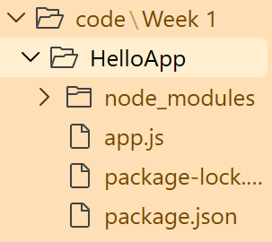

- Modify app.js so that the greeting changes to “Hello RP!”
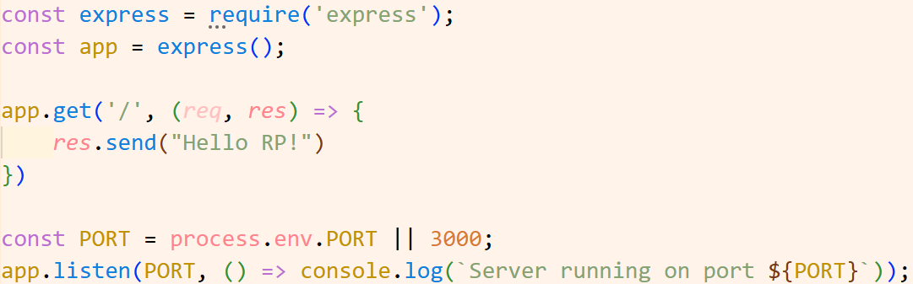

- Paste a screenshot of your web browser displaying the new greeting from HelloApp in your worksheet.
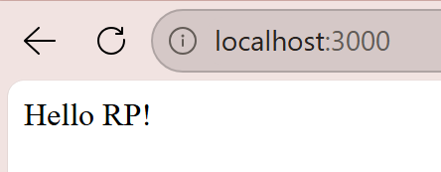

Exercise 2
- Paste a screenshot of your VS Code PetCareApp project structure in your worksheet.
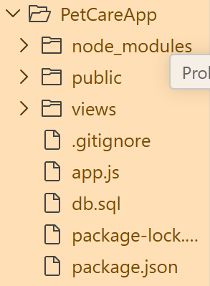

- Paste a screenshot of your web browser displaying the list of users from PetCareApp in your worksheet.
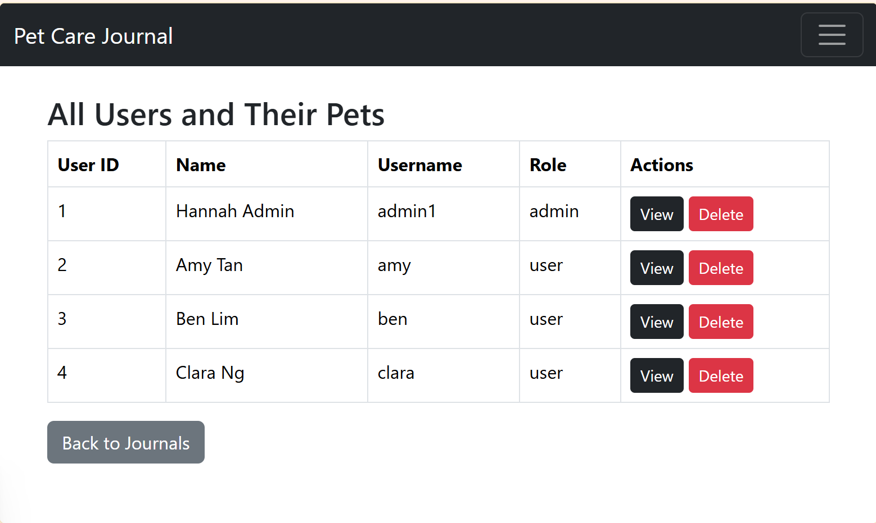

Section C – Submissions
Deliverables for today
- Worksheet (Individual)
- Upload your deliverables to POLITEMALL even if it is incomplete before the next session.
- You can resubmit by 2359 if there are updates.

