Lesson 02

Overview
In this worksheet, we review some basic JavaScript concepts and walkthrough the PetCareApp.
Before you attempt the questions in this worksheet, you should go through the respective topics in your notes:
Worksheet | Notes
Section A | Web Application Revision
Section B | PetCareApp Walkthrough
Section C | Submissions

Materials
There is one problem statement for each learning package. A learning package is made up of a few lessons. In each lesson in the learning package, you will generally find a set of slides that serves as your notes, and a worksheet. As you go through the day with your lecturer, there will be activities for you to work on. Some activities are meant to help you take notes, while others are for you to delve deeper into the topics.
These activities will be mapped in both the slides and worksheet. You should put your answers in the worksheet. Below are some icons to guide you on what an activity will require you to do.
 Answer some questions on your own as you watch a video or listen to your lecturer.
 Team discussions
 This is a lecturer-led activity. Your lecturer will guide you through an activity step-by-step. Pay attention!

Do seek your lecturer’s advice when in doubt

Section A – Web Application Revision
Exercise 1
- In the Revision folder, create a file named ex01.js. In ex01.js, type the following code below to calculate the pet grooming fee.
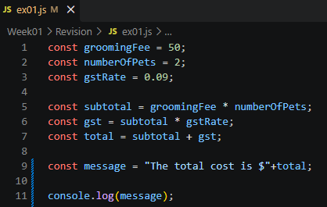
- Ensure that you are in the right folder in the console(You should be in the Revision folder.)
- Run the JS file: node ex01.js
- What is the output?
The total cost is $109

- What are the datatypes of the variables?
Variable | Data Type
groomingFee | number
numberofPets | Number
gstRate | Number
subtotal | Number
gst | Number
message | String

- What is the difference between const and let?
Const is fixed and cannot be reassigned
(read-only reference) while
let can be reassigned.

Exercise 2
In the Revision folder, create a file named ex02.js. In ex02.js, implement the logic shown in the table below to process a grooming fee payment status. (Use conditional logic to decide what users see.)

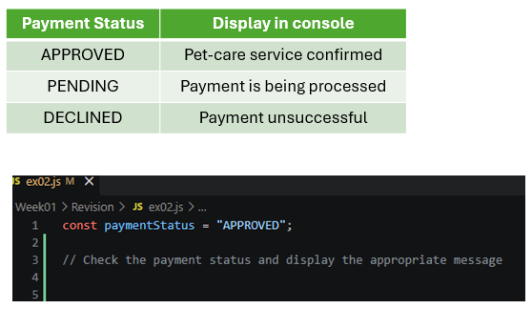

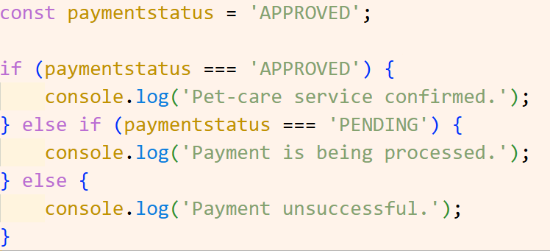

Exercise 3
In the Revision folder, create a file named ex03.js.
Given the payments array as shown:
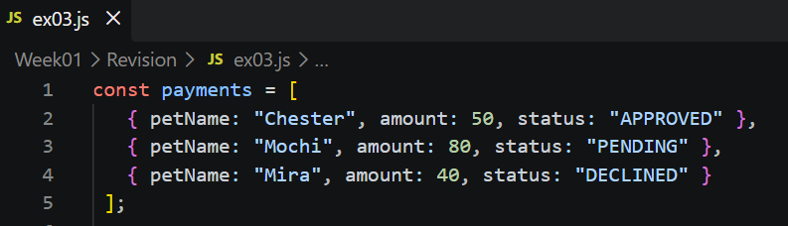

In ex03.js,
- Write the code to display Mochi’s payment status
- Use a loop to display the payment details for each pet.
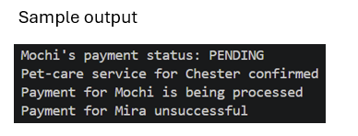
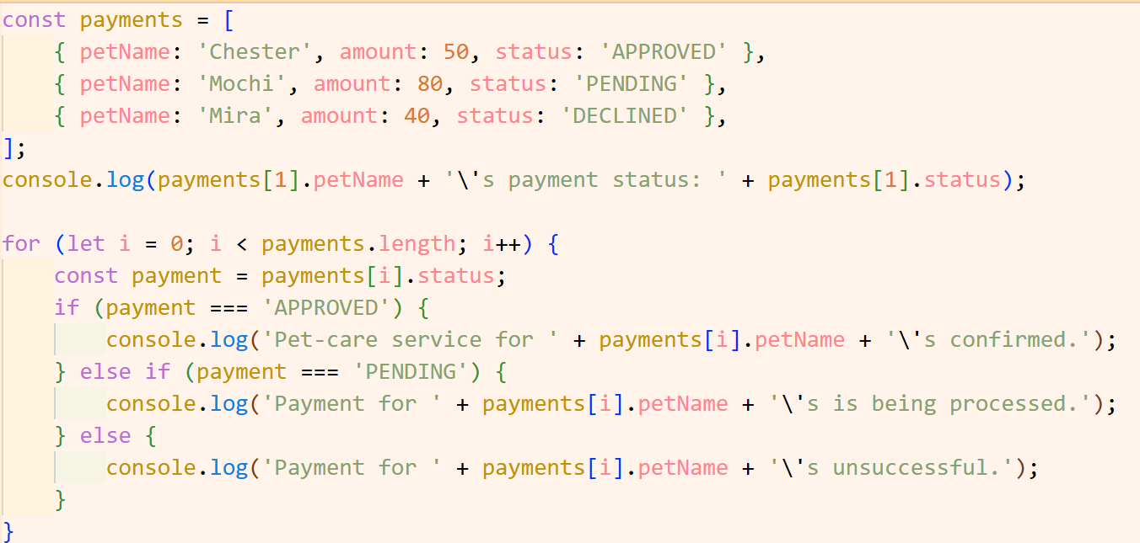

Section B – PetCareApp Walkthrough
Exercise 4
Given the page shown, trace the request.
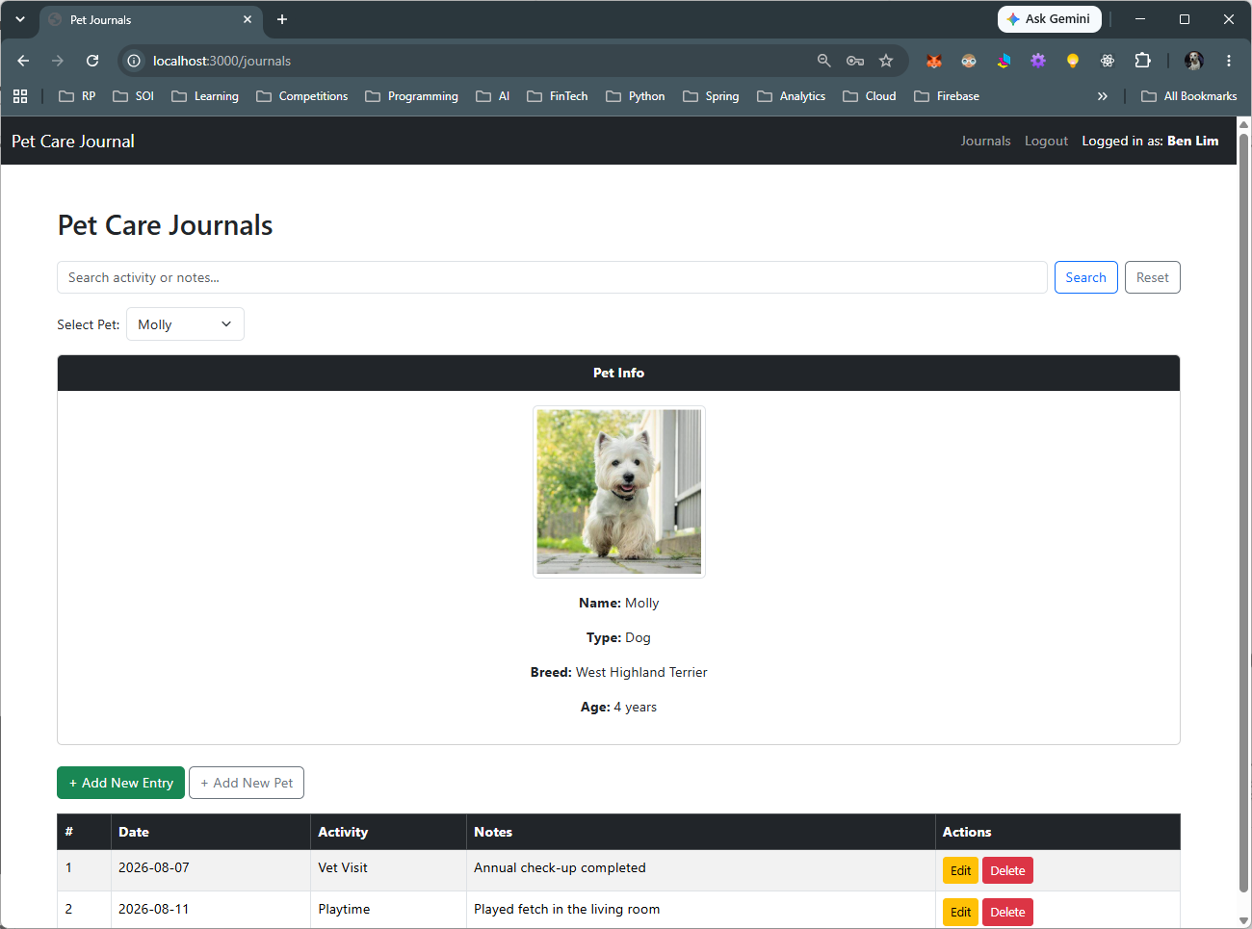

Step | Question | Answer
Browser action | Which link did you click? What URL was requested? | https://localhost:3000/journals
Route handler | What HTTP method and route pattern handle this request? | GET route, /journals
Input | What value does the handler read, and where does it come from—for example, req.params? | userId = req.session.user.id;  selectedPetId = req.query.petId
Database operation | Which SQL query runs? Which table and record does it access? | 'SELECT * FROM pets WHERE owner_id = ?'  SELECT journal.*, pets.name, pets.species, pets.breed, pets.age, pets.image  FROM journal  JOIN pets ON journal.pet_id = pets.id  WHERE pets.owner_id = ? AND pets.id = ?
View | Which EJS template is rendered? What data is passed into it? | Journals ejs file  Relevant data retrieved via the SQL statement
Output | Where does the template display that data? | Journal entries display tables, pet names appears as a dropdown. EJS template loops through the supplied data to display them.

Exercise 5
Given the page shown, trace the request.
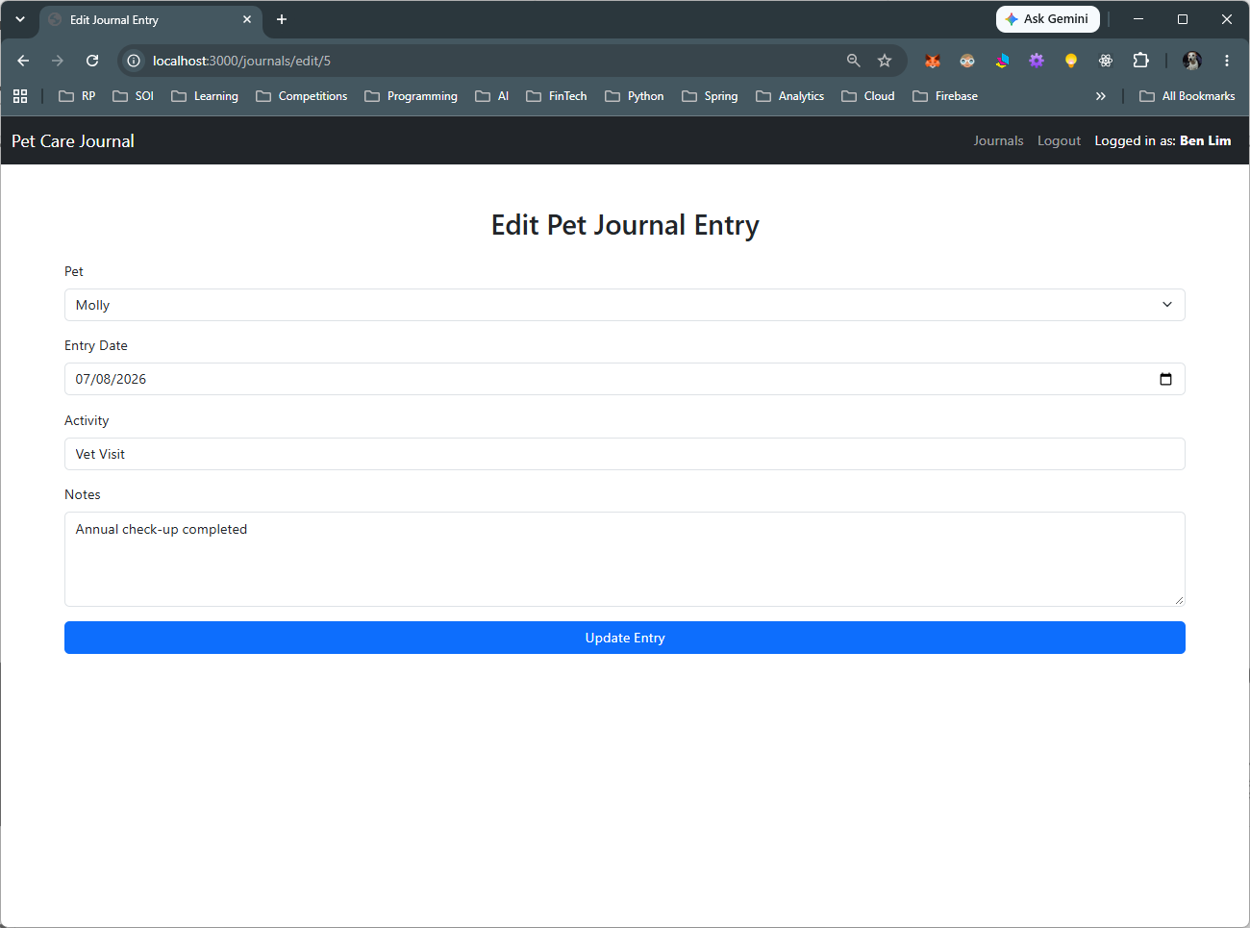

Step | Question | Answer
Browser action | Which link did you click? What URL was requested? | https://localhost:3000/  journals/edit/5
Route handler | What HTTP method and route pattern handle this request? | GET method and / journals/edit/:id  POST method to process updates after submission
Input | What value does the handler read, and where does it come from—for example, req.params? | GET method:  The JournalId from the URL  The userId from req.session.user.id  POST method:  The JournalId from the URL  The userId from req.session.user.id  Petid, entry date, activity and notes. Req.body
Database operation | Which SQL query runs? Which table and record does it access? | GET = SELECT queries to run pet and journal tables  POST = UPDATE on journal table
View | Which EJS template is rendered? What data is passed into it? | GET = SELECT queries to run pet and journal tables  POST = UPDATE on journal table
Output | Where does the template display that data? | Journal entries display in edit form to update. After submission, user is redirected to journals. Journals entries appear as rows in journal table and pet name appear in filter dropdown. EJS template loops through supplied data to display them.

Section C – Submissions
Deliverables for today
- Worksheet (Individual)
- Upload your deliverables to POLITEMALL even if it is incomplete before the next session.
- You can resubmit by 2359 if there are updates.

