Lesson 06

Overview
In this worksheet, we explore API testing and mock payment integration using Postman. Students will prepare the PetCare application, create and test API requests, interpret HTTP responses, and examine how payment statuses are mapped to booking outcomes. They will also learn why trusted payment amounts should come from the server catalogue and practise handling pending, declined, approved, and invalid payment requests.
Before you answer the questions in this worksheet, you should go through the respective topics in your notes:
Worksheet | Notes
Section A | Testing APIs with Postman
Section B | Mock Payment API Integration
Section C | Test the mock payment in Postman
Section D | Submissions

Do seek your lecturer’s advice when in doubt

Section A – Testing APIs with Postman
Exercise 1
- In your C372 project workspace, Week03 folder, create a new folder named Lesson06.
- Copy your completed Week03\Lesson05\PetCareAppMVC into Lesson06
- Right-click on Week03\Lesson06\PetCareAppMVC, select Open in Integrated Terminal
- Run npm install, then node app.js.
- Test that the application is working as expected.
- Keep the Lesson05 folder unchanged as your reference.
Note:
When copying a project, do not include node_modules as it is a very large folder
No working Lesson 5 app? Copy PetCareAppMVC from today's Resources folder.

Exercise 2
Install and open Postman
- Visit https://www.postman.com/downloads/ and select the desktop app for your OS.
- On Windows, run the installer; then launch Postman from Start.
- Complete any sign-in or initial setup following the on-screen instructions

Setting up Postman workspace
- Once logged in to Postman, click on Workspaces at the top left, select Create
- Give your workspace a name, keep the default settings. Click Create Workspace
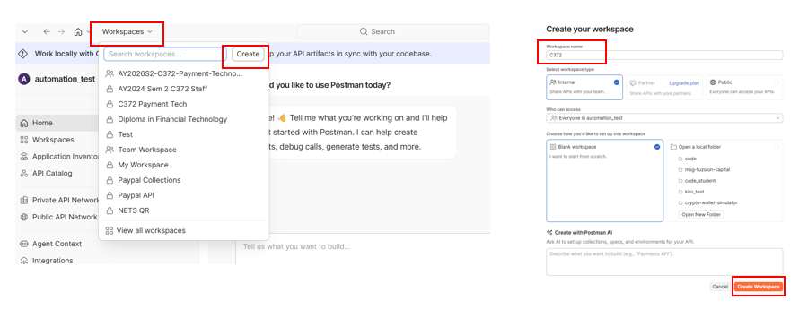
- Under COLLECTIONS, click Create

- Give your collections a name, Week03
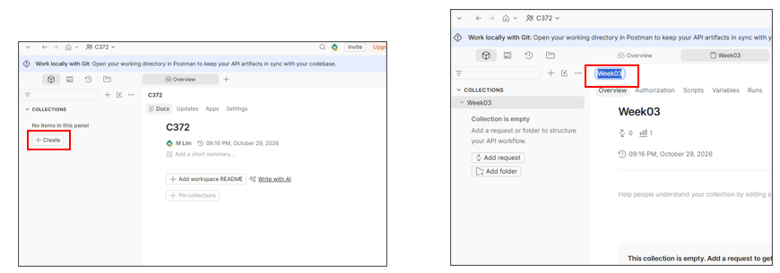

Adding a Postman request
- In Week03 collections, click Add request
- Choose GET and enter the full URL shown below
http://localhost:3000/payments/prepare/2
- Leave everything else as it is
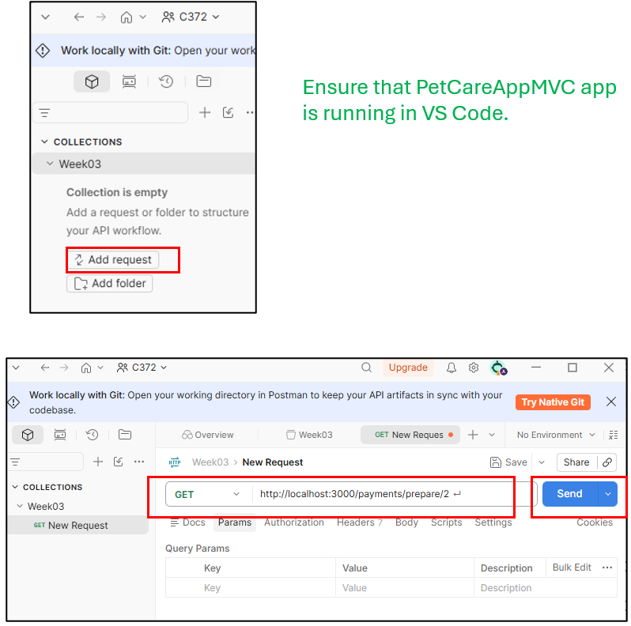
- Click Send.
- You should see the following HTTP status and response.
HTTP Status: 200
Response: {
"serviceId": 2,
"serviceName": "Pet Grooming",
"amount": 50,
"currency": "sgd",
"status": "READY_FOR_PAYMENT"
}

Exercise 3
- You can rename the request.
- Create a new request for each URL below and give it a name.
- Test the request and fill in the blanks

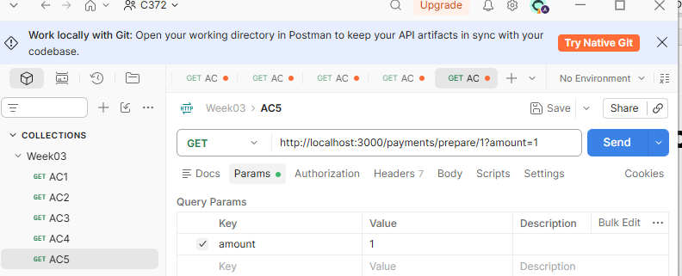

Check | Request (Body: none) | HTTP Status | Service Name; amount
AC1 | GET /payments/prepare/1 | 200 | Grooming, 50
AC2 | GET /payments/prepare/2 | 200 | Vaccination, 35
AC3 | GET /payments/prepare/3 | 200 | Boarding, 80
AC4 | GET /payments/prepare/999 | 404 | "error": "Service not found"
Price | GET /payments/prepare/1?amount=1 | 200 | Grooming, 50

Exercise 4
Indicate the correct sequence of the events below.
Add a role to each event: client, PetCare or local mock.
Event | Sequence | Role
Returns providerPaymentId and status PENDING. | 3 | Local mock
Maps the status and sends the HTTP JSON response. | 4 | Client
Sends POST /payments/mock/2 with testStatus PENDING. | 1 | Client
Reads the $50 catalogue price, then calls the local mock. | 2 | PetCare

Section B – Mock Payment API Integration

Exercise 5
Follow the instructions in the notes.

Exercise 6
Scenario: A client sends the following request to simulate a pending payment for service 2:
- Trusted price: Where should PetCare obtain the payment amount - from the client’s request or the server catalogue?
From Server catalogue (make a systematic list)

- Booking outcome: The mock provider returns PENDING. What value should PetCare return in bookingStatus?
"AWAITING_PAYMENT"

- Unknown service: If the request uses a service ID that does not exist, what HTTP status code and error message should PetCare return?
HTTP 404 'Service not found'

Section C – Test the mock payment in Postman

Exercise 7
Test the requests in POSTMAN. Predict each result before clicking Send.
Check | Request / JSON body | Expected result
MC1 | payments/mock/2 + {"testStatus":"APPROVED"} | 200; APPROVED > CONFIRMED
MC2 | payments/mock/2 + {"testStatus":"PENDING"} | 200; PENDING > AWAITING_PAYMENT
MC3 | payments/mock/2 + {"testStatus":"DECLINED"} | 200; PENDING > AWAITING_PAYMENT
MC4 | payments/mock/999 + {"testStatus":"PENDING"} | 404; Service not found
MC5 | payments/mock/2 + {} | 200; PENDING > AWAITING_PAYMENT

Section D – Submissions
Deliverables for today
- Worksheet (Individual)
- Upload your deliverables to POLITEMALL even if it is incomplete before the next session.
- You can resubmit by 2359 if there are updates.

