Cross-cohort transportability of RNA-to-protein prediction is target- and context-specific
Deyuan You1, Haoyang Zhang1, Haotian Liu1, Zhaoliang Xia1, Yadong Zhang1, Jiarui Man2, Jiawei Zhang1
1 College of Life Sciences, Zhejiang University, Hangzhou, 310058, P.R. China
2 School of Low-Altitude Science and Engineering, Shandong University, Weihai, 264209, P.R. China
*Corresponding author:
Deyuan You
E-mail: tianyang087@gmail.com
Postal address: College of Life Sciences, Zhejiang University, Hangzhou 310058, P.R. China

Abstract

Purpose
We evaluated whether RNA-to-antibody-derived-tag relationships remain transportable across patients, cohorts and platforms, focusing on applicability boundaries rather than a universal imputation model.

Methods
Two breast-cancer CITE-seq cohorts formed an 11-target anchor for donor-held-out and bidirectional transfer analyses comparing a sciPENN-style single-cohort neural reimplementation, ridge regression and cognate-RNA baselines under source-only preprocessing. Extensions included a 43-target panel, an independent healthy-PBMC stress test, six external evaluations of a retrospectively locked target-level predictor, four repeatability resources, spatial protein measurements and six immunotherapy cohorts. Numerical transport required rank association, specificity, positive R2, calibration and variance preservation; donors, patients or sections were the inferential units.

Results
The strict gate was satisfiable in 4 of 22 source-internal donor-held-out target-cohort settings, versus 0 of 22 label-shuffled controls, but within-cohort generalization did not guarantee external transport. After corrected-source propagation, 5 of 43 targets met the conditional numerical criteria in both frozen source settings of the healthy-PBMC stress test; 3 were primary direct mappings and 2 were sensitivity-only non-direct mappings. Across a 51-target master boundary, 17 targets failed transport criteria in every evaluated setting and 12 additional targets failed at the measurement layer. The external target-level predictor had no multiplicity-controlled success across six cohorts. Technical decomposition identified a small post-CLR target-specific concentration fraction (0.0069) and a larger repeat/library fraction (0.1848). A four-gene score showed heterogeneous AUROCs across six immunotherapy cohorts and did not generalize as a specific biomarker. Spatial analyses produced no family-level significant result.

Conclusions
RNA-to-protein transportability was target- and context-specific. Rank conservation did not establish numerical interchangeability, and direct protein measurement remained necessary for many targets. The clinical score is exploratory and unsuitable for treatment selection.
Keywords: CITE-seq; antibody derived tags; RNA to protein prediction; transportability; technical variance; spatial proteomics; immunotherapy

1 Introduction
Cellular indexing of transcriptomes and epitopes by sequencing measures RNA and antibody derived tags in the same cells and exposes both the complementarity and imperfect concordance of the two molecular layers [1] (Figure 1). Joint probabilistic and deep learning frameworks can exploit paired measurements to impute missing proteins or transfer protein state estimates to RNA only cells [2-4]. These methods broaden the analytical value of transcriptomic datasets, but downstream conclusions remain dependent on whether the learned RNA protein relationship persists outside the training study.
Most prediction studies emphasize held out cells, donors or batches within one dataset. Such tests are necessary, but an independent cohort introduces shifts in patient composition, cell states, RNA detection, antibody dynamic range, sample processing and sequencing chemistry. Broader single cell benchmarks have shown that algorithm rankings depend on the task and evaluation design [5,6]. Transfer learning studies similarly treat mapping to a new reference as an empirical question rather than an architectural property [7]. A model may therefore recover variation among donors in one cohort while failing to preserve either protein ordering or numerical scale in another.
This distinction is biologically plausible. Transcription, translation, protein turnover, trafficking, receptor complex formation, alternative splicing and post translational modification can each weaken a direct relationship between one transcript and one antibody signal. It is also technically important because antibody clone, staining concentration, library preparation, sequencing lane, normalization and tissue processing can change the observed ADT distribution. A favorable pooled cell correlation can consequently reflect shared lineage structure or cell composition rather than a target-specific mapping meeting the analysis-defined criteria.
The anchor analysis used two breast cancer CITE-seq cohorts, GSE199219 and GSE267552, and 11 immune proteins to separate leave one donor out generalization from bidirectional independent cohort transfer. It further compared neural and linear models, retained shuffled controls and evaluated measured protein in imaging mass cytometry and spatial antibody capture. The present analysis extends that foundation in three directions. First, it expands the target boundary to a 43 target panel and applies frozen rules in an independent healthy PBMC stress test. Second, it evaluates a frozen target level transportability predictor in six external cohorts without refitting. Third, it quantifies several technical variance components and evaluates a frozen patient level RNA score in six independent immunotherapy cohorts.
We define cross cohort RNA ADT transportability as more than rank correlation. Numerical transport additionally requires external prediction accuracy, calibration and preservation of prediction variance. Rank only targets may be useful for ordering cells or exploratory enrichment but cannot justify substituting predicted values for measured ADT signal. Our aim is to estimate the distribution and heterogeneity of transportability across predefined targets and contexts, identify stable, context dependent and non transportable classes, and state the evidence boundary for spatial and clinical interpretation. The central message is that the external validity of RNA derived protein estimates is an empirical property of the target, context and measurement system, not a property of the prediction algorithm alone.

2 Methods

2.1 Study design and evidence hierarchy
The analysis was organized into three evidence layers. The main line evaluated patient and cohort transportability of paired RNA ADT mappings. The clinical extension evaluated whether selected RNA states carried patient level response information. The integration layer combined observed transport, shuffled baselines, technical repeatability and spatial evidence. Versioned baseline outputs were preserved. Every extension was written to an independent versioned directory, with input paths, parameters, software versions, exclusions and errors retained.
The evidence hierarchy distinguished four questions. Leave one donor out analysis assessed generalization to a new donor within a cohort. Frozen transfer assessed application to an independent cohort without refitting. Spatial analysis assessed whether an inferred or measured protein state retained an association in a different measurement modality. Clinical analysis assessed patient level association and was not allowed to redefine single cell transport grades. A favorable result at one level did not automatically promote a claim at another.

2.2 Primary paired single cell cohorts
The original anchor used public human breast cancer CITE-seq datasets GSE199219 and GSE267552. After the predefined cell selection, GSE199219 contributed 7,147 joint annotation T lineage cells from six donors and GSE267552 contributed 3,765 tumor T cells from five donors. Eleven matched immune protein targets were available in both datasets: CD8A, CD4, CD14, CD19, CD56, HLA-DR, PD-1, PD-L1, CTLA4, TIGIT and CD103. Counts, donor labels and target mappings were fixed before model fitting.
Additional cancer and immune cohorts were used as external stress tests when paired RNA and ADT data and the required target mappings were available. Missing ADTs were considered structurally unavailable and were neither imputed nor counted as failures. Cohorts with partial panels contributed only to targets that could be evaluated under the frozen mapping. The GSE245108 technical resource described here was restricted to four healthy donors in the titration design; the four additional donors associated with an optimization mixture in the depositor description were not part of the fitted crossed design and were excluded from the variance model.
GSE334503 and GSE335494 formed the paired RNA and antibody-derived tag (ADT) expanded-panel analysis. GSE334503 profiled peripheral immune responses across health, specific antibody deficiency and common variable immunodeficiency in a vaccination study; GSE335494 profiled patients with melanoma. After reconstruction and alignment to depositor barcodes, GSE334503 contributed 422,786 paired cells from 30 donors and GSE335494 contributed 186,753 paired cells from 10 patients. Forty-seven identical ADT barcodes were shared; four non-biological controls were removed without reference to outcomes, leaving 43 biological targets. Thirty-seven had direct named-gene mappings and six ambiguous composite, isoform, glycan-epitope or paralog mappings were retained only for sensitivity analysis. Marker-score annotation using 31 RNA markers assigned eight broad lineages (CD4 T, CD8 T, NK, B, monocyte, cDC, pDC and platelet); ambiguous cells were excluded from lineage-adjusted analyses. The principal direction treated GSE334503 as discovery/source and GSE335494 as external validation/target, with the reverse direction analyzed separately. RNA feature definition, standardization and ridge fitting were performed in the source cohort only; target-cohort RNA or ADT values were not used for feature selection, scaling, coefficient fitting or threshold optimization. For composition-adjusted analyses, the same fixed 31-marker scoring rules were applied independently within each cohort, rather than transferring labels from the source cohort. ADT counts were CLR-transformed before residualization. For each target and cohort, the mean CLR-ADT value was calculated within each of the eight assigned lineages and subtracted from each cell's CLR-ADT value; Spearman correlation was then computed between cognate log-normalized RNA and the resulting ADT residual. Ambiguous cells were excluded before lineage means were calculated and did not contribute to adjusted or within-lineage correlations.

2.3 Expanded target panel and independent PBMC stress test
The expanded atlas contained 43 ADT targets. Thirty seven mappings directly linked an antibody analyte to its cognate gene and formed the primary inference set. Six non direct mappings were restricted to sensitivity analysis because they represented receptor complexes, paralog ambiguity, an HLA-DR heterodimer proxy, a glycan epitope or PTPRC splice isoforms. These were CD3 to the CD3 complex, CD16 to FCGR3 paralogs, HLA-DR to HLA-DRA or HLA-DRB1, CD57 to B3GAT1, and CD45RA and CD45RO to PTPRC isoform proxies.
GSE314416 was used as a cross platform and cross disease state stress test, not as a third cancer replication cohort. Valid follow up ADT measurements were available for 84,177 cells from 17 independent participants. Baseline ADT matrices were empty and could not support longitudinal validation. This limitation was treated as structural unavailability rather than an analysis failure.

2.4 RNA and ADT preprocessing
RNA and ADT modalities were aligned by shared cell identifiers. For the original source target models, RNA counts were library normalized to 10,000 counts per cell and log transformed. Gene eligibility required detection in at least the larger of 20 cells or 1% of source training cells. The 1,000 genes with greatest variance in the source training partition were retained and standardized with source means and standard deviations. No target cohort observations were used for feature selection, scaling, checkpoint selection or hyperparameter choice.
ADT measurements were analyzed using the normalization specified for each frozen analysis, principally centered log ratio values where available. Cross study comparisons did not assume that CLR values from different antibody panels represented an identical absolute scale. Empty matrices, duplicated technical files and samples without required metadata were logged and excluded before inference.

2.5 Prediction models and matched comparators
The neural comparator was a fidelity oriented reimplementation of the sciPENN recurrent feed forward architecture [3]. It used a 512 unit input block with batch normalization, PReLU activation and dropout of 0.25, followed by a recurrent hidden cell, three feed forward or recurrent updates and a joint linear output for the 11 ADTs. Training minimized mean squared error against measured ADT using Adam with a learning rate of 0.001, batch size 128 and at most 200 epochs. The best source validation checkpoint was retained with early stopping. The fixed ensemble seeds were 20260820 through 20260824.
Ridge regression used the same source target partitions, selected genes and source only scaling. Cognate RNA only and cognate excluded ridge models evaluated the contribution of the matched transcript. Residual feed forward and shallow multilayer perceptron models used the same input, output and training budget. totalVI was retained as a within cohort multimodal reference but was not ranked as a cross cohort comparator because its evaluation task differed [2].
Shuffled controls retained the source design while disrupting the RNA ADT relationship. Because a ridge model with one cognate RNA feature is an affine transformation of that feature, Spearman correlation for this model was interpreted as rank coupling rather than evidence that training source information transported. Numerical claims therefore required metrics sensitive to scale and error in addition to rank correlation.

2.6 Donor held out and cross cohort evaluation
Within each anchor cohort, leave one donor out models were trained on the remaining donors and evaluated on the untouched donor. This assessed new donor generalization within a study and was not considered evidence of independent cohort transport. Ridge regularization was fixed at alpha=10.0 with solver='lsqr' (fit_intercept=True) rather than tuned on a validation grid; the validation metric was the held out donor Spearman correlation together with mean absolute error, coefficient of determination and calibration. Genes absent from a cohort were recorded as exclusions rather than silently imputed, and each fold retained its selected feature list, scaler parameters, held out predictions and a SHA-256 hash. The per fold held out target, training target set, selected features, scaler mean and scale, ridge alpha and solver, and observed versus predicted value are provided in Supplementary Table B (the 11 target leave one target out fold table), enabling replication of each held out target prediction.
The donor-level leave-one-donor-out folds underpinning the CD4 counterexample - source cohort, held out donor, training donors, selected features, source-only scaler scale, ridge alpha and solver and observed versus predicted donor-level metrics, with SHA-256 hashes of the held out prediction arrays provided in the accompanying B2 prediction manifest - are provided in Supplementary Table B2, enabling replication of each held out donor prediction and assessment of the CD4 counterexample at the donor level. Model uncertainty was estimated from fixed seeds, and rejection analyses removed increasing fractions of the most uncertain cells under locked thresholds. The supplementary audit hierarchy is: B = leave-one-target-out model-fold records; B2 = donor-level LODO fold records for the CD4 counterexample; B3 = reconstructed source-internal strict-gate target and donor-target metrics plus null mapping and hash audit. These are different evaluation levels and should not be pooled.
Table 1. Supplementary audit hierarchy and evaluation levels.
Supplement | Evaluation level | Purpose | Key contents
B | target held out | reconstruct 11-target model folds | training/held-out targets, genes, scaler and predictions
B2 | donor held out | replicate donor-level CD4 counterexample | donors, folds, metrics and prediction-array manifest
B3 | target/cohort and donor-target | positive-control gate and reconstruction audit | five metrics, null mapping, hashes and consistency checks
Gate satisfiability was evaluated as a source-internal positive control by applying the same strict five-component rule to pooled out-of-fold donor-held-out predictions in each anchor cohort. Legacy predictions had been stored on the ADT scale standardized within each training fold; for each held-out donor they were returned to CLR units using the mean and standard deviation estimated from all other donors before Spearman correlation, coefficient of determination, calibration slope and predicted-to-observed standard deviation ratio were calculated. Specificity gain was the cognate Spearman correlation minus a fixed noncognate ADT correlation under a seeded random derangement (seed 20260902), with the mapping retained. The target-level and 121 donor-target metrics, input hashes and reconstruction audit are provided in Supplementary Table B3 and its manifest.
Cross cohort models were trained entirely in one source cohort and applied to the independent target cohort without target label access. Evaluation included pooled cell Spearman correlation, donor median correlation, coefficient of determination, mean absolute error, root mean squared error, calibration slope and intercept, and the ratio of predicted to observed standard deviation. Results were retained by target and direction rather than averaged into a single headline score.

2.7 Target classification and threshold sensitivity
The versioned decision framework separated numerical transport, rank invariance, context dependence, instability, measurement failure, failure across all evaluated settings and insufficient evidence. Measurement failure was operationalized by two distinct triggers: a repeatability trigger when the orthogonal intraclass correlation fell below 0.50, and a dynamic range or convergence trigger when a target could not be estimated reliably in the technical resource. Biological discordance was then reserved for reliable targets that still failed transport, and was only described as consistent with technical noise being insufficient, never asserted as a confirmed molecular mechanism. Numerical transport required favorable external association, error, calibration and variance preservation under the applicable frozen thresholds. Rank invariant targets retained monotonic ordering but did not meet numerical criteria. Rank conservation was further separated into global rank preservation, where the pooled ranking held, and robust rank preservation, where the ordering also held at the median and worst donor level; global rank preservation alone did not support numerical substitution. Context dependent targets showed material changes across source settings or cohorts. Weak or non transportable targets failed the association or error requirements.
Target denominators reflected distinct evidence roles rather than nested claims. The 11-target anchor was the matched breast-cancer benchmark. The expanded analysis used 43 shared biological ADTs between GSE334503 and GSE335494 (37 direct mappings for primary inference and six non-direct mappings for sensitivity analysis); only the targets overlapping the anchor contribute to both sets. The 51-target master boundary was the union of evaluable targets across the anchor, expanded-panel and external stress-test evidence after target harmonization and therefore was not obtained by simply adding 11 and 43. The 265 GSE245108 ADT features belonged to a separate technical titration resource and were used for variance and effective-dimensionality analyses, not as 265 transport targets. Structurally unavailable ADTs were not imputed and were excluded from the relevant denominator. After canonical-name harmonization, the 43 expanded ADTs represented 42 master rows because the CD57 Recombinant assay was consolidated under CD57; nine anchor or stress-test-only targets then produced the 51-row master audit. The 29 hard failures comprised 17 failures across all evaluated settings and 12 measurement failures under the master rules. Bidirectionally stable denotes favorable transport in both GSE334503-to-GSE335494 directions, whereas threshold stable denotes an unchanged class under the 18 one-at-a-time threshold perturbations.
Table 2 separates the non-nested classification systems used in this manuscript. Bidirectional stability is a descriptive rank-gain label for the GSE334503/GSE335494 pair and is not synonymous with numerical transport. The canonical system adds error, calibration and variance requirements. The GSE314416 stress-test labels answer a third question: whether either frozen source model retained rank or numerical behavior in a healthy PBMC context.
Threshold sensitivity was evaluated by one at a time perturbation of seven decision parameters across 18 settings. For each target, stability was the fraction of perturbations retaining the primary category. This analysis tested whether the reported target classes depended on arbitrary threshold choices near the locked boundary. Threshold values were set a priori from four distinct sources: statistical floors for association and specificity, measurement equivalence criteria for calibration slope and variance preservation, published antibody and normalization practice, and an explicit statement of which rules were locked retrospectively rather than preregistered; sensitivity testing then verified that no single threshold choice drove the classification.
Table 2. Target-classification systems, denominators, and interpretation.
System | Evidence and rule | Denominator | Reported counts
Corrected directional strict gate | Rank + specificity + R2 + calibration + SD-ratio gate, evaluated separately by direction | 43 shared ADTs | 1 numerical pass per direction (CD11c forward; CD16 reverse); 0 bidirectional numerical passes
Corrected integrated classes | Feature-type-safe synthesis of both transfer directions | 43 shared ADTs | 1 primary direction-specific numerical (CD11c); 1 sensitivity-only non-direct pass (CD16); 0 primary bidirectional numerical passes
Independent PBMC stress test | Two frozen source models evaluated in GSE314416 | 43 harmonized targets | 20 rank-only; 23 weak/non-transportable; 0 conditionally numerical in both source settings
Master boundary | Harmonized transport plus measurement evidence | 51 master rows | 42 barcode-aligned expanded targets plus 9 anchor/other-evidence targets; failure labels remain evidence-layer specific
To make the decision rules reproducible, three null models were distinguished. Null A permuted target labels within the source design, breaking the RNA-ADT pairing while preserving marginal structure. Null B substituted non-cognate antibodies to estimate specificity; in the corrected expanded-panel analysis, 100 independently seeded derangements were evaluated and the median non-cognate correlation defined the specificity reference. Null C permuted donor signs for donor-level sign-flip tests. For Null A, 1,000 permutations were used per target and direction with deterministic seeds, and permutation P values used the plus-one correction. Null C used exact enumeration when the donor count was at most 20 and otherwise 1,000 Monte Carlo permutations. Benjamini-Hochberg correction was applied across 43 targets within each direction. The corrected machine-readable evidence records directional pooled, within-donor and between-donor metrics; 100-derangement Null-B summaries; 500-donor-bootstrap gate-pass probabilities; and integrated classes. The canonical numerical gate required Spearman correlation at least 0.20, specificity gain at least 0.10, positive R2, calibration slope from 0.5 to 2.0 and predicted-to-observed SD ratio from 0.5 to 2.0. The SD-ratio interval is an analysis-defined measurement-equivalence criterion, not a universally validated assay threshold; the broader 0.05-to-20 interval was exploratory only. A target had to pass every component. One-at-a-time perturbations across 18 settings assessed boundary sensitivity. Leave-one-donor-out and leave-one-patient-out remained distinct evaluation levels. Because no public preregistration or immutable pre-analysis release was available, these rules are described as analysis-defined and retrospectively locked rather than preregistered.

2.8 Frozen target level predictor and external evaluation
The target level predictor used two frozen features derived from the original anchor: cognate RNA ADT coupling and within cohort donor held out performance. Feature definitions, transformations, ridge coefficient structure and evaluation rules were locked before external application. Each independent cohort was evaluated without feature reselection, coefficient refitting or threshold optimization.
The six external evaluations were GSE305118 acute myeloid leukemia (11 evaluable targets), GSE309625 colorectal liver metastasis (11), GSE316782 non-small-cell lung cancer (11), GSE317605 biliary tract cancer (9), GSE334503 immune-deficiency vaccination samples (11) and GSE335494 melanoma (10). These cohorts differed in disease context, donor composition and available ADT panel; unavailable targets were excluded rather than scored as failures. Cohort-level permutation results were interpreted as a six-test family, so one nominal success was not treated as independent validation of a universal predictor. Table 3 gives the complete cohort-level outcome record. The frozen predictor used two anchor-derived features, ridge alpha 1.0, a fixed coefficient vector, seed 20260903, and 10,000 label permutations per cohort; it was evaluated only for previously seen target identities, not for unseen proteins. The cohort-by-role matrix is explicit: GSE334503/GSE335494 serve as the expanded-panel source/target pair and also as external frozen-predictor evaluation cohorts; GSE314416 is a separate stress-test target cohort. Reuse is disclosed, and no cohort is treated as independent evidence for more than its stated role. This downstream evaluation is flagged in the leakage-impact audit as requiring a corrected source-model propagation check before it is treated as final evidence.
Table 3. External evaluation of the frozen target-level predictor.
Cohort | Context | Evaluable targets | Target-level rho | Permutation P | Outcome
GSE305118 | AML | 11 | 0.445 | 0.1745 | not above benchmark
GSE309625 | colorectal liver metastasis | 11 | 0.764 | 0.0096 | strongest nominal signal; not significant after six-test correction
GSE316782 | NSCLC | 11 | 0.091 | 0.8022 | not above benchmark
GSE317605 | biliary tract cancer | 9 | 0.017 | 0.9824 | partial panel; not above benchmark
GSE334503 | immune-deficiency vaccination | 11 | -0.336 | 0.3064 | not above benchmark
GSE335494 | melanoma | 10 | 0.079 | 0.8341 | not above benchmark
External outcomes included target level Spearman association between predicted and observed transport performance, absolute error, class discrimination and a label permutation benchmark. Results were reported separately by cohort because target availability and biological setting differed. Passing in one cohort did not validate universal screening performance.

2.9 Technical variance and repeatability analyses
Four complementary resources addressed different measurement components. Kotliarov data [11] supplied donor, lane and batch structure. GSE282881 [12] provided four split pool replicates for 89,321 paired RNA ADT cell indices from one donor. GSE135325 [13] informed cross experiment or platform repeatability, although its three donor design and lack of reliable cell type labels limited biological variance estimation. GSE245108 [14] provided a crossed four donor, five antibody concentration and two repeat or library preparation design for 31,851 cells and 265 ADT features. Kotliarov supplied the orthogonal ICC values used for the 0.50 repeatability trigger. GSE282881 was used only as a one-donor, four-pool technical-variability proxy: nine of the original eleven targets were available, but it did not provide same-cell repeats or an ICC-based noise ceiling.
GSE245108 CLR values were modeled with mixed effects containing donor, cell type, antibody concentration and repeat or library components. Convergence status was retained for every target. Primary summaries used converged targets; non converged fits were listed separately and sensitivity summaries included all fits. Donor effects were examined as a distribution rather than represented only by one median. Components from different datasets were not pooled as though they were measured on the same scale. The Kotliarov lane fraction (median 0.0126) and the GSE135325 cross-experiment/platform fraction (median 0.0017) are reported descriptively in Figure 7; they are not pooled with the GSE245108 components because the study designs and scales differ.
Spectral analysis of the target correlation matrix quantified effective dimensionality. Parallel analysis was performed in the full data and after cell type residualization. The effective number of independent target dimensions was calculated from the eigenvalue spectrum, preventing hundreds of correlated antibodies from being interpreted as hundreds of independent replications.

2.10 Identifiability analysis
Simulation assessed whether donor, technical and residual components could be recovered under three Gaussian mixed-effects designs with total generative variance normalized to approximately one. The low-donor setting used variance components donor=0.01, cell type=0.30, concentration=0.005, repeat=0.19 and residual=0.495; the high-donor setting used donor=0.33, cell type=0.005, concentration=0.005, repeat=0.19 and residual=0.47. The confounded design nested eight donors within two batches (four donors per batch), used two repeats and added batch variance 0.05 while omitting batch from the fitted model. The crossed design used four donors by five concentrations by two repeats without batch confounding. The idealized design crossed eight donors with three days and two repeats and added day variance 0.05. Data were generated with normal random effects and residual error and fitted by REML mixed models (statsmodels, L-BFGS, maximum 500 iterations). The main bias experiment used 40 Monte Carlo replicates per design-by-target-type condition (seed 20260904). The donor-number experiment used 30 replicates at 4, 8, 16 and 32 donors under the high-donor idealized design, with 150 simulated cells per donor-day-repeat combination. Recovery was summarized by bias, RMSE, the mean estimated-to-generative donor-variance ratio and its between-replicate standard deviation; the analysis-defined precision target was an SD of the relative donor-variance estimate below 0.40. These analyses quantified statistical identifiability and did not convert observational variance components into molecular causal effects.
A separate normalization-sensitivity simulation generated 20 correlated targets with shared donor, cell-type, antibody-concentration and library-repeat effects, library-size variation and Poisson sampling, then compared raw counts, counts per million and CLR normalization. The generative repeat variance was 0.19. Under the explicitly global repeat-effect assumption, CPM and CLR produced repeat-component biases of approximately -0.18, whereas raw-scale behavior depended strongly on donor variance. This experiment tests a specific global-effect scenario rather than estimating the unobserved total technical variance in GSE245108; it shows that normalization can remove a global repeat component and therefore that the observed CLR repeat fraction should be interpreted as the retained target-specific component, not as a corrected estimate of total technical noise.

2.11 Spatial protein analyses
Orthogonal spatial evidence used an imaging mass cytometry resource containing 12 breast cancer patients and 77 regions of interest, and GSE289326, which contained paired pretreatment and post treatment spatial RNA plus antibody capture sections from six patients [8,9]. Technical duplicate files were analyzed only for repeatability and never increased the biological sample size.
Spatial analyses used patient or tissue section as the independent unit. In imaging mass cytometry, author annotated T or NK cells and the supplied neighbor graph were used. Marker high and marker low groups were defined within eligible regions, and tumor neighbor fractions were aggregated within patient by taking the median across regions. Exact patient level sign flip tests enumerated all sign combinations and patient bootstrap intervals used 10,000 resamples with Benjamini Hochberg correction [10].
In GSE289326, CD3E high anchors were defined within section and direct neighbors were derived from Visium coordinates. Same spot and neighbor associations were calculated using measured antibody values and frozen RNA derived predictions. Target decoy specificity compared each prediction with its matched antibody and mismatched antibodies. Conditional analysis residualized predicted and measured target ranks on measured CD3E rank. Anchor level Spearman statistics were tested with 1,000 label permutations and patient level summaries with exact sign flip enumeration; coordinate block permutations assessed spatial robustness. No cell or spot level P value was interpreted as independent biological replication. The patient, section and region aggregation table, the sign flip statistics with raw P and Benjamini Hochberg q values, and the block bootstrap intervals are provided in Supplementary Tables C1 and C2.

2.12 Clinical score and independent cohorts
The frozen patient level score was the arithmetic mean of log transformed expression of CD8A, HLA-DRA, PDCD1 and ITGAE. Gene directions, aggregation and preprocessing were frozen before external evaluation. The score was not refitted and no cohort specific cutoff was optimized.
Six independent pretreatment immune checkpoint inhibitor cohorts were evaluated: three melanoma cohorts, one mixed four cancer cohort, one urothelial cancer cohort and one renal cell carcinoma cohort. GSE93157 was the Prat 2017 anti-PD-1 cohort of 65 patients with melanoma, lung squamous carcinoma, lung non-squamous carcinoma or head and neck carcinoma, measured using an nCounter expression panel [17]. Response followed the available study specific objective response definition, generally complete or partial response versus stable or progressive disease, with non-evaluable patients excluded before analysis. Evaluable analytic counts (27, 49, 65, 298, 73 and 172) are reported cohort by cohort; source records did not provide a uniform screening-log field for every cohort, so excluded counts are not reconstructed or pooled. Patient-level data were analyzed separately by cohort and were not pooled across platforms.
Each cohort was evaluated using AUROC, AUPRC where available, Brier score, calibration estimates where identifiable, bootstrap uncertainty and label permutation. Response was encoded as a binary responder versus non responder label following each study specific objective response definition, with non evaluable patients excluded rather than imputed. AUROC permutation P values used 10,000 response shuffles with a plus one correction, and 95% confidence intervals were obtained by bootstrap. Immune infiltration genes, housekeeping genes and library size controls were tested where possible to determine whether an apparent association was specific to the four gene score or reflected general immune content. The Gide 2019 permutation P value of 0.0002 corresponded to a plus-one-corrected permutation P value of 0.0002 in 10,000 shuffles. Because the source studies use different response ascertainment and reporting conventions, a single pooled non-evaluable denominator is not scientifically reconstructable; the manuscript therefore reports the analytic n and preserves original exclusion records rather than imputing screening counts.

2.13 Statistical analysis and reproducibility
All stochastic procedures used recorded fixed seeds, principally 20260820 unless otherwise specified. Exact tests were used where feasible and Monte Carlo P values used plus one corrections. Multiple testing families were defined before analysis and controlled with the Benjamini Hochberg procedure. Effect sizes and uncertainty were reported together; nominal P values were not used to override failed analysis-defined gates. The evidence hierarchy was nested with cells within donors, donors within cohorts and cohorts within targets; target level counts are descriptive summaries of availability rather than inferential sample sizes, and inference was performed at the donor, patient or section level.
Inputs, target maps, parameters, source versions, software environments, errors and exclusion reasons were retained in versioned outputs. Deterministic reruns were compared by SHA-256 and fold level metadata retained selected features, scaling parameters and held out predictions. Analyses used Python with NumPy, pandas, SciPy, scikit-learn, PyTorch and statsmodels, and R for selected statistical graphics and sensitivity analyses.
Analyses were defined and locked before each stated extension using local versioned files with recorded timestamps. In the absence of a public preregistration or immutable release, the terms frozen and prespecified describe analysis defined rules that were locked retrospectively, not a formal preregistration.

Data-integrity correction for the expanded panel
During v9 quality control, the GSE335494 reconstruction was found to resolve feature names without enforcing feature type, causing 18 of 43 RNA columns to equal same-named ADT columns. We re-extracted all RNA features from the raw matrices using feature_type = Gene Expression, verified the corrected matrix by SHA-256, and repeated the expanded-panel analyses. Only the corrected outputs are interpreted below; the original outputs remain archived for auditability.

3 Results

3.1 Donor held out performance did not establish cohort transport
The GSE199219/GSE267552 two-cohort anchor analysis produced strongly target specific behavior. Several proteins with favorable leave one donor out performance lost association, numerical accuracy or calibration after transfer. CD4 was the clearest counterexample: it generalized across held out donors within the two anchor cohorts but failed the independent cohort gate. This discrepancy demonstrated that shared study processing and cell composition can support within cohort prediction without establishing external transport.
The CD4 counterexample was evaluated at donor level in Supplementary Table B2; the fold definitions, selected features, source-only scalers, observed and predicted donor-level metrics, and prediction-array manifest support independent replication. With five to six anchor donors, exact sign-flip tests have only 32-64 permutations (minimum attainable two-sided P approximately 0.031-0.063); these results are therefore gate-satisfiability and heterogeneity evidence rather than high-powered hypothesis tests.
Applying the strict external numerical rule as a source-internal positive control showed that 4 of 22 target-cohort settings (18.2%) passed: CD8A and PD-1 in GSE199219, and PD-1 and CD103 in GSE267552. No label-shuffled Null A setting passed (0 of 22); this null permuted ADT labels. Null B, used separately in the specificity component, was the seeded non-cognate target derangement and was not the source-positive-control comparator. Across all 22 observed settings, median Spearman correlation was 0.080, median specificity gain was 0.065, median coefficient of determination was -0.475, median calibration slope was 0.166 and median predicted-to-observed standard deviation ratio was 0.792. Thus, the AND gate was empirically satisfiable but selective even within source cohorts. The external zero-pass result is consistent with additional loss under distribution shift, but the pass-count contrast alone cannot assign every failure to cohort shift; continuous source-internal and external metrics are therefore reported alongside threshold categories (Supplementary Table B3).
Increasing model complexity did not remove this boundary. The sciPENN style model improved selected targets and directions but was worse than ridge for others. Across the original 11 targets, its median bidirectional Spearman gain over ridge was -0.0167. Residual and shallow neural architectures likewise did not show a consistent improvement over ridge across targets and directions. Target identity and context explained more of the external pattern than architecture class.

3.2 External stress tests revealed heterogeneous target behavior
A separate composition analysis evaluated whether pooled cell-level correlations were inflated by shared lineage structure (Figure 2). This analysis is orthogonal to the target-class labels below: it supplies a bias diagnostic, not an additional transport category.
Observed minus shuffled rank performance varied across source target combinations and immune proteins (Figure 3). Strong gains were concentrated in selected targets and directions, whereas several markers were weak, negative or structurally unavailable. Donor level results also varied within the same transfer setting (Figure 4). These patterns argued against describing the protein layer as a single transportable outcome.
After feature-type-safe RNA extraction, the corrected expanded dual-source analysis identified 13 bidirectional rank-only targets, 19 context- or direction-dependent targets, nine bidirectional non-transportable targets and two direction-specific numerical targets. CD11c was the only primary direction-specific numerical pass. CD16 passed only in the reverse direction but is a retained non-direct FCGR3 sensitivity mapping and is therefore not counted as a primary numerical pass. No primary target passed numerically in both directions. These corrected classes supersede the invalidated expanded-panel summary produced before the GSE335494 feature-type indexing error was identified. The leakage-impact audit distinguishes rerun analyses from downstream analyses that still require a corrected source-model rebuild.
Table 4. Continuous evidence retained across analysis layers.
Evidence layer | Unit | Continuous quantities retained | Interpretation
Expanded bidirectional panel | target x direction | pooled, within-donor and between-donor metrics; raw/CLR and alpha sensitivity; 100-derangement Null B; 500-donor-bootstrap gate probability | corrected directional and integrated classes; continuous uncertainty retained
Source-internal positive control | target x cohort | Spearman, specificity delta, R2, calibration slope, SD ratio | same strict gate; 4/22 pass establishes satisfiability
External frozen predictor | cohort x target | predicted versus observed target score, absolute error, permutation P | context-dependent hypothesis testing; not universal screening
Applying the corrected canonical classification to the feature-type-safe matrices, pooled-cell Spearman remained the operational rank input while donor-median and composition-adjusted correlations were retained as bias diagnostics. The corrected analysis found no bidirectional numerical transport; one primary target passed in one direction (CD11c forward); CD16 was a sensitivity-only non-direct mapping, and no primary target passed in both directions.

3.3 The independent PBMC cohort supported rank conservation but not numerical transport
In GSE314416, the corrected-source rerun identified 5 of 43 targets meeting the analysis-defined conditional numerical criteria in both evaluated source settings (3 primary direct mappings and 2 sensitivity-only mappings), 15 retaining rank information in both settings but lacking full numerical support, and 23 weak or non-transportable. The previous 20/23 summary was invalidated by the GSE335494 feature-type leakage and is not used. Because GSE314416 comprised healthy PBMC follow-up samples from 17 usable donors, the result was interpreted as a cross-disease-state and platform stress test rather than third-cancer replication.
The 51 target master boundary combined transport and measurement evidence and classified 29 targets as hard failures: 17 failed the transport boundary in every evaluated setting and 12 failed at the measurement layer. Threshold perturbation yielded a mean classification stability of 0.966. Twenty six of the 43 expanded panel targets were unchanged under every perturbation, no target met the predefined instability criterion and the minimum target stability was 0.889. The central classification was therefore not driven by a single narrow threshold choice. The 29/51 and other category counts are analysis-defined descriptive summaries; the continuous correlations, specificity deltas and bootstrap intervals in Supplementary Tables A2 and B3 should be consulted alongside these threshold-dependent counts.
The corrected stress-test result does not imply universal transport: conditional numerical behavior was observed for only a subset of targets and included sensitivity-only mappings. No primary target demonstrated unconditional transfer across every evaluated cohort, tissue and platform. The result instead separates locally useful numerical mappings from claims of universal substitution.

3.4 The frozen target predictor was externally testable but context dependent
The frozen target level predictor was applied without refitting to GSE305118 acute myeloid leukemia, GSE309625 colorectal liver metastasis, GSE316782 non-small-cell lung cancer, GSE317605 biliary tract cancer, GSE334503 immune-deficiency vaccination samples and GSE335494 melanoma (Figure 6). Evaluable target counts were 11, 11, 11, 9, 11 and 10, respectively. External target-level Spearman correlations ranged from -0.336 to 0.764. GSE309625 was the strongest nominal cohort-level signal (permutation P = 0.0096), but it did not pass Bonferroni family-wise correction across six cohorts (alpha = 0.0083; BH-adjusted P = 0.0576). The six-cohort evaluation therefore provided no multiplicity-controlled external success and retained the predictor only as a context-dependent hypothesis. Predictor features were derived solely from the 11-target anchor; GSE334503 and GSE335494 were external for predictor evaluation although they separately served as expanded-panel transport datasets.
The predictor is therefore retained as a context dependent hypothesis generator. It may prioritize targets for prospective laboratory validation when its paired RNA-ADT inputs are available, but this research prioritization does not include patient stratification, treatment selection or any clinical decision, and it cannot screen new proteins without direct external confirmation. The one positive cohort does not override five failures, and performance differences cannot be attributed solely to cancer type because panels, donors, cell composition and assay formats also differed.

3.5 Technical decomposition localized distinct measurement components
The four technical resources measured complementary sources of variation. In GSE245108 the design was fully crossed at the sample level: four donors, five antibody concentrations (0.25, 0.5, 1, 2 and 4 fold) and two independent library preparations, giving 40 non empty donor by concentration by rep combinations across 31,851 cells and 78 annotated clusters. For each of the 265 antibody features the model was ADT centered log ratio equal to an intercept plus random intercepts for donor, cell type, concentration and rep, fitted by restricted maximum likelihood with a convergence flag taken from the optimizer. The per feature variance components and their fractions are provided in Supplementary Table D2, and the sample level design matrix in Supplementary Table D. The deposited variance-component table contained 273 assay rows and 265 unique feature labels, so 8 rows repeated a feature label. Of the assay-row fits, 241 converged and 32 did not; convergence fractions and component medians reported here use assay rows, while the nominal panel size refers to unique feature labels. Among converged targets, the median antibody concentration variance fraction was 0.0069 and the CLR-retained, target-specific repeat or independent library-preparation fraction was 0.1848 (Figure 7). Corresponding all fit values were 0.0066 and 0.1884, showing that exclusion of non converged fits did not alter the conclusion. A formal convergence bias comparison is provided in Supplementary Tables D3 and D4, comparing abundance, variance, coefficient of variation, donor variance and repeatability between converged and non converged targets (Mann Whitney U test). The non converged targets were not missing at random: they had significantly higher cell to cell coefficient of variation (1.40 versus 0.90, P = 0.014) and higher donor variance fractions, consistent with biologically heterogeneous targets that place the mixed model at its identifiability boundary. Their exclusion therefore did not bias the technical components, which were uncorrelated with convergence. The small concentration fraction is specifically the concentration effect remaining after CLR transformation; it should not be interpreted as evidence that antibody concentration is globally negligible.
Donor variance was bimodal. One hundred thirteen targets had donor fractions below 0.01, consistent with broadly expressed or lineage driven signals, whereas 101 lay between 0.30 and 0.40, consistent with substantial donor specific expression. A single median of 0.2327 fell between these modes and was not used as the biological summary.
The four proteins corresponding to the clinical score illustrated different failure mechanisms. HLA-DR had low orthogonal repeatability and a GSE245108 repeat or library fraction of 0.453 compared with a concentration fraction of 0.010; because the HLA-DR antibody may bind multiple heterodimers and cell sources, HLA-DRA expression in the clinical score is interpreted as a transcriptional proxy rather than a direct readout of a single protein species. CD103 or ITGAE was limited by abundance and measurement in the evaluated context. PD-1 or CD279 was technically more repeatable but externally unstable, whereas CD8 was context dependent. Eight targets classified as transport failures across all evaluated settings had available orthogonal ICC values from the Kotliarov donor/lane/batch resource from 0.428 to 0.804; four of these eight met the reliability threshold of ICC at least 0.50 (CD11b, CD45RA, CD45RO and CD69). Those four failures could not be dismissed as low repeatability alone, whereas the remaining four did not provide measurement-reliable evidence for biological discordance. The 12 separate measurement-layer failures were not described as transport failures with reliable measurement.

3.6 Correlated panels had far fewer independent dimensions than targets
Real data spectral analysis of GSE245108 estimated an effective dimensionality of approximately 24, or 9.1% (Figure 8) of the nominal target count. The effective dimension was computed as the squared sum of eigenvalues divided by the sum of squared eigenvalues of the target correlation matrix. Parallel analysis permuted each target column 20 times and retained nine factors in the full data and seven after cell type residualization. The first eigenvalue was 51.85 and explained 19.6% of the target spectrum, consistent with a dominant lineage axis. Thus, 265 correlated antibodies did not represent 265 independent tests of transport biology.
In the expanded 500-replicate identifiability simulation, convergence varied from 255/500 to 392/500 across the six design-by-variance conditions. Low donor variance remained boundary-sensitive even under crossed or idealized designs, whereas the idealized high-donor condition had donor-variance bias 0.042 (Monte Carlo SE 0.0069). In the high-donor idealized donor-count experiment, the SD of the relative donor-variance estimate decreased from 0.595 at four donors to 0.458, 0.371 and 0.294 at 8, 16 and 32 donors, respectively; corresponding Monte Carlo SEs of the mean relative estimate were 0.0266, 0.0205, 0.0166 and 0.0132. These results support a precision benefit from additional donors but do not identify a universal donor-count threshold or establish causal attribution. Figure 9 is a design-derived identifiability matrix: values are shown only when the resource design identifies the relevant component.

3.7 The frozen clinical score did not generalize as a specific biomarker
Across six independent immunotherapy cohorts, the frozen four gene score yielded AUROCs of 0.483 in GSE78220 [15], 0.631 in GSE91061 [16], 0.592 in GSE93157 [17], 0.542 in IMvigor210 [18], 0.771 in Gide 2019 [19] and 0.516 in Braun 2020 [20] (Figure 10). Evaluable sample sizes were 27, 49, 65, 298, 73 and 172, respectively. Label permutation P values were 0.552, 0.109, 0.122, 0.147, 0.0002 and 0.383. Bootstrap 95% confidence intervals for the AUROC were 0.250 to 0.725, 0.396 to 0.838, 0.419 to 0.755, 0.473 to 0.614, 0.649 to 0.882 and 0.411 to 0.615, respectively; only the Gide 2019 interval excluded 0.5. The four genes were selected from the anchor target-level analyses before clinical evaluation because three had direct cognate mappings and HLA-DRA provided an interpretable non-direct HLA-DR proxy; this selection was not optimized on treatment response. In the independent Gide 2019 melanoma cohort, the four-gene score AUROC was 0.744 in anti-PD-1 monotherapy (n=41; permutation P=0.0037) and 0.828 in combined anti-PD-1/CTLA-4 therapy (n=32; P=0.0023); these regimen-specific signals remained consistent with broad immune-infiltration markers and were not interpreted as treatment-specific biomarker validation.
Gide 2019 was the sole strong nominal result. Both Bonferroni family-wise correction and Benjamini-Hochberg false-discovery-rate correction across the six cohorts yielded an adjusted P value of 0.0012 for this smallest P value, but it did not indicate four gene specific discrimination. In that cohort, however, a broad set of T cell, interferon and immune infiltration markers showed comparable or stronger discrimination, while housekeeping and library size controls did not. The score therefore behaved as a context specific proxy for immune infiltration rather than a four gene specific response predictor. A post hoc HLA-DRA association in IMvigor210 did not show a unique advantage in Gide and was absent in Braun. Neither the composite score nor HLA-DRA met the standard for a generalizable predictive biomarker.

3.8 Spatial measurements were orthogonal but non confirmatory
Patient level spatial analyses did not produce a target passing the analysis-defined family level multiplicity gate (Figure 11). All adjusted sign flip results had q values of at least 0.109. HLA-DR showed the most consistent patient level direction, but this analyte had poor technical repeatability in an orthogonal CITE-seq resource. An apparent CD19 direction conflicted with its prior target class.
Frozen same spot prediction and target decoy analyses similarly failed the project wide gate. HLA-DR retained the clearest matched antibody and CD3E conditioned association, whereas CD8A and PD-1 were weaker. Technical repeat correlations were low and target dependent. Spatial measurements therefore supplied useful constraints and a negative result but did not upgrade any target to unconditional transport or establish clinical validity.

4 Discussion

4.1 Principal findings
This study reframes RNA to protein prediction as a transportability problem. The principal result is a graded applicability boundary. The strict gate was attainable in 4 of 22 source-internal donor-held-out settings, but no primary target satisfied it bidirectionally in the corrected principal expanded external transfer; a larger subset preserved ranks without adequate numerical calibration, and many targets failed because of measurement limitations, context dependence or measurement reliable RNA protein discordance. Successful prediction within a cohort cannot be assumed to provide an externally valid protein measurement.
The distinction between conditional transport and transport that held across every evaluated setting is central. Only a subset of targets met conditional numerical criteria in the corrected GSE314416 stress test, and none accumulated evidence for unconditional transfer across every evaluated cohort, tissue and platform. Rank conservation may still support exploratory ordering or enrichment. It does not justify replacing observed ADT signal when calibration and variance are not preserved.

4.2 Model complexity and target biology
The absence of global neural superiority is consistent with the target specific boundary. A flexible model can improve selected mappings when multigene transcriptional information is present, but it cannot recover information lost through protein turnover, trafficking, epitope definition or technical compression. Ridge regression remained a useful transparent baseline, and single cognate RNA models clarified rank coupling, although neither represents the theoretical limit of representation learning. This comparison addressed transportability rather than an imputation accuracy leaderboard: the study does not claim that deep learning is generally unhelpful, only that no consistent global advantage was observed under the locked cross cohort evaluation design.
The external target predictor demonstrates the value of freezing a hypothesis before testing it. Its performance in one of six cohorts indicates that source derived target characteristics can be informative in a compatible context. Five failures show that the same features are not a universal screening rule. Further development should use prospectively specified complete panels and should report cohort specific calibration rather than optimize after observing each outcome.

4.3 Technical and biological contributions
The variance analyses argue against one explanation for all failures. Antibody concentration and lane components were generally small in the available designs, while independently prepared repeat libraries contributed a larger target-specific CLR-retained component (Figure 7). In a simulation where the repeat effect acted globally across targets, CLR and CPM normalization underestimated the generative repeat component by approximately 0.18 (Figure 12). This value is scenario-specific and is not an additive correction to the observed 0.1848 fraction. The empirical fraction therefore measures technical structure retained after CLR and may omit a global component; total technical variance cannot be inferred by adding the two quantities. Because CLR is compositional and panel-dependent, SD-ratio and calibration gates are interpreted as within-panel preservation criteria, not evidence that absolute CLR units are identical across antibody panels. The corrected expanded-panel analysis was repeated on raw-log1p and CLR scales and across ridge alpha values 0.1, 1 and 10. A post hoc target-quantile mapping was also evaluated as a deliberately optimistic relative-scale upper bound. Because this mapping uses the observed target distribution, it is not deployable and does not replace the primary frozen-scale gate. Across available donor/tissue-unit resources, the reported variation is descriptive; no confidence interval is treated as a causal partition of technical and biological variance because matched technical replicates were not available across all resources.
At the same time, several targets failed transport despite acceptable protein repeatability. This provides evidence that technical noise alone is insufficient and that genuine context dependent RNA protein discordance contributes for a subset. The study does not identify a molecular cause for any individual target. Such attribution would require matched aliquots, experimental perturbation and orthogonal protein assays under a fully crossed prospective design.

4.4 Clinical and spatial interpretation
The clinical extension reinforces the applicability boundary. A fixed immune state score discriminated response in one cohort where broad immune infiltration was also predictive, but it failed in other cancers and cohorts. This pattern does not validate a biomarker. It shows that patient level associations can inherit the context dependence of immune composition and measurement platform. No harmonized public TIDE or 18-gene GEP implementation was prespecified across all six heterogeneous platforms; the analysis therefore uses infiltration-marker controls and makes no head-to-head superiority or inferiority claim against published signatures.
The clinical and transport analyses also operate at different biological scales. CITE-seq evaluates cell level RNA protein mappings, whereas the clinical cohorts use patient level bulk expression. Connecting them requires an aggregation assumption about cell abundance and state composition. The patient level score may therefore reflect either the relative abundance of marker positive cell populations, the within cell expression state, or a mixture of both; the present data do not resolve this, and sensitivity to deconvolution or purity adjustment was not evaluated. The clinical results were therefore maintained as a separate exploratory evidence chain rather than used to validate cell level transport.
Spatial data provided measured protein in an orthogonal context but had limited patient counts and heterogeneous technology. The lack of multiplicity adjusted significance and low technical repeatability prevented confirmatory interpretation. Retaining these negative findings is important because selecting only HLA-DR or another favorable direction would overstate the project level evidence.

4.5 Research use framework
The practical output is a research use decision framework. Targets with numerical accuracy, calibration and variance support may be considered for carefully bounded RNA based screening. Rank only targets may support ordering but should not be numerically imputed. Context dependent targets require validation in the intended population. Measurement risk and hard failure targets require direct ADT or another protein assay. The decision inputs are the frozen target class, the source to target RNA mapping, the calibration slope and variance preservation, and the availability of an independent same modality validation. Permitted uses are research screening, ordering and enrichment with explicit rank only caveats. Prohibited uses are numerical imputation of rank only or failing targets, diagnostic decisions, treatment selection and any use outside the intended population without recalibration. When a target falls below the numerical gate, the prescribed action is direct protein measurement rather than weaker RNA inference. The integrated workflow and evidence layers are summarized in Figure 13. A compact target-level deliverable is provided in Supplementary Table A2: it lists the provisional 17 transport-failure and 12 measurement-layer-failure labels, plus the 13 bidirectional rank-only targets from the corrected 43-target analysis, together with each target’s evaluable-setting count. Small-sample intercept or slope recalibration remains a possible research-use extension, not a validated deployment procedure. The v9 corrected target-level evidence package supersedes the earlier expanded-panel classification; downstream frozen-predictor and master-boundary outputs remain provisional until their source-model propagation audit is complete.
This framework is not intended for diagnosis, patient stratification or treatment selection. The four gene score remains research use only, and the frozen target predictor remains a hypothesis generator. Prospective deployment would require a defined use case, standardized inputs, locked software, independent calibration, decision curve analysis and clinical utility testing.

4.6 Limitations
Several limitations were directly quantified. GSE314416 is a healthy PBMC cohort rather than a third cancer cohort, and only 17 donors had usable follow up ADT data. Its baseline ADT matrices were empty, making longitudinal stability structurally untestable. Six of 43 expanded mappings were non direct proxies and were excluded from primary inference. The independent unit was the donor or patient, not the large number of cells. Threshold sensitivity was favorable, but it cannot compensate for limited donor counts; likewise, a source-internal strict-gate pass rate of 4 of 22 shows satisfiability but does not make the retrospective thresholds assay-validated equivalence limits. With only five to six donors in the anchor cohorts, the 4-of-22 versus 0-of-22 contrast is qualitative evidence that the gate is satisfiable, not a precise estimate of a transport-failure rate. Lineage-adjusted sensitivity analyses excluded 32.2-35.4% of cells labeled Ambiguous; because excluded-cell properties were not formally contrasted with retained cells, this diagnostic may carry selection bias.
Other limitations could be measured but not eliminated. Antibody clones, TotalSeq formats, dynamic ranges and normalization differed across cohorts. Cell type residualization was possible in selected technical resources, but cross cohort cell composition could not be harmonized completely. External cohorts had heterogeneous or partial panels. Spatial analyses included only 12 IMC patients and six spatial antibody capture patients, and no family level result survived multiplicity correction. The clinical bulk and single cell transport evidence require an unverified aggregation bridge. The cognate RNA and ridge analyses are transparent baselines, not an upper bound for multigene representation learning.
The technical decomposition is descriptive rather than causal. No public resource simultaneously crossed enough donors, matched aliquots, independent complete RNA and ADT preparation, repeated days and platforms. Normalization may remove some global technical structure. For targets with near zero biological variance, variance components are statistically non identifiable even in favorable simulations. The current results quantify uncertainty and localize associated layers, but they cannot prove that a component represents pure measurement noise or a particular post transcriptional mechanism.
The clinical extension remains retrospective. Six cohorts increase the evidence base but differ in cancer type, platform, treatment and response definition. Only Gide showed a strong nominal score association, and specificity controls indicated general immune infiltration. The study provides no prospective threshold, incremental benefit over routinely measured PD-L1 or tumor mutational burden, clinical utility analysis or treatment interaction test. Clinical deployment therefore remains NO-GO. Published-signature comparisons were outside the prespecified scope.
Finally, the study does not establish generality across all cancers, tissues, cell types or immune proteins. It estimates a distribution within predefined panels and available public contexts. Failure across evaluated settings does not establish universal failure, and no observational analysis can establish universal success. A prospective study should use a common antibody panel, a donor count justified for its intended context, randomized matched aliquots across staining concentration, preparation day, library and platform, and analysis-defined external calibration. Under the present high-donor idealized simulation, approximately 16-32 donors were indicated for near-target to target precision; this number is not a universal design requirement.

5 Conclusions
RNA-to-ADT transportability was target- and context-specific across the evaluated cohorts. Within-cohort donor-held-out performance and pooled cell-level rank correlation did not guarantee external numerical fidelity, calibration, or variance preservation. The resulting evidence boundary supports research-use target triage and direct protein measurement when numerical criteria fail, but it does not establish a universal predictor or a clinically deployable biomarker.

Acknowledgements
We thank all researchers for depositing the publicly available datasets used in this work. We appreciate the discussion feedback from lab members during manuscript preparation.

Declarations

Ethics statement
This study reanalyzed publicly available deidentified datasets. Ethical approval and informed consent procedures for each source cohort are described in the corresponding records and publications. No additional ethical approval was required for the present secondary data-only analysis.

Data and code availability Supplementary Tables E and F are archival manifests and are not inferential tables; their file-level provenance is recorded here. The v9 correction package includes a feature-type leakage audit and a typed re-extraction manifest; earlier expanded-panel outputs are retained only as invalidated audit artifacts. The corrected-source GSE314416 rerun and propagation audit are versioned locally in the v9 evidence package; immutable external release remains pending. A machine-readable reconciled master boundary is provided as A_51TARGET_MASTER_EVIDENCE_V10_RECONCILED.csv with validity_status and source-role fields.
The primary paired single cell datasets are available from NCBI GEO under GSE199219 and GSE267552. The expanded 43-target paired analysis used GSE334503 and GSE335494. Additional stress-test and technical resources include GSE314416, GSE282881, GSE135325 and GSE245108. Paired spatial RNA and antibody capture data are available under GSE289326, and the imaging mass cytometry data are available from Zenodo record 4911135 [8]. Versioned scripts, target maps, manifests, hashes, fold level metadata, evidence matrices and figure source data are retained in the reproducibility package. The analysis code and machine-readable evidence tables are publicly available at https://github.com/y0307Yd/rna-adt-transportability-boundary. Four versioned snapshots are permanently archived on Zenodo. The initial submission snapshot (v1.0.0, commit efb381f) carries DOI 10.5281/zenodo.22516091 (record https://zenodo.org/records/22516091); the revised snapshot incorporating the SD-ratio strict gate (v1.0.1, commit aaaa2fb) carries DOI 10.5281/zenodo.22538415 (record https://zenodo.org/records/22538415); the v1.0.2 snapshot incorporating the term rename (v1.0.2, commit 728a424) carries DOI 10.5281/zenodo.22542933 (record https://zenodo.org/records/22542933); the current snapshot incorporating the donor-level LODO evidence (v1.0.4, commit 0e46c75) is archived on Zenodo; DOI: 10.5281/zenodo.22544808. All snapshots share the same concept DOI 10.5281/zenodo.22516090. Supplementary materials comprise (A) the 51 target master summary with mapping, classification, technical repeatability and boundary tier (legacy-compatible filename: A_target_direction_cohort_master_audit.csv); the target-by-direction evidence is provided separately in A2_43target_bidirectional_evidence_matrix.csv, (B) the 11 target leave one target out fold table with training and held out targets, selected features, scaler parameters and observed versus predicted values (B_fold_level_model_table.csv), plus the source-internal donor-held-out strict-gate positive-control tables and reconstruction audit (B3_source_lodo_target_metrics.csv, B3_source_lodo_donor_target_metrics.csv, B3_null_b_noncognate_mapping.csv and B3_legacy_fold_consistency_audit.csv), (C) spatial statistical tables with patient, section and region effects (C0_spatial_patient_section_statistics.csv, C1_spatial_sign_flip_bh_qvalues.csv, C2_spatial_block_rho_bootstrap_ci.csv), (D) the GSE245108 sample design matrix and variance components (D_gse245108_sample_design_matrix.csv, D2_gse245108_variance_components_all.csv, D3_convergence_bias_features.csv, D4_convergence_bias_tests.csv), (E) the frozen evidence and version history timeline (E_frozen_evidence_timeline_audit.md, version_history.csv), and (F) the code and data manifest, and (G) the six cohort clinical statistics table (G_six_ICI_cohort_full_stats.csv); each is provided as a machine readable table referenced from the corresponding Methods and Results section. The machine readable tables are delivered in the local supplementary evidence package v2 (2026 09 07) alongside the reproducibility package, with per file letter mapping and the extracted analysis parameters documented in its README; the B3 source-internal positive-control addition is archived in GitHub release v1.0.4 (commit 0fcd660) and Zenodo DOI 10.5281/zenodo.22646830; all releases share concept DOI 10.5281/zenodo.22516090.

Author contributions
Conceptualization: D.Y., H.Y.Z;
Methodology: D.Y., H.Y.Z;
Software: D.Y.;
Validation: D.Y., H.Y.Z, H.T.L, Z.L.X, Y.D.Z, J.W.Z;
Formal analysis: D.Y.;
Writing-original draft: D.Y.;
Writing-review & editing: D.Y., H.Y.Z, H.T.L, Z.L.X, Y.D.Z, J.R.M, J.W.Z;
Visualization: D.Y.;
Supervision: D.Y.;
Funding acquisition: Not applicable.

Funding
No funding was received towards this work.

Competing interests
The authors declare that they have no competing interests.

References
[1] Stoeckius M et al. Simultaneous epitope and transcriptome measurement in single cells. Nature Methods. 2017;14:865-868. doi:10.1038/nmeth.4380.
[2] Gayoso A et al. Joint probabilistic modeling of single-cell multi-omic data with totalVI. Nature Methods. 2021;18:272-282. doi:10.1038/s41592-020-01050-x.
[3] Lakkis J et al. A multi-use deep learning method for CITE-seq and single-cell RNA-seq data integration with cell surface protein prediction and imputation. Nature Machine Intelligence. 2022;4:940-952. doi:10.1038/s42256-022-00545-w.
[4] Zhang L et al. scMMT: a multi-use deep learning approach for cell annotation, protein prediction and embedding in single-cell RNA-seq data. Briefings in Bioinformatics. 2024;25:bbad523. doi:10.1093/bib/bbad523.
[5] Tran HTN et al. A benchmark of batch-effect correction methods for single-cell RNA sequencing data. Genome Biology. 2020;21:12. doi:10.1186/s13059-019-1850-9.
[6] Hu Y et al. Benchmarking algorithms for single-cell multi-omics prediction and integration. Nature Methods. 2024. doi:10.1038/s41592-024-02429-w.
[7] Lotfollahi M et al. Mapping single-cell data to reference atlases by transfer learning. Nature Biotechnology. 2022;40:121-130. doi:10.1038/s41587-021-01001-7.
[8] Tietscher S. Imaging mass cytometry dataset of exhausted and non-exhausted breast cancer microenvironments. Zenodo. 2022. doi:10.5281/zenodo.4911135.
[9] Chang AC-C et al. CITEgeist: Cellular Indexing of Transcriptomes and Epitopes for Guided Exploration of Intrinsic Spatial Trends. bioRxiv preprint. 2025. doi:10.1101/2025.02.15.638331.
[10] Benjamini Y, Hochberg Y. Controlling the false discovery rate: a practical and powerful approach to multiple testing. Journal of the Royal Statistical Society Series B. 1995;57:289-300. doi:10.1111/j.2517-6161.1995.tb02031.x.
[11] Kotliarov Y et al. Broad immune activation underlies shared set point signatures for vaccine responsiveness in healthy individuals and disease activity in patients with lupus. Nature Medicine. 2020;26:618-629. doi:10.1038/s41591-020-0769-8.
[12] Lee SH et al. SCITO-seq2: ultra-high-throughput single-cell transcriptome and epitope sequencing. Genome Biology. 2026;27:45. doi:10.1186/s13059-026-03954-x. PMID:41593779.
[13] Mair F et al. A targeted multi-omic analysis approach measures protein expression and low-abundance transcripts on the single-cell level. Cell Reports. 2020;31(1):107499. doi:10.1016/j.celrep.2020.03.063. PMID:32268080.
[14] Zhang X et al. An immunophenotype-coupled transcriptomic atlas of human hematopoietic progenitors. Nature Immunology. 2024;25:703-715. doi:10.1038/s41590-024-01782-4.
[15] Hugo W et al. Genomic and transcriptomic features of response to anti-PD-1 therapy in metastatic melanoma. Cell. 2016;165:35-44. doi:10.1016/j.cell.2016.02.065.
[16] Riaz N et al. Tumor and microenvironment evolution during immunotherapy with nivolumab. Cell. 2017;171:934-949. doi:10.1016/j.cell.2017.09.028.
[17] Prat A et al. Immune-related gene expression profiling after PD-1 blockade in non-small cell lung carcinoma, head and neck squamous cell carcinoma, and melanoma. Cancer Research. 2017;77:3540-3550. doi:10.1158/0008-5472.CAN-16-3556. PMID:28487385.
[18] Mariathasan S et al. TGF-beta attenuates tumour response to PD-L1 blockade by contributing to exclusion of T cells. Nature. 2018;554:544-548. doi:10.1038/nature25501.
[19] Gide TN et al. Distinct immune cell populations define response to anti-PD-1 monotherapy and anti-PD-1/anti-CTLA-4 combined therapy. Cancer Cell. 2019;35:238-255. doi:10.1016/j.ccell.2019.01.003. PMID:30753825.
[20] Braun DA et al. Interplay of somatic alterations and immune infiltration modulates response to PD-1 blockade in advanced clear cell renal cell carcinoma. Nature Medicine. 2020;26:909-918. doi:10.1038/s41591-020-0839-y.

Figures
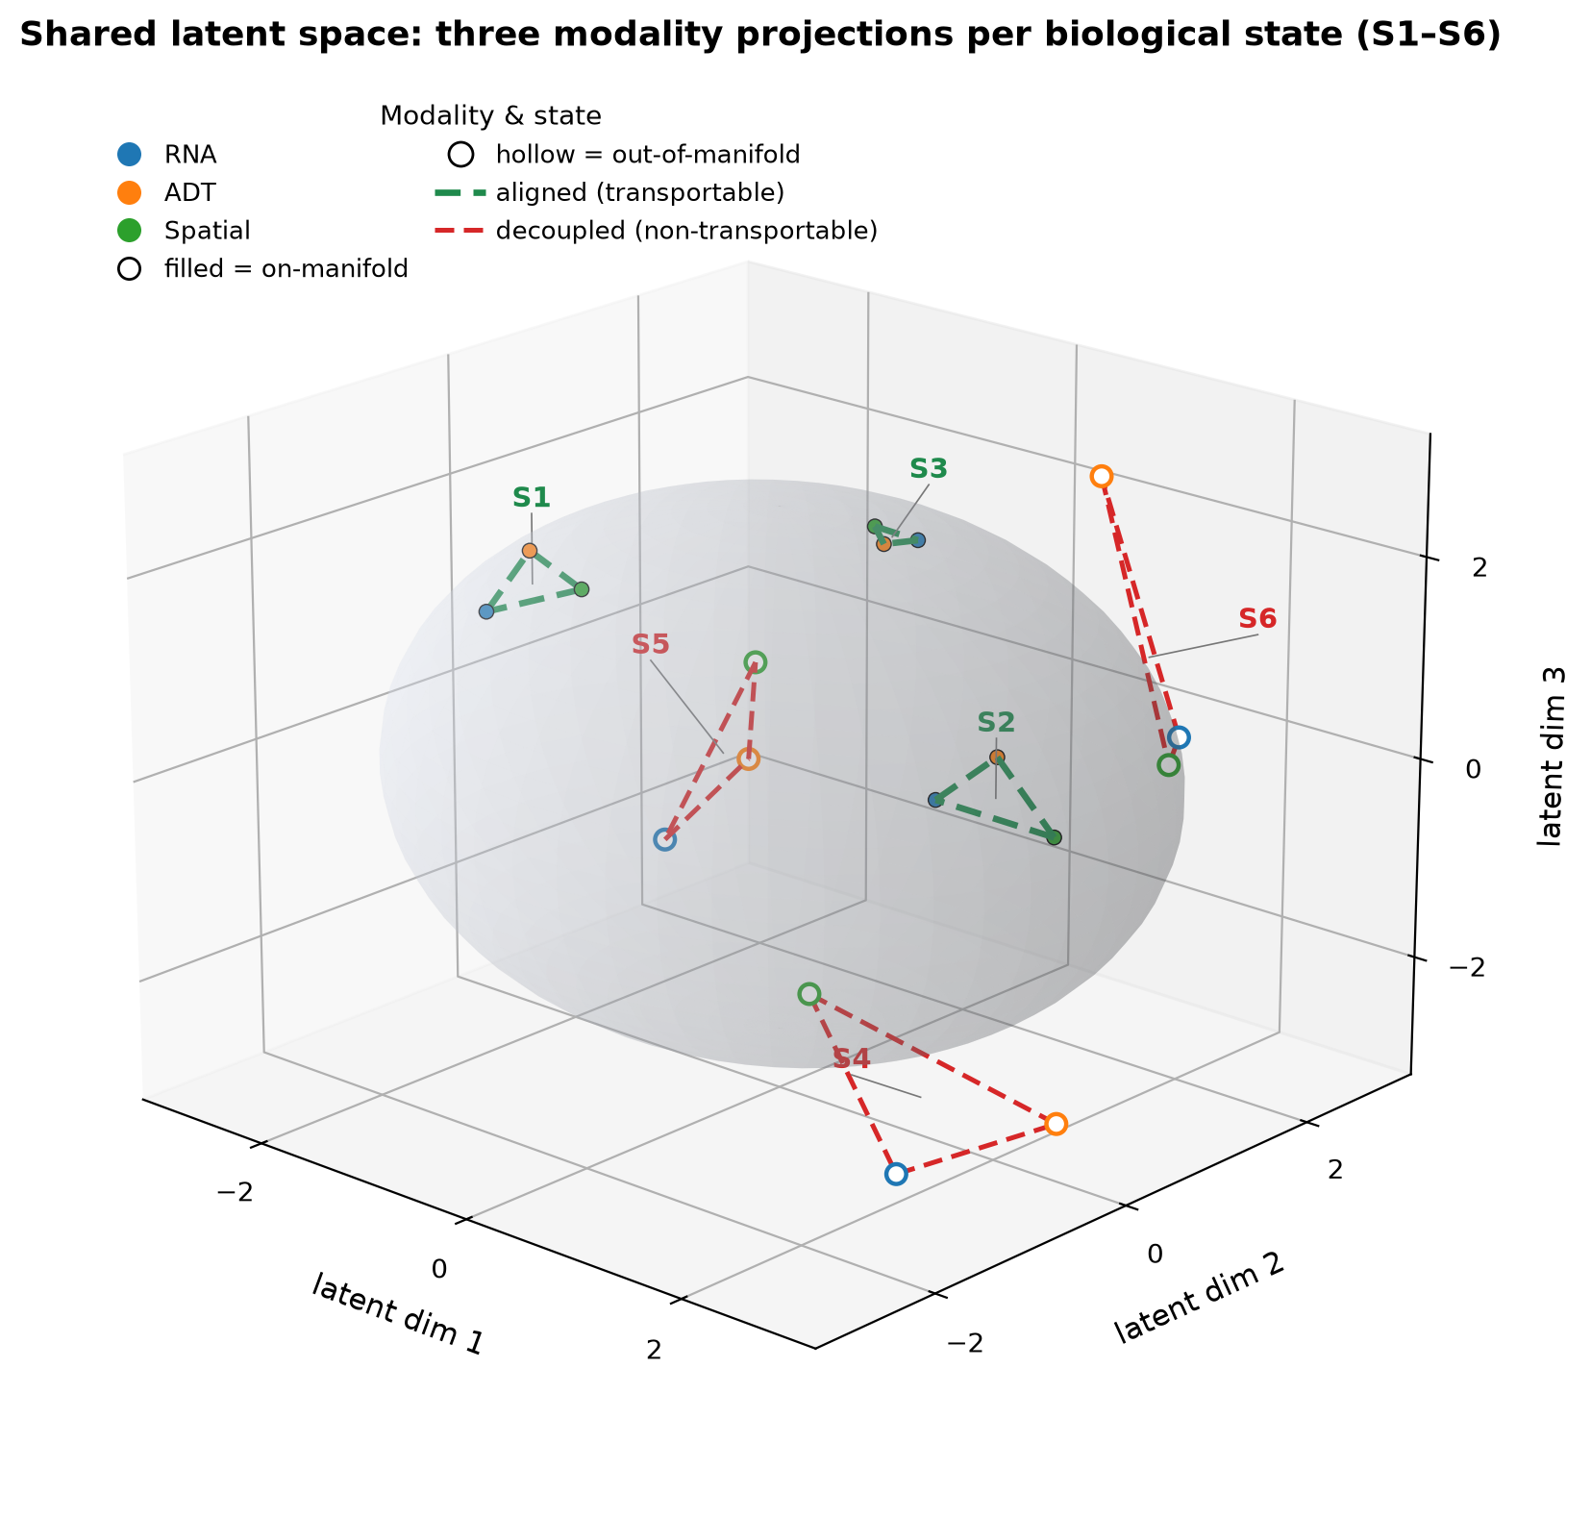
Figure 1. Conceptual framework. Each biological state is represented by one triangle whose three vertices are the RNA (blue), ADT surface protein (orange) and spatial protein (green) projections of that state onto a shared latent manifold. When the three modalities encode the same state they cluster tightly (aligned, green; transportable); when technical or biological decoupling separates them the projections scatter apart and leave the manifold (hollow markers, red; non-transportable). The figure summarizes the three-modality mapping problem that motivates the empirical transportability, technical variance and clinical score analyses below.
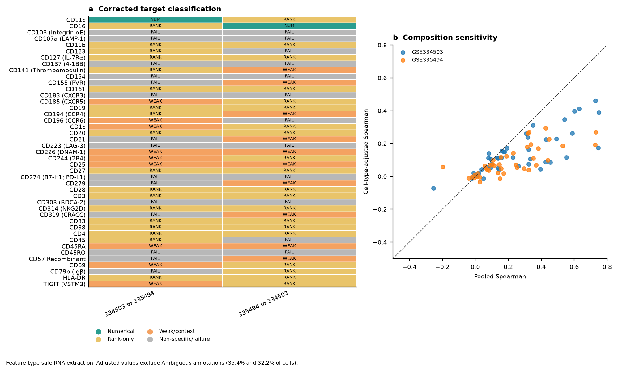
Figure 2. Corrected feature-type-safe 43-target transport and composition sensitivity. Left, strict directional classifications after typed RNA extraction, 100 Null-B derangements and 500 donor bootstraps. CD11c passed only from GSE334503 to GSE335494 and CD16 only in the reverse direction; no target passed numerically in both directions. Right, pooled versus cell-type-adjusted cognate RNA-ADT correlations. Most points lie below the identity line, with composition-dominant estimates for 35/43 targets in GSE334503 and 37/43 targets in GSE335494.
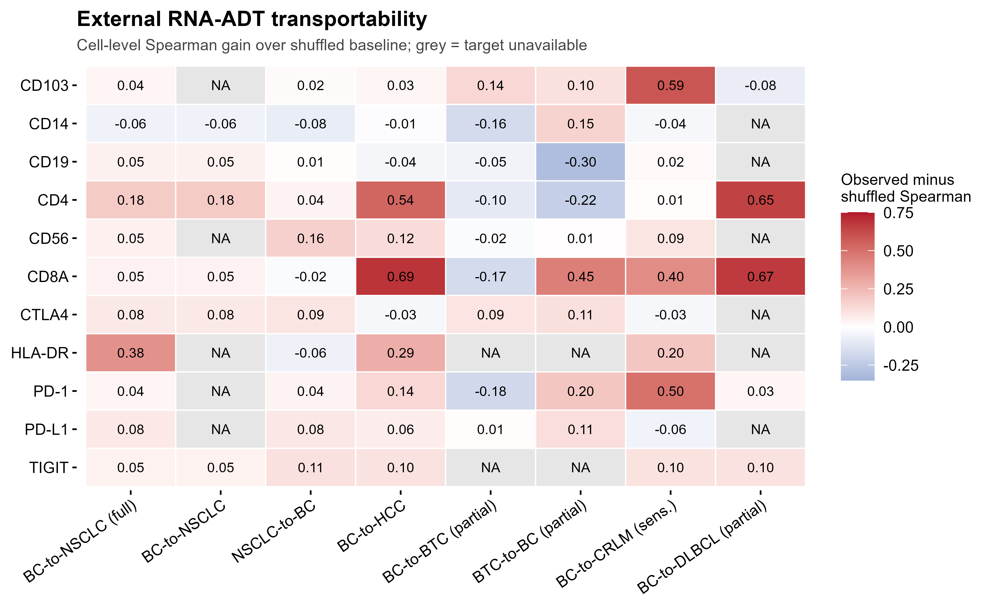
Figure 3. External RNA ADT transportability relative to shuffled controls. Cells report observed minus shuffled pooled cell Spearman correlation for each target and transfer setting. Gray heatmap cells, rather than the white figure background, indicate that the target was structurally unavailable. Positive values identify rank information beyond the shuffled baseline but do not alone establish numerical transport, which also required external error, calibration and variance preservation.
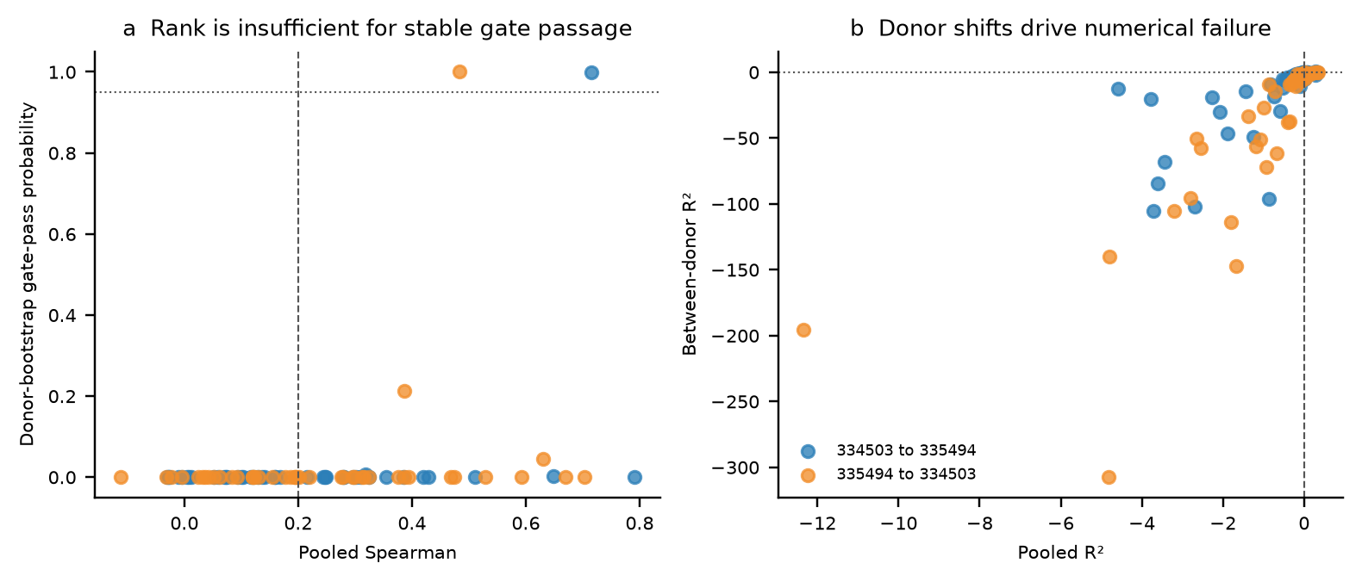
Figure 4. Donor-bootstrap uncertainty and donor-shift diagnostics for the corrected 43-target analysis. (a) Pooled Spearman correlation versus the probability of passing the complete numerical gate across 500 donor bootstraps; dashed lines mark the rank threshold and a 0.95 probability reference. High rank correlation alone did not imply stable gate passage. (b) Pooled and between-donor R2 values by transfer direction. Strongly negative between-donor R2 values identify donor-level mean shifts that pooled cell metrics can conceal. Each point is one target-direction evaluation.
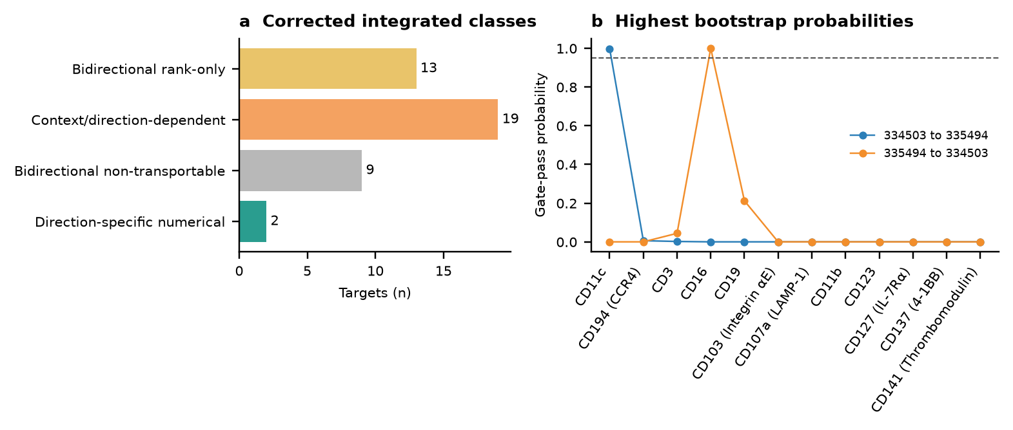
Figure 5. Corrected integrated transport classes and directional gate stability. (a) Feature-type-safe classification of 43 shared targets: 13 bidirectional rank-only, 19 context- or direction-dependent, nine bidirectional non-transportable and two direction-specific numerical targets; no target passed numerically in both directions. (b) Highest donor-bootstrap gate-pass probabilities across the two transfer directions. CD11c was the only primary direction-specific pass; CD16 passed only in the reverse direction but was retained as sensitivity-only because its FCGR3 mapping is non-direct. The 0.95 line is a stability reference rather than a biological cutoff.
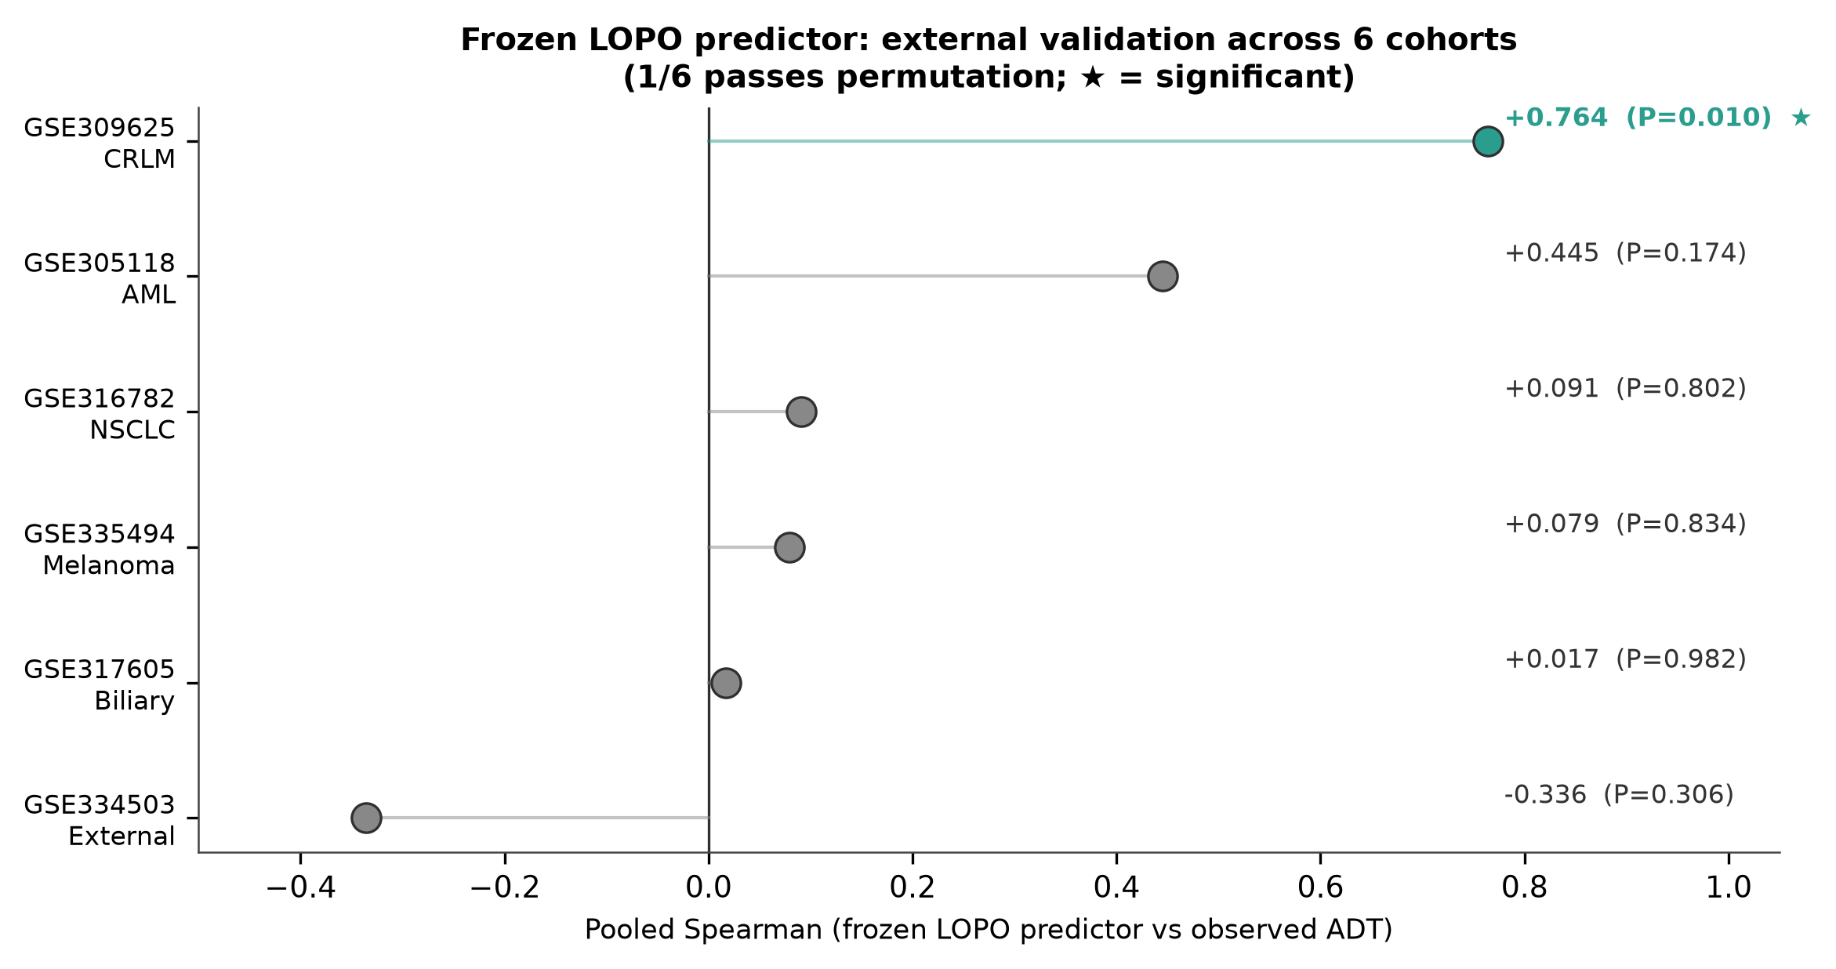
Figure 6. Frozen target level predictor across six external cohorts. Points show pooled Spearman correlation between predicted and observed target transport; only the colorectal liver metastasis cohort exceeded its label permutation benchmark. The predictor is retained as a context dependent hypothesis generator rather than a universal screening rule.
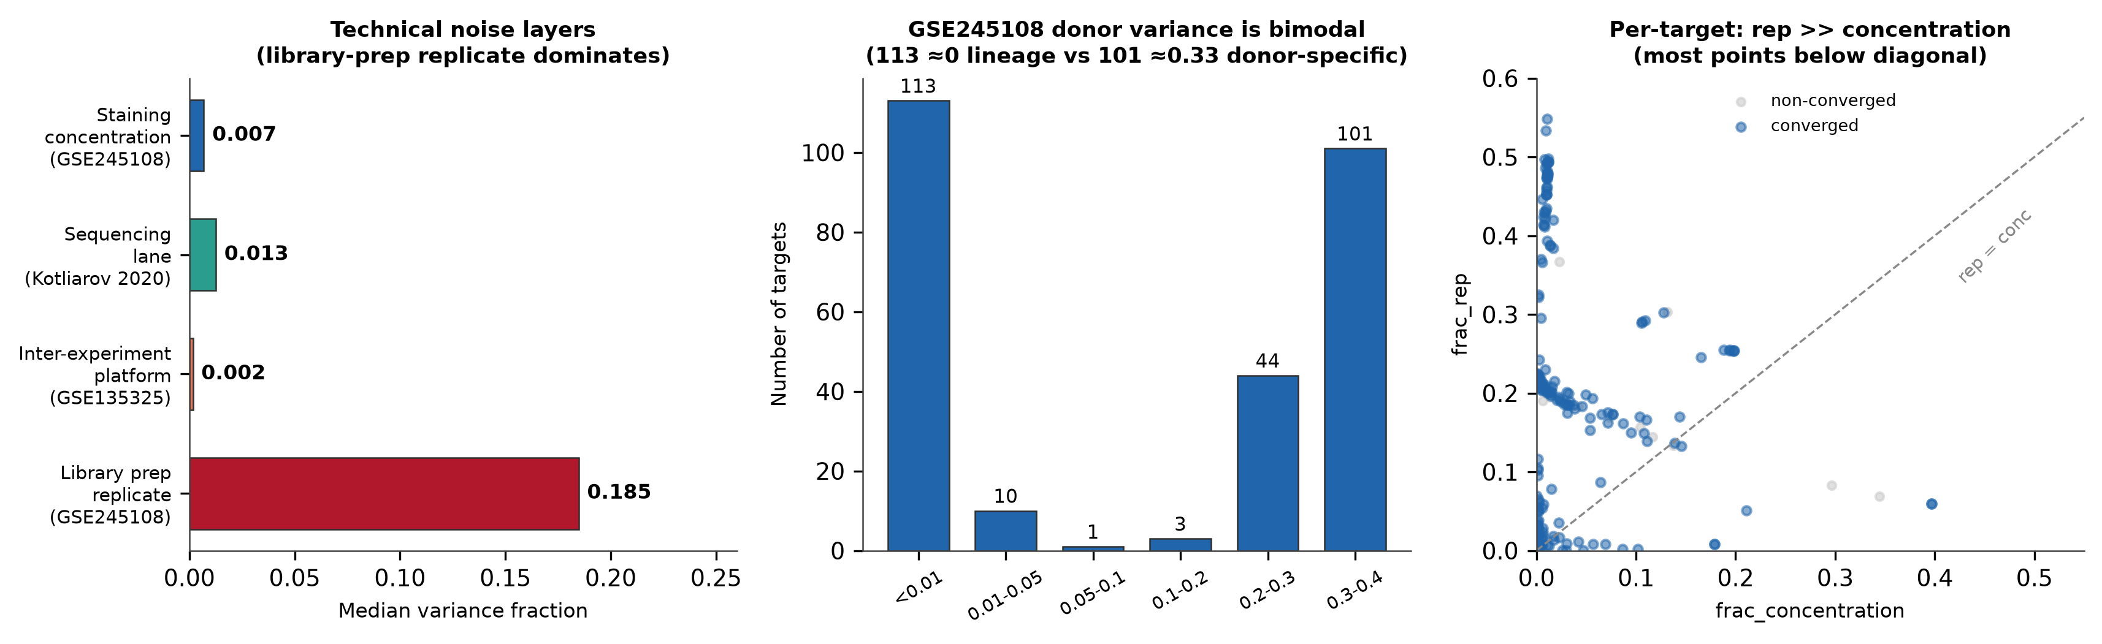
Figure 7. Technical variance decomposition. Left, median variance fractions of the measured technical layers across resources: antibody staining concentration (0.0069), sequencing lane (0.0126), inter experiment or platform (0.0017) and independent library preparation repeat (0.1848). Center, donor variance is bimodal with 113 targets near zero and 101 targets between 0.30 and 0.40. Right, per target repeat versus concentration fractions, with most converged targets below the identity line. Resources are shown in separated panels; bars from different resources are not on a common scale and are not intended for direct comparison.
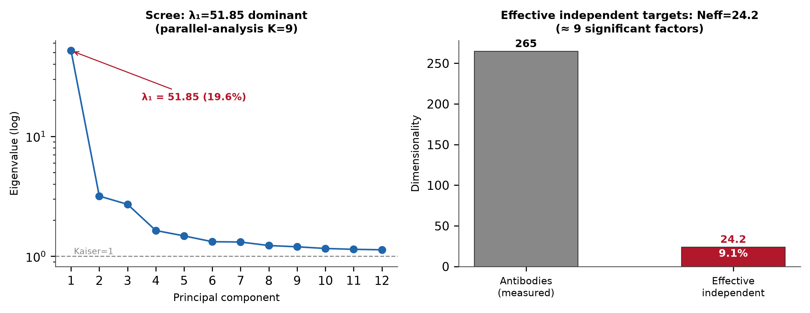
Figure 8. Principal component spectrum of the GSE245108 target correlation matrix. Left, scree plot showing the dominant first eigenvalue of 51.85 with parallel analysis retaining nine factors. Right, effective dimensionality of approximately 24 independent dimensions, or 9.1% of the nominal 265 targets.
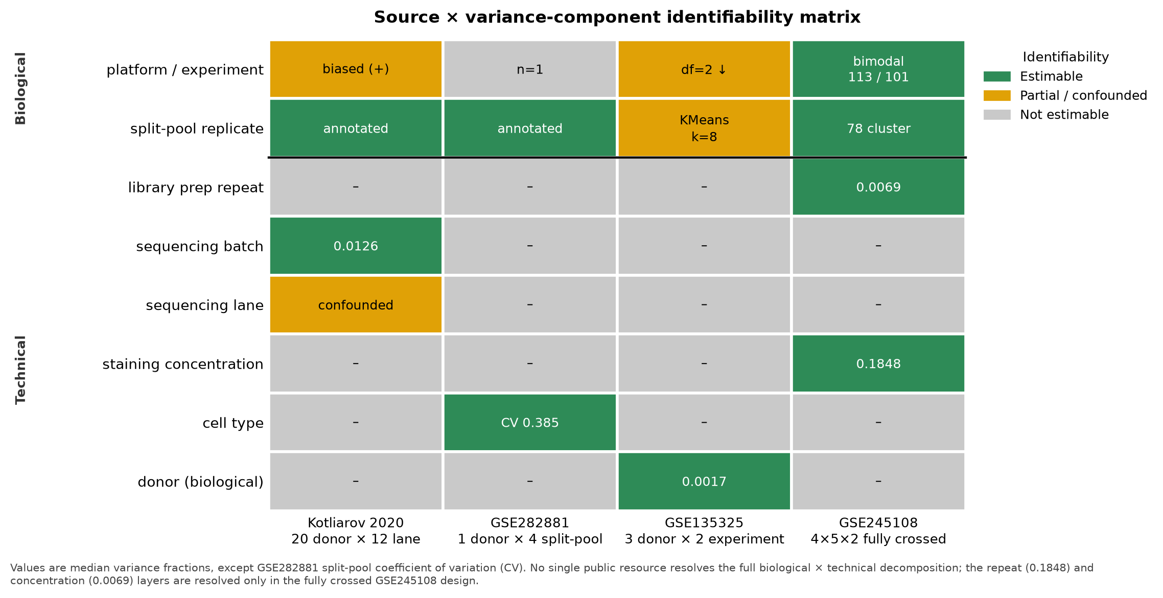
Figure 9. Source by variance component identifiability matrix. Each cell marks whether a biological or technical variance component is estimable (green), partially confounded (amber) or unavailable (grey) in each public resource. Median variance fractions are shown where resolved; no single dataset resolves the full biological and technical decomposition.
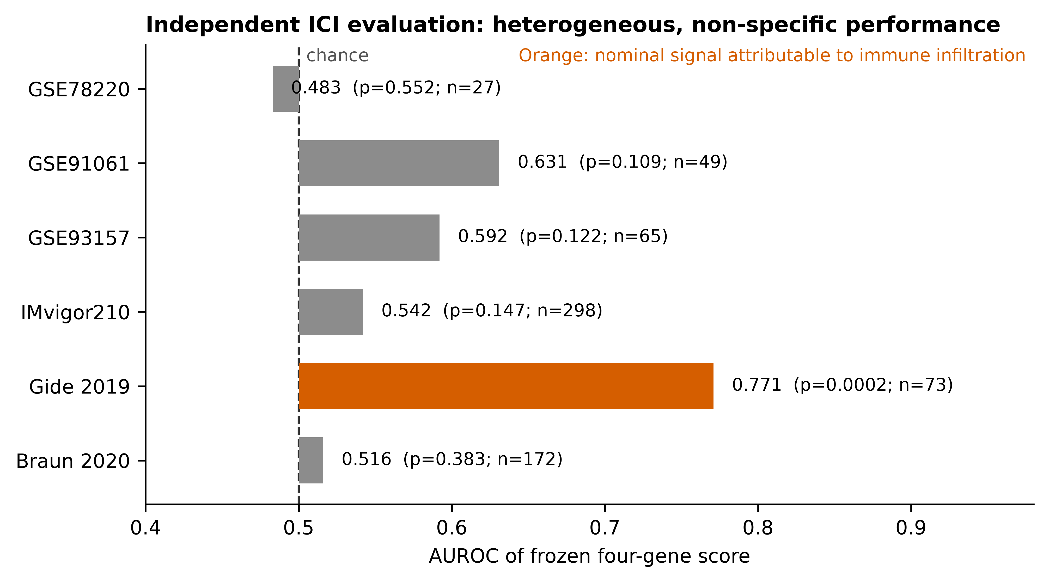
Figure 10. Frozen four gene score across six independent immune checkpoint inhibitor cohorts. Bars show cohort specific AUROC relative to chance at 0.5; response definitions follow study-specific criteria described in Methods Section 2.12. Full per-cohort statistics are reported in Supplementary Table G: AUROC with 95% confidence interval, AUPRC, Brier score, calibration intercept and slope, nominal and family adjusted permutation P values, and evaluable sample size. In summary, AUROCs were 0.483 (GSE78220, n=27, 95% CI 0.250 to 0.725), 0.631 (GSE91061, n=49, 0.396 to 0.838), 0.592 (GSE93157, n=65, 0.419 to 0.755), 0.542 (IMvigor210, n=298, 0.473 to 0.614), 0.771 (Gide 2019, n=73, 0.649 to 0.882) and 0.516 (Braun 2020, n=172, 0.411 to 0.615). Nominal permutation P values were 0.552, 0.109, 0.122, 0.147, 0.0002 and 0.383; after false discovery rate correction only Gide 2019 remained nominally significant at corrected P of 0.0012. Gray denotes cohorts without evidence beyond the permutation benchmark. Orange identifies Gide 2019, where comparable or stronger performance from broad immune infiltration markers indicated a context specific infiltration proxy rather than a four gene specific biomarker. Patient level observations were not pooled across platforms. GSE93157 is a mixed-cancer cohort analyzed as one study-specific test.
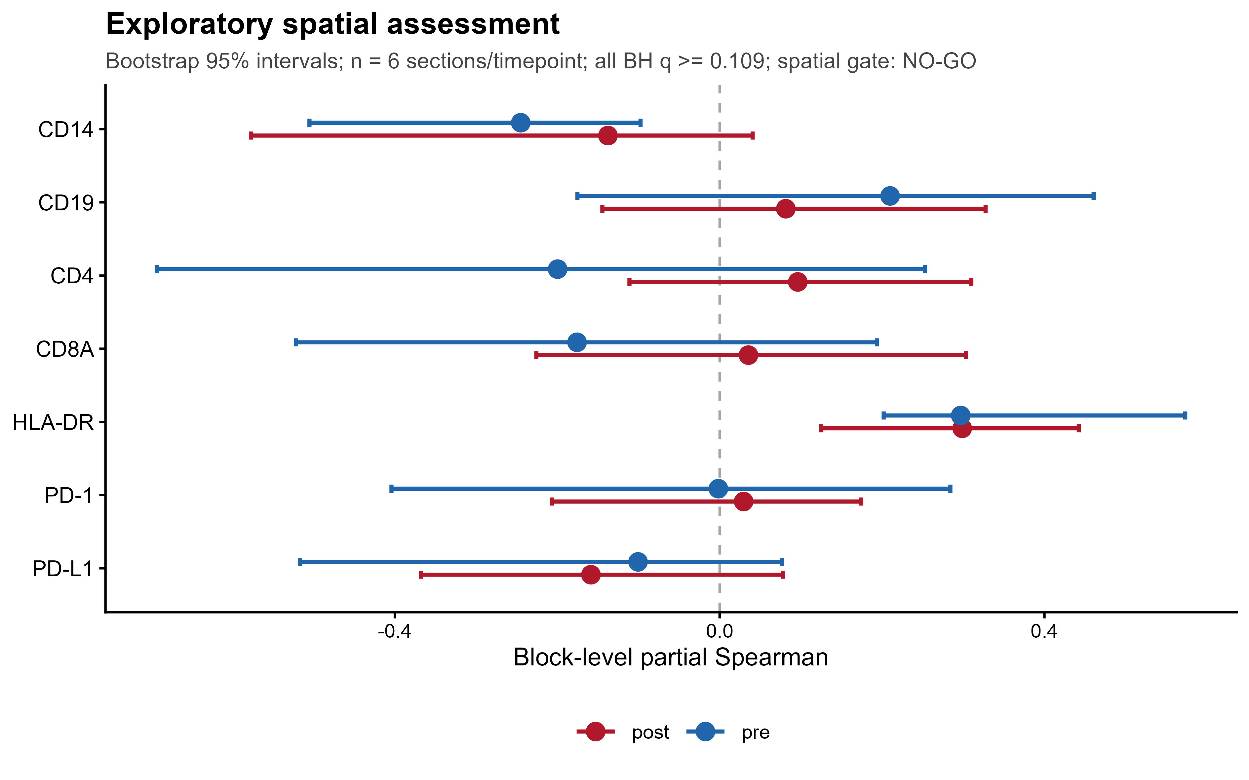
Figure 11. Exploratory spatial protein assessment. Points show block level partial Spearman estimates and patient section bootstrap 95% intervals before and after treatment. One section per patient was available at each time point, giving six sections per time point. All Benjamini Hochberg adjusted sign flip tests had q values of at least 0.109, and the analysis-defined project level spatial gate was NO-GO. Per target raw P values, Benjamini Hochberg q values and block partial rho bootstrap confidence intervals are provided in Supplementary Tables C1 and C2; the section level audit statistics are in Supplementary Table C0.
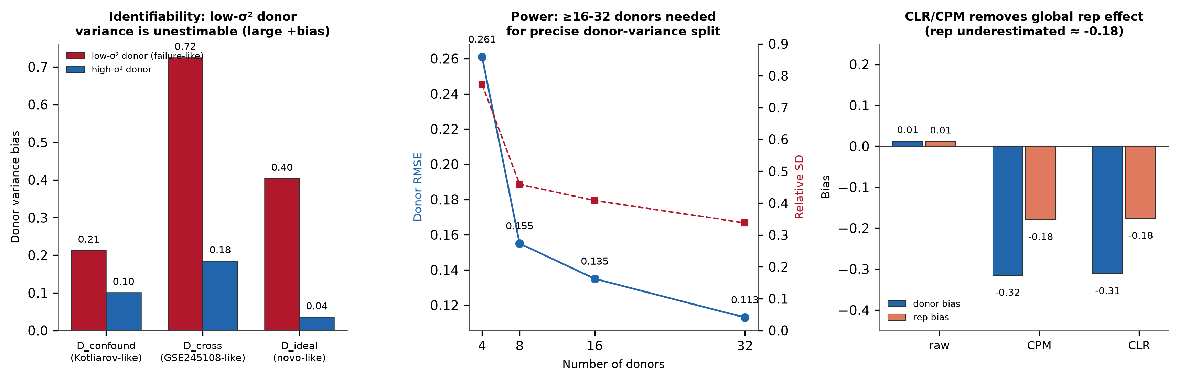
Figure 12. Identifiability simulations. Left, donor variance bias across confounded, crossed and ideal designs, with convergence reported for each condition. Center, donor-count precision under the high-donor idealized simulation: relative-estimate SD decreased from 0.595 at 4 donors to 0.294 at 32 donors, while mean relative estimates remained 1.078-1.151. Right, under the simulated global-repeat-effect scenario, CLR or CPM underestimated the generative repeat component by approximately 0.18; this scenario-specific bias is not an additive correction to the empirical 0.1848 CLR-retained fraction.
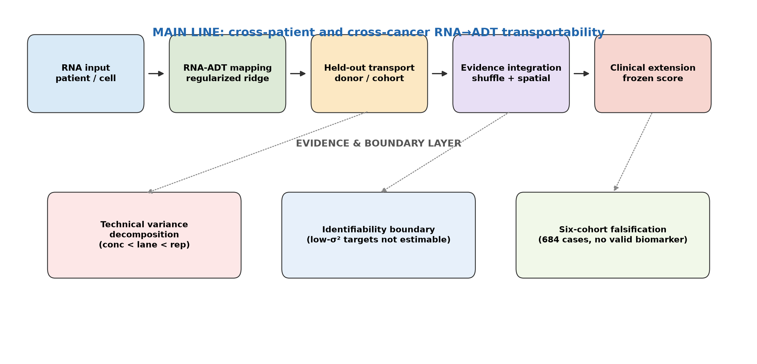
Figure 13. Multimodal RNA ADT transportability framework. The main line proceeds from RNA input through regularized RNA ADT mapping and donor or cohort held out transport. Shuffled controls, technical repeatability and spatial protein form the evidence integration layer. The patient level clinical score is a separate frozen extension and does not redefine target transport grades. An evidence and boundary layer adds technical variance decomposition, identifiability limits and six cohort falsification. The resulting framework assigns research use boundaries rather than supporting clinical deployment.

