**The effect of Bed Thickness on Hillslope Morphology and Sediment Size in Last Chance Canyon, New Mexico**

Sam Anderson1, Nicole Gasparini1, Joel Johnson2

1Earth and Environmental Science, Tulane University, New Orleans, 70118, USA

2Jackson School of Geosciences, University of Texas at Austin, Austin, 78712, USA

*Correspondence to*: Sam Anderson (sanderson@tulane.edu)

**Abstract.** In this study we explore the effect that hillslope bed thickness variations have on hillslope form, as well as channel grain size distributions and form, in Last Chance canyon, New Mexico, USA. The landscape is composed of horizontally to near horizontally bedded sandstone and carbonate rock. The hillslopes have relatively little regolith, yet most hillslopes have a convex diffusive shape despite the lack of continuous soil cover. We posit that differences in bedrock bed thickness influence hillslope shape in Last Chance canyon, where thinner bedrock generates a more diffusive geometry resembling the idealised convex hillslope shape endemic of soil mantled landscapes. We used drone photos to construct high resolution orthomosaics and digital elevation models (DEMs) of seven hillslope transects and stream channels at the base of each transect from two headwater catchments. Using these DEMs and orthomosaics, we measured bed thicknesses, slope, and curvature on the hillslopes and grain size distributions at the base of each hillslope. We find that hillslopes are steeper and less convex where there is more thickly bedded rock and become shallower and convex in thinly bedded rock. Furthermore, sediment input to channels is controlled by bed thickness on hillslopes and affects channel morphology. Thickly bedded rock units on proximal hillslopes contribute larger sized colluvial sediment to the channels, and these channel reaches have relatively high channel steepness index. We find that where hillslopes drain to relatively steep channel sections with coarse sediment, hillslope form transitions from convex to straight or concave, but where hillslopes drain to relatively shallow channel sections, hillslope form is predominantly convex. These observations suggest a tight coupling between hillslope bedrock properties, hillslope form, channel grain size distribution, and channel steepness.

# 1 Introduction (NOT MY DOG)

Variance in relevant bedrock properties influences the production and size of sediment on hillslopes (Johnstone and Hilley, 2015), erosion rates (Dixon et al, 2012), and landscape form (Glade, 2017; Hurst, 2013). Rock properties, specifically fracture spacing, has been shown to influence rock surface slope (e.g., Brook and Tippett, 2002; Matasci et al., 2015; Moore et al., 2009; Selby, 1980), erosion, and imprints its signature into the topography (Molnar et al., 2007; Clarke and Burbank, 2011; St. Clair et al., 2015; Voigtlander et al., 2017; Eppes and Keanini, 2017; Eppes et al., 2018). Soil depth, a function of both soil production and erosion rate, has been shown to affect hillslope convexity (Roering, 2008). Soil mantled hillslopes are thought to generate convex hillslopes, however, in Last Chance canyon, sandstone hillslopes with predominantly exposed bedrock are convex in shape and resemble soil mantled hillslopes. But what about these bedrock hillslopes causes them to look like soil mantled hillslopes? Why do predominantly sandstone hillslopes appear diffusive while carbonate hillslopes are steep and shear?

In this study, we seek to understand the effect that changes in rock properties have on sediment production and erosion. More specifically, we ask what controls weathering, soil production, and sediment movement on hillslopes with high spatial variability in rock properties? how is sediment removed so that diffusive looking landscapes are generated in thinly bedded sandstone and not in the more thickly bedded carbonates? To answer these questions, we will couple a hillslope sheet wash component with the overland flow model to explore sediment delivery from hillslopes to channels. We will inform our model runs with realistic hydrographs reconstructions and field measurements of sediment size. and distance between bedrock beds. We will also measure sediment depth, bulk lithology of less than gravel sized colluvium, and the lithology of larger sized sediment.

I RECOMMEND WE DEFINE AND DESCRIBE WHAT AN IDEAL HS IS.

Foto of end member parts of LS.

# 2 Field Area

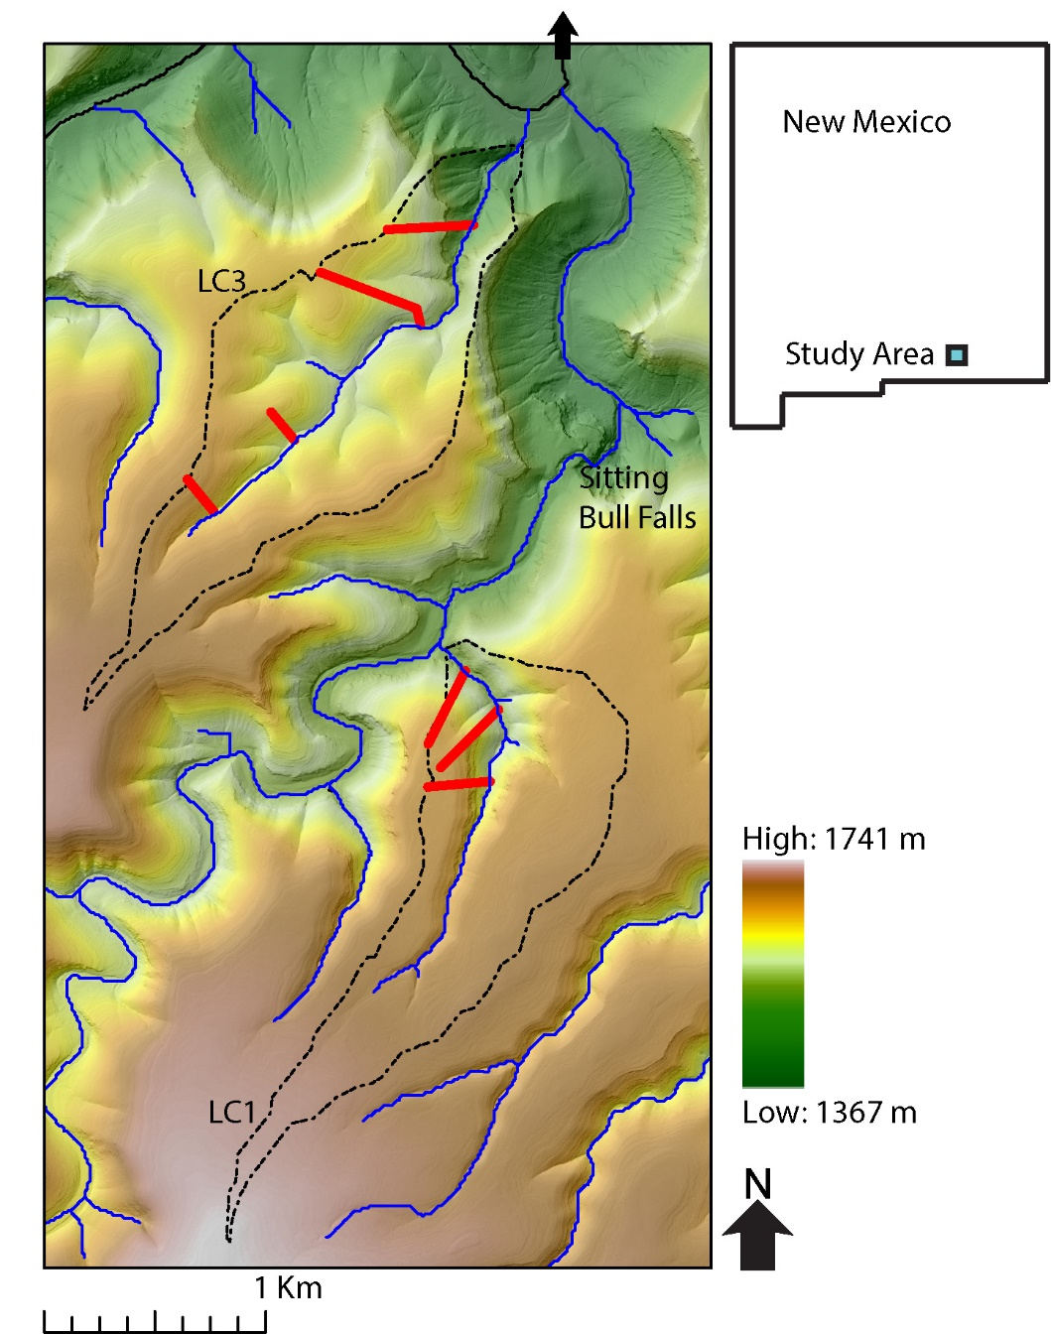

Figure : Topographic map with elevations superimposed on a hillshade of Last Chance canyon with ephemeral stream channels. Main stem of channel coloured black with arrow indicating the direction of stream flow. The two watersheds we took measurements in are outlined with dotted black line and labelled LC1 and LC2. The seven hillslope transects we surveyed are marked on the map with red bars.

We conducted fieldwork in Last Chance Canyon, located in the Guadalupe Mountains of southern New Mexico, USA. Because of their morphology and accessibility, we collected data along 2 different tributaries, called LC1 and LC3 (figure 1), and seven different hillslope transects that terminate at the base of each of the 2 stream channels (3 transects in the LC1 watershed and 4 transects in the LC3 watershed). These transects were chosen to capture variations in bed thickness and hillslope shape across the two watersheds. By examining the influence of bed thickness on hillslope form and sediment input to channels, we aim to better understand how changes in bed thickness correlate with boulder characteristics, stream channel shape, hillslope form and the morphology of Last Chance Canyon. Over the small spatial area and range of vertical elevations of the specific study channels, climate varies minimally. Mean annual precipitation is ≈40-50 cm/year, and mean annual temperature ≈14-16 ℃ (PRISM Climate Group). Last Chance Canyon has horizontally to near horizontally bedded bedrock and is currently tectonically inactive (Hill, 1987; Hill, 2006). During Permian time, a shallow lagoon existed behind a reef complex to the south and deposited what would become interbedded carbonate and siliciclastic bedrock of various thicknesses (Hill, 2000; Phelps et al., 2008; Kerans et al., 2017). The Guadalupe mountains were uplifted during basin and range extension beginning 27 million years ago, exposing the previously buried bedrock (Chapin and Cather, 1994; Ricketts et al.., 2014, Hoffman, 2014; Decker et al., 2018). Rock unit descriptions from published maps lack the relevant information needed to constrain bed thickness (NPS, 2007).

# 3 Methods

## 3.1 DEM Analysis

We used a 10 m digital elevation model (DEM) of Last Chance canyon to identify channels and hillslopes of interest to survey and to calculate relevant topographic metrics, and slope breaks along longitudinal stream profiles (USGS, 2019). The normalized channel steepness index, *ksn*, is a measure of channel gradient normalized for drainage area (i.e., in principle allowing reach slope to be compared independent of drainage area):

(#),

where is a reference concavity (Whipple and Tucker, 1999; Wobus et al., 2006). Based on a calibration to this landscape we use , giving m-1 as the units for . Although *ksn* is an empirical metric of fluvial topography and not model dependent, if the stream power model is assumed to be valid then combining Equations (1) and (2) gives , illustrating how this topographic metric potentially informs both erosion rates and erodibilities. *ksn* allows for the comparison of slope along a single channel or among multiple channels to isolate erosional and/or bedrock erodibility patterns (Kirby & Whipple, 2012). We also calculated χ plots (Perron and Royden, 2012; Willet et al., 2014), which represent a method of transforming the horizontal variable (x) of longitudinal stream profiles into dimensionless variable χ. Generally speaking, a smoothly concave stream profile without changes in erodibility or erosion rate along its length will be a straight line on a χ plot, while deviations from linear may represent changes in erodibility or erosion rate (Perron and Royden, 2012; Willet et al., 2014). Because channels can adjust to more resistant lithologic units by steepening across them (Duval et al., 2004; Jansen et al., 2010), we used χ plots and *ksn* maps to detect changes in slope that could be due to differences in bedrock erodibility and/or sediment size and cover. TopoToolBox and Matlab were used to generate longitudinal profiles, *ksn* maps and χ (chi) plots of all surveyed channels (Schwanghart and Scherler, 2014).

## 3.2 Field Survey

In March and May of 2018, and in February of 2021, we surveyed 2 channels and 7 hillslope transects which we had preselected based on previous fieldwork, DEM analysis, mapped geology, and accessibility. Our investigation started in lower order channels and proximal hillslopes at elevations above 1400 m in channel LC3 and in elevations above 1500 in channel LC1 (map figure). We studied zones of varying length in the 2 different channels and seven hillslope transects. USGS topographic contour maps of the field area use a 40 ft (≈12.2 m) contour interval. Following these maps for convenience and to ensure unbiased sampling, at every ≈12.2 m contour interval we measured the depth to both saprolite and bedrock along the 7 hillslope transects. At every contour interval along the 2 channels, we measured the size of the largest, assumedly most immobile, boulder in the channel. Previous work suggests that boulders and the coarsest sediment size fractions can significantly influence reach topography, erosion, and transport (e.g. REFS). The largest boulder was chosen (rather than a particular coarse grain size percentile such as D84) as a balance between available time for field surveys and statistical accuracy for characterizing coarse sediment. We assume that the largest boulder size is positively correlated with other coarse grain size percentiles when averaged over many surveyed reaches. For each boulder we measured the longest (a), intermediate (b) and shortest (c) axes (dog on rock figure). We multiply these dimensions together to approximate boulder volumes. We also constrain differences in boulder shape using the Corey Shape Factor (REF ):

(#)

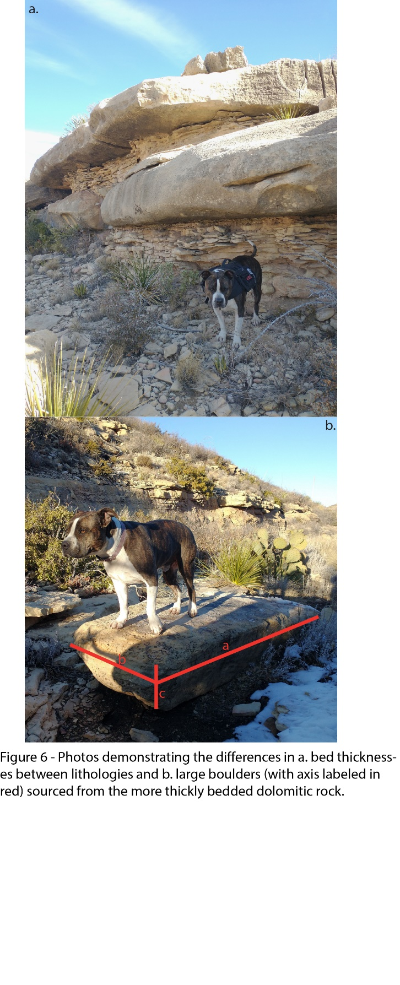

INCLUDE BOULDER MEASUREMENT EXPLANATION

## 3.3 Drone Based Photogrammetry

We used a drone, DJI Mavic 2 pro, to take photos of the 7 hillslope transects, along with photos of reaches from the 2 surveyed channels at the base of the 7 transects, at approximately 20 meters above the channels, and 20 meters above the highest elevation of the 7 hillslope transects. We used Agisoft photoscan to generate high resolution digital surface models (DSMs) with 0.027 to 0.28 m resolution (we refer to these as DSMs rather than DEMs because vegetation is not removed from the DSMs) and orthomosaics of the 7 hillslope transects and channel sections at the base of each transect. The methodology we used to create the DSMs and orthomosaics is the same that we used to create the orthomosaics of the reaches and is described in the previous paragraph. We used the orthomosaics to quantify relative proportion of where stream channel beds were exposed bedrock or covered with sediment. We used Agisoft Photoscan (Agisoft PhotoScan Professional, 2018) to generate high resolution orthomosaics and DSMs first by aligning the frames from the GoPro videos, then building a dense cloud, then creating a DEM and finally making an orthomosaic.

## 3.2 Photogrammetry to Measure Bed Thickness and Hillslope Morphology

At every 20m, beginning at the channel and moving up each hillslope transect, we measured slope and curvature over a 80m window (40m upslope and 40m downslope of each point) using the DSM we generated with Agisoft Photoscan (hillslope schematic figure). Elevations were measured 40 m upslope and 40 m downslope of each 20m interval, the downslope elevation was then subtracted from the upslope elevation and the value was divided by the length, 80 m, to determine slope. To determine curvature, we used the same methodology, but we subtracted slope values instead of elevation values 40 m up and downslope from the 20 m interval.

Within the same 80 m window that we found slope and curvature in, we measured the thickness all beds and found average bed thickness, the sum of all bed thicknesses, and the largest bed thickness. As the beds are horizontal, we define bed thickness as the vertical distance between the upper and lower horizontally oriented bedding planes. We measured every exposed bed on each of the seven hillslope transects using the high-resolution orthomosaics we generated using Agisoft Photoscan in the ArcScene program (figure showing Sophia method maybe).

## 3.2 Photogrammetry to make Sediment Size Measurements

We measured the diameter of alluvium in channels at the base of the seven hillslope transects with the PebbleCounts image analysis package (Purinton and Bookhagen, 2019). PebbleCounts is a Python based product for the detection and sizing of sediment grains from drone images. We used the k means with manual (KMS) method, which allows an operator to validate measured grains to mitigate error. Due to the relatively large size of the orthomosaics we utilized the PebbleCounts-Application, which subset the images to manageable sizes (photo sieve fig maybe). To account for the large size of the orthomosaics, we first subset the images into manageable sizes. We then validated the results of the initial automatic counting with the k-means with manual (KMS) method, which allows an operator to validate measured grains and mitigate error. Finally, we compiled all the data for each channel section into a single file. All the data are available in the GitHub repository for this paper.

# 4 Results

## 4.1 Last Chance Canyon Morphology

Last Chance canyon tributaries have upstream sections with relatively shallow channels and lower gradient hillslopes, and a knickzone downstream which has steep channels and hillslopes (map figure 2). LC1 has shallower hillslopes than LC3, and smaller bed thicknesses. Based on χ plots and field observations, we find that the stream channels transition from steep to shallow at approximately 1640 m for channel LC1 and at approximately 1550 m for channel LC3. The transition from steep to shallow is more subtle in LC1- χ changes less than in LC3. Both LC1 and LC3 have relatively little regolith. On average the depth to saprolite was 5.6 cm (standard deviation = 5.3 cm) and depth to bedrock was 20.1 cm (standard deviation = 15.5cm).

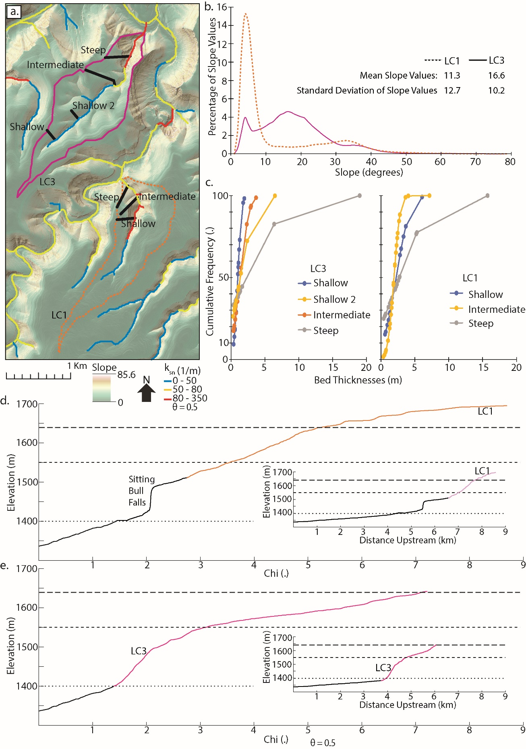

**Figure 2 - a. Slope map of Last Chance canyon with values plotted across it. The contour lines correspond to elevations which are interpreted as approximate inflection points for hill and channel slope (1550m for LC 3 and 1640m for LC 1). b. Percentage of slope values from the hillslopes in LC3 and LC1. c. Cumulative frequency plots of bed thicknesses from the 4 surveyed hillslope transects on LC3 and the 3 surveyed hillslope transects on LC1. d. Chi plots of LC1 and e. LC3 with inset of channel profiles. Channel sections which were not surveyed are indicated in black.**

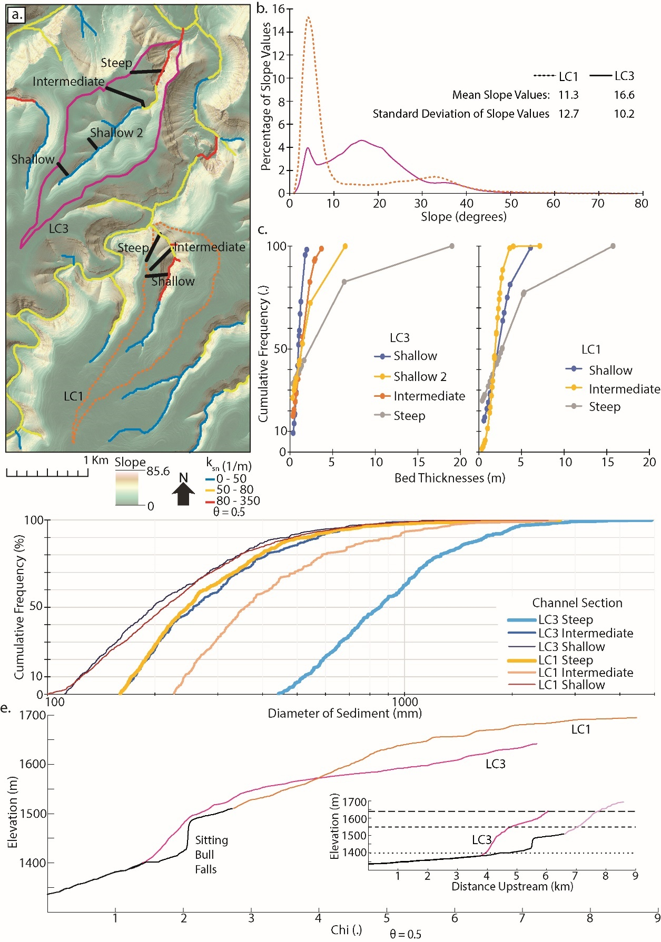

**Fig2 - OPTION2 (mark where steep shallow and intermediate channel section are on each chi plot)**

## 4.2 Bed Thickness and Hillslope Morphology

We observed patterns relating to the interplay between bed thickness and slope characteristics across our study area. Specifically, we found that variations in the average, maximum, and cumulative bed thickness within an 80-meter measurement window corresponded with variations in slope over the same spatial extent, as shown in the local slope vs. bed thickness figure. (local slope vs bed thickness figure). We chose to measure slope and bed thicknesses over a 80 m window because it diminished slope errors from boulders and plants over relatively larger distances. Furthermore, as the average bed thickness for a entire hillslope transects increases, the slope of the entire transect likewise increases (total slope figure). Beds are generally thinner in the upstream sections of the landscape, where hillslopes shallow.

­­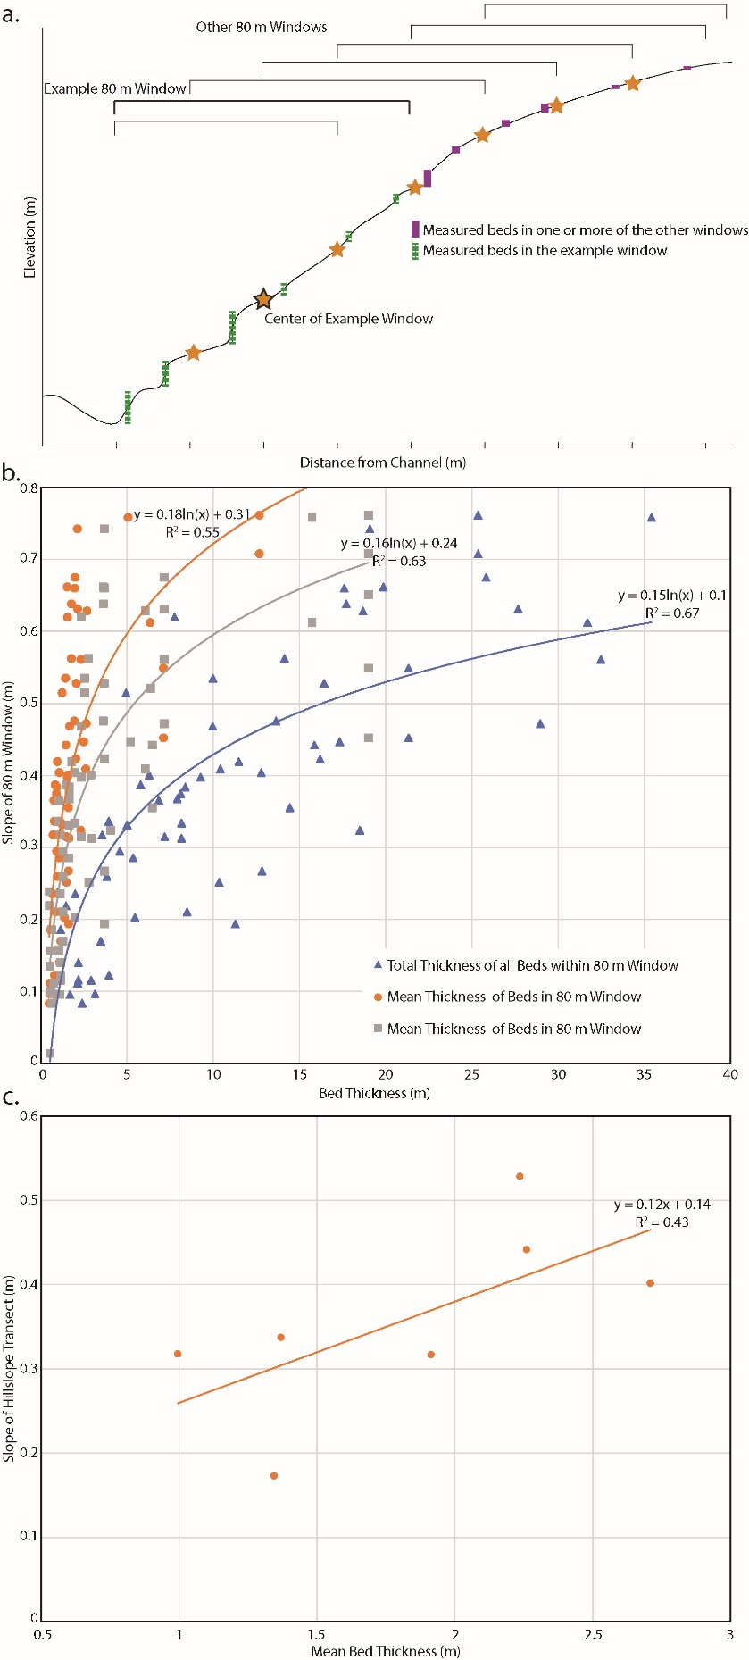

**Figure 3 – a. Schematic (not to scale) demonstrating how slope and bed thicknesses were calculated to generate the results presented in 5b. Mean bed thickness is the vertical height of measured beds divided by the number of measured beds within the 80 m window. Total bed thickness is the sum of the vertical height of all measured beds within the 80 m window. Max bed thickness is the vertical height of the largest measured bed in the window. Slope was calculated by subtracting the maximum from the minimum elevation of the 80 m window and then dividing the value by the distance. Figure 5b. shows the control that mean, max, and total bed thickness has on slope over an 80 m window. c. The mean bed thickness of each hillslope transect vs. the total slope of each hillslope transect.**

Hillslope curvature is a fundamental topographic characteristic that offers valuable insights into landscape dynamics. Typically, curvature exhibits a distinct pattern from the channel, located at the base of the hillslope, to the ridgeline, its highest point. Near the channel, curvature tends to be negative, reflecting the erosional processes associated with water flow, sediment transport, and fluvial incision. This concavity often results in the development of channels, gullies, and other erosional features. As one ascends towards the hillslope's midsection, curvature often transitions to relatively planar or gently convex profiles. Here, sediment deposition and weathering processes tend to dominate, creating a more stable environment conducive to soil formation and vegetation growth. Towards the ridgeline, curvature tends to be positive, indicating a pronounced erosional influence due to factors like surface runoff and mass wasting. This transition from concave near the channel to convex at the ridgeline represents the complex interplay of geological, climatic, and hydrological factors shaping hillslope morphology.

We plotted curvature values by distance from the channel in the seven hillslopes. On a hillslope transect in the shallow section of watershed LC3, curvature is positive at the ridgeline and decreases towards a negative value as the transect moves away from the ridgeline and towards the channel. The slope of the linear function describing the relationship between distance from the channel and curvature is negative (m = -0.012) and the r^2 value is 0.68, which is in agreement with what common perception of the manner curvature changes across a hillslope transect.

## 4.3 Size of Alluvium and Boulders affects channel morphology

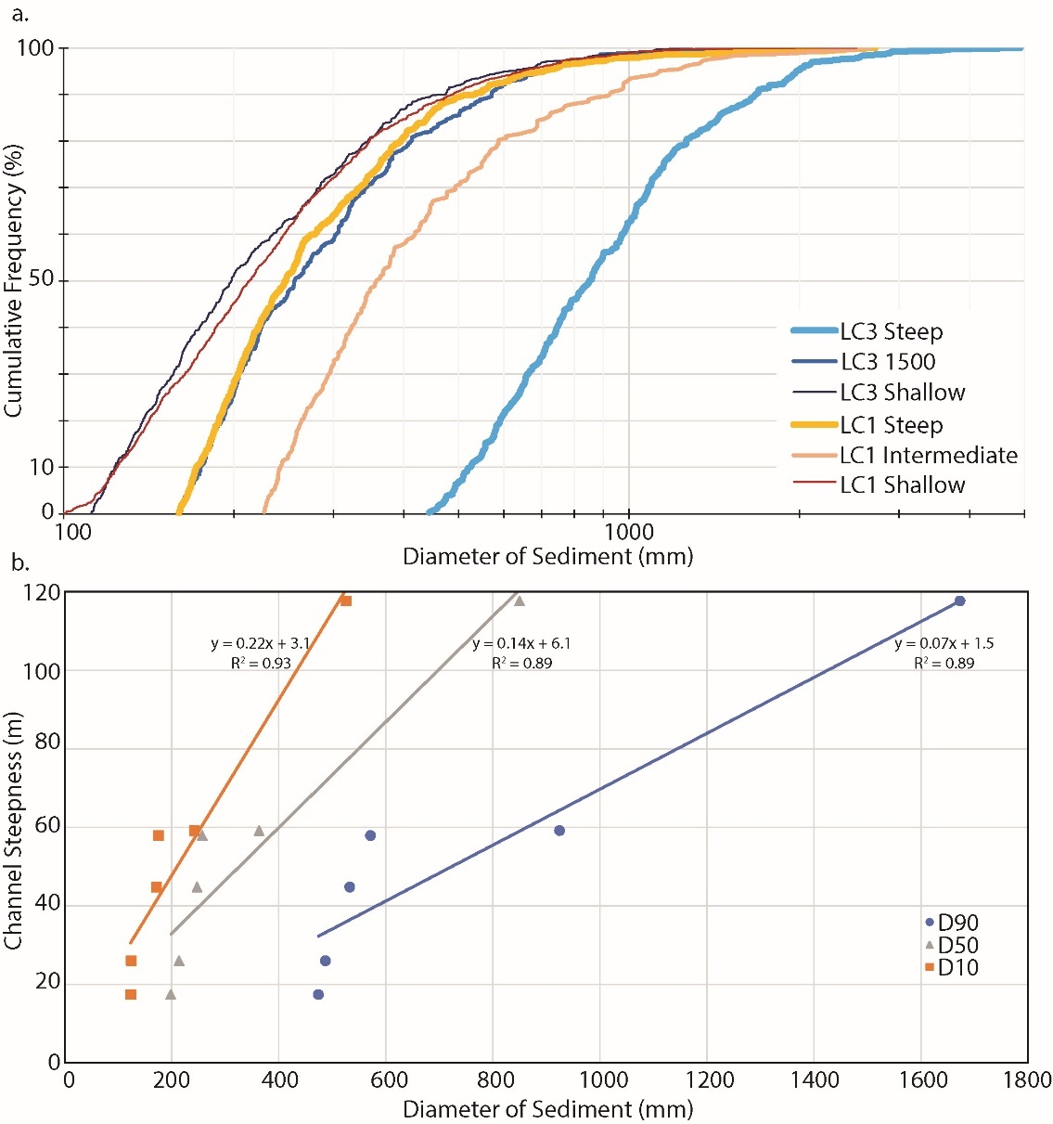

**Figure 4 – Two options. Either the figure above, or if fig2-option2 is chosen then figure4a will be removed**

Channel steepness is controlled by sediment diameter in the channel reaches at the base of the 7 hillslope transects we measured (figure4). An increase in sediment diameter corresponds to a concurrent increase in channel steepness, demonstrating a clear positive correlation between larger sediment sizes and the steepness of the channel profile. This observation emphasizes the significant influence of sediment dynamics on the fluvial system's morphology. Conversely, our findings also indicate that smaller sediment sizes are generally associated with shallower upstream hillslopes. This outcome underscores the role of particle size in shaping the topographic characteristics of hillslopes in proximity to the channel.

## 4.4 Bed thickness affects size and shape of Alluvium and Boulders

Variations in the maximum bed thickness were correlated with changes in the sediment diameter at the base of each hillslope transect (figures of bed thickness effect on grain size, and on channel steepness). The analyses revealed that as the maximum bed thickness increased, there were discernible effects on the D10, D50, and D90 of sediments present within the alluvium at the base of each hillslope transect, as well as the average sediment diameter. Conversely, the average bed thickness along a hillslope transect did not appear to significantly influence the diameter of sediment in the channel reaches below. These findings illuminate the intricate interplay between bedrock properties, sediment dynamics, and channel morphology, underscoring the importance of considering maximum bed thickness as a key factor in understanding the complex processes governing landscape evolution.

Both maximum bed thickness and the average bed thickness along hillslope transects had a significant impact on the average dimensions of boulders, including their axis length (a, b, and c) and overall volume (figure of max and average bed thickness vs boulder volume and dimensions). The boulders were measured in the field and were the largest boulder in each reach. It's noteworthy that the relationship between average bed thickness and boulder dimensions, particularly axis length and volume, demonstrated a stronger correlation with boulder geometry than the maximum bed thickness. This finding underscores the importance of average bed thickness as a prominent factor in determining the dimensions of the large boulders within Last Chance canyon.

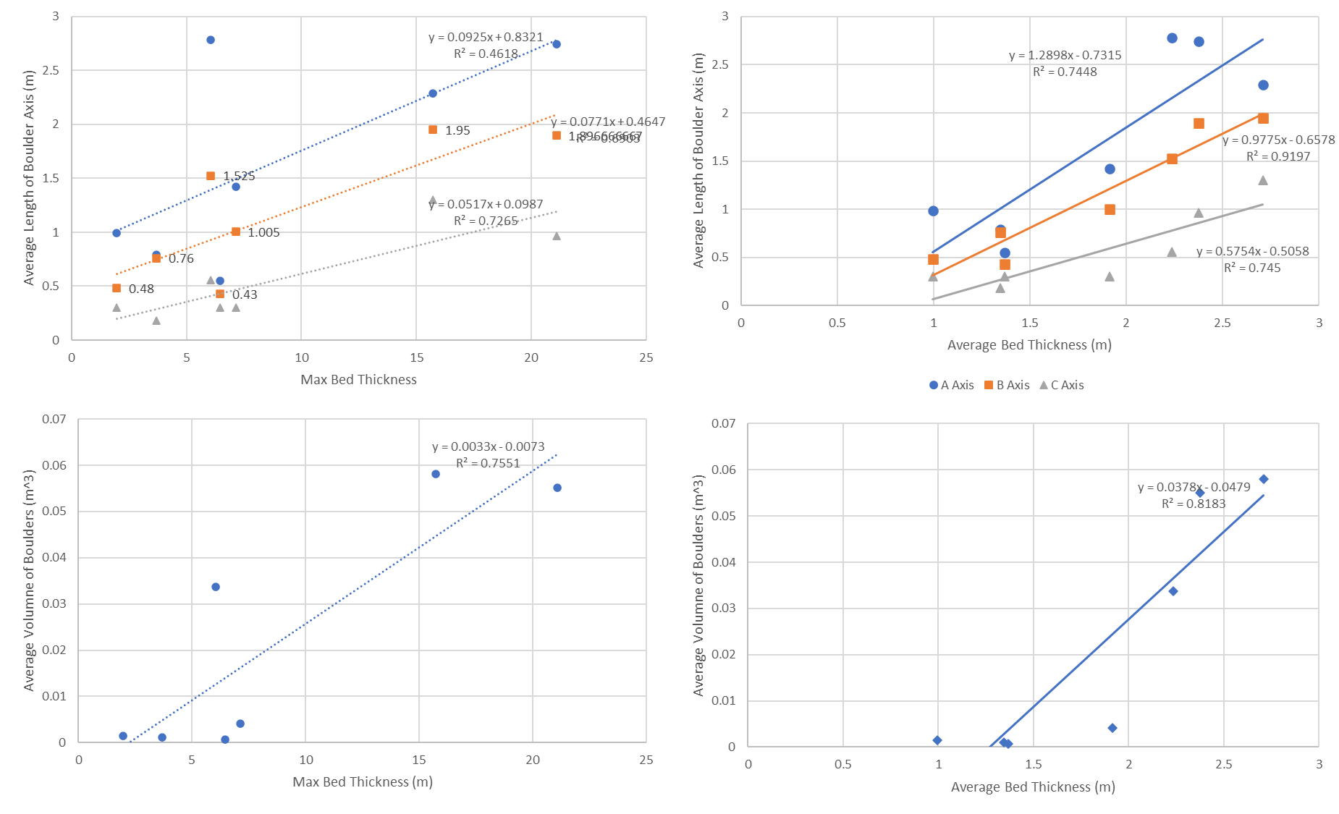

## 4.5 Bed thickness affects Channel Morph

In our results, we observed distinct relationships between bed thickness and channel steepness across hillslope transects. Specifically, we found that the maximum bed thickness along these transects exhibited a particularly strong influence on channel steepness, with a notable coefficient of determination (r^2 value) of 0.68. In contrast, the average bed thickness and the total bed thickness across the same transects also displayed correlations with channel steepness, albeit with comparatively lower r^2 values of 0.45 and 0.27, respectively. These findings underscore the significance of maximum bed thickness as a key factor in determining the steepness of the channels within the landscape, while also highlighting the varying degrees of influence associated with average and total bed thicknesses.

## 5 Discussion

Bed thickness varies across the landscape and etches their signal on it’s morphology. In Last Chance canyon, differences in measured bed thickness affect morphology in multiple ways. Here, we introduce three key interpretations from our study. (1) Changes in bed thickness affects hillslope morphology. We interpret that thinly bedded hillslopes in our study area have lower slopes. In contrast, we interpret that the more thickly bedded rock has higher slopes. (2) We interpret that bed thickness along hillslopes affects the size and dimensions of large boulders and the diameter of alluvium in channel reaches at the base of hillslope transects. (3) We interpret that bed thickness affects channel steepness by contributing larger or smaller sediment and boulders to channel at its base.

In Last Chance canyon, hillslopes are more diffuse in the more thinly bedded rock, but not in the more thickly bedded rock (curve vs distance fig). The term "idealized hillslope" may provide a more accurate descriptor than "diffusive." We should, however, define precisely what we mean by "idealized" in the context of our study to ensure clarity. Furthermore, hillslopes with less variance in bed thickness appear more “idealize”. Diffusive hillslopes are convex near the ridgeline and become more concave as the hillslope approach the channel. We plotted the slope values and the r squared values for the seven transects against max bed thickness and found that where the max bed thickness is lower, the slope of the distance vs curvature function is more negative and has a higher r-squared value, both indicating a more diffusive shape. We believe the spread in the data is due to position of the hillslope in the landscape. We did not take drainage area into account when plotting hillslope curvature (slope of function and r^2 of function figure). Also, hillslope transects that have more variation in bed thickness appear less diffuse suggesting that a hillslope made of a variety of different bed thicknesses can cause a hillslope to appear less diffuse.

Our study has unveiled significant insights into the complex relationships between bedrock characteristics, hillslope morphology, and channel dynamics within our research area. Notably, the correlation between bed thickness and various landscape attributes emerges as a central theme, shedding light on the critical role of bedrock in shaping the landforms and processes we observed. Maximum bed thickness exhibited a pronounced effect on the characteristics of both boulders within hillslope environments and the size of alluvium. A strong correlation was observed between maximum bed thickness and these landscape attributes, as indicated by a robust r^2 value of 0.68 for channel steepness. This suggests that variations in the thick bedrock layers within our transects play a pivotal role in shaping the physical attributes of boulders and channel gradients. In contrast, the influence of average bed thickness, while still significant, displayed comparatively weaker correlations, with r^2 values of 0.45 and 0.27 for hillslope boulder dimensions and channel steepness, respectively. This discrepancy highlights the varying degrees of influence that maximum and average bed thickness exert on landscape features. While both metrics are integral in understanding the geomorphic processes at play, maximum bed thickness emerges as a particularly salient factor in determining alluvial size, underlining its critical role in governing hillslope and channel morphology within our research area.

Our observations further underscore the significance of bed thickness in shaping the overall landscape morphology. The transition from upstream to downstream sections of the landscape, where hillslopes tend to become shallower, aligns with the thinner bedrock beds typically found in upstream regions, as well as smaller sediment and boulders. This systematic variation in bed thickness across the landscape accentuates the concept of hillslope convexity and its dynamic relationship with bedrock properties.

In conclusion, our study underscores the intricate interplay between bedrock attributes, hillslope features, and channel dynamics, offering valuable insights into the processes governing landscape evolution. These findings enhance our understanding of the geomorphological factors influencing sediment and boulder morphology and channel steepness within hillslope environments, ultimately contributing to a more comprehensive knowledge of landscape dynamics.

One intriguing avenue for future research is to explore the extent to which bed thickness impacts the transition from diffusive to non-diffusive hillslope forms. This could be investigated by tracking changes along the channel and comparing variations between different segments of the landscape, such as LC1 and LC3. Additionally, we might need to consider the combined influence of bed thickness and drainage area to comprehensively explain these transitions. Furthermore, we propose exploring whether bed thickness plays a role in defining the inflection point between linear and non-linear slope shapes and whether it influences the transition from convex to concave curvature. This could lead to the identification of potential threshold values for bed thickness or reveal the significance of proximity to larger bedrock features in shaping these landscape characteristics.

Overall, our study lays the foundation for further investigations into the multifaceted interactions between bed thickness, geomorphological processes, and landscape evolution within our research area.

## IDEAS

Bed thickness affects hs morph, and an make look more “ideal”

1. Curve vs distance figs
2. Seems like mean bed thickness most affects slope. But max bed thickness affects curvature more.

Why max bed thickness affects some things more as opposed to mean which affects some things more than others.

THE LARGER THE BED (ie max bed thickness) THE MORE RELEVANT IT IS TO HS MORPH, SED SIZE, and CHANNEL MORPH

I wonder if we can separate the effect bed thickness has on where a hs looks diffusive or not by tracking changes up channel and comparing between lc1 and 3. Worst comes to worst if it’s not just distance up channel we can say that it’s a combo of bed thickness and drainage area. Like maybe the spread in the data with max bed thickness vs r squared and slope of function is from drainage area.

Does bed thickness affect the inflection point between non linearity and linear slope shape? Does it affect the transition from convex to concave curvature? Is there a threshold thickness? Or proximity to a large bed?

Idealized hillslope is probably a better word than diffusive. Describe what idealized means tho…

Strait HS is where curve is 0. Maybe see location/elevation where hs become strait? Is there a pattern?

# 6 Conclusions

We present several observations about the effect of bed thickness on landscape morphology in Last Chance canyon. We suggest that bed thickness influences hillslope geometries. hills steepen across units with thicker beds. Conversely, hills are shallower in thinly bedded units. Furthermore, hillslopes with smaller max bed thickness appear more diffusive.

The size of boulders in the channel also impacts channel morphology. More thickly bedded rock on the hillslopes contributes larger sized, and more geomorphically relevant, alluvium to the channel. This coarse sediment armors the channel and causes channel steepness to increase. In Last Chance canyon, channel sections that contain larger alluvium are generally steeper.

# Old References

Bell, F. G. (2005). ENGINEERING GEOLOGY| Problematic Rocks.

Bursztyn, N., Pederson, J. L., Tressler, C., Mackley, R. D., & Mitchell, K. J. (2015). Rock strength along a fluvial transect of the Colorado Plateau – quantifying a fundamental control on geomorphology. Earth and Planetary Science Letters, 429, 90–100. doi:10.1016/j.epsl.2015.07.042

Chapin, C. E., Cather, S. M., & Keller, G. R. (1994). Tectonic setting of the axial basins of the northern and central Rio Grande rift. Special Papers-Geological Society of America, 5–5.

Chilton, K. D., & Spotila, J. A. (2020). Preservation of Valley and Ridge topography via delivery of resistant, ridge-sourced boulders to hillslopes and channels, Southern Appalachian Mountains, U.S.A. Geomorphology, 365, 107263. doi:10.1016/j.geomorph.2020.107263

Darling, A., & Whipple, K. (08 2015). Geomorphic constraints on the age of the western Grand Canyon. Geosphere, 11(4), 958–976. doi:10.1130/GES01131.1

Decker, D. D., Polyak, V. J., Asmerom, Y., & Lachniet, M. S. (2018). U--Pb dating of cave spar: a new shallow crust landscape evolution tool. Tectonics, 37(1), 208–223.

DiBiase, R. A., Rossi, M. W., & Neely, A. B. (2018). Fracture density and grain size controls on the relief structure of bedrock landscapes. Geology, 46(5), 399–402. doi:10.1130/G40006.1

DiBiase, R. A., Whipple, K. X., Heimsath, A. M., & Ouimet, W. B. (2010). Landscape form and millennial erosion rates in the San Gabriel Mountains, CA. Earth and Planetary Science Letters, 289(1), 134–144. doi:10.1016/j.epsl.2009.10.03

Duvall, A., Kirby, E., & Burbank, D. (2004). Tectonic and lithologic controls on bedrock channel profiles and processes in coastal California. Journal of Geophysical Research: Earth Surface, 109(F3). doi:10.1029/2003JF000086

Forte, A. M., Yanites, B. J., & Whipple, K. X. (2016). Complexities of landscape evolution during incision through layered stratigraphy with contrasts in rock strength. Earth Surface Processes and Landforms, 41(12), 1736–1757. doi:10.1002/esp.3947 Finnegan, N. J., Klier, R. A., Johnstone, S., Pfeiffer, A. M., & Johnson, K. (2017). Field evidence for the control of grain size and sediment supply on steady-state bedrock river channel slopes in a tectonically active setting. Earth Surface Processes and Landforms, 42(14), 2338–2349.

Harel, M.-A., Mudd, S. M., & Attal, M. (2016). Global analysis of the stream power law parameters based on worldwide 10Be denudation rates. Geomorphology, 268, 184–196. doi:10.1016/j.geomorph.2016.05.035

Healy, D., Rizzo, R. E., Cornwell, D. G., Farrell, N. J. C., Watkins, H., Timms, N. E., … Smith, M. (2017). FracPaQ: A MATLABTM toolbox for the quantification of fracture patterns. Journal of Structural Geology, 95, 1–16.

Hill, C. A. (1987). Geology of Carlsbad cavern and other caves in the Guadalupe Mountains, New Mexico and Texas. Bull. 117, New Mexico Bureau of Mines and Minerals Resources.

Hill, C. A., & Others. (2000). Overview of the geologic history of cave development in the Guadalupe Mountains, New Mexico. Journal of Cave and Karst Studies, 62(2), 60–71.

Hill, C. A. (2006). Geology of the Guadalupe Mountains: An overview of recent ideas. Caves and karst of southeastern New Mexico: Guidebook, 57th Field Conference, New Mexico Geological Society, Guidebook, 57th Field Conference, 145–150.

Hilley, G. E., & Arrowsmith, J. R. (2008). Geomorphic response to uplift along the Dragon’s Back pressure ridge, Carrizo Plain, California. Geology, 36(5), 367–370.

Hoffman, L. L. (2014). Spatial variability of erosion patterns along the eastern margin of the Rio Grande Rift. Illinois State University.

Jansen, J. D., Codilean, A. T., Bishop, P., & Hoey, T. B. (2010). Scale dependence of lithological control on topography: Bedrock channel geometry and catchment morphometry in western Scotland. The Journal of geology, 118(3), 223–246.

Johnson, J. P. L., Whipple, K. X., Sklar, L. S., & Hanks, T. C. (2009). Transport slopes, sediment cover, and bedrock channel incision in the Henry Mountains, Utah. Journal of Geophysical Research: Earth Surface, 114(F2). doi:10.1029/2007JF000862

Katz, O., Reches, Z., & Roegiers, J.-C. (2000). Evaluation of mechanical rock properties using a Schmidt Hammer. International Journal of rock mechanics and mining sciences, 37(4), 723–728.

Keen-Zebert, A., Hudson, M. R., Shepherd, S. L., & Thaler, E. A. (2017). The effect of lithology on valley width, terrace distribution, and bedload provenance in a tectonically stable catchment with flat-lying stratigraphy. Earth Surface Processes and Landforms, 42(10), 1573–1587.

Kerans, C., Zahm, C., Garcia-Fresca, B., & Harris, P. M. (2017). Guadalupe Mountains, West Texas and New Mexico: Key excursions. AAPG Bulletin, 101(4), 465–474.

Kirby, E., & Whipple, K. X. (2012). Expression of active tectonics in erosional landscapes. Journal of structural geology, 44, 54–75.

Konare, A., Zakey, A. S., Solmon, F., Giorgi, F., Rauscher, S., Ibrah, S., & Bi, X. (2008). A regional climate modeling study of the effect of desert dust on the West African monsoon. Journal of Geophysical Research: Atmospheres, 113(D12).

Lai, L. S.-H., Roering, J. J., Finnegan, N. J., Dorsey, R. J., & Yen, J.-Y. (2021). Coarse sediment supply sets the slope of bedrock channels in rapidly uplifting terrain: Field and topographic evidence from eastern Taiwan. Earth Surface Processes and Landforms, 46(13), 2671–2689. doi:10.1002/esp.5200

Montgomery, D. R., & Gran, K. B. (2001). Downstream variations in the width of bedrock channels. Water Resources Research, 37(6), 1841–1846. doi:10.1029/2000WR900393

Murphy, B., Johnson, J., Gasparini, N., & Sklar, L. (04 2016). Chemical weathering as a mechanism for the climatic control of bedrock river incision. Nature, 532, 223–227. doi:10.1038/nature17449

National Park Service Resources Inventory Program Lakewood Colorado, (2007). Digital geologic map of Guadalupe Mountains National Park and vicinity, Texas (NPS, GRD, GRE, GUMO).

Niedzielski, T., Migoń, P., & Placek, A. (2009). A minimum sample size required from Schmidt hammer measurements. Earth Surface Processes and Landforms: The Journal of the British Geomorphological Research Group, 34(13), 1713–1725.

Perne, M., Covington, M. D., Thaler, E. A., & Myre, J. M. (2017). Steady state, erosional continuity, and the topography of landscapes developed in layered rocks. Earth Surface Dynamics, 5(1), 85–100. doi:10.5194/esurf-5-85-2017

Phelps, R. M., Kerans, C., Scott, S. Z., Janson, X., & Bellian, J. A. (2008). Three-dimensional modelling and sequence stratigraphy of a carbonate ramp-to-shelf transition, Permian Upper San Andres Formation. Sedimentology, 55(6), 1777–1813.

Ricketts, J. W., Karlstrom, K. E., Priewisch, A., Crossey, L. J., Polyak, V. J., & Asmerom, Y. (2014). Quaternary extension in the Rio Grande rift at elevated strain rates recorded in travertine deposits, central New Mexico. Lithosphere, 6(1), 3–16.

Scharf, T. E., Codilean, A. T., De Wit, M., Jansen, J. D., & Kubik, P. W. (2013). Strong rocks sustain ancient postorogenic topography in southern Africa. Geology, 41(3), 331–334.

Scholle, P. A., Ulmer, D. S., & Melim, L. A. (1992). Late-stage calcites in the Permian Capitan Formation and its equivalents, Delaware Basin margin, west Texas and New Mexico: evidence for replacement of precursor evaporites. Sedimentology, 39(2), 207–234.

Schwanghart, W., & Scherler, D. (2014). Short Communication: TopoToolbox 2 – MATLAB-based software for topographic analysis and modeling in Earth surface sciences. Earth Surface Dynamics, 2(1), 1–7. doi:10.5194/esurf-2-1-2014

Sklar, L. S., & Dietrich, W. E. (12 2001). Sediment and rock strength controls on river incision into bedrock. Geology, 29(12), 1087–1090. doi:10.1130/0091-7613(2001)029<1087:SARSCO>2.0.CO;2

Spotila, J. A., Moskey, K. A., & Prince, P. S. (2015). Geologic controls on bedrock channel width in large, slowly-eroding catchments: Case study of the New River in eastern North America. Geomorphology, 230, 51–63. doi:10.1016/j.geomorph.2014.11.004

Thaler, E. A., & Covington, M. D. (2016). The influence of sandstone caprock material on bedrock channel steepness within a tectonically passive setting: Buffalo National River Basin, Arkansas, USA. Journal of Geophysical Research: Earth Surface, 121(9), 1635–1650. doi:10.1002/2015JF003771

Tranel, L. M., & Happel, A. A. (2020). Evaluating escarpment evolution and bedrock erosion rates in the western Guadalupe Mountains, West Texas and New Mexico. Geomorphology, 368, 107335.

US Geologic Survey, 2017, 1/3rd arc-second digital elevation models (DEMs). USGS National Map 3DEP downloadable data collection.

Verdian, J. P., Sklar, L. S., Riebe, C. S., & Moore, J. R. (2021). Sediment size on talus slopes correlates with fracture spacing on bedrock cliffs: implications for predicting initial sediment size distributions on hillslopes. Earth Surface Dynamics, 9(4), 1073–1090.

Whipple, K. X., & Tucker, G. E. (1999). Dynamics of the stream-power river incision model: Implications for height limits of mountain ranges, landscape response timescales, and research needs. Journal of Geophysical Research: Solid Earth, 104(B8), 17661–17674. doi:10.1029/1999JB900120

Wobus, C., Whipple, K. X., Kirby, E., Snyder, N., Johnson, J., Spyropolou, K., … Sheehan, D. (01 2006). Tectonics from topography: Procedures, promise, and pitfalls. Tectonics, Climate, and Landscape Evolution. doi:10.1130/2006.2398(04)

Wohl, E. E., Greenbaum, N., Schick, A. P., & Baker, V. R. (1994). Controls on bedrock channel incision along nahal paran, Israel. Earth Surface Processes and Landforms, 19(1), 1–13. doi:10.1002/esp.3290190102

Yanites, B. J., Becker, J. K., Madritsch, H., Schnellmann, M., & Ehlers, T. A. (2017). Lithologic effects on landscape response to base level changes: a modeling study in the context of the Eastern Jura Mountains, Switzerland. Journal of Geophysical Research: Earth Surface, 122(11), 2196–2222.

Yanites, B. J. (2018). The dynamics of channel slope, width, and sediment in actively eroding bedrock river systems. Journal of Geophysical Research: Earth Surface, 123(7), 1504–1527.

Zaleski, E., Eaton, D. W., Milkereit, B., Roberts, B., Salisbury, M., & Petrie, L. (1997). Seismic reflections from subvertical diabase dikes in an Archean terrane. Geology, 25(8), 707–710.

# New References

Mudd, Simon & Furbish, David. (1625). Influence of chemical denudation on hillslope morphology. Geomorphology J. Geophys. Res. 109. 10.1029/2003JF000087.

Shobe, C. M., Tucker, G. E., and Anderson, R. S. (2016), Hillslope-derived blocks retard river incision, Geophys. Res. Lett., 43, 5070– 5078, doi:10.1002/2016GL069262.

Neely, A. B., DiBiase, R. A., Corbett, L. B., Bierman, P. R., & Caffee, M. W. (2019). Bedrock fracture density controls on hillslope erodibility in steep, rocky landscapes with patchy soil cover, southern California, USA. Earth and Planetary Science Letters, 522, 186-197.

Ben-Asher, M., Haviv, I., Roering, J. J., & Crouvi, O. (2019). The potential influence of dust flux and chemical weathering on hillslope morphology: Convex soil-mantled carbonate hillslopes in the Eastern Mediterranean. Geomorphology, 341, 203-215.

Gilbert, G. K. (1909). The convexity of hilltops. The Journal of Geology, 17(4), 344-350.

Culling, W. E. H. (1960). Analytical theory of erosion. The Journal of Geology, 68(3), 336-344.

Roering, J. J., Kirchner, J. W., & Dietrich, W. E. (1999). Evidence for nonlinear, diffusive sediment transport on hillslopes and implications for landscape morphology. Water Resources Research, 35(3), 853-870.

Tucker, G. E., & Bras, R. L. (1998). Hillslope processes, drainage density, and landscape morphology. Water resources research, 34(10), 2751-2764.