reference – osa Management System
link = https://itsourcecode.com/uml/food-ordering-system-dfd/

DFD level 0
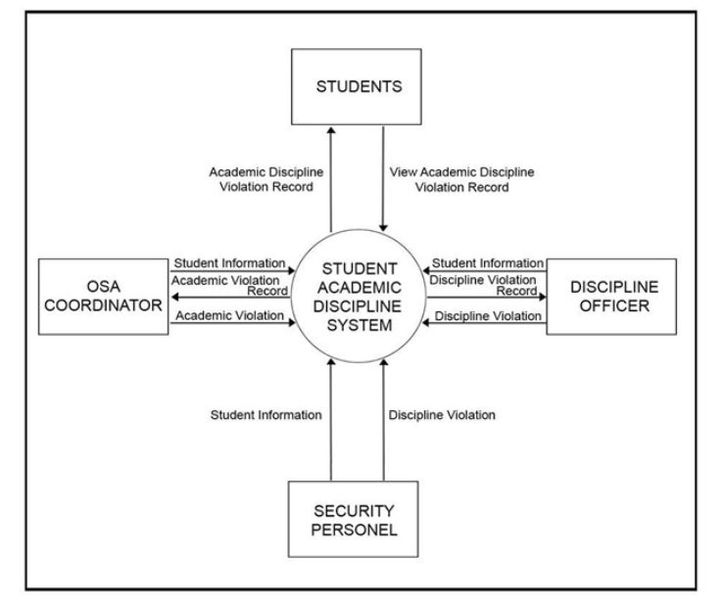
Level 1 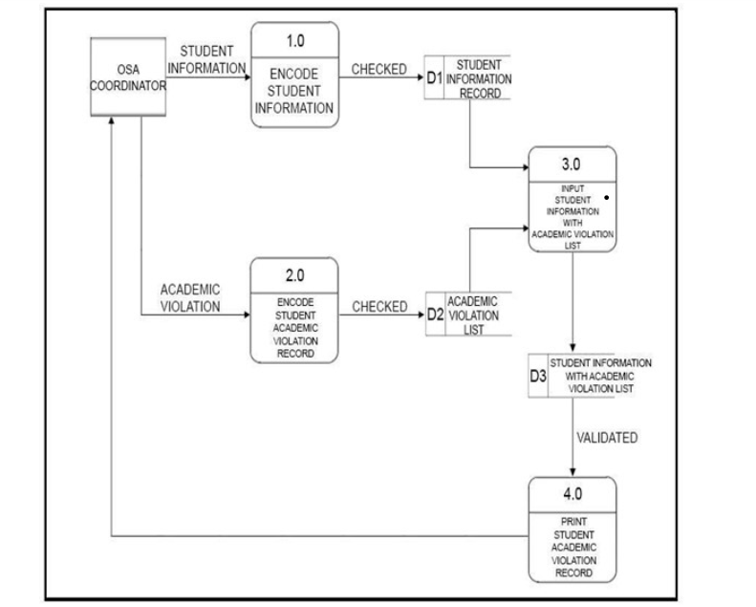

Todo-Vanguard ATM System

Opo mahal. Let’s finalize **our original DFD**, with only the formatting and data-flow simplification you requested.

# Enterprise-Kiosk Vanguard

## Final Data Flow Diagram

### Shape / Symbol Legend

| Label | Meaning |
| -------------- | ---------------- |
| `*ENTITY*` | External Entity |
| `*PROCESS*` | Process / action |
| `*DATA FLOW*` | Data in motion |
| `*DATA STORE*` | Stored data |

---

# LEVEL 0 — CONTEXT DIAGRAM

**System Process:** `PROVIDE ATM SERVICES`

### External Entities

* `*ENTITY* CUSTOMER`
* `*ENTITY* CORE BANKING SYSTEM`
* `*ENTITY* FLEET OPERATIONS CENTER`

### Final Level 0

```text
*ENTITY*
CORE BANKING SYSTEM
│
│ *DATA FLOW*
│ Account Data
│ Authorization
▼
*PROCESS*
PROVIDE ATM SERVICES
│
│ *DATA FLOW*
│ Transaction Data
│ Account Updates
▼
*ENTITY*
CORE BANKING SYSTEM

*ENTITY* CUSTOMER
│
│ *DATA FLOW*
│ Biometric Data
│ Gesture Input
│ Transaction Request
│ Security Request
▼
*PROCESS*
PROVIDE ATM SERVICES
│
│ *DATA FLOW*
│ Authentication
│ Dashboard
│ Transaction Result
│ Cash Status
│ Receipt
▼
*ENTITY* CUSTOMER

*PROCESS*
PROVIDE ATM SERVICES
│
│ *DATA FLOW*
│ Telemetry
│ Cash Status
│ Maintenance Status
▼
*ENTITY*
FLEET OPERATIONS CENTER
│
│ *DATA FLOW*
│ Dispatch Status
│ Maintenance Status
▼
*PROCESS*
PROVIDE ATM SERVICES
```

### Level 0 Data Flows — Final Prepared Terms

| Direction | Data Flow |
| ---------------------- | ----------------------- |
| Customer → ATM | **Biometric Data** |
| Customer → ATM | **Gesture Input** |
| Customer → ATM | **Transaction Request** |
| Customer → ATM | **Security Request** |
| ATM → Customer | **Authentication** |
| ATM → Customer | **Dashboard** |
| ATM → Customer | **Transaction Result** |
| ATM → Customer | **Cash Status** |
| ATM → Customer | **Receipt** |
| Core Banking → ATM | **Account Data** |
| Core Banking → ATM | **Authorization** |
| ATM → Core Banking | **Transaction Data** |
| ATM → Core Banking | **Account Updates** |
| ATM → Fleet Operations | **Telemetry** |
| ATM → Fleet Operations | **Cash Status** |
| ATM → Fleet Operations | **Maintenance Status** |
| Fleet Operations → ATM | **Dispatch Status** |
| Fleet Operations → ATM | **Maintenance Status** |

---

# LEVEL 1 — DETAILED DFD

The original four processes are retained:

| Process | Action |
| ------- | ------------------------- |
| **1.0** | **Authenticate User** |
| **2.0** | **Process Transaction** |
| **3.0** | **Monitor ATM Resources** |
| **4.0** | **Protect ATM Session** |

### Data Stores

| Data Store | Name |
| ---------- | -------------------------- |
| **D1** | Customer / Biometric Data |
| **D2** | Account / Transaction Data |
| **D3** | ATM Terminal Data |
| **D4** | Cassette Inventory |
| **D5** | Maintenance Records |

---

## 1.0 Authenticate User

```text
*ENTITY*
CUSTOMER
│
│ *DATA FLOW*
│ Biometric Data
▼
*PROCESS*
1.0 AUTHENTICATE USER
│
│ *DATA FLOW*
│ Biometric Profile
▼
*DATA STORE*
D1 CUSTOMER / BIOMETRIC DATA

*PROCESS*
1.0 AUTHENTICATE USER
│
│ *DATA FLOW*
│ Authentication
▼
*ENTITY*
CUSTOMER

*PROCESS*
1.0 AUTHENTICATE USER
│
│ *DATA FLOW*
│ User Context
▼
*PROCESS*
2.0 PROCESS TRANSACTION
```

---

# 2.0 Process Transaction

```text
*ENTITY*
CUSTOMER
│
│ *DATA FLOW*
│ Gesture Input
│ Transaction Request
▼
*PROCESS*
2.0 PROCESS TRANSACTION
│
│ *DATA FLOW*
│ Account Data
▼
*DATA STORE*
D2 ACCOUNT / TRANSACTION DATA

*ENTITY*
CORE BANKING SYSTEM
│
│ *DATA FLOW*
│ Account Data
│ Authorization
▼
*PROCESS*
2.0 PROCESS TRANSACTION

*PROCESS*
2.0 PROCESS TRANSACTION
│
│ *DATA FLOW*
│ Transaction Data
│ Account Updates
▼
*ENTITY*
CORE BANKING SYSTEM

*PROCESS*
2.0 PROCESS TRANSACTION
│
│ *DATA FLOW*
│ Dashboard
│ Transaction Result
│ Cash Status
│ Receipt
▼
*ENTITY*
CUSTOMER
```

---

# 3.0 Monitor ATM Resources

```text
*DATA STORE*
D3 ATM TERMINAL DATA
│
│ *DATA FLOW*
│ Terminal Data
▼
*PROCESS*
3.0 MONITOR ATM RESOURCES

*DATA STORE*
D4 CASSETTE INVENTORY
│
│ *DATA FLOW*
│ Cash Data
▼
*PROCESS*
3.0 MONITOR ATM RESOURCES

*DATA STORE*
D5 MAINTENANCE RECORDS
│
│ *DATA FLOW*
│ Maintenance Data
▼
*PROCESS*
3.0 MONITOR ATM RESOURCES

*PROCESS*
3.0 MONITOR ATM RESOURCES
│
│ *DATA FLOW*
│ Telemetry
│ Cash Status
│ Maintenance Status
▼
*ENTITY*
FLEET OPERATIONS CENTER

*ENTITY*
FLEET OPERATIONS CENTER
│
│ *DATA FLOW*
│ Dispatch Status
│ Maintenance Status
▼
*PROCESS*
3.0 MONITOR ATM RESOURCES
```

---

# 4.0 Protect ATM Session

```text
*ENTITY*
CUSTOMER
│
│ *DATA FLOW*
│ Security Request
▼
*PROCESS*
4.0 PROTECT ATM SESSION
│
│ *DATA FLOW*
│ Security Status
▼
*ENTITY*
CUSTOMER

*PROCESS*
4.0 PROTECT ATM SESSION
│
│ *DATA FLOW*
│ Security Data
▼
*DATA STORE*
D3 ATM TERMINAL DATA
```

---

# FINAL LEVEL 1 — DATA FLOW SUMMARY

This is the **clean list to use when drawing the arrows**:

| From | Data Flow | To |
| --------------------------- | ----------------------- | -------------------------- |
| Customer | **Biometric Data** | 1.0 Authenticate User |
| 1.0 Authenticate User | **Biometric Profile** | D1 Customer/Biometric Data |
| 1.0 Authenticate User | **Authentication** | Customer |
| 1.0 Authenticate User | **User Context** | 2.0 Process Transaction |
| Customer | **Gesture Input** | 2.0 Process Transaction |
| Customer | **Transaction Request** | 2.0 Process Transaction |
| D2 Account/Transaction Data | **Account Data** | 2.0 Process Transaction |
| 2.0 Process Transaction | **Authorization** | Core Banking System |
| Core Banking System | **Account Data** | 2.0 Process Transaction |
| 2.0 Process Transaction | **Transaction Data** | Core Banking System |
| 2.0 Process Transaction | **Account Updates** | Core Banking System |
| 2.0 Process Transaction | **Dashboard** | Customer |
| 2.0 Process Transaction | **Transaction Result** | Customer |
| 2.0 Process Transaction | **Cash Status** | Customer |
| 2.0 Process Transaction | **Receipt** | Customer |
| D3 ATM Terminal Data | **Terminal Data** | 3.0 Monitor ATM Resources |
| D4 Cassette Inventory | **Cash Data** | 3.0 Monitor ATM Resources |
| D5 Maintenance Records | **Maintenance Data** | 3.0 Monitor ATM Resources |
| 3.0 Monitor ATM Resources | **Telemetry** | Fleet Operations Center |
| 3.0 Monitor ATM Resources | **Cash Status** | Fleet Operations Center |
| 3.0 Monitor ATM Resources | **Maintenance Status** | Fleet Operations Center |
| Fleet Operations Center | **Dispatch Status** | 3.0 Monitor ATM Resources |
| Fleet Operations Center | **Maintenance Status** | 3.0 Monitor ATM Resources |
| Customer | **Security Request** | 4.0 Protect ATM Session |
| 4.0 Protect ATM Session | **Security Status** | Customer |
| 4.0 Protect ATM Session | **Security Data** | D3 ATM Terminal Data |

### Final process names

**1.0 Authenticate User**
**2.0 Process Transaction**
**3.0 Monitor ATM Resources**
**4.0 Protect ATM Session**

### Final prepared data-flow vocabulary

**Biometric Data • Biometric Profile • Authentication • User Context • Gesture Input • Transaction Request • Account Data • Authorization • Transaction Data • Account Updates • Dashboard • Transaction Result • Cash Status • Receipt • Terminal Data • Cash Data • Maintenance Data • Telemetry • Maintenance Status • Dispatch Status • Security Request • Security Status • Security Data**

This is now the **finalized DFD vocabulary and structure** for our Enterprise-Kiosk Vanguard case, while retaining the original DFD design.

___________________________________________________________

ERD Ms Access
___________________________________________________________
Opo mahal. We'll make this specifically for **Microsoft Access SQL**, using your naming convention and all **9 tables**, with the **PK/FK relationships** included.

One important Access detail: because some Access versions can be picky about executing multiple `CREATE TABLE` statements at once, **run each table statement separately first**, then run each `ALTER TABLE` relationship statement. That avoids the naming/parser errors you're encountering.

## 1. Create `tblCustomers`

Open **Create → Query Design → SQL View**, paste this, then click **Run**:

```sql
CREATE TABLE tblCustomers (
numCustomerID AUTOINCREMENT CONSTRAINT PK_tblCustomers PRIMARY KEY,
txtFirstName TEXT(50),
txtLastName TEXT(50),
txtContactNumber TEXT(20),
txtEmail TEXT(100),
dteRegistrationDate DATETIME,
txtStatus TEXT(20)
);
```

---

## 2. Create `tblBiometricTypes`

```sql
CREATE TABLE tblBiometricTypes (
numBiometricTypeID AUTOINCREMENT CONSTRAINT PK_tblBiometricTypes PRIMARY KEY,
txtBiometricTypeName TEXT(50),
txtDescription TEXT(255)
);
```

---

## 3. Create `tblBiometricProfiles`

```sql
CREATE TABLE tblBiometricProfiles (
numBiometricProfileID AUTOINCREMENT CONSTRAINT PK_tblBiometricProfiles PRIMARY KEY,
numCustomerID LONG,
numBiometricTypeID LONG,
memBiometricTemplate LONGTEXT,
dteEnrollmentDate DATETIME,
txtStatus TEXT(20)
);
```

---

## 4. Create `tblAccounts`

```sql
CREATE TABLE tblAccounts (
numAccountID AUTOINCREMENT CONSTRAINT PK_tblAccounts PRIMARY KEY,
numCustomerID LONG,
txtAccountNumber TEXT(30),
txtAccountType TEXT(30),
curCurrentBalance CURRENCY,
txtAccountStatus TEXT(20),
dteDateOpened DATETIME
);
```

---

## 5. Create `tblTransactionTypes`

```sql
CREATE TABLE tblTransactionTypes (
numTransactionTypeID AUTOINCREMENT CONSTRAINT PK_tblTransactionTypes PRIMARY KEY,
txtTransactionTypeName TEXT(50),
txtDescription TEXT(255)
);
```

---

## 6. Create `tblATMTerminals`

```sql
CREATE TABLE tblATMTerminals (
numATMID AUTOINCREMENT CONSTRAINT PK_tblATMTerminals PRIMARY KEY,
txtTerminalSerialNumber TEXT(50),
txtLocation TEXT(150),
txtStatus TEXT(20),
dteInstallationDate DATETIME
);
```

---

## 7. Create `tblATMTransactions`

```sql
CREATE TABLE tblATMTransactions (
numTransactionID AUTOINCREMENT CONSTRAINT PK_tblATMTransactions PRIMARY KEY,
numAccountID LONG,
numATMID LONG,
numTransactionTypeID LONG,
curAmount CURRENCY,
dteTransactionDateTime DATETIME,
txtTransactionStatus TEXT(20),
txtReceiptType TEXT(30)
);
```

---

## 8. Create `tblCassetteInventory`

```sql
CREATE TABLE tblCassetteInventory (
numCassetteID AUTOINCREMENT CONSTRAINT PK_tblCassetteInventory PRIMARY KEY,
numATMID LONG,
curDenomination CURRENCY,
numCurrentQuantity LONG,
numMaximumCapacity LONG,
txtCassetteStatus TEXT(20),
dteLastRefilledDate DATETIME
);
```

---

## 9. Create `tblMaintenanceRecords`

```sql
CREATE TABLE tblMaintenanceRecords (
numMaintenanceID AUTOINCREMENT CONSTRAINT PK_tblMaintenanceRecords PRIMARY KEY,
numATMID LONG,
txtMaintenanceType TEXT(50),
dteMaintenanceDate DATETIME,
memDescription LONGTEXT,
txtTechnicianName TEXT(100),
txtMaintenanceStatus TEXT(20)
);
```

# Now create the PK/FK relationships

After all **9 tables have been successfully created**, create the relationships.

### Relationship 1 — Customer → Biometric Profiles

```sql
ALTER TABLE tblBiometricProfiles
ADD CONSTRAINT FK_BiometricProfiles_Customers
FOREIGN KEY (numCustomerID)
REFERENCES tblCustomers (numCustomerID);
```

### Relationship 2 — Biometric Type → Biometric Profiles

```sql
ALTER TABLE tblBiometricProfiles
ADD CONSTRAINT FK_BiometricProfiles_BiometricTypes
FOREIGN KEY (numBiometricTypeID)
REFERENCES tblBiometricTypes (numBiometricTypeID);
```

### Relationship 3 — Customer → Accounts

```sql
ALTER TABLE tblAccounts
ADD CONSTRAINT FK_Accounts_Customers
FOREIGN KEY (numCustomerID)
REFERENCES tblCustomers (numCustomerID);
```

### Relationship 4 — Account → ATM Transactions

```sql
ALTER TABLE tblATMTransactions
ADD CONSTRAINT FK_ATMTransactions_Accounts
FOREIGN KEY (numAccountID)
REFERENCES tblAccounts (numAccountID);
```

### Relationship 5 — Transaction Type → ATM Transactions

```sql
ALTER TABLE tblATMTransactions
ADD CONSTRAINT FK_ATMTransactions_TransactionTypes
FOREIGN KEY (numTransactionTypeID)
REFERENCES tblTransactionTypes (numTransactionTypeID);
```

### Relationship 6 — ATM Terminal → ATM Transactions

```sql
ALTER TABLE tblATMTransactions
ADD CONSTRAINT FK_ATMTransactions_ATMTerminals
FOREIGN KEY (numATMID)
REFERENCES tblATMTerminals (numATMID);
```

### Relationship 7 — ATM Terminal → Cassette Inventory

```sql
ALTER TABLE tblCassetteInventory
ADD CONSTRAINT FK_CassetteInventory_ATMTerminals
FOREIGN KEY (numATMID)
REFERENCES tblATMTerminals (numATMID);
```

### Relationship 8 — ATM Terminal → Maintenance Records

```sql
ALTER TABLE tblMaintenanceRecords
ADD CONSTRAINT FK_MaintenanceRecords_ATMTerminals
FOREIGN KEY (numATMID)
REFERENCES tblATMTerminals (numATMID);
```

## Final relationship structure

```text
tblCustomers

```

### One thing to be careful about, mahal

For these foreign-key fields:

```text
numCustomerID
numBiometricTypeID
numAccountID
numATMID
numTransactionTypeID
```

the **data type is `LONG` (Number)**, not AutoNumber.

Only the corresponding primary keys are `AUTOINCREMENT`:

```text
numCustomerID → AutoNumber
numBiometricTypeID → AutoNumber
numBiometricProfileID → AutoNumber
numAccountID → AutoNumber
numTransactionTypeID → AutoNumber
numATMID → AutoNumber
numTransactionID → AutoNumber
numCassetteID → AutoNumber
numMaintenanceID → AutoNumber
```

That distinction is important for Access relationships.

**Also, don't execute all 17 SQL blocks together.** Create the 9 tables first, one query at a time, and only after all tables exist, execute the 8 relationship queries. This is the safest way to avoid another Access SQL error.
___________________________________________________________

Search Key words:
2. Complete ERD with Entities, PK/FKs, Attributes, & Cardinality Notations
- at least these 6 entities
3: Low-Fidelity (Low-Fi) HCI Physical & Software Prototype

