Matoi
Agent Intelligence Market
Unified Technical Submission Document

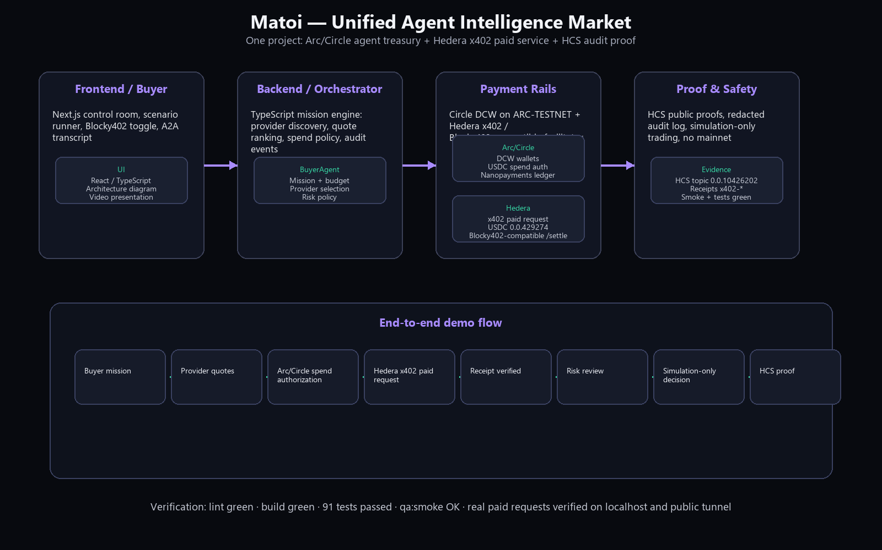
Project | Matoi — Agent Intelligence Market
Submission tracks | Arc/Circle Agentic Economy + Hedera x402 / Blocky402 paid service
Contact email | geraldwarren77@gmail.com
X / Twitter | @NikiYomek — https://x.com/NikiYomek
Discord | yomek
Arc House | Niki Li (yomek)
Document date | 2026-09-12

1. Executive summary
Matoi is a control room for autonomous economic agents. A BuyerAgent opens a mission, discovers sellable intelligence providers, ranks their quotes, authorizes bounded USDC spend through Arc/Circle testnet wallets, optionally pays a Hedera x402-gated service through a Blocky402-compatible facilitator, receives normalized intelligence, produces a simulation-only trading/risk decision, and leaves a redacted public proof on Hedera HCS.
The project is one coherent product, not two separate bounty demos: Arc/Circle is the agent treasury and USDC spend layer; Hedera is the x402 paid-service and audit-proof layer; the frontend and backend connect them into one agent mission flow.

2. Submission fit
Track | Requirement | Matoi proof
Arc/Circle | Functional MVP with working frontend and backend | Next.js control room plus API backend: /api/mission/run, /api/arc/status, /api/arc/authorize-payment
Arc/Circle | Architecture diagram | docs/architecture.svg and this document's embedded architecture diagram
Arc/Circle | Effective Circle Developer tools/tech usage | Circle DCW role wallets, ARC-TESTNET USDC, guarded real transfer proof, spend ledger, nanopayments
Hedera | Live x402-gated service on Hedera testnet | POST /api/x402/blocky402/pay
Hedera | Settled through Blocky402 facilitator | Self-hosted Blocky402-compatible /settle route consumed via BLOCKY402_URL
Hedera | Platform/agent consumes the service | BuyerAgent mission flow adds BLOCKY402_* receipt messages
Hedera | Real paid request end-to-end | Verified localhost and public tunnel receiptIds x402-*

3. Core functions
- Mission runner: five judge-visible buyer tasks with one-click RUN FULL MISSION flow.
- Provider marketplace: provider discovery, quote ranking, reputation and task-relative summaries.
- Arc/Circle treasury: three role wallets, spend authorization and provider payout ledger.
- Nanopayments: per-call metering and NANOPAYMENT_SETTLED ledger entries.
- Hedera x402 service: live paid request route, signed Hedera transaction payload, HMAC receipt.
- HCS audit: redacted, allowlisted public proof path to topic 0.0.10426202.
- Safety: mainnet disabled, real trades/swaps disabled, secrets never exposed in browser/audit/HCS.

4. Unified architecture
The following architecture is the same system diagram used in the README and presentation deck.
Flow: Buyer mission → provider quotes → Arc/Circle spend authorization → Hedera x402 paid request → receipt verification → risk review → simulation-only decision → HCS proof.

5. Frontend and backend implementation
Layer | Implementation | Key files / endpoints
Frontend | Next.js / React / TypeScript control room UI | src/components/InkExperience.tsx, route /
Mission backend | TypeScript orchestrator for scenarios, providers, payments, audit events | src/lib/mission-orchestrator.ts, POST /api/mission/run
Arc/Circle backend | Wallet readiness, spend authorization, settlement lifecycle, optional real transfer | GET /api/arc/status, POST /api/arc/authorize-payment, POST /api/arc/testnet-transfer/run
Hedera backend | x402 paid request, Blocky402-compatible facilitator, HCS audit | POST /api/x402/blocky402/pay, /api/x402/blocky402-facilitator/settle, /api/audit/hcs
Testing | Unit, integration and HTTP smoke coverage | 91 tests passed, qa:smoke OK

6. Circle / Arc developer technology usage
Circle / Arc tech | How it is used | Proof
Circle Developer Controlled Wallets | Three agent role wallets: Trader, ArcResearch, Risk | GET /api/arc/status
ARC-TESTNET | All Arc wallet actions are testnet-only | Status route and README track section
USDC | Agent spend authorization and optional real transfer proof | Circle tx a0042c1c-ae9a-5120-accc-7116dfc1ec31 COMPLETE
Circle transaction API | Guarded real transfer endpoint with double opt-in | POST /api/arc/testnet-transfer/run
Agent Stack concept | BuyerAgent, ProviderAgent, RiskAgent, ArcTreasuryAgent cooperate in one mission | A2A transcript in /api/mission/run
Nanopayments | Per-provider-call metering and settlement ledger | src/lib/nanopayments.ts; NANOPAYMENT_SETTLED entries

7. Hedera x402 / Blocky402 payment flow
- BuyerAgent selects provider service telegram-pulse.
- POST /api/x402/blocky402/pay builds Hedera payment requirements: network hedera:testnet, USDC token 0.0.429274, amount 10000 smallest units = 0.01 USDC.
- src/lib/hedera-payment-signer.ts signs a Hedera TransferTransaction using @hashgraph/sdk and the ECDSA payer key for account 0.0.10380366.
- src/lib/blocky402.ts encodes the signed transaction as an x402-style PAYMENT-SIGNATURE header.
- src/lib/blocky402-client.ts posts to <BLOCKY402_URL>/settle.
- The Blocky402-compatible facilitator route auto-opens a matching challenge when needed and returns an HMAC-signed receipt.
- The buyer mission consumes the receipt and appends BLOCKY402_CHALLENGE_RECEIVED, BLOCKY402_PAYMENT_SUBMITTED and BLOCKY402_RECEIPT_VERIFIED messages.
Hedera network | testnet
USDC token | 0.0.429274, 6 decimals
Payer account | 0.0.10380366
Payer EVM address | 0x4b7c9e49609650056c64bf111131503f6cca8c05
Token association proof | 0.0.10380366@1789189919.552662668
Recent verified receipts | localhost x402-d72b519cbeb82c65; public tunnel x402-44df75b702d9b507

8. Verification and proof state
Check | Result
npm run lint | exit 0
npm run build | exit 0
npx vitest run | 42 files, 91 tests passed
npm run qa:smoke | RESULT: SMOKE_HTTP_OK http://127.0.0.1:3100
Blocky402 paid request localhost | ok=true, receiptId=x402-d72b519cbeb82c65
Blocky402 paid request public tunnel | ok=true, receiptId=x402-44df75b702d9b507
HCS topic | 0.0.10426202

9. Setup and operations
Full setup lives in docs/SETUP.md. The core local run path is:
- npm install
- Copy .env.example to .env.local and fill only the integrations being tested.
- Start production server with BLOCKY402_URL=http://127.0.0.1:3100/api/x402/blocky402-facilitator npm run start -- --hostname 127.0.0.1 --port 3100.
- Expose public URL with cloudflared tunnel --url http://127.0.0.1:3100.
- Run npm run lint, npm run build, npx vitest run and npm run qa:smoke before submission.

10. Safety, privacy and non-goals
- Mainnet disabled; every live financial proof is testnet-only.
- Real trading/swaps disabled; trading desk emits simulation-only decisions.
- Arc real transfer path is off by default and requires ARC_REAL_USDC_TRANSFER=true plus confirmRealTransfer=true.
- No private keys, Circle entity secret, OpenRouter key, Telegram token, sessions or tdata are committed.
- HCS payloads are allowlisted and redacted; no raw private messages or credentials are published.
- The public demo favors honest readiness/status over hidden mocks.

11. Demo / presentation structure
- Open README and show the unified architecture diagram.
- Open the live control room and run a buyer mission.
- Show Arc/Circle role wallets, spend authorization and nanopayments.
- Run the Hedera x402 paid request through the public tunnel and show ok=true + receiptId.
- Show BLOCKY402_RECEIPT_VERIFIED in the A2A transcript.
- Show HCS topic 0.0.10426202 / proof path.
- Close with safety: testnet-only, no real trades, secrets server-side only.

12. Contact
Email | geraldwarren77@gmail.com
X / Twitter | @NikiYomek — https://x.com/NikiYomek
Discord | yomek
Arc House | Niki Li (yomek)

Appendix: repository documentation
- README.md — judge-facing project overview and track mapping.
- docs/architecture.svg and docs/architecture.md — diagram and architecture details.
- docs/ARC_TRACK.md — Arc/Circle proof mapping.
- docs/HEDERA_TRACK.md — Hedera x402 / Blocky402 proof mapping.
- docs/SETUP.md — per-integration wiring guide.
- DEMO_SCRIPT.md — video demonstration shot list.

