CMSC203 Assignment 6 Documentation

Class: CMSC203 CRN 20813
Program: Assignment 6
Instructor: Ahmed Tarek
Summary of Description: implementation of bob’s digital circus
Due Date: 12/3/2025
Integrity Pledge: I pledge that I have completed the programming assignment independently.
I have not copied the code from a student or any source.
Student Name: Yonatan Rubin

(I am trying to make headings so this disgustingly massive document is easier to navigate)
(oh my god I am doing this for all my documentations now)

Part1: Pseudo Code: Here is a pseudo code for Assignment 6 program:

Acrobatic section

Constructor method:
1. Receive a name, an age, a number of years worked, and a job title.
2. Set the performer’s name to the received name.
3. Set the performer’s age to the received age.
4. Set the performer’s years worked to the received number.
5. Set the performer’s job title to the received job.

equals method:
1. If the two compared items refer to the exact same performer, return true.
2. If the item being compared is not provided or is not an acrobatic performer, return false.
3. Compare both performers:
a. Check if their names match.
b. Check if their ages match.
c. Check if their years worked match.
d. Check if their job titles match.
4. If all comparisons match, return true; otherwise return false.

toString method:
1. Create a text phrase describing the performer’s name, age, years worked, and job title.
2. Return this descriptive text.

Arena section

Constructor method:
1. Receive a color, a length, and a width.
2. Set the building’s color to the received color.
3. Set the building’s length to the received length.
4. Set the building’s width to the received width.
5. Set the building’s type to “Arena”.

setSize method:
1. Receive a length and a width.
2. Set the building’s length to the received length.
3. Set the building’s width to the received width.

getLength method:
1. Return the building’s length.

getWidth method:
1. Return the building’s width.

setColor method:
1. Receive a color.
2. Set the building’s color to the received color.

getColor method:
1. Return the building’s color.

setBuildingType method:
1. Receive a building type.
2. Set the building’s type to the received type.

getBuildingType method:
1. Return the building’s type.

toString method:
1. Create a text description containing the building’s color, length, width, and building type.
2. Return this descriptive text.

Bird section

Constructor method:
1. Receive a name, an age, a species, and a color.
2. Set the bird’s name to the received name.
3. Set the bird’s age to the received age.
4. Set the bird’s species to the received species.
5. Set the bird’s color to the received color.

move method:
1. Create a message stating that the bird flies and hops around the arena.
2. Display this message.

makeSound method:
1. Create a message stating that the bird squawks and whistles.
2. Display this message.

getName method:
1. Return the bird’s name.

getAge method:
1. Return the bird’s age.

equals method:
1. If the two compared items refer to the same bird, return true.
2. If the item being compared is not provided or is not a bird, return false.
3. Compare both birds:
a. Check if their names match.
b. Check if their ages match.
c. Check if their species match.
d. Check if their colors match.
4. If all comparisons match, return true; otherwise return false.

toString method:
1. Create a text description containing the bird’s name, age, species, and color.
2. Return this descriptive text.

Circus section

Constructor method:
1. Create empty lists for animals, persons, buildings, tickets, and current sale details.

addBuilding method:
1. If the provided building exists:
a. Add the building to the building list.
b. Display a message stating that the building type was added.

displayBuilding method:
1. If the building list is empty:
a. Display a message saying no buildings are listed.
b. Stop.
2. Display a header for all circus facilities.
3. For each building in the list:
a. Display the building’s description.

addPerson method:
1. If the provided person exists:
a. Add the person to the person list.
b. Display a message stating that the person was added to staff.

displayPerson method:
1. If the person list is empty:
a. Display a message saying no staff are listed.
b. Stop.
2. Display a header for all circus staff.
3. For each person in the list:
a. Display the person’s description.

addAnimal method:
1. If the provided animal exists:
a. Add the animal to the animal list.
b. Display a message stating that the animal was added.

displayAnimal method:
1. If the animal list is empty:
a. Display a message saying no animals are listed.
b. Stop.
2. Display a header for all circus animals.
3. For each animal in the list:
a. Display the animal’s description.

addTicket method:
1. If the provided ticket exists:
a. Add the ticket to the ticket list.

generateTicket method:
1. Create a new ticket using the provided day, base price, age, and seat choice.
2. Add the new ticket to the ticket list.
3. Return the newly created ticket.

processTicketSale method:
1. Set a temporary age to zero.
2. Set day discount and customer discount values to zero.
3. Determine the name of the day:
a. If the chosen day number is between 1 and 5:
i. Set day discount to ten percent.
ii. Choose the corresponding weekday name.
b. Otherwise:
i. Set the day name to Saturday or Sunday depending on the number.
4. Determine the customer type:
a. If customer type is child:
i. Set the customer discount to ten percent.
ii. Set type name to “Child”.
iii. Set temporary age to ten.
b. If student:
i. Set the customer discount to ten percent.
ii. Set type name to “Student”.
iii. Set temporary age to twenty.
c. If adult:
i. Set type name to “Adult”.
ii. Set temporary age to forty.
d. If senior:
i. Set the customer discount to five percent.
ii. Set type name to “Senior”.
iii. Set temporary age to seventy.
e. For any other choice, stop.
5. Create a temporary ticket using the determined day name, base price, temporary age, and seat choice.
6. Compute the final price per ticket by calculating the temporary ticket price.
7. Create a sale detail entry using:
– customer type name
– day name
– final price per ticket
– day discount
– customer discount
– number of tickets purchased
8. Add the sale detail entry to the list of current sale details.
9. For each ticket being purchased:
a. Add a new ticket with the same details to the ticket list.

displayTicketSummary method:
1. Set the final total to zero.
2. Display a header for ticket calculation details.
3. Display the regular base ticket price.
4. For each sale detail:
a. Display the sale detail information.
b. Add the sale’s calculated total cost to the running final total.
5. Display the final total amount.
6. Display an enjoyment message.
7. Clear the list of current sale details.
8. Return the final total.

sortAnimalsByAge method:
1. For each position in the animal list except the last:
a. Assume the current position holds the minimum age.
b. For each later position:
i. If a later animal is younger than the current minimum, update the minimum position.
c. Swap the animal at the current position with the youngest animal found.
2. Display a message stating animals were sorted by age.

sortAnimalsByName method:
1. For each position in the animal list except the last:
a. Assume the current position holds the alphabetically earliest name.
b. For each later position:
i. If a later animal’s name comes earlier alphabetically, update the minimum position.
c. Swap the animal at the current position with the earliest-name animal found.
2. Display a message stating animals were sorted by name.

searchAnimalByName method:
1. For each animal in the animal list:
a. If the animal’s name matches the searched name (ignoring case), return that animal.
2. If no match is found, return nothing.

getAnimals method:
1. Return the list of animals.

getPersons method:
1. Return the list of persons.

getBuildings method:
1. Return the list of buildings.

TicketSaleDetail section
(out of order because it’s inside the Circus.java file)
Constructor method:
1. Receive a customer type, a day name, a final price per ticket, a day discount percentage, a customer discount percentage, and a ticket count.
2. Set the stored customer type to the received value.
3. Set the stored day name to the received value.
4. Set the stored final ticket price to the received value.
5. Set the stored day discount to the received value.
6. Set the stored customer discount to the received value.
7. Set the stored number of tickets to the received number.

toString method:
1. Create a capitalized version of the stored day name.
2. Compute the total cost as the final price per ticket multiplied by the number of tickets.
3. Create a text phrase containing:
a. the number of tickets,
b. the customer type in lowercase,
c. the total cost formatted to two decimals,
d. the capitalized day name,
e. the day discount percent as a whole number,
f. the customer discount percent as a whole number.
4. Return this descriptive phrase.

Circus section

Constructor method:
1. Create an empty list to store animals.
2. Create an empty list to store persons.
3. Create an empty list to store buildings.
4. Create an empty list to store tickets.
5. Create an empty list to store current ticket sale details.

addBuilding method:
1. If a building is provided:
a. Add the building to the building list.
b. Display a message stating that the building type was added.

displayBuilding method:
1. If the building list has no items:
a. Display a message stating that no buildings are listed.
b. Stop.
2. Display a header indicating that all circus facilities will be shown.
3. For each building in the list:
a. Display the building’s descriptive text.

addPerson method:
1. If a person is provided:
a. Add the person to the person list.
b. Display a message stating that the person was added to staff.

displayPerson method:
1. If the person list has no items:
a. Display a message stating no staff are listed.
b. Stop.
2. Display a header indicating that all circus staff will be shown.
3. For each person in the list:
a. Display the person’s descriptive text.

addAnimal method:
1. If an animal is provided:
a. Add the animal to the animal list.
b. Display a message stating that the animal was added.

displayAnimal method:
1. If the animal list has no items:
a. Display a message stating that no animals are listed.
b. Stop.
2. Display a header indicating that all circus animals will be shown.
3. For each animal in the list:
a. Display the animal’s descriptive text.

addTicket method:
1. If a ticket is provided:
a. Add the ticket to the ticket list.

generateTicket method:
1. Create a new ticket using the provided day, base price, age, and seat choice.
2. Add the new ticket to the ticket list.
3. Return the newly created ticket.

processTicketSale method:
1. Set a temporary age to zero.
2. Set the day discount amount to zero.
3. Set the customer discount amount to zero.
4. Determine the name of the day:
a. If the selected day is between 1 and 5:
i. Apply a ten-percent day discount.
ii. Select the corresponding weekday name.
b. Otherwise:
i. If the day is 6, set the name to Saturday.
ii. Otherwise set the name to Sunday.
5. Determine the customer category:
a. If the choice is child:
i. Apply a ten-percent customer discount.
ii. Set the type to “Child”.
iii. Set temporary age to ten.
b. If the choice is student:
i. Apply a ten-percent customer discount.
ii. Set the type to “Student”.
iii. Set temporary age to twenty.
c. If the choice is adult:
i. Set the type to “Adult”.
ii. Set temporary age to forty.
d. If the choice is senior:
i. Apply a five-percent customer discount.
ii. Set the type to “Senior”.
iii. Set temporary age to seventy.
e. If the choice does not match any valid type, stop.
6. Create a temporary ticket containing the chosen day, base price, temporary age, and seat selection.
7. Compute the final price per ticket using this temporary ticket.
8. Create a sale detail entry that stores all ticket sale information.
9. Add the sale detail entry to the current sale detail list.
10. Repeat the following for the number of tickets purchased:
a. Add a new ticket with the same sale information to the ticket list.

displayTicketSummary method:
1. Set the final total cost to zero.
2. Display a header explaining that ticket calculations will follow.
3. Display the base price of a regular ticket.
4. For each stored sale detail:
a. Display the sale detail’s descriptive text.
b. Add the sale’s total cost to the final total.
5. Display the final amount owed.
6. Display a message telling the customer to enjoy the show.
7. Clear all stored sale details.
8. Return the final total cost.

sortAnimalsByAge method:
1. For each animal position except the last:
a. Assume the current position has the youngest animal.
b. For each later position:
i. If a later animal is younger, update the minimum position.
c. Swap the animal at the current position with the youngest animal found.
2. Display a message stating animals were sorted by age.

sortAnimalsByName method:
1. For each animal position except the last:
a. Assume the current position has the alphabetically earliest name.
b. For each later position:
i. If a later name comes earlier alphabetically, update the minimum position.
c. Swap the animal at the current position with the earliest-name animal found.
2. Display a message stating animals were sorted by name.

searchAnimalByName method:
1. For each animal in the list:
a. If the animal’s name matches the searched name (ignoring upper or lower case), return that animal.
2. If no match is found, return nothing.

getAnimals method:
1. Return the animal list.

getPersons method:
1. Return the person list.

getBuildings method:
1. Return the building list.

CircusDriverApp section

main method:
1. Create a new circus system.
2. Create a tool that allows the user to enter responses.
3. Set a flag indicating that the program should continue running.
4. Display a welcome message.

5. WHILE the program should continue running:
a. Display the menu of available actions.
b. Ask the user to choose an option.
c. Repeatedly request input until a valid whole-number option is entered.

d. Based on the option selected:
i. If the user chooses to add an animal:
- Call the method that handles adding a new animal.
ii. If the user chooses to add a person:
- Call the method that handles adding a new person.
iii. If the user chooses to add a building:
- Call the method that handles adding a new building.
iv. If the user chooses to generate a ticket:
- Call the method that handles generating tickets.
v. If the user chooses to display all animals:
- Display a header, then request the circus to show all animals.
vi. If the user chooses to display all persons:
- Display a header, then request the circus to show all persons.
vii. If the user chooses to display all buildings:
- Display a header, then request the circus to show all buildings.
viii. If the user chooses to sort animals by age:
- Display a message, then request that animals be sorted by age.
ix. If the user chooses to sort animals by name:
- Display a message, then request that animals be sorted by name.
x. If the user chooses to search for an animal:
- Ask the user for the animal name.
- Request the circus to search for the animal.
- If found, display the animal’s information.
- Otherwise, display a message that no match was found.
xi. If the user chooses to exit:
- Set the running flag to false.
- Display a goodbye message.
xii. Otherwise:
- Display a message that the option is invalid.

6. Close the input tool.

validateInput method:
1. Attempt to read a whole number from the user.
2. If the input is not a whole number:
a. Clear the invalid input.
b. Signal that a whole number was expected.
3. If valid, return the number.

handleAddAnimal method:
1. Display animal type choices.
2. Request the user’s choice of animal type.
3. Ask the user to enter the animal’s name.
4. Ask the user to enter the animal’s age.
5. Ask the user to enter the animal’s species or breed.
6. Ask the user to enter the animal’s color.

7. Based on the chosen type:
a. If dog is selected, create a dog with the provided information.
b. If bird is selected, create a bird with the provided information.
c. If horse is selected, create a horse with the provided information.
d. If lion is selected, create a lion with the provided information.
e. Otherwise, display that the type is invalid and stop.

8. Add the new animal to the circus.
9. If any input fails during this process, display an appropriate error message.

handleAddPerson method:
1. Display the available person types.
2. Request the user’s choice of person type.
3. Ask the user to enter the person’s name.
4. Ask the user to enter the person’s age.
5. Ask the user to enter the person’s years of experience.
6. Ask the user to enter the person’s job or role.

7. Based on the selected type:
a. If clerk is selected, create a clerk with the provided information.
b. If acrobatic performer is selected, create an acrobatic performer with the provided information.
c. Otherwise, display that the type is invalid and stop.

8. Add the new person to the circus.
9. If numeric values are not valid, display an error message.

handleAddBuilding method:
1. Display the building type choices.
2. Request the user’s building type selection.
3. Ask the user to provide the building’s color.
4. Ask the user to provide the building’s length.
5. Ask the user to provide the building’s width.

6. Based on the chosen type:
a. If arena is selected, create a new arena with the given values.
b. If ticketing office is selected, create a new ticketing office with the given values.
c. Otherwise, display that the type is invalid and stop.

7. Add the new building to the circus.
8. If numerical values are invalid, display an appropriate error message.

handleGenerateTicket method:
1. Ask the user for the base ticket price.
2. If the value is invalid, display an error and stop.

3. Set a flag indicating whether more tickets will be added.

4. WHILE tickets should continue being added:
a. Ask the user to choose a day of the week from a displayed list.
- If the choice is not within the valid range, notify the user and repeat.
b. Ask the user to choose the customer type.
- If invalid, notify the user and repeat.
c. Ask the user to choose the seat location.
- If invalid, notify the user and repeat.
d. Ask the user how many tickets they want to purchase.
- If the number is less than one, notify the user and repeat.

e. Ask the circus to process the ticket sale using the collected details.

f. Ask the user if they wish to add more tickets.
- If the user answers “yes,” repeat.
- Otherwise stop adding tickets.

5. Request the circus to display the summary of ticket charges using the base price.

Wow that sucked, next

Clerk section

Constructor method:
1. Receive a name, an age, a number of years worked, and a job title.
2. Set the clerk’s name to the received name.
3. Set the clerk’s age to the received age.
4. Set the clerk’s years worked to the received number.
5. Set the clerk’s job title to the received job.

equals method:
1. If the two compared items refer to the exact same clerk, return true.
2. If the item being compared is not provided or is not a clerk, return false.
3. Compare both clerks:
a. Check if their names match.
b. Check if their ages match.
c. Check if their years worked match.
d. Check if their job titles match.
4. If all comparisons match, return true; otherwise return false.

toString method:
1. Create a text description containing the clerk’s name, age, years worked, and job title.
2. Return this descriptive text.

CustomInputMismatchException section
Not sure if I need this? But it does have logic so pseudocode can be used for it, rather safe than sorry

Default constructor method:
1. Create an exception object.
2. Set the stored message to a standard phrase indicating that the user entered an incorrect type.

Constructor with message:
1. Receive a custom message.
2. Create an exception object.
3. Set the stored message to the provided custom message.

DayOfWeek section

Enum values:
1. Define seven day choices:
a. Monday with a ten-percent discount.
b. Tuesday with a ten-percent discount.
c. Wednesday with a ten-percent discount.
d. Thursday with a ten-percent discount.
e. Friday with a ten-percent discount.
f. Saturday with no discount.
g. Sunday with no discount.

Constructor method:
1. Receive a discount amount.
2. Store the provided discount amount for that specific day.

getDiscount method:
1. Return the stored discount amount for the selected day.

Dog section

Constructor method:
1. Receive a name, an age, a species, and a color.
2. Set the dog’s name to the received name.
3. Set the dog’s age to the received age.
4. Set the dog’s species to the received species.
5. Set the dog’s color to the received color.

move method:
1. Create a message that the dog runs and retrieves items.
2. Display this message.

makeSound method:
1. Create a message that the dog barks and whines.
2. Display this message.

getName method:
1. Return the dog’s name.

getAge method:
1. Return the dog’s age.

equals method:
1. If the two compared items refer to the exact same dog, return true.
2. If the item being compared is not provided or is not a dog, return false.
3. Compare both dogs:
a. Check if their names match.
b. Check if their ages match.
c. Check if their species match.
d. Check if their colors match.
4. If all comparisons match, return true; otherwise return false.

toString method:
1. Create a text description containing the dog’s name, age, species, and color.
2. Return this descriptive text.

Horse section

Constructor method:
1. Receive a name, an age, a species, and a color.
2. Store the received name.
3. Store the received age.
4. Store the received species.
5. Store the received color.

move method:
1. Display a message saying the horse trots and gallops around the ring.

makeSound method:
1. Display a message saying the horse neighs loudly.

getName method:
1. Return the horse’s name.

getAge method:
1. Return the horse’s age.

equals method:
1. If both items refer to the exact same object, return true.
2. If the other item is missing or is not a Horse, return false.
3. Compare both horses:
a. Compare their names.
b. Compare their ages.
c. Compare their species.
d. Compare their colors.
4. If all comparisons match, return true; otherwise, return false.

toString method:
1. Create a text description showing the horse’s name, age, species, and color.
2. Return that text.

Lion section

Constructor method:
1. Receive a name, an age, a species, and a color.
2. Store the received name.
3. Store the received age.
4. Store the received species.
5. Store the received color.

move method:
1. Display a message saying the lion prowls across the stage.

makeSound method:
1. Display a message saying the lion roars powerfully.

getName method:
1. Return the lion’s name.

getAge method:
1. Return the lion’s age.

equals method:
1. If both items refer to the same lion, return true.
2. If the other item is missing or not a Lion, return false.
3. Compare both lions by name, age, species, and color.
4. If all details match, return true; otherwise return false.

toString method:
1. Build a text description showing the lion’s name, age, species, and color.
2. Return this description.

Person section

Constructor method:
1. Receive a name, an age, and a number of years worked.
2. Store the received name.
3. Store the received age.
4. Store the received years worked.

getName method:
1. Return the person’s name.

getAge method:
1. Return the person’s age.

getYearsWorked method:
1. Return the total number of years the person has worked.

Ticket section

Constructor method:
1. Receive a day of the week, a base price, an age, and a seat choice.
2. Store the base price.
3. Store the age.
4. Store the seat choice.
5. Convert the day to lowercase and store it.

calculatePrice method:
1. Start with price equal to the base price.
2. Set total discount to zero.

3. If the day is a weekday:
Add 10% of base price to total discount.

4. If the age is 12 or under:
Add 10% of base price to total discount.
Else if the age is between 13 and 25:
Add 10% of base price.
Else if the age is 65 or older:
Add 5% of base price.

5. Subtract total discount from base price.

6. Determine the seat multiplier:
If seat is 2 → multiplier = 2.0
If seat is 3 → multiplier = 0.95
Otherwise → multiplier = 1.0

7. Multiply the price by the seat multiplier.

8. Return the final price.

getSeatLocationName method:
1. If seatChoice is 1, return "Lower level".
2. If seatChoice is 2, return "T-level".
3. If seatChoice is 3, return "Upper level".
4. Otherwise return "Unknown".

displayTicketDetails method:
1. Capitalize the day of the week for display.
2. Display the age, day, seat name, and calculated price.

toString method:
1. Create a formatted text containing the ticket’s day, age, seat location, and price.
2. Return the formatted text.

TicketingOffice section

Constructor method:
1. Receive a color, a length, and a width.
2. Store the color.
3. Store the length.
4. Store the width.
5. Set the building type to "Ticketing Office".

setSize method:
1. Receive a new length and width.
2. Update the stored length and width.

getLength method:
1. Return the building’s length.

getWidth method:
1. Return the building’s width.

setColor method:
1. Receive a color.
2. Update the stored color.

getColor method:
1. Return the building’s color.

setBuildingType method:
1. Receive a type.
2. Update the stored building type.

getBuildingType method:
1. Return the building type.

toString method:
1. Build a text description including color, length, width, and building type.
2. Return this text.
DONE

Part2: UML Class Diagram
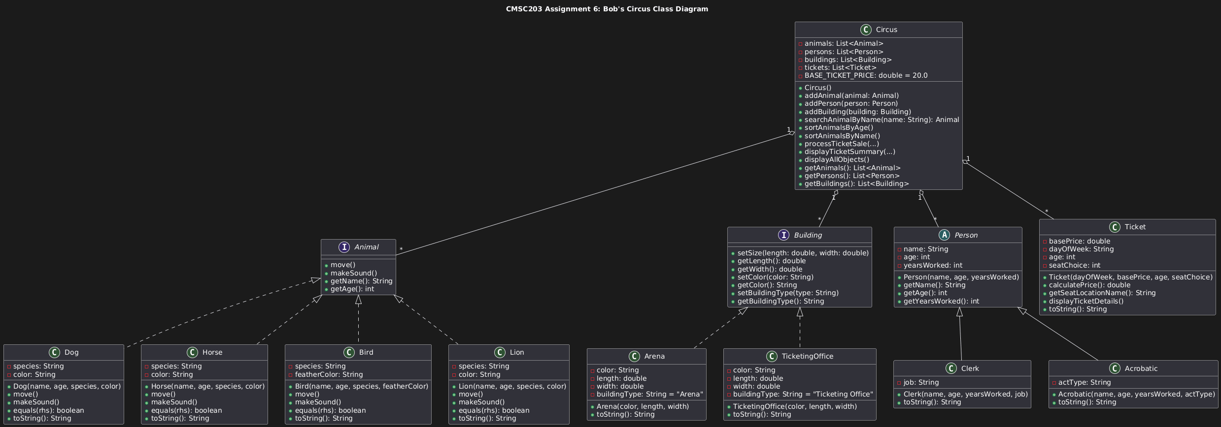
plantUML my beloved

Part3: Comprehensive Test Plan
Test Case # | Input | Actual Input | Expected Output | Actual Output | Did the test pass?
1 | Ticket: Day="SATURDAY", Base Price=20.0, Age=40 (Adult), Seat=1 (Lower Level) | Same | 20.0 (No discounts applied) | Same | Yes
2 | Ticket: Day="MONDAY", Base Price=20.0, Age=10 (Child), Seat=1 (Lower Level) | Same | 16.0 (10% day disc + 10% child disc) | Same | Yes
3 | Dog: Create new Dog("Buddy", 5, "Lab", "Brown") and call getAge() | Same | 5 | Same | Yes
4 | Arena: Call setSize(150.5, 75.2) on an Arena object | Same | getLength() returns 150.5, getWidth() returns 75.2 | Same | Yes
5 | Lion toString: Create Lion("Simba", 9, "African Lion", "Gold") | Same | “lion [name=Simba, age=9, species=African Lion, color=Gold]" | Same | Yes
6 | Circus Search: Add Dog("Shila") to Circus, then call searchAnimalByName("Shila") | Same | Return object is not null and name is "Shila" | Same | Yes

Part4: Screenshots:

Screen snapshots of outputs from Eclipse based on your Test Plan
(multiple pages long)

Test case 1
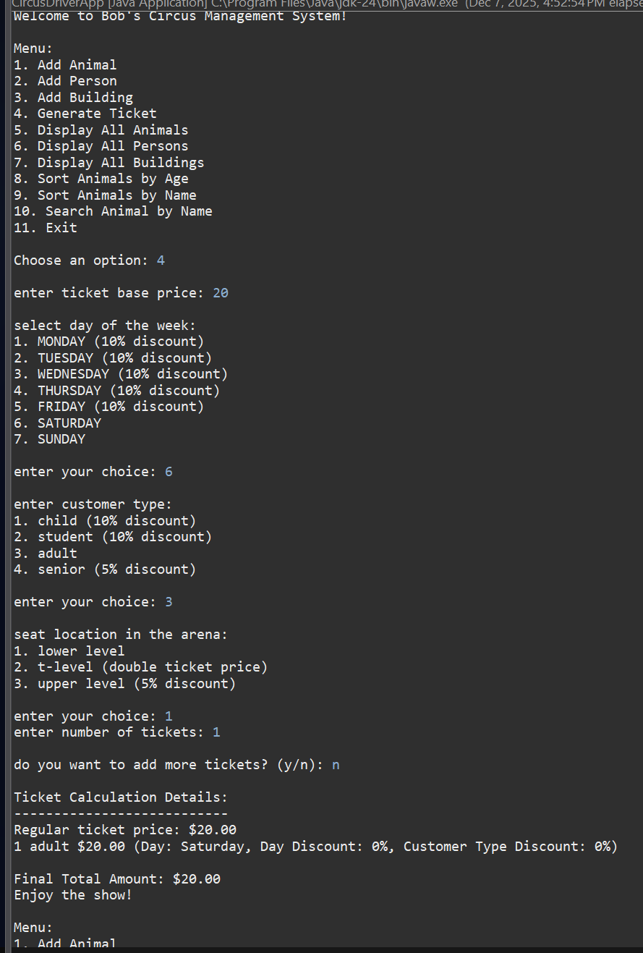

Test case 2
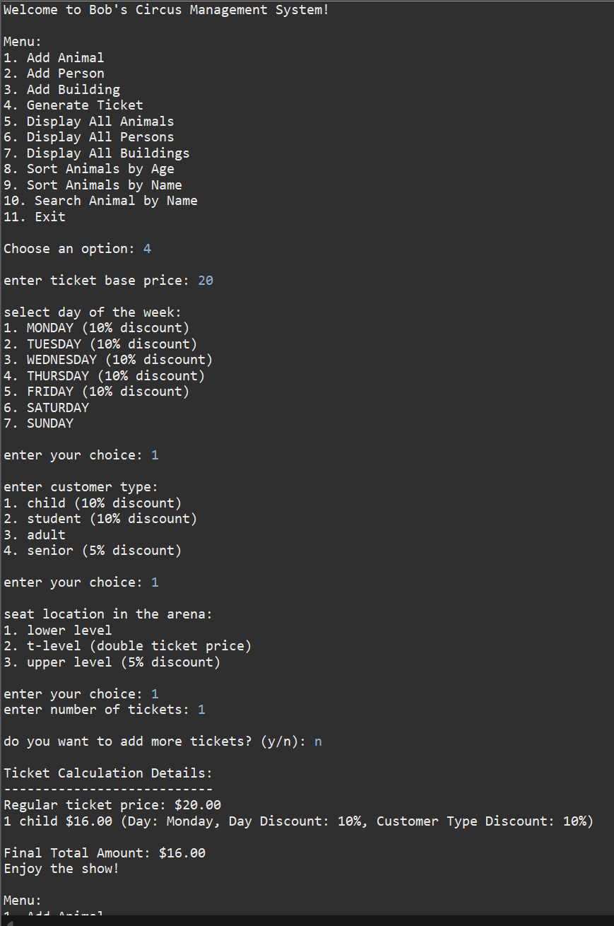

Test case 3
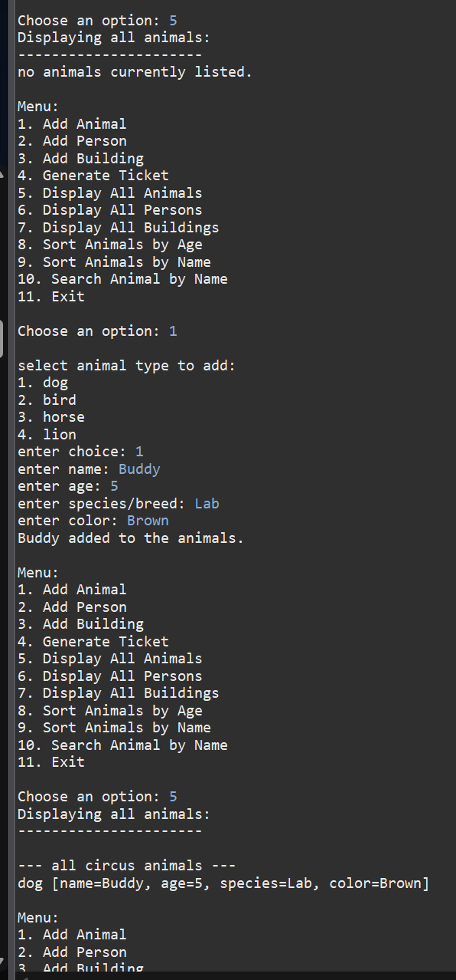

Test case 4
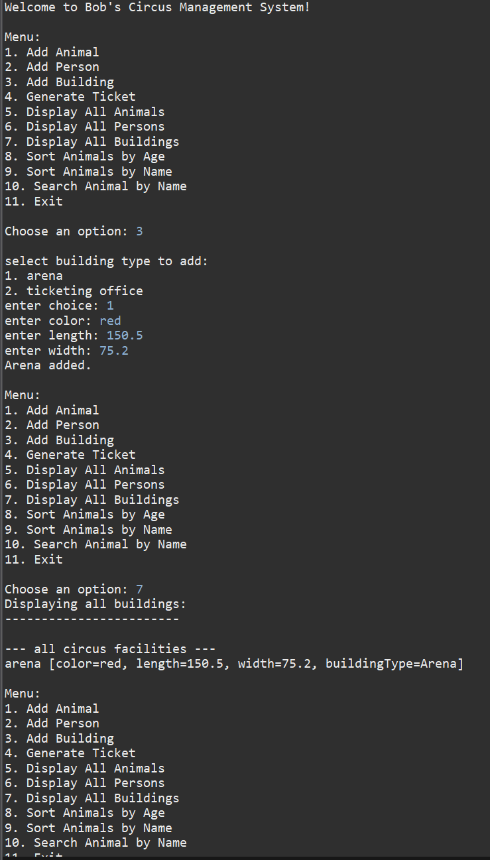

Test case 5
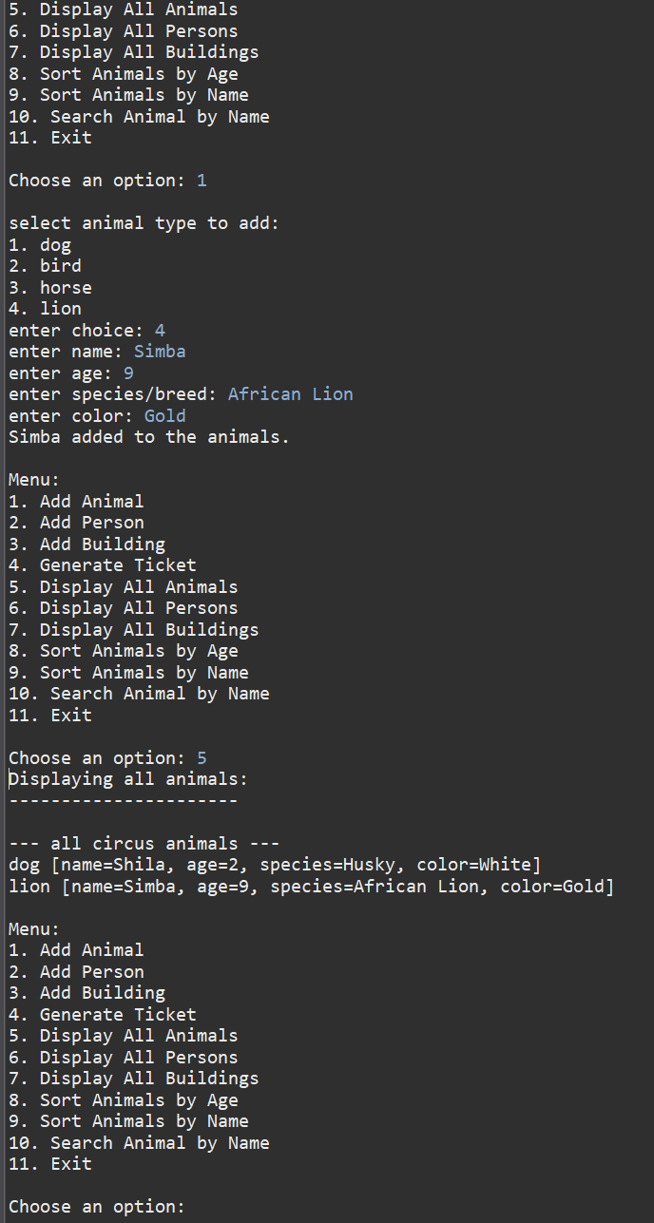

Test case 6
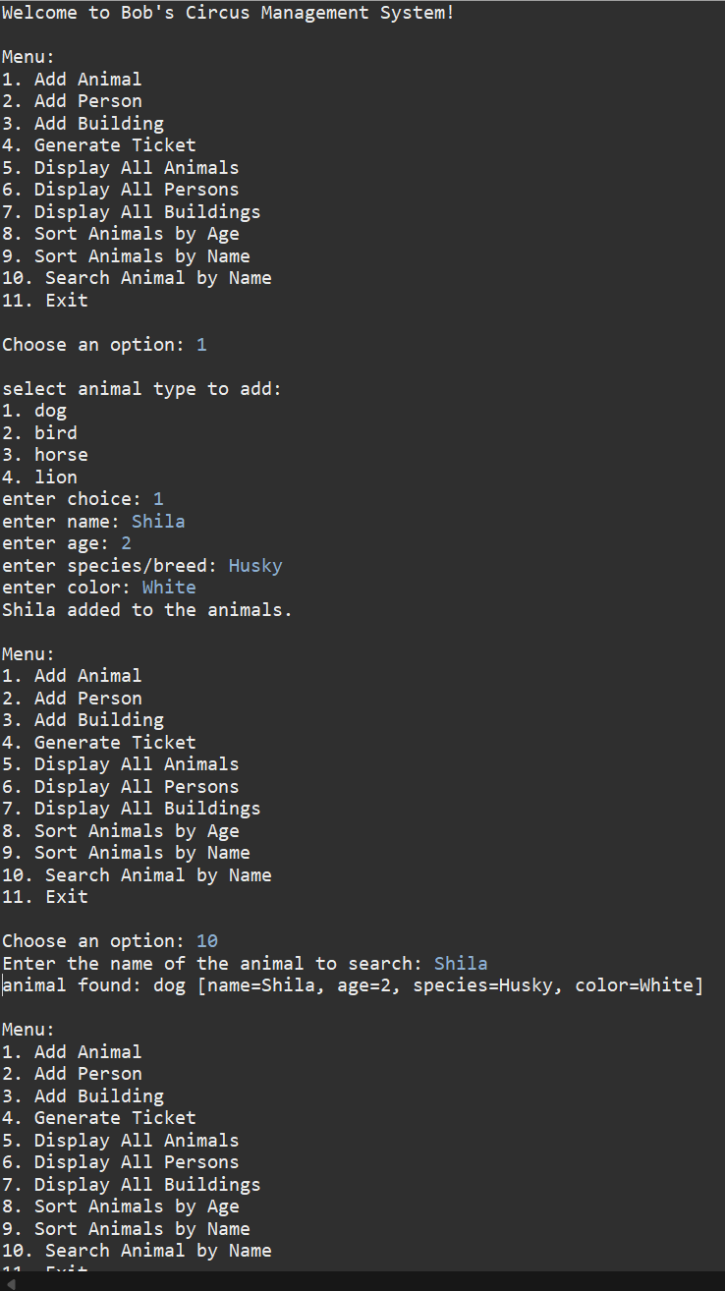

Screen snapshots of Junit Tests with extended methods’ tests
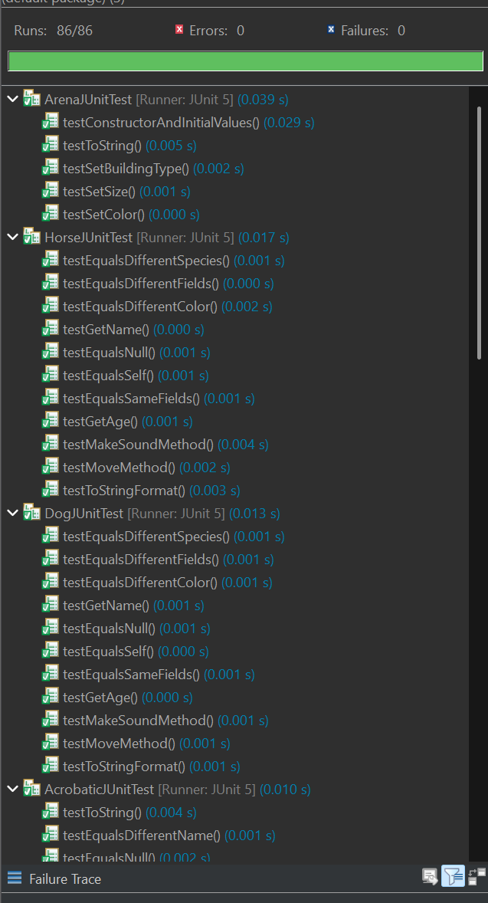
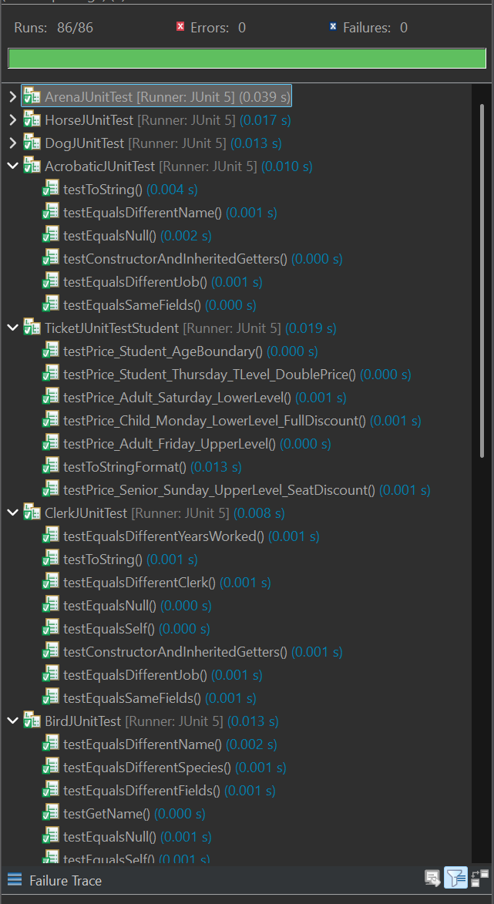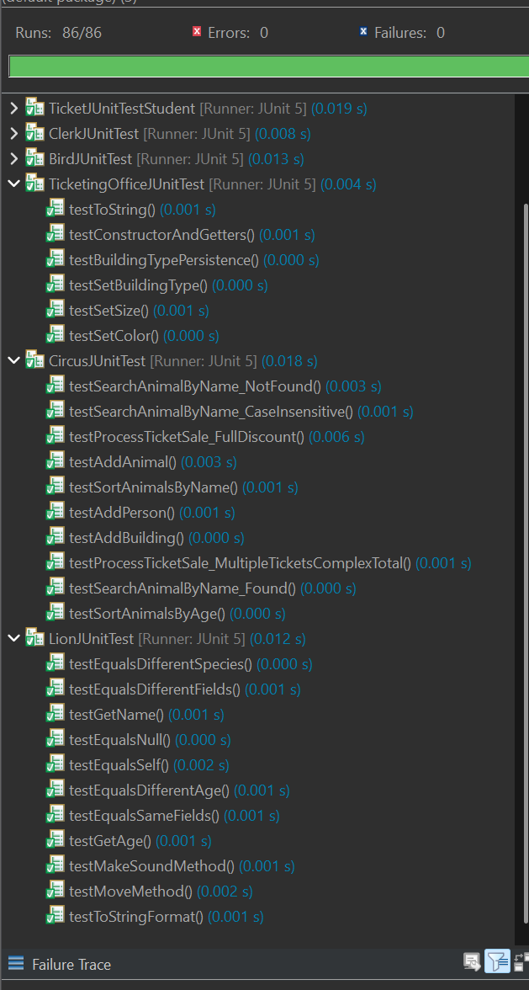

Screen shot of src folder files in your GitHub repository.
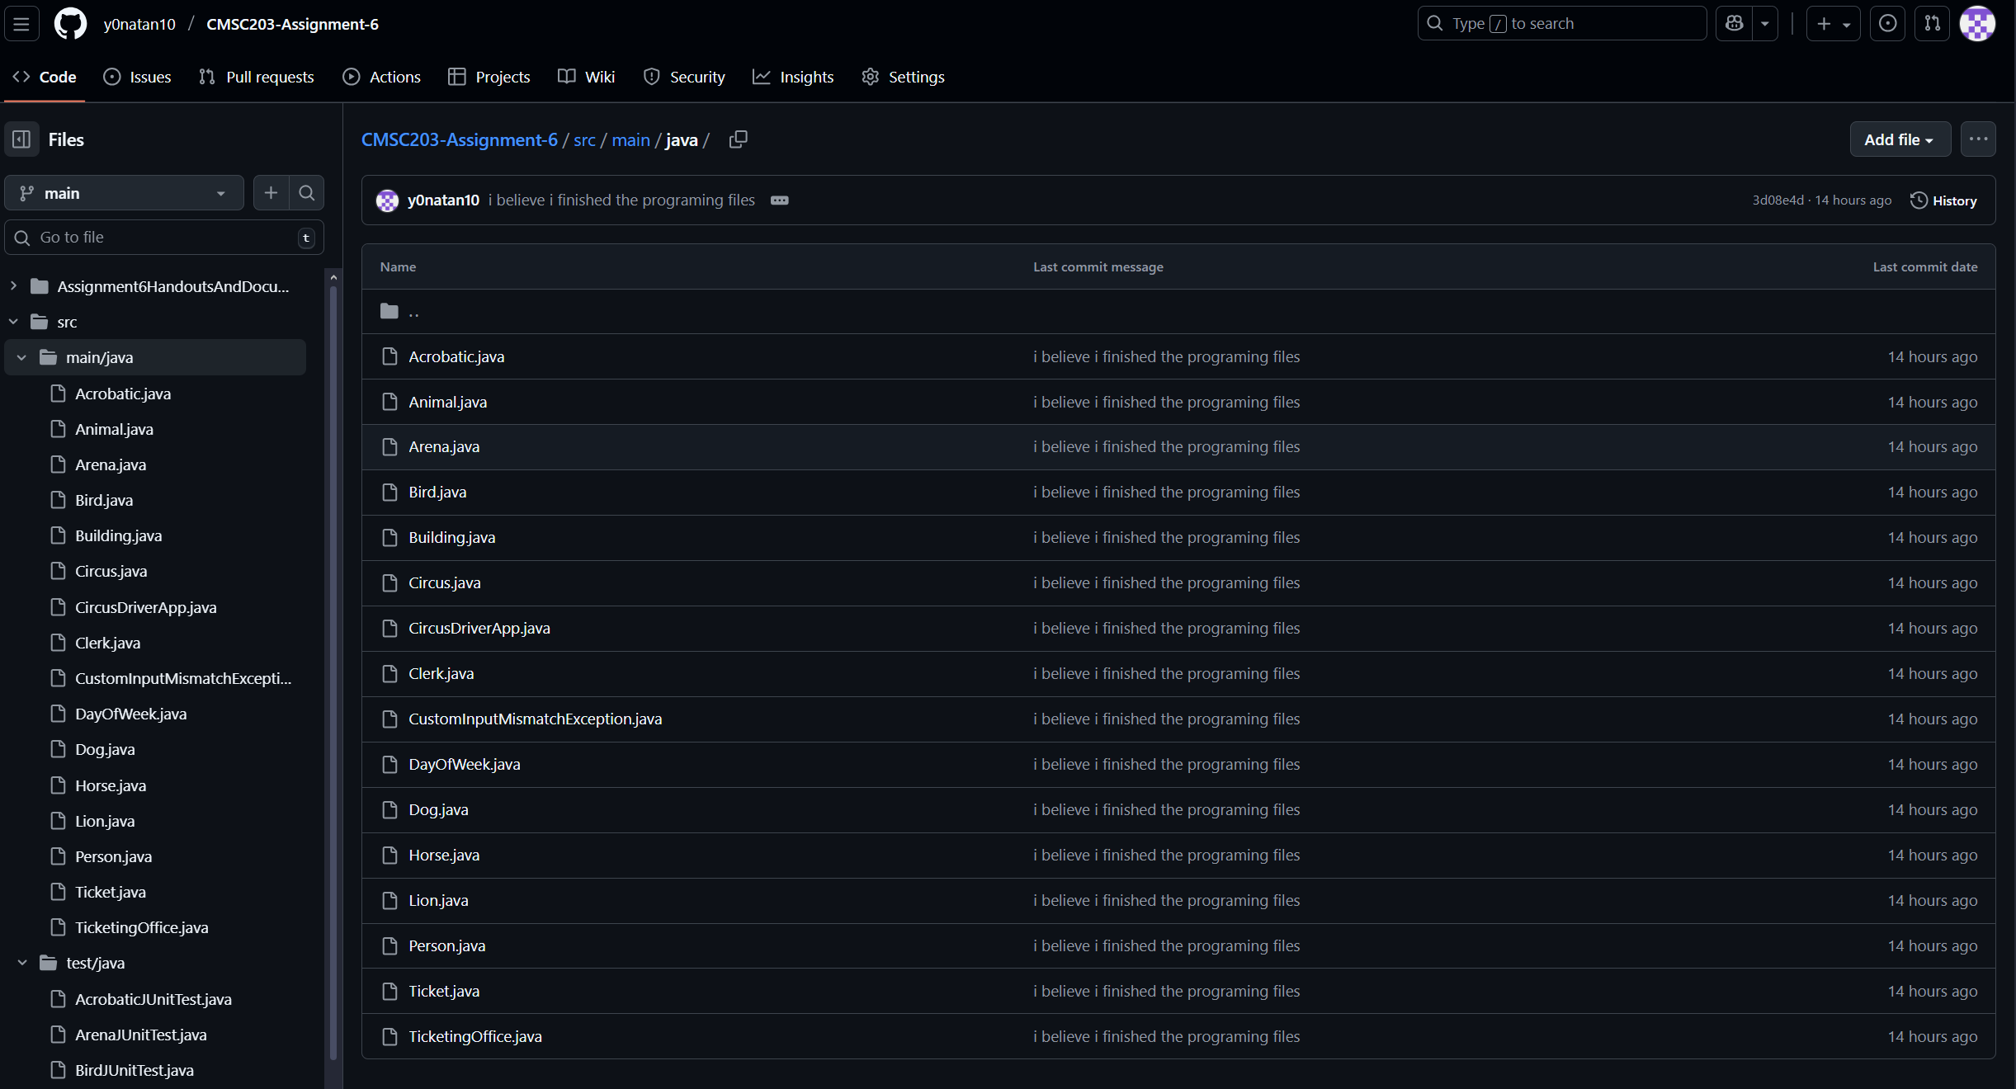
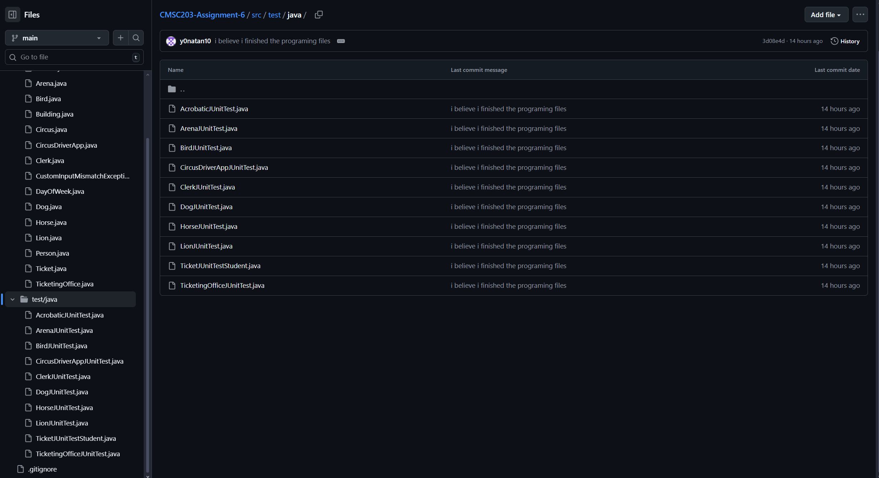

Lessons Learned <Provide answers to the questions listed above>:

Write about your Learning Experience, highlighting your lessons learned and learning experience from working on this project.

What have you learned?
I learned the proper syntax for inheriting based on a class versus an interface

What did you struggle with?
The sheer length of the assignment. There was so much repetition that could have been avoided had Animal been an abstract class.

What would you do differently on your next project?
Since the assignment forbade the changing of the abstact/interface classes, there’s not much I could do differently. I would likely use AI to complete the repetitive files instead of doing it myself for every single one. But that would violate the pledge so I’m not sure if there’s anything I could do differently.

What parts of this assignment were you successful with, and what parts (if any) were you not successful with?
All parts were successful

Provide any additional resources/links/videos you used to while working on this assignment/project.
PlantUML

Check List: <Provide answers to the column Y/N or N/A >:

# |  | Y/N
 | Assignment files:
 | FirstInitialLastName_ Assignment4_Complete.zip | Yes
 | FirstInitialLastName_Assignment4.docx/.pdf | Yes
 | Source java files
 | FirstInitialLastName_ Assignment4_JavaFiles.zip | Yes
 | Program compiles | Yes
 | Program runs with desired outputs related to a Test Plan | Yes
 | Documentation file: | Yes
 | Comprehensive Test Plan | Yes
 | Screenshots from IDE | Yes
 | Screenshots of your GitHub account with submitted Assignment# (if required) | Yes
 | Pseudocode | Yes
 | Lessons Learned | Yes
 | Checklist is completed and included in the Documentation | Yes

