Learning Experience
This project provided a practical and intuitive way to visualize recursive logic with the binary MorseCodeTree. By taking advantage of the tree’s inherent branching, implementing methods for adding and retrieving data became straightforward. This structure made navigation simple since there was only 2 options for the next direction, left or right.
This project was also good practice for generics since the MorseCodeTree had to implement the generic LinkedConverterTreeInterface as a String. The interface required type safety throughout the MorseCodeTree and the supporting class TreeNode. Dealing with these 3 classes while also dealing with custom exception cases for invalid inputs, helped my understanding of reusable data structures.

UML diagram screenshot
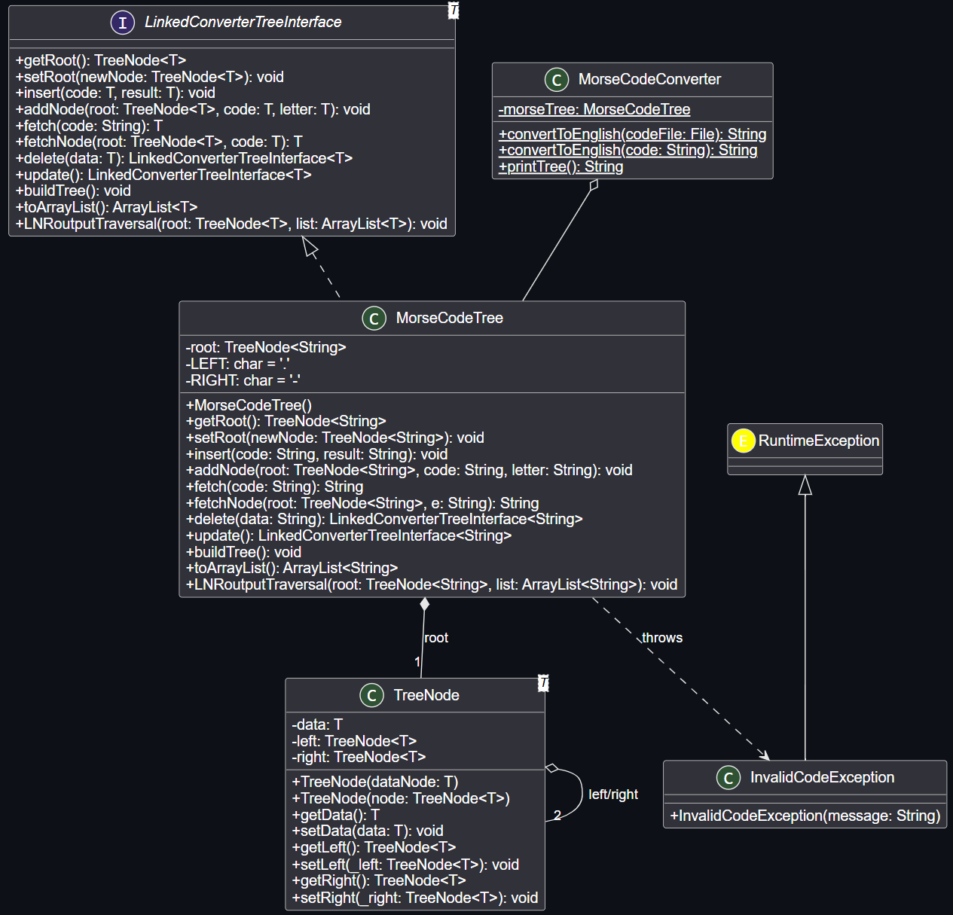
JUnit tests screenshot
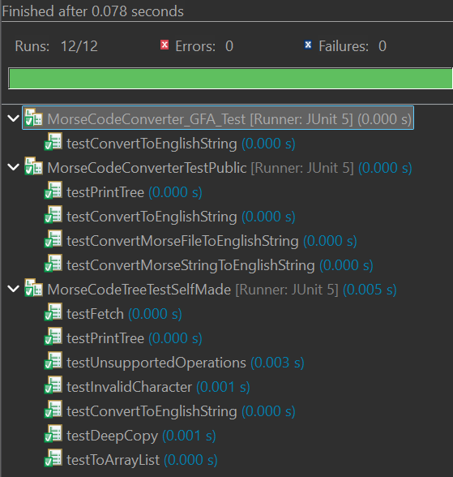
Github Screenshots
