Learning Experience
I like that this project forced me to use structures that I built myself instead of just repeatedly using an ArrayList. Though it was frustrating to have to refactor those old pieces of code. I learned how to use regular expressions in the ‘.replaceAll’ when sanitizing the words for input. Forcing all letters in a word to be lower case and then deleting anything that wasn’t a lower case letter made the process simple and easy.
At the current sample size the difference between O(n) and O(1) is not noticeable. However, it is very nice to know that if my sample size was well into the billions, the hash table implementation will allow me to add delete update and search through the dictionary in O(1) every time.

UML diagram screenshot (2 screenshots because it wouldn’t fit in 1)
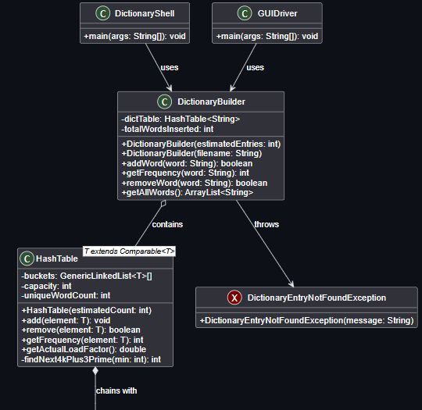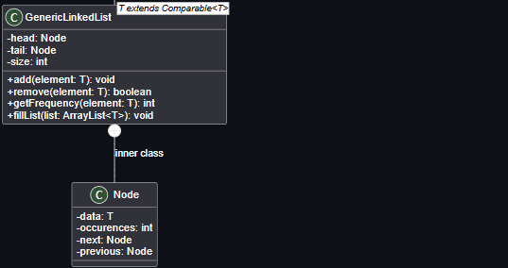
JUnit tests screenshot
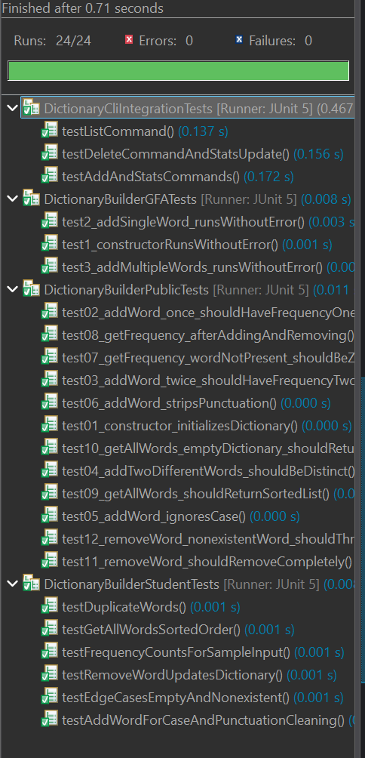
Github Screenshots
